# Objectives

* + Guided Practices up to this point complete.

## Skills graded

* + Plan IP address for host in network.
  + Rename & disable network adapter.
  + Add role to Windows.
  + Install Active Directory.
  + Install Windows.
  + Rename computer.
  + Join computer to domain.
  + Disable windows service.

# Initial Conditions

Your virtual machine should be in this state prior to beginning this performance assessment:

* 1. All VMs in Hyper-V should be stopped.

# Performance Assessment Network setup

Perform the following:

* Download the **PA1-Create-Topology.ps1** file to the **C:\Scripts** folder.
* On you **VMHost** machine, open **PowerShell**. (**Start** -> **Windows PowerShell**).
* In PowerShell, enter the command below to create the network for the Performance Assessment.

1. C:\Scripts\PA1-Create-Topology.ps1

The network that is created is shown below.

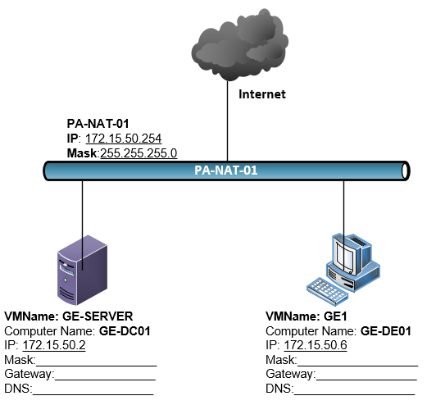

# Performance assessment Instructions

1. Plan IP addressing before proceeding past step 1)
   1. You are assigned the IP address range of **172.15.50.0 /24** for this performance assessment.
   2. **GE-SERVER** will host DNS.
   3. **PA-NAT-01** is a HyperV switch running NAT.
2. (10 pts) Perform initial startup on **GE-SERVER**. Set the **Administrator** password to **Password1**.
3. Rename **GE-SERVER** to **GE-DC01**.
4. Rename NIC on **GE-SERVER** as **LAN**.
5. On **GE-SERVER**, configure **LAN** NIC with your planned IP address, subnet mask, gateway, and DNS.
6. Add **Active Directory Domain Services** role to **GE-SERVER**.
   1. Promote **GE-SERVER** to a domain controller Active Directory domain. You assigned domain name is **GE.local.**
7. On **GE1**, perform a clean install of Windows 10 from ISO (CD/DVD). Create the initial user as **ecpi** with the password of **Password1**.
8. After the install of **GE1**:
   1. Rename NIC on **GE1** as **LAN**.
   2. On **GE1**, configure the IP addressing as planned above.
   3. Rename **GE1** computer to **GE-DE01**.
   4. Join **GE1** to your domain.
   5. Stop the **Windows Update** service and set startup type to Manual.
   6. Download and install **Google Chrome** web browser.

# Document your work

* 1. On your VMHost, d**ownload** the **grading** **script** from the assignment page of the course to the **C:\Scripts** folder.
  2. On your VMHost, execute the command:

Invoke-Pester -Path C:\Scripts\PA1-InstallUpgrade.test.ps1

**Note**: You will see a security warning when running the script. Enter **R** to run the script.

If you want to see more detail, add **-Output Detailed** to the command. This may assist you with troubleshooting

Invoke-Pester -Path C:\Scripts\PA1-InstallUpgrade.test.ps1 -Output Detailed

You should not see any red in the output. Red in the PowerShell way of telling you that an error condition exists. Most of the time, the output will tell you what is wrong. If it is not obvious, contact your teacher and ask for assistance. You will be learning PowerShell during this term. **Correct** any **errors** you may have and run the script until all the output has no red. You should see the output like the images below

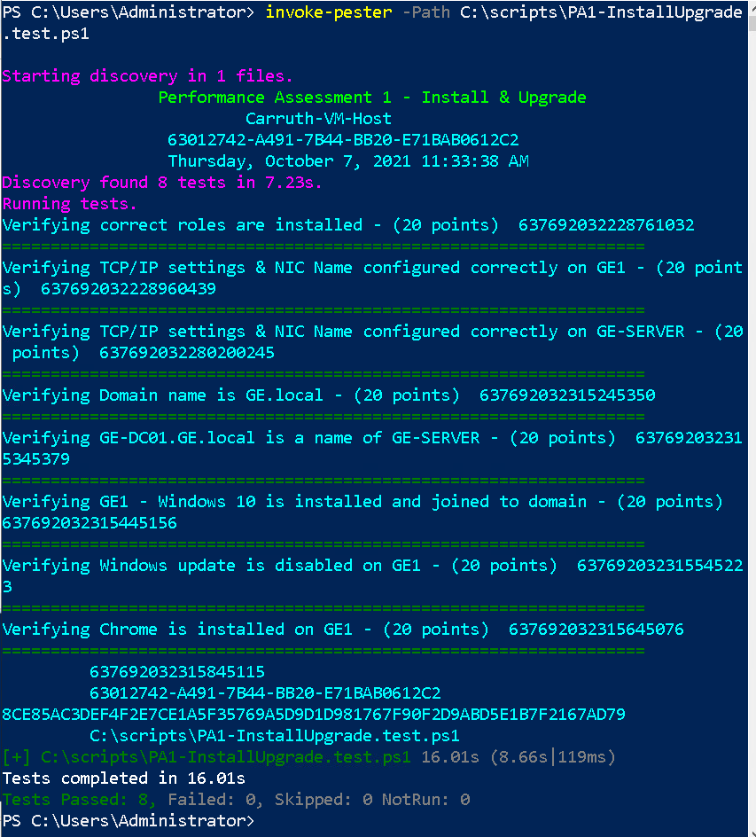

1. Capture a snippet that shows the PowerShell Command and all its output. If you must use more than one snippet to capture the output, you must have at least **one line of overlap** in the snippets. The text in the snippets **must be legible** when pasted into the Word document. Paste the snippet(s) into **PA1_*FirstName*_*LastName*.docx** where ***FirstName*** is your first name and ***LastName*** is your last name.
2. Upload **PA1_*FirstName*_*LastName*.docx** as the submission for this activity.