# Objectives

* + All prior guided practices completed.

## Skills graded

* + Activating Windows
  + Rename & disable network adapter.
  + Join computer to domain.
  + Rename computer.
  + Enable system protection.
  + Creating restore points.
  + Application download and installation.
  + Configure File History.

# Initial Conditions

Your virtual machine should be in this state prior to beginning this performance assessment:

* + Use **GE-SERVER** VM created for the first performance assessment**.**
    - IP address range of **172.15.50.0 /24** for LAN network. **SERVER** will host DNS. DNS client is configured using the DNS server on **SERVER.**
    - Active Directory Domain Services installed and configured as **GE.local**.
    - Passwords **Administrator –** Password1 (administrator)
    - **GE-SERVER** is running
  + All other VMs are shutdown.

# Instructions

Perform the following:

* Download the **PA4-Create-Topology.ps1** file to the **C:\Scripts** folder.
* On your **VMHost** machine, open **PowerShell**.
* In PowerShell, enter the command below to create the network for the Performance Assessment. Note the **GE-SERVER** was created in previous performance assessments.

C:\Scripts\PA4-Create-Topology.ps1

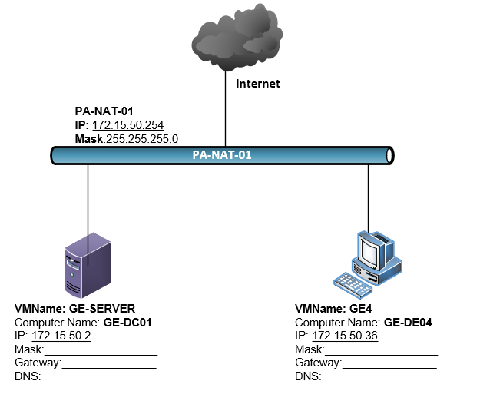

1. Perform the initial startup of **GE4**. Set the initial user to **student** with a password of **Password1**. Rename **GE4** to **GE-DE04**
2. On **GE4**, configure the IP address and default gateway as seen in the topology picture above. **GE-SERVER** will host DNS. Configure the DNS client on **GE4** to use the DNS server on **GE-SERVER.**
3. Join **GE4** to your domain.
4. Perform the remaining administrative actions on **GE4** using your administrative account in Active Directory. If you have not created a domain administrative account in Active Directory, do so now. The username for the account must be your **studentID**.
5. On **GE4**, Enable **System Protection.**
6. On **GE4,** create a restore point named **Restore-GE.**
   1. After creating the restore point, download and install **Greenshot** from <http://getgreenshot.org/downloads/>
7. Create a Virtual Hard Disk in HyperV named **GE4-HD-02** that is 50 GB in size. The disk must be a dynamically expanding. Attach the disk to **GE4**.
   1. Create a simple volume using the newly created VHD. Format the disk as NTFS; use the whole disk as the volume. Assign the drive letter **M:\** to the Volume.
8. On **GE4**, create the **C:\data** directory. Include this directory in the **Documents** library.
   1. Add a **FileHistory.txt** file to the **C:\data** directory. Add “ECPI is the best decision I have ever made” to **FileHistory.txt.**
      1. Enable **File History**.
      2. Edit **FileHistory.txt**, add your ***studentID*** to the second line in the file.

# Document Work

1. On your VMHost, download the **grading** **script** from the assignment page of the course to the **C:\Scripts** folder.
2. On your VMHost, execute the command:

Invoke-Pester -Path C:\Scripts\PA4-RecoveryTools.test.ps1 -Output Detailed

**Note**: you will see a security warning when running the script. Ener **R** to run the script.

If you want to see more detail, add **-Output Detailed** to the command. This may assist you with troubleshooting

Invoke-Pester -Path C:\Scripts\PA3-RemoteManagement.test.ps1   
-Output Detailed

1. You should not see any red in the output. Red in the PowerShell way of telling you that an error condition exists. Most of the time, the output will tell you what is wrong. If it is not obvious, contact your teacher and ask for assistance. You will be learning PowerShell during this term. **Correct** any **errors** you may have and run the script until all the output has no red. You should see the output like the images below

1. Capture a snippet that shows the PowerShell Command and all its output. If you must use more than one snippet to capture the output, you must have at least **one line of overlap** in the snippets. The text in the snippets **must be legible** when pasted into the Word document. The snippet should look like the images above. Paste the snippet into a new Word document and name the document **PA4_*FirstName*_*LastName*.docx** where ***FirstName*** is your first name and ***LastName*** is your last name.
2. Upload **PA4_*FirstName*_*LastName*.docx** as the submission for this activity.