# Objectives

* + All prior guided practices completed.

## Skills graded

* + Configuring Remote access and Remote assistance
  + Configure remote server management
  + Create custom MMC
  + Configure Windows update to use WSUS server
  + Use PowerShell to get services and processes
  + Extract data from event logs
  + Create and run data collector sets

# Initial Conditions

Your virtual machine should be in this state prior to beginning this performance assessment:

* + Use **GE-SERVER** VM created for the first performance assessment**.**
    - IP address range of **172.16.*X*.0 /24** for LAN network. **SERVER** will host DNS. DNS client is configured using the DNS server on **SERVER.**
    - Active Directory Domain Services installed and configured as **GE.local**.
    - Passwords **Administrator –** Password1 (admin user)
    - **GE-SERVER** is running
  + All other VMs are shutdown.

# Instructions

Perform the following:

* Download the **PA3-Create-Topology.ps1** file to the **C:\Scripts** folder.
* On your **VMHost** machine, open **Powershell**.
* In PowerShell, enter the command below to create the network for the Performance Assessment. Note the **GE-SERVER**, **GE1**, and **GE2** were created in previous performance assessments.

C:\Scripts\PA3-Create-Topology.ps1

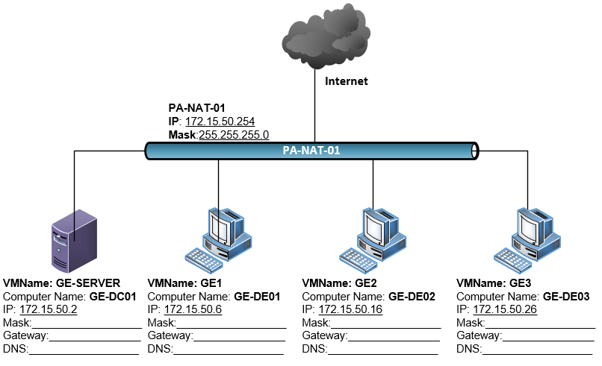

1. Perform the initial startup for **GE3**. The initial user will be **student**. You are assigned the IP address range of **172.15.50.0 /24** for this performance assessment. On **GE3**, configure a valid IP address, subnet mask, and default gateway. **GE-SERVER** will host DNS. Configure the DNS client on **GE3** to use this DNS server**.**
2. Rename **GE3** to ***GE-*DE03*.***
3. Join **GE3** to your domain.
4. Set the **Windows Update** service startup type to **Manual**.
5. Perform the remaining administrative actions on **GE3** using your administrative account in Active Directory. If you have not created a domain administrative account in Active Directory, do so now. The username for the account must be your **studentID** where ***studentID*** is your assigned studentID.
6. Configure **GE3** so that members of the **Domain Users** group can access the computer via **Remote Desktop**.
7. On **GE3**, enable **PowerShell remote** so that PowerShell can be used to remotely manage this system.
8. On **GE3**, enable **Remote Server Administration Tools for Windows 10.**
9. Create a user defined **Data Collector Set** named **PA3**. Use the **Basic template** to create the **Data Collector Set**. Save the data in the default location.
   1. Start the **PA3** data collector and run for 2 minutes and then stop the data collector.

# Document Work

1. On your VMHost, d**ownload** the **grading** **script** from the assignment page of the course to the **C:\Scripts** folder.
2. On your VMHost, execute the command:

Invoke-Pester -Path C:\Scripts\PA3-RemoteManagement.test.ps1 -Output Detailed

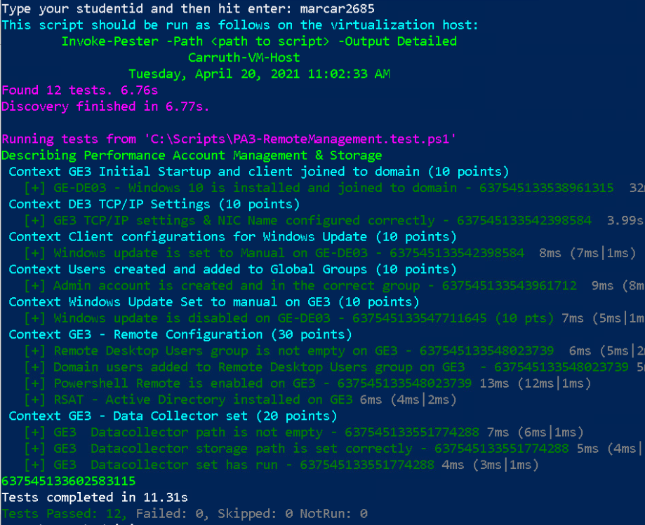

1. Capture a snippet of the output of the command and paste the snippet in a Word document. The length of the output may require two snippets to capture all the output. Ensure that there is some overlap on the snippets. The snippet should look like the images above. Name the document **PA3_*FirstName*_*LastName*.docx** where ***FirstName*** is your first name and ***LastName*** is your last name.
2. Upload **PA3_*FirstName*_*LastName*.docx** as the submission for this activity.