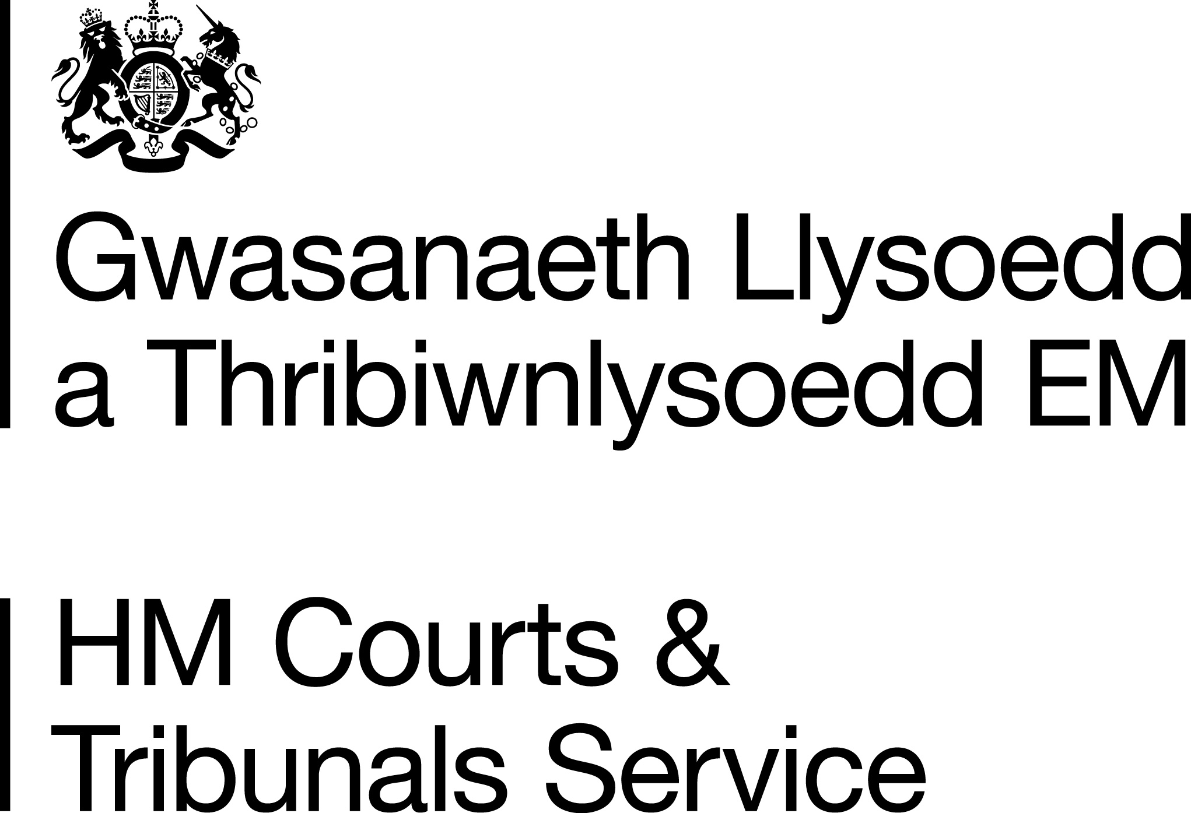 PA97

Hysbysiad i  geisydd personol |  | Notice to personal applicant
Mae’r Grant Cynrychiolaeth bellach wedi’i roi. |  | The Grant of Representation is now issued.
Eich dogfennau |  | Your documents
Amgaeir y dogfennau canlynol; |  | The following documents are enclosed:
- Grant Cynrychiolaeth a chopi o’r ewyllys (os oes un) yn atodedig i’r Grant |  | - Grant of Representation with a copy of the will (if any) attached to the Grant
- copïau swyddogol ychwanegol o’r grant a/neu’r ewyllys (os gofynnwyd amdanynt) |  | - additional official copies of the grant and/or will (if requested)
- Tystysgrif marwolaeth (os nad yw wedi’i dychwelyd i chi eisoes) |  | - Death certificate (if not already returned to you)
- unrhyw ddogfennau eraill a anfonwyd gennych chi ond nad oes yn rhaid i'r gofrestrfa eu cadw. |  | - any other documents which were sent in by you but are not required to be kept by the registry.
Os bydd angen, gellir cael rhagor o gopïau swyddogol o'r Grant (a'r ewyllys) drwy lenwi ffurflen PA1S a'i hanfon i'r cyfeiriad a ddarparwyd. Bydd yn rhaid talu ffi, yn dibynnu ar nifer y copïau y bydd eu hangen arnoch. Gellir cael gwybodaeth am hyn ar y ffurflen PA1S. Mae'n bosib lawrlwytho'r ffurflen oddi ar www.gov.uk/wills-probate-inheritance/searching-for-probate-records |  | If required, further official copies of the Grant (and the will) may be obtained by completing form PA1S and sending it to the address provided. A fee will be payable, depending on the number of copies you require and information about this can be found on form PA1S. You can obtain the form by downloading it from www.gov.uk/wills-probate-inheritance/searching-for-probate-records
Darllenwch eich grant yn ofalus. Rydym yn cymryd gofal i sicrhau cywirdeb ond, os oes unrhyw wall, a fyddech yn dychwelyd y grant gwreiddiol ac unrhyw gopïau swyddogol i’r gofrestrfa er mwyn gallu'u cywiro. Byddwn yn ceisio dychwelyd eich grant diwygiedig a’r copïau yn ddi-oed. |  | Please check your grant carefully. We take care to ensure accuracy, but if there is any error, please return the original grant and any official copies to the registry for correction. We will endeavour to return your amended grant and copies without delay.
Cedwir Ffurflenni PA1 a IHT421 yn y gofrestrfa. |  | Forms PA1 and IHT421 are retained in the registry.

Mae Ffurflenni IHT 205, 207 a 217 yn cael eu hanfon at Gyllid a Thollau Ei Mawrhydi (HMRC) - Treth Etifeddiant, ac fe’u cedwir am gyfnod cyfyngedig yn unig. |  | Forms IHT 205, 207 and 217 are sent to Her Majesty’s Revenue & Customs (HMRC) Inheritance Tax where they are kept for a limited period only.
A’r Grant cynrychiolaeth yn awr wedi’i anfon atoch, mae gwaith y Gofrestrfa Brofiant ar ben. |  | Now that the Grant of representation has been sent to you, the work of the Probate Registry is complete.
Ceir anfon y grant neu'r copïau swyddogol at y bobl neu'r cwmnïau (banciau, cymdeithasau adeiladu, cwmnïau yswiriant, cofrestryddion stociau a chyfranddaliadau ayb.) sy'n dal arian neu asedau a oedd yn perthyn i'r ymadawedig. Byddant yn trefnu i ryddhau’r asedau a dychwelyd y grant (neu gopi o’r grant) atoch. |  | The Grant or official copies may be sent to the people or companies (banks, building societies, insurance companies, registrars of stocks and shares etc.) holding money or assets which belonged to the deceased. They will arrange to release the assets and return the grant (or copy) to you.
Dyma’ch dyletswyddau fel ysgutor neu weinyddwr |  | Your duties as an executor or administrator
Eich dyletswyddau yw: |  | Your duties are to:
- casglu’r ystad (arian, eiddo ayb) |  | - collect the estate (money, property, etc)
- talu dyledion, treuliau’r angladd ayb |  | - pay debts, funeral expenses etc
- talu’r balans i’r bobl y mae ganddynt hawl cyfreithiol iddo |  | - pay the balance to the persons who are legally entitled to it
- cadw derbynebau a chofnod o’r hyn yr ydych wedi’i wneud. |  | - keep receipts and a record of what you have done.
Efallai y byddwch am agor cyfrif banc yn benodol i helpu rheoli’r arian a delir i mewn ac allan o'r ystad. Bydd hyn yn eich helpu i gadw cofnod o drafodion yr ystad ar wahân i'ch arian chi eich hun. |  | You may wish to open a bank account specifically to help manage the money that is paid into and out from the estate. This will help you keep a record of estate transactions, separate from your own money.
Rheoli’r ystad |  | Managing the estate
Os byddwch yn cael trafferthion i ddelio â'r ystad, efallai y bydd eich canolfan Cyngor Ar Bopeth leol yn gallu helpu neu gallech gysylltu â chyfreithiwr. Mae’r mwyafrif o achosion yn ddigon syml, ond efallai y bydd angen cyngor yn y sefyllfaoedd canlynol: |  | If you have any difficulties in dealing with the estate, your local Citizens’ Advice Bureau may be able to help, or you could consult a solicitor. Most cases are straightforward, but advice may be needed if:
- nid oes digon o arian i dalu holl ddyledion yr ymadawedig |  | - there is not enough money to pay all the deceased’s debts
- nid ydych yn sicr a ydych yn gwybod am holl ddyledion yr ymadawedig |  | - you are not certain that you know of all the deceased’s debts
- mae anghytuno ynghylch yr ystad |  | - there is any disagreement about the estate
- nid ydych yn sicr sut y dylai’r ystad gael ei rannu |  | - you are not certain how the estate should be shared
- mae’r ystad yn cynnwys tŷ neu dir |  | - there is a house or land
- mae’n rhaid sefydlu ymddiriedolaeth |  | - a trust has to be set up
- mae rhywun sydd â hawl i ran o’r ystad yn iau na 18 oed |  | - anyone who benefits from the estate is under 18 years of age
- mae rhywun sydd â hawl i ran o’r ystad heb alluedd meddyliol, ac felly dylech hysbysu’r Llys Gwarchod, First Avenue House, PO Box 70185, 42-49 High Holborn, Llundain, WC1A 9JA Ffôn: 0300 456 4600. |  | - anyone who benefits from the estate lacks mental capacity in which case you should notify the Court of Protection, First Avenue House, PO Box 70185, 42-49 High Holborn, London, WC1A 9JA. Tel: 0300 456 4600.
Adran Gwaith a Phensiynau |  | Department for Work and Pensions
Bydd yr Adran Gwaith a Phensiynau yn ysgrifennu atoch os oedd yr ymadawedig mewn dyled i’r Adran Gwaith a Phensiynau, neu os talwyd arian i mewn i’w cyfrif banc/cymdeithas adeiladu ar ôl y farwolaeth. Hefyd, gall yr Adran Gwaith a Phensiynau gysylltu â chi am fanylion ynglŷn â’r ystad os talwyd budd-dal seiliedig ar incwm. Bydd hyn yn caniatáu i'r Adran Gwaith a Phensiynau gadarnhau hawl i fudd-dal a phenderfynu a oes unrhyw hawliad ar yr ystad. Gofynnir i gynrychiolwyr beidio â rhannu’r ystad nes bydd yr Adran Gwaith a Phensiynau wedi cadarnhau unrhyw hawliad. |  | DWP will write to you if the deceased owed money to DWP or if money was paid into their bank/building society after they died. DWP may also contact you for details of the estate where an income based benefit had been in payment. This will allow DWP to confirm benefit entitlement and decide whether there is any claim on the estate. Representatives are asked not to distribute the estate until DWP has confirmed any claim.
Treth Etifeddiant |  | Inheritance Tax
- Nid yw rhoi’r Grant yn golygu o anghenraid eich bod wedi talu’r holl Dreth Etifeddiant a llog sydd o bosibl yn ddyledus ar yr ystad. Mae’r cyfrifiadau cychwynnol yn seiliedig ar yr wybodaeth yr ydych chi wedi’i darparu. |  | - The issue of the Grant does not necessarily mean that you have paid all the Inheritance Tax and interest which may be due on the estate. Initial calculations are based on the information you supplied.
- Os ydych wedi llenwi’r ffurflen fer – IHT205 neu 207 - Mae gennych ryddhad awtomatig rhag Treth Etifeddiant ar ôl i 35 diwrnod fynd heibio ers dyddiad rhoi’r grant, ar yr amod bod yr holl ffeithiau perthnasol wedi cael eu datgelu’n llawn. |  | - If you completed the short form – IHT205 or 207 - You have automatic clearance from Inheritance Tax once 35 days have passed from the day the grant was issued, provided a full disclosure of all material facts has been made.
- Ym mhob achos arall, bydd Cyllid a Thollau EM yn archwilio'r cyfrif yn llawn, ac efallai y byddant yn codi cwestiynau ac yn gofyn i’r Prisiwr Dosbarth edrych ar werth yr eiddo. Efallai hefyd y byddant yn darparu cyfrifiadau interim (a elwir yn asesiadau anffurfiol) o'r dreth a'r llog sy'n daladwy. Bydd y rhain yn eich helpu chi i wneud darpariaeth ar gyfer bodloni’r rhwymedigaeth treth. |  | - In all other cases the account will be fully examined by HMRC who may raise questions and ask the District Valuer to look at the value of the property. They may also issue interim calculations of tax and interest payable (called informal assessments). These will help you make provision to meet the tax liability.
- Cewch ofyn am dystysgrif glirio gan Gyllid a Thollau EM pan fydd yr ohebiaeth wedi’i chwblhau a’r holl dreth a llog wedi'u talu. Yn gyffredinol, mae hyn yn eich rhyddhau rhag talu rhagor o dreth a llog ar yr asedau a ddatgelwyd. |  | - You may ask for clearance from HMRC when the correspondence has been concluded and all tax and interest has been paid. This generally discharges you from further tax and interest on the assets disclosed.
- Mae llog ar Dreth Etifeddiant heb ei thalu yn dechrau dod yn daladwy 6 mis ar ôl diwedd y mis pan ddigwyddodd y farwolaeth. Gellir talu i mewn i gyfrif Treth Etifeddiant ar unrhyw adeg yn HMRC Banking,St Mungo's Road, Cumbernauld, Glasgow, G70 5WY. Cofiwch roi cyfeirnod y Dreth Etifeddiant, enw llawn yr ymadawedig a dyddiad ei farwolaeth ar bob gohebiaeth. Gallwch gael rhagor o wybodaeth ar sut i dalu Treth Etifeddiant ar wefan Cyllid a Thollau EM yn www.hmrc.gov.uk/payinghmrc. |  | - Interest on unpaid Inheritance Tax begins to be payable 6 months after the end of the month in which the death occurred. Money on account of Inheritance Tax may be placed on deposit at any time, at HMRC Banking,St Mungo's Road, Cumbernauld, Glasgow, G70 5WY. Please be sure to quote the Inheritance Tax reference, full name of the deceased and the date of death in all correspondence. Further information on how to pay Inheritance Tax may be found on the HMRC website at www.hmrc.gov.uk/payinghmrc.
- Gallwch gael rhagor o wybodaeth ar Dreth Etifeddiant ar wefan Cyllid a Thollau EM yn www.hmrc.gov.uk/inheritancetax. Mae’n bosib cysylltu â Chyllid a Thollau EM drwy’r Linell Gymorth Profiant, Treth Etifeddiant ac Ymddiriedolaethau – 0300 123 1072 |  | - Further information on Inheritance Tax may be found on the HMRC website at www.hmrc.gov.uk/inheritancetax.  HMRC may also be contacted via the Probate, Inheritance Tax & Trusts Helpline – 0300 123 1072
Newidiadau i’r ystad |  | Alterations to the estate
Os nad oedd rhaid i chi gwblhau cyfrif llawn (e.e. os caniatawyd i chi gwblhau IHT 205) a bod gwerth yr ystad yn newid, dim ond os fyddai hyn wedi golygu y byddai cyfrif llawn yn angenrheidiol pe byddech yn gwybod yr holl wybodaeth pan oeddech yn llenwi’r ffurflen y mae’n rhaid ysgrifennu at Gyllid a Thollau EM. Bydd angen ichi anfon copi o’r ffurflen wreiddiol a’r Cyfrif wedi’i Gywiro C4 i Gyllid a Thollau EM, Ferrers House, PO Box 38, Castle Meadow Road, Nottingham, NG2 1BB. Os na wnaethoch gadw copi o’r ffurflen, bydd rhaid ichi gwblhau’r cyfrif llawn (IHT400) yn lle hynny. |  | If you did not have to complete a full account (e.g. if you were allowed to complete an IHT 205) and there is a change to the value of the estate, you only have to write to HMRC if the change means that a full account (IHT400) would have been required if you had known all the information when you filled in the form. You will need to send a copy of the original form and a Corrective Account C4 to HMRC, Ferrers House, PO Box 38, Castle Meadow Road, Nottingham, NG2 1BB. If you did not keep a copy of the form you will have to complete a full account (IHT400) instead.
Os cwblhawyd cyfrif llawn (IHT400) a bod gwerth yr ystad yn newid cyn i Gyllid a Thollau EM ddod â'r mater i ben, dylech gwblhau Cyfrif wedi'i Gywiro C4 a'i anfon i Gyllid a Thollau EM, Ferrers House, PO Box 38, Castle Meadow Road, Nottingham, NG2 1BB. Pan fydd Cyllid a Thollau EM yn cau’r ffeil, mae’r llythyr cau yn nodi fod rhaid i chi ddweud am unrhyw newidiadau sy’n effeithio ar gyfanswm y Dreth Etifeddiant sy’n daladwy ar yr ystad. |  | If you completed a full account (IHT400) and there is a change to the value of the estate before HMRC finalises matters, you should complete a Corrective Account C4 and send it to HMRC, Ferrers House, PO Box 38, Castle Meadow Road, Nottingham, NG2 1BB. When HMRC closes its file the closure letter says that you must report any changes which affect the amount of Inheritance Tax payable on the estate.
Pan fydd Gweinyddiaeth yr Ystad wedi ei chwblhau |  | When the Administration of the Estate is completed
Pan fyddwch wedi delio â’r ystad, nid oes rhaid ichi hysbysu’r Gofrestrfa Brofiant. Fodd bynnag, dylech gadw pob derbynneb a chofnod. Efallai y bydd eu hangen fel tystiolaeth os yw buddiolwr neu gredydwr yn cwestiynu beth oedd cynnwys yr ystad, neu sut rydych wedi ei weinyddu. |  | When you have dealt with the estate, you do not need to inform the Probate Registry. You should, however, keep all receipts and records. They may be needed as evidence if a beneficiary or a creditor questions what the estate consisted of, or how you have administered it.

