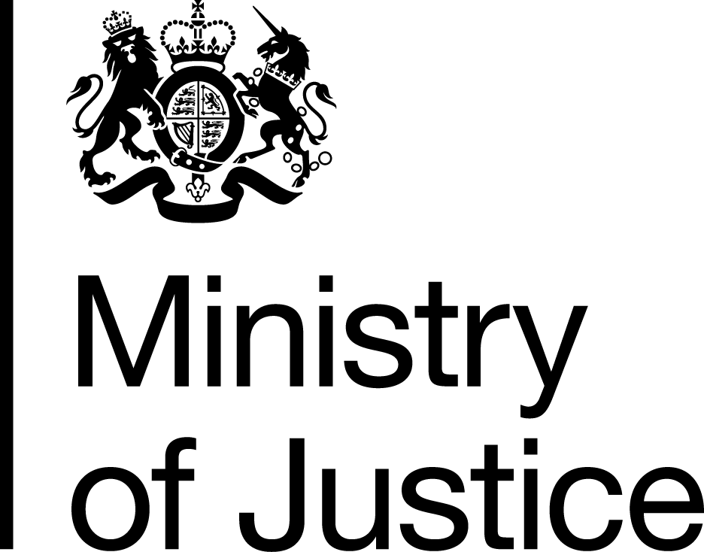 | National Security Vetting – Assessment of Need

This form should be completed by a line manager or contract manager. Completion of this form will allow MoJ Group Security to determine the correct level of National Security Clearance.

Name of the employee requiring clearance
Employee’s employment status Agency Contracted Directly employed by MoJ
Work-based activity for which clearance is required

Employee’s location

Assessment questionnaire

1 | Does the individual require access to knowledge or custody of any classified assets, including information assets? | Yes | Go to Q2
1 |  | No | Go to Q7

2 | Is OFFICIAL (either limited via access to individual records or via accumulated knowledge) the highest level of classified information or access that the individual will have? | Yes | Go to Q7
2 |  | No | Go to Q3

3 | Is SECRET (either limited via access to individual records or via accumulated knowledge) the highest level of classified information the individual will have access to? | Yes | Go to Q5
3 |  | No | Go to Q4

4 | Is TOP SECRET (either limited via access to individual records or via accumulated knowledge) the highest level of classified information the individual will have access to? | Yes | Go to Q6
4 |  | No | Go to Q7

5 | Is access to SECRET long-term, frequent and uncontrolled, or sufficient to form a comprehensive picture of a policy, plan or project? | Yes | SC required
5 |  | No | Go to Q7
5 | If ‘Yes’, please explain the nature of the job and the information involved:

6 | Is access to TOP SECRET long-term, frequent and uncontrolled, or sufficient to form a comprehensive picture of a policy, plan or project? | Yes | DV required
6 |  | No | Go back to Q5
6 | If ‘Yes’, please explain the nature of the job and the information involved:

7 | a) Is the individual likely to be in close proximity to public figures who are at risk from terrorists, or those who threaten national security? | Yes | CTC required
7 |  | No | Go to 7b
7 | If ‘Yes’, which public figures and what is your assessment of the risk?

 | b) Is the individual likely to require unescorted access to buildings assessed to be at risk from terrorists or those who threaten national security? | Yes | CTC required
 |  | No | Go to 7c
If ‘Yes’, which building(s) and what is your assessment of why they pose a risk?
e.g. Require a Palace of Westminster Pass

 | c) Is the individual likely to have access to information assessed to be of interest to terrorists or those who threaten national security? | Yes | CTC required
 |  | No | No clearance required
 | If ‘Yes’, what type(s) of information, and what is your assessment of why it is of interest?

d) Please provide any other relevant information:

By submitting this form, you are giving your personal assurance that the individual is being cleared specifically for work in MoJ, its agencies and sponsored bodies and not for any other Government Department or organisation. Clearances granted by MoJ will not be transferable to non-MoJ sites, without prior approval of MoJ Group Security.

Name

Email Address

Telephone Number

Business Area

The completed form should be sent to MoJGroupSecurity@justice.gov.uk for consideration.
.

