Cartesian products

* What is the def of Cartesian product
* 🡪 A cartesian product is a list of sets
* If S = {1,2,3}, T = null, the SxT = ??
* 🡪 null
* Graphs
* Draw S = {1,2,3} , T = {4,5} in a graph

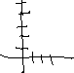

* If |S} = 2, |T| = 3, what is }SxT|?
* 🡪 6
* Is SxTxR = (SxT)xR ? Why not?
* 🡪 no because grouped differently

Indices

* U, upside down U
* 🡪 U means all the contained, upside down is every seperate
* Let Ci = {1,2…i} 🡪 what is C1, C2?
* 🡪 C1 = {1} , C2 = {2}
* What is C10^6 intersect C101? 🡪 C10^6
* What is C10^6 union C101? 🡪 c101

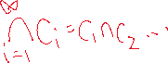

* Ex) let Pr = {(x,y)ㅌ RXR : y = x^2+r} (rㅌR)
  + What is P0? And then draw it



* + What is P1?



* + What is P-1?



* (homework question) What is

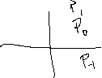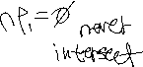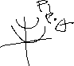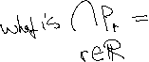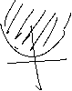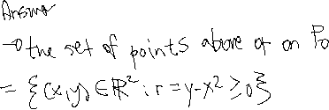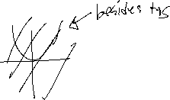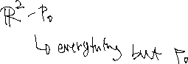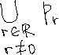

Ex) Let x ㅌR. Define, Jx = [x,2]x[3,3+x]

* Find



🡪Find J1 : [1,2]x[3,4]

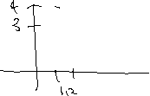

* Find J2 : [2,2]x[3,5]



* Find J3/2 :





