Seatalk to USB Converter

Installation
If not supplied in a box, you can use the four holes in the corner of the board to attach the device. The holes are 3.2mm diameter and will accept standard board mounts or an M3 bolt.

Connect your Seatalk cable to the blue or black connector. Each connection is labelled:

R Seatalk red which is +12V
Y Seatalk yellow which is data
B Seatalk black which is 0V

Use a standard USB Type A to Type B cable to connect the device to a computer.

Software Compatibility
This device has been tested on Windows XP, Vista, 7, 8 (all 32 bit editions) and Server 2008 R2 64 bit. 8 requires driver signing to be switched off. Contact me for details if necessary. If anyone tries any other version and it works please feed back this information so I can update these instructions. Not tested on any other operating system.

Power Supply
This device requires 12V power from the Seatalk connection to run. It will not appear in Windows as a device without an external power supply. It does not take power from the computer it is plugged in to. Consumption is 28 mA.

Driver Installation
The first time you connect this device to a Windows computer you will be asked for a driver, which will be on the CD or can be downloaded from the website. The device must be powered by the Seatalk cable when you do this. Browse to file yappcdc.inf. If successfully installed you should see the following dialog, or similar…

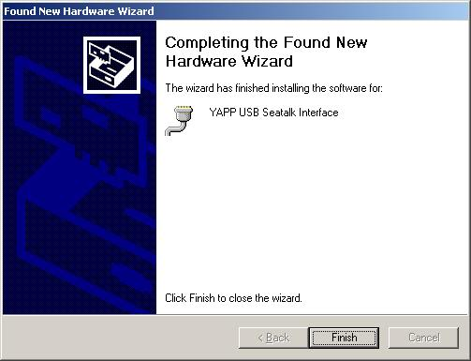

Message Conversions
This device converts Seatalk messages to the following NMEA 0183 format messages:

VWR (apparent wind speed and direction old format)
VWT (true wind speed and direction old format)
VHW (true heading, magnetic heading, boat speed)
DBT (depth below transducer)
HDM (magnetic heading different format)
MTW (water temperature)
RMC (time, date, lat, long, SOG, COG, magnetic variation)
VLW (trip and total log)
RMB (distance and bearing to destination, but not the other RMB fields)
MWV (true and apparent wind speed and direction, new format)
RSA (rudder sensor angle, 1 rudder only)

The NMEA format messages have been verified with OpenCPN and MaxSea.

Finding You COM Port
Windows will allocate the device a COM port. You need this information to put into your Windows application that is using the NMEA data, for example OpenCPN. To find the COM port, you need to run Windows’ Device Manager. Here is one way of doing it…

Start|Run
devmgmt.msc

Open the Ports (COM and LPT) sub-list, and you should see the device listed as YAPP USB Seatalk Interface (COMxx). It is this xx number that you need to know. This is shown as 16 in the example below:

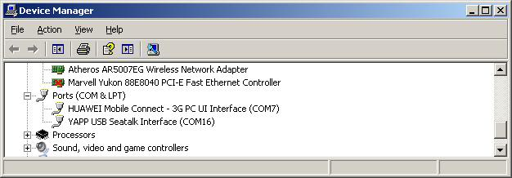

When setting up your Windows application, you need to enter this COM port number. The baud rate is 4800, data length is 8 and parity is none.

Variable COM Port Numbers
Once you have found out your COM port number, it will remain the same as long as each time you plug the device into the same USB socket on your computer. If you plug it into a different socket, the driver will be installed again and the COM port number will be different. You will have to find it out again and change the settings in your Windows application. Using the same USB slot each times is simpler.

If you power off the device while an application like OpenCPN is still running then before restarting you will have to close the application and remove the USB cable from your computer and replace. If you don’t, the device will appear in your device list but your application won’t be able to open it. Annoying, I know, but this is a Windows feature that can’t be got round.

Usual Disclaimer
This is a hobby project and should be treated as such. If you are going to navigate into a harbour in the dark or fog via GPS, use a professional chart plotter and GPS source, and keep a good lookout!

www.yappelectronics.co.uk

yapp@yappelectronics.co.uk

