YAPP Anchor Watcher

Introduction
The YAPP Anchor Watcher is a small low powered device that monitors various data values from the instruments on your Seatalk network and compares them to user-set threshold values. If any monitored value goes beyond its threshold value then an audible alarm is sounded. The following values can be monitored:

- Depth
- SOG
- Windspeed
- Heading change from a previously set heading
- Distance from a previously set position
- Loss of data on your Seatalk network

All alarm thresholds are configurable, and 1 to 5 can be individually switched on or off. 6 is always active.

The advantage of this device compared to using alarms on conventional boat instrumentation are these:

- Low power consumption.
- Can be installed near where you sleep
- Flexible one-time configuration
- Quick and easy to start and stop monitoring and accept an alarm.
- Visual assurance indication that monitoring is taking place.

Configuration of the device is performed through the front panel and two buttons. Once configuration settings are saved in the device they will remain saved until the values are changed. They do not need setting every time the device is used.

Installation
Connect your Seatalk cable to the blue or black connector. Each connection is labelled:

R Seatalk red which is +12V
Y Seatalk yellow which is data
B Seatalk black which is 0V

Power Supply
This device takes 10mA at 12V from the Seatalk connection to run. The device can safely reject power supply spikes up to 60V.

Configuring the Device
Configuration of the YAPP Anchor Watcher is performed through the front panel using the LCD display and the two buttons. The meaning of each button is shown by the text immediately to the left of each button.

Using the Device
When you power up the device the display will show NO DATA. This means that the device is waiting for the arrival of the first value from your instruments via the Seatalk network. The device requires only the data on the Seatalk network for those values being watched. For example, if you have chosen in the settings not to watch depth then the device will not expect depth data to arrive via Seatalk. You cannot switch on watching while NO DATA is shown but you can change the settings.

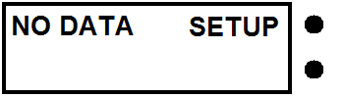

When NO DATA changes to STANDBY this means that the required data is being received via the Seatalk network regularly and you can start watching with a short press of the button labelled START. You can also modify settings at this point by pressing the button labelled SETUP.

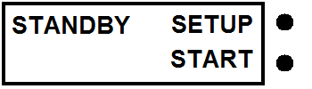

When watching is happening the display will show WATCHING and STOP next to the top button. It will also cycle through the data being watched showing the current value received via Seatalk.

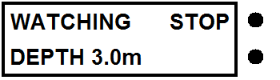

For values not being monitored this is shown on the watching display.

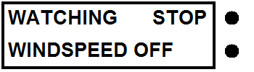

When watching is started the current GPS position and current heading are taken as the reference values. These reference values are subsequently used to calculate if the position or heading has changed sufficiently to sound an alarm. New reference values are taken each time watching is started by pressing the button labelled START.

When watching is on you can stop it by pressing the button labelled STOP and go back to the standby state. It is not possible to change settings in this state. To change settings you need to press STOP and go back to the standby state.

When an alarm goes off the beeper sounds. If the sound is continuous this means that a watched value has passed its threshold value and you should check your boat or the weather. If the sound is intermittent this means that the required values needed from your instruments via the Seatalk network have not been received. You should check your instruments. If the alarm is caused by a value passing its threshold the value is shown on the display.



If the alarm is caused by a loss of Seatalk data the following display is shown:

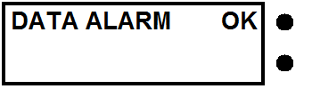

Either alarm can be accepted by pressing the button labelled OK. This stops the audible sound. No alarm will happen again within the alarm re-arm time set in the configuration. The display shows when the device is re-arming.



When a data value goes past its threshold value an alarm is not raised immediately. There will be a delay of a few seconds while the device confirms that an alarm state really exists. Similarly a loss of data alarm is activated only after 10 seconds of not receiving the expected data. This prevents spurious data creating false alarms.

What the Sounds and Alarms Mean
Continuous beep Watched value has passed its threshold
Intermittent beep Loss of Seatalk connection or values not arriving

Settings
The following settings can be changed by the user from the front panel. Each setting has an allowable range as shown:

Minimum depth threshold (1-25 metres)
Maximum speed over ground threshold (SOG) (0-6 knots)
Maximum windspeed threshold (0-50 knots)
Maximum heading change from set heading threshold (0-179 degrees)
Maximum position change from set position threshold (10-250 metres)
Backlight level (0-3)
Re-arm time after an alarm (0-15 minutes)

You can also test the alarm at the end of the settings.

To enter the setup menu press the button labelled SETUP when NO DATA or STANDBY shows on the screen. If in the watching state press STOP to return to the standby state. Watching does not take place when in the setup menu. Any settings changes will remain when the device is powered off.

For each item in the setup menu you can select that item to change or move on to the next item by pressing the appropriate button. The current settings is shown, so for example depth watching is on.

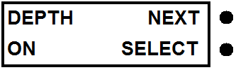

The last setting (alarm test and software version) has NEXT replaced by EXIT. This takes you back to the state you entered settings from (NO DATA or STANDBY).

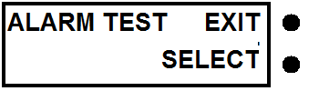

For the settings for watched data, when you press select, you can then toggle watching on or off by pressing the button labelled TOGGLE. The current value is shown and changes when TOGGLE is pressed.

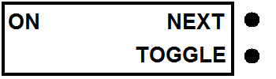

If the toggle value is ON when pressing NEXT then you are taken to a screen where the threshold value can be changed. If the toggle value is OFF then on pressing NEXT you are taken to the next watched value. The current threshold value is shown. The value can only be incremented but wraps around when it reaches the maximum allowed.

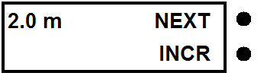

A short press of the button labelled INCR increments the right hand digit. A long press of the same button increments the left hand digit of the numerical value.
All settings are saved by the device instantly when a setting value is changed and will remain when the device is unpowered.

Changing the settings for all the other values follows a similar process. Backlight and re-arm time have no toggle settings, just a numerical value. The last item in the settings menu is alarm test. This changes no value but tests the audible alarm and shows the software version number.

Usual Disclaimer
This is a hobby project and should be treated as such.

www.yappelectronics.co.uk yapp@yappelectronics.co.uk

