YAPP Seatalk to NMEA-0183 Bi-Directional Bridge

This is an open source amateur produced device for hobby purposes only. It is up to you to confirm that the hardware design, assembly and software are suitable for your purpose if you put the device into use on a boat. All the design and source code are available on www.yappelectronics.co.uk.

Overview
This device will connect a Seatalk network with a NMEA-0183 one. Data values that come in on the Seatalk side are transferred to the NMEA-0183 output line and similarly data values that come in on the NMEA-0183 input line are transferred to the Seatalk network. As this is only a small low cost device not all Seatalk or NMEA-0183 message types are handled, but most basic boat data types are.

Messages
The following Seatalk values are handled (shown with their identification number):

00 Depth
20 Boat speed
9C Compass heading and rudder angle
99 Magnetic variation
10 Apparent wind speed
11 Apparent wind angle
27 Temperature
50 Latitude
51 Longitude
53 Course over ground
52 Speed over ground
54 Time
56 Date
21 Trip log
22 Total log
25 Combined trip and log

The following NMEA-0183 messages are interpreted and created:

DPT
DBT
VHW
RSA
HDM
HDG
HDT
MTW
VLW
VWR
VWT
MWV
RMC
GLL

Connections
The Seatalk connection requires all 3 wires – red for +12V power, yellow for data and black or bare wire for 0V power.

The NMEA-0183 device you are connecting to the NMEA-0183 input may call its connections a variety of terms. The list below shows what you should connect to what…

Remote NMEA-0183 device connection name to connect to this device’s RxD/A
NMEA+
A
Data
TxD

Remote NMEA-0183 device connection name to connect to this device’s GND/B
NMEA-
B
GND or GROUND
0V

The NMEA-0183 device you are connecting the output to will call its connections a variety of terms. This is what you should connect to what…

Remote device connection name to connect this device’s NMEA+ or DATA to
NMEA+
Data
A
RxD

Remote device connection name to connect this device’s NMEA- or GND to
NMEA-
GND or GROUND
B
0V

Which Output to Use?
NMEA-0183 devices use either RS-232 voltage levels or RS-422 voltage levels – there is no consistency. However, it is a requirement for all NMEA-0183 listeners to be able to accept RS-232 voltage levels. Therefore try the RS-232 output first (labelled RS232 OUT). If this does not work, try the RS-422 output (labelled NMEA OUT). Only one of the 2 outputs should be used at a time.

Default Configuration
The rate of transmission of any message type can be configured or switched off. When the device arrives all message rates will be set to their default values. These are:

- NMEA-0183 messages are all transmitted with a period of 2 seconds.

- Seatalk messages are transmitted at the following periods:

Depth | 3s
Boatspeed | 3s
Compass+rudder | 1s
Variation | 5s
Temperature | 10s
Combined trip/log | 3s
Trip | Off
Log | Off
Apparent wind speed | 2s
Apparent wind angle | 2s
Speed over ground | 2s
Course over ground | 2s
Latitude | 2s
Longitude | 2s
Time | 2s
Date | 10s

Configuration Cable and Terminal Program
To change the device’s configuration from the default a configuration cable is needed. This cable comprises a female 9 pin D connector onto which need soldering wires. This cable needs connecting to a computer’s RS-232 serial port or a serial to USB converter for computers without a 9 pin serial port (available from ebay for about £3). A configuration cable can be supplied if required.

You need a female 9 pin D connector like this…

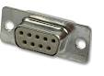
You need wire 3 different colour wires that you can solder to the connector above. I shall use in this description RED, GREEN and BLACK.

If you look carefully at the connections on the socket you will see that they are numbered 1-9. You need to make the following connections:

GREEN to pin 2.
RED to pin 3.
BLACK to pin 5.

Once you have made or obtained your cable you need to wire it to the device as shown:

GREEN to RS232 OUT DATA
BLACK to RS232 OUT GND
RED to IN NMEA RxD/A

A separate wire is needed to connect IN NMEA GND/B to RS232 OUT GND. You also need 12V power connected to the Seatalk R and B connections.

This diagram shows the connections:

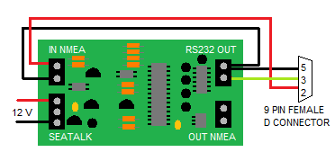

You need to obtain a serial terminal program to communicate with the device to configure it. There are many free terminal programs available on the internet, but termite is a small simple one that can be downloaded from here…

http://www.compuphase.com/software_termite.htm

Choose the “program only” link to download the least.

You need to set the settings to 4800 baud and choose your COM port. Other settings can remain the same.

PuTTY is an alternative serial terminal application that is also free and has more features.

Configuration Commands
The commands are very simple. You can see the current settings, change a setting, or set all output to off.

You show the current Seatalk output periods by typing #S then enter. You will see the output period in seconds for all message types like this:

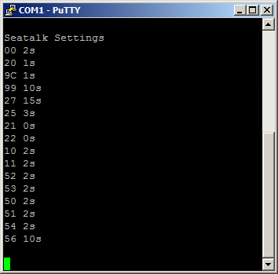

The message numbers are those given in the table above. To change an output period for a message you type #S,message number,message period then enter. For example to change the depth message output period to 3 seconds type #S,00,3 then enter. You can see the depth period changed below:

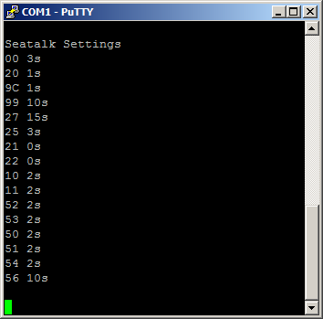

Changing an NMEA-0183 channel output period is similar. You can see the current settings by typing #N then enter as shown below:
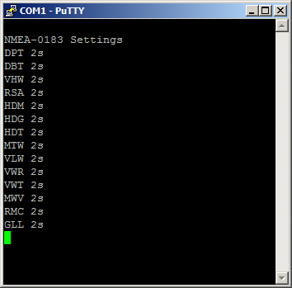

You change an NMEA-0183 message output period by typing #N,message name,period followed by enter, for example #N,DPT,3.

To set a Seatalk or NMES-0183 message output to off set the period to 0, for example #S,00,0 or #N,DPT,0.

You can set all Seatalk and NMEA-0183 messages to off (period of zero) by typing O (capital letter ‘o’, not zero), then enter.

