Hybrid Identity — Day 3 Guide
On-Prem Active Directory to Microsoft Entra ID — nishant360.online Edition
Domain Change Notice
This guide replaces every use of minjtech.xyz from the earlier draft with nishant360.online — the domain actually owned in GoDaddy. minjtech.xyz cannot be used for the Entra ID custom-domain verification steps in this guide (Section 6) because ownership can't be proven for a domain that isn't actually registered to you. It can still be used as a purely internal, never-verified AD name if you ever want a lab that skips cloud verification entirely — but everything below assumes the real, ownable domain: nishant360.online.

Updated Lab Values
Setting | Value
Public domain (GoDaddy) | nishant360.online
AD domain | nishant360.online (bare — matches the public domain, see Section 3)
NetBIOS name | NISHANT360
Resource Group | rg-nishant360-hybrid-id
VNet | vnet-nishant360-hybrid (10.10.0.0/16)
Domain Controller | app010w001 — 10.10.1.10
Entra Connect server | AADCONNECT01 — 10.10.1.20
Test client | CLIENT01 — 10.10.2.10
Build method | C:\Scripts\Setup-ADDS-DNS.ps1 ($DomainName = "nishant360.online", $NetbiosName = "NISHANT360")
All IPs and names are lab values — change them to match your own environment.

1. What Is Hybrid Identity?
On-prem Active Directory stays the source of truth for user accounts. Microsoft Entra Connect continuously copies (synchronizes) those accounts into Microsoft Entra ID, so one identity — nishant@nishant360.online — works for both office logins and cloud apps like Microsoft 365. This lab uses Password Hash Synchronization (PHS): Entra ID can authenticate users even if the on-prem network or app010w001 is temporarily down, and it's the simplest method to deploy and operate.
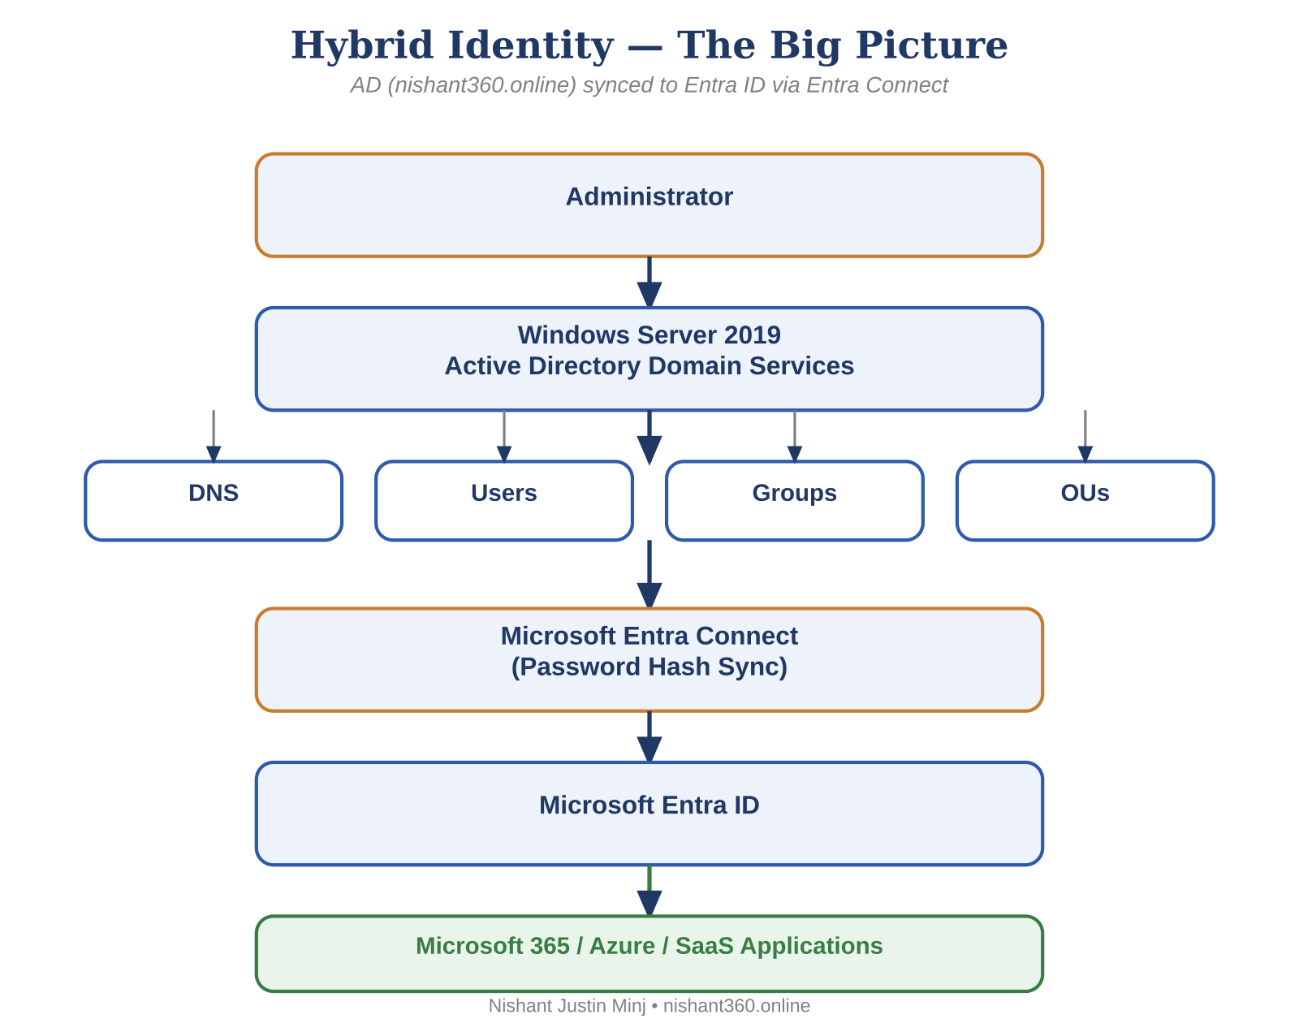

2. Lab Network Architecture
A mini version of a real company network, entirely inside Azure. app010w001 is the Domain Controller (AD DS + DNS). AADCONNECT01 is kept on a separate VM deliberately, so an Entra Connect issue never affects core domain services. CLIENT01 is optional, for testing real sign-in and SSO.
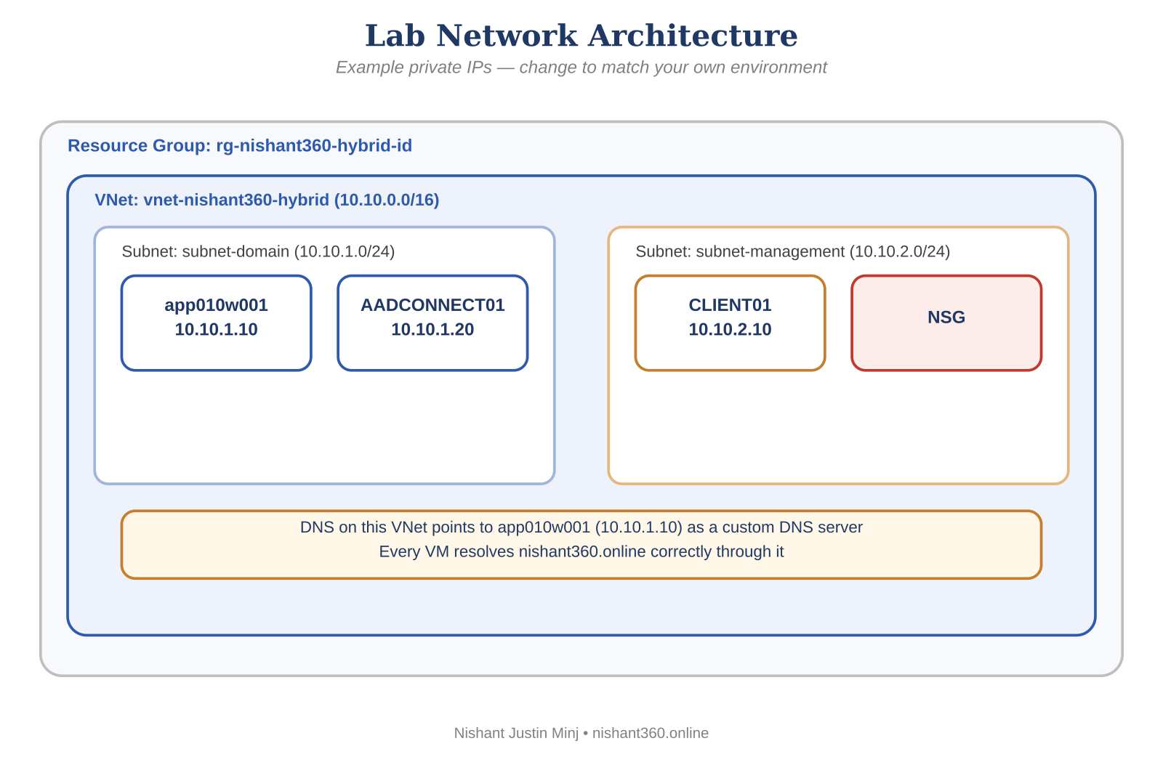

Portal navigation — create the network foundation
- portal.azure.com → Resource groups → + Create → rg-nishant360-hybrid-id → pick a region → Review + create
- Virtual networks → + Create → Resource group = rg-nishant360-hybrid-id → Name = vnet-nishant360-hybrid → IPv4 address space = 10.10.0.0/16
- IP Addresses tab → + Add subnet → subnet-domain (10.10.1.0/24) → Add another subnet → subnet-management (10.10.2.0/24) → Review + create
- Network security groups → + Create → nsg-nishant360-hybrid → associate it to subnet-management after creation

3. Domain Naming Decision — Why the Bare Domain
The options, same trade-offs as before, now against the domain you actually own:
- nishant360.online (bare, same as public domain) — SELECTED. Simplest: one less moving part, every login is already a clean nishant@nishant360.online with zero extra UPN configuration. This is what Setup-ADDS-DNS.ps1 deploys.
- ad.nishant360.online (subdomain) — cleaner public/private DNS separation, at the cost of one extra UPN suffix configuration step. Equally valid if you'd rather isolate the AD namespace from the internet-facing one.
- nishant360.local — avoid. Non-routable, breaks certificate issuance, and Microsoft no longer recommends .local for new builds.
If you later want stricter public/private separation, moving to a subdomain is a forest rebuild, not a simple rename — worth deciding deliberately, which is why this trade-off is called out explicitly rather than assumed.

4. Public DNS (GoDaddy) vs Private AD DNS
You own nishant360.online through GoDaddy. Public DNS there is for things the whole internet needs to find (a website, mail routing, and — critically — the one TXT record that proves ownership to Entra ID). Private AD DNS, hosted on app010w001, is for things only the internal network needs (domain controllers, LDAP, Kerberos SRV records like _ldap._tcp.dc._msdcs.nishant360.online). Never publish internal AD records in GoDaddy — that exposes internal infrastructure to the internet.
 | Public DNS (GoDaddy) | Private AD DNS (app010w001)
Records live here | MX, TXT (verification), website A/CNAME | _ldap, _kerberos SRV, A, PTR (internal only)
Who queries it | Anyone on the internet | Only devices inside the VNet
Never put here | Any internal AD/domain-controller record | Anything the public internet needs

5. Build app010w001 — What the Script Actually Does
app010w001 was built with C:\Scripts\Setup-ADDS-DNS.ps1 rather than the manual Server Manager wizards — a single unattended, reboot-resilient script. It writes progress to SetupStage.txt before anything that reboots, and a scheduled task (ADSetupContinuation) re-launches it at every startup until setup finishes.
Stage | What it does
1 | Renames to app010w001 (skips cleanly if already named correctly).
2 | Ensures a local Administrator account exists, is enabled, is in the Administrators group, and has its password set — via ADSI/WMI, not the LocalAccounts module.
3 | Points this server's own DNS client at its own IP, since it's about to become the DNS server itself.
4 | Installs AD-Domain-Services and calls Install-ADDSForest -InstallDns:$true for domain nishant360.online, NetBIOS NISHANT360, forest/domain mode WinThreshold.
5 | Waits for the DNS service, re-detects the current IP, computes the correct in-addr.arpa reverse zone, creates it, and explicitly writes the PTR record — not just hoping dynamic registration does it.
Run it:
PowerShell.exe -NoProfile -ExecutionPolicy Bypass -File C:\Scripts\Setup-ADDS-DNS.ps1
Repair just the reverse DNS/PTR step later without repeating earlier stages:
PowerShell.exe -NoProfile -ExecutionPolicy Bypass -File C:\Scripts\Setup-ADDS-DNS.ps1 -RepairReverseDns
Monitor progress: C:\Scripts\Setup.log (every stage, timestamped, echoed live to console) and C:\Scripts\SetupStage.txt (current stage — gone entirely once Stage 5 finishes, which doubles as your "fully done" signal).

6. Verify AD, DNS & Prepare Entra ID
dcdiag
dcdiag /test:dns
Get-ADDomain
Get-ADForest
nslookup nishant360.online
Resolve-DnsName nishant360.online
Get-ADDomain should show DNSRoot = nishant360.online and NetBIOSName = NISHANT360, matching the script's variables exactly.

Add & verify the custom domain in Entra ID
- portal.azure.com → Microsoft Entra ID → Custom domain names → + Add custom domain
- Type nishant360.online → Add — Entra ID generates a unique TXT verification value for your tenant (always copy the real one shown, never reuse an example)
- GoDaddy → My Products → Domains → nishant360.online → DNS → Manage DNS → Add Record → Type = TXT → Host = @ → Value = [the exact value from Entra ID] → Save
- Wait for DNS propagation (minutes to a few hours), then back in Entra ID → Custom domain names → nishant360.online → Verify
This step is exactly what fails with minjtech.xyz — you can only add that TXT record in GoDaddy for a domain in your own account, which is nishant360.online.

7. AADCONNECT01 & Microsoft Entra Connect (PHS)
- Create AADCONNECT01 in subnet-domain, static IP 10.10.1.20, domain-joined to nishant360.online.
- Confirm connectivity to app010w001 before installing Entra Connect: Test-NetConnection app010w001 -Port 389 / 636 / 88 / 53 — all must return True.
- Install Microsoft Entra Connect → Customize (not Express) → Password Hash Synchronization → sign in with Global Administrator (cloud) and Enterprise Admin (on-prem) → Domain/OU filtering: sync only Users, SyncUsers, and Groups OUs, excluding Computers and ServiceAccounts → Install.
- First sync: Start-ADSyncSyncCycle -PolicyType Initial. Verify nishant@nishant360.online appears in Entra ID → Users, with On-premises sync enabled = Yes.

8. End-to-End Flow
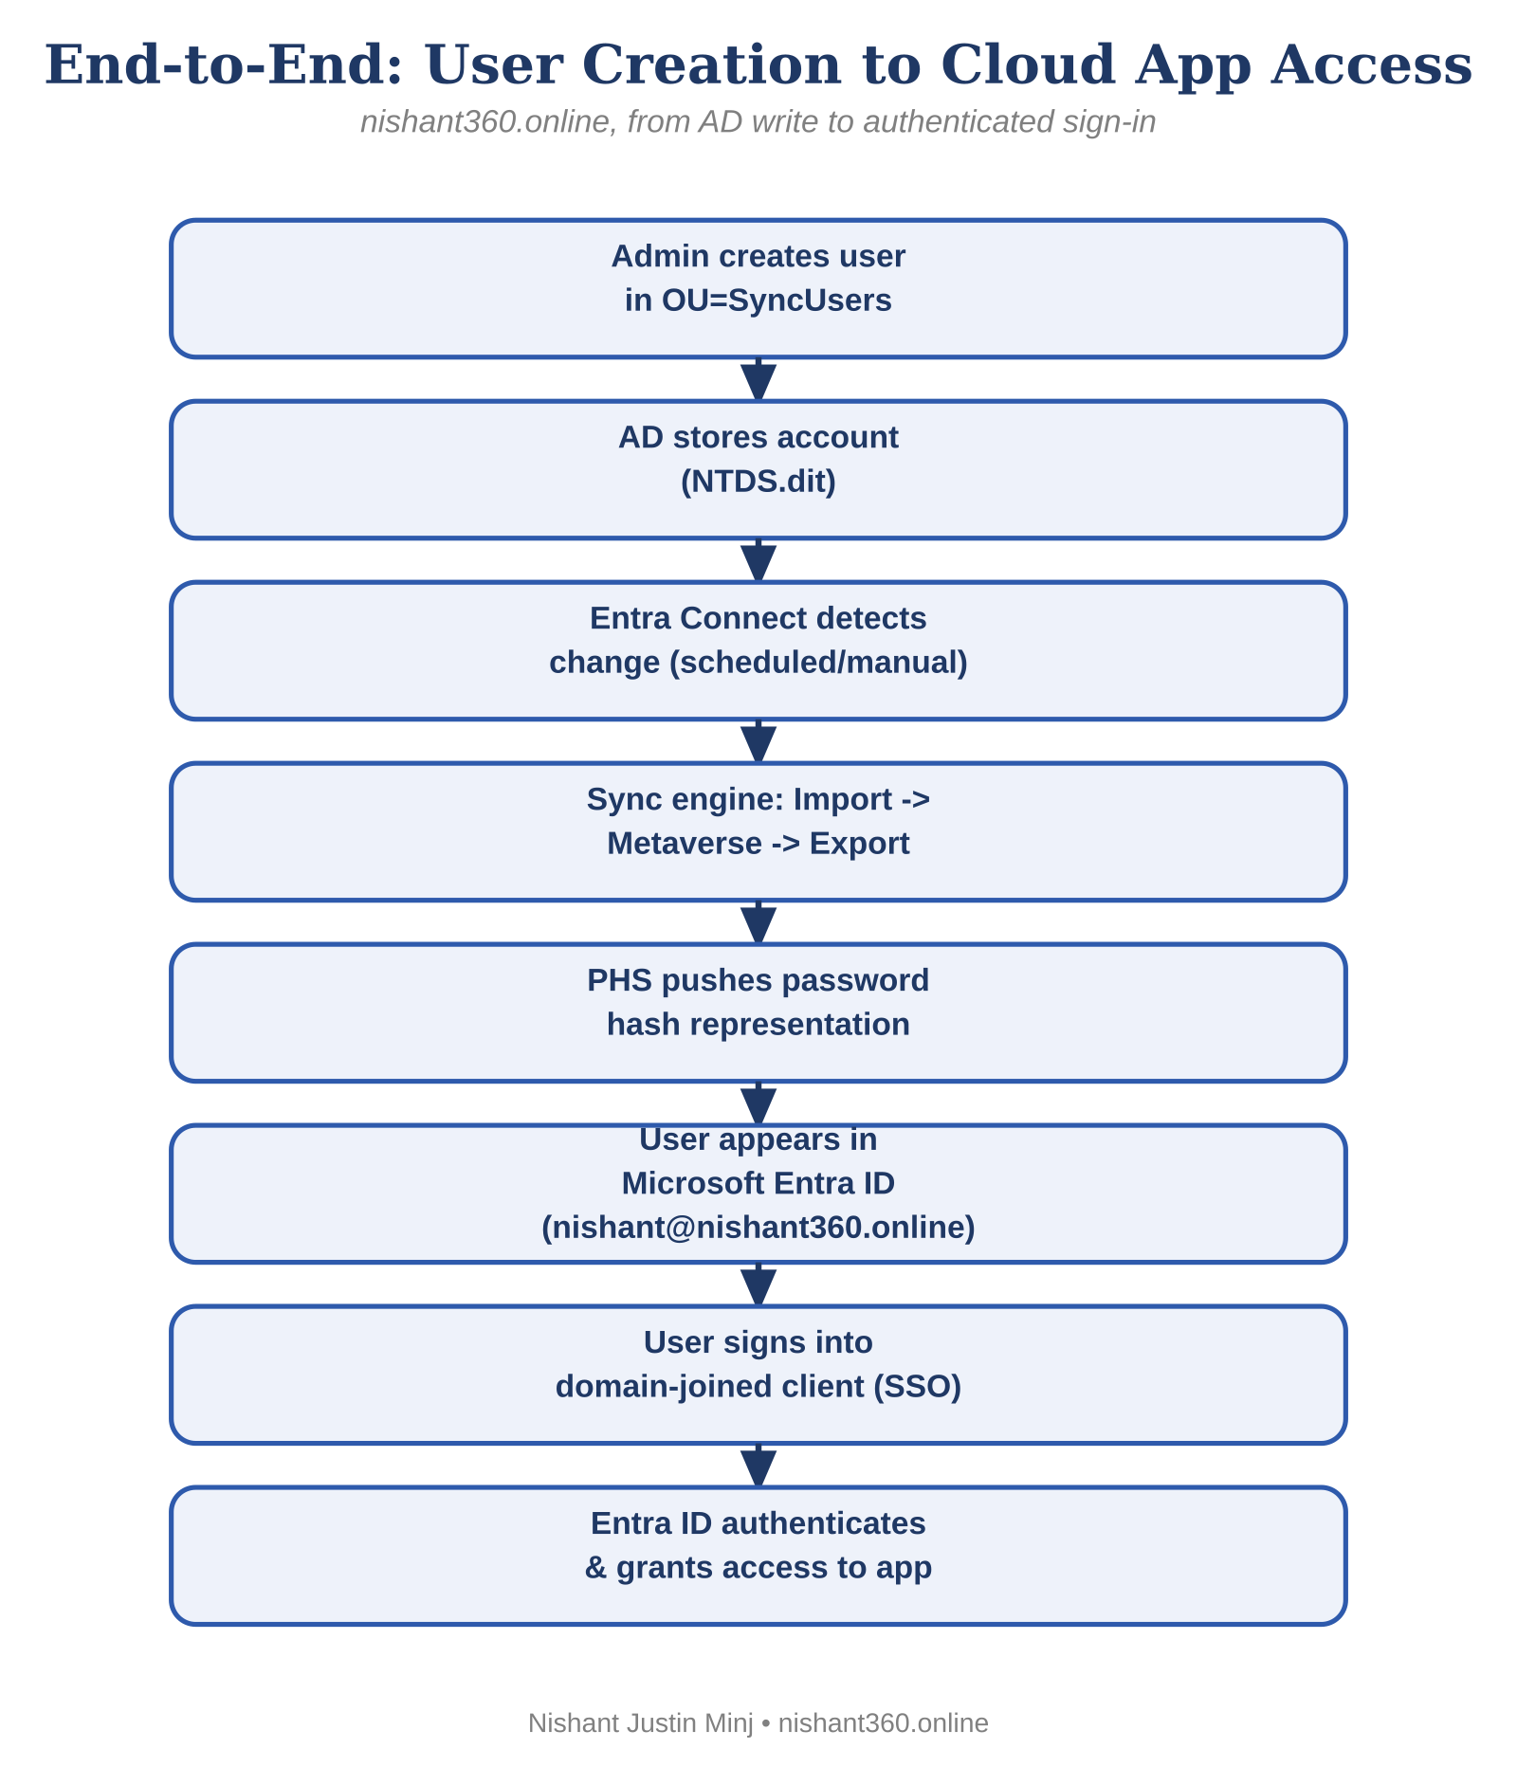

9. Updated Lab Validation Checklist
- VNet (10.10.0.0/16) and both subnets created
- app010w001 built via Setup-ADDS-DNS.ps1 with static IP 10.10.1.10
- Get-ADDomain shows DNSRoot = nishant360.online, NetBIOSName = NISHANT360
- dcdiag and dcdiag /test:dns run clean
- Reverse DNS zone + PTR record confirmed with nslookup 10.10.1.10 (or run -RepairReverseDns if not)
- nishant360.online added as a custom domain in Entra ID and verified via the GoDaddy TXT record
- AADCONNECT01 built, domain-joined, connectivity confirmed on ports 53/88/135/389/445/464/636
- Microsoft Entra Connect installed (Customize path), PHS selected, OU filtering scoped correctly
- Initial sync completed; nishant@nishant360.online visible in Entra ID with On-premises sync = Yes
- Seamless SSO enabled (AZUREADSSOACC computer object present) and verified on CLIENT01

10. What Changed From the Original minjtech.xyz Draft
Item | Old (minjtech.xyz) | New (nishant360.online)
Domain you actually own | No — not registered to you | Yes — in your GoDaddy account
AD domain / $DomainName | minjtech.xyz | nishant360.online
NetBIOS / $NetbiosName | MINJTECH | NISHANT360
Entra ID custom domain verification | Fails — can't prove ownership | Works — TXT record addable in your GoDaddy
UPN logins | nishant@minjtech.xyz (cloud sign-in would fail) | nishant@nishant360.online (works end-to-end)
Resource Group / VNet naming | rg-minjtech-hybrid-id / vnet-minjtech-hybrid | rg-nishant360-hybrid-id / vnet-nishant360-hybrid
Everything else — the script's stage logic, the network layout, PHS reasoning, OU filtering, troubleshooting approach — carries over unchanged; only the domain-dependent values were swapped.

