NorthStar Group - Internal Knowledge Base
Employee handbook, policies, office guides and product reference.
Field | Value
Version | 3.2
Published | 15 January 2026
Owners | People Team (Chapters 1-12, 14-17); Product Documentation (Chapter 13)
Classification | INTERNAL
Applies to | NorthStar Software (NSS), NorthStar Field Services (NSFS) and Shared Services

All companies, people, products, addresses and figures in this document are fictional and were created for training purposes.

Contents
Contents 2
1. About NorthStar and This Knowledge Base 5
1.1 Who we are 5
1.2 Legal entities 5
1.3 How to read this knowledge base 6
1.4 Who to contact 6
2. Onboarding 8
2.1 Before your first day 8
2.2 Your first day 8
2.3 Buddy programme 8
2.4 Probation and notice 8
2.5 Equipment 8
2.6 Accounts and access 9
3. Working Time, Hybrid Work and Remote Work 11
3.1 Working hours 11
3.2 Hybrid work 11
3.3 Overtime and on-call 11
3.4 Work from Anywhere (temporary work abroad) 12
3.5 Relocation (permanent move) 12
3.6 Summary 12
4. Leave and Absence 14
4.1 Annual leave 14
4.2 Sick leave 14
4.3 Parental leave 14
4.4 Other types of leave 14
5. Travel and Expenses 16
5.1 Booking travel 16
5.2 Hotels 16
5.3 Per diems and meals 16
5.4 Local transport and mileage 17
5.5 Client entertainment and team events 17
5.6 Submitting expense claims 17
5.7 Non-reimbursable items 18
6. Purchasing and Procurement 19
6.1 Purchase thresholds 19
6.2 Software and cloud services 19
6.3 New vendors 19
6.4 Company cards 19
7. IT and Information Security 21
7.1 Passwords and multi-factor authentication 21
7.2 Devices 21
7.3 Reporting incidents 22
7.4 Networks and remote access 22
7.5 Software and AI tools 23
8. Offices and Facilities 24
8.1 Group-wide office rules 24
8.2 Prague (headquarters) office 25
8.3 Lisbon office 26
8.4 Krakow office 27
8.5 Austin office 28
8.6 Toronto office 29
8.7 Singapore office 30
9. Performance and Career 31
9.1 Review cycles 31
9.2 Career levels 31
9.3 Promotions and internal moves 32
10. Compensation and Benefits 33
10.1 Salary and bonus 33
10.2 Learning budget 33
10.3 Wellness allowance 33
10.4 Other benefits 33
11. Code of Conduct 35
11.1 Gifts and hospitality 35
11.2 Conflicts of interest and side jobs 35
11.3 Speaking up 35
11.4 Social media 35
12. Information Classification and Data Handling 36
12.1 Classification levels 36
12.2 Retention periods 37
13. Polaris Product Reference 38
13.1 Product overview 38
13.2 Standard support 38
13.3 Release notes - Polaris Cloud 39
13.4 Release notes - Polaris Edge 39
14. Frequently Asked Questions 41
15. Glossary 44
16. Change Log and Memos 46
16.1 Version history 46
16.2 Memos issued after version 3.2 46
17. Archive - Superseded Policies (Do Not Apply) 48
17.1 Travel and Expenses Policy v2.1 (valid 1 March 2023 - 31 December 2024) 48
17.2 Hybrid Work Policy v2.1 (valid 1 March 2023 - 31 December 2024) 48
17.3 Learning Budget v2.1 (valid until 30 June 2025) 48
17.4 Password Policy v2.0 (valid until 31 December 2024) 48

1. About NorthStar and This Knowledge Base

1.1 Who we are
NorthStar Group was founded in 2009 as a small analytics consultancy and today operates through two operating companies and a shared services organisation. Our flagship product, Polaris, helps industrial customers collect sensor data, detect anomalies and plan maintenance. Polaris is offered as a cloud service (Polaris Cloud) and as an on-premises appliance (Polaris Edge).
The group headquarters is in Prague. Other offices are located in Lisbon, Krakow, Austin, Toronto and Singapore. Around 690 employees work for the group, excluding contractors.

1.2 Legal entities
Table: Legal entities of the NorthStar Group
Entity | Abbreviation | Main activity | Main offices | Approx. headcount
NorthStar Software s.r.o. | NSS | Develops, sells and operates Polaris Cloud | Prague, Lisbon, Austin, Singapore | 430
NorthStar Field Services Ltd. | NSFS | Installs and maintains Polaris Edge appliances at customer sites | Krakow, Toronto, Austin | 260
NorthStar Group (Shared Services) | SSC | People, Finance, IT, Legal, Procurement | Prague, Krakow | included above

Where a rule differs between NSS and NSFS, this knowledge base states both values. Employees of Shared Services follow the NSS rules unless stated otherwise.
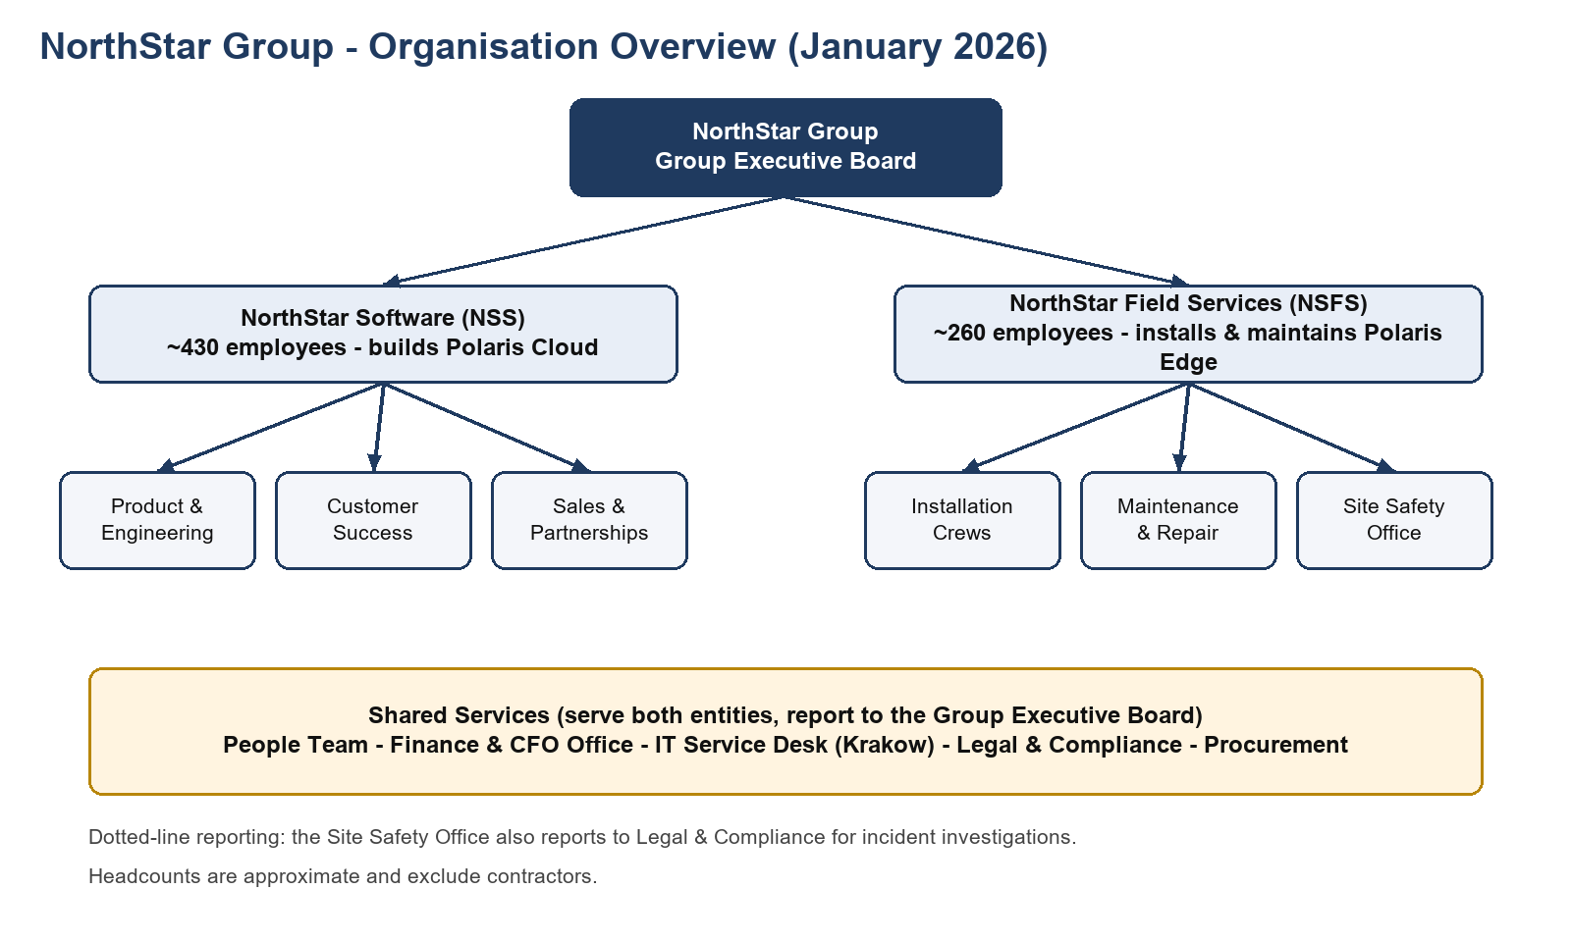
Figure 1: Organisation overview

1.3 How to read this knowledge base
Rules apply in the following order of precedence: (1) memos issued after the publication of this version, listed in Chapter 16; (2) entity-specific rules; (3) group-wide rules. Archived policies in Chapter 17 are provided for reference only and must never be applied to new cases.
All amounts are in euro (EUR). For offices outside the euro area, Finance publishes a conversion rate on the first business day of each month, and that rate applies to all claims submitted in that month. Unless stated otherwise, 'days' means calendar days and 'business days' means Monday to Friday excluding local public holidays.

1.4 Who to contact
Table: Contact points
Topic | Team | Channel
Contracts, leave, benefits, payroll questions | People Team | HR Hub ticket
Laptops, accounts, access, software | IT Service Desk | Service Portal or chat #it-help
Expense claims, company cards, invoices | Finance | Chat #finance-help
Purchasing and vendors | Procurement | ProcureNow request
Contracts with customers, conflicts of interest | Legal & Compliance | legal@northstar.example
Desks, rooms, parking, visitors | Facilities | Reception of your office
Concerns about misconduct | Ethics | Speak-Up line (web form, anonymous option)

2. Onboarding

2.1 Before your first day
About one week before your start date, the People Team sends you a welcome e-mail with your start time, office address and the name of your buddy. IT ships your laptop and accessories to your home address so that you can set up your accounts on day one. If you have not received the shipping notification three business days before your start date, reply to the welcome e-mail rather than opening an IT ticket, because you do not yet have portal access.

2.2 Your first day
On your first day you collect your access badge at the reception of your office. Bring an official photo ID; the badge cannot be issued without it. The welcome session covers the company history, the Polaris products, the security basics and a short tour of the office. Field employees of NSFS additionally receive their safety equipment and a site safety briefing from the Site Safety Office.

2.3 Buddy programme
Every new joiner is paired with a buddy from a different team. Buddies help with practical questions, introduce the new joiner to colleagues and meet with them regularly during the first six weeks. Buddies may spend up to two hours per week on buddy activities during this period. The buddy role is voluntary and is recognised in the performance review.

2.4 Probation and notice
Table: Probation and notice periods
Item | NSS | NSFS
Probation period | 3 months | 6 months
Notice during probation | 2 weeks | 1 week
Notice after probation | 1 month (2 months after 3 years of service) | 1 month (2 months after 5 years of service)
Probation review | Day 90 | Day 180
Probation extension | Possible once, by up to 1 month | Not possible

2.5 Equipment
Table: Standard equipment by role
Equipment | NSS | NSFS (field roles) | NSFS (office roles)
Laptop | 14-inch standard laptop | 13-inch rugged laptop | 14-inch standard laptop
Monitor for home office | 1 x 27-inch | Not provided | 1 x 24-inch
Headset | Noise-cancelling headset | Bluetooth headset | Standard headset
Mobile phone | Only for on-call engineers | Company smartphone | Not provided
Safety kit | - | Boots, helmet, high-visibility vest, gloves, ear protection | -

Equipment remains company property and must be returned within five business days of the last working day. Lost or damaged equipment must be reported as described in Chapter 7.
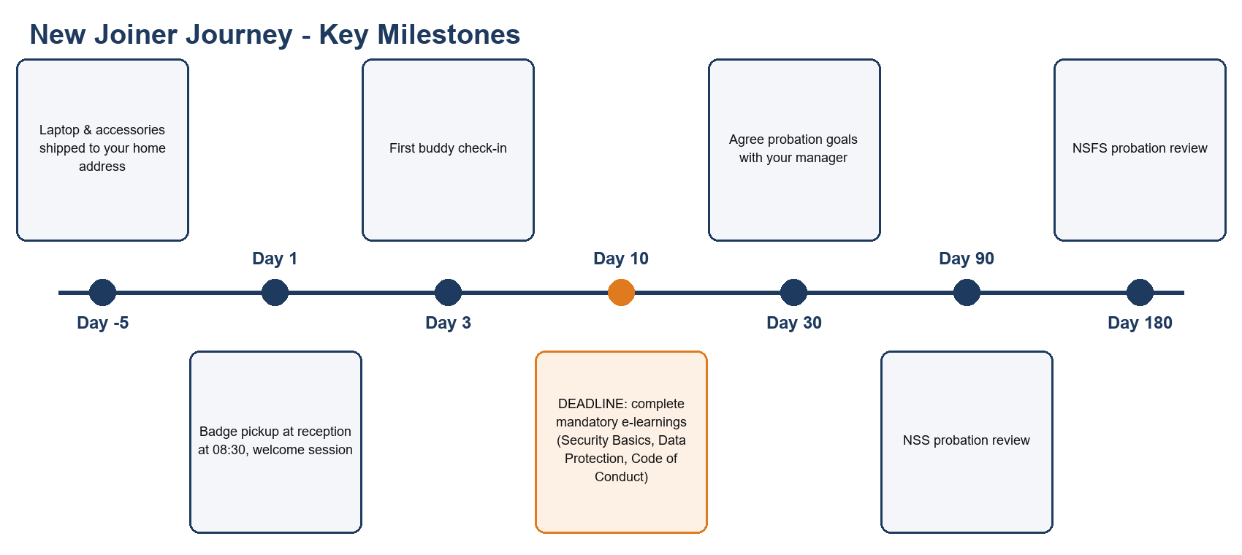
Figure 2: New joiner journey

2.6 Accounts and access
Your e-mail address follows the pattern firstname.lastname@northstar.example. Access to source code repositories, customer data and production systems is granted only after the mandatory e-learnings have been completed and your manager has submitted an access request. Access requests are approved by the data owner, not by IT.

3. Working Time, Hybrid Work and Remote Work

3.1 Working hours
The standard working week is 40 hours for both entities. NSS uses flexible working time with core hours from 10:00 to 15:00 local time, during which employees are expected to be available for meetings. Outside the core hours, employees organise their time freely in agreement with their team.
NSFS uses shift-based working time for field and workshop roles. Office-based NSFS employees follow the NSS core hours.
Table: NSFS shift patterns
NSFS shift | Time | Typical use
Early shift | 06:00 - 14:30 | Installations at production sites before line start
Standard shift | 07:00 - 15:30 | Most maintenance and workshop work
Late shift | 13:30 - 22:00 | Customer sites operating evening shifts

All shifts include an unpaid 30-minute break, which must be taken after no more than six hours of work.

3.2 Hybrid work
NSS employees may work remotely on up to two days per week. Tuesday is the mandatory in-office collaboration day for all NSS teams. Remote work must take place in the country of your employment contract; working from another country is covered by the Work from Anywhere rules in section 3.4.
Office-based NSFS employees may work remotely on one day per week. Field roles are not eligible for hybrid work because their work takes place at customer sites.
Note: Memos issued after publication may change these limits. Always check Chapter 16.

3.3 Overtime and on-call
NSS employees are salaried and do not receive overtime pay. Extra hours approved by the manager can be compensated as time off in lieu at a ratio of 1:1, up to 16 hours per quarter. NSS engineers on the P1 on-call rotation receive an on-call allowance of 25 EUR per weekday night and 60 EUR per weekend or public-holiday day.
NSFS employees receive overtime pay of 150% of the hourly rate on weekdays and Saturdays, and 200% on Sundays and public holidays. NSFS on-call allowance is 40 EUR per weekday night and 90 EUR per weekend or public-holiday day. Call-outs are paid as overtime in addition to the allowance.

3.4 Work from Anywhere (temporary work abroad)
Employees of both entities may work temporarily from another country for up to 20 working days per calendar year, with a maximum of 10 consecutive working days. Requests must be approved by the manager and the People Team at least 10 working days before the first day abroad. Work from Anywhere is not possible from countries on the group's sanctions list, and field roles of NSFS are not eligible. Unused days do not carry over to the next year.

3.5 Relocation (permanent move)
Relocation means a permanent move to another country or office, usually linked to a new role. Relocation always requires a new or amended employment contract and is never handled through Work from Anywhere. NSS offers a relocation support package of up to 4,000 EUR covering moving costs, temporary housing for up to 30 days and one visa application. NSFS offers up to 2,500 EUR and does not cover temporary housing. Employees who resign within 12 months of relocation must repay 50% of the package.

3.6 Summary
Table: Working time rules at a glance
Rule | NSS | NSFS
Core hours | 10:00 - 15:00 | Shift-based; office roles 10:00 - 15:00
Remote days per week (v3.2) | 2 | 1 (office roles), 0 (field roles)
Overtime | Time off in lieu 1:1, max 16 h/quarter | 150% / 200%
On-call allowance (weekday night / weekend day) | 25 / 60 EUR | 40 / 90 EUR
Work from Anywhere | 20 days/year, max 10 consecutive | Same, office roles only
Relocation package | Up to 4,000 EUR | Up to 2,500 EUR

4. Leave and Absence

4.1 Annual leave
NSS employees receive 25 days of annual leave per calendar year; NSFS employees receive 23 days. In both entities, employees receive one additional day after 5 years of service and two additional days after 10 years of service. Leave is accrued pro rata for part-time employees and for employees who join or leave during the year.
NSS employees may carry over up to 5 unused days, which must be taken by 31 March of the following year. NSFS employees may carry over up to 3 unused days, which must be taken by 30 April of the following year. Carried-over days not taken by these dates expire.
Leave is requested in HR Hub. Requests for more than 3 consecutive days should be submitted at least two weeks in advance. Leave of more than 10 consecutive working days requires approval by both the manager and the head of department. NSFS has a leave blackout period from 1 to 15 December, when most customers schedule their annual maintenance shutdowns.

4.2 Sick leave
If you are ill, inform your manager before 09:00 (NSS) or before the start of your shift (NSFS). NSS employees may self-certify up to 3 consecutive days of sickness; NSFS employees may self-certify up to 2 consecutive days. A doctor's certificate is required from the following day. Sick leave during annual leave is converted back into sick leave only if a doctor's certificate is provided.

4.3 Parental leave
The primary caregiver receives 20 weeks of parental leave on full pay (NorthStar tops up any statutory benefit). The secondary caregiver receives 6 weeks on full pay. Parental leave applies equally to birth, adoption and surrogacy and must be taken within 12 months of the child's arrival. It may be split into a maximum of three blocks.

4.4 Other types of leave
Volunteering leave allows employees to support registered charities for 2 days per year. Study leave covers exam days and exam preparation for courses approved by the manager. Bereavement leave applies to the loss of a family member. A moving day is granted once per year when you change your home address; it is not related to the relocation package in section 3.5.
Table: Leave entitlements
Leave type | NSS | NSFS | Carry-over | Notes
Annual leave | 25 days | 23 days | NSS: 5 days to 31 Mar; NSFS: 3 days to 30 Apr | +1 day after 5 years, +2 after 10 years
Sick leave (self-certified) | Up to 3 days | Up to 2 days | - | Doctor's note afterwards
Parental leave, primary caregiver | 20 weeks | 20 weeks | - | Within 12 months, max 3 blocks
Parental leave, secondary caregiver | 6 weeks | 6 weeks | - | Within 12 months
Bereavement, immediate family | 5 days | 5 days | - | Partner, child, parent, sibling
Bereavement, extended family | 2 days | 2 days | - | Grandparent, in-laws
Volunteering | 2 days | 2 days | No | Registered charities only
Study leave | 5 days | 3 days | No | Approved courses only
Moving day | 1 day | 1 day | No | Change of home address
Civic duties (jury, elections) | As required by law | As required by law | - | Proof required

5. Travel and Expenses

5.1 Booking travel
All business trips are booked through the TripDesk travel portal after the manager has approved the trip. Bookings should be made at least 14 days before departure whenever possible. Rail is preferred over flights for journeys of less than four hours; first-class rail tickets are allowed for journeys of more than three hours.
Economy class is the standard for flights shorter than 6 hours. Premium economy is allowed for flights of 6 hours or longer. Business class requires prior approval by the CFO Office and is only considered for overnight flights longer than 10 hours.

5.2 Hotels
Hotels must be booked within the nightly caps below. The caps include taxes but exclude breakfast. If no hotel within the cap is available, the traveller documents three alternatives in TripDesk before booking above the cap.
Table: Hotel caps by city
City | Cap per night (EUR)
Prague | 130
Krakow | 110
Lisbon | 140
Austin | 210
Toronto | 190
Singapore | 220
London | 240
New York | 280
Other cities in the EU | 150
Other cities outside the EU | 170

5.3 Per diems and meals
Table: Per diems
Situation | Per diem (EUR)
Domestic day trip longer than 8 hours | 20
Domestic trip with overnight stay, per day | 35
International trip, per day | 55
Reduction if breakfast is included in the hotel rate | - 10
Reduction for each lunch or dinner provided by a customer or event | - 15

Per diems cover meals and small incidental costs, so individual meal receipts are not reimbursed on days for which a per diem is paid.

5.4 Local transport and mileage
Public transport is preferred. Taxis and ride-hailing are reimbursed between 22:00 and 06:00, when carrying equipment or luggage, or when no public transport is available. Use of a private car is reimbursed at 0.30 EUR per kilometre. NSFS service vans are refuelled with the fuel card only and may not be used for private trips.

5.5 Client entertainment and team events
Client entertainment is limited to 80 EUR per person, including drinks, and the names and companies of all attendees must be listed in the claim. Alcohol is reimbursed only as part of client entertainment. Team events are paid from the team budget of 40 EUR per person per quarter; this budget cannot be transferred between quarters.

5.6 Submitting expense claims
Expense claims are submitted in HR Hub within 30 days of the end of the trip or the date of purchase, with original receipts attached. Claims submitted between 31 and 90 days late require additional approval by the cost-centre owner; claims older than 90 days are rejected. The approval levels and the process for missing receipts are shown in Figure 3.
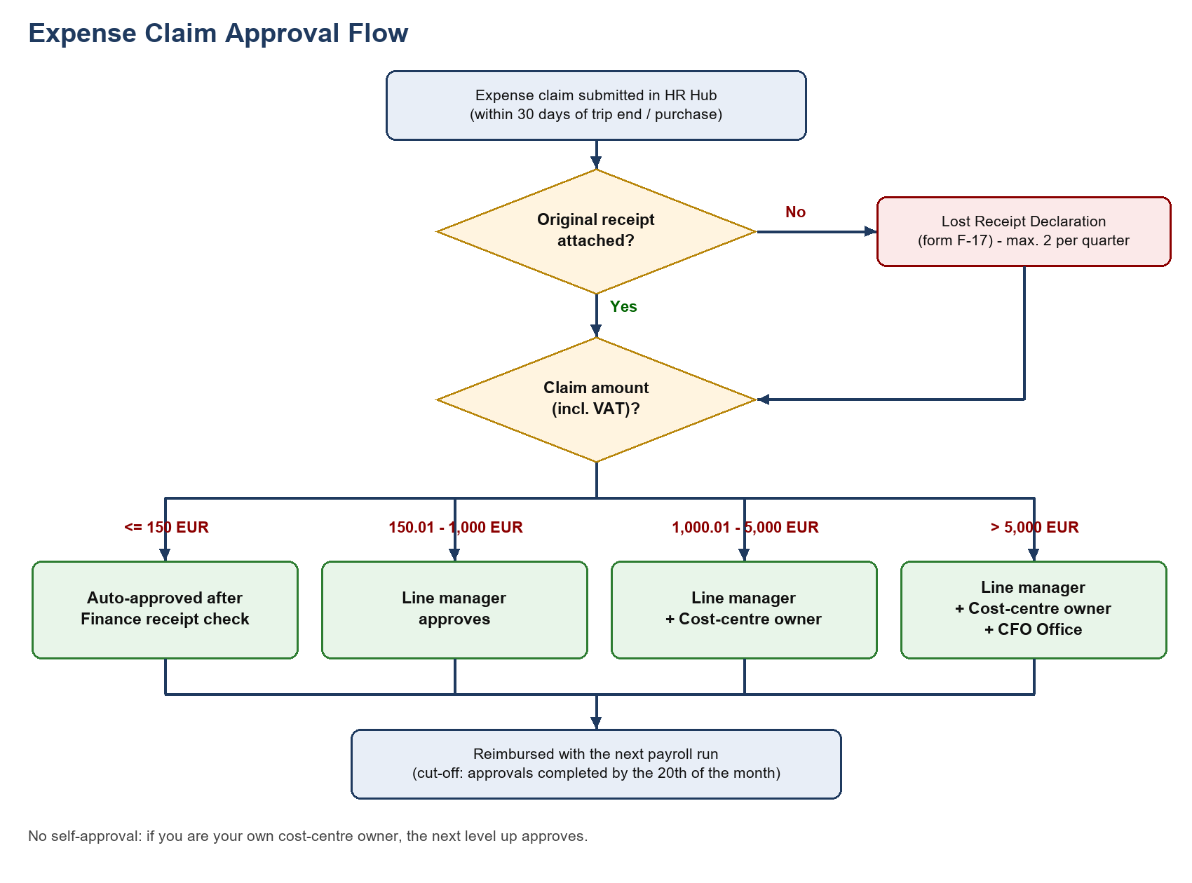
Figure 3: Expense claim approval

5.7 Non-reimbursable items
- Minibar items, in-room films and other personal entertainment.
- Traffic and parking fines.
- Seat, cabin or room upgrades paid privately.
- Laundry on trips shorter than five nights.
- Alcohol, except as part of client entertainment.
- Costs for accompanying family members or friends.

6. Purchasing and Procurement

6.1 Purchase thresholds
Purchasing rules apply to goods and services bought for the company, as opposed to the travel and expense rules in Chapter 5, which apply to costs incurred by individual employees. Thresholds below refer to the total contract value excluding VAT. Splitting a purchase to stay below a threshold is a breach of this policy.
Table: Purchase thresholds
Contract value (EUR, excl. VAT) | Required process | Approval
Up to 2,500 | Company card or expense claim, no purchase order | Budget owner
2,500.01 - 15,000 | Purchase order in ProcureNow, 1 written quote | Budget owner
15,000.01 - 100,000 | Purchase order, 3 written quotes, Procurement review | Budget owner + Finance
Above 100,000 | Formal tender led by Procurement | CFO Office + Legal & Compliance

6.2 Software and cloud services
All software, SaaS subscriptions and browser extensions must be requested through IT, regardless of price, so that a security review can be performed. Buying software with a company card without an IT request is considered shadow IT and the subscription will be cancelled.

6.3 New vendors
New vendors are onboarded by Procurement. Vendors that will process personal or customer data must complete the vendor security questionnaire and sign a data processing agreement before any data is shared. Vendor onboarding typically takes 10 business days.

6.4 Company cards
Table: Company card limits
Card holder | Monthly limit (EUR)
NSS team leads | 3,000
NSFS site supervisors | 5,000
Other employees | On request, approved by Finance

Card statements must be reconciled in HR Hub by the 5th business day of the following month. Private use of a company card is not permitted, even if repaid.

7. IT and Information Security

7.1 Passwords and multi-factor authentication
Standard accounts require passwords of at least 14 characters; administrator accounts require at least 20 characters. Passphrases are encouraged. Passwords are changed only when a compromise is suspected, not on a fixed schedule. All passwords are stored in the company password manager, Keyvault.
Multi-factor authentication is mandatory for all accounts. Administrators and employees in Finance and the People Team must use hardware security keys; all others use the authenticator app.

7.2 Devices
NSS laptops lock automatically after 5 minutes of inactivity; NSFS rugged tablets lock after 2 minutes. USB storage devices are blocked on all company devices. NSFS diagnostic equipment that requires USB can be exempted through an IT request. Personal devices may access e-mail and chat only through the managed mobile app.
Hardware faults are handled through the Service Portal. Lost or stolen devices are an emergency and must be reported via the Security Hotline shown in the portal.
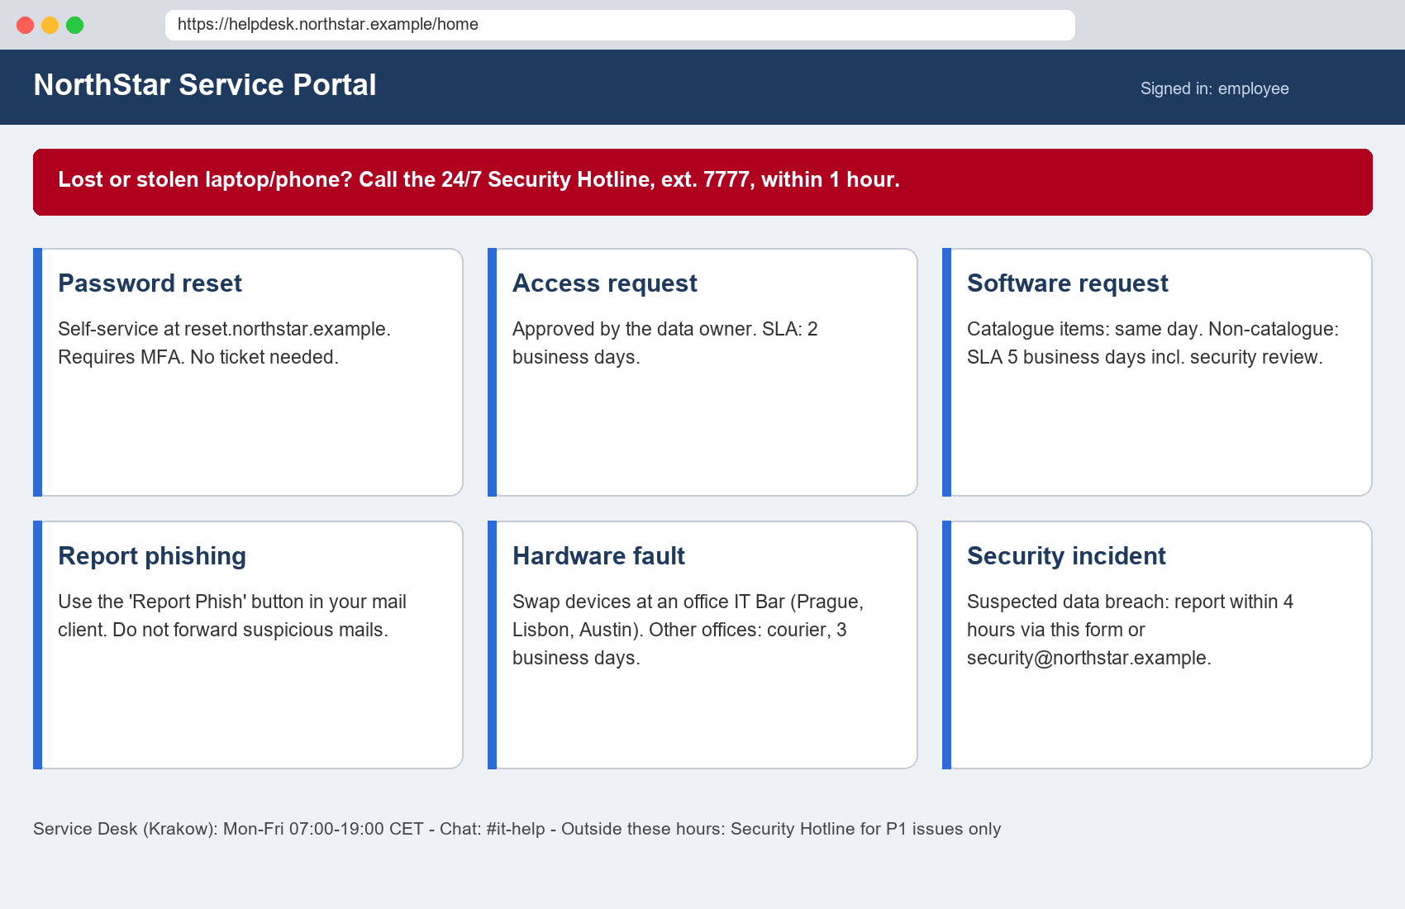
Figure 4: IT Service Portal home page

7.3 Reporting incidents
Table: Incident reporting
Event | Deadline | Channel
Lost or stolen laptop or phone | Immediately, at the latest within 1 hour | Security Hotline
Lost access badge | Within 24 hours | Reception of your office
Suspected data breach | Within 4 hours | Security incident form
Phishing e-mail | As soon as noticed | Report Phish button
Safety incident at a customer site (NSFS) | Immediately; written report within 48 hours | Site Safety Office

7.4 Networks and remote access
Company devices connect to the corporate network NS-Corp using certificate login. Outside the office, the always-on VPN NS-Connect must stay enabled. Public Wi-Fi may be used only with the VPN. Each office provides a separate guest network for visitors; network names differ by office and are displayed on posters at reception.
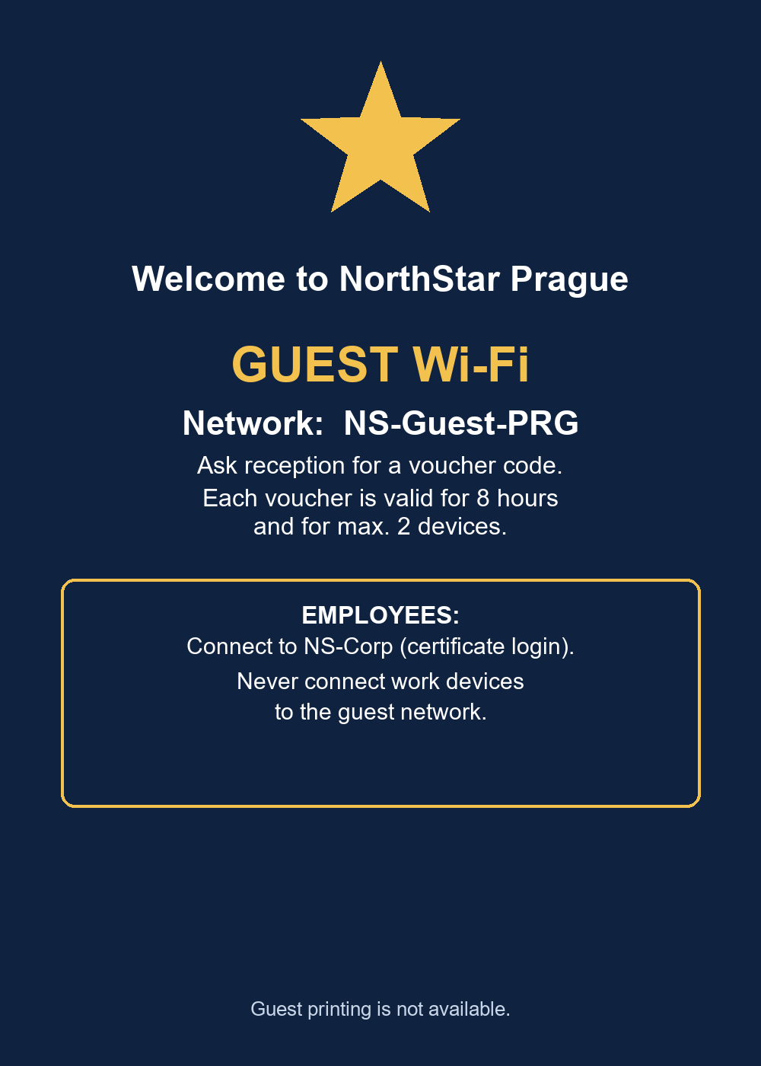
Figure 5: Reception poster

7.5 Software and AI tools
Software from the IT catalogue can be installed directly. Other software requires a request and a security review. The approved AI assistant, NorthStar Assistant, may be used with data up to the CONFIDENTIAL classification. Public AI tools may be used only with PUBLIC data.

8. Offices and Facilities

8.1 Group-wide office rules
Desks in all offices are booked in SpaceFinder up to 14 days in advance. Meeting rooms with more than 8 seats may be booked for a maximum of 2 hours per booking between 10:00 and 15:00. A clean desk policy applies: documents and devices must be locked away at the end of the day.
Visitors must be registered by their host in SpaceFinder at least 24 hours in advance, and a host may receive no more than 4 visitors at the same time without approval from Facilities. Visitors must be accompanied at all times outside the reception area.
Lost badges are charged at the replacement fee of the respective office. Replacement of a damaged badge is free of charge once per year. Pets are not allowed in NorthStar offices unless the office page below states otherwise.
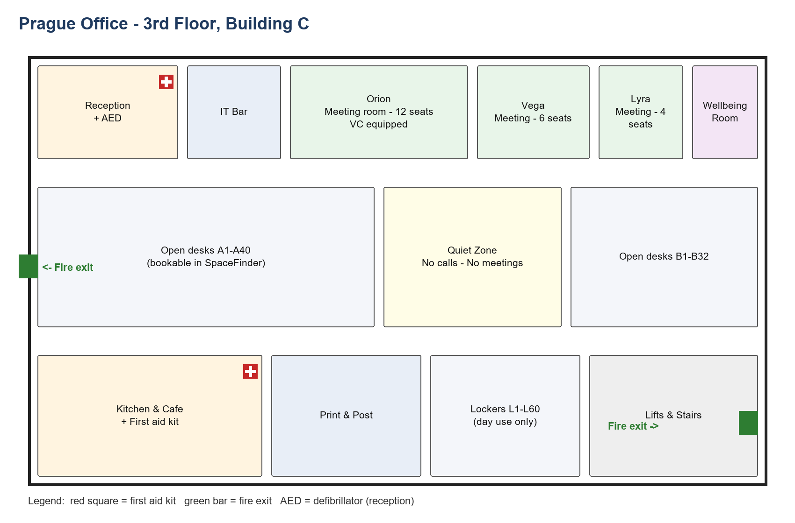
Figure 6: Office floor plan

8.2 Prague (headquarters) office
The Prague office (PRG) hosts NSS, the Group Executive Board and most Shared Services teams.
Table: Prague office facts
Item | Details
Address | Building C, Orbit Business Park, Prague (fictional)
Building opening hours | 07:00 - 20:00, Monday to Friday
Reception staffed | 08:00 - 17:00
Badge replacement fee (lost badge) | 15 EUR
Parking | 38 underground spaces, booked in SpaceFinder; 6 EV chargers
Bicycles and showers | Secure bike room on level -1 (40 racks); showers on the 2nd floor
Lunch arrangement | Meal vouchers for each day worked in the office
Public holidays per year | 13
First aid kits | Reception and kitchen (3rd floor)
Emergency assembly point | Car park P2, north side
Pets | Not allowed

The Prague office has an IT Bar for same-day device swaps. Weekend access requires a request to Facilities by Thursday 12:00. The Wellbeing Room on the 3rd floor is booked through reception and can be used for up to 45 minutes at a time.

8.3 Lisbon office
The Lisbon office (LIS) hosts NSS product and engineering teams.
Table: Lisbon office facts
Item | Details
Address | Floor 5, Tagus Tech Centre, Lisbon (fictional)
Building opening hours | 08:00 - 19:00, Monday to Friday
Reception staffed | 08:30 - 17:30
Badge replacement fee (lost badge) | 10 EUR
Parking | No company parking; 30% discount at the public garage next door
Bicycles and showers | 12 bike racks in the courtyard; showers on floor 5
Lunch arrangement | Meal card loaded with a daily amount for each working day
Public holidays per year | 14 (13 national + 1 municipal)
First aid kits | Reception
Emergency assembly point | Square in front of the main entrance
Pets | Dogs allowed on Fridays; register in advance, max. 3 dogs per day

The Lisbon office has an IT Bar open from 09:00 to 16:00. The roof terrace may be used for team events until 21:00 with approval from reception. Because of building rules, deliveries are accepted only until 16:00.

8.4 Krakow office
The Krakow office (KRK) hosts NSFS Europe, the IT Service Desk and Finance operations.
Table: Krakow office facts
Item | Details
Address | Building 2, Vistula Office Park, Krakow (fictional)
Building opening hours | 07:00 - 21:00, Monday to Friday; 08:00 - 14:00 Saturday (Service Desk only)
Reception staffed | 07:30 - 16:30
Badge replacement fee (lost badge) | 12 EUR
Parking | 25 spaces, first come first served
Bicycles and showers | 20 racks in the garage; showers on the ground floor
Lunch arrangement | Meal vouchers
Public holidays per year | 13
First aid kits | Reception, workshop and Service Desk area
Emergency assembly point | Green area behind Building 2
Pets | Not allowed

The NSFS workshop on the ground floor requires safety boots at all times; visitors receive overshoes at the workshop entrance. The Service Desk area is restricted to Service Desk staff after 19:00.

8.5 Austin office
The Austin office (AUS) hosts NSS Sales Americas and NSFS Americas.
Table: Austin office facts
Item | Details
Address | Suite 400, Lone Pine Plaza, Austin (fictional)
Building opening hours | 07:00 - 19:00 local time, Monday to Friday
Reception staffed | 08:00 - 17:00
Badge replacement fee (lost badge) | 20 EUR (charged in USD at the monthly rate)
Parking | Free surface parking, 120 spaces
Bicycles and showers | Bike racks at the garage entrance; no showers
Lunch arrangement | Catered lunch on Tuesdays and Thursdays
Public holidays per year | 10
First aid kits | Reception and NSFS equipment room
Emergency assembly point | North parking lot, row A
Pets | Not allowed

In case of a severe weather warning, use the shelter area in stairwell B. The Austin office has an IT Bar open Monday to Thursday. NSFS equipment may be stored overnight only in the locked equipment room.

8.6 Toronto office
The Toronto office (YYZ) hosts NSFS Canada (field technicians and dispatch).
Table: Toronto office facts
Item | Details
Address | Unit 12, Maple Industrial Park, Toronto (fictional)
Building opening hours | 06:30 - 18:00, Monday to Friday
Reception staffed | 08:00 - 16:00
Badge replacement fee (lost badge) | 15 EUR (charged in CAD at the monthly rate)
Parking | 8 reserved spaces for NSFS service vans only; staff use street parking
Bicycles and showers | Indoor bike storage in the warehouse; no showers
Lunch arrangement | Fruit and snacks provided
Public holidays per year | 10 (9 statutory + 1 company day)
First aid kits | Dispatch desk and warehouse
Emergency assembly point | Front lot, next to the flag poles
Pets | Not allowed

The Toronto office has no IT Bar; devices are replaced by courier. Winter tyres are mandatory on service vans from 1 November to 15 April. Vans are loaded at the warehouse door between 06:30 and 07:30.

8.7 Singapore office
The Singapore office (SIN) hosts NSS Asia-Pacific sales and customer success.
Table: Singapore office facts
Item | Details
Address | Level 18, Meridian Tower, Singapore (fictional)
Building opening hours | 08:30 - 19:30, Monday to Friday
Reception staffed | 09:00 - 18:00
Badge replacement fee (lost badge) | 18 EUR (charged in SGD at the monthly rate)
Parking | No parking provided; monthly transport allowance instead
Bicycles and showers | No bike storage
Lunch arrangement | No lunch arrangement
Public holidays per year | 11
First aid kits | Reception
Emergency assembly point | Open plaza at the tower's west entrance
Pets | Not allowed

Building management requires visitors to be registered 48 hours in advance, which is stricter than the group rule. Air-conditioning switches off at 19:30; after-hours cooling must be requested 24 hours in advance.

9. Performance and Career

9.1 Review cycles
NSS runs two review cycles per year: a mid-year review in July and a year-end review in January. NSFS runs one annual review in February, after the December maintenance season. Each review consists of a self-assessment, manager assessment, optional peer feedback and a calibration meeting within the department.
Table: Performance rating scale
Rating | Name | Meaning
1 | Not meeting expectations | Significant gaps; a performance improvement plan is likely
2 | Partially meeting expectations | Some goals met; development needed
3 | Meeting expectations | Solid performance in all key areas
4 | Exceeding expectations | Consistently above the requirements of the level
5 | Exceptional | Outstanding impact well beyond the role

9.2 Career levels
Career levels describe the scope and seniority of a role and are separate from performance ratings. NSS and Shared Services use levels L1 to L6. NSFS technical roles use technician grades T1 to T4; NSFS office roles use the L levels.
Table: Career levels and technician grades
Level | Title | Typical scope
L1 | Associate | Works on defined tasks with guidance
L2 | Professional | Owns tasks independently
L3 | Senior | Owns features or processes; mentors others
L4 | Lead / Staff | Leads a team or a cross-team technical area
L5 | Principal | Shapes strategy for a department
L6 | Distinguished | Group-wide impact
T1 | Trainee Technician | Works only under supervision
T2 | Technician | Performs standard installations alone
T3 | Senior Technician | Handles complex repairs; trains T1 and T2
T4 | Field Lead | Leads a crew and signs off site safety checks

9.3 Promotions and internal moves
NSS promotions are decided twice per year, aligned with the review cycles; NSFS promotions once per year. Employees must have spent at least 12 months at their current level before promotion. Employees may apply for internal vacancies after 12 months in their role, or after 9 months if their latest rating was 4 or 5. A performance improvement plan lasts 60 days.

10. Compensation and Benefits

10.1 Salary and bonus
NSS salaries are paid on the 25th of each month; if the 25th is not a business day, payment is made on the previous business day. NSFS salaries are paid on the 15th of the following month, together with overtime and allowances for the previous month.
NSS employees participate in an annual bonus with a target between 0% and 15% of base salary, depending on level, company results and individual rating. It is paid in March. NSFS employees receive a quarterly safety and productivity bonus of up to 6% of quarterly base salary; any lost-time safety incident in the crew reduces the bonus for that quarter to zero.

10.2 Learning budget
Every employee has a personal learning budget of 1,200 EUR per calendar year for courses, conferences, books and certifications. Items above 500 EUR require manager approval. The budget resets on 1 January and unused amounts are not carried over. If an employee leaves within 12 months of a certification costing more than 1,000 EUR, the cost is repaid pro rata.

10.3 Wellness allowance
Every employee may claim up to 300 EUR per calendar year for gym memberships, sports equipment, sports courses and mental health apps. Claims are reimbursed quarterly and must be submitted by the 15th of the month following the end of the quarter. Unused amounts are not carried over.

10.4 Other benefits
Table: Benefits overview
Benefit | NSS | NSFS
Learning budget | 1,200 EUR/year | 1,200 EUR/year
Wellness allowance | 300 EUR/year | 300 EUR/year
Home office allowance | 400 EUR one-off for hybrid employees | 250 EUR one-off, office roles only
Mobile phone | 20 EUR/month allowance for on-call engineers | Company smartphone (field roles)
Referral bonus | 2,000 EUR (engineering), 1,000 EUR (other) | 1,000 EUR (all roles)

Referral bonuses are paid after the referred person has successfully completed probation. Managers cannot receive a referral bonus for hires into their own team.

11. Code of Conduct

11.1 Gifts and hospitality
Employees may accept gifts with a value of up to 50 EUR per gift, and no more than 150 EUR per year from the same business partner. Any gift worth more than 25 EUR must be recorded in the Gift Register within 5 business days. Cash and cash equivalents, such as vouchers, may never be accepted.
Gifts given to business partners may not exceed 75 EUR per recipient and must be recorded in the Gift Register regardless of value. No gifts or hospitality of any value may be offered to public officials.

11.2 Conflicts of interest and side jobs
Potential conflicts of interest must be declared to Legal & Compliance within 14 days of becoming aware of them. Side jobs require prior written approval from the manager and the People Team; side jobs for competitors or customers are not approved.

11.3 Speaking up
Concerns about misconduct can be raised with the manager, the People Team, Legal & Compliance, or anonymously through the Speak-Up line. Reports are acknowledged within 7 days and the reporter receives feedback within 3 months. NorthStar does not tolerate retaliation against anyone who raises a concern in good faith.

11.4 Social media
Employees may mention that they work at NorthStar, but must not share INTERNAL, CONFIDENTIAL or RESTRICTED information, customer names or photos taken at customer sites. Only the Communications team speaks on behalf of the company.

12. Information Classification and Data Handling

12.1 Classification levels
Table: Classification levels
Level | Examples | Who may access | External sharing
PUBLIC | Website content, published release notes | Anyone | Allowed
INTERNAL | This knowledge base, internal announcements | All employees and contractors | Not allowed without approval
CONFIDENTIAL | Customer contracts, salary data, customer sensor data | Employees with a business need | Only encrypted and under NDA
RESTRICTED | Acquisition plans, encryption keys, investigation files | Named individuals only | Never

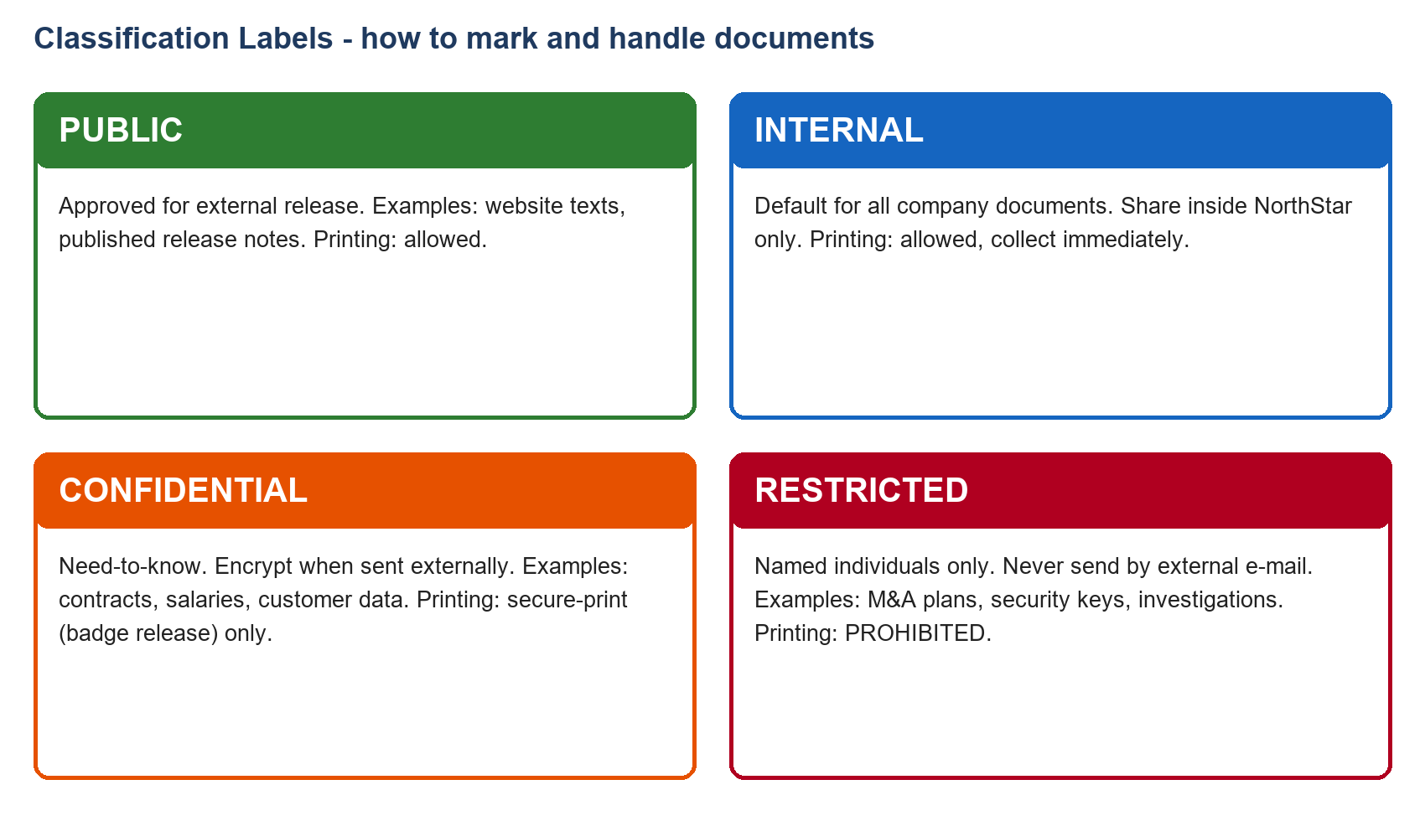
Figure 8: Classification labels

12.2 Retention periods
Table: Retention periods
Data | Retention
Customer contracts | 10 years after the end of the contract
Invoices and accounting records | 10 years
Recruitment data of rejected candidates | 6 months after the end of the process (12 months with consent)
Employee files | 3 years after the end of employment, unless law requires longer
CCTV recordings | 30 days
Building access logs | 1 year

Note: Retention of customer data inside Polaris products is described in Chapter 13 and follows customer contracts, not this table.

13. Polaris Product Reference

13.1 Product overview
Table: Polaris Cloud and Polaris Edge
Property | Polaris Cloud | Polaris Edge
Deployment | Software as a service | Appliance at the customer site
Operated by | NSS | Customer, maintained by NSFS
Hosting regions | EU-Central and US-East | Customer premises
Release cadence | Quarterly (version format YYYY.N) | Approx. quarterly (version format 4.x)
Supported versions | Latest version only | Latest four minor versions
Single sign-on | SAML 2.0 (since 2025.3) | LDAP (since 4.4)
Default retention of raw data | 13 months; aggregates 5 years | 90 days local storage
Capacity limit | 40 widgets per dashboard | 500 sensors per appliance (since 4.5)

13.2 Standard support
All customers receive Standard support. Standard support is available Monday to Friday, 08:00 - 18:00 CET. For Polaris Edge P1 incidents under Standard support, an on-site engineer is dispatched within 3 business days. Customers with the Premium plan receive the targets shown in Figure 9.
Table: Standard support response targets
Severity | Definition | First response (Standard)
P1 | Production down or data loss, no workaround | 4 hours
P2 | Major function impaired, workaround exists | 8 business hours
P3 | Minor issue, limited impact | 2 business days
P4 | Question or feature request | 5 business days

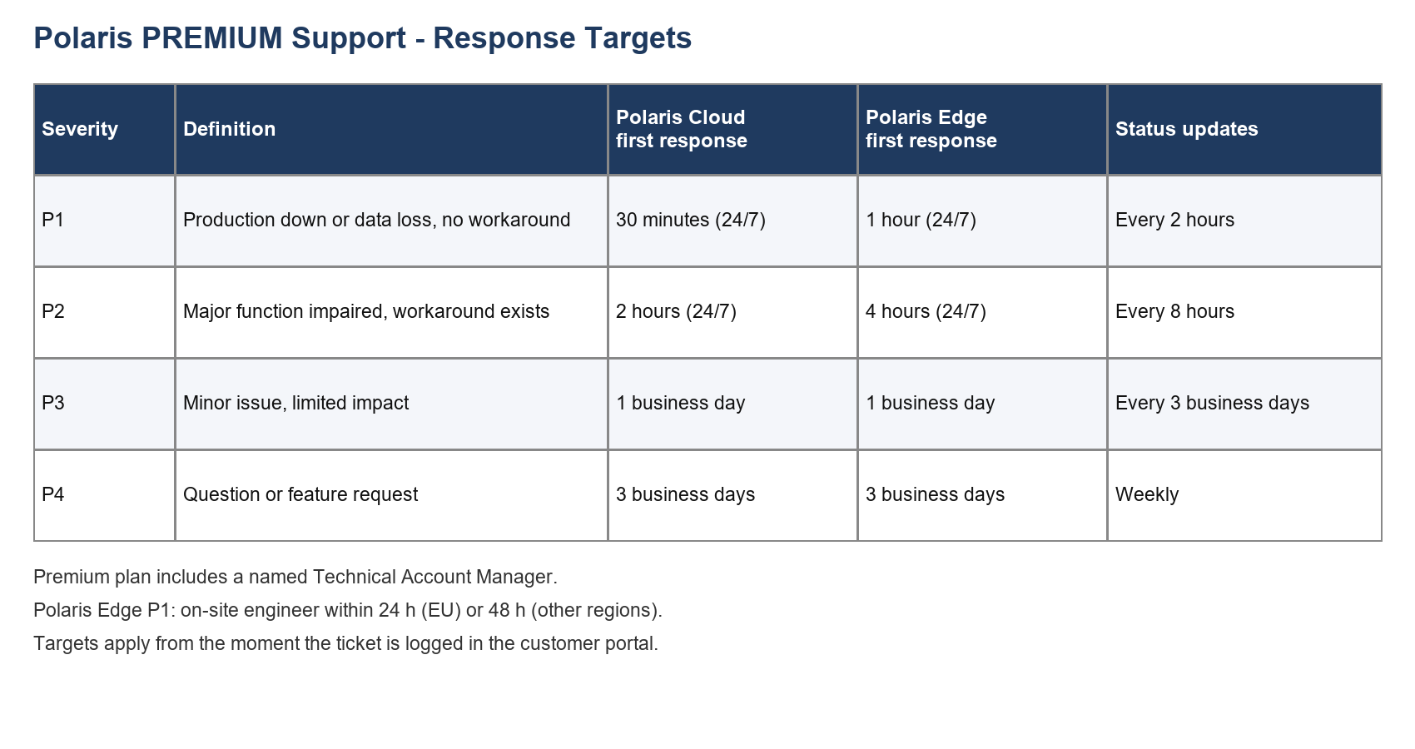
Figure 9: Support targets

13.3 Release notes - Polaris Cloud
Polaris Cloud 2025.1 (January 2025). Dashboard sharing via link for internal users; CSV export up to 1 million rows. Legacy API v1 deprecated, removal planned for 2025.4.
Polaris Cloud 2025.2 (April 2025). Row-level security for datasets; alerting via e-mail; CSV export limit raised to 5 million rows.
Polaris Cloud 2025.3 (July 2025). Single sign-on via SAML 2.0; audit log retention of 12 months. Removal of legacy API v1 postponed to 2026.1.
Polaris Cloud 2025.4 (October 2025). Alerting via webhooks; scheduled PDF reports; dark mode.
Polaris Cloud 2026.1 (January 2026). Legacy API v1 removed; SCIM user provisioning; audit log retention extended to 24 months; natural-language queries (beta).

13.4 Release notes - Polaris Edge
Polaris Edge 4.2 (March 2025). Default local retention of 60 days; up to 200 sensors per appliance.
Polaris Edge 4.3 (June 2025). Offline mode for up to 72 hours with automatic synchronisation; signed firmware.
Polaris Edge 4.4 (September 2025). Single sign-on via LDAP; default local retention raised to 90 days.
Polaris Edge 4.5 (December 2025). Up to 500 sensors per appliance; remote diagnostics (customer opt-in required).
Polaris Edge 4.6 (February 2026). Offline mode extended to 7 days; TLS 1.3 only; end of support for 4.2.
Note: Polaris Edge 4.6 was released after the publication of this knowledge base and is included as a pre-release summary approved by Product Documentation.

14. Frequently Asked Questions
Q: Can I carry over unused annual leave?
A: Yes, within limits. NSS employees may carry over up to 5 days until 31 March; NSFS employees up to 3 days until 30 April. See section 4.1.
Q: Can I carry over my unused learning budget?
A: No. The learning budget resets on 1 January. See section 10.2.
Q: Can I carry over unused volunteering days?
A: No. Volunteering leave is 2 days per year and expires at the end of the year.
Q: Can I carry over the wellness allowance?
A: No. Unused amounts expire at the end of the calendar year.
Q: I lost my laptop on the train. What do I do?
A: Report it immediately via the Security Hotline, at the latest within one hour. The hotline number is shown on the IT Service Portal.
Q: I lost my badge. What do I do?
A: Inform the reception of your office within 24 hours. A replacement fee applies, which differs by office (see Chapter 8).
Q: I lost a receipt. Can I still claim the expense?
A: Yes, with a Lost Receipt Declaration. The number of declarations per quarter is limited; see Figure 3.
Q: I missed the 30-day deadline for my expense claim.
A: Claims up to 90 days late can still be paid with additional approval from the cost-centre owner. Older claims are rejected.
Q: Can I work from Spain for a month?
A: Not in one block. Work from Anywhere allows a maximum of 10 consecutive working days and 20 working days per year.
Q: I am moving permanently to Lisbon. Is that Work from Anywhere?
A: No. A permanent move is a relocation and requires a new or amended contract. See section 3.5.
Q: I am moving to a new flat in the same city. Do I get a day off?
A: Yes, one moving day per year. This is unrelated to the relocation package.
Q: Can I bring my dog to the office?
A: Only in Lisbon, on Fridays, after registering in advance.
Q: What is the guest Wi-Fi?
A: Guest network names differ by office and are displayed on posters at reception. Employees must never connect work devices to a guest network.
Q: How do I book a meeting room?
A: Use SpaceFinder. Rooms with more than 8 seats can be booked for max. 2 hours between 10:00 and 15:00.
Q: Can I use public AI chatbots for my work?
A: Only with PUBLIC data. For INTERNAL and CONFIDENTIAL data, use NorthStar Assistant. RESTRICTED data may not be used with any AI tool.
Q: Am I paid for overtime?
A: NSS: no, but approved extra hours can be taken as time off in lieu. NSFS: yes, at 150% or 200%.
Q: When is my salary paid?
A: NSS on the 25th of the month; NSFS on the 15th of the following month.
Q: When is the referral bonus paid?
A: After the referred person has completed probation.
Q: A supplier sent me a bottle of wine worth 40 EUR. May I keep it?
A: Yes, it is below 50 EUR, but because it is worth more than 25 EUR you must record it in the Gift Register within 5 business days.
Q: May I invite a city official to lunch?
A: No. No gifts or hospitality may be offered to public officials.
Q: Do I need a purchase order for a 1,800 EUR purchase?
A: No, a company card or expense claim is enough. If it is software, it must still go through IT.
Q: Who approves an expense claim of 800 EUR?
A: See the approval flow in Figure 3.
Q: How many sick days can I take without a doctor's note?
A: NSS: up to 3 consecutive days. NSFS: up to 2.
Q: What is the difference between Polaris Cloud and Polaris Edge?
A: Polaris Cloud is the SaaS product operated by NSS. Polaris Edge is an appliance at the customer site, maintained by NSFS.
Q: Which Polaris Edge versions are supported?
A: The latest four minor versions.
Q: What is the P1 response time for a customer?
A: It depends on the plan. Standard: 4 hours. Premium: see Figure 9.
Q: Can I print a RESTRICTED document?
A: See the classification labels in Figure 8.
Q: Where are the first aid kits in the Prague office?
A: At reception and in the kitchen on the 3rd floor.
Q: Is P1 the same as a level 1 rating?
A: No. P1 is a support severity; ratings are 1 to 5; career levels are L1 to L6; technician grades are T1 to T4.
Q: How long are building access logs kept?
A: 1 year.

15. Glossary
Table: Glossary
Term | Meaning
AED | Automated external defibrillator
Buddy | Colleague from another team who supports a new joiner during the first six weeks
Calibration | Meeting in which managers align performance ratings across a department
Core hours | 10:00-15:00; time when NSS employees are expected to be available
Cost-centre owner | Person responsible for a budget; second approver for larger expense claims
Edge | Polaris Edge, the on-premises appliance (not to be confused with 'edge case')
F-17 | Lost Receipt Declaration form
HR Hub | System for leave, expenses and HR tickets
Keyvault | Company password manager
L1-L6 | Career levels for NSS, Shared Services and NSFS office roles
NSS | NorthStar Software
NSFS | NorthStar Field Services
NS-Corp | Corporate Wi-Fi network for company devices
NS-Connect | Always-on VPN
P1-P4 | Support severity levels for Polaris customer tickets
PIP | Performance improvement plan, 60 days
PO | Purchase order, created in ProcureNow
ProcureNow | Purchasing system
PT | People Team (also used in memo references, e.g. PT-2026-04)
SpaceFinder | Desk, room, parking and visitor booking tool
T1-T4 | Technician grades for NSFS technical roles
TripDesk | Travel booking portal
WFA | Work from Anywhere, temporary work abroad (max. 20 days per year)

16. Change Log and Memos

16.1 Version history
Table: Version history
Version | Date | Main changes
3.0 | January 2025 | New travel policy (per diems, hotel caps); hybrid work raised to 2 days for NSS; password policy without forced rotation.
3.1 | July 2025 | Learning budget raised to 1,200 EUR; Work from Anywhere raised to 20 days.
3.2 | January 2026 | Office pages for Toronto and Singapore; Polaris release notes; classification labels.

16.2 Memos issued after version 3.2
The following memos were issued after publication of version 3.2 and take precedence over the chapters they refer to.
Memo PT-2026-02 (Finance & People Team, 2 February 2026): Because of rising hotel prices, the hotel cap for Lisbon is raised from 140 EUR to 160 EUR per night for stays from 1 April 2026. All other hotel caps in section 5.2 remain unchanged.
Memo PT-2026-04 is available only as a scanned copy and is reproduced below.
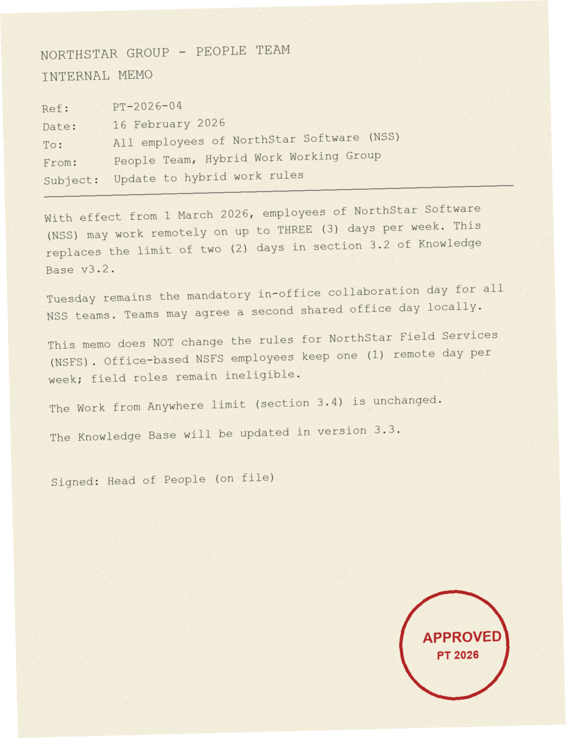
Figure 7: Scanned memo PT-2026-04

17. Archive - Superseded Policies (Do Not Apply)
The policies in this chapter are no longer valid. They are kept so that employees can understand decisions made under earlier rules. Never apply them to current cases.

17.1 Travel and Expenses Policy v2.1 (valid 1 March 2023 - 31 December 2024)
SUPERSEDED. Under this version, the per diem was 30 EUR per day for domestic trips and 50 EUR per day for international trips. A single hotel cap of 120 EUR per night applied to all cities except Singapore, where the cap was 180 EUR. Economy class was mandatory for all flights shorter than 8 hours. Expense claims had to be submitted within 60 days. Claims up to 2,000 EUR were approved by the line manager, and all claims above 2,000 EUR by the CFO Office.

17.2 Hybrid Work Policy v2.1 (valid 1 March 2023 - 31 December 2024)
SUPERSEDED. NSS employees could work remotely on one day per week. Work from Anywhere was limited to 10 working days per year. NSFS office roles were not eligible for remote work.

17.3 Learning Budget v2.1 (valid until 30 June 2025)
SUPERSEDED. The learning budget was 1,000 EUR per year, and up to 50% of an unused budget could be carried over to the following year.

17.4 Password Policy v2.0 (valid until 31 December 2024)
SUPERSEDED. Passwords required at least 12 characters and had to be changed every 90 days. Hardware security keys were not required.

