This application is base on codeigniter PHP MVC framework.
Installation guide:
- Unzip the package into web root / web path(like yourhost/snafoo), OR, use git clone form https://github.com/minjia-tang/snafoo to web root/web path.
- Edit the file application/config/config.php, on line 20, if you put the project on web root, the line should be like: “ $config['base_url'] = ' '; ”. If you put under some path, the line should be like: “ $config['base_url'] = '/yourpath'; ”.
- Create or pick your database, run snafoo.sql script to store all the tables and data for this project.
- Edit the file application/config/database.php, update your database host, user, password and database name.
- Adjust the permission right for the web user like apache or root, so they can put export list for the shopping list.
That’s all for installation.

Brief instruction:
1. For home page (Voting page), it lists all the snacks always purchased from database which I did here or via API call on the left column. On the right column, it lists all vote snacks for this month. If a snack has been voted by the user this month, the vote button for this snack is disabled for preventing duplicated votes on same snack from same user.
If user has been voted all three snacks, all the vote buttons are disabled. If a vote has been issued, the current votes count will be updated.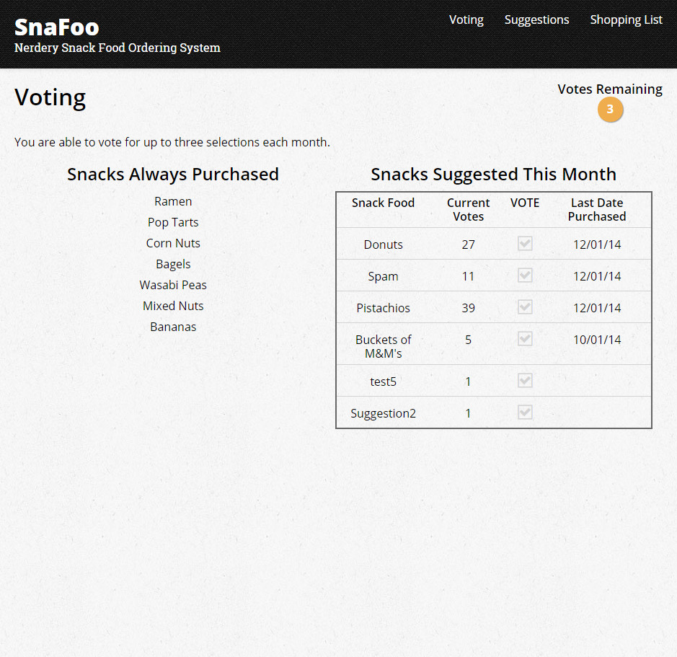
2. For the Suggestions page, the selection box will list all the snacks are optional but not on the vote list for user to pick, if user pick one (the new snack suggestion input box will be disabled), this one will show up on vote list and remove from suggestion list. If the user doesn’t pick from selection box, he/she can enter new suggestion to the input box under, the entered new snack will be insert as new entry into database or via API for the snack list and will put on the vote list as well.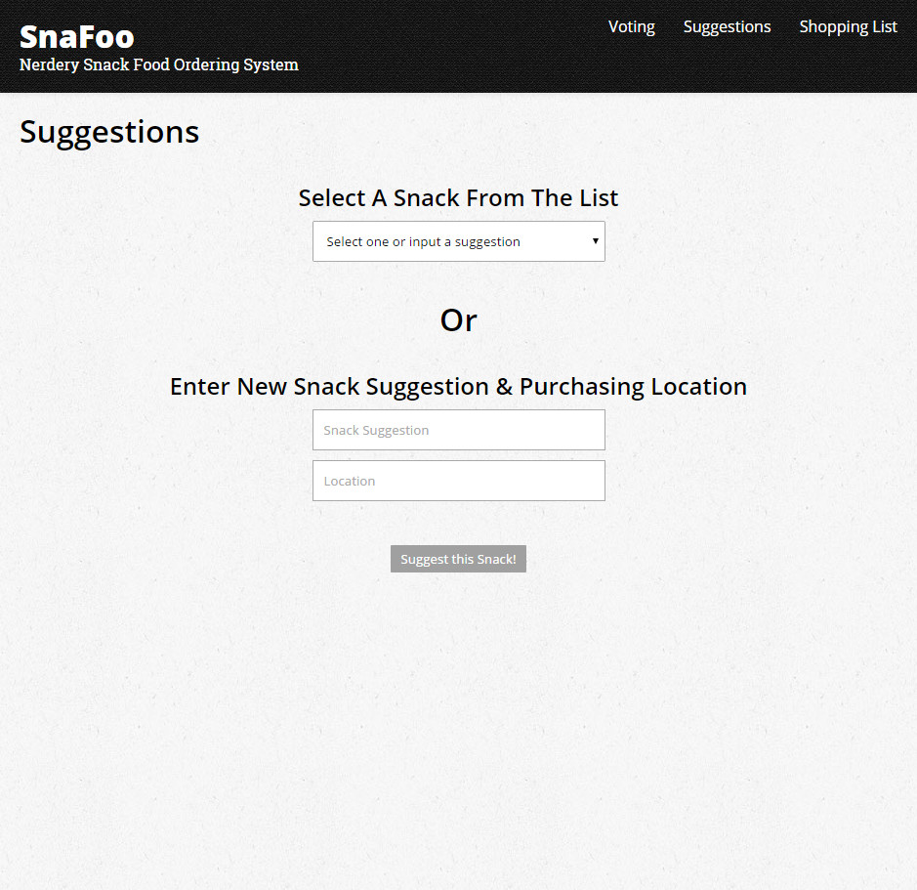
3. For the Shopping List page, list all snacks always purchased, followed by optional snacks list base on this month votes, the total number of optional snacks is base on the number of always purchased, the total snacks count is 10. the page also export the purchased list into a CSV format file.