**WSU STATS419 Measure Project Data Collection Handout**

**Part 1. Please fill out the questions below**

Name:

Gender: Age:

Ethnicity:

Dominant Eye (right, left, or equal): Eye color:

Dominant arm for swing a bat (right, left, or both): Dominant writing hand (right, left, or both):

Notes/Comments:

**Part 2. Measurements**

* **You will need a soft measuring tape**
* **Please record how long it took you to finish part2.**
* **Measure the following locations in cm. Measure right and left if applicable.**

**Please refer to the next page for visual representation for measurement locations.**

|  |  |  |  |
| --- | --- | --- | --- |
|  | Description | Right  (cm) | Left  (cm) |
| 1.Height | Standing height (head to floor with no shoes on) |  |  |
| 2.Floor to knee pit | Distance from the floor to the knee pit |  |  |
| 3.Floor to hip | Distance from the floor to the hip bone |  |  |
| 4.Floor to navel | Distance from the floor to the belly button |  |  |
| 5.Floor to armpit | Distance from the floor to the armpit |  |  |
| 6.Standing reach | Standing flatfooted, length from floor to the extended arm maximum point. |  |  |
| 7.Wingspan | middle finger of each hand fully stretched out |  |  |
| 8.Middle finger to elbow | Distance from middle finger to elbow (measure from the inside) |  |  |
| 9.Elbow to armpit | Distance from the elbow to armpit |  |  |
| 10.Length of foot | Distance from back of the heal to the longest toe |  |  |
| 11.Head height | Distance from the top of the head to below the chin |  |  |
| 12.Head circumference | Distance around head, measured right above ears/eyes |  |  |
| 13.Hand length | Distance from middle finger to wrist (horizontal line just below the palm) |  |  |
| 14.Hand span | Distance from pinkie to thumb fully stretched |  |  |

Time spent on part2:

1.height

3.floor to hip

4.floor to navel

2.floor to knee pit

5.floor to armpit

6.standing reach

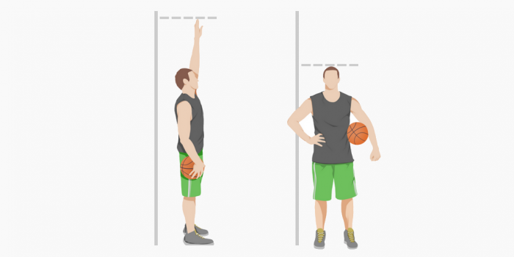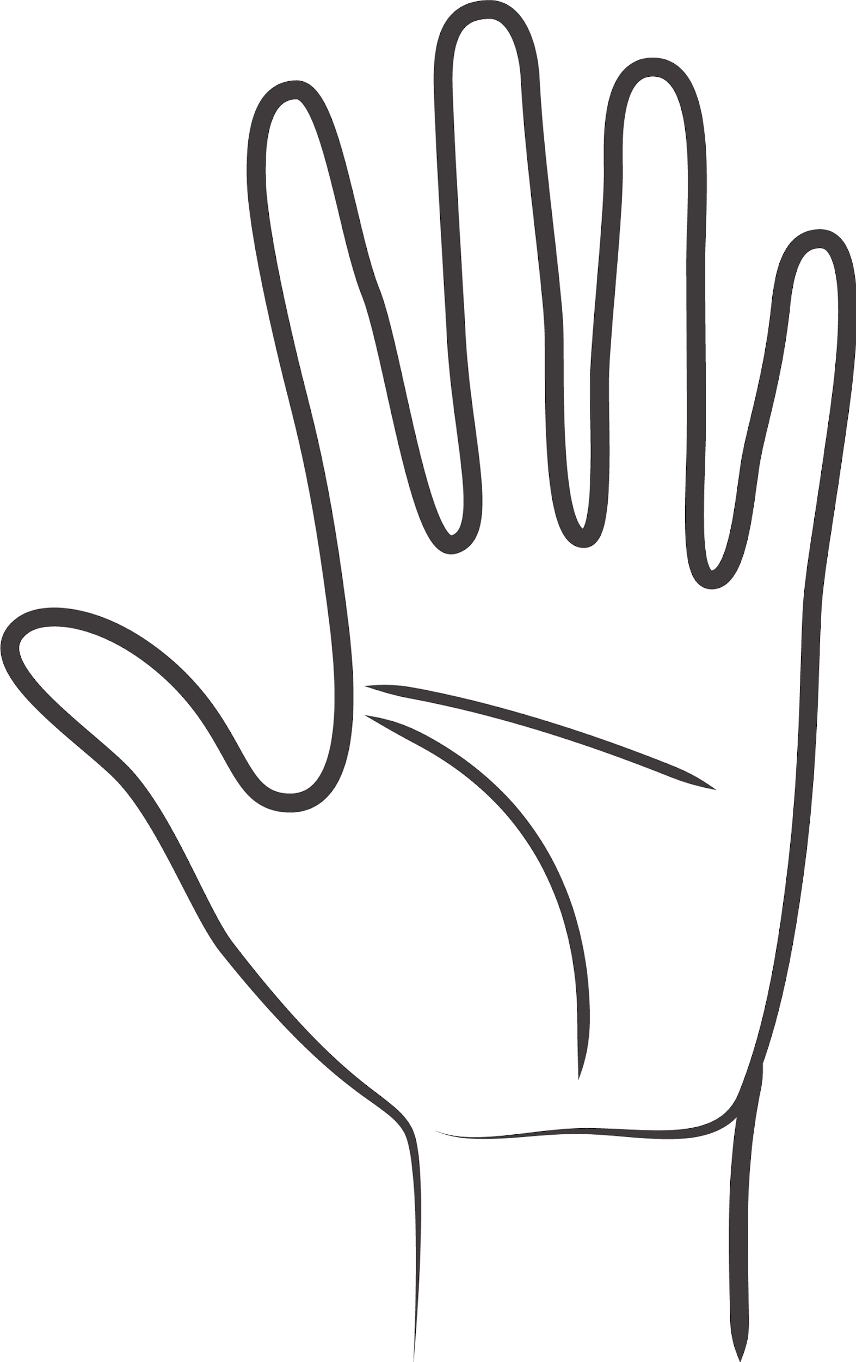

13.hand length

14.hand span



8.middle finger to elbow

9.elbow to armpit

7.wingspan

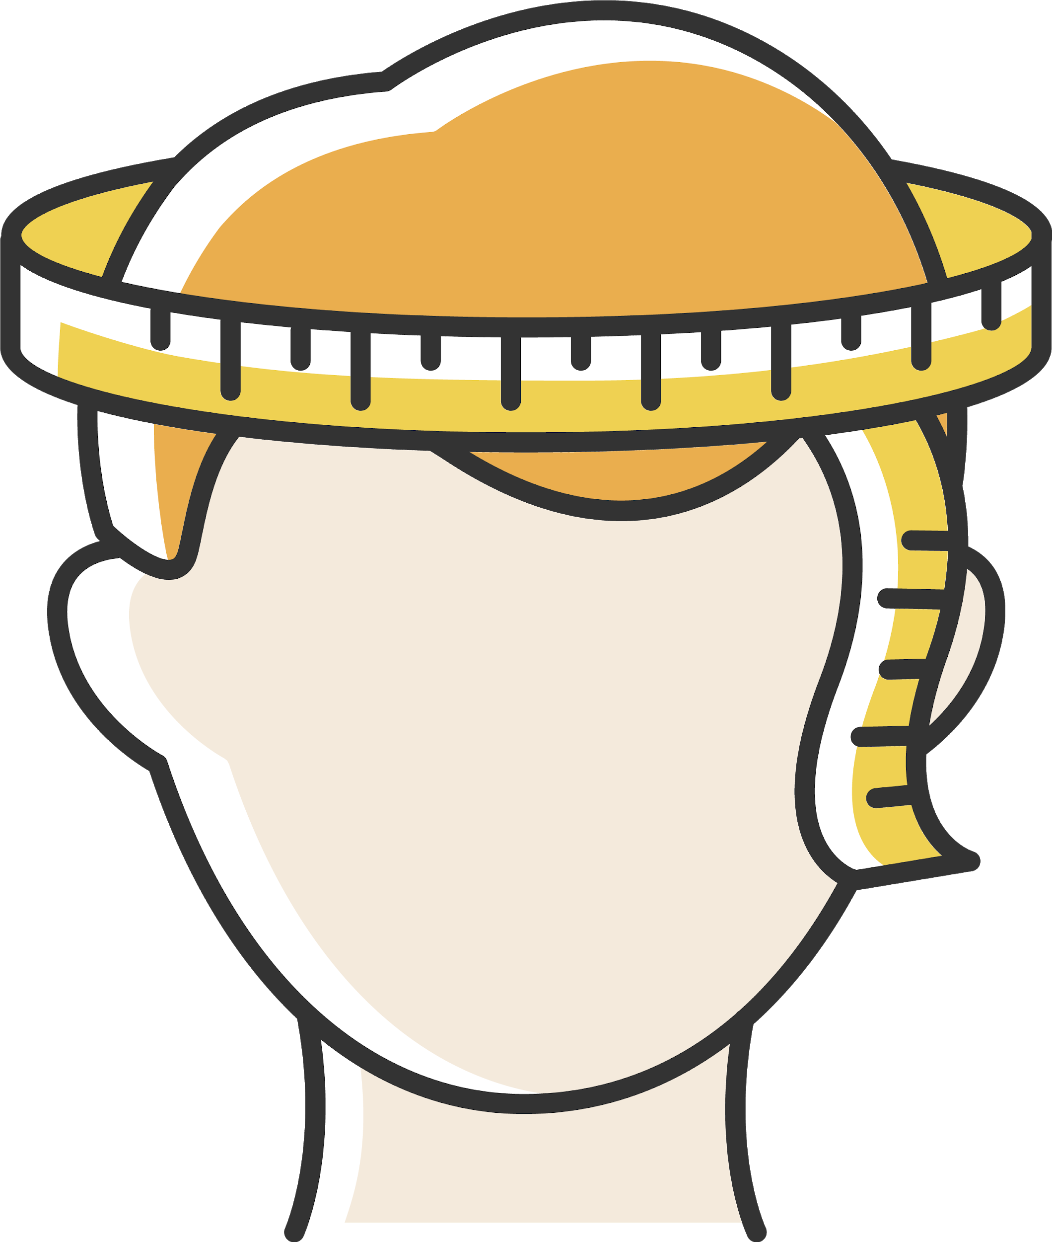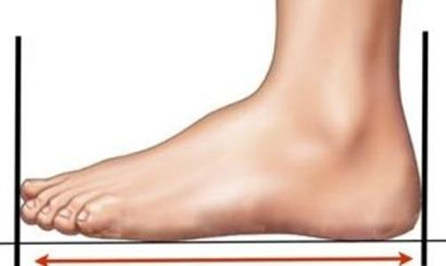

10.Length of foot

11.head height

12.head circumference