FYS3150 Computational Physics - Project 4

Minju Kum

November 11, 2019

Abstract here

**I Introduction**

Ferromagnetic materials exhibit characteristic phase transition behaviors at the critical temperature. It is identified with discontinuity of expectation values of energy and magnetization (first-order phase transition), and divergence of heat capacity(Cv) and magnetic susceptibility (second-order phase transition). The non-equilibrium state of the matter is not fully understood, yet models to simulate the transition behaviors were developed. In this project, simulation of magnetic phase transition of ferromagnetism is studied with Ising model in two dimensions. The model reproduced the probability distribution of energy, as well as the transition behaviors of certain physical quantities. The characteristic temperature of infinite lattice was also estimated from the results with finite lattices.

It is possible to find the analytic expressions of expectation values and variances of energy and magnetization for one or two-dimension model, (Onsager, 1944) but for three and higher dimensions, numerical method is the only possible approach. In this project the small 2X2 spin lattice is first studied. The numerical results for mean energy, heat capacity, mean magnetization and susceptibility are compared with the analytical calculations to ensure that the model properly reproduces the expected results. Next we move on to 20X20 and larger systems. In this case we study the physical quantities mentioned above and also the equilibration of the model as a function of time and temperature. Also, the probability distribution of the energy is studied. Phase transition behavior around the critical temperature was reproduced with finite-sized lattices. Critical temperature at infinite-sized lattice is estimated with the results from finite-sized lattices, using power law relations.

I see that the model shows the struggle between energy minimization and entropy maximization.

**II Method**

2.1 Ising model

The system being studied in the project can be modeled with Ising model with discrete spin variables in a lattice structure. The energy of the system is expressed as

$$E=-\sum_{<kl>}^{N}{J_{kl}s_{k}s_{l}}-μ\sum_{k}^{N}{h_{k}s_{k},}$$

while *s* indicating the spin, *J* being a coupling constant for each spin site, *N* being the total number of spins, $μ$ being the magnetic moment and *h* indicating the external magnetic field interacting with each spin site. <*kl*> indicates that the sum is over the nearest neighbors.

In this project, we take two-dimensional square lattice with periodic boundary condition. We also take the simplest form of the expression above, namely, the coupling constant *J* is assumed as the same for all spin sites and the contribution of external magnetic field is ignored. The simplification makes

$$E=-J\sum_{<kl>}^{N}{s_{k}s_{l}},$$

with *J* now being universal.

The probability of the system being found in a state *i* is given as the Boltzmann distribution of *Ei*

while *Ei* indicating the energy at a given spin configuration *i* and *Z* being the partition function which sums over all M spin configurations,

$$Z=\sum_{i=1}^{M}{e^{-βE_{i}}}.$$

Expectation value and variance of energy and magnetization can be calculated with the probability expression above. With the expression for magnetization for a given spin configuration *i* being

$$M_{i}=\sum_{k=1}^{N}{s_{k},}$$

expectation value of energy < *E* >, specific heat at constant volume *CV*, expectation value of absolute magnetization < $|M|$ > and magnetic susceptibility $χ$ is expressed as below.

$$<E> = \frac{1}{Z}\sum_{i=1}^{M}{{E_{i}e}^{-βE_{i}}}$$

$$C_{v}=\frac{σ_{E}}{k_{B}T^{2}}=\frac{<E^{2}>-<E>^{2}}{k_{B}T^{2}}$$

$$<|M|> = \frac{1}{Z}\sum_{i=1}^{M}{{M_{i}e}^{-βE_{i}}}$$

$$χ=\frac{σ_{M}}{k_{B}T}=\frac{<M^{2}>-<M>^{2}}{k_{B}T}$$

These are the main physical quantities that will be studied in this project.

2.2 Markov chain and Monte Carlo method, with Metropolis algorithm

With the model introduced above, we have to mimic the system stabilizing to the equilibrium state. The system behaves to minimize the energy and maximize the entropy. It evolves towards equilibrium state. In order to do this, the Markov process is used in Monte Carlo simulations until it reaches the most likely state.

In order to compute markov chain, we implement Monte carlo with metropolis algorithm

wi = Boltzmann

Wij = metropolis

Pseudocode….

2.3 error calculation

overestimated

2.4 Implementations

**III Results and discussions**

**3.1 Ising model of 2x2 lattice**

**3.1.1 Analytical expressions**

Here we find the analytical expressions for 2x2 spin lattice, which will be compared with the numerical results. All the spin configurations are described in Table 1.

Table 1. Spin configurations, degeneracy, energy and magnetization of 2x2 spin lattice. Different configurations with same energy and magnetization is denoted as degenerated.

|  |  |  |  |
| --- | --- | --- | --- |
| Configuration | Degeneracy | Energy | Magnetization |
| ↑ ↑  ↑ ↑ | 1 | -8J | 4 |
| ↓ ↑  ↑ ↑ | 4 | 0 | 2 |
| ↓ ↓  ↑ ↑ | 4 | 0 | 0 |
| ↓ ↑  ↑ ↓ | 2 | 8J | 0 |
| ↓ ↓  ↓ ↑ | 4 | 0 | -2 |
| ↓ ↓  ↓ ↓ | 1 | -8J | -4 |

Using formulae in 2.1, we get

$$Z=e^{\frac{8J}{k_{B}T}}+4+4+2×e^{- \frac{8J}{k_{B}T}}+4+e^{\frac{8J}{k_{B}T}}$$

$$<E> = \frac{1}{Z}(1×(-8J)×e^{\frac{8J}{k_{B}T}}+2×8J×e^{- \frac{8J}{k_{B}T}}+1×(-8J)×e^{\frac{8J}{k_{B}T}})$$

$$C_{v}=\frac{1}{k_{B}T^{2}}(1×64J^{2}×\frac{e^{\frac{8J}{k_{B}T}}}{Z}+2×64J^{2}×\frac{e^{- \frac{8J}{k_{B}T}}}{Z}+1×64J^{2}×\frac{e^{\frac{8J}{k_{B}T}}}{Z}-\frac{1}{Z^{2}}{\left(1×\left(-8J\right)×e^{\frac{8J}{k_{B}T}}+2×8J×e^{- \frac{8J}{k_{B}T}}+1×(-8J)×e^{\frac{8J}{k_{B}T}}\right)}^{2})$$

$$<|M|> =\frac{1}{Z}(1×4×e^{\frac{8J}{k_{B}T}}+4×2+4×2+1×4×e^{\frac{8J}{k_{B}T}})$$

$$χ=\frac{1}{k_{B}T}(1×16×\frac{e^{\frac{8J}{k_{B}T}}}{Z}+4×4×\frac{1}{Z}+4×4×\frac{1}{Z}+1×16×\frac{e^{\frac{8J}{k_{B}T}}}{Z}-\frac{1}{Z^{2}}{\left(1×4×e^{\frac{8J}{k_{B}T}}+4×2+4×2+1×4×e^{\frac{8J}{k_{B}T}}\right)}^{2})$$

**3.1.2 Numerical results**

Now we implement the codes for 2x2 spin lattice. The initial state is set as the ground state, namely, all spins in the upward direction. The results for T = 1.0 (in units of *kBT/J*) is compared with the analytical calculation in Table 2 with different number of Monte Carlo cycles. Note that all values are presented in the unit of “per spin,” and temperature is in units of *kBT/J.*

Table 2. Comparison of numerical results with analytical calculations. It shows good agreement to the third-fourth leading digit with 106 Monte Carlo cycles.

|  |  |  |  |  |
| --- | --- | --- | --- | --- |
|  |  |  |  |  |
| Analytical | -1.9959821 | 0.032082332 | 0.99866073 | 0.0040107395 |
| 102 | -2 | 0 | 1 | 0 |
| 103 | -2 | 0 | 1 | 0 |
| 104 | -1.9946 | 0.04308336 | 0.9982 | 0.00538704 |
| 105 | -1.9964 | 0.02874816 | 0.99882 | 0.00347443 |
| 106 | -1.995962 | 0.032238778 | 0.9986535 | 0.004033748 |
| 107 | -1.996008 | 0.031881856 | 0.99866685 | 0.004000391 |

From Table 2, we can see that with 106 Monte Carlo calculation, the numerical results show good agreement with the analytical ones to the third leading digit for all quantities. The plot for expectation value of energy with varying N below (Figure 1) shows that the analytical value falls within the error range of numerical result and shows a good agreement from 106 cycles.

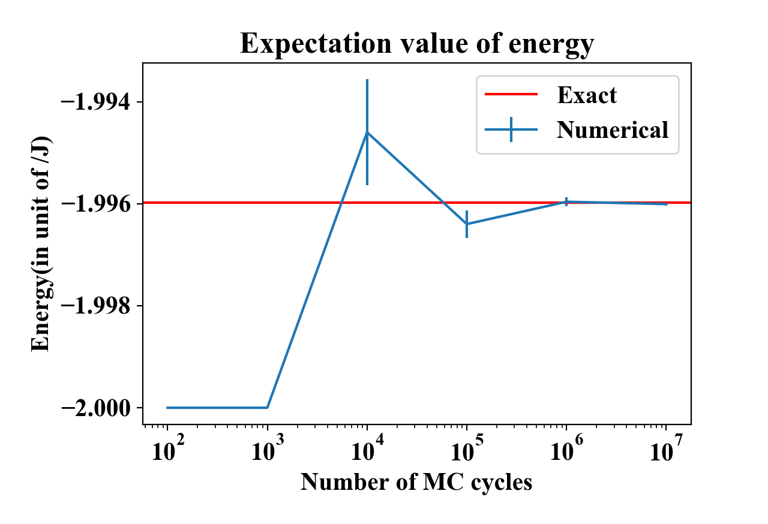

Figure 1. Expectation value of energy with different numbers of Monte Carlo cycles. Error bar indicates the standard deviation of expectation value of energy, calculated based on the central limit theorem. It is shown that the analytical (labeled as “Exact”) result falls within the error range of numerical results and achieves good agreement from N=106.

**3.2 Equilibration of the system**

Here we look more into the equilibration behavior of the system, including the time needed for the system to reach the most likely state, which can be considered proportional to the number of MC cycles. Figure 2 shows the evolution of expectation values of energy and magnetization of 20x20 spin lattice with increasing MC cycles, which denotes time, at two different temperatures; T=1.0 and T=2.4, and from two different initial conditions; ground state and random state. It is read that in low temperature(T=1.0), the system evolves to low-energy state close to -2.0, and in most cases the spin configuration is found to be ordered to one direction. In higher temperature(T=2.4) the system evolves to relatively higher-energy state, and the spin configurations are more disordered. The situation is physically equivalent to taking an object of 0K(ground state) or infinitely high temperature(random state) to a room at T=1.0 or T=2.4, and the object achieving the thermal equilibrium state, losing/gaining energy in the form of heat.

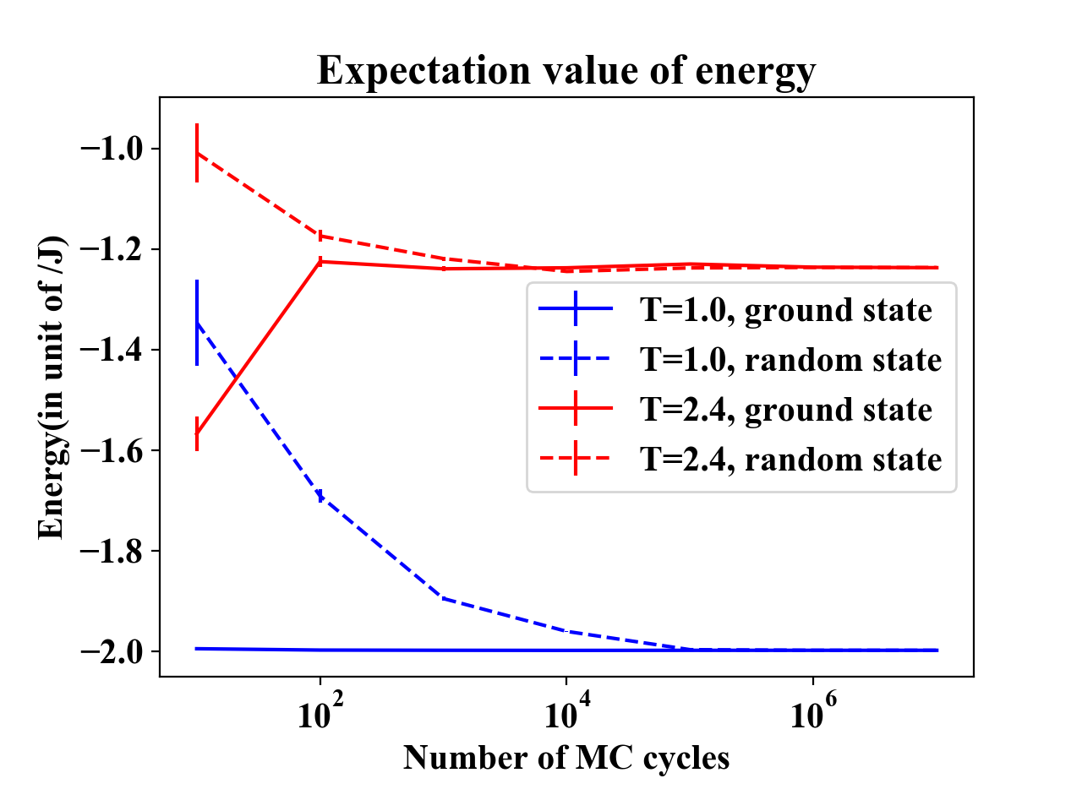

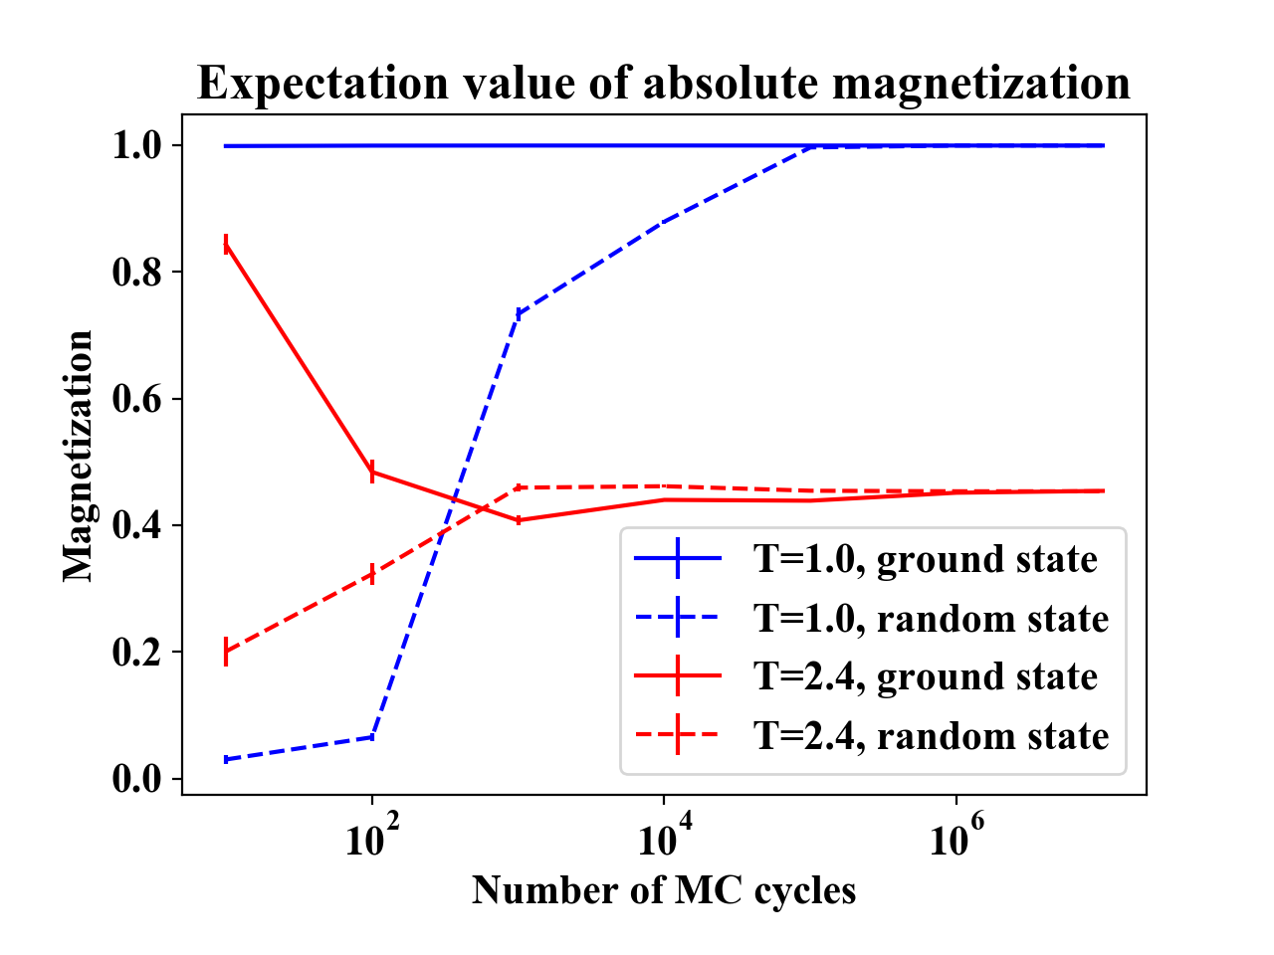

Figure 2. Evolution of expectation values of energy(above) and absolute magnetazation(below) with increasing number of MC cycles. Blue denotes T=1.0 and red denotes T=2.4. Two initial states are tested, ground state(solid line) and random state(dashed line). Error bar denotes the standard deviation of expectation values, calculated based on the central limit theorem. In the first figure we see that at T=1.0 the system evolves to the low-energy state close to -2.0, and at T=2.4 the system evolves to the higher-energy state around -1.2. Magnetization evloves to near 1.0 at low temperature while it converges to lower value around 0.4 at higher temperature, which indicates higher entropy. Both graph shows good enough convergence from 106 Monte Carlo cycles.

**3.3 Probability distribution**

Here we study the probability distribution of expectation value of energy after the equilibrium state is reached. The 20x20 lattice system is simulated at T=1.0 and T=2.4 with $9×{10}^{6}$ effective Monte Carlo samples. Since the system is studied after the equilibrium state is reached, the initial state, which is set as ground state in this case, is considered to have no contribution to the result. In Figure 4, probability distribution of total energy of the system is presented. At low temperature, T=1.0, energies are distributed in low-energy states, with mean value being -798.87 and variance being 9.32(STD=3.05). At higher temperature, T=2.4, energies are distributed in higher-energy states and more spread out. The mean value is -494.90 with variance being 3250.72(STD=57.02).

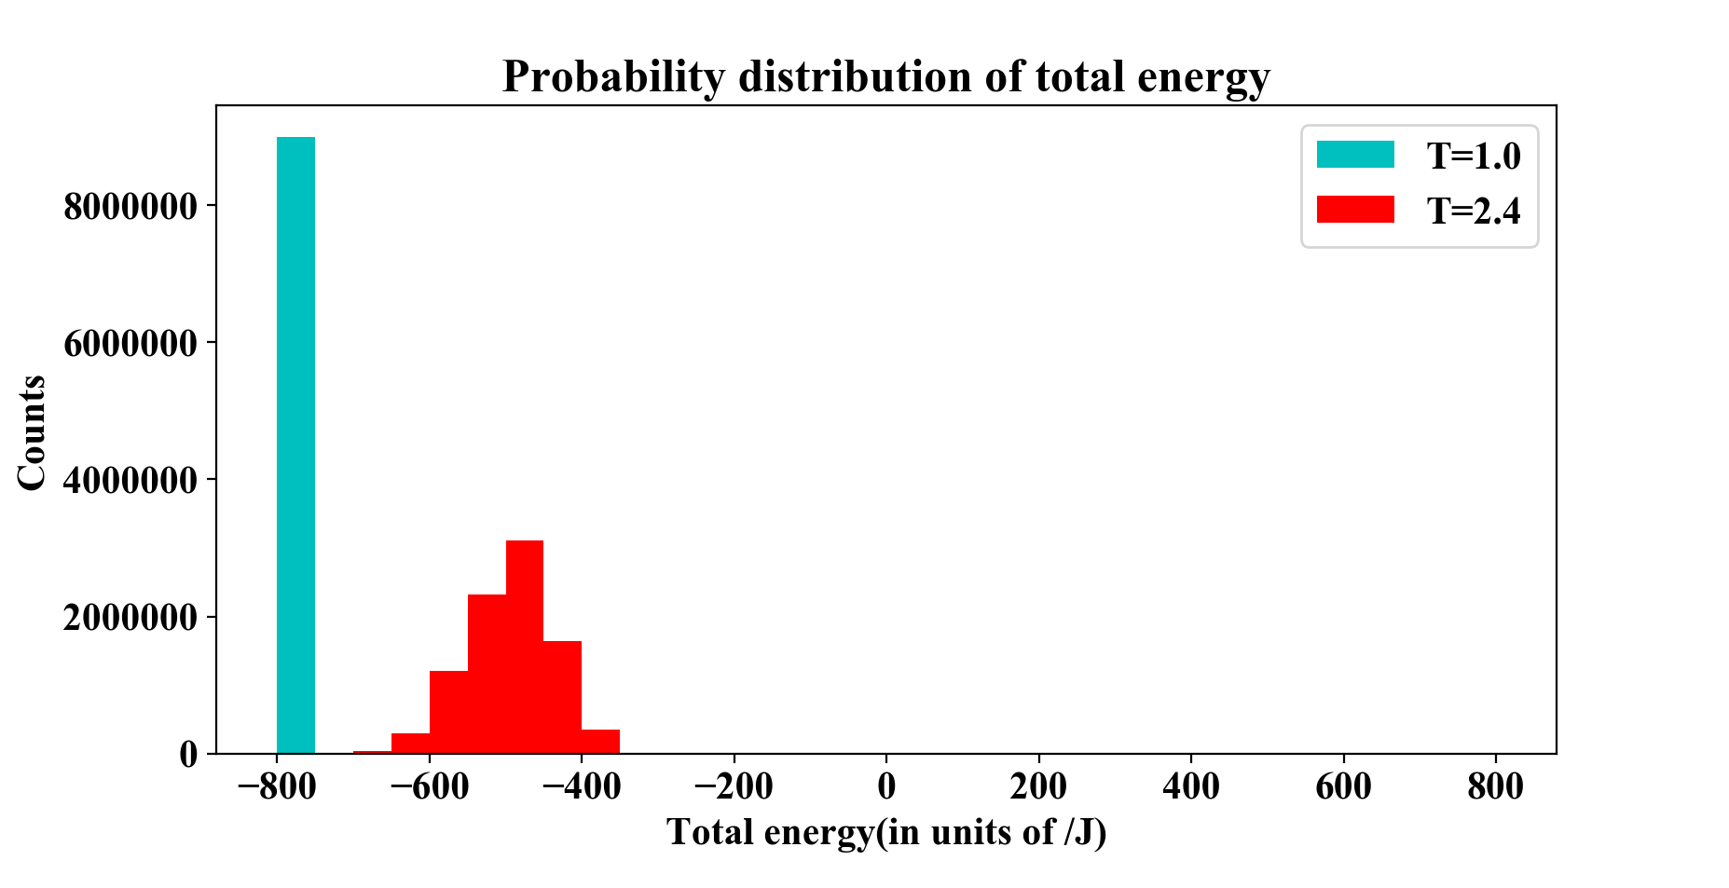

Figure 4. Probability distribution of total energy at T=1.0(cyan) and T=2.4(red). At T=1.0, all energies are falling into a single bin (-800 ~ -750), while at T=2.4 the mean is shifted to higher energy level and more spread out. Total counts are $9×{10}^{6}$ for each case.

**3.4 Phase transitions and the critical temperature**

Phase transitions analysis was conducted by the Ising model with five difference sizes of lattices (20X20, 40X40, 60X60, 80X80 and 100X100). All expected values were simulated over a temperature range T = [2.20, 2.36] where we expect the critical temperature for phase transition. The step of temperature is 0.02 and using 106 Monte Carlo cycles.

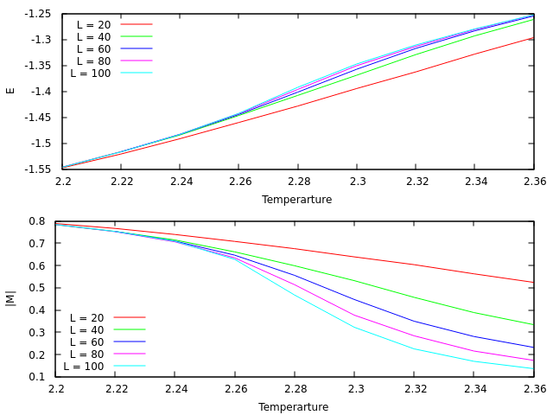

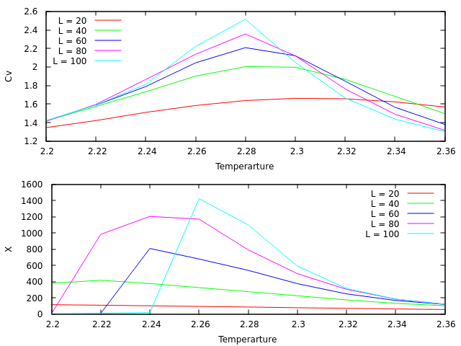

(We need Figure comment above!)

Our critical temperature was compared with the exact result from (Onsager, 1944). The exact critical temperature TC(L) for a finite lattice of size LxL can calculate as

$$T_{C}\left(L\right)-T_{C}\left(L=∞\right)=aL^{-\frac{1}{v}}$$

where $a$ is a constant and the exponent constant ν. Applying two lattices with sizes L1 × L1 and L2 × L2 gives us the opportunity to write

$$T_{C}\left(L_{1}\right)-T_{C}\left(L=∞\right)=aL_{1}^{-1}$$

$$T_{C}\left(L_{2}\right)-T_{C}\left(L=∞\right)=aL_{2}^{-1}$$

Then solving this set of equations for TC (L = ∞) by eliminating $a$ gives

$$T_{C}\left(L=∞\right)=\frac{L_{2}T_{C}\left(L_{2}\right)-L_{1}T_{C}\left(L_{1}\right)}{L_{2}-L_{1}}$$

(I think this part above can be moved to the method part, because it describes how we calculate the critical temperature. Can I create the new section in method part and put it there?)

The critical temperature was expected where the susceptibility is maximum. (<-seems like we get the maximum at 2.8 from C_v and 2.6 from susceptibility. Wouldn’t it be better if we use the average (2.7)?) As shown in figure ???, the maximum susceptibility for the 100X100 lattices is 2.26 which strongly corresponds with the Onsager’s exact result of 2.269, approximately (Onsager, 1944). This apparently represents the effect of larger sizes of lattices to estimation of the critical temperature.

**IV Conclusion**

**References**

Hjort-Jensen, M. (2015), Computational physics, accessible at course github repository. https://github.com/CompPhysics/ComputationalPhysics/tree/master/doc/Lectures

Onsager, L. (1944), Crystal statistics. i. A two-dimensional model with an order-disorder transition, Phys. Rev., 65:117–149