FYS3150 Computational Physics - Project 4

Minju Kum

Pipatthra Saesin

November 11, 2019

This project aims to study the evolution of thermal energy and spin interaction in magnetic field (>>the equilibrium process and probability distribution of energy in two different phases, and phase transition behavior of a ferromagnetic system,) using the two-dimension Ising model and Monte Carlo simulations. Statistical properties of the system for difference lattice sizes were studied with the parallel Ising model. The results show that the convergence to the steady state depends on temperature. (>>system reaches steady state in lower energy levels and higher magnetization at temperature below the critical temperature(TC), and in higher energy levels and lower magnetization above TC, with larger variance.) Initial spin configuration also affect to the convergence (>I think it doesn’t affect the final equilibrium state?). Transition of magnetic phase is also included in this study. The Ising model with the parallel simulated the (first and the) second order phase transition with the range of temperature T = [2.20, 2.36]. It apparently results the more pronounced critical temperature for larger lattice sizes. The critical temperature extracted from the simulations is found to be in fairly well agreement with Onsager’s exact value.

**I Introduction**

Ferromagnetic materials exhibit characteristic phase transition behaviors at the critical temperature. It is identified with discontinuity of energy and magnetization (first-order phase transition), and divergence of heat capacity(Cv) and magnetic susceptibility (second-order phase transition). The non-equilibrium state of the matter is not fully understood, yet models to simulate the transition behaviors were developed. It is possible to find the analytic expressions of expectation values and variances of energy and magnetization for one or two-dimension model, (Onsager, 1944) but for three and higher dimensions, numerical method is the only possible approach. Therefore, study of ferromagnetism with numerical methods stands in great importance.

In this project, simulation of magnetic phase transition of ferromagnetism is studied with Ising model in two dimensions. The small 2X2 spin lattice is first studied. The numerical results for mean energy, heat capacity, mean magnetization and susceptibility are compared with the analytical calculations to ensure that the model properly reproduces the expected results. Next we move on to 20X20 and larger systems. In this case the equilibration of physical quantities as functions of time step is studied in two different temperatures, each below and above TC, as well as the probability distribution of mean energy after the equilibrium is reached. Phase transition behavior around the critical temperature was reproduced with 20X20, 40X40, 60X60, 80X80 and 100X100 sized lattices. Critical temperature at infinite-sized lattice is estimated with the results from finite-sized lattices, using power law relations.

**II Method**

**2.1 Ising model**

The system being studied in the project can be modeled with Ising model with discrete spin variables in a lattice structure. The energy of the system is expressed as

while *s* indicating the spin, *J* being a coupling constant for each spin site, *N* being the total number of spins, being the magnetic moment and *h* indicating the external magnetic field interacting with each spin site. <*kl*> indicates the summation over the nearest neighbors.

In this project, we take two-dimensional square lattice with periodic boundary condition. We also take the simplest form of the expression above, namely, the coupling constant *J* is assumed as the same for all spin sites and the contribution of external magnetic field is ignored. The simplification makes

with *J* now being universal.

The probability of the system being found in a state *i* is given as the Boltzmann distribution of *Ei*

while *Ei* indicating the energy at a given spin configuration *i* and *Z* being the partition function which sums over all M spin configurations,

Expectation value and variance of energy and magnetization can be calculated with the probability expression above. With the expression for magnetization for a given spin configuration *i* being

with dimensionless unit, expectation value of energy < *E* >, specific heat at constant volume *CV*, expectation value of absolute magnetization <> and magnetic susceptibility is expressed as below.

These are the main physical quantities that is studied in this project.

**2.2 Markov chain and Monte Carlo method, with Metropolis algorithm**

With the model introduced above, we mimic the system behaving with the rule of energy minimization and entropy maximization. In order to do this, the Markov process is implemented using Monte Carlo simulations with Metropolis algorithm.

Markov process is described with normalized probability distribution vector and stochastic matrix . The next probability distribution is determined by current state and the stochastic matrix . In this project, the same approach is implemented with spin matrix, which serves as the state matrix, and the Monte Carlo simulation with Metropolis algorithm, which serves as the stochastic matrix. The first state of spin matrix is given as a guess, either ground state or random state.

The metropolis algorithm is really useful technique. We do not need to reach all possible microstates in the system. The algorithm allows us to figure out the energy difference between the initial state and a new proposed state, then apply the difference to an acceptance routine.

The Monte Carlo cycles with Metropolis algorithm is implemented as below.

1. Generate a starting state

2. Generate a trial mode

3. Check the energy difference between the proposed state against the starting state

4. Calculate probability and compare with the random number

if , we accept the new state, if not keep the old value.

5. Find the new expectation values

6. Do 1 to 5 steps over and over again (applying the Monte Carlo cycles)

The expected values from the few first step of the Monte Carlo cycles are vary. This cause the large error in the results. In order to get rid of this error, we will accept the values after it reach the most likely state (equilibrium state). The values of interest, energy and magnetization will be plotted as a function of number of the Monte Carlo cycles. Then, we will select the number of cycles where the graph trend to stable.

**2.3 Power-law relation of critical temperature (*TC*)**

The critical temperature of infinitely large lattice can be calculated with the results from finite-size lattice(L) as below,

where is a constant and the exponent constant ν is given as 1 (Onsager, 1944). We get critical temperature of finite lattice by taking the temperatures where extremum point of energy and magnetization lie and averaging the two, then we make linear regression with least-variance approach to estimate . The estimated value is compared with Onsager’s exact calculation, .

**2.4 Implementations**

The codes for programs are written in C++ and Fortran. For simulations in 3.4, codes are parallelized in 4 processors using MPI. All relevant codes and data files are available at:

<https://github.com/minjukum/FYS3150-Computational-Physics/tree/master/Project4>

**III Results and discussions**

**3.1 Ising model of 2x2 lattice**

**3.1.1 Analytical expressions**

Here we find the analytical expressions for 2x2 spin lattice, which will be compared with the numerical results. All the spin configurations are described in Table 1.

Table 1. Spin configurations, degeneracy, energy and magnetization of 2x2 spin lattice. Different configurations with same energy and magnetization is denoted as degenerated.

|  |  |  |  |
| --- | --- | --- | --- |
| Configuration | Degeneracy | Energy | Magnetization |
| ↑ ↑  ↑ ↑ | 1 | -8J | 4 |
| ↓ ↑  ↑ ↑ | 4 | 0 | 2 |
| ↓ ↓  ↑ ↑ | 4 | 0 | 0 |
| ↓ ↑  ↑ ↓ | 2 | 8J | 0 |
| ↓ ↓  ↓ ↑ | 4 | 0 | -2 |
| ↓ ↓  ↓ ↓ | 1 | -8J | -4 |

Using formulae in 2.1, we get

**3.1.2 Numerical results**

Now we implement the codes for 2x2 spin lattice. The initial state is set as the ground state, namely, all spins in the upward direction. The results for T = 1.0 (in units of *kBT*) is compared with the analytical calculation in Table 2 with different number of Monte Carlo cycles. Note that all values are presented in the unit of “per spin,” and the energy is dimensionless, namely in units of [energy /*J*].

Table 2. Comparison of numerical results with analytical calculations. It shows good agreement to the third-fourth leading digit with 106 Monte Carlo cycles.

|  |  |  |  |  |
| --- | --- | --- | --- | --- |
|  |  |  |  |  |
| Analytical | -1.9959821 | 0.032082332 | 0.99866073 | 0.0040107395 |
| 102 | -2 | 0 | 1 | 0 |
| 103 | -2 | 0 | 1 | 0 |
| 104 | -1.9946 | 0.04308336 | 0.9982 | 0.00538704 |
| 105 | -1.9964 | 0.02874816 | 0.99882 | 0.00347443 |
| 106 | -1.995962 | 0.032238778 | 0.9986535 | 0.004033748 |
| 107 | -1.996008 | 0.031881856 | 0.99866685 | 0.004000391 |

From Table 2, we can see that with 106 Monte Carlo calculation, the numerical results show good agreement with the analytical ones to the third leading digit for all quantities. The plot for expectation value of energy with varying N below (Figure 1) shows that the analytical value shows acceptable accordance with numerical results after 104 MC cycles. It eventually falls within the error range of numerical result and shows a good agreement from 106 cycles.

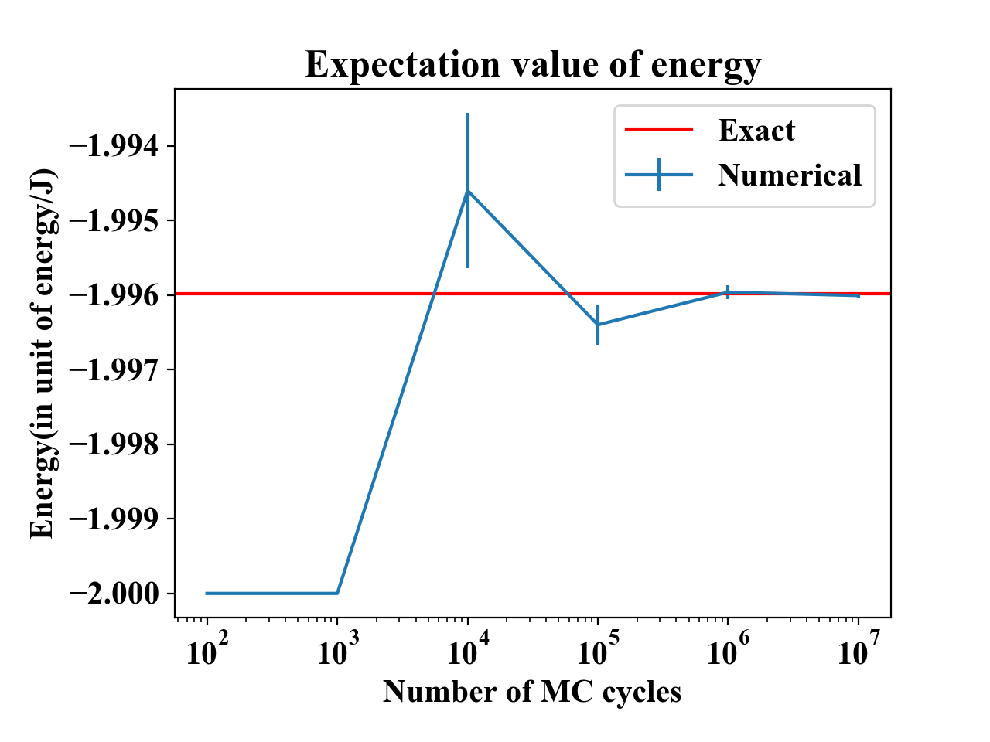

Figure 1. Expectation value of energy with different numbers of Monte Carlo cycles. Error bar indicates the standard deviation of expectation value of energy, calculated based on the central limit theorem. It is shown that the analytical (labeled as “Exact”) result shows acceptable accordance with numerical result from 104 cycles. It eventually falls within the error range of numerical results and achieves good agreement from N=106.

**3.2 Equilibration of the system**

Here we look more into the equilibration behavior of the system, including the time needed for the system to reach the most likely state, which can be considered proportional to the number of MC cycles. Figure 2 shows the evolution of expectation values of energy and magnetization of 20x20 spin lattice with increasing MC cycles, which denotes time, at two different temperatures; T=1.0 and T=2.4, and from two different initial conditions; ground state and random state. T=1.0 is in fact below the critical temperature which is to be derived in later section, and T=2.4 is above the critical temperature. It is read that in low temperature(T=1.0), the system evolves to low-energy state close to -2.0, and in most cases the spin configurations are found to be ordered to one direction. In higher temperature(T=2.4) the system evolves to relatively higher-energy state, and the spin configurations are more disordered. The situation is physically equivalent to taking an object of 0K(ground state) or infinitely high temperature(random state) to a room at T=1.0 or T=2.4, and the object achieving the thermal equilibrium state.

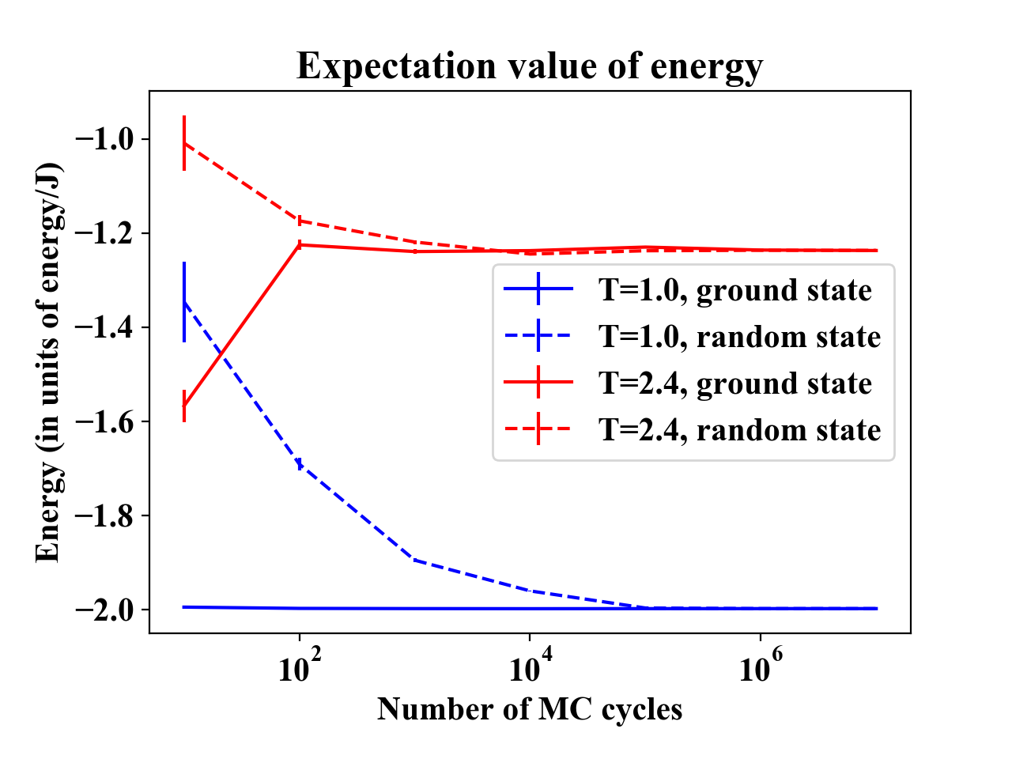

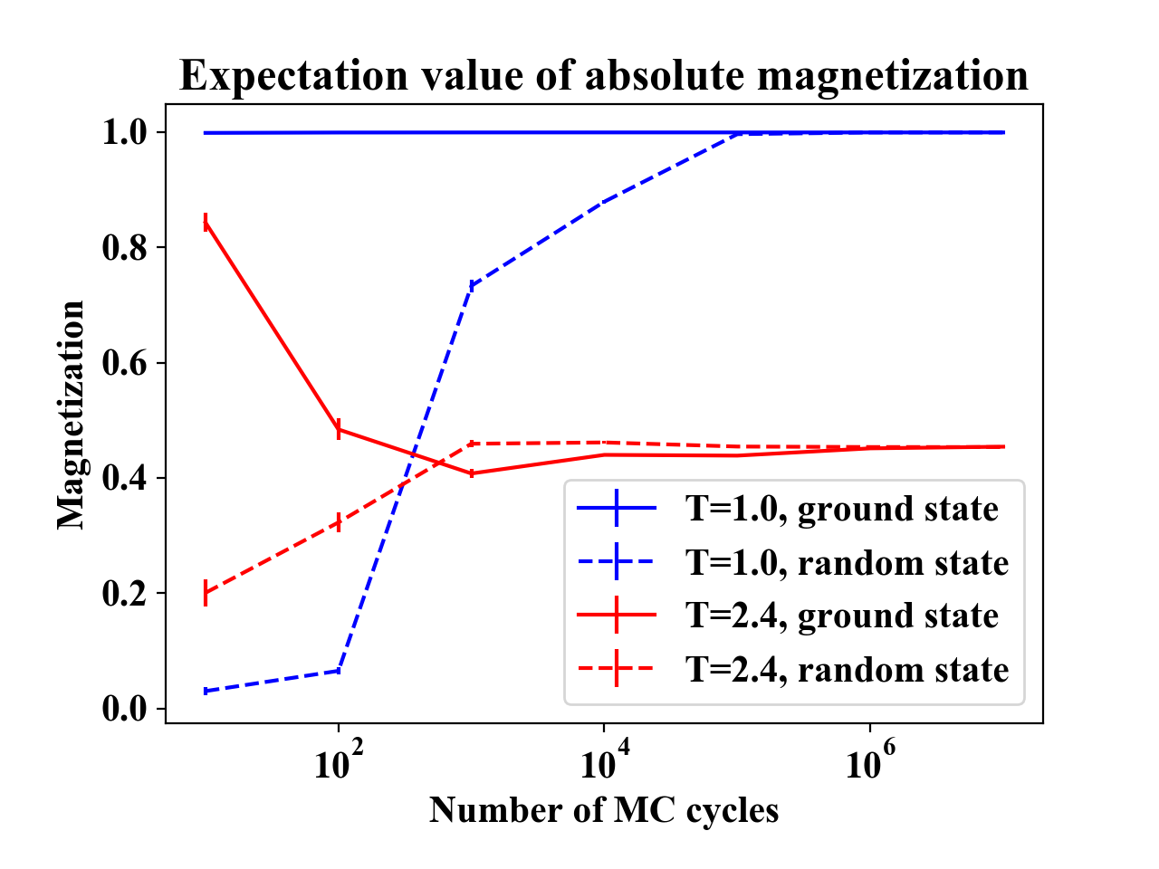

Figure 2. Evolution of expectation values of energy(above) and absolute magnetazation(below) with increasing number of MC cycles. Blue denotes T=1.0 and red denotes T=2.4. Two initial states are tested, ground state(solid line) and random state(dashed line). Error bar denotes the standard deviation of expectation values, calculated based on the central limit theorem. In the first figure we see that at T=1.0 the system evolves to the low-energy state close to -2.0, and at T=2.4 the system evolves to the higher-energy state around -1.2. Magnetization evloves to near 1.0 at low temperature while it converges to lower value around 0.4 at higher temperature, which indicates higher entropy. Both graph shows good enough convergence from 106 Monte Carlo cycles.

**3.3 Probability distribution**

Here we study the probability distribution of expectation value of energy after the equilibrium is reached. The 20x20 lattice system is simulated at T=1.0 and T=2.4 with Monte Carlo cycles, with taking the last effective Monte Carlo samples. Since the system is studied after the equilibrium state is reached, the initial state, which is set as ground state in this case, is considered to have no contribution to the result. In Figure 4, probability distribution of total energy of the system is presented. At low temperature, T=1.0, energies are distributed in low-energy states, with mean value being -798.87 and variance being 9.32(STD=3.05). At higher temperature, T=2.4, energies are distributed in higher-energy states and more spread out. The mean value is -494.90 with variance being 3250.72(STD=57.02).

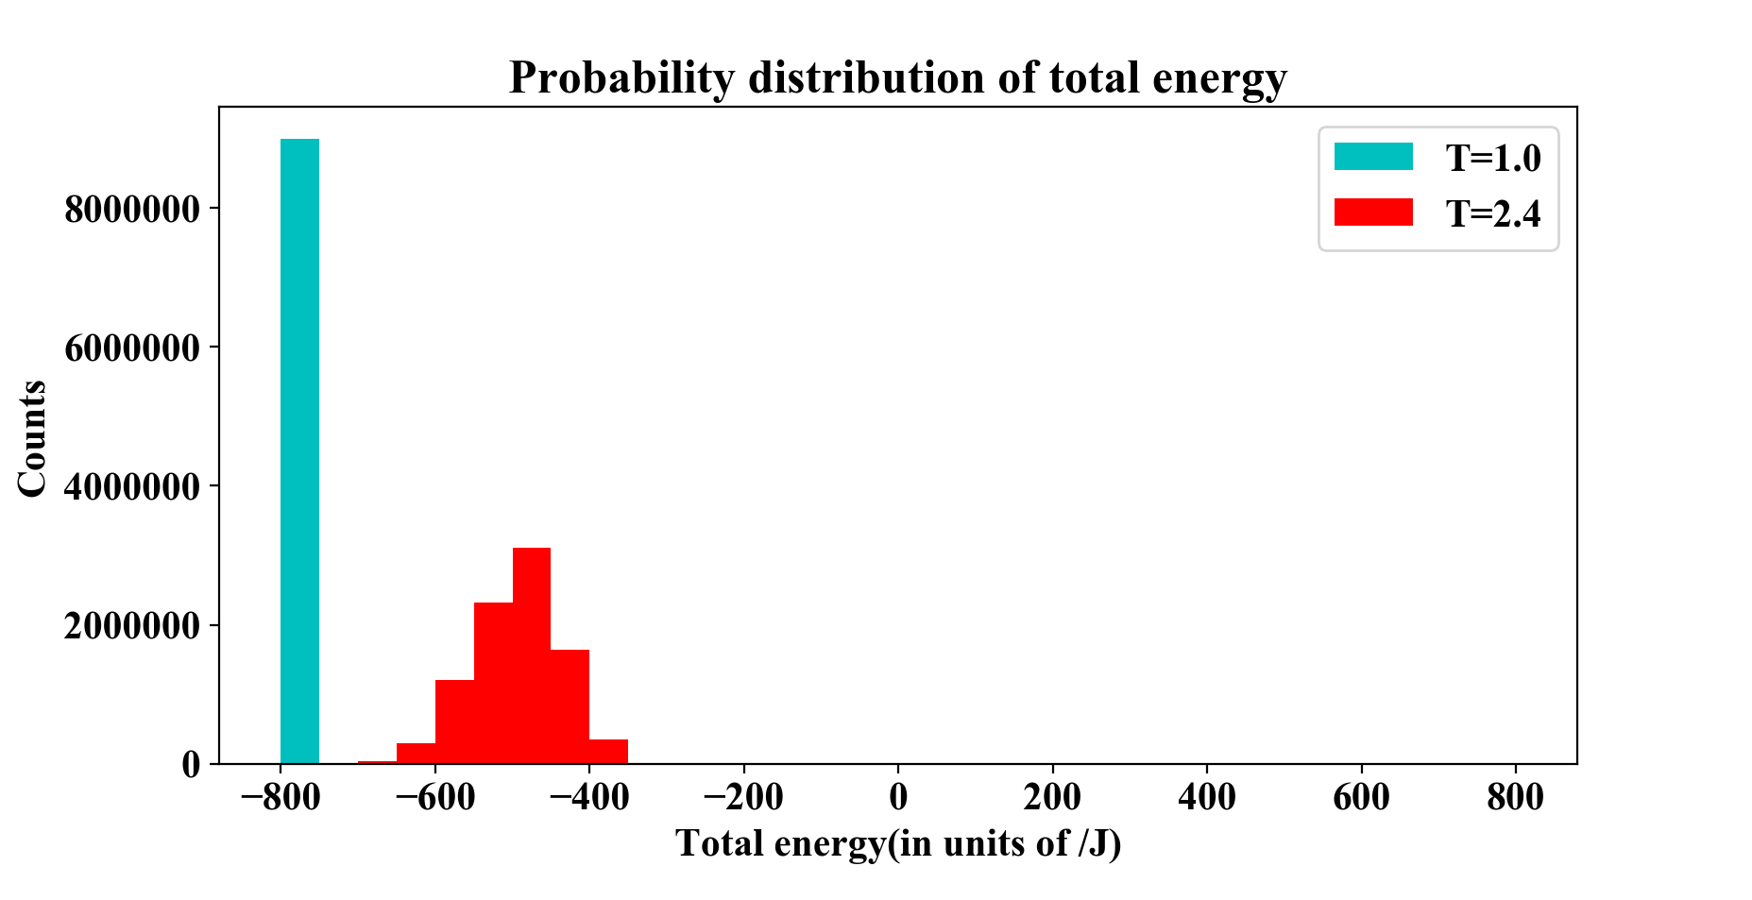

Figure 4. Probability distribution of total energy at T=1.0(cyan) and T=2.4(red). At T=1.0, all energies are falling into a single bin (-800 ~ -750), while at T=2.4 the mean is shifted to higher energy level and more spread out. Total counts are for each case.

**3.4 Phase transitions and the critical temperature**

Phase transitions analysis was conducted with the Ising model with five difference sizes of lattices (20X20, 40X40, 60X60, 80X80 and 100X100). All expected values were simulated over a temperature range T = [2.20, 2.36] where we expect the critical temperature for phase transition. The step of temperature is 0.02 and using 106 Monte Carlo cycles.

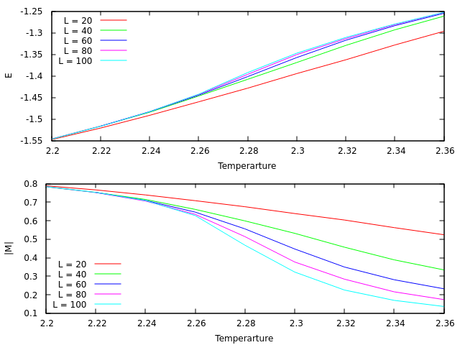

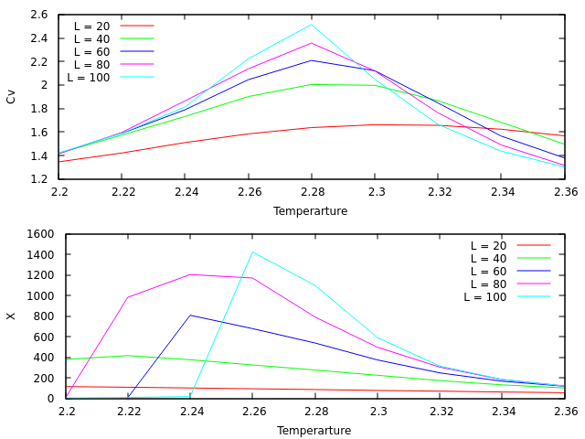

Figure 5. The expected values of energy (E), magnetization(|M|)(above) and heat capacity (CV), magnetic susceptibility ()(below) simulation for T = [2.2,2.36] with step of 0.2 and 106 Monte Carlo cycles. The simulations perform in five different lattices size which are 20X20, 40X40, 60X60, 80X80, and 100X100.

According to Hjort-Jensen (2015), both heat capacity and susceptibility diverge at the critical temperature. This could imply that the critical temperature is at the maximum of heat capacity and susceptibility. As shown in figure 5, the maximum susceptibility for the 100X100 lattices is at T = 2.26 which strongly corresponds with the Onsager’s exact approximation of 2.269 (Onsager, 1944). In contrast, the maximum heat capacity is at T = 2.28 where a bit different from the Onsager's exact value about 0.5 % (relative error). However, we assume the critical temperature (for L=100) is about 2.27 by the averaging the values from both heat capacity and susceptibility.

In term of the sizes of lattices, the larger size simulations perform well to estimate the critical temperature. It is difficult to exact the critical temperature from the 20X20 and 40X40 lattices sizes simulations by looking the graph. This apparently represents the effect lattices sizes to estimation of the critical temperature. The high accuracy simulation in the critical temperature need larger size lattices.

Our critical temperatures of finite-size lattices are gradually approaching that of infinite-size lattice with growing L. Here we try to estimate the critical temperature for infinite-size lattice. We have

while L=20, 40, 60, 80, 100. The constant was calculated as -1.83, which generated the least variance of calculated ’s. With the regression constant, we get the following result.

Table 3. The critical temperature of each finite lattices and estimated critical temperatures for infinite lattice, with and . The average is 2.289. L=20 was omitted because we couldn’t get the proper extremum point from the data.

|  |  |  |
| --- | --- | --- |
|  |  |  |
| 40 | 2.25 | 2.295 |
| 60 | 2.26 | 2.290 |
| 80 | 2.26 | 2.282 |
| 100 | 2.27 | 2.288 |
|  |  | Average 2.289 |

L=20 was omitted because we couldn’t get the proper extremum point from the data. By taking the average of four critical temperatures of infinite lattice, we get , which differs with Onsager’s exact result with 0.88%.

**IV Conclusion**

**References**

Hjort-Jensen, M. (2015), Computational physics, accessible at course github repository. https://github.com/CompPhysics/ComputationalPhysics/tree/master/doc/Lectures

Onsager, L. (1944), Crystal statistics. i. A two-dimensional model with an order-disorder transition, Phys. Rev., 65:117–149