ViaL Instruction
Download and Install ViaL App
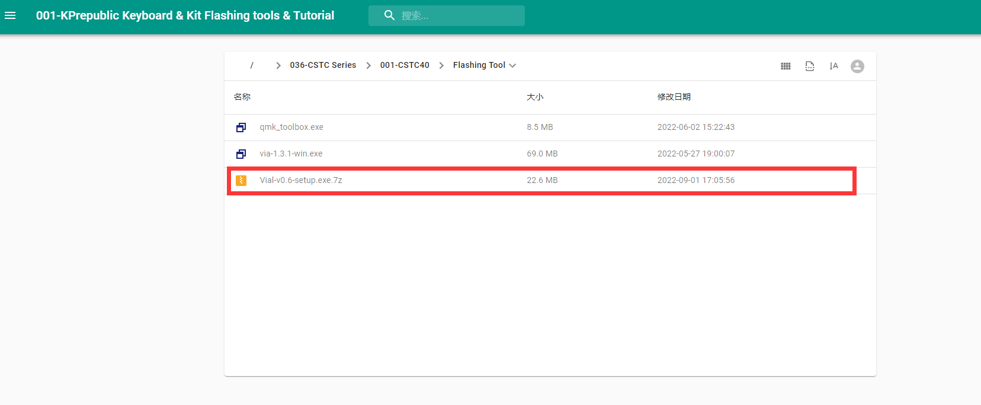
Go to KPrepublic Drive to download ViaL.exe
If you have the Browser download Block notification, please kindly approve the software passing your firewall. It doesn’t mean the software has malware.

Change keymap
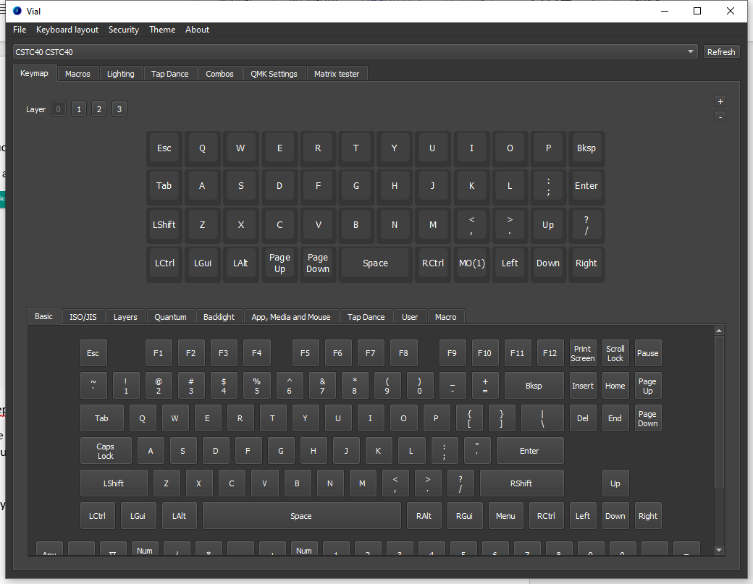
After installation, open ViaL and plug your CSTC40 PCB. You will get the keymap. You can change the keymap now. The changing will be auto saved.

