**Game Development Studio II**

**RISING SUNS Prototype Plan**

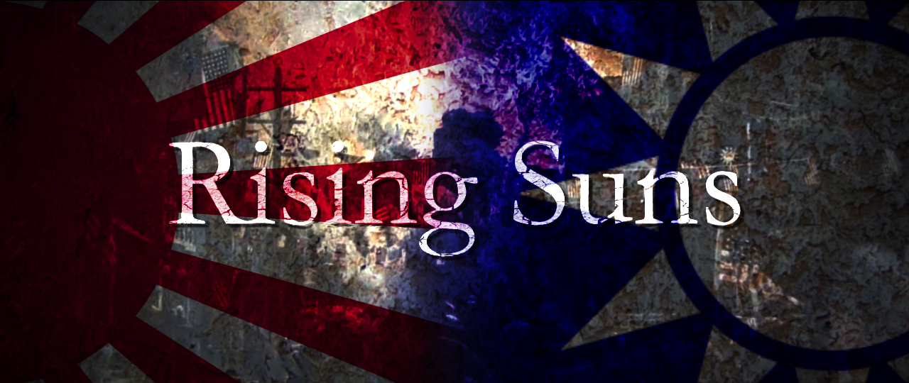

**Creators:** Bruce Lan, Allen Yu

**Created Date:** Feb 5th. 2014

**Players:** Local Multiple Players

**Play Time:**  30 minutes +/-

**Platform:** PC

**GAME SUMMARY**

*Rising Suns is an objective-oriented First-Person-Shooter multiplayer game based on the historical event of WWII between Chinese Nationalist Army and Imperial Japanese Army in Shanghai 1937. The game mechanic is based dynamic time, narrative scenes, and branching outcomes.*

**UNKNOWNS**

1. Gameplay

* Firstly we need to make sure that several major in-map objectives are interesting for both the attacking (Japanese army) and defending (Chinese army) sides, and based on basic shooting and moving skills in FPS.
* Need to experiment more ways of narrative style in order to implement the storytelling into the gameplay well.

2. Technical

* We need to figure out how to modify the Unreal script in order to make the variation from Capture The Flag to our mechanics.
* We should test out as soon as possible whether the lan game could be set up with a custom map and played by multiple players from different computers at a same time.
* Whether the AI’s waypoints can be separated to specific location.
* Figure out how to let the players throw first-aid kits as medic.
* How to set up different classes of soldiers.

3. Visual

* Need to do research on finding references for visual style.
* Need to do the research on importing and exporting assets from Maya to UDK.

**GAMEPLAY GOALS**

Since the gameplay mainly relies on choosing different objectives to achieve different missions at certain period of time (day or night), we are aiming to prototype on main objectives such as pushing cannons within a certain range, attacking one of the main gates of the warehouse until it breaks.

**OTHER GOALS**

The technical goals would be if we can fully modify from Capture The Flag mode in Unreal script to the “Team Last Man Standing” mode, which two teams both has their [reinforcement number. O](http://planetunreal.gamespy.com/View.php?view=UTFiles.Detail&id=3148#Files)r we will have to scope down to use the original Capture The Flag mode. Before doing that, prototyping the three in-map objectives would be the priority, because this could also be embedded into other modes.

**TASK LIST DOCUMENT**

1st Week:

* Block out the basic game level with UDK BSP and make the *“Cannon Mechanic”* using UDK Kismet.
* Complete the level design of the map as well as in-map objectives.

2nd Week:

* Playtest the BSP level and keep iterating on its layout with the *Cannon Mechanic*.

3rd Week:

* Build the game level into the designed map.