**Training Hyperparameters**

Training: end_to_end_training  
Architecture: mobilenetv2_based  
AE loss: MSE  
Classifier loss: weightedSigmoid  
Optimizer: sgd  
Data sampling strategy: None  
Learning rate: 0.1  
************************************************************

**Dataset**

* Evalution on Cifar10 test set (10,000 images, 100 images in each class)  
  Model was trained on 41650 images (training_set: Total->50,000, Used->41650)  
  Training Data distribution:  
  {'airplane 0': 4900, 'automobile 1': 4900, 'bird 2': 2450, 'cat 3': 4900, 'deer 4': 2450, 'dog 5': 4900, 'frog 6': 4900, 'horse 7': 4900, 'ship 8': 4900, 'truck 9': 2450}  
  1,000 images of training set were used to validate the model during the training  
  ************************************************************

**Classification report:**

|  |  |  |  |  |  |
| --- | --- | --- | --- | --- | --- |
| class | label | precision | recall | f1-score | support |
| airplane | 0 | 0.83 | 0.94 | 0.88 | 1000 |
| automobile | 1 | 0.91 | 0.97 | 0.94 | 1000 |
| bird | 2 | 0.91 | 0.72 | 0.80 | 1000 |
| cat | 3 | 0.73 | 0.80 | 0.76 | 1000 |
| deer | 4 | 0.93 | 0.78 | 0.85 | 1000 |
| dog | 5 | 0.80 | 0.83 | 0.81 | 1000 |
| frog | 6 | 0.86 | 0.94 | 0.90 | 1000 |
| horse | 7 | 0.89 | 0.93 | 0.91 | 1000 |
| ship | 8 | 0.93 | 0.94 | 0.94 | 1000 |
| truck | 9 | 0.97 | 0.86 | 0.91 | 1000 |
| accuracy |  |  |  | 0.87 | 10000 |
| macro | avg | 0.88 | 0.87 | 0.87 | 10000 |
| weighted | avg | 0.88 | 0.87 | 0.87 | 10000 |

************************************************************

**Confusion matrix:**

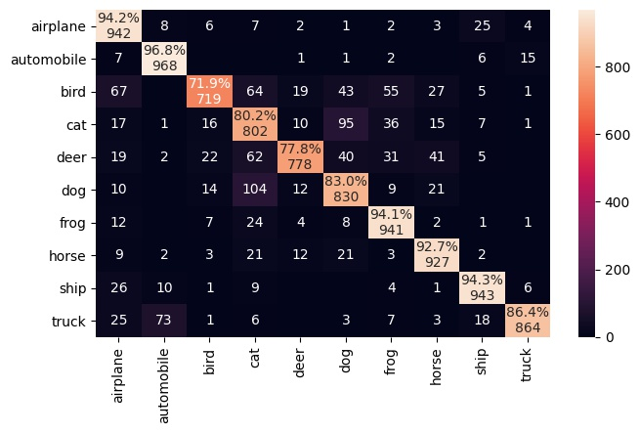

************************************************************ **Clusters of encoded features of 1000 images:**

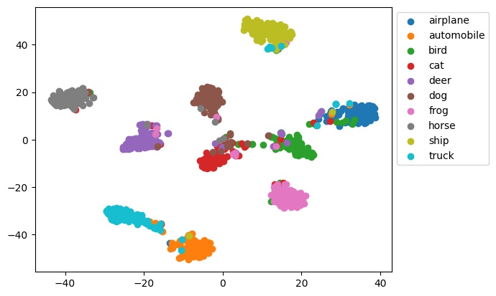

************************************************************ **Reconstrcted image samples:**



Actual class=9, Predicted class = 9



Actual class=6, Predicted class = 6