# Here’s the Instructions/Documentation

[24/02/2024] – For Om

You will be working with overlays.py as instructed in this file.

This code is supposed to add whatever text you put in it to the blank PDF that the school gave us.

DO NOT fuck with utility.py, that stuff is barely hanging in there by a thread and can break if anything is changed inside it at all.

The main aim right now is to Find the coordinates of all the data entries. So don’t worry if you don’t know what to fill inside the pdf, I am mostly interested in the x and y of each entry, just fill it with random letters or something.

to run this code

1. Open terminal
2. Go to this folder using cd (like how we used to in OS lab, ask Sathwik if you don’t know how)
3. Run "pip install PyPDF2" to install the dependency (if it shows an error: try “pip install chardet”)
4. Run "python overlays.py"

4b. Running this script will update the output.py, so you must run it every time to see changes.

1. the overlays are in this syntax =>

[

    ['text', x-coordinate, y-coordinate, font_size],

    ['text2',x-coordinate2,y-coordinate2,font_size2],

....

] and so on

6. Use the example.pdf to see how to fill/compare the data

7. I have separated the overlays into 3 parts:

1. school_data – this contains the school’s info and dates and stuff

Fill it in this area at the top:

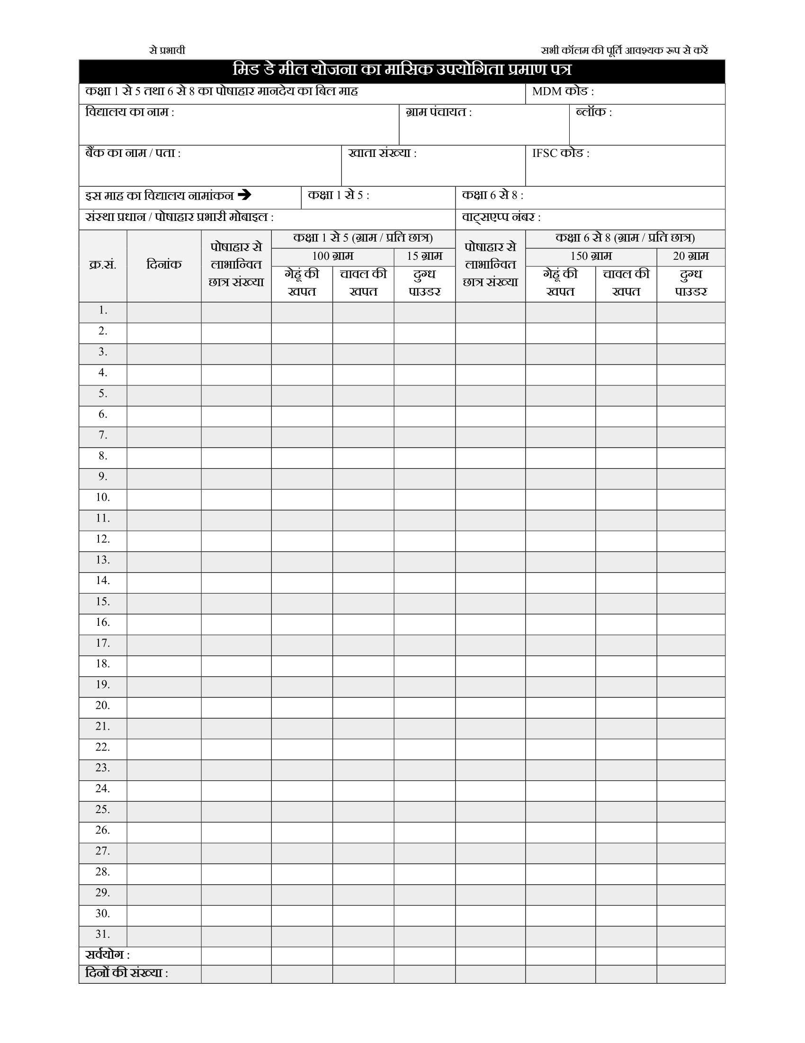

-PTO to Next Page-

1. table – You might want to do this part last, try page2 first(it’s below this one) then try this.

This is the part I think can be automated a bit more since all rows will have about the same data, ask Sathwik and ChatGPT for help on this one and see if you can make it so you can set the position with a script instead of changing number every time.

Fill it in this area on page 1:



1. page2 – by changing to page_number=2 in the function below you can add text to page 2, you can divide it into even more parts if you want, like I did with the page one

