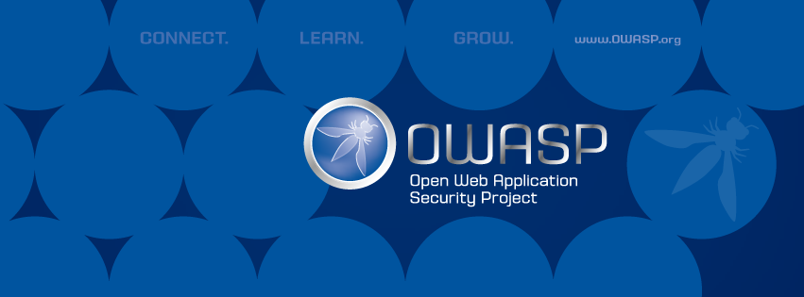

**OWASP Cheat Sheet Series project**

[**https://www.owasp.org/index.php/OWASP_Cheat_Sheet_Series**](https://www.owasp.org/index.php/OWASP_Cheat_Sheet_Series)

**Our goal**

The OWASP Cheat Sheet Series was created to provide a concise collection of high value information on specific application security topics. These cheat sheets were created by various application security professionals who have expertise in specific topics. We hope that the OWASP Cheat Sheet Series provides you with excellent security guidance in an easy to read format.

If you have any questions about the OWASP Cheat Sheet Series, please email the project leader Jim Manico, subscribe to our project email list or contact us on the project's Slack channel.

**Authors**

*Project Leaders:*

Jim Manico and Dominique Righetto.

*Contributors:*

Paweł Krawczyk, Mishra Dhiraj, Shruti Kulkarni, Torsten Gigler, Michael Coates, Jeff Williams, Dave Wichers, Kevin Wall, Jeffrey Walton, Eric Sheridan, Kevin Kenan, David Rook, Fred Donovan, Abraham Kang, Dave Ferguson, Shreeraj Shah, Raul Siles, Colin Watson, Neil Matatall, Zaur Molotnikov **and many more!**