* 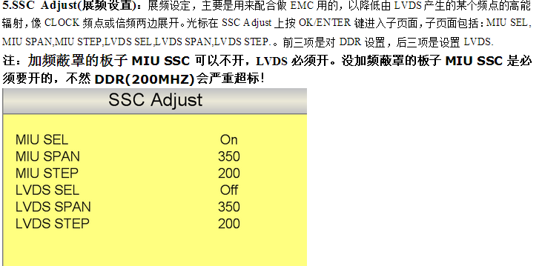**SSC:** [spread](javascript:void(0);) [spectrum](javascript:void(0);) control
* EMC 电磁兼容性（Electro Magnetic Compatibility）
* 