Power BI Assignment
Introduction to Power BI, Charts, DAX & Report Creation

Question 1 : Define Power BI and What are the key components of the Power BI ecosystem? Briefly explain: ● Power BI Desktop ● Power BI Service ● Power BI Mobile ● Power BI Gateway

Power BI is a business intelligence and data visualization platform used to transform, model, and visualize data.
Components:
• Power BI Desktop – For modeling and report creation.
• Power BI Service – Cloud platform for publishing and sharing.
• Power BI Mobile – View dashboards on mobile.
• Power BI Gateway – Connects on‑premise data to Power BI Service.

Question 2 : Compare the following Power BI visuals:

Pie Chart vs Donut Chart

● Bar Chart vs Column Chart

When would you prefer one over the other? Give one example for each pair.

1. Pie Chart vs Donut Chart
Pie Chart
- A circular chart divided into slices.
- Each slice shows a category’s proportion of the whole.
- Best when comparing a small number of categories (2–5).
- Visually simple, suitable when no extra information is needed in the center.
Donut Chart
- Similar to a pie chart but with a hole in the middle.
- The empty center creates space for a label or total value.
- More modern-looking and easier to read when displaying percentage contributions.
Visual Type | Use When… | Example
Pie Chart | You want basic proportion comparison with few categories | Show Market Share of 3 regions: East, West, Central
Donut Chart | You want to show proportions plus display the total in the center | Sales % Contribution by Category with total sales shown in the middle

2. Bar Chart vs Column Chart
Bar Chart (Horizontal Bars)
- Bars extend horizontally.
- Best when category names are long.
- Ideal for rankings and comparison across categories.
Column Chart (Vertical Bars)
- Bars extend vertically.
- Best for showing changes over time.
- Excellent for trend analysis (months, quarters, years).
Visual Type | Use When… | Example
Bar Chart | You have long text labels or want to compare categories side-by-side | Sales by Sub-Category (e.g., “Office Supplies”, “Binders”, “Bookcases”)
Column Chart | You want to show patterns or trends over time | Monthly Profit Trend from Jan–Dec

Question 3 : Explain the significance of:

● Star schema vs Snowflake schema

● Primary key vs Foreign key in relationships (Power BI) Why is cardinality important?

Star Schema vs Snowflake Schema
Star Schema
- Fact table in center with dimension tables around
- Simple and recommended for Power BI
Snowflake Schema
- Dimension tables normalized into multiple layers
- More complex, reduces redundancy

Primary Key vs Foreign Key in Power BI
- Primary Key: Unique identifier in dimension table
- Foreign Key: Matching field in fact table
They form relationships (1:M) needed for accurate filtering and modeling.
Importance of Cardinality
Cardinality defines relationship type (1:1, 1:M, M:M). Correct cardinality ensures proper filtering, aggregation, and model performance.

Question 4 : Differentiate between: ● Calculated column vs Measure Also, define Row context and Filter context with simple examples.

Calculated Column – Row-level, stored.
Measure – Calculated at query time, not stored.

Row Context Example: Quantity * Unit Price
Filter Context Example: SUM(Sales).

Question 5: What is the difference between a report and a dashboard in Power BI?
Report – Multi-page, created in Desktop.
Dashboard – Single page, created in Service.

Question 6 : Using the Sample Superstore dataset:

● Create a Clustered Bar Chart to display Total Sales by Sub-Category

● Create a Donut Chart for Sales % by Region

Provide screenshots of both visuals.
Clustered Bar Chart – Sales by Sub-Category.
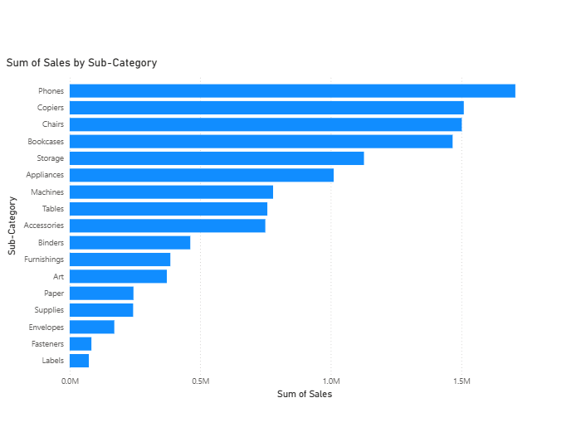

Donut Chart – Sales % by Region.
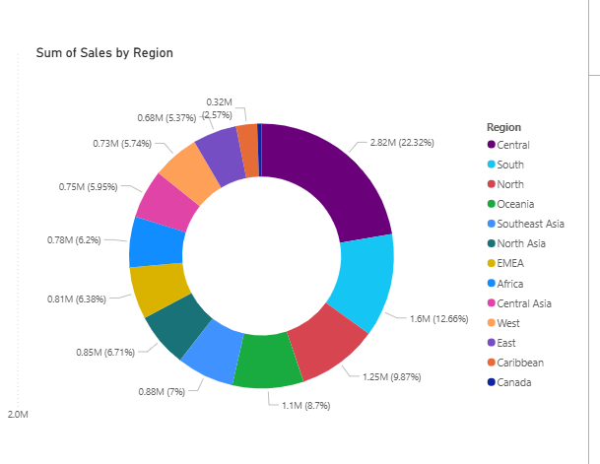

Question 7 Write and apply the following measures:

● Total Profit = SUM([Profit])

● Average Discount = AVERAGE([Discount])

Display both in a KPI Card, and use a Line Chart to show profit trend over months. Add visuals and DAX formulas.

Total Profit = SUM(Sales[Profit])
Average Discount = AVERAGE(Sales[Discount])
KPI Cards + Line Chart.
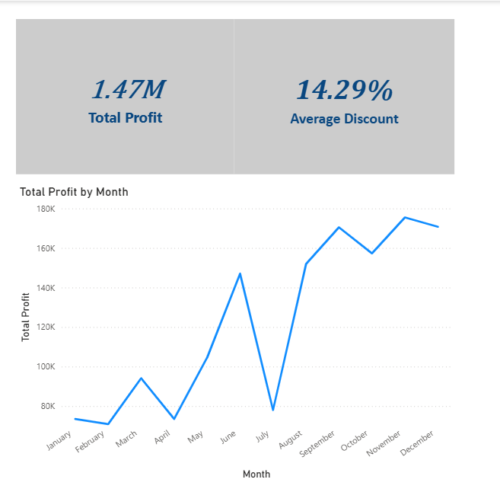

Question 8 : Implement a DAX measure that calculates the percentage of total sales by product category.
Product_category Sales_Amount Electronics 5000 Clothing 3000 Home Appliances 7000 Books 2000 Tables & Chairs 8000 Toy 1500 Sports Equipment 1200 Office Supplies 1000 Beauty Products 4400 Garden Supplies 1000 Jewelry 1800 Automative 2600

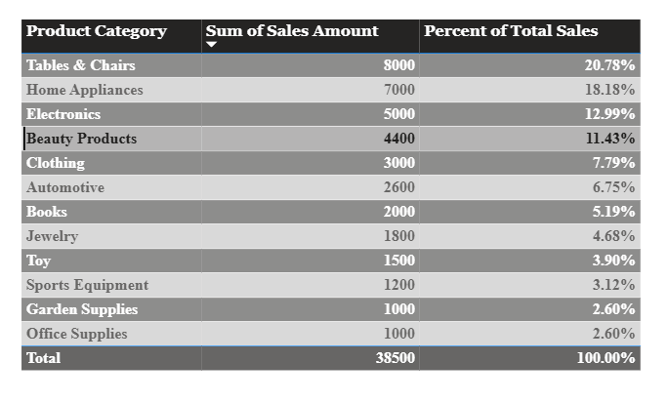

Question 9 : ● Create a DAX Measure for Total Profit

● Use it in a Waterfall Chart to analyze how different Sub-Categories contribute to overall profit

● Add a Slicer for Region to filter the visual

● Write brief business insights (4–5 lines) from the chart and provide 2–3 data-driven recommendations to improve profit.

Total Profit = SUM(Sales[Profit])
Waterfall Chart Setup + Region slicer.
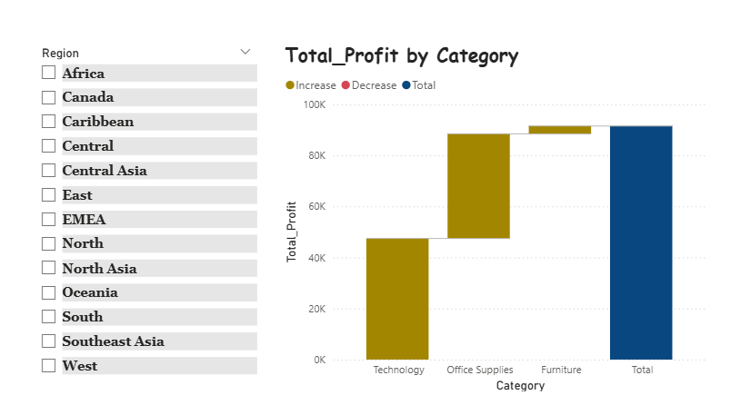

Insights:
• Some categories generate high profit.
• Some show losses due to discounts.
• Regions differ in profitability.
Recommendations:
1. Reduce discounts on loss-making products.
2. Promote high-profit categories.
3. Optimize regional inventory.

Question 10 : Scenario: VitaTrack Wellness, a digital health company in FitZone, has collected data on users’ daily habits and health vitals. The analytics team is tasked with drawing actionable insights from this data to improve lifestyle suggestions and prevent heart-related risks.

Your Task: Using the provided dataset (includes Age, Gender, BMI, Steps, Calories, Sleep, Heart Rate, Blood Pressure, Smoking, Alcohol, Exercise, Diabetic & Heart Disease status): Build a one-page Power BI dashboard that answers:

1. Are users maintaining a balanced lifestyle (Steps, Sleep, Calories)

2. What lifestyle patterns (Smoking, Alcohol, BMI, etc.) indicate heart disease risk?

3. Is there any visible relationship between Sleep and Physical Activity?

4. How does BMI vary across Age Groups and Genders?

5. What is the impact of smoking and alcohol on heart rate and blood pressure?
6. Segment people based on their health activity to suggest lifestyle changes
DATASET LINK: Health_activity_data
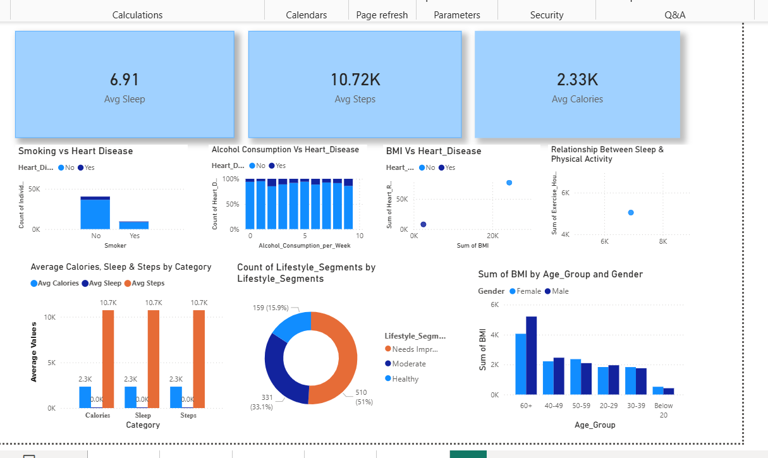
Lifestyle Recommendations Based on Insights
1. Balanced Lifestyle (Steps, Sleep, Calories)
- Users show moderate sleep (Avg ~6.9 hrs) – slightly below the recommended 7–8 hours.
- Steps (~10.7K) are good, but calories burnt are low → indicating sedentary hours or low-intensity activity.
Recommendation:
Increase daily activity through brisk walking or light workouts.
Improve sleep hygiene (consistent schedule, limit screen time).

2. Lifestyle Factors Affecting Heart Disease (Smoking, Alcohol, BMI)
- Smokers show higher cases of heart disease in your chart.
- Higher alcohol consumption also correlates with increased heart disease bars.
- High BMI points cluster with higher heart rates.
Recommendation:
Reduce smoking and alcohol intake.
Maintain BMI through balanced diet & regular exercise.

3. Sleep vs Physical Activity
- Users with higher physical activity (exercise hours) tend to have slightly higher sleep hours.
- Poor sleep correlates with low exercise levels.
Recommendation:
Light activity before evening improves sleep quality.
Adequate sleep enhances daytime activity and metabolism.

4. BMI Across Age Groups & Gender
- Older age groups (40–60+) show higher BMI.
- Females show slightly higher BMI than males in some age groups.
Recommendation:
Age-specific intervention: focus on weight management for 40+.
Encourage both genders to monitor BMI regularly.

5. Smoking & Alcohol Impact on Heart Rate & Blood Pressure
- Smokers and heavy drinkers show higher blood pressure and heart rate spikes.
- Heart disease risk appears elevated in these groups.
Recommendation:
✔ Smoking cessation & moderation of alcohol.
✔ Regular monitoring of BP & HR.

6. Lifestyle Segmentation Results
Segments you created (e.g., Healthy, Moderate, Needs Improvement) show:
- Majority fall under Healthy, but a large share needs improvement.
- Moderate group shows mixed sleep/activity patterns.
Recommendation:
✔ “Needs Improvement” users → increase activity + reduce sedentary time.
✔ “Moderate”→ improve sleep consistency.
✔ “Healthy” → maintain habits.

