Lab 1: Requirements Engineering & UML Use-Case Modelling
Problem Statement #09 — Faculty Research Grant & Publication Tracker

Name: Sampreeth Jaladi
SRN: PES1UG24AM246
Section / Semester: E/5

1. Problem Context
The research deanery currently tracks sponsored grants, expenditure and faculty publication metrics across disconnected spreadsheets, which makes fund utilisation opaque and publication counts unverifiable at audit time. The proposed portal provides a single system of record for grant sanctions, expense logging with automatic balance computation, verified publication indexing and citation metrics, a co-author approval workflow, and fund burn-up analytics — all backed by a tamper-evident audit ledger.

1.1 Actors
Faculty Researcher (primary). Principal Investigator on one or more sanctioned grants. Logs procurement expenses, submits publication records, requests co-author approval, and views burn-up analytics for their own grants.
Research Dean (primary). Registers sanctioned grants and budget caps, approves overdraft override requests, reviews the audit ledger, and views institution-wide analytics.
Co-Author (primary, specialises Faculty Researcher). Approves or rejects claimed co-authorship on a submitted publication record.
Indexing & Citation Service (secondary, external system). Scopus or Web of Science API queried for indexing status and citation counts against a DOI.
Notification Service (secondary, external system). Institutional e-mail and SMS gateway used to notify co-authors and the Research Dean.

2. Requirements Table
Five functional requirements (FR-001 to FR-005) and two non-functional requirements (NFR-001, NFR-002), each specified with ID, Type, Description, Priority, Acceptance Criteria and Rationale.
ID | Type | Description | Priority | Acceptance Criteria | Rationale
FR-001 | Functional — Fund & Expense Management | The system shall track grant fund allocations per budget head, allow a Faculty Researcher to log equipment and consumable procurement expenses against a sanctioned grant, and automatically recompute the remaining budgetary balance after every logged transaction. | High | Pass: Remaining balance = sanctioned amount minus the sum of recorded expenses, updated within the same transaction; an expense exceeding the remaining cap is blocked and raises an override request to the Research Dean.  Fail: Overdraft is allowed to post without an explicit Dean override. | Prevents overdraft of sponsored funds and keeps the ledger consistent with the Utilisation Certificate submitted to the funding agency.
FR-002 | Functional — Master Data Management | The system shall allow the Research Dean to register a sanctioned grant capturing sponsor name, sanction order number, Principal Investigator, sanctioned amount, head-wise budget split, start and end dates, and milestone schedule. | High | Pass: The grant is created with status Active, appears on the PI dashboard with its cap, and a duplicate sanction order number is rejected.  Fail: A grant is saved without a fund cap, or with an end date earlier than its start date. | The grant record is the anchor entity for every downstream expense, analytics and audit operation; bad master data corrupts all of them.
FR-003 | Functional — Publication Management | The system shall let a Faculty Researcher submit a publication record (title, venue, DOI/ISSN, year, linked grant) and shall verify its indexing status (SCI / Scopus / WoS) and citation count via the external Indexing & Citation Service, refreshing metrics at least monthly. | High | Pass: For a valid DOI, indexing status and citation count are populated within 10 seconds and stamped with source and retrieval date; an unresolvable DOI saves the record as Unverified and flags it for review.  Fail: An unverified publication is counted in official indexed-publication metrics. | NIRF and NAAC reporting, and funding-agency closure reports, depend on verified indexed counts rather than self-declared ones.
FR-004 | Functional — Workflow / Approval | When a submitted publication lists internal co-authors, the system shall route an approval request to each co-author, notify them, and mark the publication Confirmed only after all co-authors approve; any rejection shall return the record to the submitter with a mandatory reason. | Medium | Pass: The publication remains in Pending Co-Author Approval until the last approval is recorded; a rejection reverts it to Draft and notifies the submitter with the stated reason.  Fail: A publication reaches Confirmed while at least one co-author approval is still pending. | Prevents authorship disputes and stops the same paper being double-counted across multiple faculty profiles.
FR-005 | Functional — Reporting & Analytics | The system shall present a fund burn-up dashboard showing cumulative expenditure versus planned spend, head-wise utilisation percentage, projected fund-exhaustion date and linked publication output, exportable as PDF or XLSX. | Medium | Pass: Dashboard figures reconcile exactly with the expense ledger for any selected date range, and the exported file carries the same values with a generation timestamp.  Fail: Dashboard and ledger disagree, or figures are stale by more than 24 hours. | Gives the Research Dean early warning of under- or over-utilisation before the funding agency milestone review.
NFR-001 | Non-Functional — Performance & Security (Auditability) | The system shall maintain an immutable, append-only, tamper-evident audit ledger for all financial approvals and publication status modifications, recording actor, timestamp, before-value and after-value, hash-chained to the previous entry and retained for seven years. No API or UI path shall permit update or deletion of a ledger entry. | High | Pass: Benchmarking under simulated peak load (200 concurrent users) confirms ledger write latency of 200 ms or less at p95; a tamper test that alters any stored row causes hash-chain verification to fail and raises an alert; no endpoint exposes UPDATE or DELETE on the ledger.  Fail: Any ledger record can be modified without detection. | Statutory audit and funding-agency scrutiny require a non-repudiable trail of who approved which expense and when.
NFR-002 | Non-Functional — Performance & Availability | The analytics dashboard shall render within 3 seconds at p95 for 500 concurrent users over five years of historical data; the portal shall sustain 99.5% monthly uptime, rising to 99.9% during the financial year-end window (1–31 March), with RPO of 15 minutes or less and RTO of 2 hours or less. | High | Pass: A load test at 500 virtual users records p95 response time of 3 seconds or less with an error rate below 1%; a quarterly failover drill restores service within 2 hours with no more than 15 minutes of data loss.  Fail: p95 exceeds 3 seconds under the stated load, or monthly downtime exceeds the error budget. | Utilisation-certificate deadlines concentrate almost all usage into the year-end window, so a slow or unavailable portal directly causes missed submissions and lapsed funds.

3. UML Use-Case Diagram
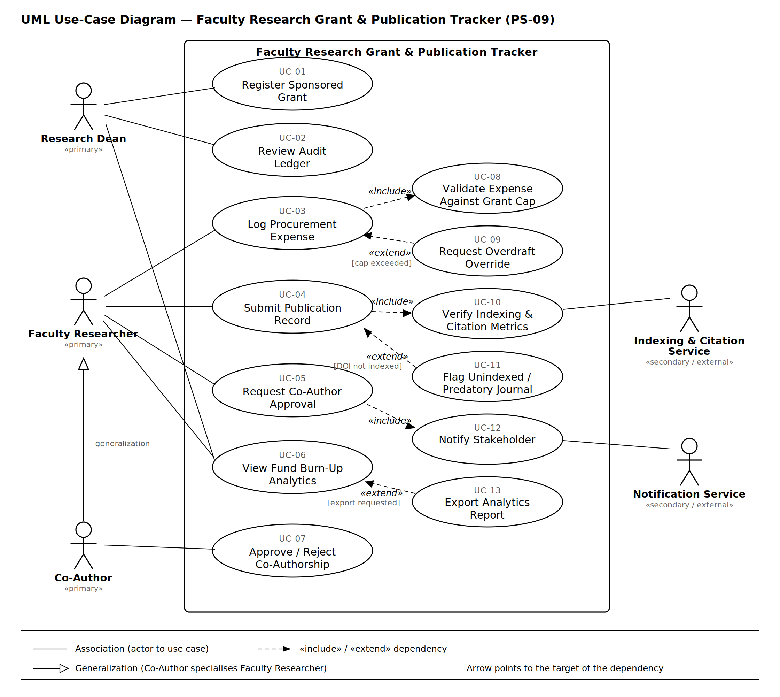
Figure 1 — Use-case diagram for the Faculty Research Grant & Publication Tracker.

3.1 Relationships Modelled
«include» UC-03 Log Procurement Expense → UC-08 Validate Expense Against Grant Cap. Validation is always executed as a mandatory sub-flow of logging an expense.
«include» UC-04 Submit Publication Record → UC-10 Verify Indexing & Citation Metrics. Every submission is always verified against the external indexing service.
«include» UC-05 Request Co-Author Approval → UC-12 Notify Stakeholder. Notification is unconditionally part of raising an approval request.
«extend» UC-09 Request Overdraft Override → UC-03 Log Procurement Expense. Conditional, only when the expense exceeds the remaining balance.
«extend» UC-11 Flag Unindexed / Predatory Journal → UC-04 Submit Publication Record. Conditional, only when the DOI is not found in the index.
«extend» UC-13 Export Analytics Report → UC-06 View Fund Burn-Up Analytics. Conditional, only when an export is requested.
Generalization Co-Author → Faculty Researcher. A Co-Author is a specialised Faculty Researcher and inherits all its associations.
Reading rule. The dependency arrow always points from the dependent element to the element it depends on, so an «include» arrow points at the included use case while an «extend» arrow points at the base use case being extended.

4. Use-Case Flow Specification

UC-03 — Log Procurement Expense Against Grant
Use-Case ID: UC-03
Primary Actor: Faculty Researcher (Principal Investigator)
Secondary Actors: Research Dean (alternate flow only), Notification Service
Trigger: The PI has procured equipment or consumables and selects Log Expense on an active grant.
Related Requirement: FR-001, audited under NFR-001
Included Use Case: UC-08 Validate Expense Against Grant Cap («include»)
Extension Point: cap exceeded — extended by UC-09 Request Overdraft Override («extend»)

4.1 Preconditions
- The Faculty Researcher is authenticated and holds the Principal Investigator role on the selected grant.
- The grant exists with status Active and its sanction period covers the expense date.
- The selected budget head exists on the grant and has a non-negative remaining balance.
- The finance master data and the audit ledger service are reachable.

4.2 Postconditions
On success
- A new expense transaction is persisted with status Recorded and a system-generated voucher number.
- The remaining balance of the affected budget head and of the grant total are decremented atomically.
- An append-only entry is written to the audit ledger capturing actor, timestamp, before-balance and after-balance (NFR-001).
- The burn-up analytics for that grant reflect the new expenditure (FR-005).
On failure
- No expense transaction is persisted and all balances remain exactly as before — the whole flow is a single transaction, so no partial write occurs.
- A rejection reason is displayed to the actor and a rejected-attempt entry is written to the audit ledger.

4.3 Main Success Scenario
- The PI selects an active grant and chooses Log Expense. The system displays the expense form pre-filled with the grant title, its budget heads and the current remaining balance per head.
- The PI selects a budget head and enters amount, vendor, invoice number, invoice date and expense category. The system validates data types, mandatory fields, and that the invoice date falls within the grant sanction period.
- The PI uploads the invoice as a supporting document. The system checks file type (PDF, JPG or PNG) and size (10 MB maximum), stores it, and links it to the draft transaction.
- The PI clicks Submit. The system «includes» UC-08 Validate Expense Against Grant Cap: it recomputes remaining = sanctioned amount minus recorded expenses for that head, and confirms the amount is within the remaining balance.
- The system checks that the invoice number is not a duplicate against the same grant.
- The system commits the transaction: it persists the expense with status Recorded, atomically decrements the head-wise and total balances, and generates a voucher number.
- The system writes a hash-chained audit ledger entry recording actor, timestamp and before/after balance, as required by NFR-001.
- The system displays a confirmation with the voucher number and the updated remaining balance, and refreshes the burn-up chart.

4.4 Alternate Flow — A1: Expense Exceeds Remaining Grant Balance
Branch point. Step 4 of the main success scenario, when UC-08 evaluates that the amount entered is greater than the remaining balance (extension point cap exceeded, use case UC-09 Request Overdraft Override).
A1.1 The system blocks the commit and displays the shortfall: the amount entered, the remaining balance and the excess figure. No balance is modified.
A1.2 The system offers two options: Revise Amount, or Request Overdraft Override.
A1.3 If the PI selects Revise Amount, the form is returned in an editable state with the entered values retained, and the flow resumes at step 2 of the main success scenario.
A1.4 If the PI selects Request Overdraft Override, the system requires a mandatory justification, saves the expense with status Pending Dean Approval, and does not alter any balance.
A1.5 The system notifies the Research Dean through the Notification Service and records the override request in the audit ledger.
A1.6 The Research Dean reviews the justification and either approves or rejects the override.
A1.7 If approved, the system posts the expense as Recorded, permits the balance to go negative up to the approved override limit, flags the grant as Over-Utilised on the analytics dashboard, and writes an audit entry naming the approving Dean. The flow rejoins the main success scenario at step 8.
A1.8 If rejected, the expense moves to status Rejected, the PI is notified with the Dean’s reason, balances remain unchanged, and the rejection is written to the audit ledger. The use case ends.

5. Traceability
FR-001 → UC-03, UC-08, UC-09
FR-002 → UC-01
FR-003 → UC-04, UC-10, UC-11
FR-004 → UC-05, UC-07, UC-12
FR-005 → UC-06, UC-13
NFR-001 → UC-02, cross-cutting on UC-01, UC-03 and UC-07
NFR-002 → cross-cutting on UC-06 and UC-13

