Name: Lu Min

[mlu821@bu.edu](mailto:mlu821@bu.edu)

**Problem Set 1**

1. Mathematical calculations
2. i. Here is the 3-regular graph:

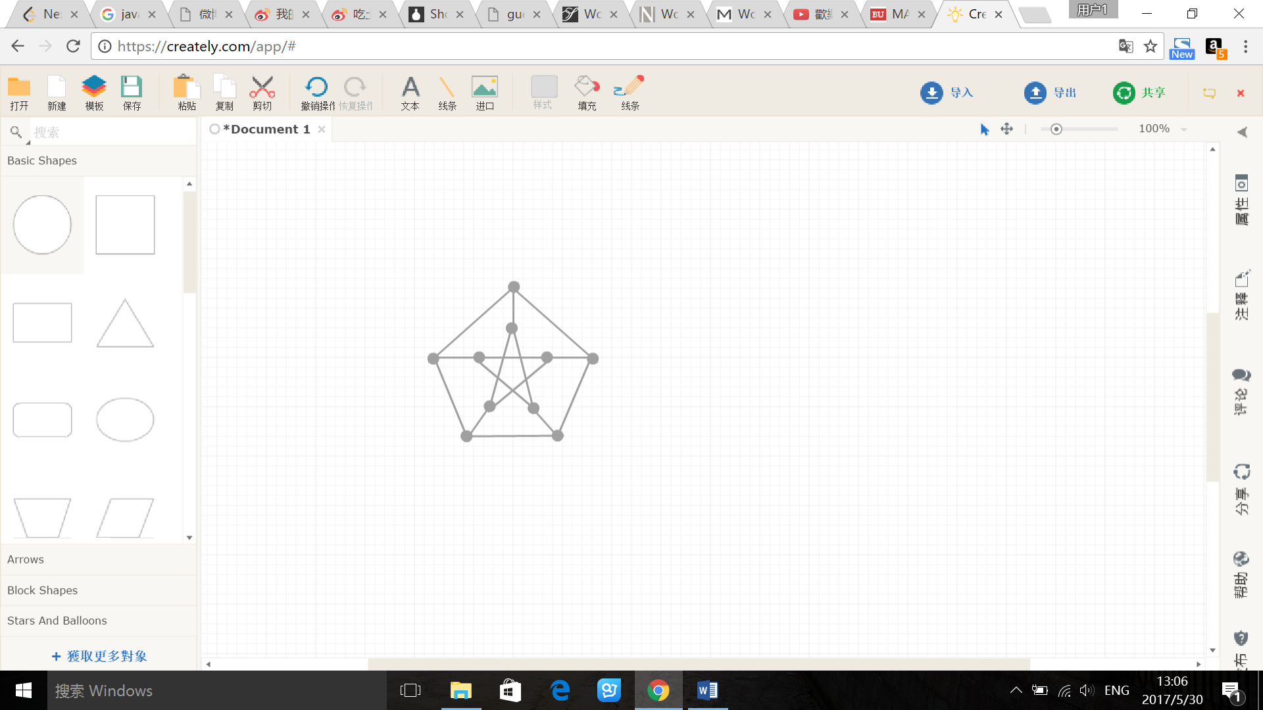

ii. If graph G contains C3, that means there will be a cycle which is triangle in G. Obviously, there is no triangle in this graph. And also, any vertex in this graph has three neighbor vertices because of 3-degree, however, none of three neighbors are connected, so G contains no cycle C3.

This is a ten-vertex 4-regular graph, and it connects 2 subsets by 5 chord. If any chord connects two vertices at distance 2 or 3, then this graph would have C3 or C4. However, this situation does not satisfy the conditions in the definition of G.

If there is C4 in this graph, there will exist two nodes sharing the same two neighbor vertices other than themselves. Graph G has no such two vertices, so G contains no cycle C4.

iii. If there is a C10, then the graph consists of C plus five chords. If each chord joins vertices opposite on C, then there is a 4-cycle. Hence some chord joins vertices at distance 4 along C. Now no chord incident to a vertex opposite an endpoint of chord on C can be added without creating a cycle with at most four vertices. Therefore, this graph does not contain C10.



And , so we get:

$$\left(3-λ\right)\left[\left(-λ\right)\left(-2-λ\right)\right]-4\left(λ-3\right)+\left(-1\right)\left[-9-3\left(-2-λ\right)\right]=0$$

$$-λ^{3}+λ^{2}+8λ-12=0$$

$$\left(λ-2\right)\left(-λ+2\right)\left(λ+3\right)=0$$

So the eigenvalues for matrix A is 2, -3, and the eigenvectors for $λ=2$ is $\left(\begin{matrix}-\frac{1}{3} \\ \frac{1}{3} \\ 1\end{matrix}\right)$, the eigenvectors for $λ=-3$ is $\left(\begin{matrix}\frac{1}{2} \\ -\frac{1}{2} \\ 1\end{matrix}\right)$.

Because the eigenvalues for matrix A is not all positive, A is not positive definite.

1. Programming

I have 10 bipartite examples and 10 non-bipartite examples, and my examples for both bipartite and non-bipartite have various size from small to 1000. Files with “bi*.txt” are bipartite examples, and files with “non*.txt” are non-bipartite examples. “bi9.txt” and “non9.txt” are both have size 1000 nodes.

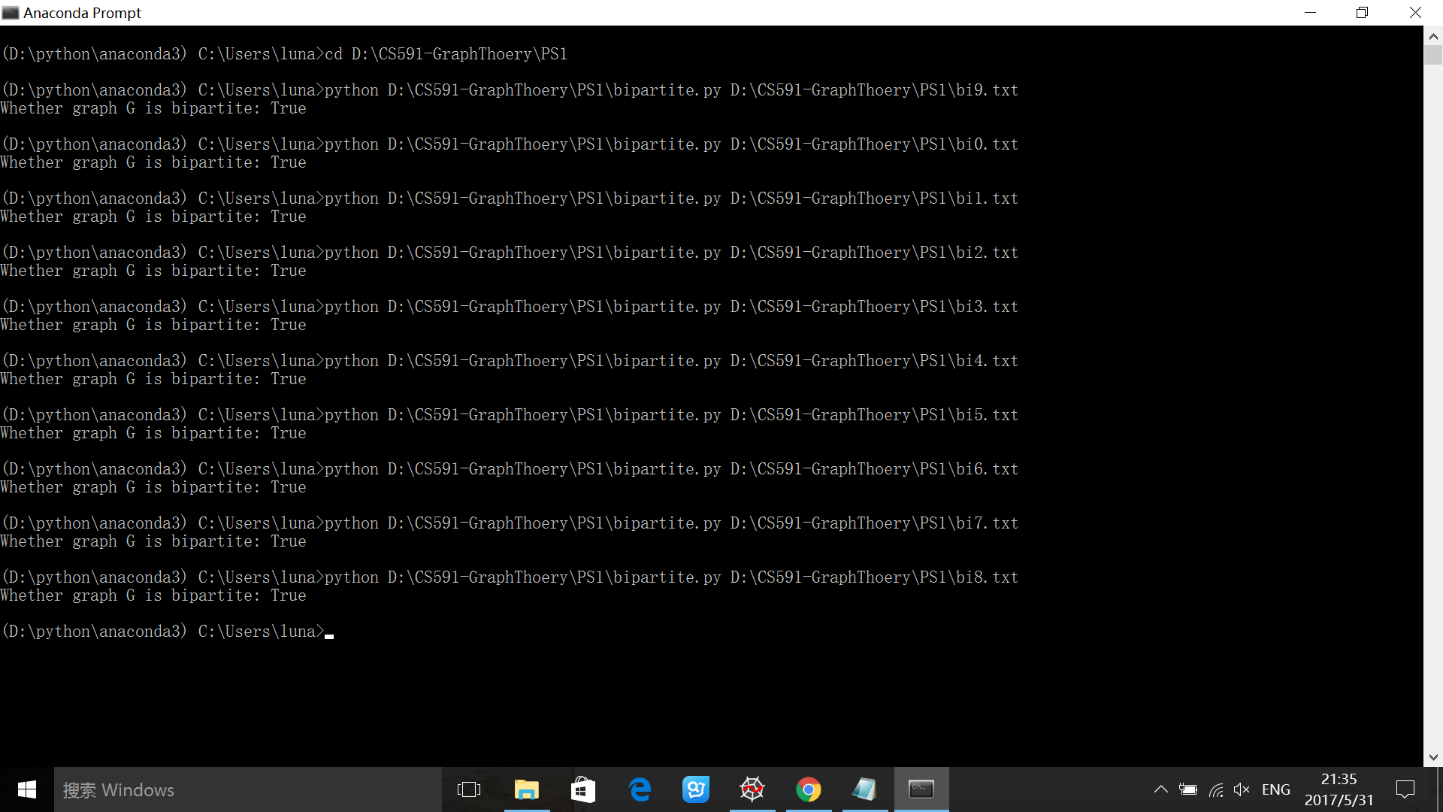Here is the result for bipartite graphs:

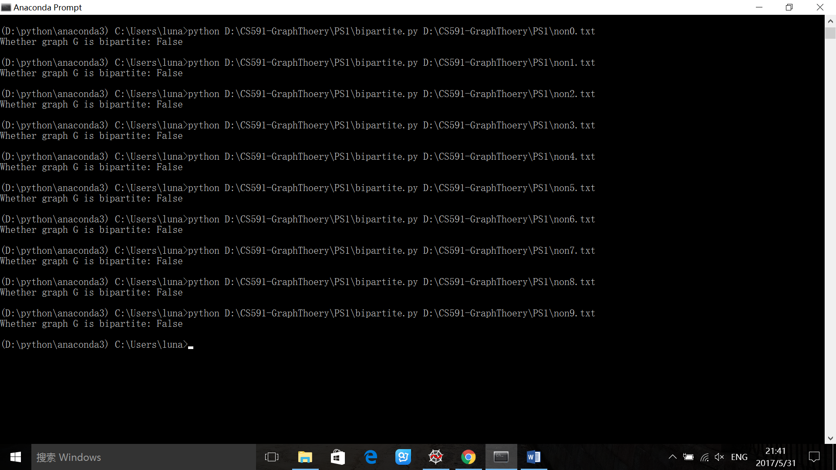Here is the result for non-bipartite graphs: