Name: Lu Min

[mlu821@bu.edu](mailto:mlu821@bu.edu)

Problem Set 2

1. Mathematical calculations
2. By contradiction, there is a tournament has no king. Because king is defined as a vertex from which every vertex is reachable by a path of length at most 2, I choose a vertex u with the largest outdegree. Because u has more possible paths to other vertices in the digraph , I suppose u is not king.

Let be the set of vertices that vertex u oriented, so the outdegree of u is Y. Since u is not a king, there is a vertex (that is, x is not oriented by vertex u) and that is not oriented by any vertex in Y. Since for any pair of vertices, one orients to the other, this means that x orients to u as well as every vertex in Y. This means that

But u was assumed to be the node with the largest outdegree in the tournament, so we have a contradiction. Hence, u must be a king.

1. In the class, we proved that 1 + 2 can get 3, so I first prove 1 + 3 can get 2, then I will prove 2 + 3 can get 1.
2. G is connected and has n – 1 edges, so G is acyclic.

I prove it by induction.

When n = 2, there will be two vertices and one edge, and these two vertices are connected, so obviously this graph is acyclic.

Then I assume this is true, when n = k – 1. That means G is connected and has k – 2 edges, and G is acyclic.

We need to consider the situation that n = k. Let T be a connected graph with k vertices and k – 1 edges. So actually we add one vertex and one edge to the connected acyclic graph G.

If we add an edge to G and make it connected, then T will be a connected cyclic graph with a single vertex. Thus T will be an unconnected graph which is contradicted to our condition T is connected.

Therefore, T is acyclic.

1. G is acyclic and has n – 1 edges, so G is connected.

I prove it by induction.

First, when n = 2, G has one edge and two vertices, G is obviously connected.

Then, we assume that this to be true when n = k – 1.

In the situation of n = k, let T be an acyclic graph with n – 1 edges and n vertices. I remove a vertex and one edge from T, . According to our assumption, is acyclic connected. So we add back the edge with a vertex to , this graph is also connected.

Therefore, T is connected.

1. Programming

I determine whether a digraph G is a Eulerian graph by the theorem that a digraph G is eulerian, if and only if G has at most one non-trivial component and for all vertices v in G, out degree of v equals to in degree of v.

After I ensure this digraph is eulerian, I will find one eulerian circuit as assignment required.

The following image is the result of a simple digraph which is eulerian and gives out the eulerian circuit. And the digraph is G.

And also the de Bruijin sequence of length 5.

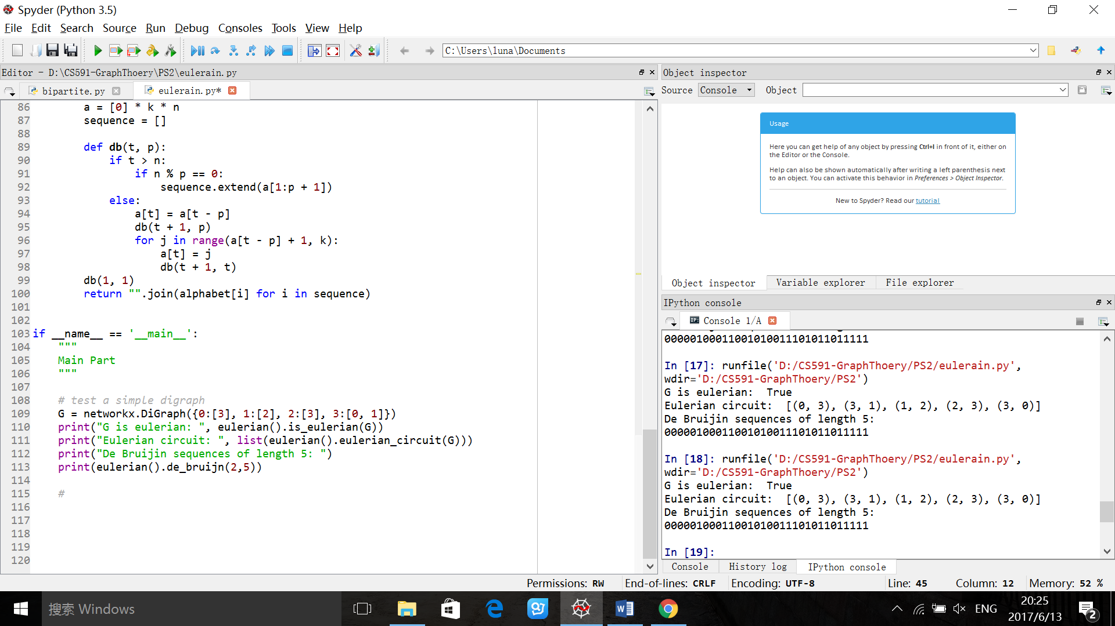

In my txt file, I have the format: node1, node2, that means node1 directs to node2. For example,

0,1

1,0

The above means node 0 directs to 1, node 1 directs to 0, that forms a cycle. And here is the result for ten Eulerian graphs with Eulerian circuit and ten non- Eulerian graphs.

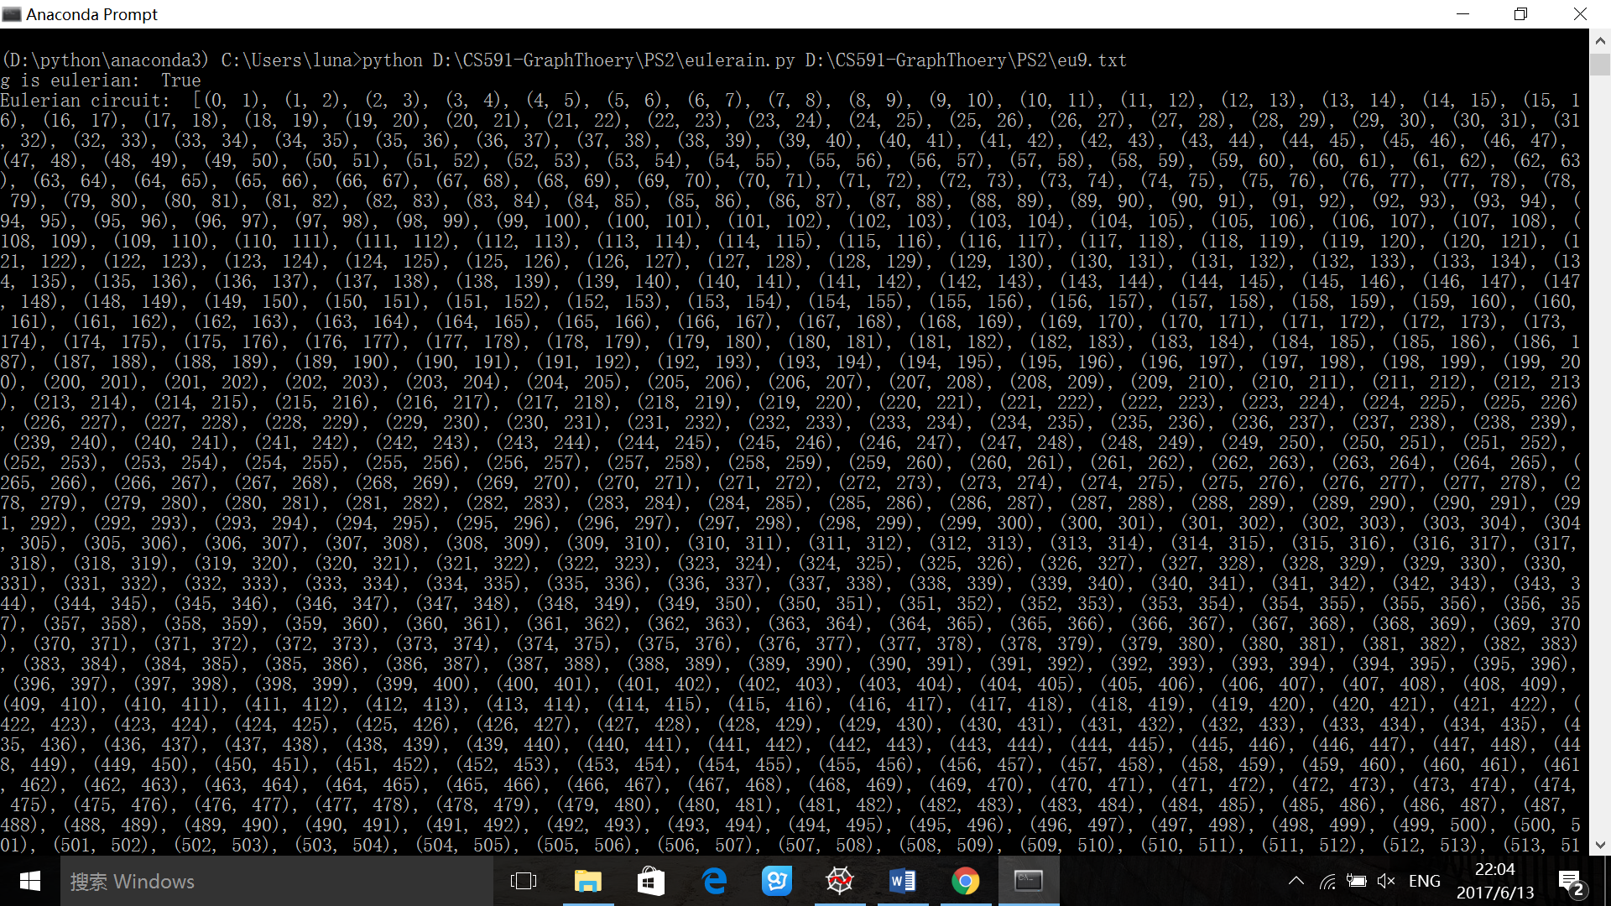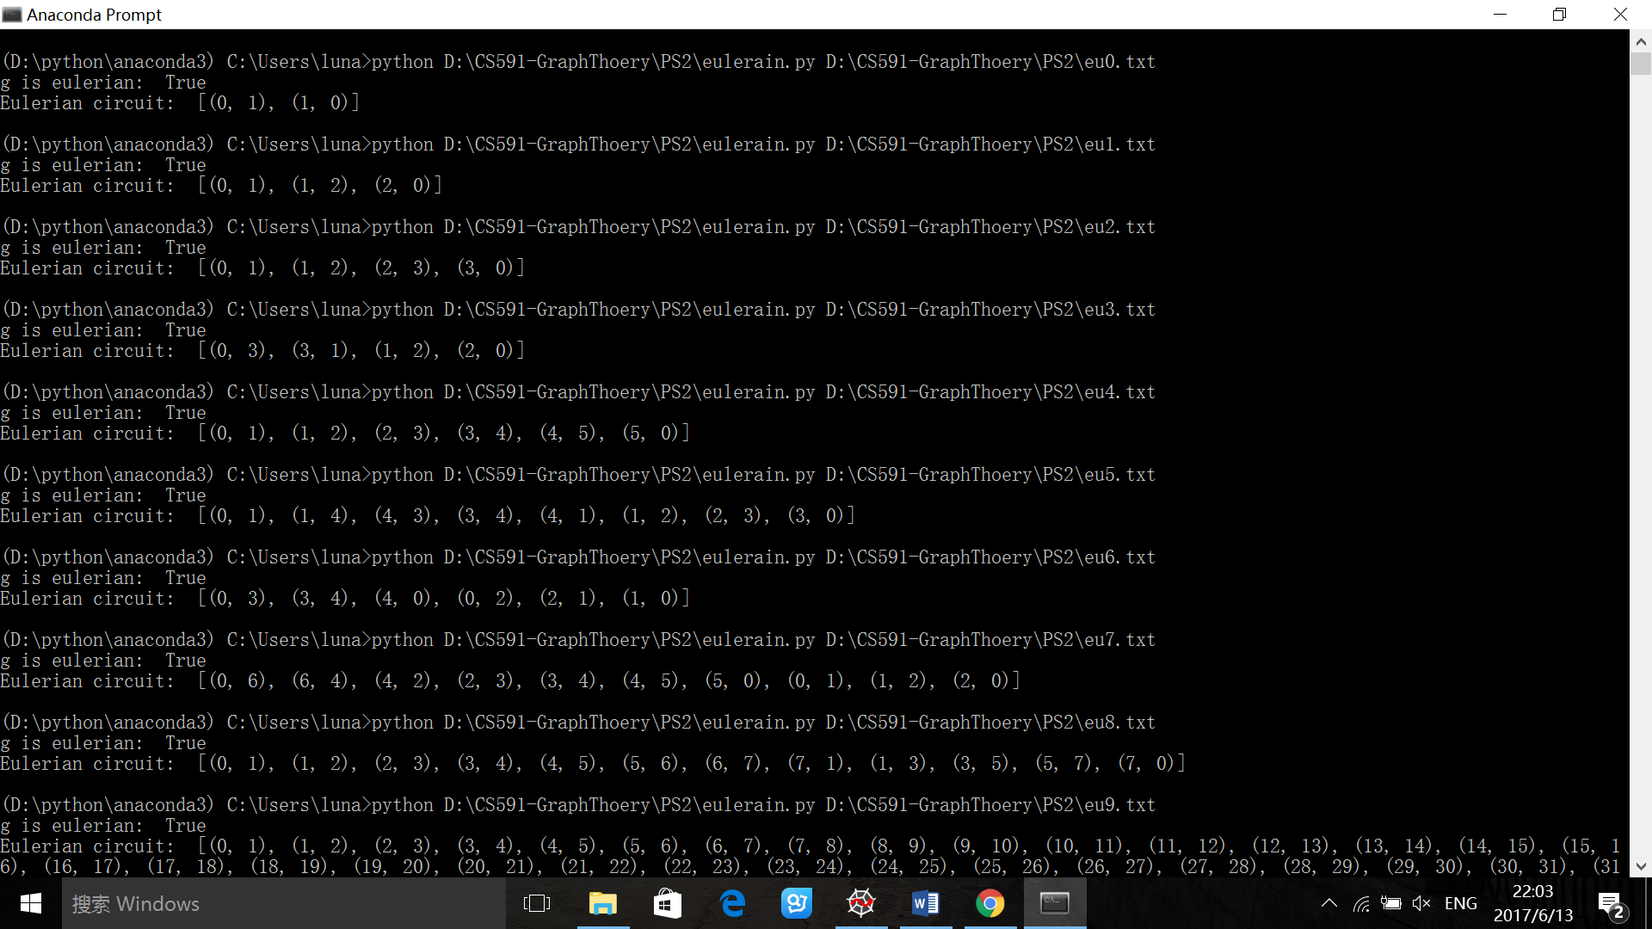Picture 1 Eulerian circuit for Eulerian digraphs from eu0.txt to eu8.txt

Picture 2 Eulerian circuit for Eulerian digraph of eu9.txt with 1000 nodes

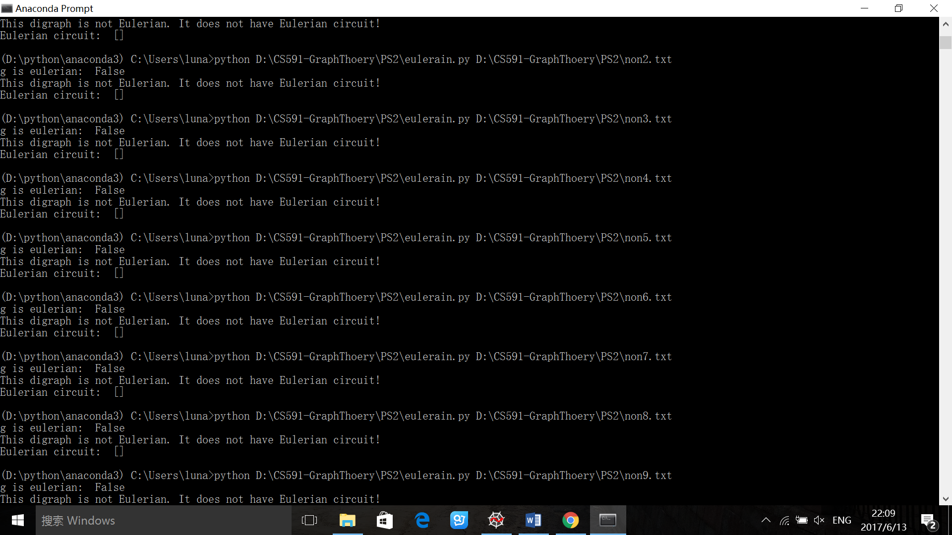

Picture 3 Results for 10 non-Eulerian digraphs in 10 txt files non0.txt~non9.txt

And also finally, we got the de Bruijin sequence of length 5.

