Name: Lu Min

[mlu821@bu.edu](mailto:mlu821@bu.edu)

Problem Set 4

1. Mathematical Calculations
2. We prove this by induction on the number of vertices in the graph. To ground the induction, consider the graph with one vertex and no edges. It has chromatic number 1 and largest eigenvalue 0. Now, assume the theorem is true for all graphs on n − 1 vertices, and let G be a graph on n vertices. By Lemma that $λ_{max}(G)$ is greater or equal than the average degree of a vertex and smaller or equal than the maximum degree of a vertex in G, G has a vertex of degree at most $\left\lfloor λ_{max}\right\rfloor$.

Let v be such a vertex and let G − {v} be the graph obtained by removing this vertex. By our induction hypothesis, G− {v} has a coloring with at most $\left\lfloor λ_{max}\right\rfloor +1$ colors. Let c be any such coloring. We just need to show that we can extend c to v. As v has at most $\left\lfloor λ_{max}\right\rfloor$ neighbors, there is some color in $\{1,…, \left\lfloor λ_{max}\right\rfloor +1\}$ that does not appear among its neighbors, and which it may be assigned. Thus, G has a coloring with $\left\lfloor λ_{max}\right\rfloor +1$ colors.

1. First, I initialize node number to the graph as following:

1

0

2

4

3

According to the graph, I get the following adjacent matrix:

$$\left[\begin{matrix}0 & 1 & 1 & 1 & 0 \\ 1 & 0 & 1 & 0 & 0 \\ 1 & 1 & 0 & 1 & 0 \\ 1 & 0 & 1 & 0 & 1 \\ 0 & 0 & 0 & 1 & 0\end{matrix}\right]$$

After that, I can derive the eigenvalues from the adjacent matrix, and eigenvalues are -1.7757, -1, -0.5892, 0.7237 and 2.6412.

1. Let $α$ be an unit eigenvector of A(H) with $λ_{min}(H)$. Because H is an induced subgraph of G, we have the following deduction.

$$λ_{min}\left(H\right)=α^{t}A\left(H\right)α$$

$$=2\sum_{i,j∈E(H)}{α_{i}α_{j}}$$

$$>2\sum_{i,j∈E(G)}{α_{i}α_{j}}$$

$${ =α}^{t}A\left(G\right)α$$

$$≥\inf{x^{t}Gx}$$

$$=λ_{min}\left(G\right)$$

So $λ_{min}\left(H\right)>λ_{min}\left(G\right)$.

1. Programming

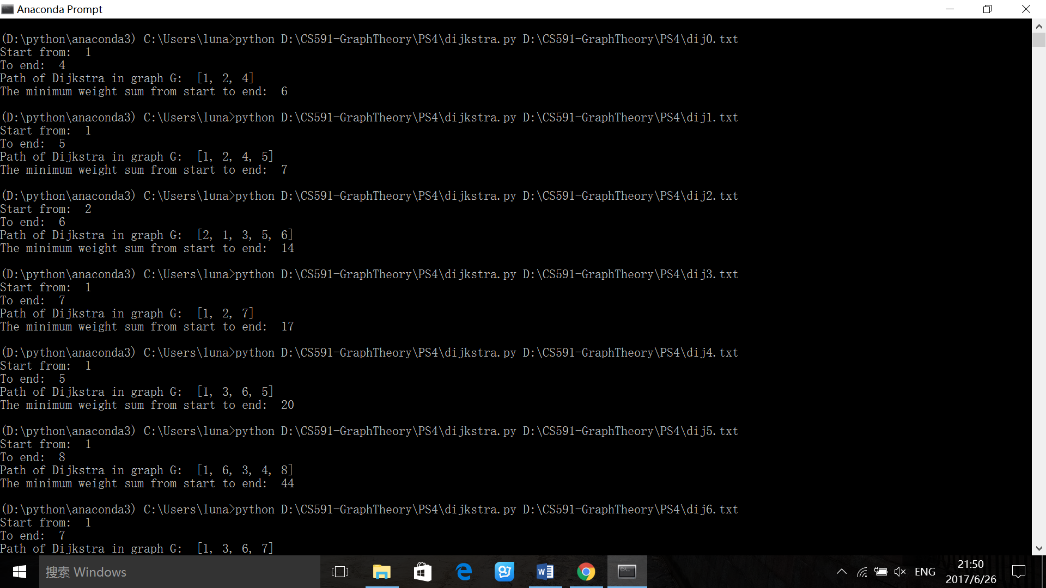Here is my execution results image. Also, each example has an output text file.