# Heading 1

Hello from heading 1

## Heading 2

### Heading 3

#### Heading 4

##### Heading 5

###### Heading 6

**Picture (***Bill gates and Linus Torvalds***)**

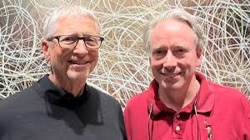

I love linux