D3 - SYSTEM MODELS PACKAGE

AgriUAV Platform: Precision Drone Dispatching Platform in the Mekong Delta
Subject | ITA301 - Information System Analysis & Design
Deliverable | D3 - System Models Package (30%)
Submission Date | 2026-07-19
Version | V3.2
Course Instructor | Mr. Tran Thanh Nguyen
Project Team | • Dang Thanh Cong - Project Manager  • Nguyen Thi Thanh Thao - Business Analyst  • Le Van Minh - System Analyst  • Tran Anh Khoa - System Designer  • Dang Vo Thanh Hieu - Presenter / QA

1. Diagram Package Index (Placeholders)
The table below indexes every UML/DFD artifact required for D3. Diagrams are intentionally left blank in this document - insert the rendered image (PlantUML render or draw.io export) at each placeholder from the listed source file. Linked UC(s)/FR(s) are restated so each inserted diagram can be checked against the rest of this package before final submission.
# | Diagram | Source File | Status
1.1 | DFD Level 0 - Context Diagram | DFD_Agriuav_level0_v1.5.drawio | Ready to insert
1.2 | DFD Level 1 - 4 Sub processes | DFD_Agriuav_level1_v1.5.drawio | Ready to insert
1.3 | Use Case Diagram | D3.mdj | Ready to insert
1.4 | Class Diagram | D3.mdj | Ready to insert
1.5 | Activity Diagram 1 Booking Flow | D3.mdj | Ready to insert
1.6 | Activity Diagram 2 Monitoring & Alert | D3.mdj | Ready to insert
1.7 | Sequence Diagram UC01 Book a Spraying Session | D3.mdj | Ready to insert
1.8 | Sequence Diagram UC03 On- site GPS Check-in | D3.mdj | NEEDS REVISION before insertion
1.9 | Sequence Diagram UC04 Near Real- time Monitoring | D3.mdj | Ready to insert

1.1 DFD Level 0 - Context Diagram
Linked UC(s): - (context- level)
Linked FR(s): Scope- level (D1 |1.2 / D2 |1.2)
Shows AgriUAV Platform as a single process bounded by 8 external entities (Farmer, HTX Manager, Operator/Pilot, Agronomist, Plant Protection Dept, Export Company [post- MVP], Weather API, SMS/Zalo Gateway).

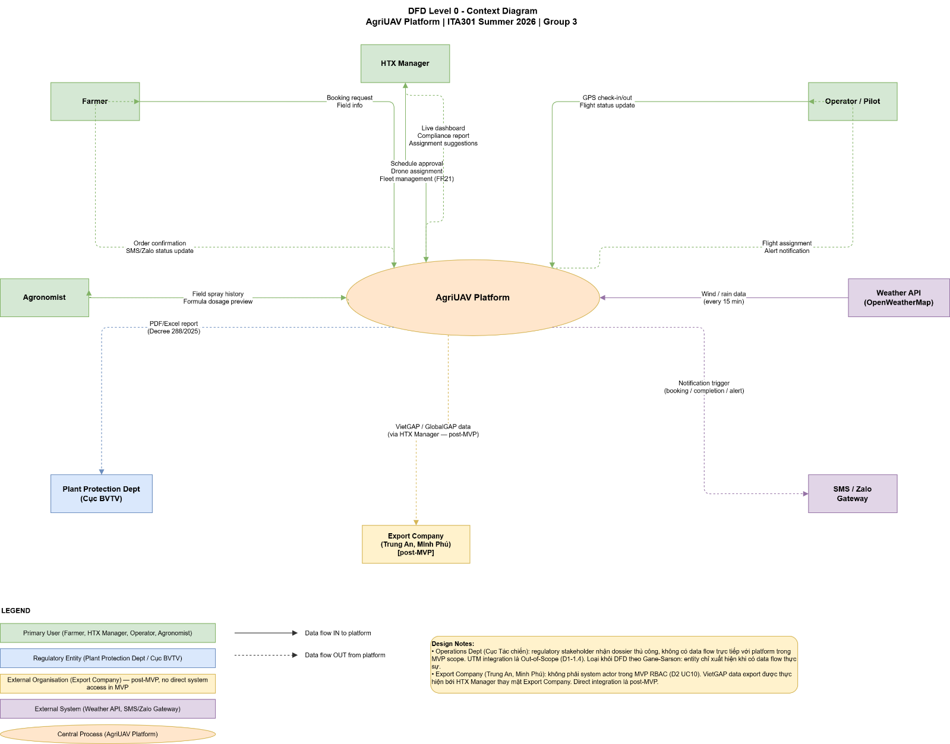

1.2 DFD Level 1 - 4 Sub- processes
Linked UC(s): UC01–UC10 (process- level)
Linked FR(s): FR01–FR17, FR21
Balances against Level 0 with P1 Booking & Schedule Management, P2 Fleet Dispatch & Assignment, P3 Real- time Monitoring & Alert, P4 Compliance Logging & Report Export, and 4 data stores (DS1–DS4). Verify all 8 external entities and data flows n1–n5 are present before insertion.

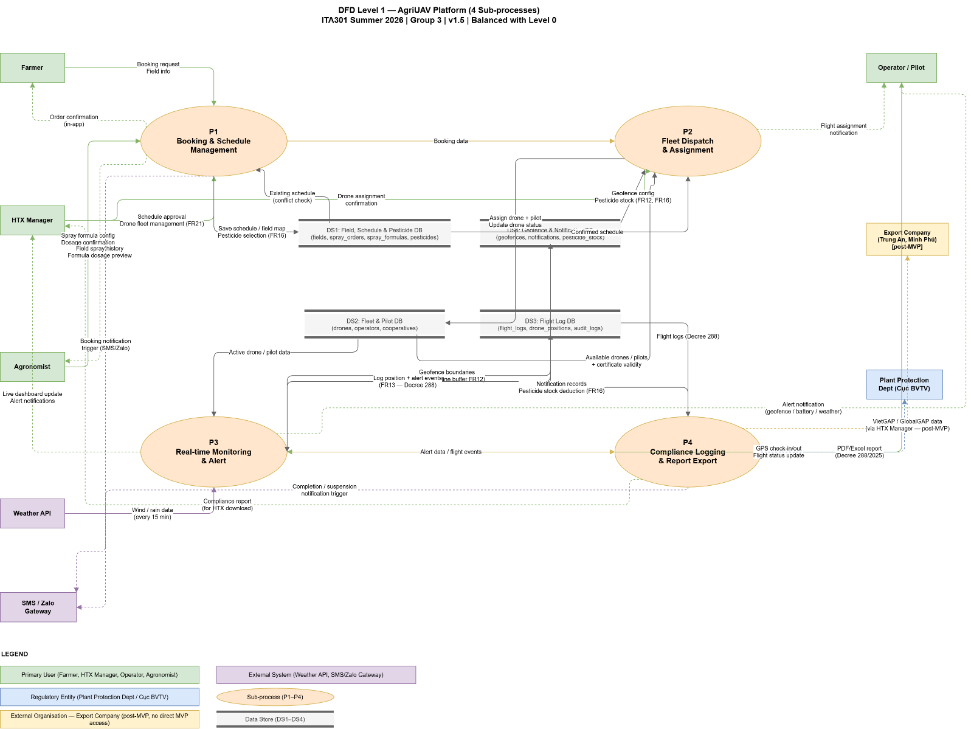

1.3 Use Case Diagram
Linked UC(s): UC01–UC10
Linked FR(s): FR01–FR21 (via UC, see |5)
Shows Admin generalizing HTX Manager (no separate Admin use cases), System (Auto) as primary actor for UC06, and «extend» (UC05→UC04, UC06→UC04) / «include» (UC07→UC03) relationships.

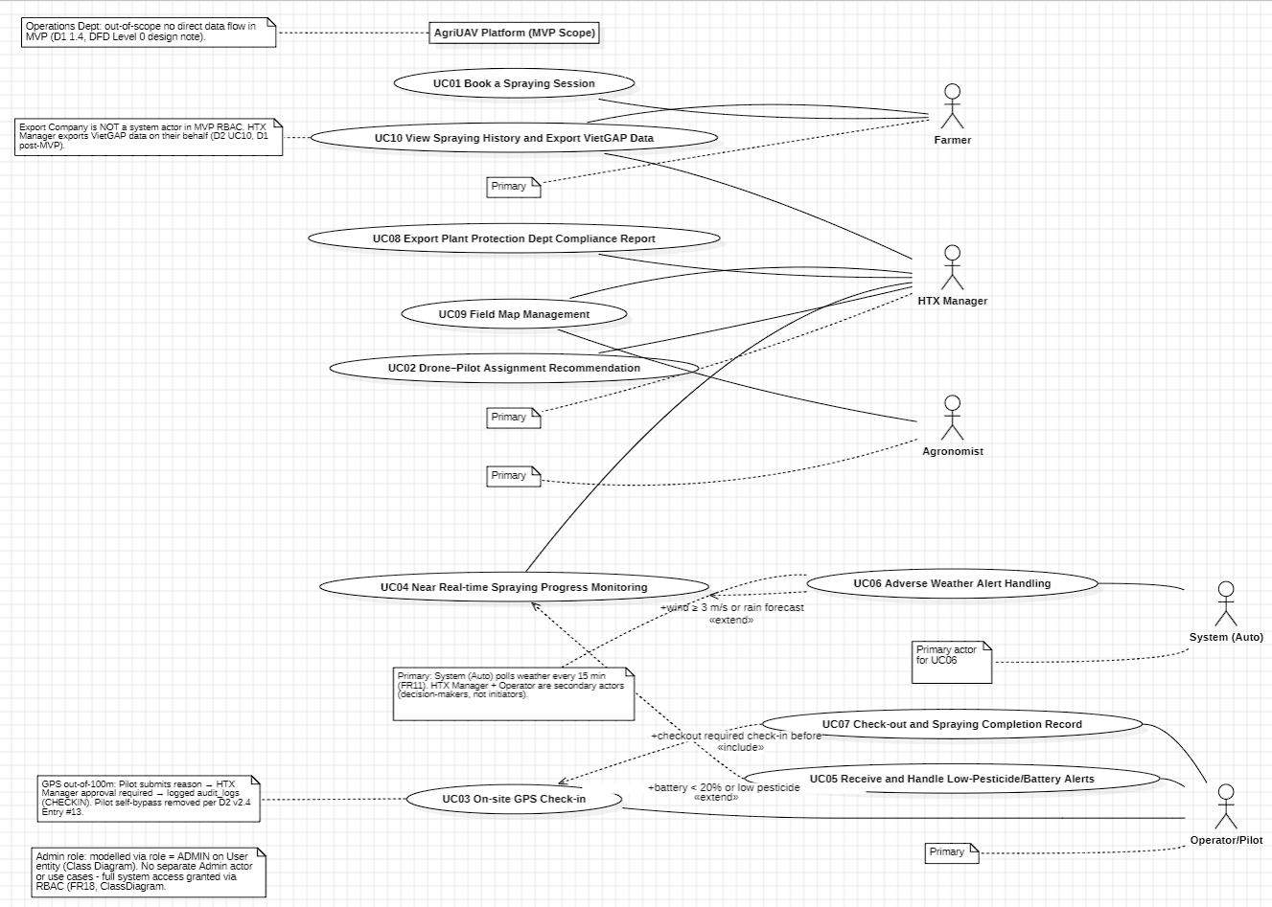

1.4 Class Diagram
Linked UC(s): All UCs
Linked FR(s): FR01–FR18, FR21
17 classes + 4 enums. Confirms the static structure backing | 2–4 of this document: User hierarchy (Farmer/Operator/HTXManager/Agronomist), Cooperative aggregation, SprayOrder lifecycle, FlightLog/AuditLog compliance pair, and the FR21 drone- registry methods on HTXManager.

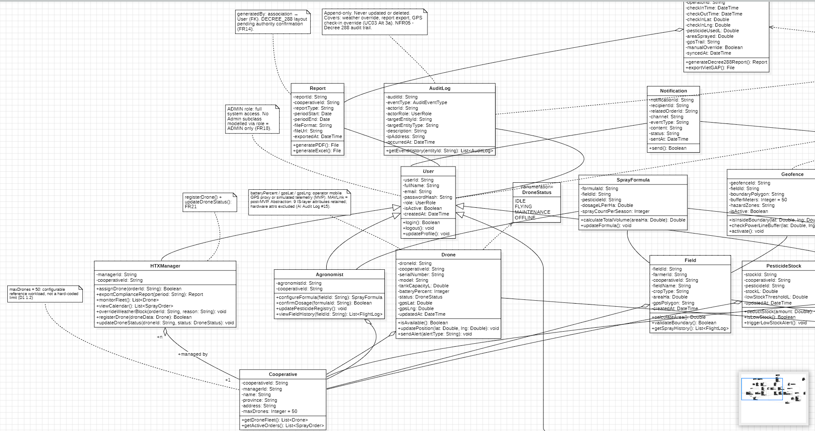

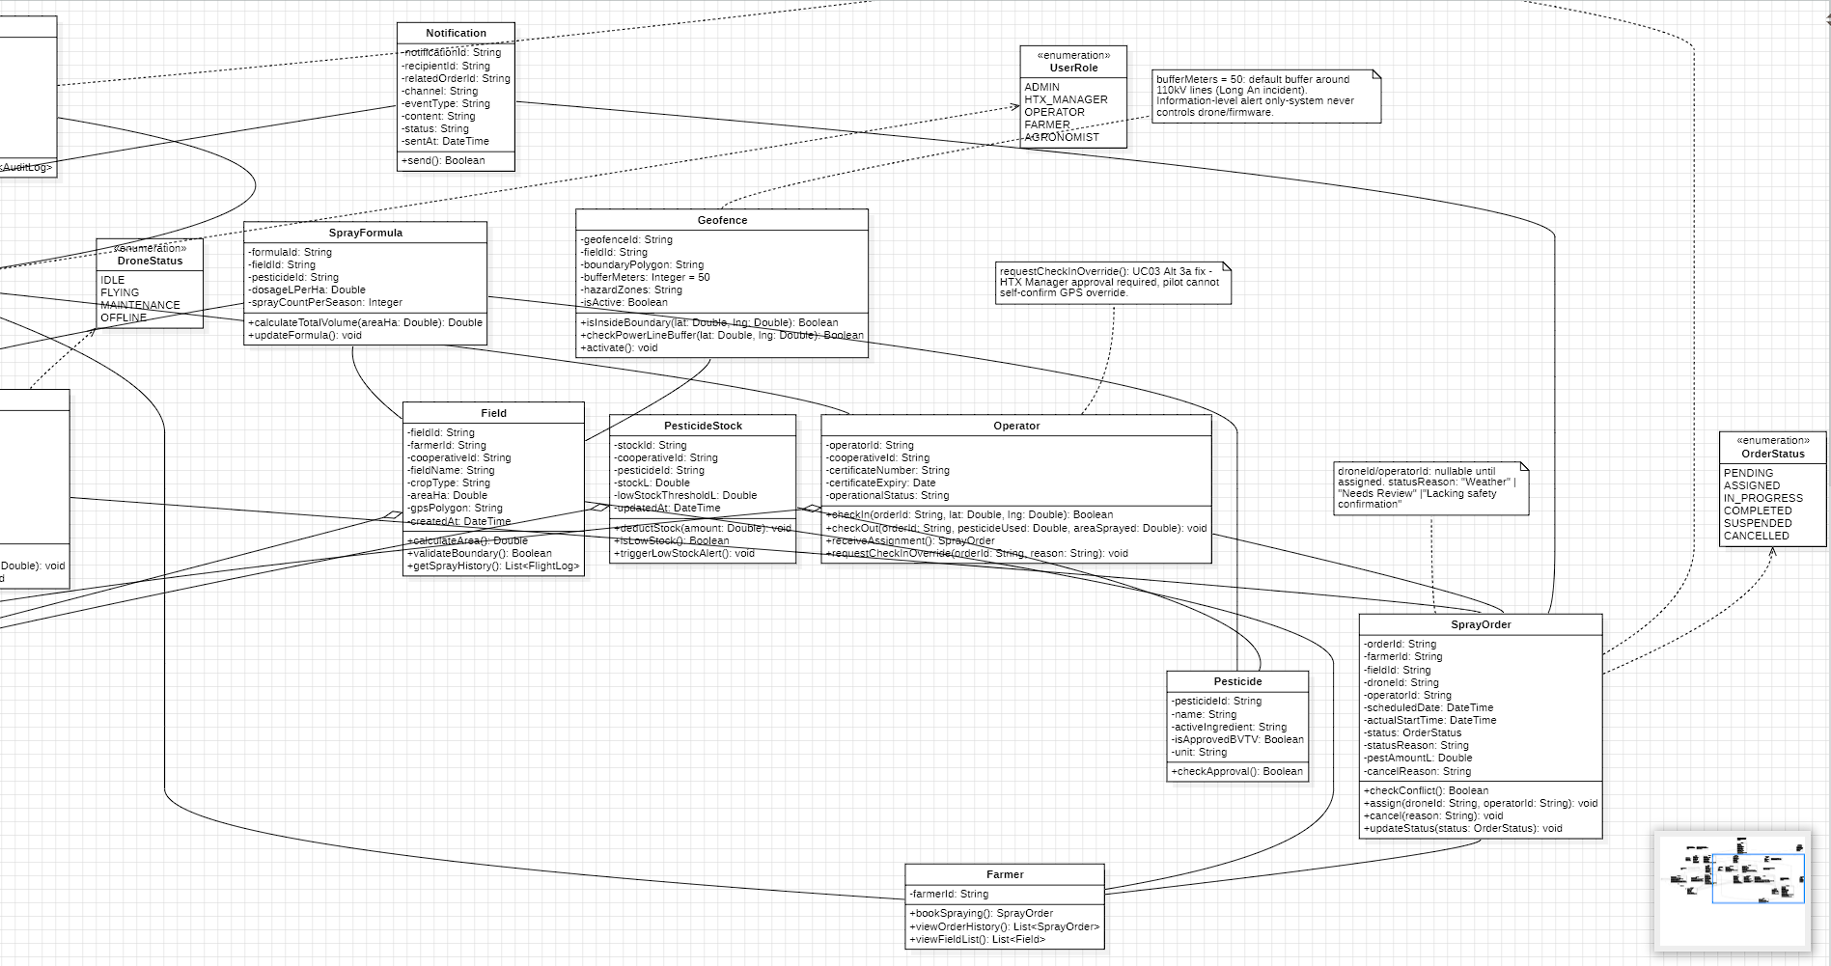

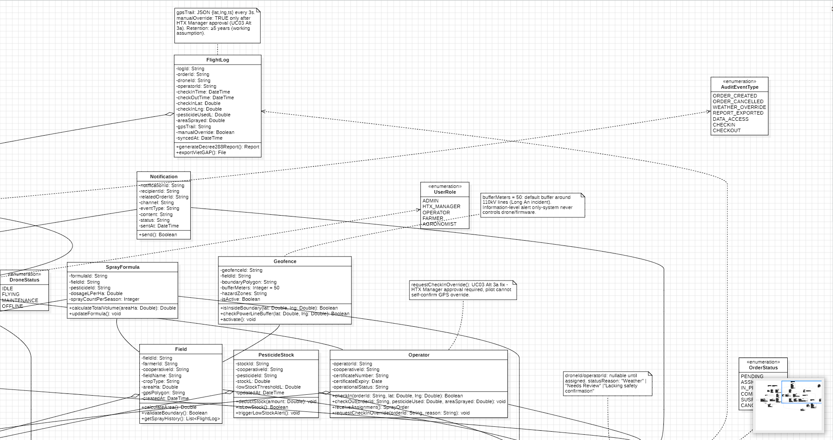

1.5 Activity Diagram 1 - Spray Order Booking Flow
Linked UC(s): UC01, UC02
Linked FR(s): FR01,02,03,04,06,07,08,13,16,17,18
3 swim lanes (Farmer / System / HTX Manager). Includes the UC01 weather soft- constraint gate with HTX Manager async override, and the corrected “no- assign” path that keeps the order PENDING rather than CANCELLED (UC02 Alt 3a).

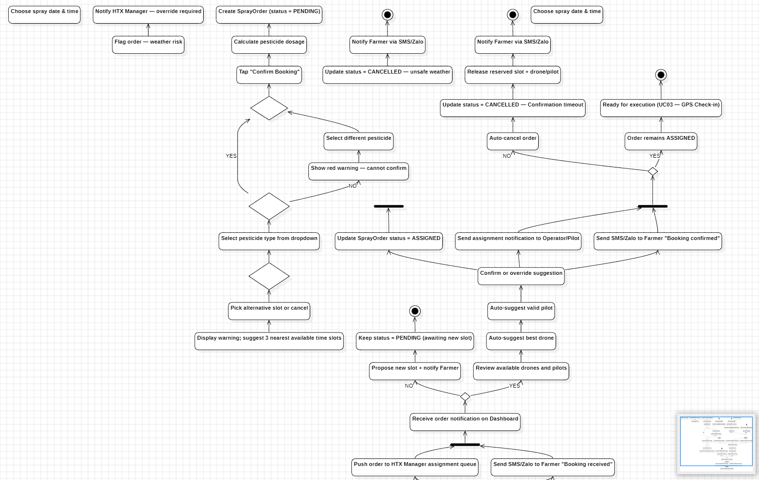

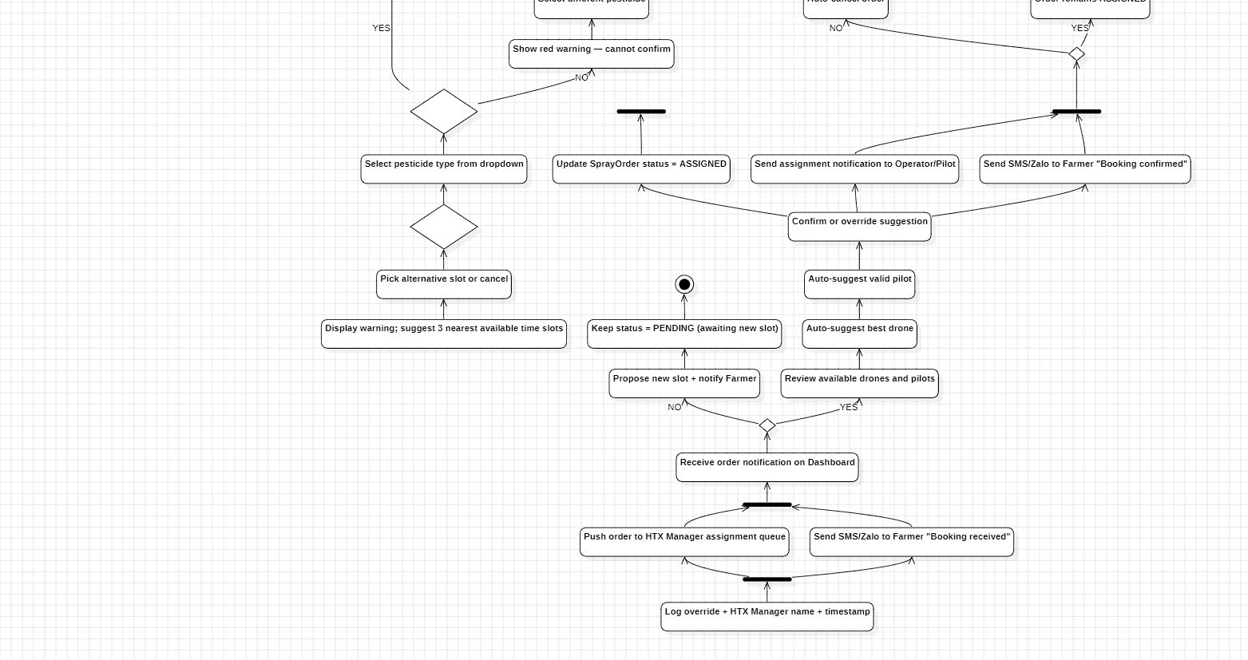

1.6 Activity Diagram 2 - Monitoring & Alert Handling Flow
Linked UC(s): UC04, UC05, UC06, UC07
Linked FR(s): FR09,10,11,12,13,16,17
3- way parallel fork (geofence / battery- pesticide / weather) plus the UC04 connection- lost check and UC07 check- out exit branch. When redrawing, replace any “GEOFENCE VIOLATION” label with “geofence alert” / “boundary crossing” wording

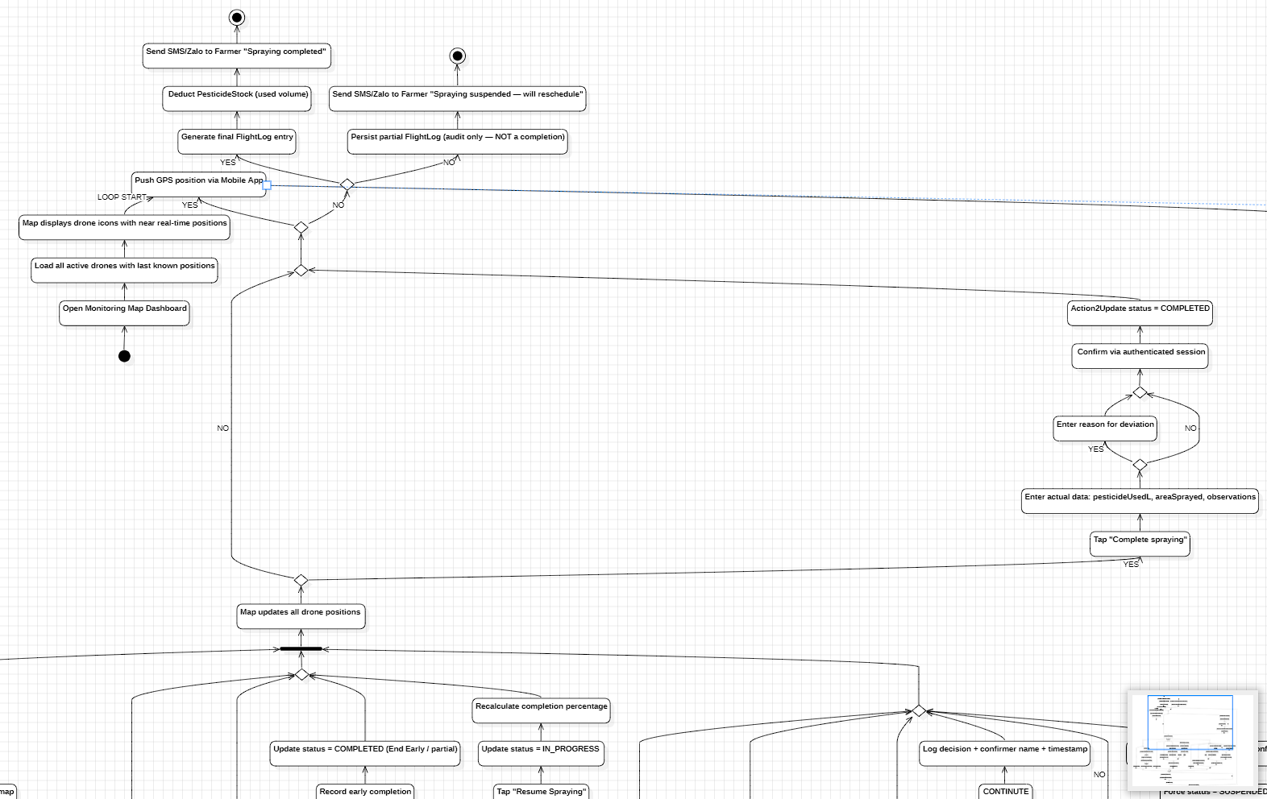

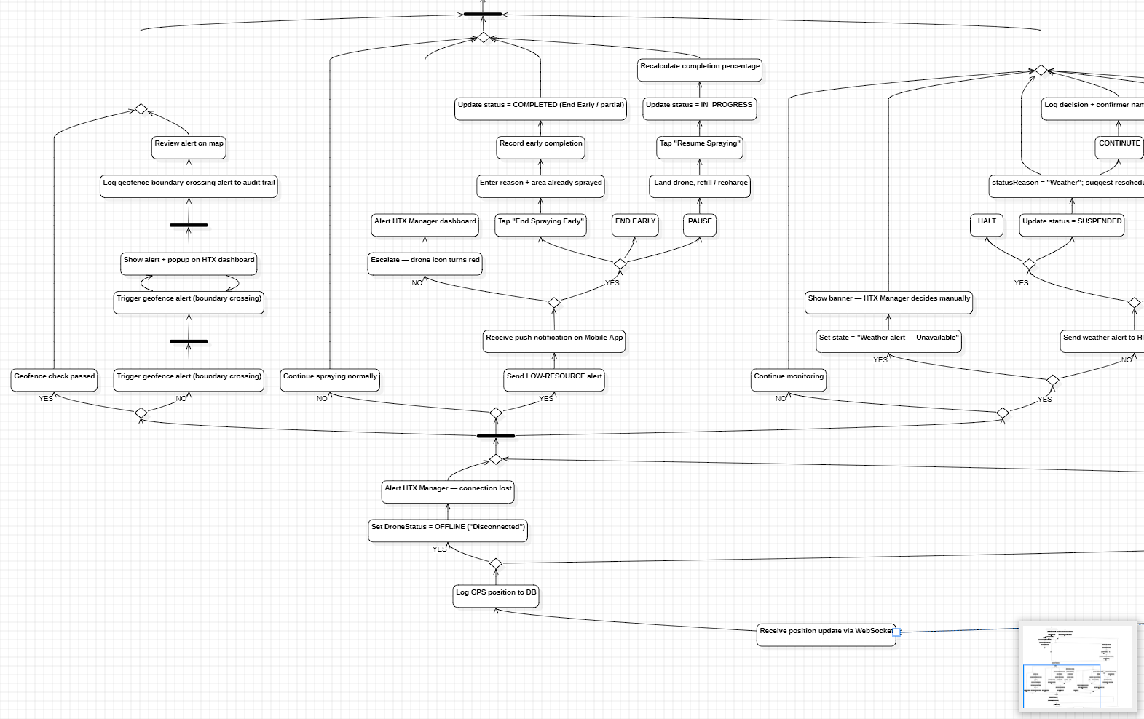

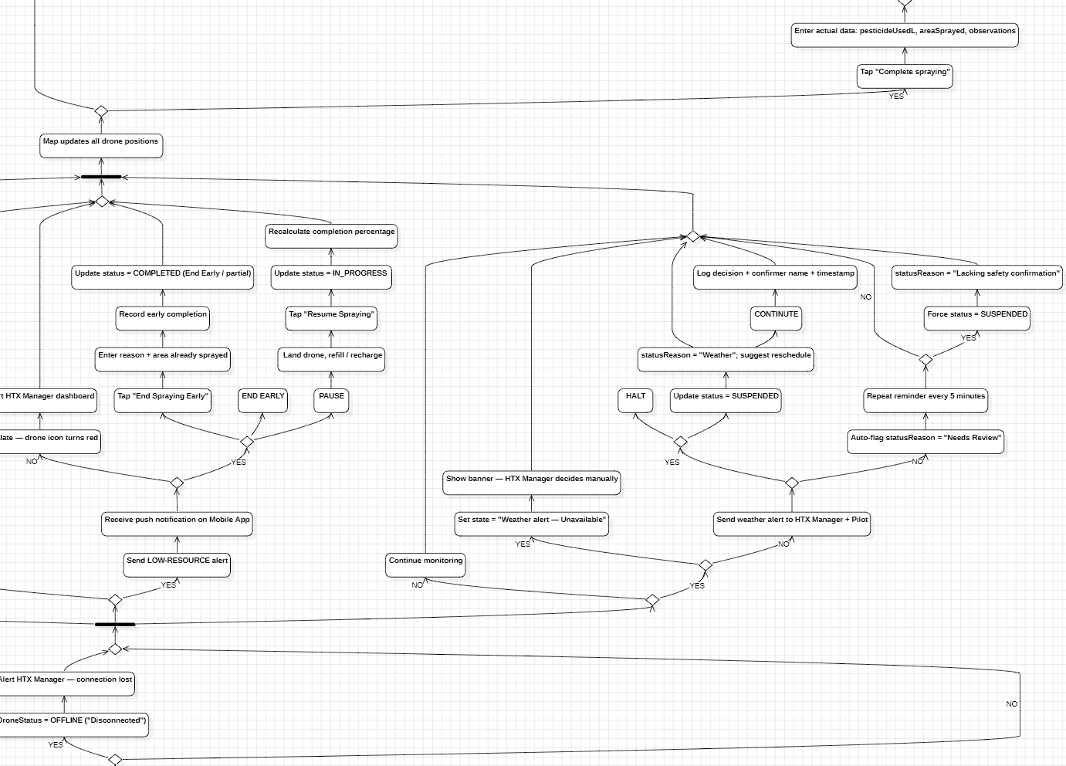

1.7 Sequence Diagram - UC01 Book a Spraying Session
Linked UC(s): UC01
Linked FR(s): FR03,04,16,17
Happy path + Alt 3a (schedule conflict) + Alt 4a (pesticide not BVTV- approved). No structural change needed for v1.5; carry forward from D3 v1.4 | 2.2.1.

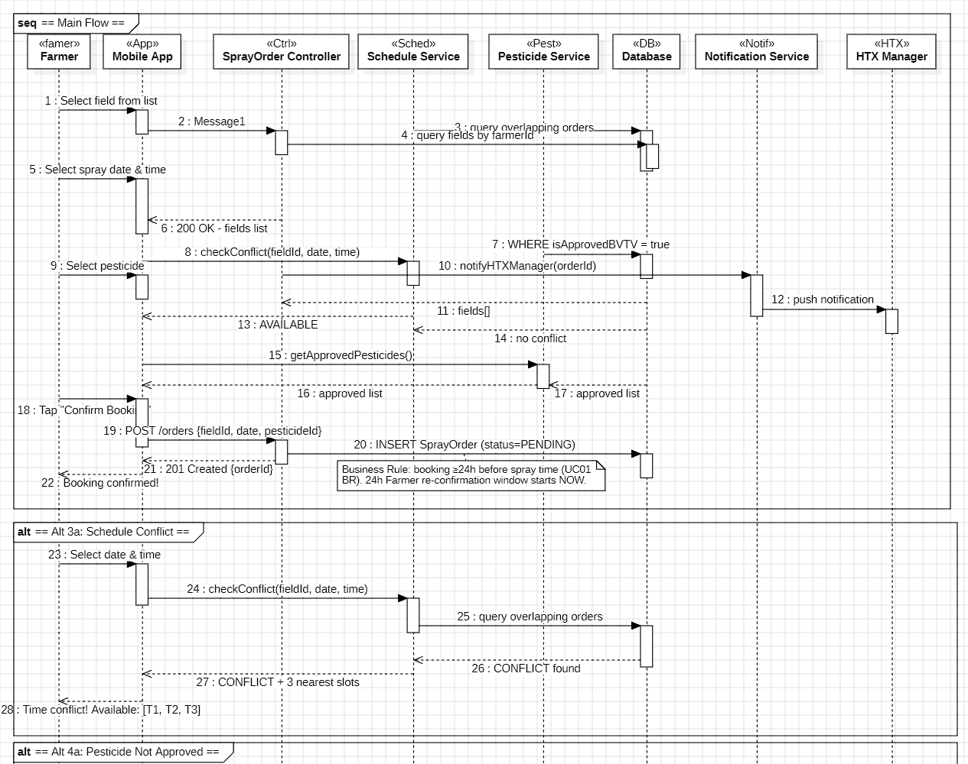

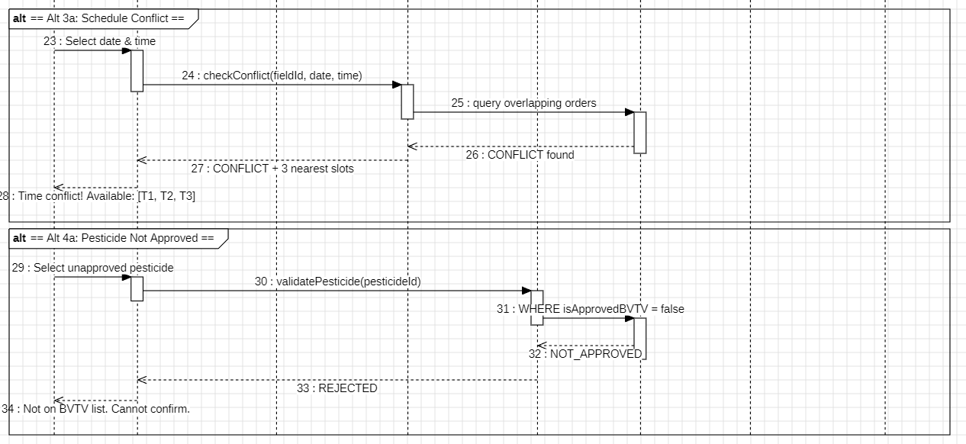

1.8 Sequence Diagram - UC03 On- site GPS Check- in
Linked UC(s): UC03
Linked FR(s): FR09, FR10, FR12, FR13
Happy path + Alt 3a (GPS outside 100m) + Alt 4a (offline / no 4G, IndexedDB cache, ≤30s sync per NFR06).

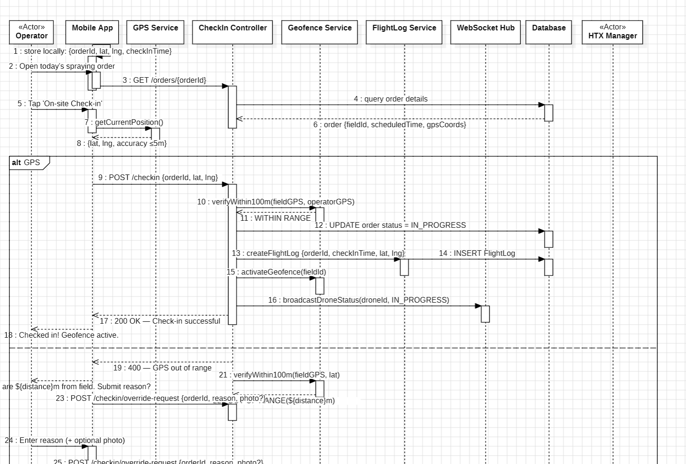

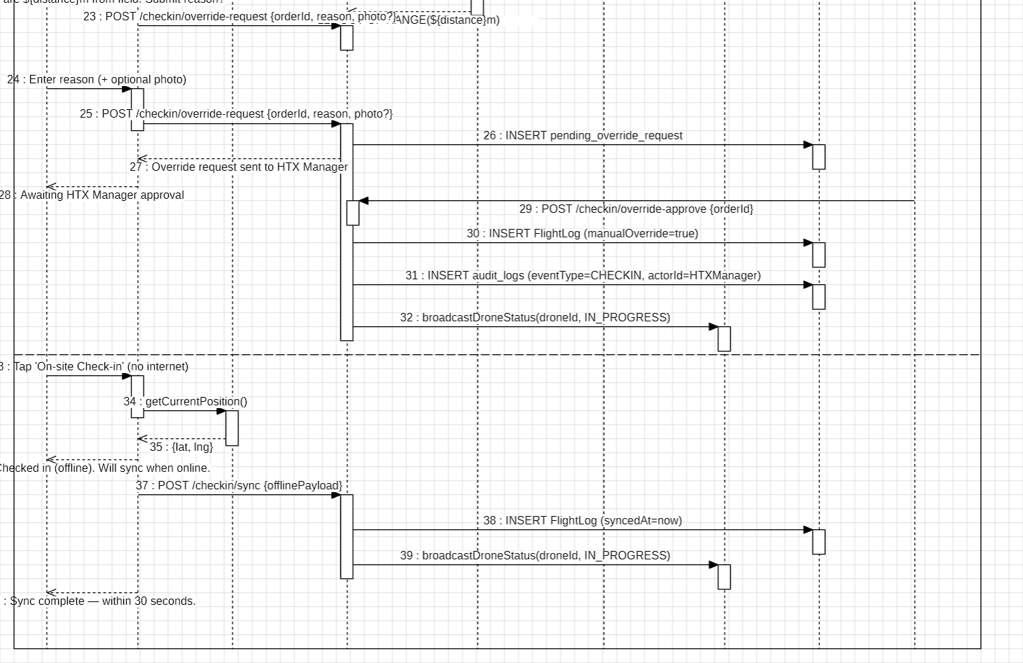

1.9 Sequence Diagram - UC04 Near Real- time Spraying Progress Monitoring
Linked UC(s): UC04
Linked FR(s): FR10,11,12,13
WebSocket loop + Alt 2a (connection lost >15s) + Alt 5a (geofence boundary crossing). When redrawing, use “information- level alert” / “boundary crossing” wording rather than “VIOLATION”, and “near real- time” rather than “real- time”, consistent with D2 v2.4 FR10/FR12.
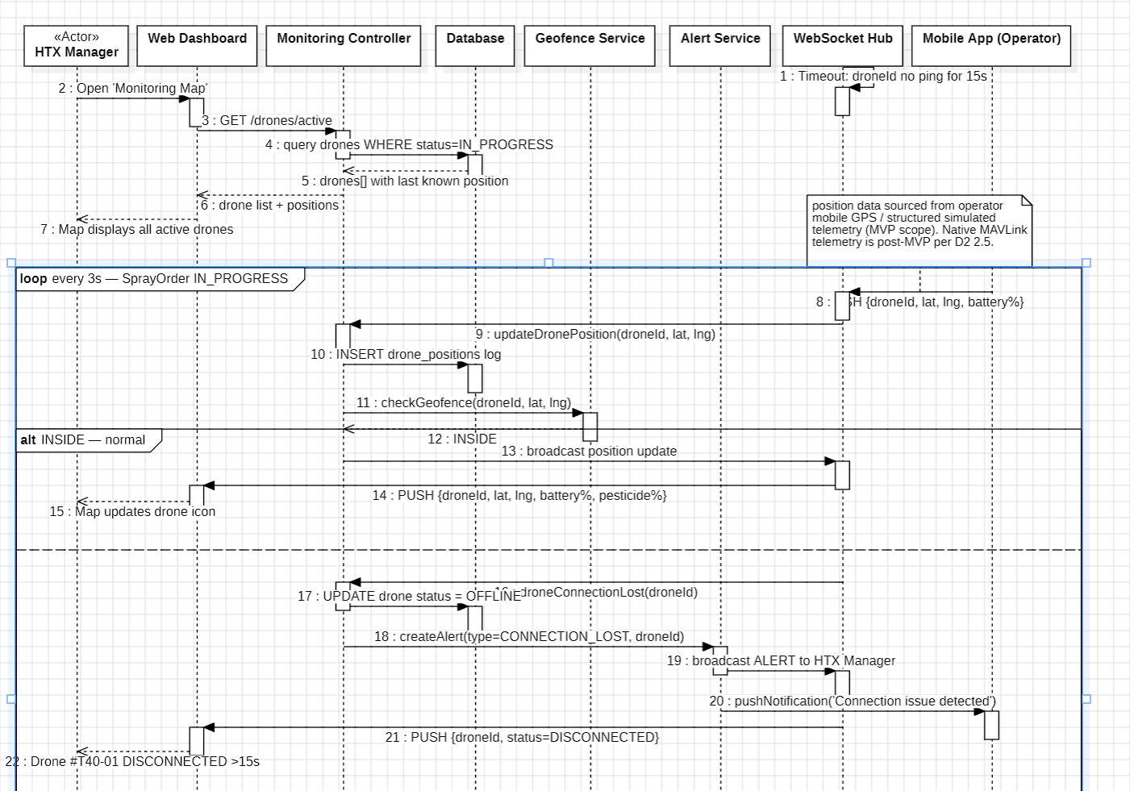
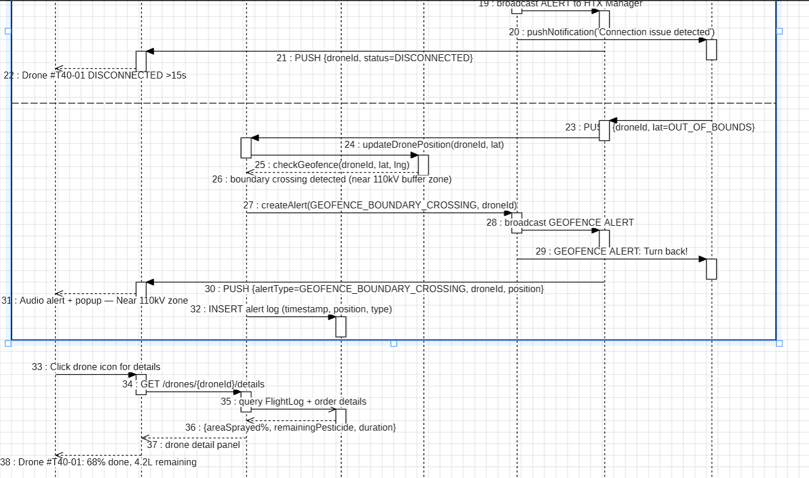

2. Entity- Relationship Diagram - Logical Model
The Logical ERD contains 14 entities derived directly from the Functional Requirements in D2 SRS. All entities satisfy Third Normal Form (3NF). Descriptions below carry the same hedging language as D2 for any item that depends on confirmation by an external authority (Decree 288/2025/ND- CP article references, Plant Protection Dept report layout, VietGAP/GlobalGAP field set).

2.1 Entity Inventory
Entity (Table) | Key Attributes | Description | Linked FR
users | userId (PK), fullName, email, passwordHash, role, isActive, createdAt | Accounts for all 5 roles (RBAC). role = ENUM(ADMIN, HTX_MANAGER, OPERATOR, FARMER, AGRONOMIST). Admin is modelled via the role attribute only - no concrete Admin subclass. | FR18
cooperatives | cooperativeId (PK), name, province, address, maxDrones=50, managerId (FK→users) | HTX entity. maxDrones = 50 is a configurable reference workload / validation baseline (D1 v1.6 |1.2), not a hard- coded system limit. | Scope (D1 |1.2)
fields | fieldId (PK), farmerId (FK→users), cooperativeId (FK), fieldName, cropType, areaHa, gpsPolygon, createdAt | GIS polygon as GeoJSON; areaHa auto- computed via PostGIS ST_Area() on INSERT. UC09 BR: closed- ring polygon, 0.1–100 ha. | FR01, FR02
spray_formulas | formulaId (PK), fieldId (FK→fields), pesticideId (FK→pesticides), dosageLPerHa, sprayCountPerSeason, configuredBy (FK→users) | 1:1 with fields. Agronomist configures the formula; per D2 v2.4 FR02 the final formula and dosage require confirmation by an authorized Agronomist or HTX Manager before mission dispatch (Agronomist.confirmDosage()). | FR02
drones | droneId (PK), cooperativeId (FK), serialNumber, model, tankCapacityL, batteryPercent, status (ENUM), gpsLat, gpsLng, updatedAt | Authoritative master record for FR21 (registered by HTX Manager/Admin via HTXManager.registerDrone()/updateDroneStatus()). Within MVP scope, gpsLat/gpsLng and batteryPercent come from the operator's mobile- app GPS (a mission- level proxy for drone position) or structured simulated telemetry, per D2 v2.4 |2.5 - not native drone sensor telemetry (MAVLink is post- MVP). | FR06, FR10, FR11, FR21
operators | operatorId (PK), userId (FK→users), certificateNumber, certificateExpiry, operationalStatus | Pilot sub- profile. certificateExpiry validated on every assignment (UC02); expired- certificate pilots are hidden from suggestions (UC02 Alt 4a). | FR07
spray_orders | orderId (PK), farmerId (FK→users), fieldId (FK→fields), droneId (FK→drones, nullable), operatorId (FK→operators, nullable), scheduledDate, actualStartTime, status (ENUM), statusReason, pestAmountL, cancelReason, createdAt | Central transactional table. droneId/operatorId are NULL while status=PENDING (order created in UC01, assigned later in UC02). statusReason ∈ {"Weather", "Needs Review", "Lacking safety confirmation", "Confirmation timeout"} per the UC06 escalation logic. | FR03–FR09
flight_logs | logId (PK), orderId (FK→spray_orders, 1:1), droneId (FK→drones), operatorId (FK→operators), checkInTime, checkOutTime, checkInLat, checkInLng, pesticideUsedL, areaSprayed, gpsTrail (JSONB), manualOverride, syncedAt | Compliance- support record for Decree 288/2025/ND- CP. gpsTrail = JSON array of {lat,lng,ts} every ~3s. manualOverride = TRUE marks a check- in approved by the HTX Manager under UC03 Alt 3a (GPS outside 100m) - per D2 v2.4 this requires HTX Manager approval, not pilot self- confirmation; the approval is additionally written to audit_logs. Checkout confirmation (UC07) is via the pilot's authenticated session (FR18 RBAC), not a biometric/PIN step. | FR09, FR13
pesticides | pesticideId (PK), name, activeIngredient, isApprovedBVTV, unit | BVTV- approved master registry. isApprovedBVTV is checked at booking (UC01 Alt 4a) and at order creation (FR03). | FR16
pesticide_stock | stockId (PK), cooperativeId (FK→cooperatives), pesticideId (FK→pesticides), stockL, lowStockThresholdL, updatedAt | Per- cooperative inventory, split from the pesticides master registry so stock can vary across cooperatives sharing the same approved list. Deducted after a COMPLETED spraying mission. | FR16
geofences | geofenceId (PK), fieldId (FK→fields, 1:1), boundaryPolygon (GeoJSON), bufferMeters=50, hazardZones (JSONB), isActive | Safety boundary. bufferMeters=50 is the default buffer around registered high- voltage power lines, informed by the Long An 110kV incident (Tuoi Tre, 2024; D1 v1.6 |1). Per D2 v2.4 FR12, the system issues information- level alerts only when a drone approaches or crosses this boundary - it does not directly control the drone, firmware, or autopilot; the pilot remains responsible for flight safety. | FR12
notifications | notificationId (PK), recipientId (FK→users), relatedOrderId (FK→spray_orders, nullable), channel, eventType, content, status, sentAt | Outbound message log. channel ∈ {SMS, ZALO, PUSH}. Triggers: booking received/confirmed, spraying started/completed/suspended, alerts. | FR17
audit_logs | auditId (PK), eventType, actorId (FK→users), actorRole, targetEntityId, targetEntityType, description, ipAddress, occurredAt | Append- only audit trail (never updated or deleted). Covers weather overrides (UC01/UC06), report exports (UC08), data- sharing access approvals (UC10), and GPS check- in overrides (UC03 Alt 3a). Supports NFR05's “all security- relevant events written to an immutable audit log” outcome. | NFR05, FR13
reports | reportId (PK), generatedBy (FK→users), cooperativeId (FK→cooperatives), reportType, periodStart, periodEnd, fileFormat, fileUrl, exportedAt | Compliance- support export record. reportType ∈ {DECREE_288, VIETGAP, GLOBALGAP}. Per D2 v2.4, the report layout is aligned with Plant Protection Dept reporting fields, but the exact official format is subject to authority confirmation (FR14); the VietGAP/GlobalGAP field set is a project- defined minimum, pending stakeholder validation with contracted export companies (FR15). | FR14, FR15

2.2 Relationships & Cardinality
From Entity | Cardinality | To Entity | FK Column | Rationale
users | 1: 0..* | spray_orders (as Farmer) | farmerId | One farmer places many spray orders
users | 1: 0..1 | operators | userId | A user may optionally hold an Operator sub- profile
users | 1: 0..* | reports | generatedBy | A user (HTX Manager) generates many reports
cooperatives | 1: 1..* | drones | cooperativeId | One cooperative manages 1..* drones (≤50, configurable)
cooperatives | 1: 0..* | pesticide_stock | cooperativeId | Per- cooperative pesticide inventory
fields | 1: 1 | spray_formulas | fieldId | Each field has exactly one spray formula
fields | 1: 0..* | spray_orders | fieldId | One field can have many orders across seasons
fields | 1: 1 | geofences | fieldId | Each field has exactly one safety geofence
drones | 1: 0..* | spray_orders | droneId (nullable) | A drone may be assigned to many orders over time
spray_orders | 1: 0..1 | flight_logs | orderId | A completed/suspended/cancelled order generates at most one log
flight_logs | 0.* : 1..* | reports | junction: report_flight_logs | A report aggregates ≥1 flight logs; a log may appear in 0..* reports
pesticides | 1: 0..* | spray_formulas | pesticideId | One pesticide may be used in many formulas
pesticides | 1: 0..* | pesticide_stock | pesticideId | One pesticide is stocked across many cooperatives
spray_orders | 1: 0..* | notifications | relatedOrderId (nullable) | One order may trigger many notifications
users | 1: 0..* | audit_logs | actorId | One user is the actor in many audit events

2.3 Normalization Proof (3NF)
Normal Form | Rule | How Satisfied in AgriUAV | Status
1NF | All attributes are atomic (no repeating groups). | gpsTrail, hazardZones stored as JSONB (single atomic column); gpsPolygon as a single GeoJSON string. | Satisfied
2NF | No partial dependency on a composite key. | All tables use single- column surrogate UUID v4 primary keys. No composite PKs exist. | Trivially satisfied
3NF | No transitive dependency: every non- key attribute depends only on the PK. | spray_orders does not store cooperativeId (derived via drones/fields), pilot name (via operatorId→users), or field area (via fieldId→fields). | Satisfied

2.4 FR21 Modeling Decision - “No Standalone Use Case”
FR21 (“HTX Manager and Admin register and manage drone master records”) is implemented entirely through the existing drones entity and the HTXManager.registerDrone()/updateDroneStatus() methods on the Class Diagram. Per the D2 traceability note (5.1) and the audit reasoning in Entry #20, FR21 is treated as a prerequisite data- management function rather than a standalone use case: it is read by UC02 (drone status/availability check for assignment) and UC08 (drone identifier listing in the compliance report). No UC11 is introduced in the Use Case Diagram - the use- case set stays at 10 UCs, matching D2 and UseCaseDiagram

3. Physical Data Model
Technology stack: PostgreSQL 16 + PostGIS 3.4 (spatial queries) + TimescaleDB 2.x (time- series telemetry). All UUIDs are v4. HYPERTABLE rows indicate TimescaleDB time- series partitioning. Retention note: flight_logs, drone_positions, and audit_logs are retained for at least 5 years as a working assumption pending confirmation of the specific Decree 288/2025/ND- CP article reference (per D2 | 2.4) - not asserted here as a confirmed legal minimum.

Table: users
Column | Data Type | Null | Key | Default | Description
userId | VARCHAR(36) | NO | PK | UUID v4 | Primary key
fullName | VARCHAR(255) | NO |  |  | Full display name
email | VARCHAR(255) | NO | UNIQUE |  | Login email
passwordHash | VARCHAR(255) | NO |  |  | bcrypt hash (cost 12)
role | ENUM(5) | NO |  |  | ADMIN│HTX_MANAGER│OPERATOR│FARMER│AGRONOMIST
isActive | BOOLEAN | NO |  | TRUE | Soft delete flag
createdAt | TIMESTAMP | NO |  | NOW() | Account creation UTC

Table: cooperatives
Column | Data Type | Null | Key | Default | Description
cooperativeId | VARCHAR(36) | NO | PK | UUID v4
name | VARCHAR(255) | NO |  |  | Official cooperative name
province | VARCHAR(100) | NO |  |  | Province in the Mekong Delta
address | TEXT | YES
maxDrones | INTEGER | NO |  | 50 | Configurable reference workload, not a hard limit (D1 v1.6 |1.2)
managerId | VARCHAR(36) | NO | FK→users |  | HTX Manager account

Table: fields
Column | Data Type | Null | Key | Default | Description
fieldId | VARCHAR(36) | NO | PK | UUID v4
farmerId | VARCHAR(36) | NO | FK→users |  | Owner farmer
cooperativeId | VARCHAR(36) | NO | FK→cooperatives |  | Managing cooperative
fieldName | VARCHAR(255) | NO
cropType | VARCHAR(100) | NO |  |  | e.g. rice, corn
areaHa | DECIMAL(8,4) | NO |  |  | Auto- computed from gpsPolygon (PostGIS ST_Area)
gpsPolygon | TEXT | NO |  |  | GeoJSON polygon - GIST index
createdAt | TIMESTAMP | NO |  | NOW()
INDEX (gpsPolygon) - PostGIS GIST index for spatial queries.

Table: drones
Column | Data Type | Null | Key | Default | Description
droneId | VARCHAR(36) | NO | PK | UUID v4
cooperativeId | VARCHAR(36) | NO | FK→cooperatives |  | Owner cooperative
serialNumber | VARCHAR(100) | NO | UNIQUE |  | Decree 288/2025 drone identifier (FR21)
model | VARCHAR(100) | NO |  |  | e.g. DJI Agras T40
tankCapacityL | DECIMAL(5,2) | NO
batteryPercent | SMALLINT | NO |  | 100 | Mobile- GPS proxy or simulated telemetry (MVP)
status | ENUM(4) | NO |  | IDLE | IDLE│FLYING│MAINTENANCE│OFFLINE
gpsLat | DECIMAL(9,6) | YES |  |  | Mobile- GPS proxy or simulated telemetry (MVP)
gpsLng | DECIMAL(9,6) | YES |  |  | Mobile- GPS proxy or simulated telemetry (MVP)
updatedAt | TIMESTAMP | NO |  | NOW() | Auto- updated on WebSocket push
INDEX (status) - B- Tree index for availability queries. FR21: HTXManager.registerDrone()/updateDroneStatus() write to this table.

Table: operators
Column | Data Type | Null | Key | Default | Description
operatorId | VARCHAR(36) | NO | PK | UUID v4
userId | VARCHAR(36) | NO | FK→users, UNIQUE
certificateNumber | VARCHAR(50) | NO | UNIQUE |  | Decree 288/2025 pilot certificate
certificateExpiry | DATE | NO |  |  | Validated on every assignment (UC02)
operationalStatus | VARCHAR(50) | NO |  | 'ACTIVE' | ACTIVE│ON_LEAVE│SUSPENDED
INDEX (certificateExpiry) - filters expired- certificate pilots from assignment suggestions (UC02 Alt 4a).

Table: spray_formulas
Column | Data Type | Null | Key | Default | Description
formulaId | VARCHAR(36) | NO | PK | UUID v4
fieldId | VARCHAR(36) | NO | FK→fields, UNIQUE |  | 1:1 with fields
pesticideId | VARCHAR(36) | NO | FK→pesticides
dosageLPerHa | DECIMAL(6,2) | NO |  |  | Dosage per hectare (FR02)
sprayCountPerSeason | SMALLINT | NO
configuredBy | VARCHAR(36) | NO | FK→users |  | Agronomist who configured the formula

Table: spray_orders
Column | Data Type | Null | Key | Default | Description
orderId | VARCHAR(36) | NO | PK | UUID v4
farmerId | VARCHAR(36) | NO | FK→users
fieldId | VARCHAR(36) | NO | FK→fields
droneId | VARCHAR(36) | YES | FK→drones | NULL | NULL until assigned (UC02)
operatorId | VARCHAR(36) | YES | FK→operators | NULL | NULL until assigned
scheduledDate | TIMESTAMP | NO |  |  | Requested spray datetime
actualStartTime | TIMESTAMP | YES |  | NULL | Set on check- in
status | ENUM(6) | NO |  | PENDING | PENDING→ASSIGNED→IN_PROGRESS→COMPLETED│SUSPENDED│CANCELLED
statusReason | TEXT | YES |  | NULL | “Weather”│“Needs Review”│“Lacking safety confirmation”│“Confirmation timeout”
pestAmountL | DECIMAL(6,2) | YES |  | NULL | Calculated on assignment
cancelReason | TEXT | YES |  | NULL
createdAt | TIMESTAMP | NO |  | NOW()
INDEX (fieldId, scheduledDate) - conflict checks (FR04). INDEX (status) - active- order filtering. “No- assign” path keeps status = PENDING (UC02 Alt 3a), not CANCELLED.

Table: flight_logs
Column | Data Type | Null | Key | Default | Description
logId | VARCHAR(36) | NO | PK | UUID v4
orderId | VARCHAR(36) | NO | FK→spray_orders, UNIQUE |  | 1:1 with spray_orders
droneId | VARCHAR(36) | NO | FK→drones
operatorId | VARCHAR(36) | NO | FK→operators
checkInTime | TIMESTAMP | NO
checkOutTime | TIMESTAMP | YES |  | NULL
checkInLat | DECIMAL(9,6) | NO
checkInLng | DECIMAL(9,6) | NO
pesticideUsedL | DECIMAL(6,2) | YES |  | NULL
areaSprayed | DECIMAL(8,4) | YES |  | NULL
gpsTrail | JSONB | YES |  | NULL | {lat,lng,ts} approx. every 3s
manualOverride | BOOLEAN | NO |  | FALSE | TRUE only after HTX Manager approval of a GPS- out- of- 100m check- in (UC03 Alt 3a)
syncedAt | TIMESTAMP | YES |  | NULL | Offline sync timestamp (NFR06, ≤30s)
HYPERTABLE (checkInTime), partitioned monthly. INDEX (droneId, checkInTime). Checkout confirmation (UC07) is via the pilot's authenticated session (FR18), not a biometric/PIN field.

Table: drone_positions (derived - supports FR10/NFR01, not one of the 14 logical entities)
Column | Data Type | Null | Key | Default | Description
posId | BIGSERIAL | NO | PK | AUTO | Auto- increment for high- volume inserts
droneId | VARCHAR(36) | NO | FK→drones
orderId | VARCHAR(36) | YES | FK→spray_orders | NULL | NULL if idle telemetry
lat | DECIMAL(9,6) | NO
lng | DECIMAL(9,6) | NO
recordedAt | TIMESTAMP | NO |  | NOW()
HYPERTABLE (recordedAt), partitioned weekly; retention per the working 5- year assumption above. INDEX (droneId, recordedAt DESC) - latest- position queries for the live map.

Table: pesticides
Column | Data Type | Null | Key | Default | Description
pesticideId | VARCHAR(36) | NO | PK | UUID v4
name | VARCHAR(255) | NO
activeIngredient | VARCHAR(255) | NO
isApprovedBVTV | BOOLEAN | NO |  | FALSE
unit | VARCHAR(20) | NO |  | 'L'
INDEX (isApprovedBVTV) - filters the booking dropdown to approved pesticides.

Table: pesticide_stock
Column | Data Type | Null | Key | Default | Description
stockId | VARCHAR(36) | NO | PK | UUID v4
cooperativeId | VARCHAR(36) | NO | FK→cooperatives
pesticideId | VARCHAR(36) | NO | FK→pesticides
stockL | DECIMAL(8,2) | NO |  | 0
lowStockThresholdL | DECIMAL(8,2) | NO
updatedAt | TIMESTAMP | NO |  | NOW()
UNIQUE (cooperativeId, pesticideId) - one stock record per pesticide per cooperative.

Table: geofences
Column | Data Type | Null | Key | Default | Description
geofenceId | VARCHAR(36) | NO | PK | UUID v4
fieldId | VARCHAR(36) | NO | FK→fields, UNIQUE
boundaryPolygon | TEXT | NO |  |  | GeoJSON - GIST index
bufferMeters | INTEGER | NO |  | 50 | Default buffer around registered 110kV lines (FR12)
hazardZones | JSONB | YES |  | NULL | {type:'POWERLINE'│'RESIDENTIAL', coords}
isActive | BOOLEAN | NO |  | FALSE | Set TRUE on UC03 check- in
Alert behaviour: information- level only - the system never directly controls the drone, firmware, or autopilot.

Table: notifications
Column | Data Type | Null | Key | Default | Description
notificationId | VARCHAR(36) | NO | PK | UUID v4
recipientId | VARCHAR(36) | NO | FK→users
relatedOrderId | VARCHAR(36) | YES | FK→spray_orders | NULL
channel | VARCHAR(20) | NO |  |  | SMS│ZALO│PUSH
eventType | VARCHAR(50) | NO
content | TEXT | NO
status | VARCHAR(20) | NO |  | 'PENDING' | PENDING│SENT│FAILED
sentAt | TIMESTAMP | YES |  | NULL
INDEX (recipientId, sentAt DESC) - delivery history.

Table: audit_logs
Column | Data Type | Null | Key | Default | Description
auditId | VARCHAR(36) | NO | PK | UUID v4
eventType | ENUM(7) | NO |  |  | ORDER_CREATED│ORDER_CANCELLED│WEATHER_OVERRIDE│REPORT_EXPORTED│DATA_ACCESS│CHECKIN│CHECKOUT
actorId | VARCHAR(36) | NO | FK→users
actorRole | ENUM(5) | NO
targetEntityId | VARCHAR(36) | NO
targetEntityType | VARCHAR(50) | NO
description | TEXT | NO
ipAddress | VARCHAR(45) | YES |  | NULL
occurredAt | TIMESTAMP | NO |  | NOW()
Append- only (DB- level trigger blocks UPDATE/DELETE). HYPERTABLE (occurredAt). INDEX (actorId, occurredAt DESC). GPS check- in overrides (UC03 Alt 3a) are logged here with eventType = CHECKIN.

Table: reports
Column | Data Type | Null | Key | Default | Description
reportId | VARCHAR(36) | NO | PK | UUID v4
generatedBy | VARCHAR(36) | NO | FK→users
cooperativeId | VARCHAR(36) | NO | FK→cooperatives
reportType | ENUM(3) | NO |  |  | DECREE_288│VIETGAP│GLOBALGAP
periodStart | DATE | NO
periodEnd | DATE | NO
fileFormat | VARCHAR(10) | NO |  |  | PDF│XLSX
fileUrl | TEXT | NO
exportedAt | TIMESTAMP | NO |  | NOW()
DECREE_288 layout aligned to Plant Protection Dept fields, exact official format pending authority confirmation (FR14). VietGAP/GlobalGAP field set is project- defined and pending export- company validation (FR15).

4. Data Dictionary - Key Fields Reference
Summarises the most business- critical fields across all tables - those directly implementing a Functional Requirement, a Decree 288/2025/ND- CP compliance- support obligation, or a consistency fix.
Table | Field | Data Type | Constraint | Business Rule / Source
users | role | ENUM | NOT NULL | Controls RBAC (FR18); 5 values incl. AGRONOMIST. ADMIN has no concrete subclass - full access via role check only.
fields | gpsPolygon | TEXT | NOT NULL | Closed- ring GeoJSON; area must be 0.1–100 ha (UC09 BR).
fields | areaHa | DECIMAL(8,4) | NOT NULL | Computed via PostGIS ST_Area() on INSERT/UPDATE; never entered manually.
drones | status | ENUM | NOT NULL | IDLE→FLYING (assignment) →IDLE (check- out) →MAINTENANCE (manual); OFFLINE after >15s no signal (UC04 Alt 2a).
drones | batteryPercent / gpsLat / gpsLng | SMALLINT / DECIMAL | NOT NULL / NULLABLE | Within MVP scope, sourced from the operator's mobile- GPS proxy or structured simulated telemetry (D2 v2.4 |2.5); native MAVLink sensor telemetry is post- MVP.
spray_orders | status | ENUM | NOT NULL | PENDING→ASSIGNED→IN_PROGRESS→COMPLETED│SUSPENDED│CANCELLED; each transition timestamped.
spray_orders | statusReason | TEXT | NULLABLE | “Weather” / “Needs Review” / “Lacking safety confirmation” / “Confirmation timeout” - set by the UC06 weather- escalation logic.
spray_orders | droneId / operatorId | VARCHAR (FK) | NULLABLE | NULL while PENDING - orders are created (UC01) before assignment (UC02); the “no- assign” path keeps status = PENDING, not CANCELLED.
operators | certificateExpiry | DATE | NOT NULL | Validated on every assignment (UC02); expired pilots are hidden from suggestions (UC02 Alt 4a).
flight_logs | gpsTrail | JSONB | NULLABLE | {lat,lng,ts} approx. every 3s; compliance- support evidence, not a legally confirmed minimum interval.
flight_logs | manualOverride | BOOLEAN | NOT NULL DEFAULT FALSE | FIX: TRUE only after HTX Manager approval of a GPS- out- of- 100m check- in (UC03 Alt 3a). The Pilot can no longer self- confirm an override; approval is also written to audit_logs (eventType = CHECKIN).
flight_logs | checkout confirmation (process rule, not a column) | — | — | FIX: Confirmed via the Pilot's authenticated session (FR18 RBAC) per UC07 step 4 - not a biometric/PIN field. An earlier draft's fingerprint/PIN requirement was removed in D2 v2.4 as a hidden requirement.
pesticides | isApprovedBVTV | BOOLEAN | NOT NULL | FALSE blocks order confirmation (UC01 Alt 4a) and hides the pesticide from the booking dropdown.
pesticide_stock | stockL / lowStockThresholdL | DECIMAL | NOT NULL | Deducted after a COMPLETED mission; low- stock alert when stockL < lowStockThresholdL (FR16).
geofences | bufferMeters | INTEGER DEFAULT 50 | NOT NULL | Default 50m buffer around registered 110kV lines, informed by the Long An incident (Tuoi Tre, 2024); configurable per field.
geofences | alert behaviour (process rule, not a column) | — | — | FIX: information- level alert only when a drone approaches/crosses the boundary; the system never directly controls the drone, firmware, or autopilot (FR12). “VIOLATION” wording removed throughout this document.
notifications | channel | VARCHAR | NOT NULL | SMS│ZALO│PUSH; decoupled from spray_orders for multi- channel delivery tracking (FR17).
audit_logs | eventType / occurredAt | ENUM / TIMESTAMP | NOT NULL | Append- only; never updated or deleted; supports NFR05's immutable- audit- log outcome.
reports | reportType | ENUM | NOT NULL | DECREE_288 (FR14, layout aligned to PPD fields, exact official format pending authority confirmation) │ VIETGAP/GLOBALGAP (FR15, project- defined minimum field set pending export- company validation).
drone_positions | recordedAt | TIMESTAMP | NOT NULL | TimescaleDB chunk key; retention follows the working 5- year assumption (|3), pending confirmation of the specific Decree 288 article reference.

5. Traceability Matrix - FR ↔ Model Elements
Maps all 21 Functional Requirements from D2 SRS (FR01–FR21, including the new FR21 drone registry requirement) to the model elements in D3: Class/Entity, DB Table, Use Case, and Diagram. The Diagram column states exactly which diagrams cover each FR, including flags where the diagram itself still needs a correction before it can be considered fully synchronized.

5.1 Full Matrix
FR ID | Short Description | Priority | Class/Entity | DB Table | UC | Diagram
FR01 | Create/edit field maps | Must | Field | fields | UC09 | Class Diagram, AD1
FR02 | Calculate per- zone dosage + Agronomist/HTX confirmation | Must | Field, SprayFormula, Agronomist | fields, spray_formulas | UC09 | Class Diagram, AD1
FR03 | Book spraying ≤ 5 steps | Must | SprayOrder | spray_orders | UC01 | Class Diagram, Sequence UC01, AD1
FR04 | Schedule- conflict alerts | Must | SprayOrder | spray_orders (idx fieldId+date) | UC01 | Class Diagram, Sequence UC01 Alt3a, AD1
FR05 | Calendar view (HTX Manager) | Should | HTXManager, SprayOrder | spray_orders | UC01, UC02 (indirect) | Class Diagram (viewCalendar())
FR06 | Rule- based drone–pilot assignment recommendation | Must | Drone, SprayOrder | drones, spray_orders | UC02 | Class Diagram, AD1
FR07 | Pilot records (certificate) | Must | Operator | operators | UC02, UC08 | Class Diagram, AD1
FR08 | Assignment notification to Operator | Must | SprayOrder, Notification | spray_orders, notifications | UC02 | Class Diagram, AD1
FR09 | GPS check- in / check- out | Must | FlightLog, Operator | flight_logs | UC03, UC07 | Class Diagram, Sequence UC03 ⚠, AD2 (UC07)
FR10 | Near real- time map ≤ 3s (telemetry proxy) | Must | Drone | drone_positions | UC03, UC04, UC05 | Class Diagram, Sequence UC04, AD2
FR11 | Battery/pesticide/geofence/weather info- level alerts | Must | Drone, Geofence | drones, geofences | UC04, UC05, UC06 | Class Diagram, Sequence UC04 Alt5a, AD2
FR12 | Geofencing - 50m buffer, information- level only | Must | Geofence | geofences | UC03, UC04 | Class Diagram, Sequence UC03 Alt3a ⚠, Sequence UC04 Alt5a, AD2
FR13 | Complete flight logs (compliance- support) | Must | FlightLog, AuditLog | flight_logs, drone_positions, audit_logs | UC02, UC04, UC07, UC08 | Class Diagram, Sequence UC03/UC04, AD1, AD2
FR14 | Export Plant Protection Dept report (format pending confirmation) | Must | Report | reports | UC08, UC10 | Class Diagram, ERD |3
FR15 | Export VietGAP/GlobalGAP (project- defined minimum field set) | Should | Report | reports | UC08, UC10 | Class Diagram, ERD |3
FR16 | Pesticide inventory management | Should | Pesticide, PesticideStock | pesticides, pesticide_stock | UC01, UC07 | Class Diagram, AD2 (stock deduction)
FR17 | SMS/Zalo notifications | Should | Notification | notifications | UC01, UC06, UC07 | Class Diagram, Sequence UC01 Alt, AD1, AD2
FR18 | RBAC - 5 roles | Must | User (abstract) | users (role ENUM) | All UCs (cross- cutting) | Class Diagram, Use Case Diagram (Admin generalization)
FR19 | Dark mode UX | Could | — | — | Cross- cutting UX | No dedicated diagram
FR20 | Multi- language VI/EN | Could | — | — | Cross- cutting i18n | No dedicated diagram
FR21 | Drone master record registry | Must | Drone, HTXManager | drones | UC02, UC08 (prerequisite read - no standalone UC, |2.4) | Class Diagram

5.2 Coverage Summary
Sequence and Activity Diagram percentages are computed directly from the Linked- FR list declared in each diagram's own header (AD1_BookingFlow, AD2_MonitoringAlertFlow) or the Sequence Diagram sections carried forward from D3 old version not estimated. They will need to be re-verified once Sequence Diagram UC03 is redrawn (1.8).
Coverage Dimension | Detail | Count | Coverage % | Note
Total FRs | 21 FRs (15 Must, 4 Should, 2 Could) | 21/21 | 100% | All FRs documented in D2 SRS v2.4
Traced to Class Diagram | 19/21 FRs (FR19, FR20 are cross- cutting UX/i18n) | 19/21 | ≈90% | FR19, FR20 explicitly excluded - no class represents UI theme or i18n
Traced to DB Table | 19/21 FRs | 19/21 | ≈90% | Same exclusions as Class Diagram
Traced to Sequence Diagram | FR03,04,09,10,11,12,13,16,17 (per Sequence UC01/UC03/UC04 headers) | 9/21 | ≈43% | UC09 (FR01,02) and UC08/UC10 (FR14,15) have no dedicated Sequence Diagram
Traced to Activity Diagram | FR01,02,03,04,06,07,08,09,10,11,12,13,16,17,18 (per AD1_v3/AD2_v3 headers) | 15/21 | ≈71% | FR05,14,15,19,20,21 are not in either AD1 or AD2's declared FR list
Traced to ≥1 UC | 19/21 FRs (Direct / Indirect / Cross- cutting / Prerequisite per D2 v2.4 |5.1 Coverage Type) | 19/21 | ≈90% | FR19, FR20 are not tied to any UC

6. AI Artifact Audit Log - Entries #14 - 20
Entries #14 - 19 are carried forward unchanged from D3 (the historical record of AI interactions is not rewritten retroactively). Legend: Accepted | Rejected | Refined | Added | Hallucination/Bias detected | Open / not yet resolved.

Entry #14 - W5
Field | Content
DTC Component | Abstraction
AI Output (tóm tắt) | AI đề xuất 6 sub- processes cho DFD Level 1: (1) Field Mgmt, (2) Scheduling, (3) Fleet Dispatch, (4) Monitoring, (5) Notification, (6) User Management. 8 external entities.
Decision & Refinement | Chấp nhận 4 sub- processes cốt lõi: Field Mgmt, Scheduling, Monitoring, Compliance. Loại Notification và User Mgmt - đây là cross- cutting services, không phải standalone process ở L1 theo Gane- Sarson convention. AI không phân biệt được cross- cutting vs standalone process - Human Delta quan trọng.
Verification | Cross- check DFD balanced rule - tất cả data flow vào/ra Level 0 phải xuất hiện đúng ở Level 1.
AI Tool / Prompt | Claude - “Đề xuất external entities, data flows và sub- processes cho DFD Level 1 của AgriUAV Platform.”

Entry #15 - W6
Field | Content
DTC Component | Abstraction
AI Output (tóm tắt) | AI sinh Drone class với 25+ attributes (firmware_version, sensor_list, obstacle_avoidance_level...) và 18 methods bao gổm cả low- level hardware ops.
Decision & Refinement | Chấp nhận 9 core attributes cho Drone: droneId, serialNumber, model, tankCapacityL, batteryPercent, gpsLat, gpsLng, status, cooperativeId. Loại 16 attributes còn lại - thuộc phạm vi drone manufacturer SDK, không thuộc IS database. Gộp 5 methods phức tạp thành 3 core: isAvailable(), updatePosition(), sendAlert().
Verification | Kiểm tra với FR06 (dispatch cần status), FR10 (monitoring cần gpsLat/Lng), FR11 (alert cần batteryPercent) - 9 attributes đủ để fulfill tất cả FR liên quan.
AI Tool / Prompt | Claude - “Vẽ Class Diagram cho AgriUAV Platform với đầy đủ attributes và methods.”

Entry #16 - W6
Field | Content
DTC Component | Process / Algorithm
AI Output (tóm tắt) | AI sinh sequence cho UC03 với 5 messages (happy path only). Không có alternative flows, không có offline scenario.
Decision & Refinement | Chấp nhận happy path cơ bản. Bổ sung ALT 3a: GPS outside 100m radius → manual override với reason (FR09 business rule). Bổ sung ALT 4a: Offline mode (no 4G) → local cache → auto- sync ≤30s khi reconnect (NFR06). v1.4: chuẩn hóa thuật ngữ cache offline thành IndexedDB.
Verification | Cross- check với D2 SRS NFR06 (offline ≤30s sync, IndexedDB) và UC03 Alt flows.
AI Tool / Prompt | Claude - “Tạo Sequence Diagram cho UC03 - On- site GPS Check- in.”

Entry #17 - W6
Field | Content
DTC Component | Process / Algorithm
AI Output (tóm tắt) | AI đề xuất activity diagram tuyến tính (sequential) cho AD2: check geofence → check battery → check weather → update map. Không có fork/join, escalation timers, repeat loop, swim lanes.
Decision & Refinement | PHẢN BIỆN: Sequential diagram sai về mặt kỹ thuật - geofence alert có thể bị delay khi đang wait weather API response (drone bay 5–7 m/s, 1s = 5–7m drift). Thiết kế lại với fork/join 3 checks đồng thời, escalation timers (5 phút UC05, 10 phút UC06, force- suspend 30 phút), repeat loop, swim lanes.
Verification | Cross- check với UC05/UC06 escalation trong D2 SRS. Tham chiếu DJI Agras T40: tốc độ bay tối đa 7 m/s.
AI Tool / Prompt | Claude - “Thiết kế Activity Diagram cho quy trình monitoring drone đang bay, 3 loại alert, escalation timers, parallel processing.”

Entry #18 - W8
Field | Content
DTC Component | Pattern Recognition
AI Output (tóm tắt) | AI kết luận Microservices ‘tốt nhất cho scalability’ với reasoning generic (Netflix/Uber style). Event- Driven xếp hạng 2.
Decision & Refinement | AI bias toward ‘trending architecture’ - Microservices overhead không phù hợp scope HTX ĐBSCL (1 cooperative = 50 drones = 5 modules; HTX không có DevOps team; inter- service latency ~50–100ms không phù hợp NFR01 ≤3s; team 5 SV/10 tuần). Final choice: Layered Architecture.
Verification | NFR01 (≤3s), NFR04 (50- drone reference workload), NFR07 (maintainability) - Layered thoả mãn tất cả.
AI Tool / Prompt | Claude - “So sánh Layered vs Microservices vs Event- Driven cho AgriUAV HTX ĐBSCL ~50 drones.”

Entry #19 - W9
Field | Content
DTC Component | Process / Algorithm
AI Output (tóm tắt) | AI đề xuất 6 STRIDE threats generic (Spoofing, Tampering, Repudiation, Info Disclosure, DoS, EoP) với mitigation generic (JWT, HTTPS, logging, rate limiting).
Decision & Refinement | STRIDE framework. Tinh chỉnh từng threat: Spoofing → ‘Fake GPS check- in’ (100m radius + manualOverride flag); Tampering → ‘WebSocket MITM inject false telemetry’ (TLS 1.3 + message signing); Repudiation → append- only FlightLog + DB audit trigger; Information Disclosure → gpsTrail AES- 256 + RBAC field- level; EoP → JWT role tampering (server- side validation).
Verification | OWASP Top 10, NFR05 (TLS 1.3, AES- 256, JWT), Decree 288/2025/NĐ- CP append- only audit requirement (working assumption).
AI Tool / Prompt | Claude - “STRIDE threat model AgriUAV: airspace data, PII nông dân, telemetry, compliance logs.”

Entry #20 - W6
Field | Content
DTC Component | Pattern Recognition / Consistency Audit
AI Output (tóm tắt) | Claude rà soát D3 v1.4 đối chiếu với D1 v1.6 và D2 v2.4 (đã có các bản sửa UC10 actor, UC03 Alt3a, UC07 bỏ biometric, telemetry semantics, FR21 mới, 5 roles). Phát hiện 5 nhóm vấn đề đồng bộ: (1) Use Case Diagram vẫn chưa tồn tại như một artifact riêng; (2) DFD Level 1 thiếu rationale khi loại Operations Dept, đã từng mất 5 data flow (n1–n5); (3) Class Diagram chưa có method cho FR21 và confirmDosage() cho FR02; (4) ngôn ngữ “GEOFENCE VIOLATION” mâu thuẫn với “information- level alert” của FR12; (5) Sequence Diagram UC03 Alt 3a vẫn cho phép Pilot tự xác nhận override GPS - mâu thuẫn với D2 v2.4.
Decision & Refinement | Tạo Use Case Diagram mới (UseCaseDiagram_v1.5.puml) - đóng gap (1). Cập nhật DFD (level0_v1.5, level1_v1.5): loại Operations Dept có rationale; khôi phục n1–n5; Export Company → “post- MVP” - đóng gap (2). Cập nhật Class Diagram (v1.5): thêm registerDrone()/updateDroneStatus() (FR21), confirmDosage() (FR02), requestCheckInOverride() - đóng gap (3) và một phần gap (5). Chuẩn hóa “VIOLATION” → “information- level alert” trong core content - đóng một phần gap (4). Sequence UC03 CHƯA được vẽ lại (theo yêu cầu Minh - UML để trống, tự paste sau) - ghi thành outstanding item, KHÔNG tự ý coi là đã đóng. Xác nhận “không có UC11” cho FR21 (giữ nguyên từ D2 v2.4 | 5.1). Viết lại Traceability Matrix cho 21 FR, % coverage tính trực tiếp từ Linked- FR header của từng diagram.
Verification | Đối chiếu trực tiếp với D1 v1.6, D2 v2.4 (FR01–FR21, UC01–UC10, NFR04/NFR05 hedge), ClassDiagram_v1.5.puml, UseCaseDiagram_v1.5.puml, DFD_Agriuav_level0_v1.5.drawio, DFD_Agriuav_level1_v1.5.drawio (đã có sẵn trước khi audit này thực hiện). Sequence/Activity FR nội dung tham chiếu theo header đã công bố trong AD1_v3/AD2_v3.
AI Tool / Prompt | Claude - “Audit D3 v1.4 against D1 v1.6 and D2 v2.4; identify structural/consistency gaps; produce updated D3 v1.5 core content while leaving UML/DFD diagram sections as placeholders.”

7. Verified Academic & Regulatory References
[1] Nguyen, D. L., Cao, H. V., Nguyen, N. A. T., Duong, V. T. T., & Nguyen, T. H. (2025). The Effect of Farm Size on the Decision to Adopt Digital Technology: The Case of Unmanned Aerial Vehicles in Rice Production in Vietnam. Research on World Agricultural Economy, 7(1), 117–132. https://doi.org/10.36956/rwae.v7i1.2358
[2] Government of Vietnam. Decree No. 288/2025/ND-CP on the management of unmanned aircraft and other flying vehicles (Effective: November 05, 2025). https://thuvienphapluat.vn/van-ban/Giao-thong-Van-tai/Nghi-dinh-288-2025-ND-CP-quan-ly-tau-bay-khong-nguoi-lai-va-phuong-tien-bay-khac-679996.aspx
[3] Vietnam News. (2024). Use of Agricultural Drones on the Rise in the Mekong Delta. https://vietnamnews.vn/society/1688198/use-of-agricultural-drones-on-the-rise-in-the-mekong-delta.html
[4] Lao Dong Newspaper. (2025). Digital Transformation Gaps in Mekong Delta Cooperatives: The Unresolved Software Problem. https://laodong.vn/xa-hoi/drone-nong-nghiep-va-bai-toan-so-hoa-o-dbscl-1498970.ldo
[5] Tuoi Tre Newspaper (2024). Investigation Report: Agricultural Drone Incident Involving 110kV Transmission Line Contact, Causing Outages for 76,000 Customers in Long An Province. https://tuoitre.vn/drone-phun-thuoc-tru-sau-va-vao-day-110kv-gay-mat-dien-o-5-huyen-tai-long-an-20241014173928997.htm
[6] Vietnam Naval News (republished from People's Army Electronic Newspaper). (2025). "Managing unmanned aerial systems in agriculture: Don't let technology become a hazard".
https://baohaiquanvietnam.vn/tin-uc/quan-ly-thiet-bi-bay-khong-nguoi-lai-trong-nong-nghiep-khong-de-cong-nghe-tro-thanh-hiem-hoa.
Note: This article discusses the regulatory gap that existed before Decree 288/2025/ND-CP took effect and confirms the Operations Department's role in processing flight-permit dossiers; it does not itself reference Decree 288/2025/ND-CP.
[7] Thanh Nien Newspaper. (June 2025). Province-Level Statistical Breakdown of Active Agricultural Drone Fleets in the Mekong Delta Region. https://thanhnien.vn/bung-no-uav-nong-nghiep-o-mien-tay-185250617232615926.htm
[8] CropLife Vietnam. (2025). Forum: Making Drones an Effective Assistant for Farmers. https://croplifevietnam.org/toa-dam-dua-drone-tro-thanh-tro-thu-dac-luc-cua-nha-nong.html
[9] VnExpress. (2025). "UAV Việt có tiềm năng cạnh tranh thế giới" [Vietnamese UAVs have potential to compete globally], citing Markets & Data. https://vnexpress.net/uav-viet-co-tiem-nang-canh-tranh-the-gioi-4991987.html

AgriUAV Platform | ITA301 Summer 2026 | Group 3 - D3 System Models Package

