AgriUAV Platform — W7 Submission
Part A: Physical Data Model
Group 3 | ITA301 | FPT University HCM | Summer 2026

1. Technology Stack
PostgreSQL 16 + PostGIS 3.4 (spatial queries) + TimescaleDB 2.x (time-series telemetry). All UUIDs are v4. HYPERTABLE rows indicate TimescaleDB time-series partitioning. Retention note: flight_logs, drone_positions, and audit_logs are retained for at least 5 years as a working assumption pending confirmation of the specific Decree 288/2025/ND-CP article reference (per D2 | 2.4) not asserted as a confirmed legal minimum.

2. Physical Table Definitions (15 tables)
Table: users
Column | Data Type | Null | Key | Default | Description
userId | VARCHAR(36) | NO | PK | UUID v4 | Primary key
fullName | VARCHAR(255) | NO |  |  | Full display name
email | VARCHAR(255) | NO | UNIQUE |  | Login email
passwordHash | VARCHAR(255) | NO |  |  | bcrypt hash (cost 12)
role | ENUM(5) | NO |  |  | ADMIN | HTX_MANAGER | OPERATOR | FARMER | AGRONOMIST
isActive | BOOLEAN | NO |  | TRUE | Soft delete flag
createdAt | TIMESTAMP | NO |  | NOW() | Account creation UTC
Table: cooperatives
Column | Data Type | Null | Key | Default | Description
cooperativeId | VARCHAR(36) | NO | PK | UUID v4
name | VARCHAR(255) | NO |  |  | Official cooperative name
province | VARCHAR(100) | NO |  |  | Province in the Mekong Delta
address | TEXT | YES
maxDrones | INTEGER | NO |  | 50 | Configurable reference workload, not a hard limit (D1 v1.6 |1.2)
managerId | VARCHAR(36) | NO | FK→users |  | HTX Manager account

Table: fields
Column | Data Type | Null | Key | Default | Description
fieldId | VARCHAR(36) | NO | PK | UUID v4
farmerId | VARCHAR(36) | NO | FK→users |  | Owner farmer
cooperativeId | VARCHAR(36) | NO | FK→cooperatives |  | Managing cooperative
fieldName | VARCHAR(255) | NO
cropType | VARCHAR(100) | NO |  |  | e.g. rice, corn
areaHa | DECIMAL(8,4) | NO |  |  | Auto-computed from gpsPolygon (PostGIS ST_Area)
gpsPolygon | TEXT | NO |  |  | GeoJSON polygon — GIST index
createdAt | TIMESTAMP | NO |  | NOW()
INDEX (gpsPolygon) — PostGIS GIST index for spatial queries.
Table: drones
Column | Data Type | Null | Key | Default | Description
droneId | VARCHAR(36) | NO | PK | UUID v4
cooperativeId | VARCHAR(36) | NO | FK→cooperatives |  | Owner cooperative
serialNumber | VARCHAR(100) | NO | UNIQUE |  | Decree 288/2025 drone identifier (FR21)
model | VARCHAR(100) | NO |  |  | e.g. DJI Agras T40
tankCapacityL | DECIMAL(5,2) | NO
batteryPercent | SMALLINT | NO |  | 100 | Mobile-GPS proxy or simulated telemetry (MVP)
status | ENUM(4) | NO |  | IDLE | IDLE | FLYING | MAINTENANCE | OFFLINE
gpsLat | DECIMAL(9,6) | YES |  |  | Mobile-GPS proxy or simulated telemetry (MVP)
gpsLng | DECIMAL(9,6) | YES |  |  | Mobile-GPS proxy or simulated telemetry (MVP)
updatedAt | TIMESTAMP | NO |  | NOW() | Auto-updated on WebSocket push
INDEX (status) — B-Tree index for availability queries. FR21: HTXManager.registerDrone()/updateDroneStatus() write to this table.
Table: operators
Column | Data Type | Null | Key | Default | Description
operatorId | VARCHAR(36) | NO | PK | UUID v4
userId | VARCHAR(36) | NO | FK→users, UNIQUE
certificateNumber | VARCHAR(50) | NO | UNIQUE |  | Decree 288/2025 pilot certificate
certificateExpiry | DATE | NO |  |  | Validated on every assignment (UC02)
operationalStatus | VARCHAR(50) | NO |  | 'ACTIVE' | ACTIVE | ON_LEAVE | SUSPENDED
INDEX (certificateExpiry) — filters expired-certificate pilots from assignment suggestions (UC02 Alt 4a).

Table: spray_formulas
Column | Data Type | Null | Key | Default | Description
formulaId | VARCHAR(36) | NO | PK | UUID v4
fieldId | VARCHAR(36) | NO | FK→fields, UNIQUE |  | 1:1 with fields
pesticideId | VARCHAR(36) | NO | FK→pesticides
dosageLPerHa | DECIMAL(6,2) | NO |  |  | Dosage per hectare (FR02)
sprayCountPerSeason | SMALLINT | NO
configuredBy | VARCHAR(36) | NO | FK→users |  | Agronomist who configured the formula
Table: spray_orders
Column | Data Type | Null | Key | Default | Description
orderId | VARCHAR(36) | NO | PK | UUID v4
farmerId | VARCHAR(36) | NO | FK→users
fieldId | VARCHAR(36) | NO | FK→fields
droneId | VARCHAR(36) | YES | FK→drones | NULL | NULL until assigned (UC02)
operatorId | VARCHAR(36) | YES | FK→operators | NULL | NULL until assigned
scheduledDate | TIMESTAMP | NO |  |  | Requested spray datetime
actualStartTime | TIMESTAMP | YES |  | NULL | Set on check-in
status | ENUM(6) | NO |  | PENDING | PENDING → ASSIGNED → IN_PROGRESS → COMPLETED | SUSPENDED | CANCELLED
statusReason | TEXT | YES |  | NULL | "Weather" | "Needs Review" | "Lacking safety confirmation" | "Confirmation timeout"
pestAmountL | DECIMAL(6,2) | YES |  | NULL | Calculated on assignment
cancelReason | TEXT | YES |  | NULL
createdAt | TIMESTAMP | NO |  | NOW()
INDEX (fieldId, scheduledDate) — conflict checks (FR04). INDEX (status) — active-order filtering. "No-assign" path keeps status = PENDING (UC02 Alt 3a), not CANCELLED.
Table: flight_logs
Column | Data Type | Null | Key | Default | Description
logId | VARCHAR(36) | NO | PK | UUID v4
orderId | VARCHAR(36) | NO | FK→spray_orders, UNIQUE |  | 1:1 with spray_orders
droneId | VARCHAR(36) | NO | FK→drones
operatorId | VARCHAR(36) | NO | FK→operators
checkInTime | TIMESTAMP | NO
checkOutTime | TIMESTAMP | YES |  | NULL
checkInLat | DECIMAL(9,6) | NO
checkInLng | DECIMAL(9,6) | NO
pesticideUsedL | DECIMAL(6,2) | YES |  | NULL
areaSprayed | DECIMAL(8,4) | YES |  | NULL
gpsTrail | JSONB | YES |  | NULL | {lat,lng,ts} approx. every 3s
manualOverride | BOOLEAN | NO |  | FALSE | TRUE only after HTX Manager approval of a GPS-out-of-100m check-in (UC03 Alt 3a)
syncedAt | TIMESTAMP | YES |  | NULL | Offline sync timestamp (NFR06, ≤30s)
HYPERTABLE (checkInTime), partitioned monthly. INDEX (droneId, checkInTime). Checkout confirmation (UC07) is via the pilot's authenticated session (FR18), not a biometric/PIN field.
Table: drone_positions
Column | Data Type | Null | Key | Default | Description
posId | BIGSERIAL | NO | PK | AUTO | Auto-increment for high-volume inserts
droneId | VARCHAR(36) | NO | FK→drones
orderId | VARCHAR(36) | YES | FK→spray_orders | NULL | NULL if idle telemetry
lat | DECIMAL(9,6) | NO
lng | DECIMAL(9,6) | NO
recordedAt | TIMESTAMP | NO |  | NOW()
Derived table — supports FR10/NFR01, not one of the 14 logical entities. HYPERTABLE (recordedAt), partitioned weekly; retention per the working 5-year assumption. INDEX (droneId, recordedAt DESC) — latest-position queries for the live map.
Table: pesticides
Column | Data Type | Null | Key | Default | Description
pesticideId | VARCHAR(36) | NO | PK | UUID v4
name | VARCHAR(255) | NO
activeIngredient | VARCHAR(255) | NO
isApprovedBVTV | BOOLEAN | NO |  | FALSE
unit | VARCHAR(20) | NO |  | 'L'
INDEX (isApprovedBVTV) — filters the booking dropdown to approved pesticides.
Table: pesticide_stock
Column | Data Type | Null | Key | Default | Description
stockId | VARCHAR(36) | NO | PK | UUID v4
cooperativeId | VARCHAR(36) | NO | FK→cooperatives
pesticideId | VARCHAR(36) | NO | FK→pesticides
stockL | DECIMAL(8,2) | NO |  | 0
lowStockThresholdL | DECIMAL(8,2) | NO
updatedAt | TIMESTAMP | NO |  | NOW()
UNIQUE (cooperativeId, pesticideId) — one stock record per pesticide per cooperative.
Table: geofences
Column | Data Type | Null | Key | Default | Description
geofenceId | VARCHAR(36) | NO | PK | UUID v4
fieldId | VARCHAR(36) | NO | FK→fields, UNIQUE
boundaryPolygon | TEXT | NO |  |  | GeoJSON — GIST index
bufferMeters | INTEGER | NO |  | 50 | Default buffer around registered 110kV lines (FR12)
hazardZones | JSONB | YES |  | NULL | {type:'POWERLINE'|'RESIDENTIAL', coords}
isActive | BOOLEAN | NO |  | FALSE | Set TRUE on UC03 check-in
Alert behaviour: information-level only — the system never directly controls the drone, firmware, or autopilot.

Table: notifications
Column | Data Type | Null | Key | Default | Description
notificationId | VARCHAR(36) | NO | PK | UUID v4
recipientId | VARCHAR(36) | NO | FK→users
relatedOrderId | VARCHAR(36) | YES | FK→spray_orders | NULL
channel | VARCHAR(20) | NO |  |  | SMS | ZALO | PUSH
eventType | VARCHAR(50) | NO
content | TEXT | NO
status | VARCHAR(20) | NO |  | 'PENDING' | PENDING | SENT | FAILED
sentAt | TIMESTAMP | YES |  | NULL
INDEX (recipientId, sentAt DESC) — delivery history.
Table: audit_logs
Column | Data Type | Null | Key | Default | Description
auditId | VARCHAR(36) | NO | PK | UUID v4
eventType | ENUM(7) | NO |  |  | ORDER_CREATED | ORDER_CANCELLED | WEATHER_OVERRIDE | REPORT_EXPORTED | DATA_ACCESS | CHECKIN | CHECKOUT
actorId | VARCHAR(36) | NO | FK→users
actorRole | ENUM(5) | NO
targetEntityId | VARCHAR(36) | NO
targetEntityType | VARCHAR(50) | NO
description | TEXT | NO
ipAddress | VARCHAR(45) | YES |  | NULL
occurredAt | TIMESTAMP | NO |  | NOW()
Append-only (DB-level trigger blocks UPDATE/DELETE). HYPERTABLE (occurredAt). INDEX (actorId, occurredAt DESC). GPS check-in overrides (UC03 Alt 3a) are logged here with eventType = CHECKIN.
Table: reports
Column | Data Type | Null | Key | Default | Description
reportId | VARCHAR(36) | NO | PK | UUID v4
generatedBy | VARCHAR(36) | NO | FK→users
cooperativeId | VARCHAR(36) | NO | FK→cooperatives
reportType | ENUM(3) | NO |  |  | DECREE_288 | VIETGAP | GLOBALGAP
periodStart | DATE | NO
periodEnd | DATE | NO
fileFormat | VARCHAR(10) | NO |  |  | PDF | XLSX
fileUrl | TEXT | NO
exportedAt | TIMESTAMP | NO |  | NOW()
DECREE_288 layout aligned to Plant Protection Dept fields, exact official format pending authority confirmation (FR14). VietGAP/GlobalGAP field set is project-defined and pending export-company validation (FR15)

3. 3NF Validation Summary
1NF: OK — all attributes atomic; gpsTrail / hazardZones stored as JSONB are treated as opaque payloads, not decomposed relational attributes, by design.
2NF: OK — every table uses a single-column surrogate UUID/BIGSERIAL primary key, so no partial-key dependency is possible.
3NF: OK — every non-key attribute checked against its PK; no transitive dependencies identified across the 15 tables above.

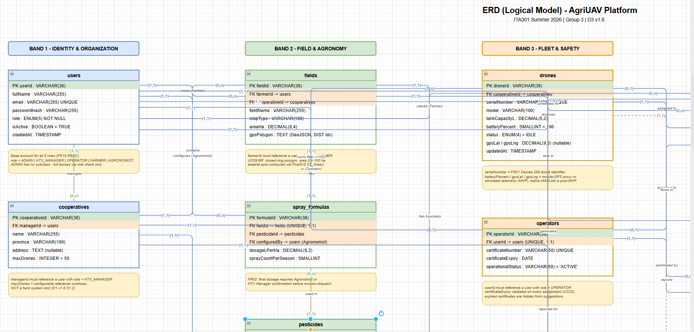

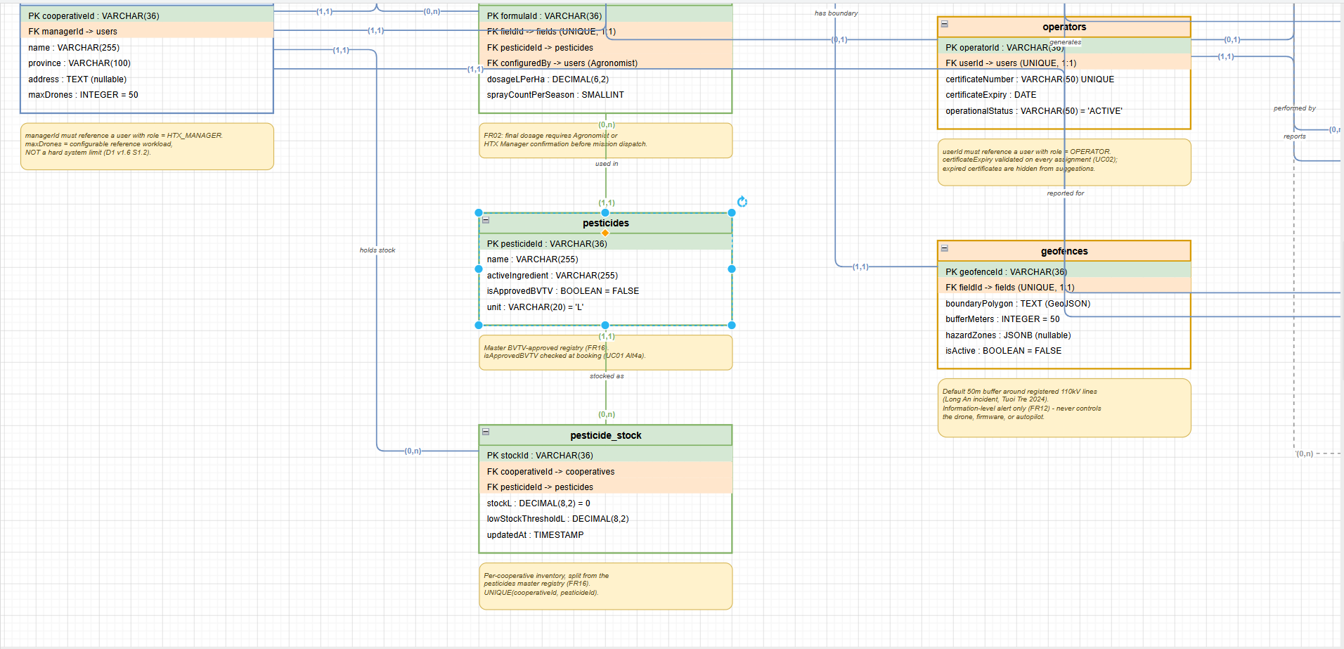

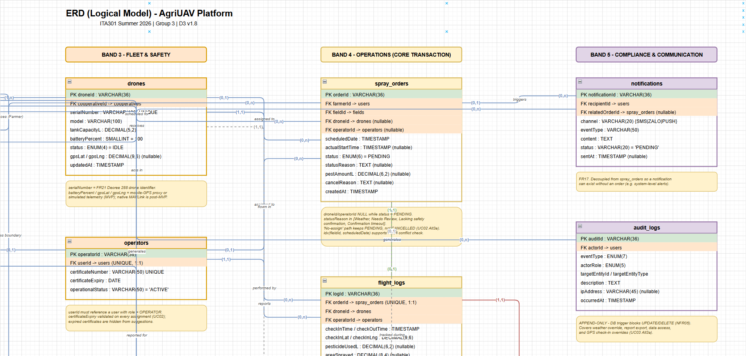

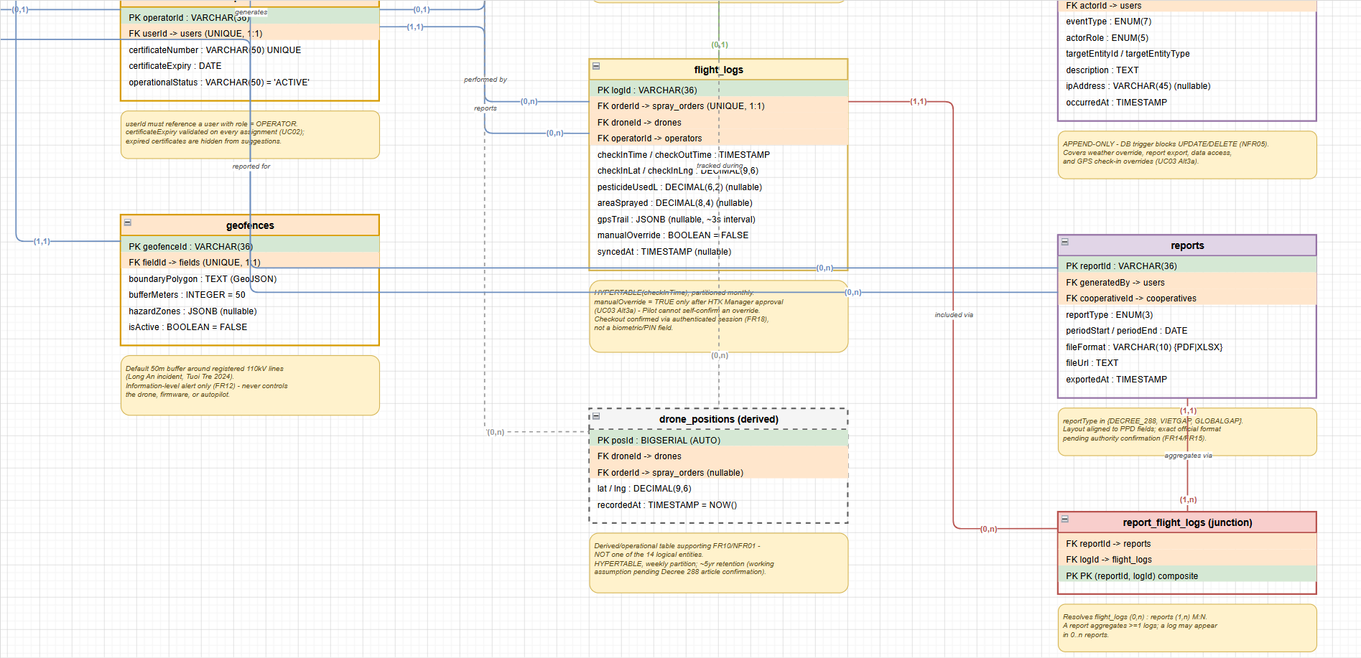

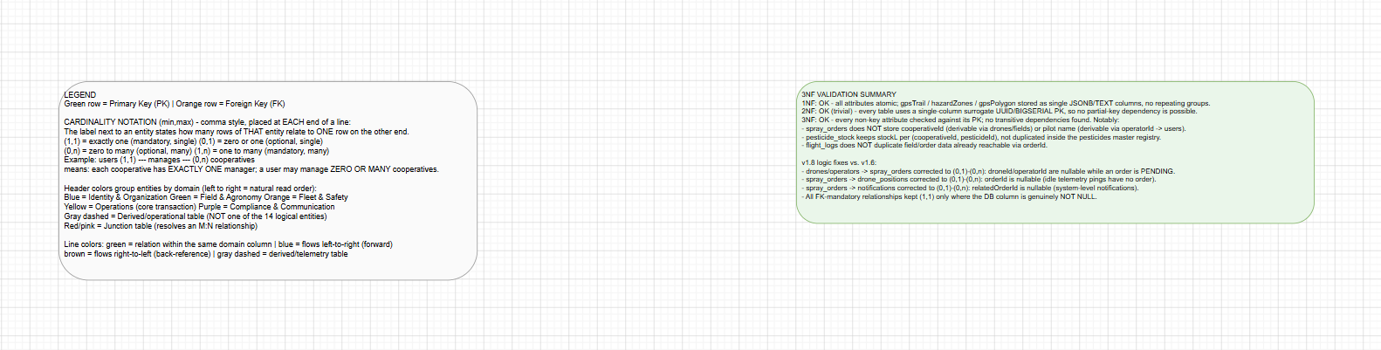

Part B: UI Wireframes
