AgriUAV Platform — W7 Submission
Part A: Physical Data Model
Group 3 | ITA301 | FPT University HCM | Summer 2026

1. Technology Stack
PostgreSQL 16 + PostGIS 3.4 (spatial queries) + TimescaleDB 2.x (time-series telemetry). All UUIDs are v4. HYPERTABLE rows indicate TimescaleDB time-series partitioning. Retention note: flight_logs, drone_positions, and audit_logs are retained for at least 5 years as a working assumption pending confirmation of the specific Decree 288/2025/ND-CP article reference (per D2 | 2.4) not asserted as a confirmed legal minimum.

2. Physical Table Definitions (15 tables)
Table: users
Column | Data Type | Null | Key | Default | Description
userId | VARCHAR(36) | NO | PK | UUID v4 | Primary key
fullName | VARCHAR(255) | NO |  |  | Full display name
email | VARCHAR(255) | NO | UNIQUE |  | Login email
passwordHash | VARCHAR(255) | NO |  |  | bcrypt hash (cost 12)
role | ENUM(5) | NO |  |  | ADMIN | HTX_MANAGER | OPERATOR | FARMER | AGRONOMISTWireframe coverage chỉ có 3 ảnh wireframe phải cover đủ các actor chính (HTX Manager, Farmer, Operator/Pilot, Export Company) đây mới chỉ 1–2 flow. nên phải làm wireframe cho toàn bộ UC chính chứ 3 ảnh có thể chưa đủ
isActive | BOOLEAN | NO |  | TRUE | Soft delete flag
createdAt | TIMESTAMP | NO |  | NOW() | Account creation UTC
Table: cooperatives
Column | Data Type | Null | Key | Default | Description
cooperativeId | VARCHAR(36) | NO | PK | UUID v4
name | VARCHAR(255) | NO |  |  | Official cooperative name
province | VARCHAR(100) | NO |  |  | Province in the Mekong Delta
address | TEXT | YES
maxDrones | INTEGER | NO |  | 50 | Configurable reference workload, not a hard limit (D1 v1.6 |1.2)
managerId | VARCHAR(36) | NO | FK→users |  | HTX Manager account

Table: fields
Column | Data Type | Null | Key | Default | Description
fieldId | VARCHAR(36) | NO | PK | UUID v4
farmerId | VARCHAR(36) | NO | FK→users |  | Owner farmer
cooperativeId | VARCHAR(36) | NO | FK→cooperatives |  | Managing cooperative
fieldName | VARCHAR(255) | NO
cropType | VARCHAR(100) | NO |  |  | e.g. rice, corn
areaHa | DECIMAL(8,4) | NO |  |  | Auto-computed from gpsPolygon (PostGIS ST_Area)
gpsPolygon | TEXT | NO |  |  | GeoJSON polygon — GIST index
createdAt | TIMESTAMP | NO |  | NOW()
INDEX (gpsPolygon) — PostGIS GIST index for spatial queries.
Table: drones
Column | Data Type | Null | Key | Default | Description
droneId | VARCHAR(36) | NO | PK | UUID v4
cooperativeId | VARCHAR(36) | NO | FK→cooperatives |  | Owner cooperative
serialNumber | VARCHAR(100) | NO | UNIQUE |  | Decree 288/2025 drone identifier (FR21)
model | VARCHAR(100) | NO |  |  | e.g. DJI Agras T40
tankCapacityL | DECIMAL(5,2) | NO
batteryPercent | SMALLINT | NO |  | 100 | Mobile-GPS proxy or simulated telemetry (MVP)
status | ENUM(4) | NO |  | IDLE | IDLE | FLYING | MAINTENANCE | OFFLINE
gpsLat | DECIMAL(9,6) | YES |  |  | Mobile-GPS proxy or simulated telemetry (MVP)
gpsLng | DECIMAL(9,6) | YES |  |  | Mobile-GPS proxy or simulated telemetry (MVP)
updatedAt | TIMESTAMP | NO |  | NOW() | Auto-updated on WebSocket push
INDEX (status) — B-Tree index for availability queries. FR21: HTXManager.registerDrone()/updateDroneStatus() write to this table.
Table: operators
Column | Data Type | Null | Key | Default | Description
operatorId | VARCHAR(36) | NO | PK | UUID v4
userId | VARCHAR(36) | NO | FK→users, UNIQUE
certificateNumber | VARCHAR(50) | NO | UNIQUE |  | Decree 288/2025 pilot certificate
certificateExpiry | DATE | NO |  |  | Validated on every assignment (UC02)
operationalStatus | VARCHAR(50) | NO |  | 'ACTIVE' | ACTIVE | ON_LEAVE | SUSPENDED
INDEX (certificateExpiry) — filters expired-certificate pilots from assignment suggestions (UC02 Alt 4a).

Table: spray_formulas
Column | Data Type | Null | Key | Default | Description
formulaId | VARCHAR(36) | NO | PK | UUID v4
fieldId | VARCHAR(36) | NO | FK→fields, UNIQUE |  | 1:1 with fields
pesticideId | VARCHAR(36) | NO | FK→pesticides
dosageLPerHa | DECIMAL(6,2) | NO |  |  | Dosage per hectare (FR02)
sprayCountPerSeason | SMALLINT | NO
configuredBy | VARCHAR(36) | NO | FK→users |  | Agronomist who configured the formula
Table: spray_orders
Column | Data Type | Null | Key | Default | Description
orderId | VARCHAR(36) | NO | PK | UUID v4
farmerId | VARCHAR(36) | NO | FK→users
fieldId | VARCHAR(36) | NO | FK→fields
droneId | VARCHAR(36) | YES | FK→drones | NULL | NULL until assigned (UC02)
operatorId | VARCHAR(36) | YES | FK→operators | NULL | NULL until assigned
scheduledDate | TIMESTAMP | NO |  |  | Requested spray datetime
actualStartTime | TIMESTAMP | YES |  | NULL | Set on check-in
status | ENUM(6) | NO |  | PENDING | PENDING → ASSIGNED → IN_PROGRESS → COMPLETED | SUSPENDED | CANCELLED
statusReason | TEXT | YES |  | NULL | "Weather" | "Needs Review" | "Lacking safety confirmation" | "Confirmation timeout"
pestAmountL | DECIMAL(6,2) | YES |  | NULL | Calculated on assignment
cancelReason | TEXT | YES |  | NULL
createdAt | TIMESTAMP | NO |  | NOW()
INDEX (fieldId, scheduledDate) — conflict checks (FR04). INDEX (status) — active-order filtering. "No-assign" path keeps status = PENDING (UC02 Alt 3a), not CANCELLED.
Table: flight_logs
Column | Data Type | Null | Key | Default | Description
logId | VARCHAR(36) | NO | PK | UUID v4
orderId | VARCHAR(36) | NO | FK→spray_orders, UNIQUE |  | 1:1 with spray_orders
droneId | VARCHAR(36) | NO | FK→drones
operatorId | VARCHAR(36) | NO | FK→operators
checkInTime | TIMESTAMP | NO
checkOutTime | TIMESTAMP | YES |  | NULL
checkInLat | DECIMAL(9,6) | NO
checkInLng | DECIMAL(9,6) | NO
pesticideUsedL | DECIMAL(6,2) | YES |  | NULL
areaSprayed | DECIMAL(8,4) | YES |  | NULL
gpsTrail | JSONB | YES |  | NULL | {lat,lng,ts} approx. every 3s
manualOverride | BOOLEAN | NO |  | FALSE | TRUE only after HTX Manager approval of a GPS-out-of-100m check-in (UC03 Alt 3a)
syncedAt | TIMESTAMP | YES |  | NULL | Offline sync timestamp (NFR06, ≤30s)
HYPERTABLE (checkInTime), partitioned monthly. INDEX (droneId, checkInTime). Checkout confirmation (UC07) is via the pilot's authenticated session (FR18), not a biometric/PIN field.
Table: drone_positions
Column | Data Type | Null | Key | Default | Description
posId | BIGSERIAL | NO | PK | AUTO | Auto-increment for high-volume inserts
droneId | VARCHAR(36) | NO | FK→drones
orderId | VARCHAR(36) | YES | FK→spray_orders | NULL | NULL if idle telemetry
lat | DECIMAL(9,6) | NO
lng | DECIMAL(9,6) | NO
recordedAt | TIMESTAMP | NO |  | NOW()
Derived table — supports FR10/NFR01, not one of the 14 logical entities. HYPERTABLE (recordedAt), partitioned weekly; retention per the working 5-year assumption. INDEX (droneId, recordedAt DESC) — latest-position queries for the live map.
Table: pesticides
Column | Data Type | Null | Key | Default | Description
pesticideId | VARCHAR(36) | NO | PK | UUID v4
name | VARCHAR(255) | NO
activeIngredient | VARCHAR(255) | NO
isApprovedBVTV | BOOLEAN | NO |  | FALSE
unit | VARCHAR(20) | NO |  | 'L'
INDEX (isApprovedBVTV) — filters the booking dropdown to approved pesticides.
Table: pesticide_stock
Column | Data Type | Null | Key | Default | Description
stockId | VARCHAR(36) | NO | PK | UUID v4
cooperativeId | VARCHAR(36) | NO | FK→cooperatives
pesticideId | VARCHAR(36) | NO | FK→pesticides
stockL | DECIMAL(8,2) | NO |  | 0
lowStockThresholdL | DECIMAL(8,2) | NO
updatedAt | TIMESTAMP | NO |  | NOW()
UNIQUE (cooperativeId, pesticideId) — one stock record per pesticide per cooperative.
Table: geofences
Column | Data Type | Null | Key | Default | Description
geofenceId | VARCHAR(36) | NO | PK | UUID v4
fieldId | VARCHAR(36) | NO | FK→fields, UNIQUE
boundaryPolygon | TEXT | NO |  |  | GeoJSON — GIST index
bufferMeters | INTEGER | NO |  | 50 | Default buffer around registered 110kV lines (FR12)
hazardZones | JSONB | YES |  | NULL | {type:'POWERLINE'|'RESIDENTIAL', coords}
isActive | BOOLEAN | NO |  | FALSE | Set TRUE on UC03 check-in
Alert behaviour: information-level only — the system never directly controls the drone, firmware, or autopilot.

Table: notifications
Column | Data Type | Null | Key | Default | Description
notificationId | VARCHAR(36) | NO | PK | UUID v4
recipientId | VARCHAR(36) | NO | FK→users
relatedOrderId | VARCHAR(36) | YES | FK→spray_orders | NULL
channel | VARCHAR(20) | NO |  |  | SMS | ZALO | PUSH
eventType | VARCHAR(50) | NO
content | TEXT | NO
status | VARCHAR(20) | NO |  | 'PENDING' | PENDING | SENT | FAILED
sentAt | TIMESTAMP | YES |  | NULL
INDEX (recipientId, sentAt DESC) — delivery history.
Table: audit_logs
Column | Data Type | Null | Key | Default | Description
auditId | VARCHAR(36) | NO | PK | UUID v4
eventType | ENUM(7) | NO |  |  | ORDER_CREATED | ORDER_CANCELLED | WEATHER_OVERRIDE | REPORT_EXPORTED | DATA_ACCESS | CHECKIN | CHECKOUT
actorId | VARCHAR(36) | NO | FK→users
actorRole | ENUM(5) | NO
targetEntityId | VARCHAR(36) | NO
targetEntityType | VARCHAR(50) | NO
description | TEXT | NO
ipAddress | VARCHAR(45) | YES |  | NULL
occurredAt | TIMESTAMP | NO |  | NOW()
Append-only (DB-level trigger blocks UPDATE/DELETE). HYPERTABLE (occurredAt). INDEX (actorId, occurredAt DESC). GPS check-in overrides (UC03 Alt 3a) are logged here with eventType = CHECKIN.
Table: reports
Column | Data Type | Null | Key | Default | Description
reportId | VARCHAR(36) | NO | PK | UUID v4
generatedBy | VARCHAR(36) | NO | FK→users
cooperativeId | VARCHAR(36) | NO | FK→cooperatives
reportType | ENUM(3) | NO |  |  | DECREE_288 | VIETGAP | GLOBALGAP
periodStart | DATE | NO
periodEnd | DATE | NO
fileFormat | VARCHAR(10) | NO |  |  | PDF | XLSX
fileUrl | TEXT | NO
exportedAt | TIMESTAMP | NO |  | NOW()
DECREE_288 layout aligned to Plant Protection Dept fields, exact official format pending authority confirmation (FR14). VietGAP/GlobalGAP field set is project-defined and pending export-company validation (FR15)

3. 3NF Validation Summary
1NF: OK — all attributes atomic; gpsTrail / hazardZones stored as JSONB are treated as opaque payloads, not decomposed relational attributes, by design.
2NF: OK — every table uses a single-column surrogate UUID/BIGSERIAL primary key, so no partial-key dependency is possible.
3NF: OK — every non-key attribute checked against its PK; no transitive dependencies identified across the 15 tables above.

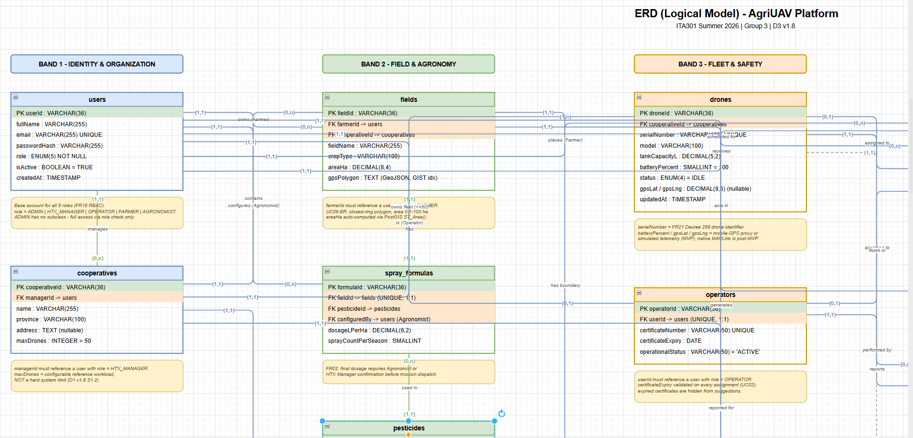

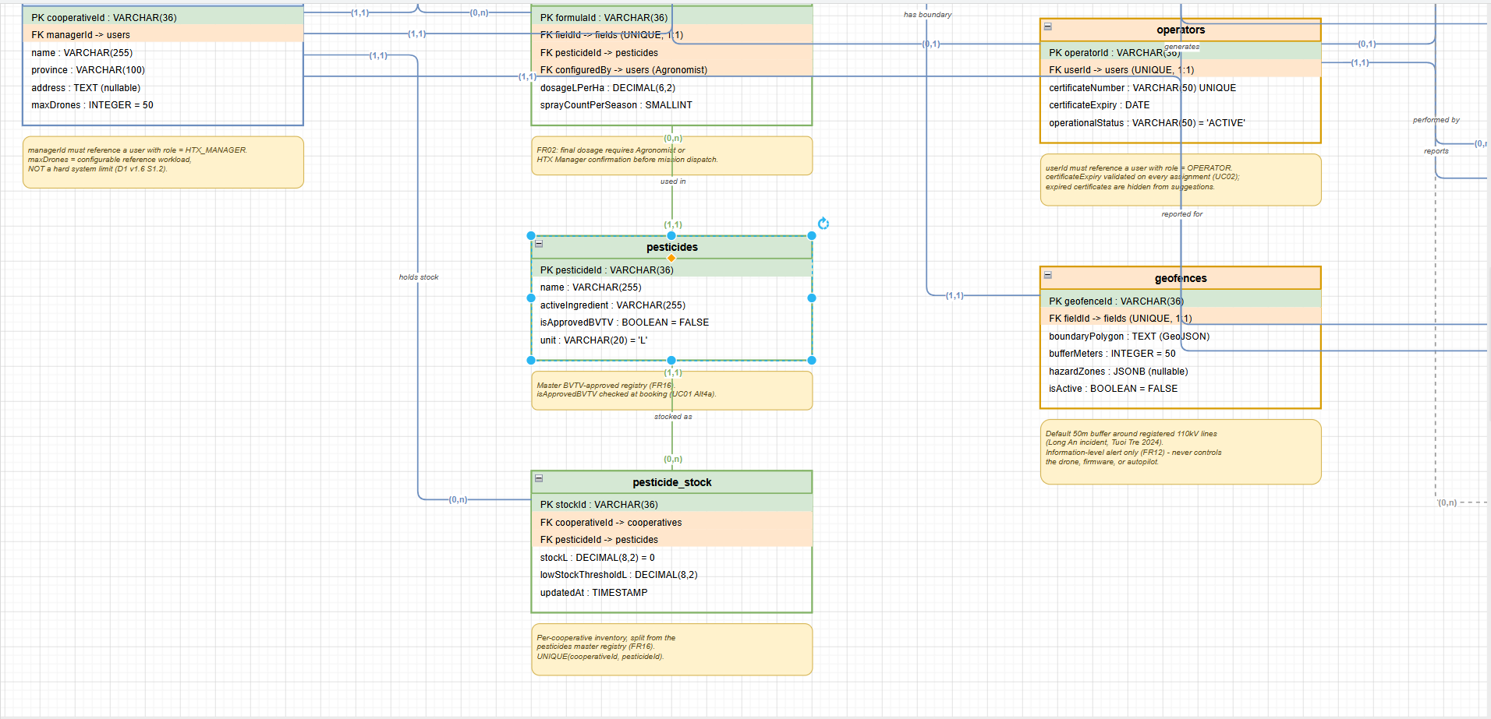

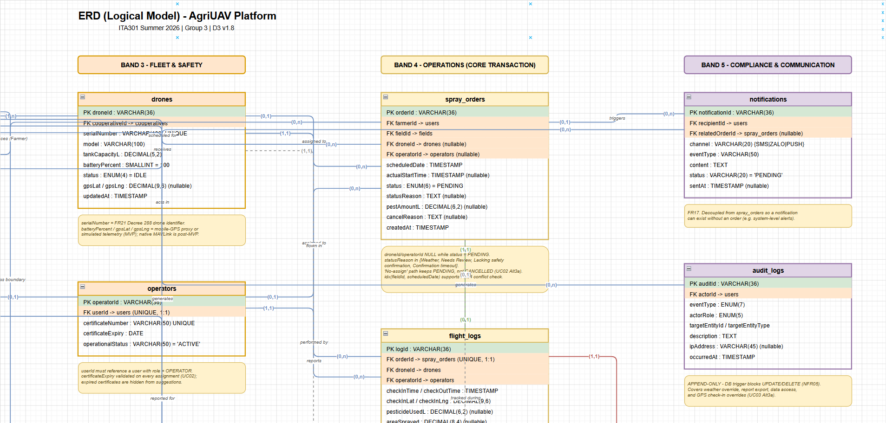

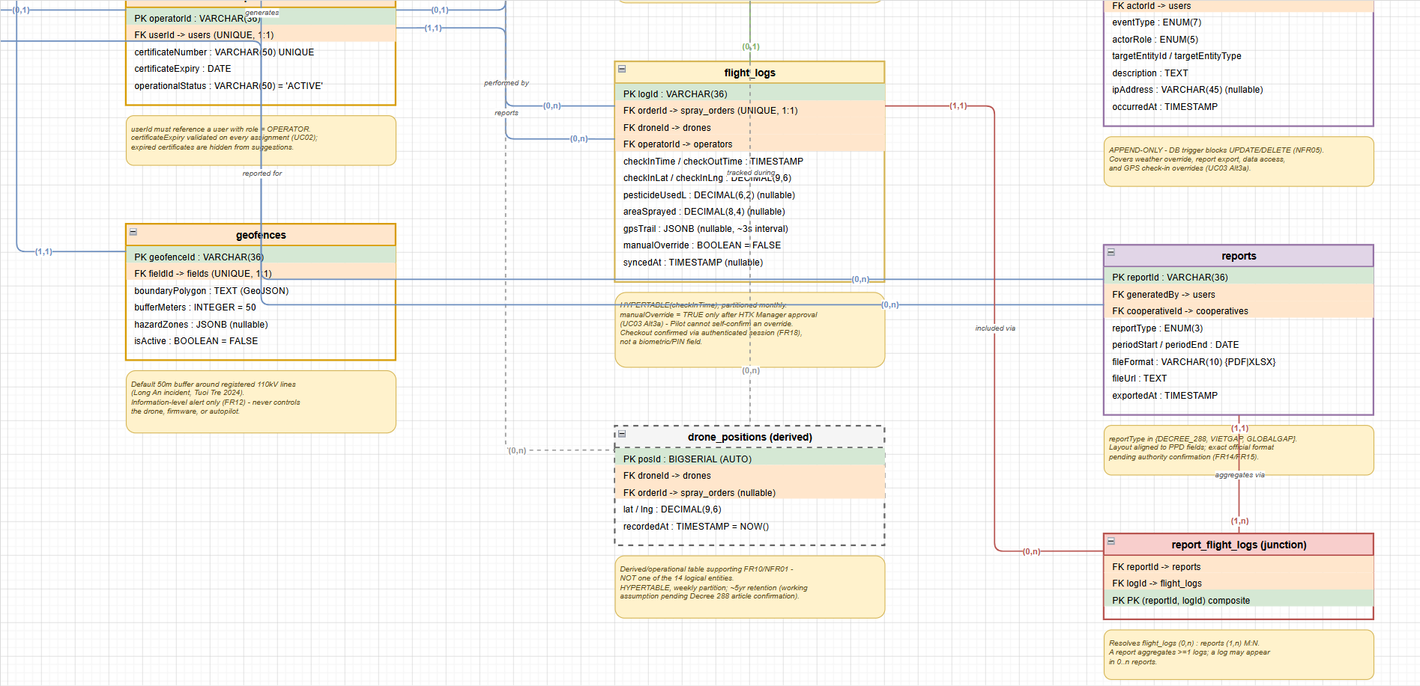

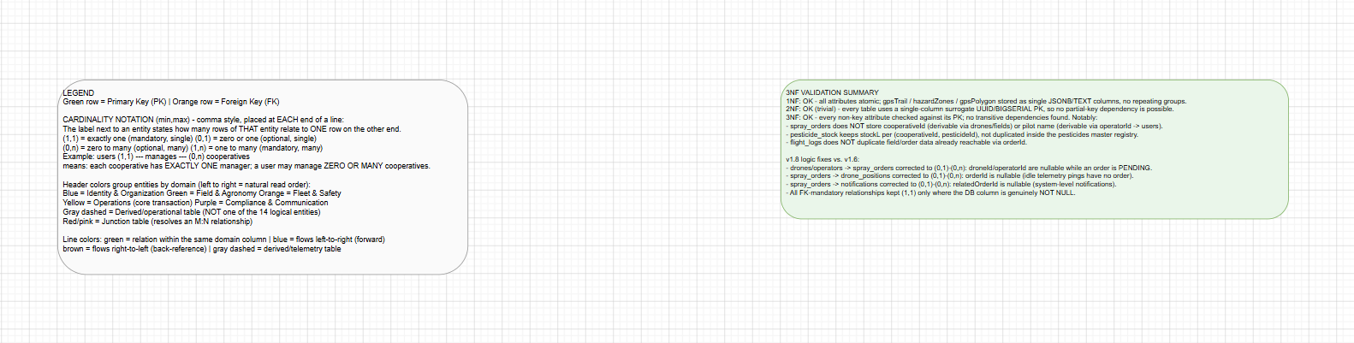

4. UI Wireframes
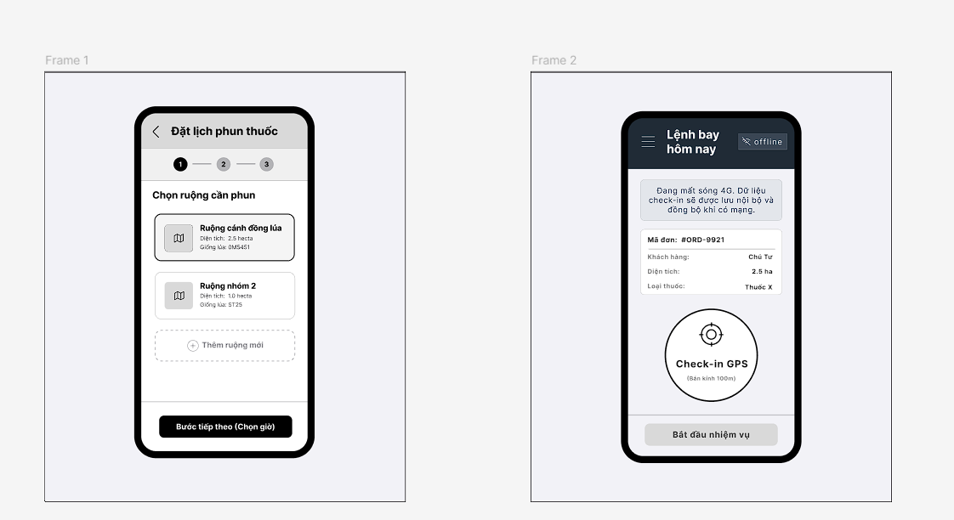
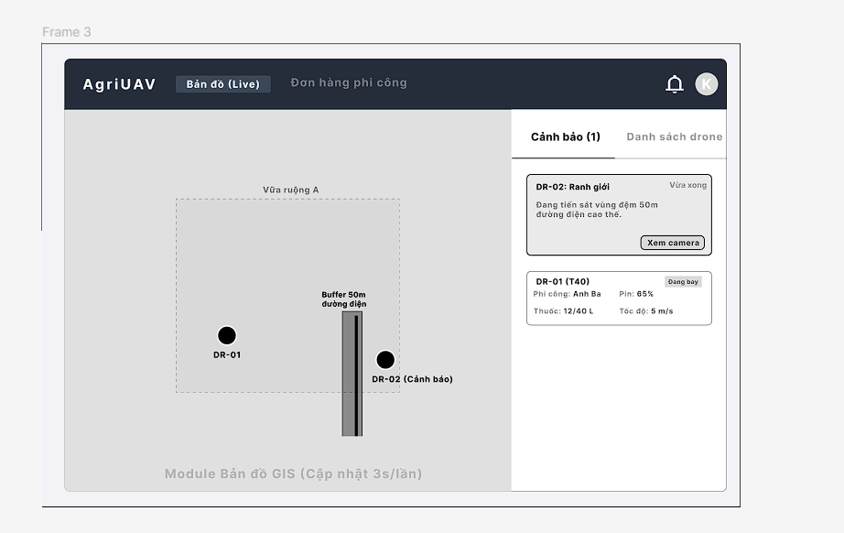
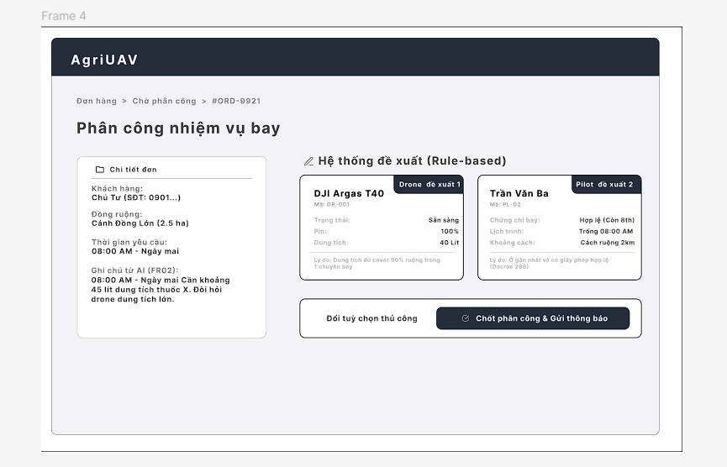

5. AI Audit Logs
No. | Week /  Phase | DTC Component | AI Tool | Prompt (Full Context) | AI Output (Summary) | Decision & Human Delta | Verification
21 | W7 / P4 Design | Pattern Recognition | Gemini | Propose UI patterns and design wireframes for the three primary user groups (Farmer, Pilot, and HTX Manager) to satisfy NFR03 (Usability) and NFR06 (Offline Mode). | Recommend choosing either a One-Long-Form or Wizard pattern for the Farmer interface, and either a Map with Popups or Master–Detail layout for the HTX Manager interface. Also suggest adding an Offline Indicator and considering Dark Mode (FR19) for the Pilot interface | Adopt the Wizard pattern for the Farmer interface to reduce cognitive load, and the Master–Detail pattern for the HTX Manager interface to ensure alerts (FR12) are not obscured. Human Delta: The team proactively excluded the Dark/Light Mode toggle (FR19) during the wireframing phase to avoid deviating into architectural discussions and instead focused on the Offline Indicator structure (NFR06). | Cross-check the design directly against NFR03 (ensuring key tasks can be completed within 5 minutes), NFR06, and the ITA301 W7 rubric (which requires justification for the selected UI patterns).
22 | W7 / P4 Design | Abstraction | Gemini | Evaluate the peer review feedback: "Wireframes should be created for all main use cases and must cover all four actors, including Export Company. Three to four screenshots are not sufficient." | Analyze the feedback against the D2 SRS and the RBL Guide. Identify elements that fall outside the intended design scope: (1) Export Company is a Post-MVP feature (no account is included in the current scope); (2) the System Design deliverable only requires 3–5 representative wireframes. | Reject the peer review feedback by applying the principle of Abstraction. The decision is to remove unnecessary UI details (such as the Export Company screens or secondary use cases) and instead focus on the four core system screens representing the main user flows (UC01, UC02, UC03, and UC04). Human Delta: Clearly specify the Post-MVP scope, reinforce the boundary of the System Design deliverable (only representative screens are required), and distinguish it from producing a complete UI for the entire system. | Verify against RBL Guide Section 6.4 (D4 SDD requires only 3–5 representative wireframes) and D2 v2.4 (UC10), which specifies that Export Company is not a system actor at this stage.

