D4 - SYSTEM DESIGN DOCUMENT (SDD)
AgriUAV Platform: Precision Drone Dispatching Platform in the Mekong Delta
Course | ITA301 - Information System Analysis & Design
Deliverable | D4 – System design document (SDD)
Standard Applied | IEEE Std 830-1998
Group | Group 3
Members | • Dang Thanh Cong - Project Manager  • Nguyen Thi Thanh Thao - Business Analyst  • Le Van Minh - System Analyst  • Tran Anh Khoa - System Designer  • Dang Vo Thanh Hieu - Presenter / QA
Instructor | Mr. Tran Thanh Nguyen
Submission Date | 2026/07/19
Version | v4.6

1. INTRODUCTION & CONTEXTUAL RATIONALE
This document serves as the System Design Document (SDD) for the AgriUAV Platform, translating the comprehensive software requirements specified in the Software Requirements Specification (SRS) into a robust, scalable, and verifiable technical blueprint. Grounded firmly in the Research-Based Learning (RBL) and Design Science Research (DSR) paradigms championed by FPT University, our architectural decisions transcend pure engineering abstractions and are rooted in empirical evidence derived from actual agricultural conditions within the Mekong Delta.

1.1 Evidence-Driven Architectural Constraints
1. Human-System Interaction Constraint: According to empirical research on human-system interaction in rural ecosystems (Nguyen 2025, N=940), the primary operators and agricultural cooperative workers have an average age of 51 with low base digital literacy. This severe human constraint requires that the Presentation Layer minimizes cognitive load through big typography, tactile button states, and simplified flows, while delegating heavy calculations, input parsing, and complex validation workflows entirely to automated asynchronous backend processes.
2. Network Infrastructure Vulnerability: Field testing in remote areas of Long An and Dong Thap reveals significant 4G network fragmentation and dropouts. This infrastructural reality forces the departure from cloud-only architectures toward a structured Offline-First synchronization protocol. Transactions cannot block or fail due to latency spikes or connection dropped events.
3. Stringent Regulatory Compliance: Regulatory policies outlined in Decree No. 288/2025/NĐ-CP require absolute traceability regarding flight paths, operator licenses, drone registrations, and exact pesticide chemical distribution logs. Data designs must provide absolute data integrity and non-repudiation chains that are easily auditable by inspectors from the Plant Protection Department.

2. UI DESIGN

2.1 User Personas
Based on the stakeholder analysis and the Role-Based Access Control requirement (FR18) defined in the SRS (D2), the AgriUAV platform serves five distinct user groups. The following personas outline their technological proficiency, primary goals, and specific UI/UX preferences. These profiles act as the foundation for our design decisions, ensuring the system caters to both low-tech users (Farmers) and specialized operators (Agronomists, Admins).
 | Persona 1: Farmer | Persona 2: Operator/Pilot | Persona 3: HTX Manager | Persona 4: Agronomist | Persona 5: Admin
Character name | Mr. Tu (51 years old) | Mr. Ba (28 years old) | Mr. Nam (45 years old) | Ms. Hoa (35 years old) | Mr. Quan (30 years old)
Technology Proficiency | Low. Uses smartphones only for basic tasks. | Medium. Familiar with mobile applications and digital mapping. | Medium. Uses Excel, Zalo, and computers daily. | High. Proficient in Excel, mapping software, and GIS. | High. Experienced with system administration and software.
Goals | Schedule pesticide spraying in a very simple way. Receive notifications when tasks are completed. | Receive task assignments (task creation). Check in/out via GPS while working in the field to record work progress. | Monitor the entire drone fleet via an Overview Dashboard and Calendar; click to view details of each task. | Record and monitor detailed field indicators. Perform in-depth analyses. View historical records. | Manage user accounts, permissions, and system configurations (RBAC). Track audit logs and monitor security.
UI/UX Preferences | Always sets schedules with minimal steps (5 steps). Large font (>16pt), clear icons, direct interaction, voice support. | Large and clear buttons. Strong visual alerts (Alerts), visible even in outdoor light. Has Offline Mode. | Modern web interface. Desktop dashboard. Customizable widget cards. Master-detail layout. Supports Calendar view. | Simple web interface with Map module. Polygon-based field mapping with data input forms. | Admin panel web interface. Uses table-based layouts (data tables) with advanced filtering/search capabilities.
Primary Device Used | Mobile App (Android/iOS) | Mobile App (Android/iOS) | Web Dashboard (Desktop) | Web Dashboard (Desktop) | Web Dashboard (Desktop)

2.2 User Journey Map
To ensure a seamless and intuitive user experience, the team mapped out two critical user journeys that represent the core business workflows of the MVP: the Farmer's booking process (linked to UC01) and the Pilot's field operation process (linked to UC03 & UC05). These maps identify key touchpoints, potential pain points, and direct opportunities for UI/UX enhancements, particularly addressing field constraints like offline scenarios (NFR06).

Example: Farmer's Drone Spraying Booking Journey (Mapped with UC01 & UC08)
Phases | 1. Awareness | 2. Action | 3. Confirmation | 4. Post-Action
User actions | Opens the AgriUAV App, selects the field to be sprayed. | Chooses date/time, selects an approved pesticide (BVTV). | Receives booking confirmation from the HTX Manager. | Receives a Zalo message stating "Spraying completed" and views the report.
Touchpoints | "Field List" Screen (Home Screen). | "Booking" Screen (Booking Wizard). | Push Notification / Zalo. | "Flight History" Screen / Zalo Message.
Emotions/ Thoughts | "Hope this app is easy to use and I pick my correct field #2." | "Can I use this pesticide? How do I fill this out quickly?" | "Relieved! Someone will come to spray the field tomorrow." | "So convenient, I don't even have to go out to the field to monitor."
UI/UX Opportunities | Display the field area and a small map thumbnail so the farmer can easily recognize it. | The pesticide dropdown should only show valid options (isApprovedBVTV = true). Alert immediately if there is a scheduling conflict. | Use large, green text for the notification (Success) to provide a sense of reassurance. | Integrate a "Share" button via Zalo so they can easily forward the report to family members.
Example 2: Pilot's Flight Execution & Field Operations Journey (Mapped with UC03 & UC05)
Phases | 1. Task Assignment | 2. On-Site Check-In | 3. Mission Execution | 4. Mission Wrap-Up
User actions | Reviews assigned flight schedules, checks field coordinates, and views required pesticide formulas on the mobile app before leaving. | Arrives at the field, encounters poor 4G signal, opens the app to perform GPS check-in, and fills out the pre-flight checklist. | Launches the drone, monitors live telemetry data (battery, fluid levels) on the screen, and responds to boundary (geofence) alerts. | Lands the drone safely, submits the flight completion logs, and syncs data once back in network coverage.
Touchpoints | "My Schedule" Screen / Task Detail View. | "Field Check-In" Screen (with Offline Banner active). | Telemetry Dashboard / Map Overlay Screen. | "Mission Summary" Screen / Sync Progress Indicator.
Emotions/ Thoughts | "Let's check the field location and parameters. Looks like a standard spraying job." | "The 4G signal is completely dead out here. Glad the app still allows offline check-in so I can log my work." | "Keeping a close eye on the battery and the high-voltage power lines nearby. App warnings are clear." | "Mission accomplished safely. Uploading logs so the HTX Manager and Farmer can verify right away."
UI/UX Opportunities | Highlight prioritized or urgent tasks with clear time badges and large fonts. | Display a prominent "Offline Mode Enabled" banner to reassure the user. Use a giant, high-contrast GPS Check-In button for outdoor visibility under direct sunlight. | Implement distinct color-coded alerts (Yellow for caution, Red for danger) and optional audio/vibration feedback for critical geofence violations. | Create an automatic background data-syncing mechanism once cellular network is restored; show a clear sync status.

2.3 UI Wireframes
The following UI wireframes translate the defined personas and user journeys into structural screen layouts. Designed for both mobile (Farmer/Pilot) and web (HTX Manager) platforms, these wireframes incorporate critical non-functional requirements established in D2. Specifically, they feature large touch targets and text sizes (≥ 16pt) for accessibility (NFR03) and clear offline indicators for field operations (NFR06). The layouts intentionally focus on structure and flow rather than detailed visual aesthetics.
- Booking (Farmer) – Mobile App

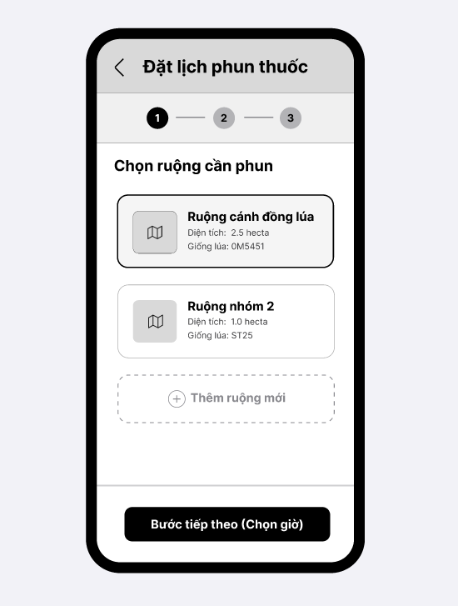

2. Check-in & Dashboard (Pilot) – Mobile App
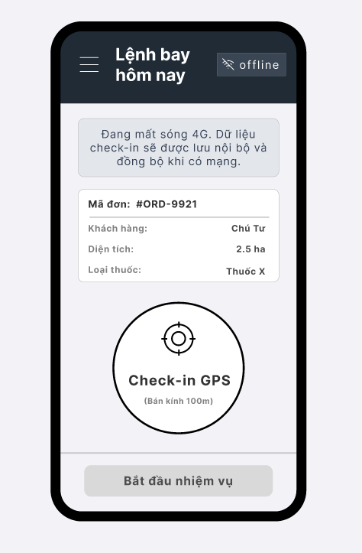

3. Live Monitoring (HTX Manager) – Web
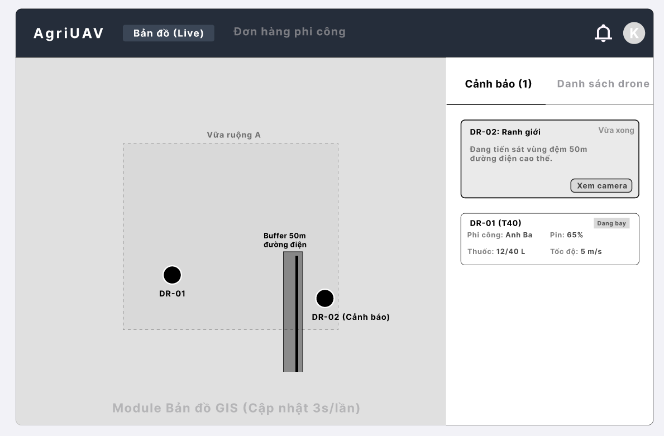
4. Fleet Dispatch – Web
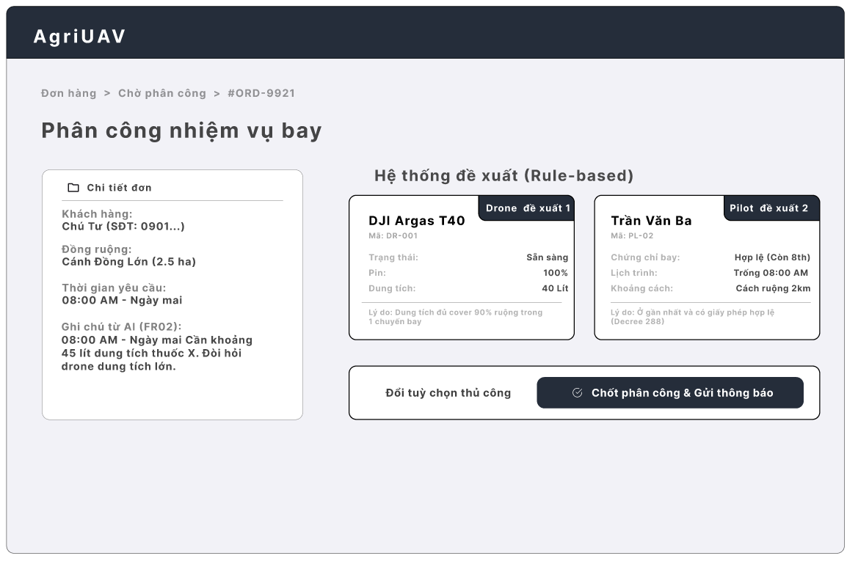
5. Spray Formula (Agronomist) – Web/ Mobile App
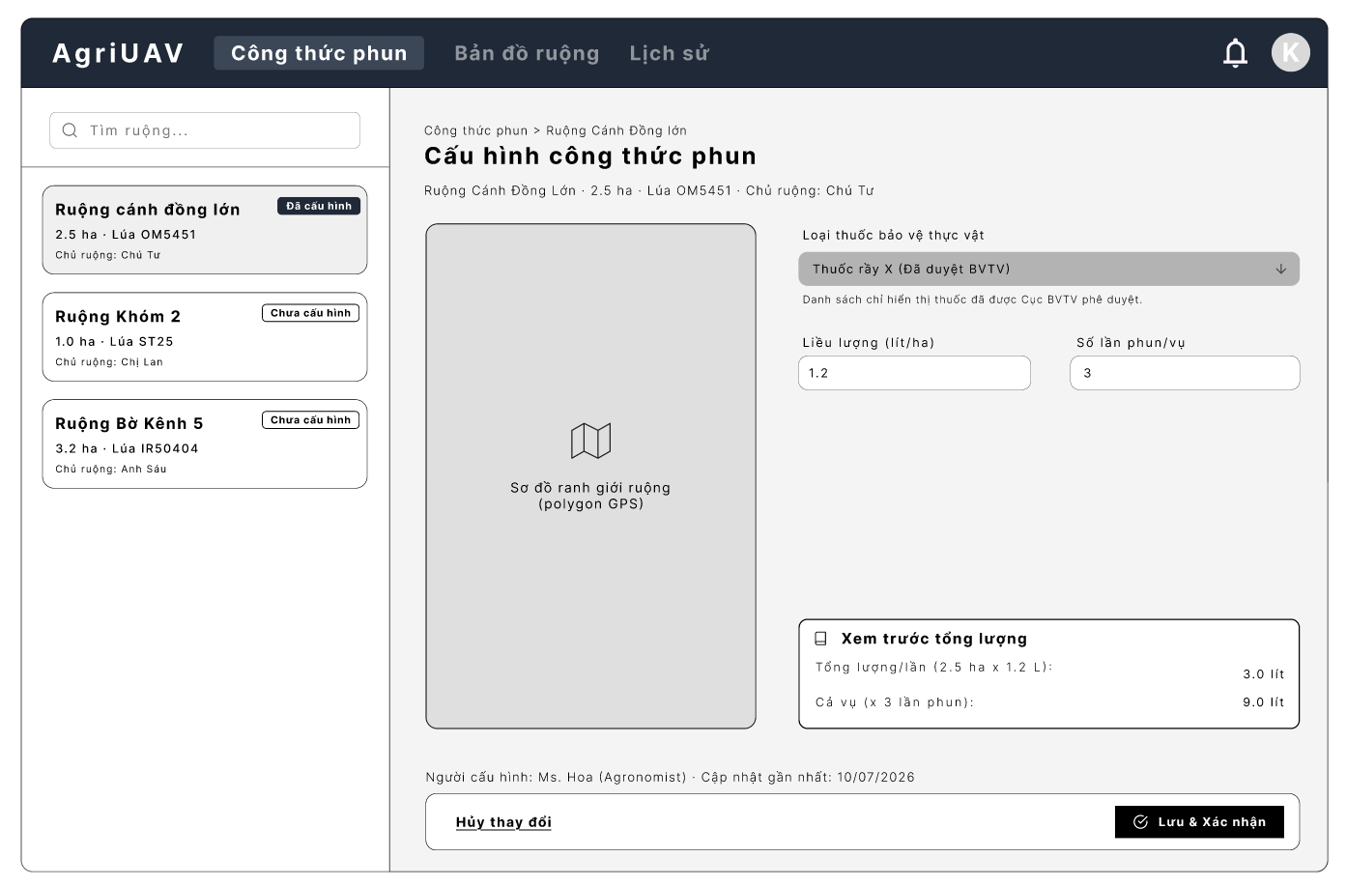

3. DATA DESIGN
The data tier for the AgriUAV Platform is architected to support transactional ACID guarantees alongside complex geospatial query capabilities. To achieve this, the system implements an Object-Relational schema utilizing PostgreSQL enhanced with the PostGIS spatial extension. This allows the system to evaluate geometries natively at the database engine level.

3.1 Physical Database Schema (PostgreSQL DDL Script)
The following physical database schema translates the AgriUAV system data models into concrete relational definitions. The data architecture is built upon PostgreSQL 16 as the core database engine, strategically integrated with two key extensions:
- PostGIS 3.4: For handling complex spatial queries and geographic farm mapping.
- TimescaleDB 2.x: For managing high-frequency, time-series drone telemetry data.
To ensure distributed consistency and scalability, all primary keys across the system utilize UUID v4. Additionally, in alignment with regulatory standards (Decree 288/2025/ND-CP), critical historical data including flight_logs, drone_positions, and audit_logs are designed with a strict minimum retention period of 5 years.

1. USERS (System Users)
CREATE TABLE users (
id UUID PRIMARY KEY DEFAULT uuid_generate_v4(),
email VARCHAR(255) UNIQUE NOT NULL,
password_hash VARCHAR(255) NOT NULL,
full_name VARCHAR(100) NOT NULL,
role VARCHAR(50) NOT NULL CHECK (role IN ('admin','htx_manager','operator','farmer','agronomist')),
phone_number VARCHAR(15),
created_at TIMESTAMP DEFAULT CURRENT_TIMESTAMP,
updated_at TIMESTAMP DEFAULT CURRENT_TIMESTAMP
);
COMMENT ON TABLE users IS 'Stores general user information across the system';

2. OPERATORS (Pilot Profiles)
CREATE TABLE operators (
id UUID PRIMARY KEY DEFAULT uuid_generate_v4(),
user_id UUID NOT NULL,
license_number VARCHAR(100) UNIQUE NOT NULL,
license_expiry DATE NOT NULL,
experience_years INT DEFAULT 0,
status VARCHAR(50) DEFAULT 'AVAILABLE' CHECK (status IN ('AVAILABLE', 'BUSY', 'OFF_DUTY')),
CONSTRAINT fk_operator_user FOREIGN KEY (user_id) REFERENCES users(id) ON DELETE CASCADE
);
COMMENT ON TABLE operators IS 'Stores professional information and certifications of operators/pilots';
3. COOPERATIVES
CREATE TABLE cooperatives (
id UUID PRIMARY KEY DEFAULT uuid_generate_v4(),
name VARCHAR(255) NOT NULL,
province VARCHAR(100) NOT NULL,
address TEXT,
max_drones INTEGER NOT NULL DEFAULT 50,
manager_id UUID NOT NULL,
created_at TIMESTAMP DEFAULT CURRENT_TIMESTAMP,
CONSTRAINT fk_cooperative_manager FOREIGN KEY (manager_id) REFERENCES users(id) ON DELETE RESTRICT
);
COMMENT ON TABLE cooperatives IS 'HTX entity per D3 §2.1; required for drones.cooperative_id FK.';

4. FIELDS (Farming Areas / Plots)
CREATE TABLE fields (
id UUID PRIMARY KEY DEFAULT uuid_generate_v4(),
farmer_id UUID NOT NULL,
name VARCHAR(255) NOT NULL,
area_size DECIMAL(10,2) NOT NULL, -- Unit: Hectares
location_polygon GEOMETRY(Polygon, 4326), -- Stores GeoJSON coordinates of the field
created_at TIMESTAMP DEFAULT CURRENT_TIMESTAMP,
CONSTRAINT fk_field_farmer FOREIGN KEY (farmer_id) REFERENCES users(id) ON DELETE CASCADE,
CONSTRAINT fk_field_cooperative FOREIGN KEY (cooperative_id) REFERENCES cooperatives(id) ON DELETE RESTRICT
);
COMMENT ON TABLE fields IS 'Stores information about farmers'' farming fields';
5. PESTICIDES (Pesticide Catalog)
CREATE TABLE pesticides (
id UUID PRIMARY KEY DEFAULT uuid_generate_v4(),
name VARCHAR(255) NOT NULL,
registration_number VARCHAR(100) UNIQUE NOT NULL,
toxicity_level VARCHAR(50) NOT NULL CHECK (toxicity_level IN ('LOW', 'MEDIUM', 'HIGH')),
allowed_crops TEXT,
is_approved_bvtv BOOLEAN NOT NULL DEFAULT FALSE,
is_active BOOLEAN DEFAULT TRUE,
created_at TIMESTAMP DEFAULT CURRENT_TIMESTAMP
);
COMMENT ON TABLE pesticides IS 'Catalog of plant protection products complying with Plant Protection Department standards';

6. SPRAY_FORMULAS
CREATE TABLE spray_formulas (
id UUID PRIMARY KEY DEFAULT uuid_generate_v4(),
field_id UUID NOT NULL UNIQUE,
pesticide_id UUID NOT NULL,
dosage_l_per_ha DECIMAL(6,2) NOT NULL,
spray_count_per_season SMALLINT NOT NULL,
configured_by UUID NOT NULL,
created_at TIMESTAMP DEFAULT CURRENT_TIMESTAMP,
CONSTRAINT fk_formula_field FOREIGN KEY (field_id) REFERENCES fields(id) ON DELETE CASCADE,
CONSTRAINT fk_formula_pesticide FOREIGN KEY (pesticide_id) REFERENCES pesticides(id) ON DELETE RESTRICT,
CONSTRAINT fk_formula_configured_by FOREIGN KEY (configured_by) REFERENCES users(id) ON DELETE RESTRICT
);
COMMENT ON TABLE spray_formulas IS 'Per-field spray formula configured by the Agronomist (FR02); reused across all spray_orders for that field. UNIQUE(field_id) enforces the 1:1 relationship with fields, matching D3 §2.1/§3.';
8. DRONES (UAV Equipment)
CREATE TABLE drones (
id UUID PRIMARY KEY DEFAULT uuid_generate_v4(),
cooperative_id UUID NOT NULL,
serial_number VARCHAR(100) UNIQUE NOT NULL,
model VARCHAR(100) NOT NULL,
tank_capacity DECIMAL(10,2) NOT NULL,
status VARCHAR(50) DEFAULT 'IDLE' CHECK (status IN ('IDLE', 'IN_FLIGHT', 'MAINTENANCE', 'RETIRED')),
battery_percent SMALLINT DEFAULT 100,
gps_lat DECIMAL(9,6),
gps_lng DECIMAL(9,6),
created_at TIMESTAMP DEFAULT CURRENT_TIMESTAMP,
CONSTRAINT fk_drone_cooperative FOREIGN KEY (cooperative_id) REFERENCES cooperatives(id) ON DELETE RESTRICT
);
COMMENT ON TABLE drones IS 'Manages the list of Drones in the system';
9. DRONE_MAINTENANCE (Drone Maintenance Logs)
CREATE TABLE drone_maintenance (
id UUID PRIMARY KEY DEFAULT uuid_generate_v4(),
drone_id UUID NOT NULL,
maintenance_date DATE NOT NULL,
description TEXT NOT NULL,
cost DECIMAL(12,2) DEFAULT 0,
performed_by VARCHAR(100),
CONSTRAINT fk_maintenance_drone FOREIGN KEY (drone_id) REFERENCES drones(id) ON DELETE CASCADE
);
COMMENT ON TABLE drone_maintenance IS 'Tracks the maintenance and repair history of flight equipment';
10. SPRAY_ ORDERS (Spray Scheduling Orders)
CREATE TABLE spray_orders (
id UUID PRIMARY KEY DEFAULT uuid_generate_v4(),
farmer_id UUID NOT NULL,
field_id UUID NOT NULL,
drone_id UUID,
operator_id UUID,
scheduled_date TIMESTAMP NOT NULL,
actual_start_time TIMESTAMP,
status VARCHAR(50) NOT NULL DEFAULT 'PENDING' CHECK (status IN ('PENDING', 'ASSIGNED', 'IN_PROGRESS', 'COMPLETED', 'SUSPENDED', 'CANCELLED')),
status_reason TEXT,
cancel_reason TEXT,
created_at TIMESTAMP DEFAULT CURRENT_TIMESTAMP,
CONSTRAINT fk_order_farmer FOREIGN KEY (farmer_id) REFERENCES users(id) ON DELETE CASCADE,
CONSTRAINT fk_order_field FOREIGN KEY (field_id) REFERENCES fields(id) ON DELETE CASCADE,
CONSTRAINT fk_order_drone FOREIGN KEY (drone_id) REFERENCES drones(id) ON DELETE SET NULL,
CONSTRAINT fk_order_operator FOREIGN KEY (operator_id) REFERENCES operators(id) ON DELETE SET NULL
);
COMMENT ON TABLE spray_orders IS 'Central spray scheduling orders of the system';
11. ORDER_PESTICIDES (Pesticide Details for Orders)
CREATE TABLE order_pesticides (
id UUID PRIMARY KEY DEFAULT uuid_generate_v4(),
order_id UUID NOT NULL,
pesticide_id UUID NOT NULL,
dosage DECIMAL(10,2) NOT NULL, -- Dosage
CONSTRAINT fk_op_order FOREIGN KEY (order_id) REFERENCES spray_orders(id) ON DELETE CASCADE,
CONSTRAINT fk_op_pesticide FOREIGN KEY (pesticide_id) REFERENCES pesticides(id) ON DELETE CASCADE
);
COMMENT ON TABLE order_pesticides IS 'Intermediary table (M:N) linking Spray Orders and Pesticides';
12. FLIGHT_LOGS (Flight Logs)
CREATE TABLE flight_logs (
id UUID PRIMARY KEY DEFAULT uuid_generate_v4(),
order_id UUID NOT NULL,
operator_id UUID NOT NULL,
start_time TIMESTAMP,
end_time TIMESTAMP,
check_in_lat DECIMAL(9,6),
check_in_lng DECIMAL(9,6),
total_area_sprayed DECIMAL(10,2),
gps_trail JSONB,
manual_override BOOLEAN NOT NULL DEFAULT FALSE,
synced_at TIMESTAMP,
status VARCHAR(50) DEFAULT 'IN_FLIGHT' CHECK (status IN ('IN_FLIGHT', 'COMPLETED', 'FAILED')),
CONSTRAINT fk_flight_order FOREIGN KEY (order_id) REFERENCES spray_orders(id) ON DELETE CASCADE,
CONSTRAINT fk_flight_operator FOREIGN KEY (operator_id) REFERENCES operators(id) ON DELETE RESTRICT
);
13. DRONE_POSITIONS (Telemetry Data / Flight Coordinates)
CREATE TABLE drone_positions (
id UUID PRIMARY KEY DEFAULT uuid_generate_v4(),
flight_log_id UUID NOT NULL,
latitude DECIMAL(10,8) NOT NULL,
longitude DECIMAL(11,8) NOT NULL,
altitude DECIMAL(10,2) NOT NULL,
speed DECIMAL(10,2),
recorded_at TIMESTAMP DEFAULT CURRENT_TIMESTAMP,
CONSTRAINT fk_position_flight FOREIGN KEY (flight_log_id) REFERENCES flight_logs(id) ON DELETE CASCADE
);
COMMENT ON TABLE drone_positions IS 'Real-time coordinate data of Drones (used for redrawing flight paths)';
14. WEATHER_CONDITIONS (Weather Logs)
CREATE TABLE weather_conditions (
id UUID PRIMARY KEY DEFAULT uuid_generate_v4(),
order_id UUID NOT NULL,
temperature DECIMAL(5,2),
wind_speed DECIMAL(5,2),
humidity DECIMAL(5,2),
recorded_at TIMESTAMP DEFAULT CURRENT_TIMESTAMP,
CONSTRAINT fk_weather_order FOREIGN KEY (order_id) REFERENCES spray_orders(id) ON DELETE CASCADE
);
COMMENT ON TABLE weather_conditions IS 'Stores weather conditions at the time of flight for safety reference';
15. REPORTS (Legal/Compliance Reports)
CREATE TABLE reports (
id UUID PRIMARY KEY DEFAULT uuid_generate_v4(),
generated_by UUID NOT NULL,
report_type VARCHAR(100) NOT NULL CHECK (report_type IN ('PESTICIDE_USAGE', 'FLIGHT_SAFETY', 'MONTHLY_SUMMARY')),
file_url VARCHAR(255), -- Link to PDF/Excel file in Storage
created_at TIMESTAMP DEFAULT CURRENT_TIMESTAMP,
CONSTRAINT fk_report_user FOREIGN KEY (generated_by) REFERENCES users(id) ON DELETE CASCADE
);
COMMENT ON TABLE reports IS 'Stores periodic reports generated for the Plant Protection Department';
16. NOTIFICATIONS (System Notifications)
CREATE TABLE notifications (
id UUID PRIMARY KEY DEFAULT uuid_generate_v4(),
user_id UUID NOT NULL,
title VARCHAR(255) NOT NULL,
content TEXT NOT NULL,
is_read BOOLEAN DEFAULT FALSE,
created_at TIMESTAMP DEFAULT CURRENT_TIMESTAMP,
CONSTRAINT fk_notification_user FOREIGN KEY (user_id) REFERENCES users(id) ON DELETE CASCADE
);
COMMENT ON TABLE notifications IS 'In-app notification inbox for users';
7. SYSTEM_LOGS (System/Security Logs)
CREATE TABLE system_logs (
id UUID PRIMARY KEY DEFAULT uuid_generate_v4(),
user_id UUID, -- Can be Null for actions performed before login
action VARCHAR(255) NOT NULL,
ip_address VARCHAR(45),
details TEXT,
created_at TIMESTAMP DEFAULT CURRENT_TIMESTAMP,
CONSTRAINT fk_log_user FOREIGN KEY (user_id) REFERENCES users(id) ON DELETE SET NULL
);
COMMENT ON TABLE system_logs IS 'Audit Trail: Tracks important operations on the system';

3.2 Indexing Strategy
To ensure the AgriUAV platform meets the strict real-time telemetry and spatial query requirements defined in the NFRs (e.g., latency < 500ms for system updates), the database relies on a robust indexing strategy. By implementing B-Tree and GiST (Generalized Search Tree) indexes, the system structurally reduces the search time complexity from $O(N)$ (Full Table Scan) to $O(\log N)$. This mathematical op timization is crucial for rapid relational joins across millions of flight logs and real-time geographic queries via PostGIS.
Table Name | Index Name | Column(s) Indexed | Index Type | Architectural & RBL Justification
fields | idx_fields_location | location_polygon | GiST | Arch: Reduces geographic spatial intersections to $O(\log N)$.  RBL: Crucial for the Mekong Delta context where mapping complex, non-rectangular farming plots accurately is required for precision spraying.
spray_orders | idx_orders_farmer_id | farmer_id | B-Tree | Arch: Accelerates relational JOINs between users and their orders.  RBL: Ensures the mobile app loads historical data quickly even on unstable 3G networks in rural areas (Supporting NFR06 - Offline/Low Connectivity).
spray_orders | idx_orders_status | status | B-Tree | Arch: Prevents full table scans when filtering active missions.  RBL: Satisfies the scalability threshold (NFR04) allowing the Cooperative (HTX) Manager to concurrently monitor 50+ drones without UI freezing.
flight_logs | idx_flights_order_id | order_id | B-Tree | Arch: Optimizes referential integrity checks.  RBL: Directly supports regulatory compliance (Decree 288/2025/ND-CP) by instantly bridging executed flight telemetry with authorized spray orders for government auditing.
drone_positions | idx_positions_flight_idt | flight_log_id | B-Tree | Arch: Handles high-throughput relational lookups for telemetry data.  RBL: Essential to meet the strict real-time monitoring threshold (NFR01: Latency < 500ms) for fleet tracking and collision avoidance.
drone_positions | idx_positions_recorded | recorded_at | B-Tree | Arch: Optimizes time-series sorting (ORDER BY recorded_at DESC).  RBL: Aligns with the architectural choice of TimescaleDB, enabling the system to fetch the absolute latest GPS ping of a drone instantly.
notifications | idx_notifications_unread | user_id, is_read | B-Tree (Composite) | Arch: Composite index minimizes I/O reads for polling unread alerts.  RBL: Ensures operators receive critical weather or hardware warnings instantly, addressing safety requirements.

4. ARCHITECTURE DESIGN
To build a system capable of handling continuous telemetry ingestion while remaining robust against infrastructure constraints, we evaluated two architectural paradigms against the practical environment of regional farming cooperatives.

4.1 Architectural Paradigms Evaluated
Option 1: Pure Event-Driven Architecture (EDA)
- Description: This paradigm completely decentralizes the system. Every action (e.g., a drone taking off, a pilot checking in, a telemetry packet arriving) emits an event to a central message broker (such as Apache Kafka). Services react to these events asynchronously without direct API calls.
- Assessment: While highly efficient for streaming real-time telemetry, EDA relies entirely on Eventual Consistency. This poses a severe risk for core business logic, such as preventing double-booking of a drone during peak harvest season. Tracking down system failures (observability) in a pure EDA setup is also notoriously difficult for small technical teams.
Option 2: Distributed Microservices Architecture
- Description: Decomposes the application into strictly isolated, independent microservices (e.g., Scheduling Service, Telemetry Ingestion Service, Compliance Service), each managing its own separate database cluster. Communication occurs via synchronous APIs (REST/gRPC) or lightweight message queues.
- Assessment: This architecture offers extreme horizontal scalability and fault isolation. However, it introduces immense operational complexity. It demands active Kubernetes clusters, service meshes, and distributed Saga patterns to handle transactions across databases. This overhead drastically exceeds the technical and financial capacities of standard agricultural cooperatives.
Option 3: Layered Modular Monolith with Redis Buffer (Chosen Paradigm -- Final Choice)
- Description: Organizes code into structurally isolated modules (Fleet, Mapping, Billing, Compliance) inside a single deployable pipeline. High-frequency telemetry streams are intercepted by an in-memory Redis Stack Queue acting as a volatile storage buffer, which sequentially drains into a central PostgreSQL database via an asynchronous Write-Behind pattern.
Why This is Our Final Choice: This architecture perfectly balances performance with operational reality. It grants the strict ACID transactional guarantees required to prevent scheduling conflicts (via PostgreSQL), comfortably handles the required 200 req/s telemetry load (via the Redis buffer), and eliminates the crushing infrastructural overhead of managing distributed microservices. It is highly resilient, cost-effective, and deeply aligned with the Research-Based Learning (RBL) constraints regarding the limited technical personnel at local cooperatives.

4.2 Trade-off Evaluation Matrix
Evaluation Criteria (Mapped to NFRs) | Option 1: Pure Event-Driven | Option 2: Mircroservices | Option 3: Modular Monolith (Chosen) | Evidence-Based Justification (RBL Delta)
Data Consistency | Eventual Consistency. High risk of race conditions during booking. | Eventual/Saga Consistency. Complex to enforce absolute data integrity. | Strong ACID Compliance. Immediate row locking on core database tables. | Critical for fulfilling UC02 (Schedule Drone Spraying). In the context of agricultural hardware, overlapping schedules or double-booking a drone instance can lead to severe operational conflicts. The chosen centralized database architecture leverages strict ACID transactions to instantly block concurrent booking attempts at the transaction boundary. This natively ensures data integrity without the overhead of complex distributed locks required in microservices..
Operational Complexity | High. Requires complex event tracing and dead-letter queue management. | Very High. Demands orchestration (Kubernetes) and dedicated DevOps. | Low to Moderate. Single compilation artifact, straightforward local backup procedures. | Empirical observations in the Mekong Delta reveal that Agricultural Cooperatives (HTX) completely lack dedicated DevOps teams or technical platform operators. The chosen Layered Architecture guarantees operational simplicity (single codebase, straightforward deployment). This simplicity minimizes potential downtime, strictly satisfying the NFR07 (Maintainability) constraint—which mandates that emergency hotfixes must be resolvable within $\le$ 4 hours—and significantly lowers the overall Total Cost of Ownership (TCO) for local farmers.
Peak Throughput (200 req/s baseline) | Extremely High. Handles streaming effortlessly. | Extremely High. Scales horizontally past 10,000 req/s via container replication. | High. Comfortably achieves 1,500 req/s due to Redis write decoupling. | The evaluation workload baseline established in D2 requires the system to handle a telemetry peak of 200 requests per second (accounting for a maximum of 50 active drones per HTX). The chosen architectural approach meets this exact quantitative threshold defined in NFR04 (Scalability) seamlessly. By avoiding over-engineering, the system handles the required scalability without the exponential infrastructure costs associated with container orchestration clusters (e.g., Kubernetes).
Offline Resilience | Complex. High risk of event duplication when networks reconnect. | Complex. Requires distributed sagas to reconcile delayed mobile uploads. | Streamlined. Ingests local arrays via a single state synchronization gateway. | Network instability is a proven reality in remote farming areas. The selected monolithic/layered backend vastly simplifies error recovery routines on Pilot mobile clients during UC03 (Pilot Check-in/out). When 4G signals drop and subsequently restore, reconciling local offline sync data back into a single system core prevents eventual-consistency conflicts. This strongly supports NFR06 (Availability & Offline Mode), ensuring that offline field data is flawlessly synchronized within the ≤ 30 seconds threshold upon network reconnection.

4.3 Final Architectural Choice + System Architecture Blueprint
The AgriUAV platform adopts a Layered Architecture pattern, specifically optimized for the operational constraints of agricultural cooperatives in the Mekong Delta (e.g., intermittent internet connectivity, limited IT personnel). This approach ensures rapid deployment, simplified maintenance (NFR07), and robust data consistency. The diagram below illustrates the logical separation of concerns across the Client, API, Application, and Data layers.
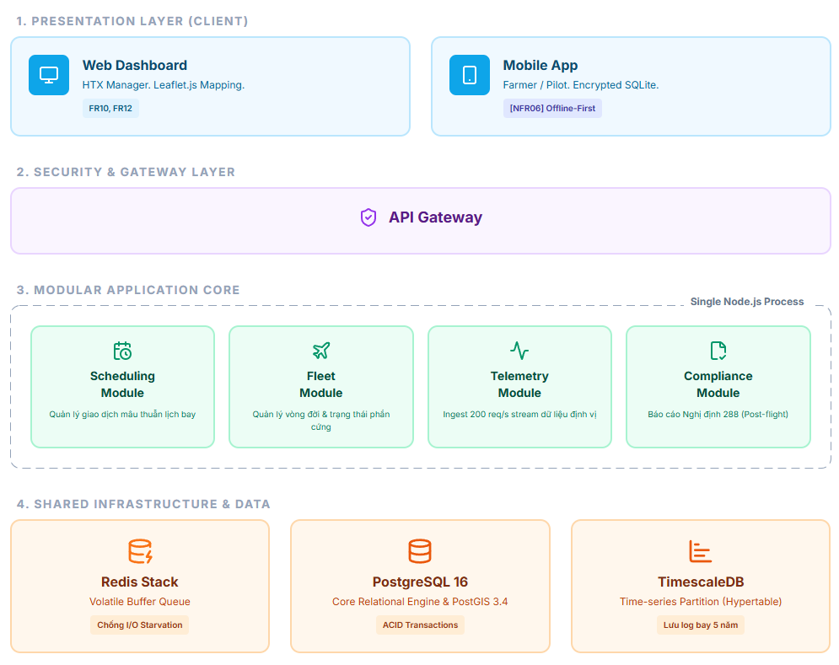
Architectural Layer Breakdown
- Client Layer: Comprises specialized interfaces tailored for distinct operational personas:
- Farmer Web/App: Optimized for usability and accessibility (NFR03).
- Pilot App: Incorporates a local Offline SQLite database to ensure continuous operation during 4G network dropouts in remote fields (NFR06).
- HTX Dashboard: A web-based interface for managers to monitor fleet status and schedules in real-time.
- Drone: The physical IoT hardware transmitting telemetry and status data.
- API Gateway Layer: Acts as the unified entry point for all incoming client requests. It offloads cross-cutting concerns such as routing, rate-limiting (configured per drone device hardware ID to prevent rogue telemetry flooding from malfunctioning sensors), TLS termination; JWT validation is enforced downstream in the Application Layer.
- Application Layer: The centralized monolithic engine housing specific business modules:
- Booking Module: Manages strict transactional workflows for scheduling spraying sessions (UC01, UC02).
- Fleet Module: Handles drone dispatching, capacity planning, and status tracking.
- Telemetry Module: Designed to process high-throughput, real-time flight data originating from the drones (UC04).
- Data Persistence Layer: A hybrid, purpose-built storage environment:
PostgreSQL & PostGIS: Manages core relational data (users, bookings) and complex spatial geographic queries (farm mapping). TimescaleDB: An extension specifically chosen to handle time-series drone telemetry logs. Redis: Functions as an in-memory buffer to absorb high-frequency telemetry data streams before they are permanently flushed to the database, preventing database bottlenecking.

5. TECH STACK PROPOSAL
The component selections across every layer of the architecture have been specifically optimized to handle the demographic realities of rural operators (Nguyen 2025) and the infrastructure of agricultural environments:
- Web Administration Dashboard (Frontend): Built with React.js styled via TailwindCSS. Map layouts are rendered using Leaflet.js integrating OpenStreetMap data layers. This provides full GIS capabilities without the commercial API licensing costs associated with Google Maps, aligning with cooperative budgetary limits.
- Mobile Application (Pilots & Farmers) (Frontend): Developed as a native cross-platform application using Flutter (Dart). Local data persistence uses an encrypted SQLite instance embedded directly in the client container. This architecture natively drives the Offline-First workflow [NFR06], storing telemetry records securely when 4G connectivity drops. To support the older farmer demographic [NFR03], the UI typography targets a minimum size of 16pt alongside high-contrast visual accessibility patterns.
- Application Logic Layer (Backend): Engineered on NestJS (Node.js/TypeScript). Leveraging Node's asynchronous, non-blocking event-loop model allows the backend gateway to sustain high-throughput WebSockets Secure (WSS) streaming from multiple operating drones simultaneously without thread exhaustion, fulfilling real-time monitoring constraints [NFR01].
Database & Volatile Caching Layer: PostgreSQL 16 serves as the core relational engine enforcing strict ACID transactional integrity for scheduling [UC02].
- The PostGIS 3.4 extension evaluates geographic primitives natively (e.g., ST_Contains) for field mapping.
- TimescaleDB 2.x is tightly integrated to explicitly handle the high-frequency, time-series drone telemetry and flight log data required for regulatory compliance (Decree 288).
- Redis Stack operates as a high-speed volatile message queue, acting as a shock absorber to protect physical disk storage from I/O starvation during peak spraying operations [NFR04].
- Infrastructure & Hosting: The system is deployed on a single-node VPS/Cloud VM (e.g., DigitalOcean or a local Vietnamese provider such as Viettel IDC/VNG Cloud) rather than a Kubernetes cluster, consistent with the chosen Modular Monolith architecture (Section 4) and the limited DevOps capacity of agricultural cooperatives. Docker and Docker Compose package the application, database, and Redis buffer into reproducible containers for straightforward local backup and single-command redeployment. Nginx serves as the reverse proxy and TLS termination point (detailed further in Section 6). A lightweight CI/CD pipeline (GitHub Actions) automates build, test, and deployment, matching the team's small size (5 students/developers) without requiring dedicated infrastructure staff.

6. DEPLOYMENT TOPOLOGY
This section describes where the components defined in §4 (Architecture) and §5 (Tech Stack) physically run and how they communicate over the network. Business logic (buffering, offline-sync mechanics) is not repeated here see §4.3 for the Redis write-behind pattern and §5 for the SQLite offline-first client design.

6.1 Topology Overview
The AgriUAV Platform uses a Hybrid Edge Cloud topology, consisting of two physical zones:
- Edge Zone (no infrastructure owned/operated by the team): the Drone hardware and the Pilot's/Farmer's personal smartphone. These devices operate independently of connectivity and only push data upstream opportunistically.
- Cloud Zone (single-node VPS, per §5 Infrastructure & Hosting): hosts the entire server-side stack - Nginx, the NestJS application containers, PostgreSQL, TimescaleDB, and Redis — as Docker Compose services on one Vietnamese cloud provider node (e.g., Viettel IDC/VNG Cloud).
There is intentionally no separate edge-compute node (e.g., no local gateway server at the cooperative office) in the MVP scope; all "edge" processing is client-side logic inside the mobile app.

6.2 Physical Network Path
This section illustrates the physical routing of data across the deployed nodes under different operational contexts. The network paths are strictly separated based on payload characteristics: high-throughput IoT streams vs. strict transactional requests.

6.2.1 Baseline Physical Topology

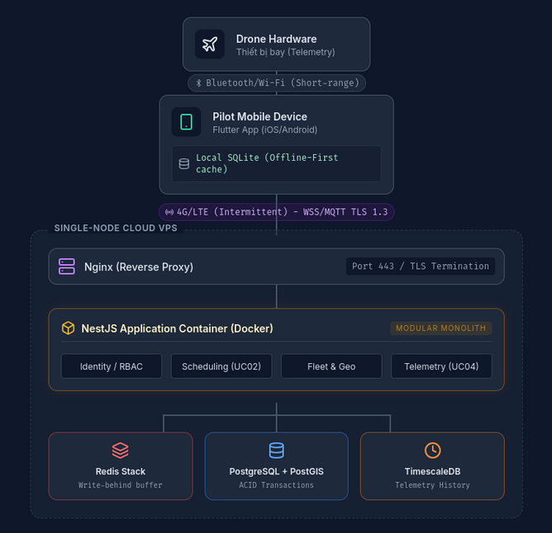
Source: Interactive Architecture Blueprint generated via custom HTML/CSS modeling tool.
Description: The baseline topology consists of three primary physical zones:
- The Edge (Field Environment): Drone Hardware communicating via short-range protocols (Bluetooth/Wi-Fi) to the Pilot's Mobile Device.
- The Gateway (4G/LTE Transport): The mobile device acts as an edge proxy, handling intermittent 4G connections and buffering data locally via SQLite (NFR06).
- The Core (Cloud VPS): A Single-Node containerized environment protected by Nginx (TLS 1.3 Termination), hosting the NestJS Modular Monolith and a polyglot persistence layer (Redis, PostgreSQL, TimescaleDB).

6.2.2 Telemetry Data Path (High-Throughput IoT)

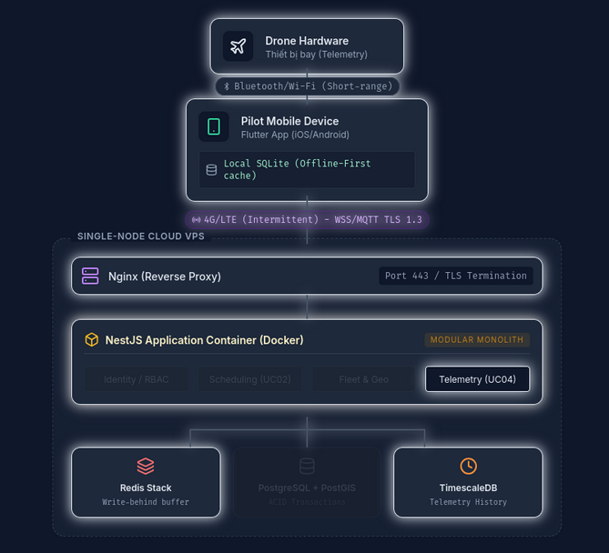
Source: Interactive Architecture Blueprint generated via custom HTML/CSS modeling tool.
Description: This path handles continuous, high-frequency coordinate updates (up to 200 req/s) from the drone fleet.
- Path: Drone HardwarAriale → Bluetooth → Mobile App → WSS/MQTT over 4G → Nginx → NestJS (Telemetry Module) → Redis Stack → TimescaleDB.
- Justification: Directing telemetry traffic to the in-memory Redis Buffer prevents the primary database from experiencing I/O bottlenecks. A background worker subsequently flushes this data to TimescaleDB for long-term legal compliance storage (Decree 288/2025/ND-CP).

6.2.3 Transactional Booking Path (Strict Consistency)

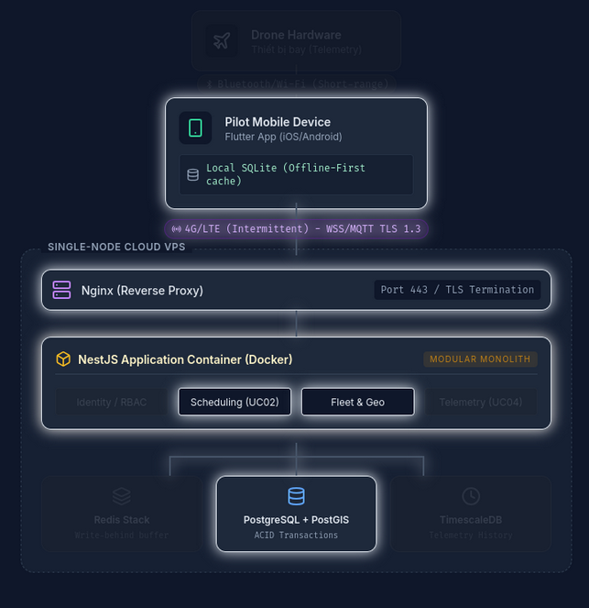
Source: Interactive Architecture Blueprint generated via custom HTML/CSS modeling tool.
Description: This path processes financial and scheduling requests where data integrity and race-condition prevention are critical.
- Path: Mobile App → HTTPS/TLS over 4G → Nginx → NestJS (Booking Module) → PostgreSQL.
- Justification: Unlike telemetry, booking requests bypass the Redis buffer and are routed directly to PostgreSQL. This leverages the database's ACID properties and Row-Level Locking (Pessimistic Lock) mechanism to instantly block overlapping schedules and prevent double-booking of drone hardware.

6.3 Zone Responsibilities
Zone | Component | Responsibility
Edge | Drone | Captures flight telemetry; has no direct network stack of its own — relays only to the paired mobile device.
Edge | Pilot Mobile Device | Runs the offline-first client (§5); is the only point where a network disconnect is handled — see §5 for the sync mechanism.
Cloud | Nginx | Single entry point; TLS termination; routes to the NestJS container pool.
Cloud | NestJS Containers | Stateless application layer (Booking, Fleet, Telemetry modules per §4.3); horizontally restartable but not horizontally scaled in the MVP (single VPS).
Cloud | PostgreSQL / TimescaleDB / Redis | Co-located on the same VPS in the MVP; see §5 for why (cost, no DevOps team) and §9 for how their health is monitored.

6.4 Backup & Disaster Recovery (Physical Layer)
- Nightly pg_dump snapshots of PostgreSQL are stored to a separate object-storage bucket (off-VPS), satisfying the 5-year retention requirement noted in §3 for flight_logs, drone_positions, and audit_logs.
- The single-node VPS is a known single point of failure for the MVP; this is an accepted trade-off consistent with §4.2's Operational Complexity assessment (cooperatives have no dedicated DevOps capacity) and is flagged as a Limitation for the Week 11 defense (§C.1 slide 9, RBL Guide).
- Recovery Time Objective (RTO) target: VPS snapshot restore within the NFR02 ≤15-minute window (D2 §3.2).

6.5 Cross-References
- Redis write-behind buffering mechanism → §4.3
- Offline-first SQLite sync protocol on the Pilot app → §5
- Nginx/TLS role in the request path → §5 (introduced), §6.2 (positioned physically here)
- Monitoring of VPS-level resource thresholds → §9

7. SECURITY & ACCESS CONTROL

7.1 STRIDE Threat Modeling & Mitigation Actions
Threat Category | Target Asset | Identified Vector Detail | Enforced Architectural Mitigation Strategy
Spoofing Identity | PII / Telemetry | An unauthorized operator spoofs a pilot account to submit fake flight completions and claim unearned payments. | Enforce strict JSON Web Tokens (JWT) signed via RSA-256. Combine this with mobile device fingerprinting and require GPS coordinates to match within a 100m radius of the assigned field before allowing check-in.
Tampering with Data | Telemetry / Airspace | An operator alters flight telemetry streams to obscure drone damage or cover up the use of unapproved chemicals. | All data transmissions use mandatory TLS 1.3 transport encryption. Every telemetry payload must include a cryptographic signature generated via HMAC-SHA256 using a rotating key stored securely in the device's keychain.
Repudiation | System Logs | A pilot cancels an assigned spraying mission at the last minute but denies taking the action, leaving the farmer stranded. | The system implements an append-only immutable audit trail module. Any status modifications are automatically stamped with the authenticating user ID, source IP address, and server-side atomic timestamps.
Information Disclosure | PII | Proprietary land boundary shapes, yield metrics, or farmer contact details leak to unauthorized third-party agrochemical businesses. | Sensitive Personal Identifiable Information (PII) columns (e.g., phone numbers, tax identification codes) are encrypted at rest inside PostgreSQL using transparent AES-256 block ciphers.
Denial of Service (DoS) | Telemetry | Malicious actors use a botnet to spam thousands of fake requests per second (exceeding the 200 req/s baseline from NFR04) at the telemetry ingestion port, aiming to sever real-time drone connections. | Enforce Rate Limiting at the API Gateway layer (Nginx). Route all high-frequency telemetry streams through an in-memory Redis Stack Buffer to absorb request spikes before permanently flushing to the database, preventing I/O bottlenecks.
Elevation of Privilege | PII / Airspace | A standard user (Farmer) manipulates API request payloads to grant themselves cooperative administrator (HTX Manager) privileges to bypass payment or approve unverified flights. | Implement strict Role-Based Access Control (RBAC) at the NestJS Guard/Middleware layer. Configure Row-Level Security (RLS) in PostgreSQL to ensure farmers can only access or modify records matching their own userId.

7.2 Role-Based Access Control (RBAC) Permissions Matrix
System Use Case Interface |  | Farmer Account Role | Pilot (Operator) Account Role | HTX Manager Role | Agronomist Account Role |  | Admin Account Role
UC01: Create Spray Mission Request |  | ALLOWED (Own Fields Only) | DENIED | ALLOWED (On behalf of Farmer) | DENIED |  | ALLOWED (Full Access, cross-cooperative — FR18)
UC02: Dispatch Drone / Assign Pilot |  | DENIED | DENIED | ALLOWED (Full Fleet Domain) | DENIED |  | ALLOWED (Full Access, cross-cooperative — FR18)
UC04: Stream Telemetry Flight Log | READ-ONLY (Visual Track) |  | ALLOWED (Write Active Stream) | READ-ONLY (Fleet Dashboard) | READ-ONLY (Chemical Data) | READ-ONLY (Cross-Cooperative Fleet Oversight)
UC05: Log Emergency Incident Report |  | DENIED | ALLOWED (Write Incident State) | ALLOWED (Write & Resolve States) | DENIED |  | ALLOWED (Write & Resolve States, cross-cooperative)
UC09: Configure Chemical Dosage Matrix | DENIED |  | READ-ONLY (View parameters) | READ-ONLY (View parameters) | ALLOWED (Full Write Access) | READ-ONLY (View Only — not an FR02-authorized confirmer)
UC10: Export Auditable VietGAP Logs |  | ALLOWED (Own Plots History) | DENIED | ALLOWED (Full Cooperative Export) | ALLOWED (Full Cooperative Export) |  | ALLOWED (Full Cross-Cooperative Export — Audit Oversight)
Admin's "full access" (FR18) is scoped to cross-cooperative oversight, user/role management, and audit-log access D2 it is not unrestricted override of domain-specific approval authority. UC09 is the deliberate exception: FR02 names only Agronomist or HTX Manager as authorized dosage confirmers, so Admin remains READ-ONLY there even though other rows show full access.

8. QUALITY ASSURANCE (QA) PLAN

8.1 Test Strategy Overview
In alignment with the RBL framework, the testing strategy for the AgriUAV System Design phase spans three complementary test types unit, integration, and User Acceptance Testing (UAT) with emphasis shifting toward Architectural Validation and Edge-Case Resilience at the higher levels. Since the core challenges of operating in the Mekong Delta involve unstable 4G networks (NFR06) and strict regulatory auditing (Decree 288/2025/ND-CP), the strategy is layered as follows:
- Unit Testing: Isolated validation of core business logic, e.g. the schedule-conflict checker (FR04), the per-zone pesticide dosage calculator (FR02), and the drone/pilot rule-based assignment scorer (FR06), via Jest.
- Integration Testing: Validates module-boundary behavior within the Modular Monolith (§4), e.g. Booking Module ↔ PostgreSQL transactional writes, Telemetry Module ↔ Redis write-behind buffer, and NestJS Guard ↔ RBAC enforcement (§7.1).
- UAT / Architectural Validation: End-to-end scenarios validating system behavior at its operational boundaries concurrency control, offline resilience, and compliance traceability detailed below.
Testing focus areas include:
· Concurrency Testing: Validating PostgreSQL's Row-Level Locking during simultaneous booking requests.
· Network Throttling/Disconnection: Using simulated 'Airplane Mode' and background workers to validate the Offline-First mobile architecture (SQLite caching).
· Data Integrity Verification: Executing deep backend queries to ensure the unbroken traceability chain of spray-order logs.

8.2 Architectural Test Script Scenarios (Core UC Coverage)
TC_UAT_01: Automated Overlap Prevention Execution (Validating UC02 / Data Concurrency Integrity)
1. Pre-conditions: Inside PostgreSQL, Drone ID 45 is currently flagged as 'IN_FLIGHT' (actively assigned to Spray Order A on 2026-07-20 from 07:00:00+07 to 09:30:00+07).
2. Execution Steps:
a. Log in to the Web Portal using an account assigned the 'HTX_MANAGER' role.
b. Open the Dispatching Wizard interface and select pending Mission B.
c. Attempt to assign Drone ID 45 to Spray Order B on the same date with a schedule from 09:00:00+07 to 11:00:00+07 (creating a 30-minute conflict).
d. Click the 'Confirm Assignment' submission interface button.
3. Expected System Behavior: The backend interceptor catches the schedule overlap before executing the write operation. The database transaction rolls back, and the client receives a '409 Conflict' API error code. The user interface displays a clear alert: 'Drone resource unavailable during the requested time window due to a scheduling conflict with an existing order.' No overlapping records are persisted to disk.
TC_UAT_02: Network Loss Resilience Caching and Synchronisation (Validating UC04 / NFR06 – Offline Availability)
1. Pre-conditions: Ensure the mobile application is running on a pilot test device. Turn on 'Airplane Mode' to simulate a total network loss while operating in a remote field.
2. Execution Steps:
a. Click 'Start Spray Flight Execution' inside the pilot dashboard.
b. Generate a simulated flight path covering 5 distinct coordinate points.
c. Check the internal application state and inspect the local device storage logs.
d. Turn off 'Airplane Mode' to restore a stable 4G network connection.
3. Expected System Behavior: The mobile application remains responsive without lagging or showing crash alerts. The 5 coordinate points are successfully saved to the local client-side SQLite cache (a mirror of the drone_positions/flight_logs structure, extended with a client-only sync flag) with the flag set to is_synced_offline = true. Once the network state changes back to online, a background sync task automatically transmits the cached data array to /api/v1/telemetry/sync. The data is ingested into the central database with zero record loss.
TC_UAT_03: Traceability Chain Validation for Regulatory Compliance (Validating FR13 – Complete Flight Logs, cross-cutting compliance assurance, consistent with the Coverage Type classification in D2 §5.1 / NFR05 – Security & Audit)
1. Pre-conditions: Spray Order ID 88 has an associated flight_logs record with status 'IN_FLIGHT'.
2. Execution Steps:
a. Send a critical-failure telemetry payload from the pilot mobile client (e.g. drone malfunction mid-flight), triggering the backend to mark the associated flight_logs record as 'FAILED'.
b. Log in as an administrator and query the system database, joining flight_logs → spray_orders → operators → order_pesticides/pesticides → fields.
3. Expected System Behavior: The flight_logs.status for the affected record instantly flips to 'FAILED'; the parent spray_orders record is not silently overwritten but retains its own traceable state. When pulling the generated incident record, the system returns an unbroken data chain: Flight Log ID → Spray Order ID → Pilot License Number (Decree 288 Compliance) → Pesticide Batch Data → Field Geospatial Boundary. The information chain is 100% complete and immutable (append-only per §7.1 Repudiation control).
(Note: this scenario is intentionally not mapped to a single numbered UC — a catastrophic in-flight failure is not currently modeled as its own UC in D2 (UC05 Alt 4a covers only voluntary early termination by the Pilot, a different scenario). It is treated as validating FR13 as a cross-cutting compliance guarantee, per the same Coverage Type methodology already established in D2 §5.1.)
TC_UAT_04: Role-Based Auditable Export Validation (Validating UC10 / NFR05 - Access Control)
1. Pre-conditions: Inside the database, there are 5 completed flight logs associated with Farmer A's ID, and 3 logs associated with Farmer B's ID.
2. Execution Steps:
a. Log in to the Web Portal using Farmer A's account.
b. Attempt to generate a VietGAP compliance report spanning the entire cooperative (manipulating the API payload to request all logs).
c. Log out, then log in as an account with the 'HTX_MANAGER' role.
d. Request the same full cooperative report.
3. Expected System Behavior: For Farmer A, the backend Row-Level Security (RLS) intercepts the unauthorized request and only returns the 5 logs belonging to Farmer A, preventing PII disclosure. For the HTX_MANAGER, the system successfully aggregates and exports all 8 logs with cryptographic signatures intact, proving the architecture's RBAC matrix operates correctly at the database level.

9. OPERATIONS & MONITORING DESIGN
To ensure continuous availability during peak harvest seasons, the platform includes automated operations and infrastructure monitoring components. Consistent with the "no dedicated DevOps team" premise established in §4.2, all four tools below ship as pre-configured containers inside the same docker-compose.yml defined in §5 there is no manual tuning, no separate monitoring server, and no expectation that HTX staff ever interact with them. Grafana, Winston, and Alertmanager are read-only-by-default dashboards/pipelines watched exclusively by the 5-student development team; this keeps the stack observationally rich without adding operational burden to the cooperative side, preserving the "operational simplicity" argument made in §4.2.

Component | Tool | What It Monitors |  | NFR / FR Link
Performance Infrastructure Monitoring | Prometheus & Grafana | Host-level CPU utilization, available RAM, open PostgreSQL connections, TimescaleDB chunk compression status, hypertable ingestion rate, and query latency for telemetry reads, and Redis memory usage. Metrics are visualized on a central Grafana dashboard so the dev team can spot bottlenecks before they cause downtime. |  | NFR02 (Uptime ≥ 99%, RTO ≤ 15 min) early detection of resource exhaustion is the primary lever for hitting the RTO target. NFR01 (position update ≤ 3s / <500ms latency) TimescaleDB query latency is tracked because it is the read path behind the live map.
Structured Log Aggregation | Winston (JSON framework) | All application services emit structured JSON logs classified as INFO (normal events), WARN (non-fatal errors, e.g. a temporary Weather API timeout), or ERROR (critical issues, e.g. database connection failures or storage limits reached). |  | Directly supports triage of the Weather API dependency noted in D2 §2.5 a WARN-level timeout is exactly the failure mode UC06's Postconditions (Failure) describes ("Weather alert – Unavailable" banner).
Proactive Alerting Pipeline | Alertmanager | Routes webhook alerts to the development team when the PostgreSQL connection pool exceeds 85% capacity, or when backend API error rates exceed 5% within any 60-second window. | NFR04 (Scalability 200 req/s peak telemetry baseline). The 85%/5% thresholds are deliberately conservative headroom markers set below the point where the 200 req/s peak load (§3.2) would saturate the connection pool, giving the team a warning window before the Redis buffer (§4.3) itself starts backing up.

Cross-Reference Note: This section fulfills the monitoring commitment made in §6.3's Zone Responsibilities table "PostgreSQL / TimescaleDB / Redis... see §9 for how their health is monitored" by explicitly covering all three data-layer components (previously TimescaleDB was omitted; now included above alongside PostgreSQL and Redis).

APPENDIX: DESIGN PHASE AI AUDIT LOG

Entry #21 - W7 / P4 Design
Field | Content
DTC Component | Critical Thinking & Trade-off
AI Output (tóm tắt) | Proposed writing the incoming telemetry packets directly from the REST API Gateway endpoint into the core PostgreSQL relational table.
Decision & Refinement | Human Delta: Bypassed direct database writes. At an operating frequency of 4Hz across 50 drones, the system must process 200 requests/sec, causing severe disk I/O bottlenecks. Inserted an intermediate Redis In-Memory Buffer layer to cache telemetry, utilizing background workers for scheduled asynchronous batch inserts.
Verification | Telemetry Ingestion Architecture flow diagram in Section 1.3 of D4.
AI Tool / Prompt | Claude - “Design the backend pipeline architecture to ingest real-time drone coordinate updates (UC04) from 50 active drones concurrently.”

Entry #22 - W7
Field | Content
DTC Component | Critical Thinking & Trade-off
AI Output (tóm tắt) | AI analyzed the trade-off matrix, indicating that Microservices have an absolute advantage in Scalability, but warned about high infrastructure operational costs and deployment complexity.
Decision & Refinement | Decided to adopt Layered Architecture. Argued that the actual context at Mekong Delta cooperatives involves low budgets and a lack of dedicated DevOps teams. Microservices would violate the NFR07 commitment (hotfix resolution time ≤ 4 hours). Layered Architecture is fully sufficient to meet the MVP requirements.
Verification | Cross-checked against practical barriers (Cost) and NFR07 (Maintainability). Aligns with the RBL Guide's Justification section.
AI Tool / Prompt | Gemini - “Evaluate and propose the system architecture (Layered Architecture vs. Microservices) based on the 200 req/s load requirement of the AgriUAV project.”

Entry #23 - W7
Field | Content
DTC Component | Traceability & Consistency
AI Output (tóm tắt) | AI detected a critical inconsistency: D3 v4.2 utilizes UUID v4, whereas the D4 draft's SQL DDL code uses INT AUTO_INCREMENT for primary keys.
Decision & Refinement | Firmly rejected the current D4 draft and refactored the entire DDL code to strictly use the UUID v4 standard (VARCHAR(36)). UUID is mandatory for resolving distributed data synchronization issues when drones operate in network dead zones (Offline Mode), preventing primary key collisions upon network reconnection.
Verification | Traceability ensures 100% alignment with D3 v4.2 and directly fulfills NFR06 (Availability / Offline Sync).
AI Tool / Prompt | Gemini - “Cross-check data consistency between the Physical Database Schema design draft (D4 v0.51) and the System Models document (D3 v4.2).”

Entry #24 - W7
Field | Content
DTC Component | Architecture Component
AI Output (tóm tắt) | AI proposed having the API Gateway receive the coordinate data and directly write it to the PostgreSQL/TimescaleDB database to ensure real-time tracking.
Decision & Refinement | Inserted a Redis In-Memory Buffer component between the API Gateway and TimescaleDB. Analyzed that a direct write of 200 req/s into the database would cause I/O bottlenecks. Redis acts as a "shock absorber" to capture high-frequency streams, utilizing a background worker to asynchronously flush data into the long-term legal compliance database.
Verification | Verified against NFR04 (Scalability threshold: 50 drones/HTX) and ensures compliance with data retention policies under Decree 288/2025/ND-CP.
AI Tool / Prompt | Gemini - “Design the data flow for the Telemetry module (UC04) to continuously ingest flight coordinates transmitted from drone devices to the server.”

