Mirenge Innocent

JAVARIS JOHNSON

10/14/2024

Mobile App

Personal Finance Manager App: “MyCash”

Proposed Group members:

1. MIRENGE INNOCENT
2. JAVARIS JOHNSON

**Project summary**

**Objective**

This is Flutter-based Personal Finance Manager app which allows users to track their income, expenses, investment, savings goals, and budgeting locally by using SQLite database. Its features are next level of money management, because the users will be able to take control of their money. The user’s data will always be protected and efficient database for storing those data. The app provides users with insights into their financial health, assisting them in making informed decisions about saving. And spending. It simplifies financial management, making it accessible for users of varying financial literacy level. With a user-friendly interface, even users with minimal financial knowledge can navigate the app with ease.

Features:

1. **Income tracking:** In this feature users will be able to add and categorize their income sources.
2. **Expense tracking:** In this feature users will be able to add and categorize their expenses, and to view spending trends.
3. **Savings Goals:** this feature will allow users to set and track specific savings goals.
4. **Investment tracking:** this feature will allow users to monitor their investments and get insights into their portfolio performance.
5. **Budgeting tools:** this feature will help users to set budgets for different categories.
6. **Reports and Insights:** This feature will allow users to view reports in form of graphs and charts to help users to understand their financial situation.
7. **Reminders:** Notifications for upcoming bills or when users are close to their budget limits.
8. **Data Export:** this feature will allow user to export their data in formats like CSV or PDF for further analysis.

**User Experience:** Designs a clean, intuitive interface that makes financial management accessible and operational efficiency for users.

**GitHub link:** <https://github.com/minnocent12/Personal_Finance>

**Proposed wireframe**

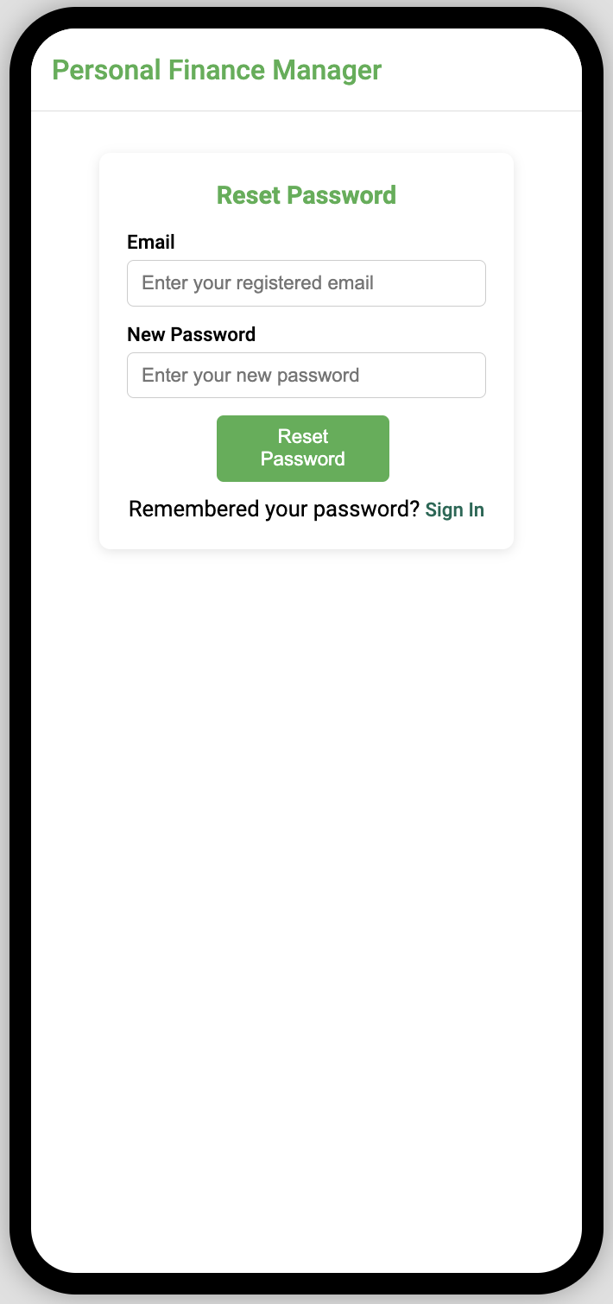

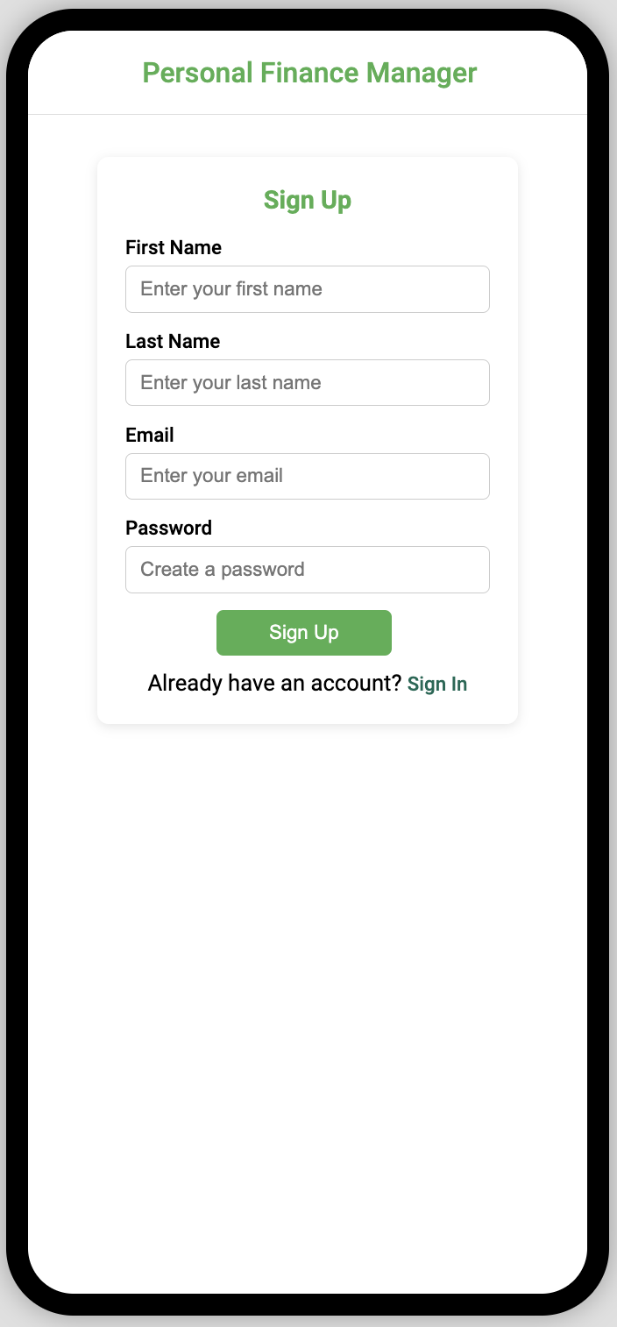

**1. Layout**

Personal Finance Manager App “MyCash” consists of the following 11 unique screens:

1. **Home Screen**
   * **Overview Widgets**: Display cards for total income, total expenses, total savings, and total investments.
   * **Quick Action Buttons**: Buttons for "Add Income," "Add Expense," "Add Savings Goal," and "Add Investment."
   * **Navigation**: Use a bottom navigation bar or a drawer menu to access different sections of the app.

**2. Income Screen**

* **Income List**: Display a list of income entries with details (source, amount, date).
* **Add Income Button**: Opens a form to input income details:
  + **Fields**: Source (e.g., job, freelance), amount, date, and notes.
* **Edit/Delete Options**: Swipe actions or a long press on an entry to edit or delete.
* **Summary Widget**: Show total income for the current month/year.

**3. Expense Screen**

* **Expense List**: Display a categorized list of expenses (e.g., groceries, bills, entertainment).
* **Add Expense Button**: Opens a form to input expense details:
  + **Fields**: Category, amount, date, notes.
* **Visual Representation**: Use charts (e.g., pie or bar charts) to show spending distribution.
* **Summary Widget**: Display total expenses and comparisons to income.

**4. Savings Goals Screen**

* **Goals List**: Display a list of savings goals with progress indicators (e.g., a progress bar).
* **Add Goal Button**: Opens a form to input goal details:
  + **Fields**: Goal name, target amount, current amount, target date.
* **Edit/Delete Options**: Like income and expense entries.

**5. Investment Screen**

* **Investment Overview**: Display a list of investments with details (e.g., stock name, current value, purchase date).
* **Add Investment Button**: Opens a form for inputting investment details:
  + **Fields**: Investment type (stocks, bonds, etc.), amount, current value, notes.
* **Performance Tracking**: Use graphs to show investment growth over time.

**6. Budgeting Screen**

* **Budget List**: Display budgets for different categories.
* **Add Budget Button**: Opens a form for setting budget details:
  + **Fields**: Category, budget amount, period (monthly, weekly).
* **Tracking Progress**: Show how much has been spent against the budget.

**7. Reports and Insights Screen**

* **Generate Reports**: Provide options for users to filter reports (e.g., monthly, yearly).
* **Visualizations**: Use charts and graphs to display income vs. expenses, savings trends, etc.
* **Insights Section**: Provide tips based on spending patterns (e.g., “Consider reducing your grocery spending”).

**8. Settings Screen**

* **Notification Settings**: Options for reminders related to expenses or savings goals.
* **Data Export Options**: Allow users to export their data to CSV or PDF.
* **Account Management**: Options for user authentication (if required) and backup settings.

1. **Sign In Screen**

* **Authentication:** Allow users to login by valid credential (email and password).

1. **Sign Up Screen**

* **Collect user information:** Allow users to register by providing their information.

1. **Reset password Screen**

**Reset password:** Allow Users to reset their password in different cases such as:

* Changing password
* Forgetting password

The key layout components include:

* **Top Bar**: Features a **Menu** icon with a label and a **Logout** button with an icon and label.
* **Drawer Menu**: Slides out from the left, containing navigation links to all primary sections.
* **Main Content Area**: Varies per screen, displaying relevant information and interactive elements.
* **Bottom Navigation Bar**: Provides quick access to primary sections with icons and labels.
* **Responsive Design**: Ensures compatibility across different screen sizes and orientations.

1. **Functionality**

**Proposed Use Cases for Transitioning from Screen to Screen**

1. **Authentication Flow**:
   * **Sign In** ➔ **Home**: Users enter credentials and click "Sign In" to access the home screen.
   * **Sign Up** ➔ **Home**: New users register via the Sign-Up screen and are redirected to Home upon successful registration.
   * **Forgot Password** ➔ **Reset Password**: Users who forget their password can navigate to the Reset Password screen from Sign In.
2. **Navigation via Bottom Navigation Bar**:
   * **Home**: Central hub displaying financial summaries.
   * **Income**: Manage and view income sources.
   * **Expenses**: Track and categorize expenses.
   * **Saving Goals**: Set and monitor savings targets.
   * **Investments**: Overview of investment portfolios.
   * **Budgeting**: Plan and manage budgets.
   * **Reports**: Overview of finance
3. **Drawer Menu Interaction**:
   * **Menu Icon Click** ➔ **Drawer Opens**: Access all navigation links from the drawer.
   * **Selecting a Link in Drawer** ➔ **Navigate to Selected Screen**: Direct transition to the chosen section.
   * **Overlay Click** ➔ **Drawer Closes**: Dismiss the drawer by clicking outside.
4. **Action Buttons**:
   * **Add Buttons** (e.g., "+ Add Income", "+ Add Expense") ➔ **Navigate to Detail Screens or Open Modals**: Facilitate adding new entries.
5. **Logout Functionality**:
   * **Logout Button Click** ➔ **Redirect to Sign In**: Securely log out and navigate back to authentication.
6. **User Experience**

**Proposed Use Cases for Each Screen**

1. **Sign In** 
   * **Use Case**: Existing users log into their accounts using email and password.
   * **Features**:
     + Email and Password input fields.
     + "Sign In" button.
     + Links to **Sign Up** and **Reset Password** screens.
2. **Sign Up**
   * **Use Case**: New users create an account by providing personal details.
   * **Features**:
     + Input fields for First Name, Last Name, Email, and Password.
     + "Sign Up" button.
     + Link to **Sign In** screen.
3. **Home** 
   * **Use Case**: Users get an overview of their financial status.
   * **Features**:
     + Summary cards displaying Total Income, Expenses, Savings, and Investments.
     + Quick Access Buttons for adding Income, Expenses, Savings Goals, and Investments.
     + Navigation via Bottom Navigation Bar and Drawer Menu.
4. **Reset Password** 
   * **Use Case**: Users reset their password if forgotten.
   * **Features**:
     + Input fields for Email and New Password.
     + "Reset Password" buttons.
     + Link to **Sign In** screen.
5. **Income**
   * **Use Case**: Users manage and review their income sources.
   * **Features**:
     + Table listing income sources with Amount and Date.
     + "Add Income" button.
     + Edit and Delete actions for each income entry.
     + Navigation via Bottom Navigation Bar and Drawer Menu.
6. **Expenses**
   * **Use Case**: Users track and categorize their expenses.
   * **Features**:
     + Table listing expenses with Category, Amount, Date, and Actions.
     + "Add Expense" button.
     + Pie chart visualizing Expenses Distribution.
     + Navigation via Bottom Navigation Bar and Drawer Menu.
7. **Saving Goals**
   * **Use Case**: Users set and monitor savings targets.
   * **Features**:
     + Cards displaying Savings Goals with Target and Current amounts.
     + Progress bars indicating goal completion.
     + "Add Savings Goal" button.
     + Navigation via Bottom Navigation Bar and Drawer Menu.
8. **Investments**
   * **Use Case**: Users view and manage their investment portfolios.
   * **Features**:
     + Table listing Investments with Type, Amount Invested, Current Value, and Actions.
     + "Add Investment" button.
     + Bar chart comparing Amount Invested vs. Current Value.
     + Navigation via Bottom Navigation Bar and Drawer Menu.
9. **Budgeting**
   * **Use Case**: Users plan and monitor their budgets.
   * **Features**:
     + Table listing Budget Categories with Budget Amount, Current Spend, Progress, and Actions.
     + Progress bars indicating budget utilization.
     + "Add Budget" button.
     + Navigation via Bottom Navigation Bar and Drawer Menu.
10. **Reports & Insights**
    * **Use Case**: Users analyze their financial data through reports and receive insights.
    * **Features**:
      + Filters for selecting Date Range.
      + Charts displaying Income vs. Expenses and Spending Patterns.
      + Insight tips to optimize financial management.
      + Navigation via Bottom Navigation Bar and Drawer Menu.
11. **Settings**
    * **Use Case**: Users customize app preferences and manage account settings.
    * **Features**:
      + Notification Settings toggle.
      + Data Export option.
      + Account Management button.
      + Navigation via Bottom Navigation Bar and Drawer Menu.
12. **Iterative Design**

**Test Cases and Approach to Refine Improvements**

To ensure the app delivers an optimal user experience, an **Iterative Design** approach will be employed. This involves continuous testing, feedback collection, and refinements. Below are proposed **Test Cases** and the **Approach** for iterative improvements:

* 1. **Test Cases**

1. **Authentication Flow**
   * **TC1**: Successful Sign In with valid credentials.
   * **TC2**: Failed Sign In with invalid credentials.
   * **TC3**: Successful Sign Up with unique email.
   * **TC4**: Sign Up failure with existing email.
   * **TC5**: Password reset process functionality.
2. **Navigation**
   * **TC6**: Navigating between screens via Bottom Navigation Bar.
   * **TC7**: Opening and closing the Drawer Menu.
   * **TC8**: Navigating to a screen from the Drawer Menu.
   * **TC9**: Ensuring Bottom Navigation Bar highlights the active screen.
3. **Data Management**
   * **TC10**: Adding a new Income, expense, savings goals, and investment entry.
   * **TC11**: Editing an existing Income, expense, savings goals, and investment entry.
   * **TC12**: Deleting Income, expense, savings goals, and investment
   * **TC13**: Exporting data.
4. **User Interactions**
   * **TC14**: Button click animations and feedback.
   * **TC15**: Form validations for input fields.
   * **TC16**: Logout functionality redirecting to Sign In.
5. **Accessibility**
   * **TC17**: Ensuring all buttons are tappable and labeled correctly.
   * **TC18**: Verifying color contrasts meet accessibility standards.
6. **Performance**
   * **TC19**: Loading times for each screen.
   * **TC20**: Smoothness of drawer animations and transitions.

**b. Iterative Approach**

1. **Prototype Development**
   * **Phase 1**: Develop the initial wireframes for all screens with basic navigation.
   * **Phase 2**: Implement interactive elements like buttons, forms, and charts.
2. **Initial Testing**
   * Conduct **Usability Testing** with a small group of users to gather feedback on layout and navigation.
   * Execute **Functionality Testing** based on the defined test cases to identify any issues.
3. **Feedback Collection**
   * Use surveys, interviews, and observation to collect user feedback.
   * Identify pain points, usability issues, and areas for improvement.
4. **Refinement**
   * **Design Refinements**: Adjust layouts, colors, fonts, and element placements based on feedback.
   * **Functionality Enhancements**: Fix bugs, improve navigation flows, and enhance interactive elements.
5. **Secondary Testing**
   * Re-test the refined wireframes with a broader user base.
   * Focus on previously identified issues to ensure they have been resolved.
6. **Final Adjustments**
   * Make final tweaks to optimize performance and user experience.
   * Ensure consistency across all screens and navigation methods.
7. **Documentation**
   * Document all changes, feedback received, and solutions implemented.
   * Prepare a guide for developers if transitioning to a fully functional app.
8. **Continuous Improvement**
   * Post-launch, continue to gather user feedback and iterate on the design as needed.
   * Plan for future features and enhancements based on user needs and technological advancements.

**I understand that I will be graded individually on group assignments and may not receive the same grade as all members”. (Mirenge Innocent)**

## **5. Roles and Responsibilities**

Mirenge Innocent: Focuses on designing the user interface (UI) using Flutter. Responsible for ensuring the app looks good and is user-friendly.  
Javaris Johnson: In charge of integrating the SQLite database and implementing features like tracking income and budgeting.  
Both members will test the app and contribute to debugging.

## **6. Revised Project Timeline and Milestones**

Week 1 (10/14/24 - 10/20/24): Complete wireframing and UI design.  
Week 2 (10/21/24 - 10/24/24): Implement income and expense tracking, and set up SQLite database.  
Week 3 (10/25/24 - 10/27/24): Develop budgeting and savings goals features, and add report functionalities.  
Week 4 (10/28/24 - Project Due Date): Finalize testing, fix bugs, and get the app ready for submission.

## **7. Technologies and Tools**

Frontend: Flutter framework.  
Backend: SQLite for local data storage.  
Version Control: GitHub for collaboration.  
Testing Tools: Flutter’s widget testing framework.

## **8. Competitor Analysis**

We compared our app to Mint and YNAB. “MyCash” stands out by focusing on offline access and local data storage for better security.

## **9. Potential Challenges**

Learning Curve: We may need extra time to master new tools like Flutter and SQLite.  
Data Security: We will use encryption and local storage to protect sensitive data.  
Time Management: Weekly check-ins will help us stay on track.

## **10. Testing Strategy**

Manual Testing: Test main features like adding income/expense entries and navigating between screens.  
Automated Testing: Use Flutter’s built-in tools to automate form/button tests.  
Usability Testing: We will gather feedback from a few users on the app's ease of use.

I understand that I will be graded individually on group assignments and may not receive the same grade as all members.

Signature: