**Project Plan**

**Passport Meals Web App**

|  |  |
| --- | --- |
| Industry Partner | N/A |
| Primary Instructor | Anjana |
| Team Member | Armen Levon Armen |
| Team Member | Jeremy Buchanan |
| Team Member | Chun-Chen Lu |
| Team Member | Zion Henry |

Document Revision History

|  |  |
| --- | --- |
| Revision # | Date |
| 1.0 | 10/4/2021 |

**Table of Contents**

Executive Summary..........................................................................................................................3

Project Approvers, Reviews and Distribution List..............................................................3

Scope.......................................................................................................................................................4

Deliverables.........................................................................................................................................4

Assumptions........................................................................................................................................5

Dependencies......................................................................................................................................5

Risk Management..............................................................................................................................6

Communication..................................................................................................................................6

Task Listing..........................................................................................................................................7

Gantt Chart...........................................................................................................................................8

Milestones............................................................................................................................................9

Responsibility Assignment Matrix............................................................................................9

Approval..............................................................................................................................................10

**1. Executive Summary**

|  |  |
| --- | --- |
| Objective | We hope to create software that will be used by restaurants to store customer information and to aid in contact tracing. We want this software to be able to target all the needs of a restaurant in the covid era and help business comply with covid regulations. |
| Corporate Goals Addressed | Create an application that can be used to showcase our teams abilities to entice future customers to invest in us. |
| Planned Start Date | October 4, 2021 |
| Planned End Date | April 1, 2022. |

**2. Project Approvers, Reviews and Distribution List**

|  |  |  |  |
| --- | --- | --- | --- |
| Project Role | Name | E-mail | Date |
| Project Manager | Armen Levon Armen | Armen.levonarmen@georgebrown.ca | 10/4/2021 |
| Software Architect | Jeremy Buchanan | jeremy.buchanan@georgebrown.ca | 10/4/2021 |
| System Analyst | Chun-Chen Lu | chun-chen.lu@georgebrown.ca | 10/4/2021 |
| Market Analyst | Zion Henry | zion.henry@georgebrown.ca | 10/4/2021 |

**3. Scope**

|  |  |
| --- | --- |
| In Scope | Out of Scope |
| Customer Profiles | Restaurant Management |
| QR Menus | Payments and ordering |
| Reservations | Food Delivery |

**4. Deliverables**

|  |  |
| --- | --- |
| Deliverable | Description |
| Customer Profile Database | A database of stored customer profiles that can be accessed by both restaurant customers and restaurants filtered through the web app. |
| Contact Tracing Interface | This will allow restaurants to store what time customers visited and pull up all the profiles of customers who visited on a certain day for contact tracing purposes. |
| Web Application | The application will store customer information in the database, allow customers to make reservations, and allow customers to view the menu for the restaurant |
| QR Codes | We will create QR Codes that restaurants can print out or display to enable use of the webapp. |
| QR Menus | We will allow customers to bring up the menu just by scanning the QR code so no physical menu needs to be touched |

**5. Assumptions**

This project makes the following assumptions;

* Restaurant will provide QR code to their customers for menu
* proof of vaccine must be presented to staff by customers.
* Failure to identify changes to draft deliverables within the time specified in the project timeline will result in project delays.
* Project Team will adhere to the communication plan.
* Project Plan (features) are subject to change based on law
* All project participants will abide by the guidelines identified within this plan.
* The Project Plan may change as new information and issues are revealed.

**6. Dependencies**

System Requirements and Analysis and Design documents must be finished before Wireframes/Prototypes and Technical Requirements can be started, and those must finish before work on the application can begin.

**7. Risk Management**

|  |  |  |  |
| --- | --- | --- | --- |
| Potential Risk | Severity (H/M/L) | Likelihood (H/M/L) | Management Strategy |
| Law and Regulation changes | M: Reduces desirability of app | M: Likely | The application will still work if covid 19 regulations are removed completely, and marketing focus could be shifted to proofing against future pandemics. |
| **Project Definition** |  |  |  |
| Project Scope Creep | L: Scope generally defined, subject to revision | L: Unlikely | Any changes to the scope require unanimous approval of all developers |
| Vendor Project Deliverables | M: Estimated, not clearly defined | M: Somewhat likely | Included in project plan, subject to amendment |
| **Project Staffing** |  |  |  |
| Project Team Availability | H: no full time team members, members busy with other projects | M: Likely | Continuous revie of project momentum by all levels. If necessary, increase commitment of members with higher availability |
| Weak User Participation in Project team | L: Users are inexperienced in project management | L: Unlikely | Group members were selected based on previous shared experience on other projects, peer review to notice issues and institute change |

**8. Communication**

**Meetings**

The following meetings/communication will be established;

|  |  |  |  |
| --- | --- | --- | --- |
| Meeting | Purpose | Attendees | Frequency |
| Sprint Review | Review Agenda for current sprint and assign tasks | Whole dev team | Weekly |
| Sprint Submisson | Review work completed during previous sprint, clean up documentation, and harmonize team knowledge | Whole dev team | Weekly |

**9. Task Listing (WBS- Work Breakdown Structure)**

**10. Gantt Chart**

**11. Milestones**

|  |  |  |
| --- | --- | --- |
| Major Activity or Milestone | Estimated Milestone Target date | Owner/Reviewer Team Members |
| Web App Completion | April 1, 2022. | All |
| Plan Completion | December 17, 2022 | All |

**12. RAM – Responsibility Assignment Matrix**

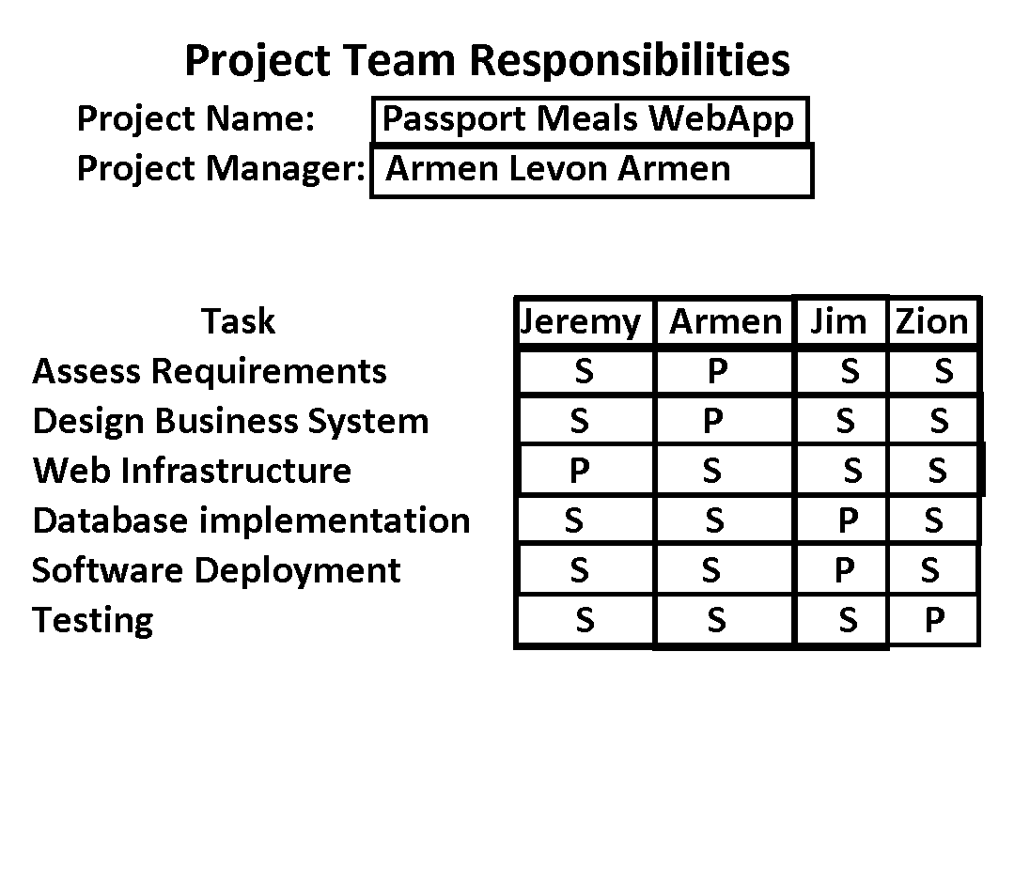

**13. Approval**

The signatures below indicate their approval of the contents of this document.

|  |  |  |  |
| --- | --- | --- | --- |
| Project Role | Name | Signature | Date |
| Project Manager | Armen Levon Armen | A.A. | 10/10/2021 |
| Software Architect | Jeremy Buchanan | J.B. | 10/10/2021 |
| System Analyst | Chun-Chen Lu | C.L. | 10/10/2021 |
| Market Analyst | Zion Henry | Z.H. | 10/10/2021 |