MongoDB In-class Exercise 1

1) Create a Database called music​.
>use music
switched to db music
> db
music
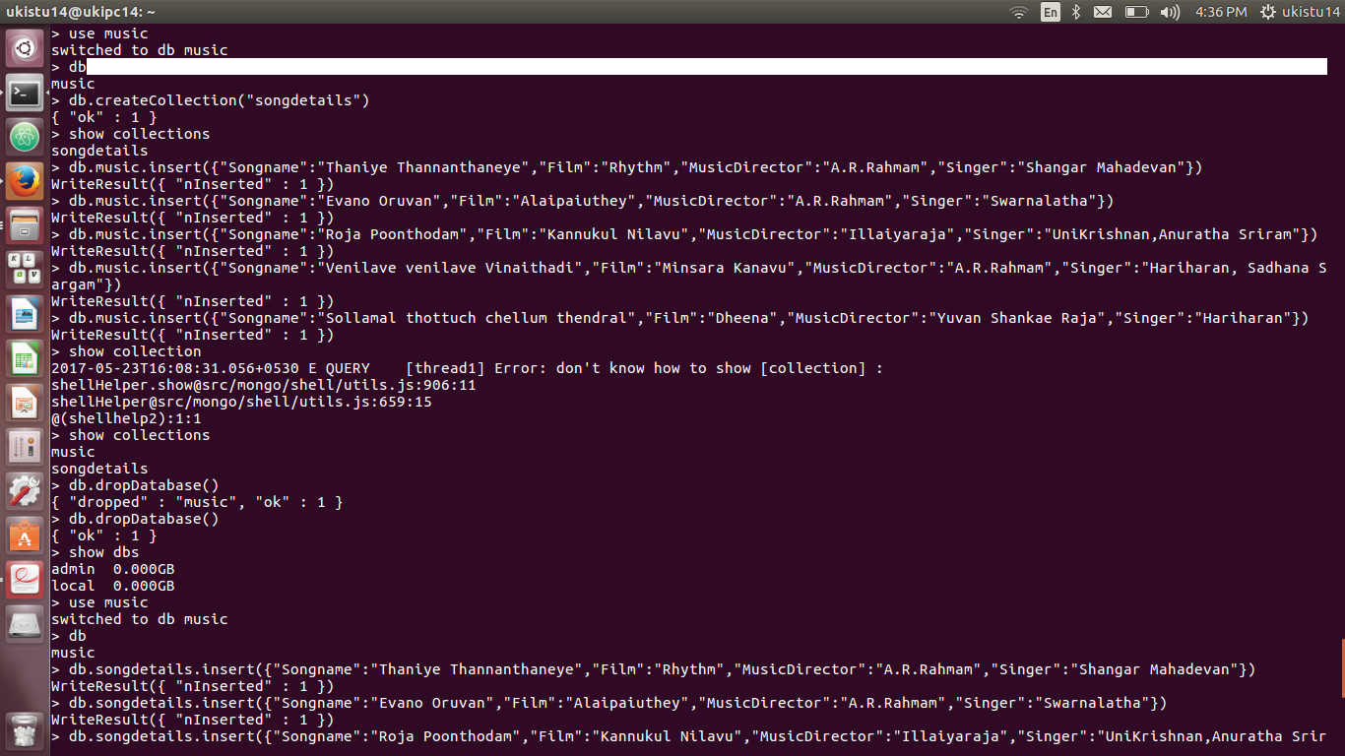

2) Create a collection called ​ songdetails​ .
> db.createCollection("songdetails")
{ "ok" : 1 }

3)Create the above 5 song documents.
> db.songdetails.insert({"Songname":"Thaniye Thannanthaneye","Film":"Rhythm","MusicDirector":"A.R.Rahmam","Singer":"Shangar Mahadevan"})
WriteResult({ "nInserted" : 1 })
> db.songdetails.insert({"Songname":"Evano Oruvan","Film":"Alaipaiuthey","MusicDirector":"A.R.Rahmam","Singer":"Swarnalatha"})
WriteResult({ "nInserted" : 1 })
> db.songdetails.insert({"Songname":"Roja Poonthodam","Film":"Kannukul Nilavu","MusicDirector":"Illaiyaraja","Singer":"UniKrishnan,Anuratha Sriram"})
WriteResult({ "nInserted" : 1 })
> db.songdetails.insert({"Songname":"Venilave venilave Vinaithadi","Film":"Minsara Kanavu","MusicDirector":"A.R.Rahmam","Singer":"Hariharan, Sadhana Sargam"})
WriteResult({ "nInserted" : 1 })
> db.songdetails.insert({"Songname":"Sollamal thottuch chellum thendral","Film":"Dheena","MusicDirector":"Yuvan Shankae Raja","Singer":"Hariharan"})
WriteResult({ "nInserted" : 1 })

4)List all documents created.
> db.songdetails.find()
{ "_id" : ObjectId("592412696c6e7ea6eee9c0a7"), "Songname" : "Thaniye Thannanthaneye", "Film" : "Rhythm", "MusicDirector" : "A.R.Rahmam", "Singer" : "Shangar Mahadevan" }
{ "_id" : ObjectId("5924127d6c6e7ea6eee9c0a8"), "Songname" : "Evano Oruvan", "Film" : "Alaipaiuthey", "MusicDirector" : "A.R.Rahmam", "Singer" : "Swarnalatha" }
{ "_id" : ObjectId("592412936c6e7ea6eee9c0a9"), "Songname" : "Roja Poonthodam", "Film" : "Kannukul Nilavu", "MusicDirector" : "Illaiyaraja", "Singer" : "UniKrishnan,Anuratha Sriram" }
{ "_id" : ObjectId("592412a86c6e7ea6eee9c0aa"), "Songname" : "Venilave venilave Vinaithadi", "Film" : "Minsara Kanavu", "MusicDirector" : "A.R.Rahmam", "Singer" : "Hariharan, Sadhana Sargam" }
{ "_id" : ObjectId("592412c66c6e7ea6eee9c0ab"), "Songname" : "Sollamal thottuch chellum thendral", "Film" : "Dheena", "MusicDirector" : "Yuvan Shankae Raja", "Singer" : "Hariharan" }

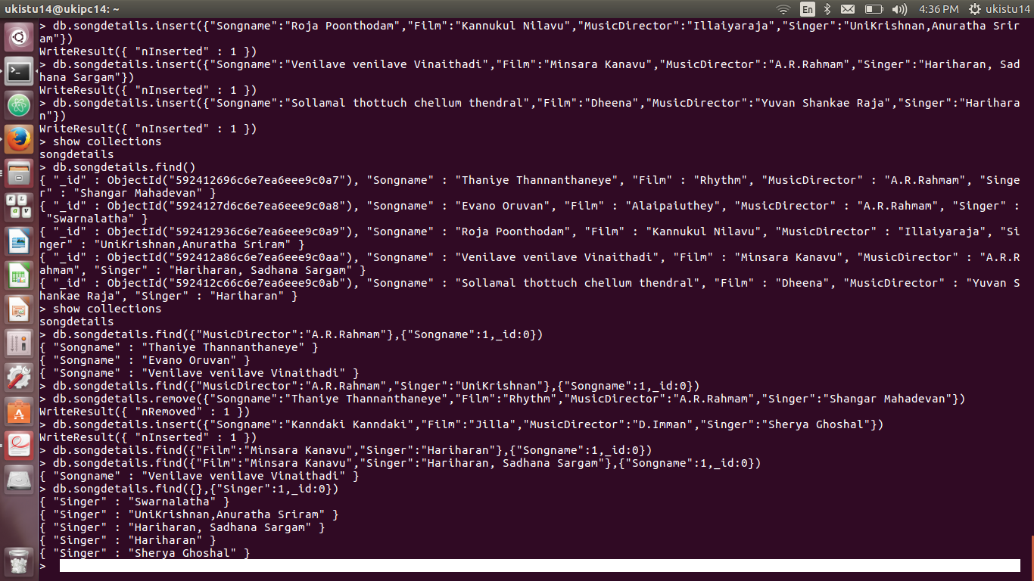

5) List A.R.Rahman’s songs
>db.songdetails.find({"MusicDirector":"A.R.Rahmam"},{"Songname":1,_id:0})
{ "Songname" : "Thaniye Thannanthaneye" }
{ "Songname" : "Evano Oruvan" }
6)List A.R.Rahman’s songs sung by Unnikrishnan.
>db.songdetails.find({"MusicDirector":"A.R.Rahmam","Singer":"UniKrishnan"},{"Songname":1,_id:0}){ "Songname" : "Venilave venilave Vinaithadi" }
7) Delete the song which you don’t like.
> db.songdetails.remove({"Songname":"Thaniye Thannanthaneye","Film":"Rhythm","MusicDirector":"A.R.Rahmam","Singer":"Shangar Mahadevan"})
WriteResult({ "nRemoved" : 1 })

8) Add new song which is your favourite.
> db.songdetails.insert({"Songname":"Kanndaki Kanndaki","Film":"Jilla","MusicDirector":"D.Imman","Singer":"Sherya Ghoshal"})
WriteResult({ "nInserted" : 1 })
9)List Songs sung by Hariharan from Minsara kanavu film.
> db.songdetails.find({"Film":"Minsara Kanavu","Singer":"Hariharan, Sadhana Sargam"},{"Songname":1,_id:0})
{ "Songname" : "Venilave venilave Vinaithadi" }

10)List out the singers’ names in your document.
> db.songdetails.find({},{"Singer":1,_id:0})
{ "Singer" : "Swarnalatha" }
{ "Singer" : "UniKrishnan,Anuratha Sriram" }
{ "Singer" : "Hariharan, Sadhana Sargam" }
{ "Singer" : "Hariharan" }
{ "Singer" : "Sherya Ghoshal" }

