Node.js + Mongo.db 01

1) Create a Database called ​music​ .
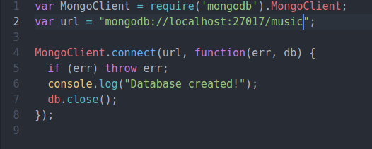

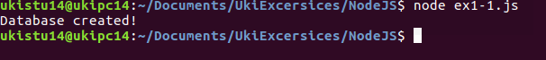

2) Create a collection called ​ songdetails​ .

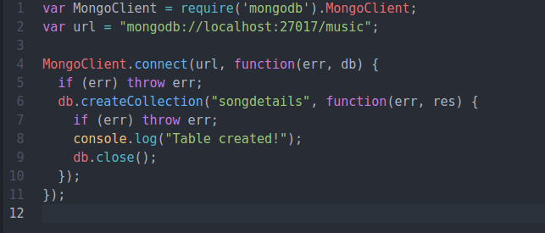

3) Create the above 5 song documents.

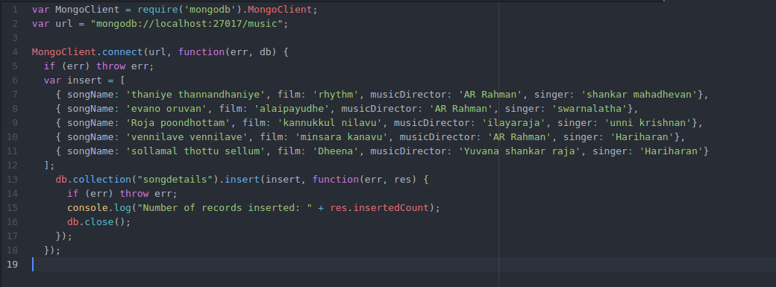

4) List all documents created.
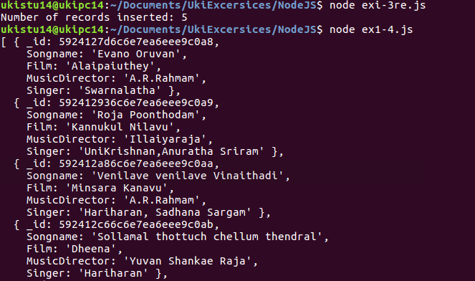
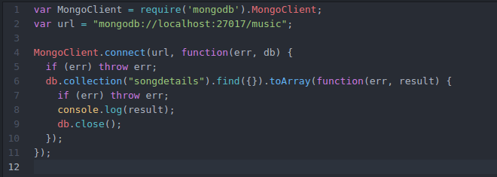

5) List A.R.Rahman’s songs.

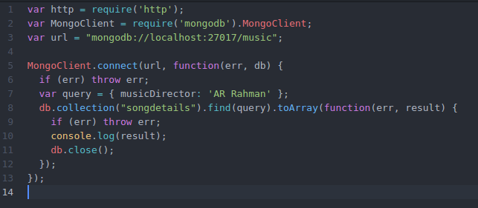

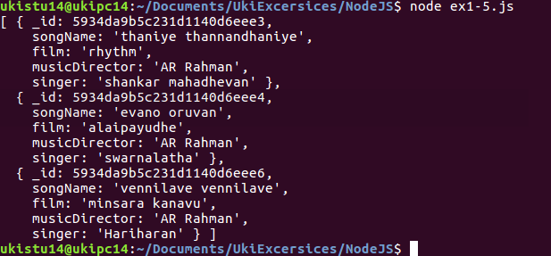

6) List A.R.Rahman’s songs sung by Unnikrishnan.

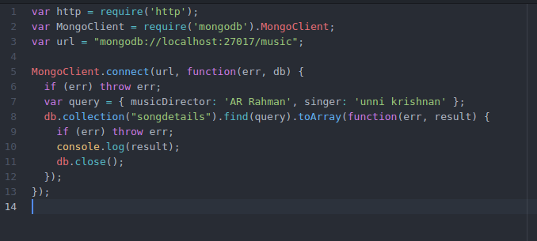

7) Delete the song which you don’t like.

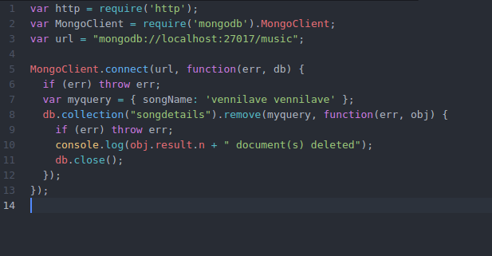

8) Add new song which is your favourite.

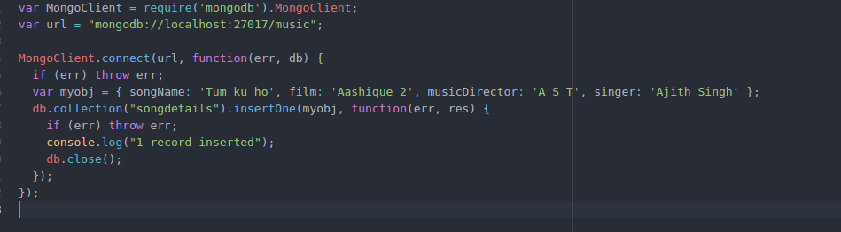

9) List Songs sung by Hariharan from Minsara kanavu film.

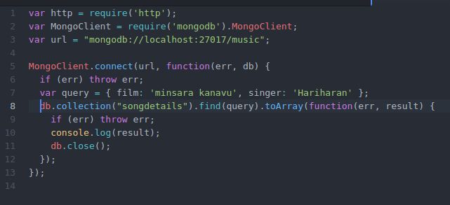
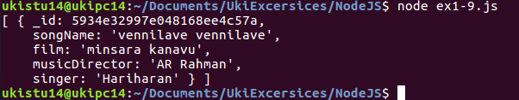

10)List out the singers’ names in your document.

