AWS PROJECT
IMPLEMENTATION GUIDES

1. EC2_S3_File_Upload_Project_Guide
2. AWS_Image_Processing_System_S3_EC2_IAM_Lab
3. Static_S3_EC2_IAM_Project_Guide

Prepared from the screenshots supplied for the completed lab tasks.

How to use this guide
This document groups the supplied screenshots into three project guides and orders each set from setup, through implementation, to verification. The instructions describe the evidence shown in the screenshots; values such as bucket names, instance IP addresses, and object names should be checked against your current AWS environment before reusing commands.

Contents
- 1. EC2_S3_File_Upload_Project_Guide — upload a selected file from a web form on EC2 to S3.
- 2. AWS_Image_Processing_System_S3_EC2_IAM_Lab — upload an image, create a processed copy, and verify both objects in S3.
- 3. Static_S3_EC2_IAM_Project_Guide — use AWS CLI/IAM permissions to upload a static HTML file and verify the S3 object.
The supplied screenshots include AWS account details and an IAM access-key identifier. Before sharing this document outside your team, redact account identifiers and key identifiers. Never include a secret access key in screenshots or source code. Prefer an EC2 instance role for application access and grant only the S3 permissions and prefixes the application needs.

1. EC2_S3_File_Upload_Project_Guide
Goal: run a small Node.js/Express upload application on an EC2 instance. A browser form submits a file to the server, and the server stores the file in the existing S3 bucket named project-s3-iam.

Step 1. Create and verify the EC2 instance
In the EC2 console, confirm that the instance is running, note its public IPv4 address, and verify that the s3EC2 IAM role is attached. The screenshot shows the EC2 instance summary for EC2FileUploadS3 in the Mumbai (ap-south-1) region. Use your current instance details if they differ.
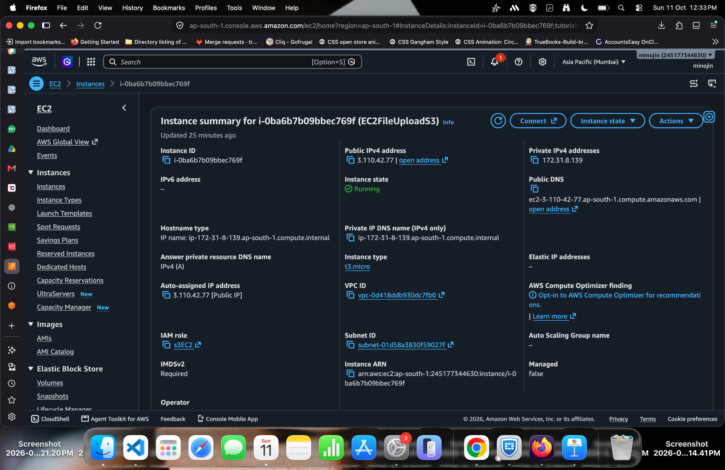
Evidence 1: EC2 instance summary and attached IAM role

Implementation sequence

Step 1. Check EC2 networking and attached role
Open the EC2 instance's Security tab. Confirm the instance has the expected IAM role and review its security group. For a lab, allow the app port only from your own IP where possible; avoid exposing SSH to the entire internet.
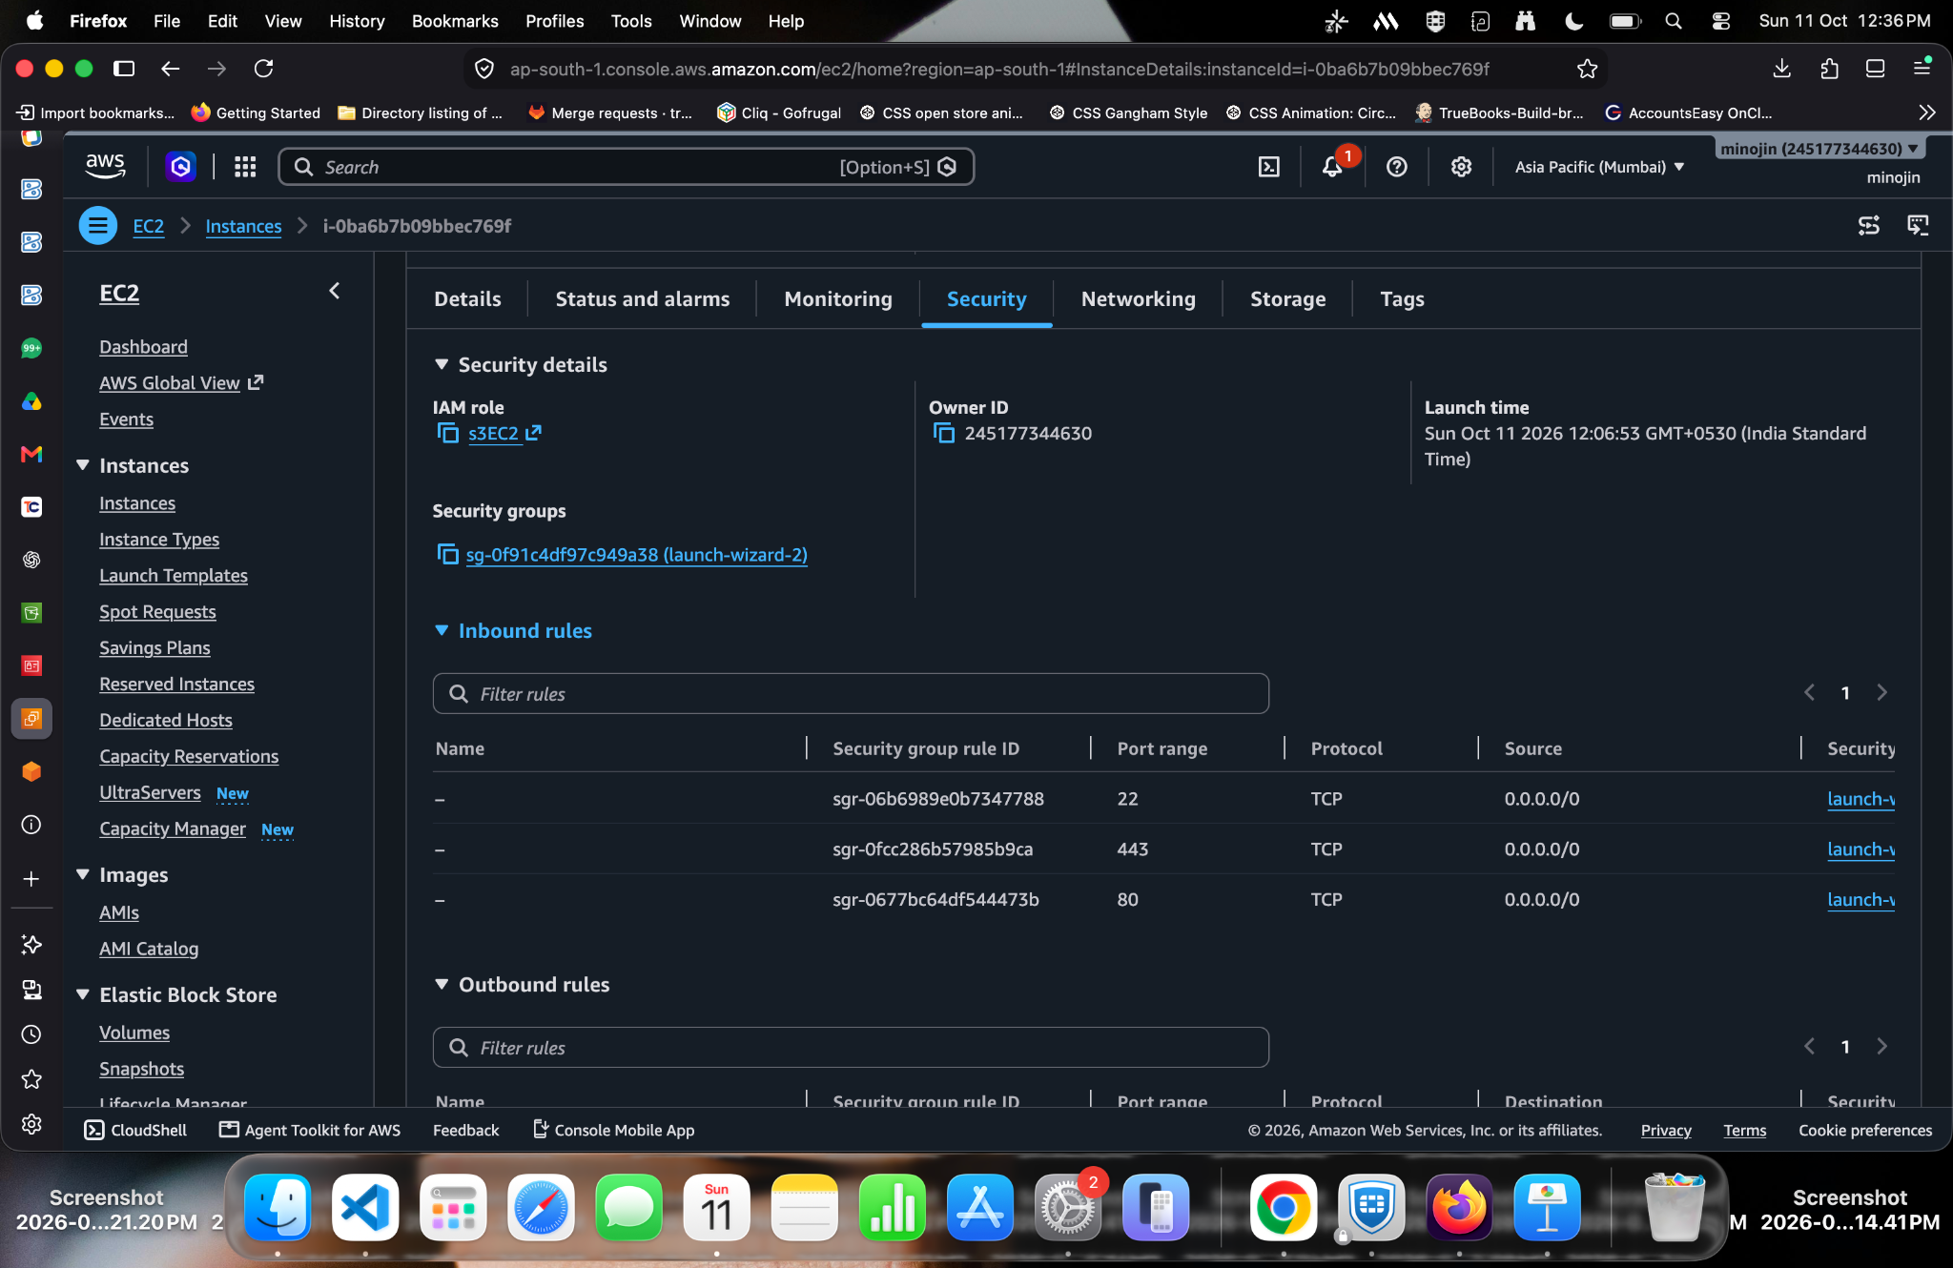
Evidence 1: Check EC2 networking and attached role

Step 2. Test the upload endpoint from EC2
Use a second terminal session to test the running service with curl and a small sample file. A successful HTTP response confirms the endpoint is reachable locally and can write to S3. A GET request to /upload is not a valid upload test; the endpoint expects POST with multipart form data.
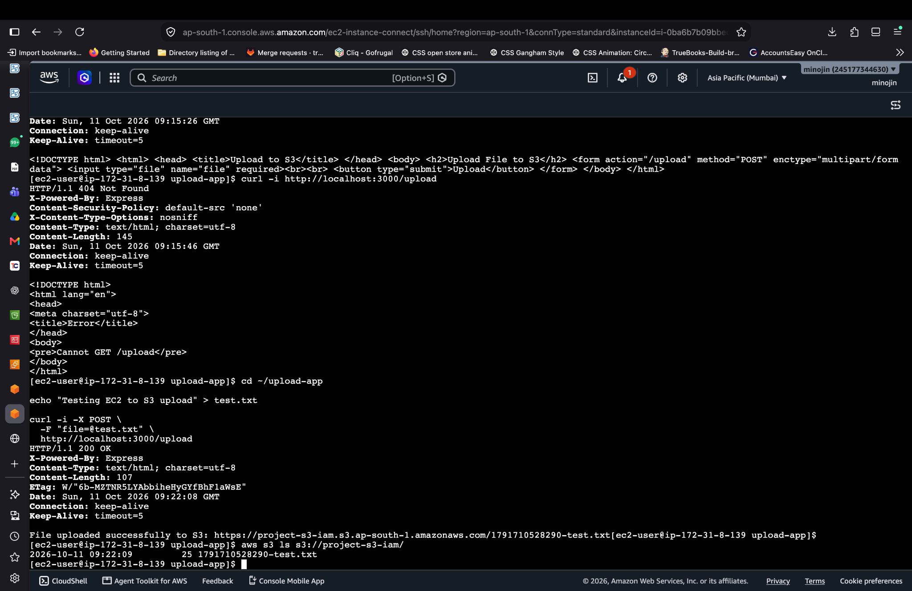
Evidence 2: Test the upload endpoint from EC2

Step 3. Configure the EC2 IAM role
The screenshots show the s3EC2 role and its S3 permissions. Attach a least-privilege policy that permits the application to write only to the required bucket/prefixes. Avoid attaching AmazonS3FullAccess to a production workload.
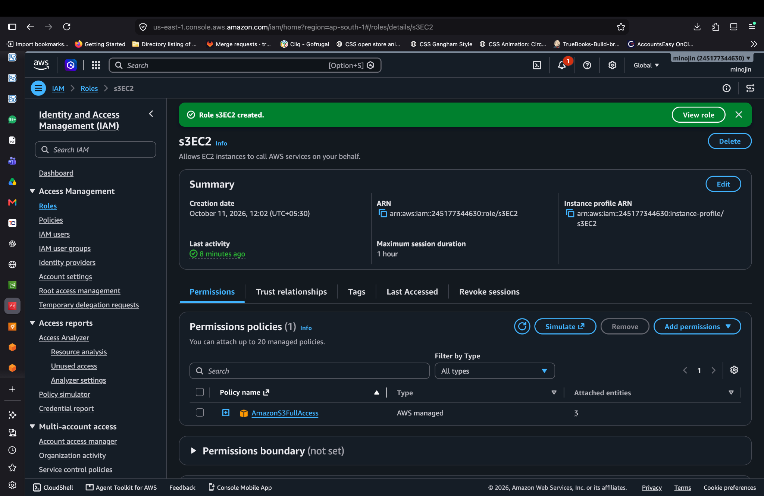
Evidence 3: Configure the EC2 IAM role

Step 4. Review the security group
The security group screenshot shows SSH, HTTP/HTTPS, and a custom TCP application port. Keep only the inbound rules you need. Restrict port 3000 to your IP for testing, and use HTTPS through a reverse proxy or load balancer for production.
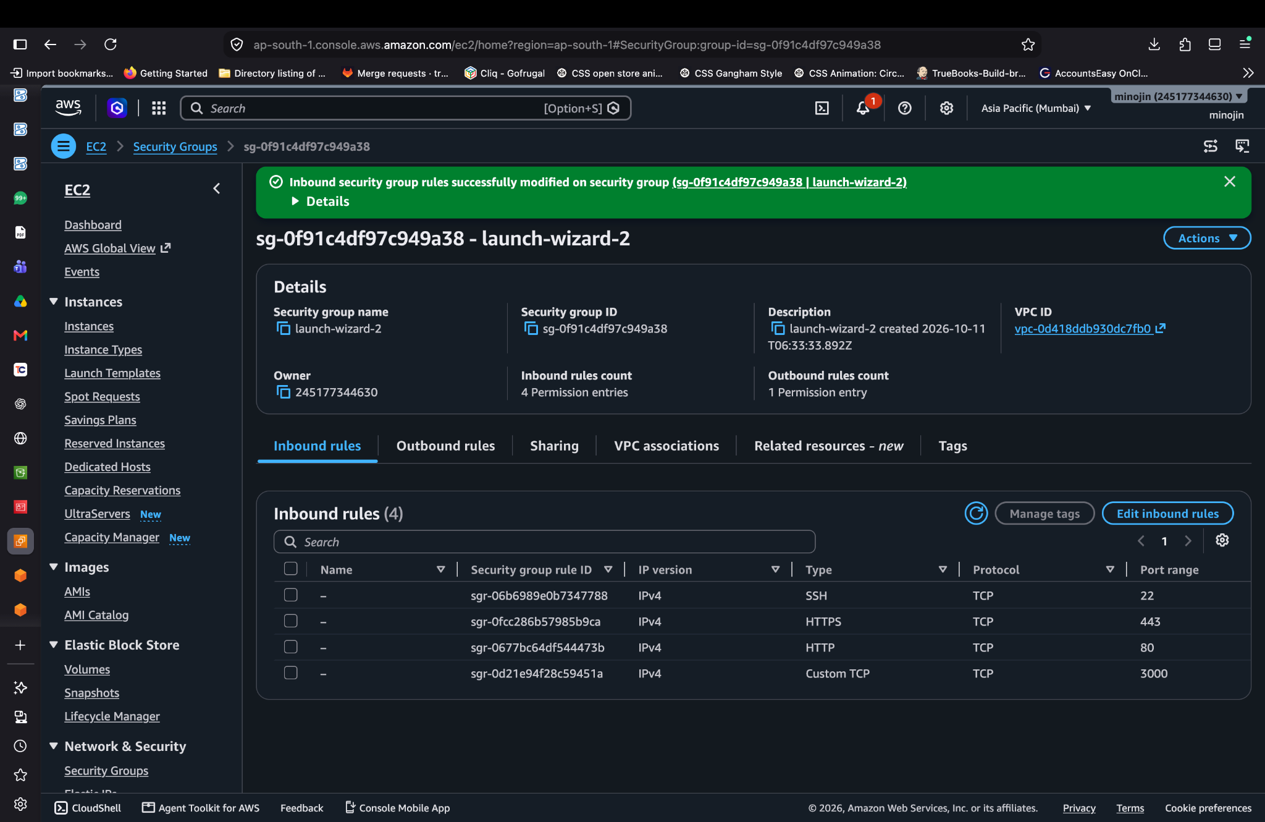
Evidence 4: Review the security group

Step 5. Start the Node.js application
From the project directory, start the server with node app.js. The terminal evidence shows the server listening on port 3000. The AWS SDK v2 end-of-support message is a warning, not necessarily an upload failure; plan to migrate to AWS SDK for JavaScript v3.
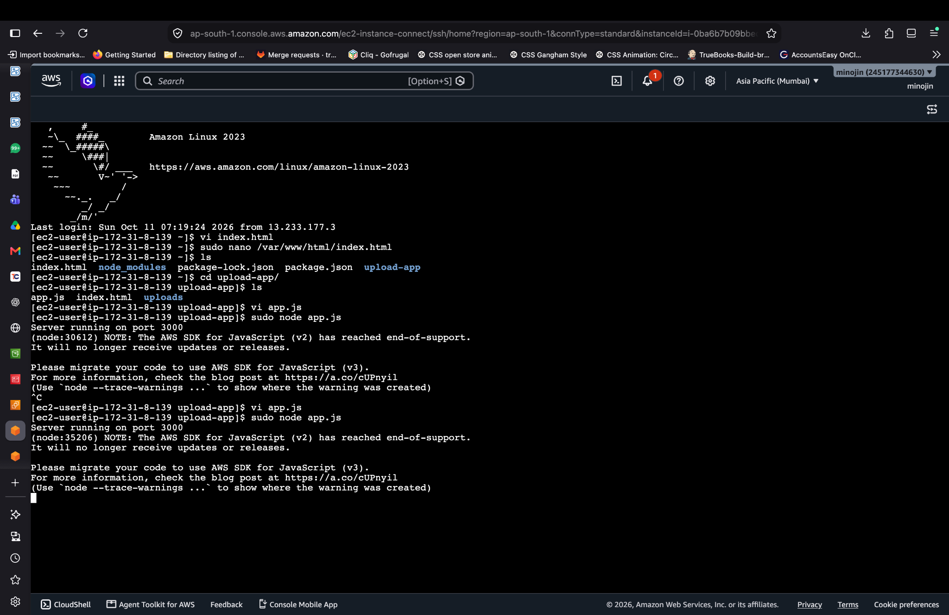
Evidence 5: Start the Node.js application

Step 6. Review the backend upload logic
The app uses Express and Multer to accept a multipart file and the AWS SDK to upload it to S3. Keep the bucket name and region consistent with your bucket. Use the EC2 instance role rather than storing access keys in app.js.
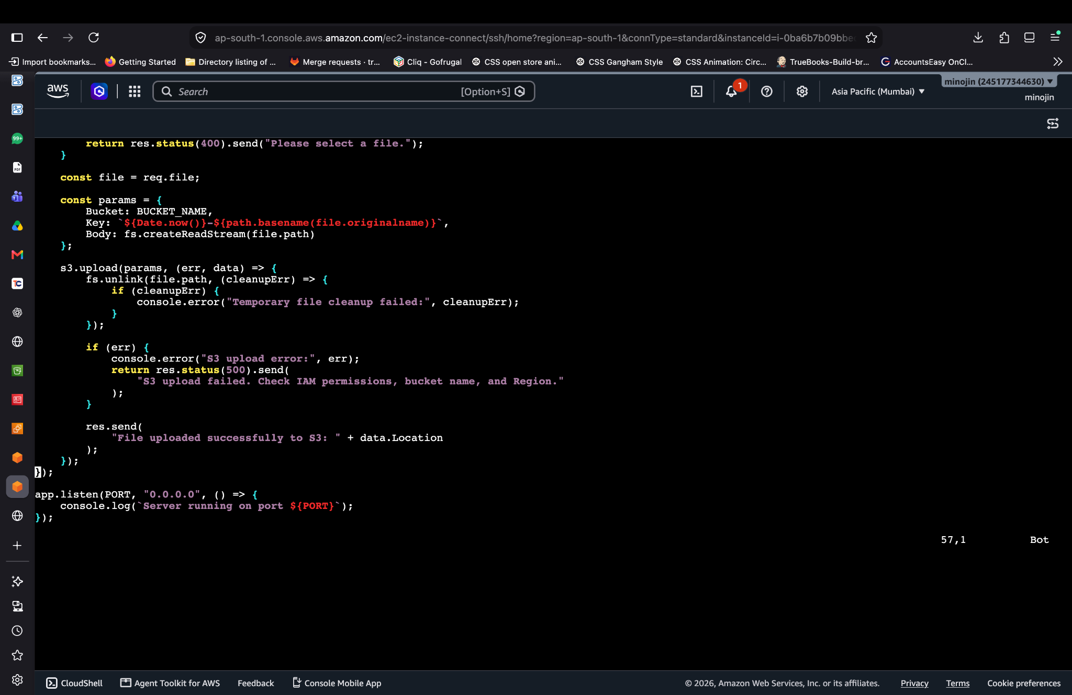
Evidence 6: Review the backend upload logic

Step 7. Review the upload page
The HTML page contains a file input and a submit button. The form uses multipart/form-data and sends the selected file to /upload. For a polished version, display progress and errors without navigating to a plain-text response page.
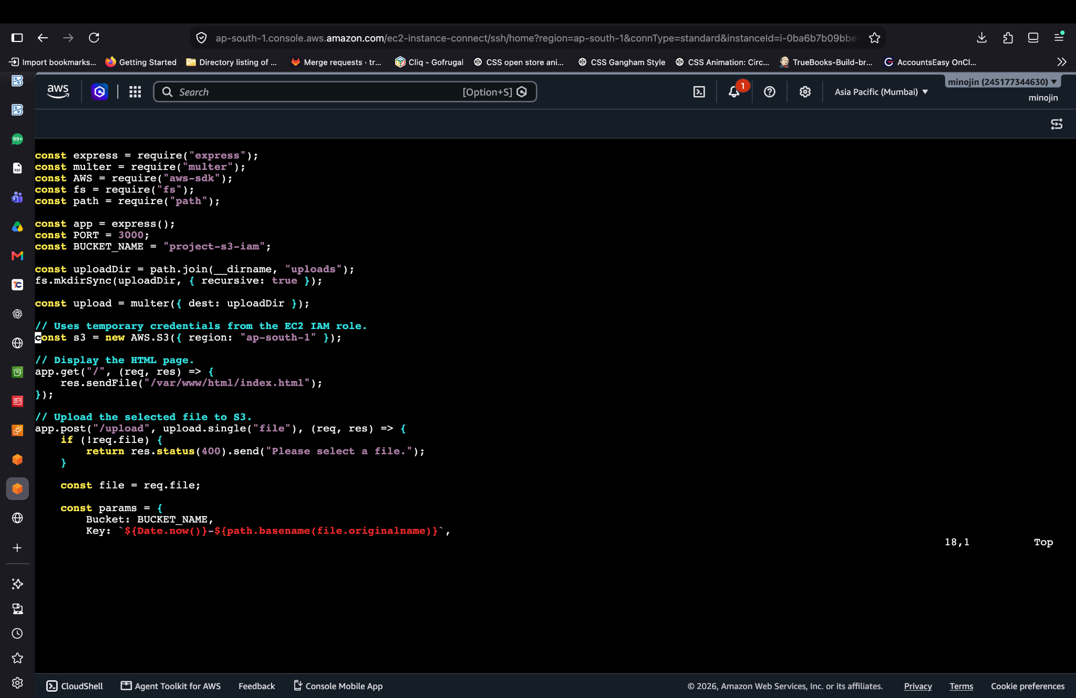
Evidence 7: Review the upload page

Step 8. Run the app and check the code in the editor
This screenshot provides additional evidence of the application code in the EC2 editor. Confirm that the route, form field name (file), S3 bucket, and region match between the frontend and backend.
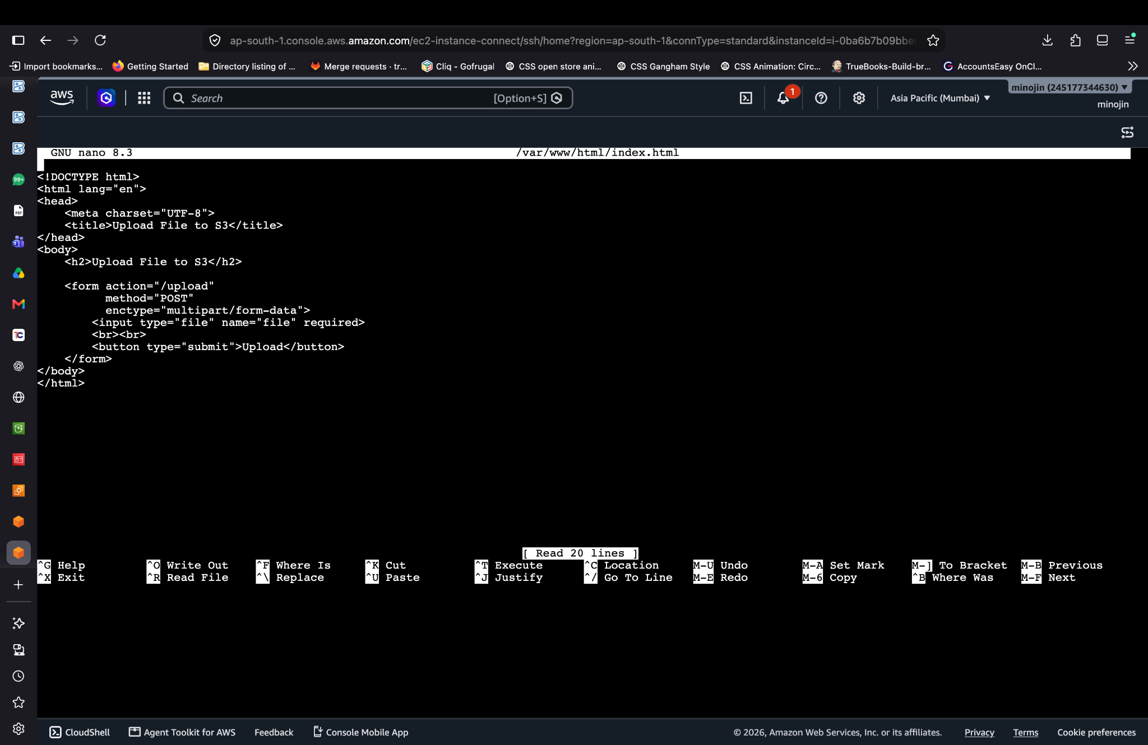
Evidence 8: Run the app and check the code in the editor

Step 9. Open the upload form in a browser
Navigate to the EC2 public address on port 3000 and select a test image or document. The screenshot shows the simple Upload File to S3 page.
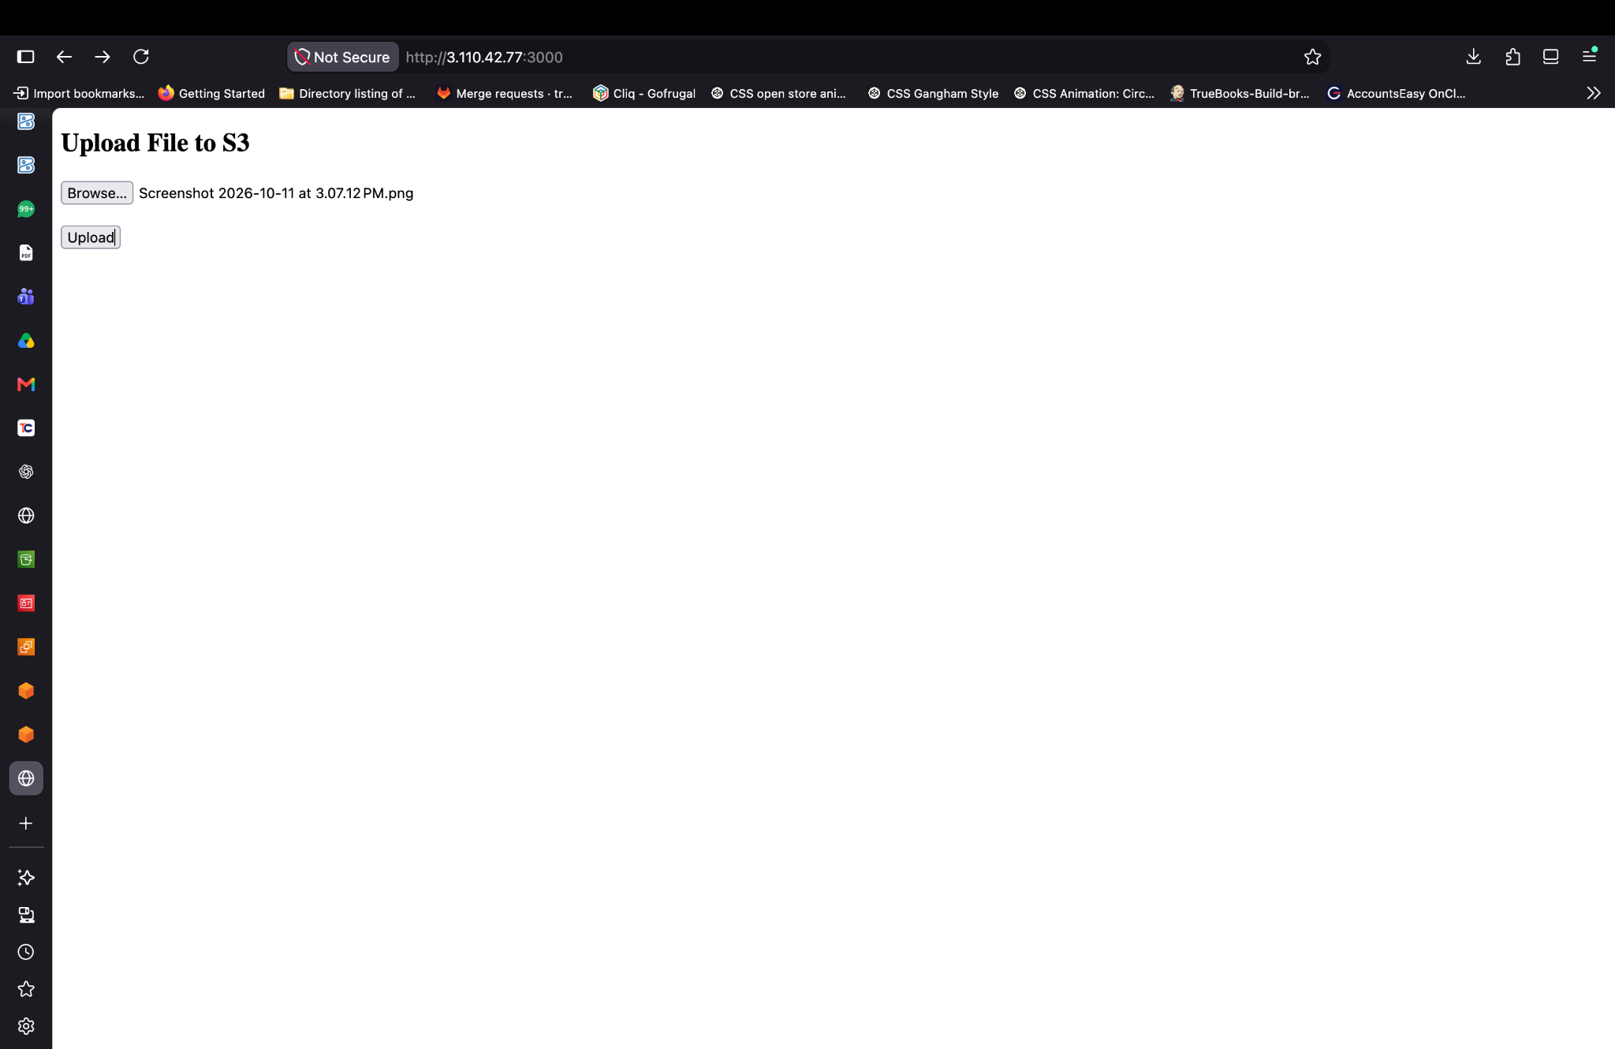
Evidence 9: Open the upload form in a browser

Step 10. Confirm the upload response
Submit the form and confirm that the server returns a successful upload message and an S3 object location. Do not treat an S3 URL as proof that the object is public; bucket access can remain private.
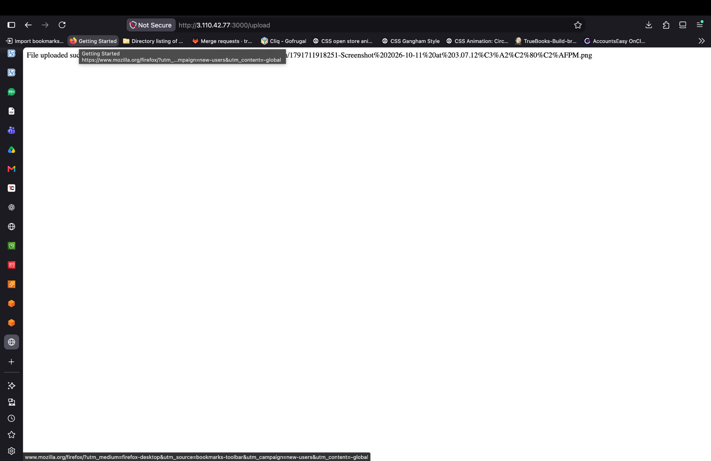
Evidence 10: Confirm the upload response

2. AWS_Image_Processing_System_S3_EC2_IAM_Lab
Goal: upload an image through the EC2-hosted web app, preserve the original in the originals/ prefix, create a resized JPEG in processed/, and verify the stored objects in S3. The screenshots show bucket project-s3-iam in ap-south-1 (Mumbai).

Implementation and verification sequence

Step 1. Upload and process an image
Open the image-processing page on the EC2 application and choose a supported image. The successful result reports the original and processed object keys, original dimensions, processed format, and the maximum processed dimensions (800 × 800).
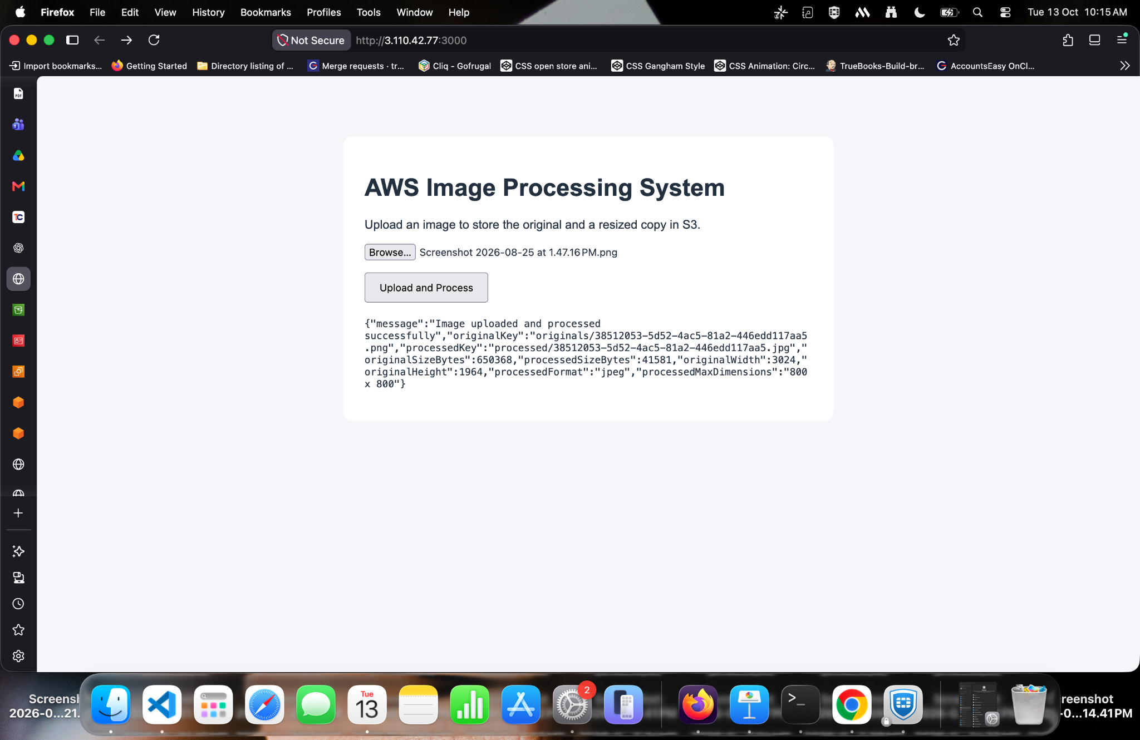
Evidence 1: Upload and process an image

Step 2. Check the bucket layout
In the S3 console, open project-s3-iam. The root listing shows index.html and the originals/ and processed/ prefixes, along with other existing objects.
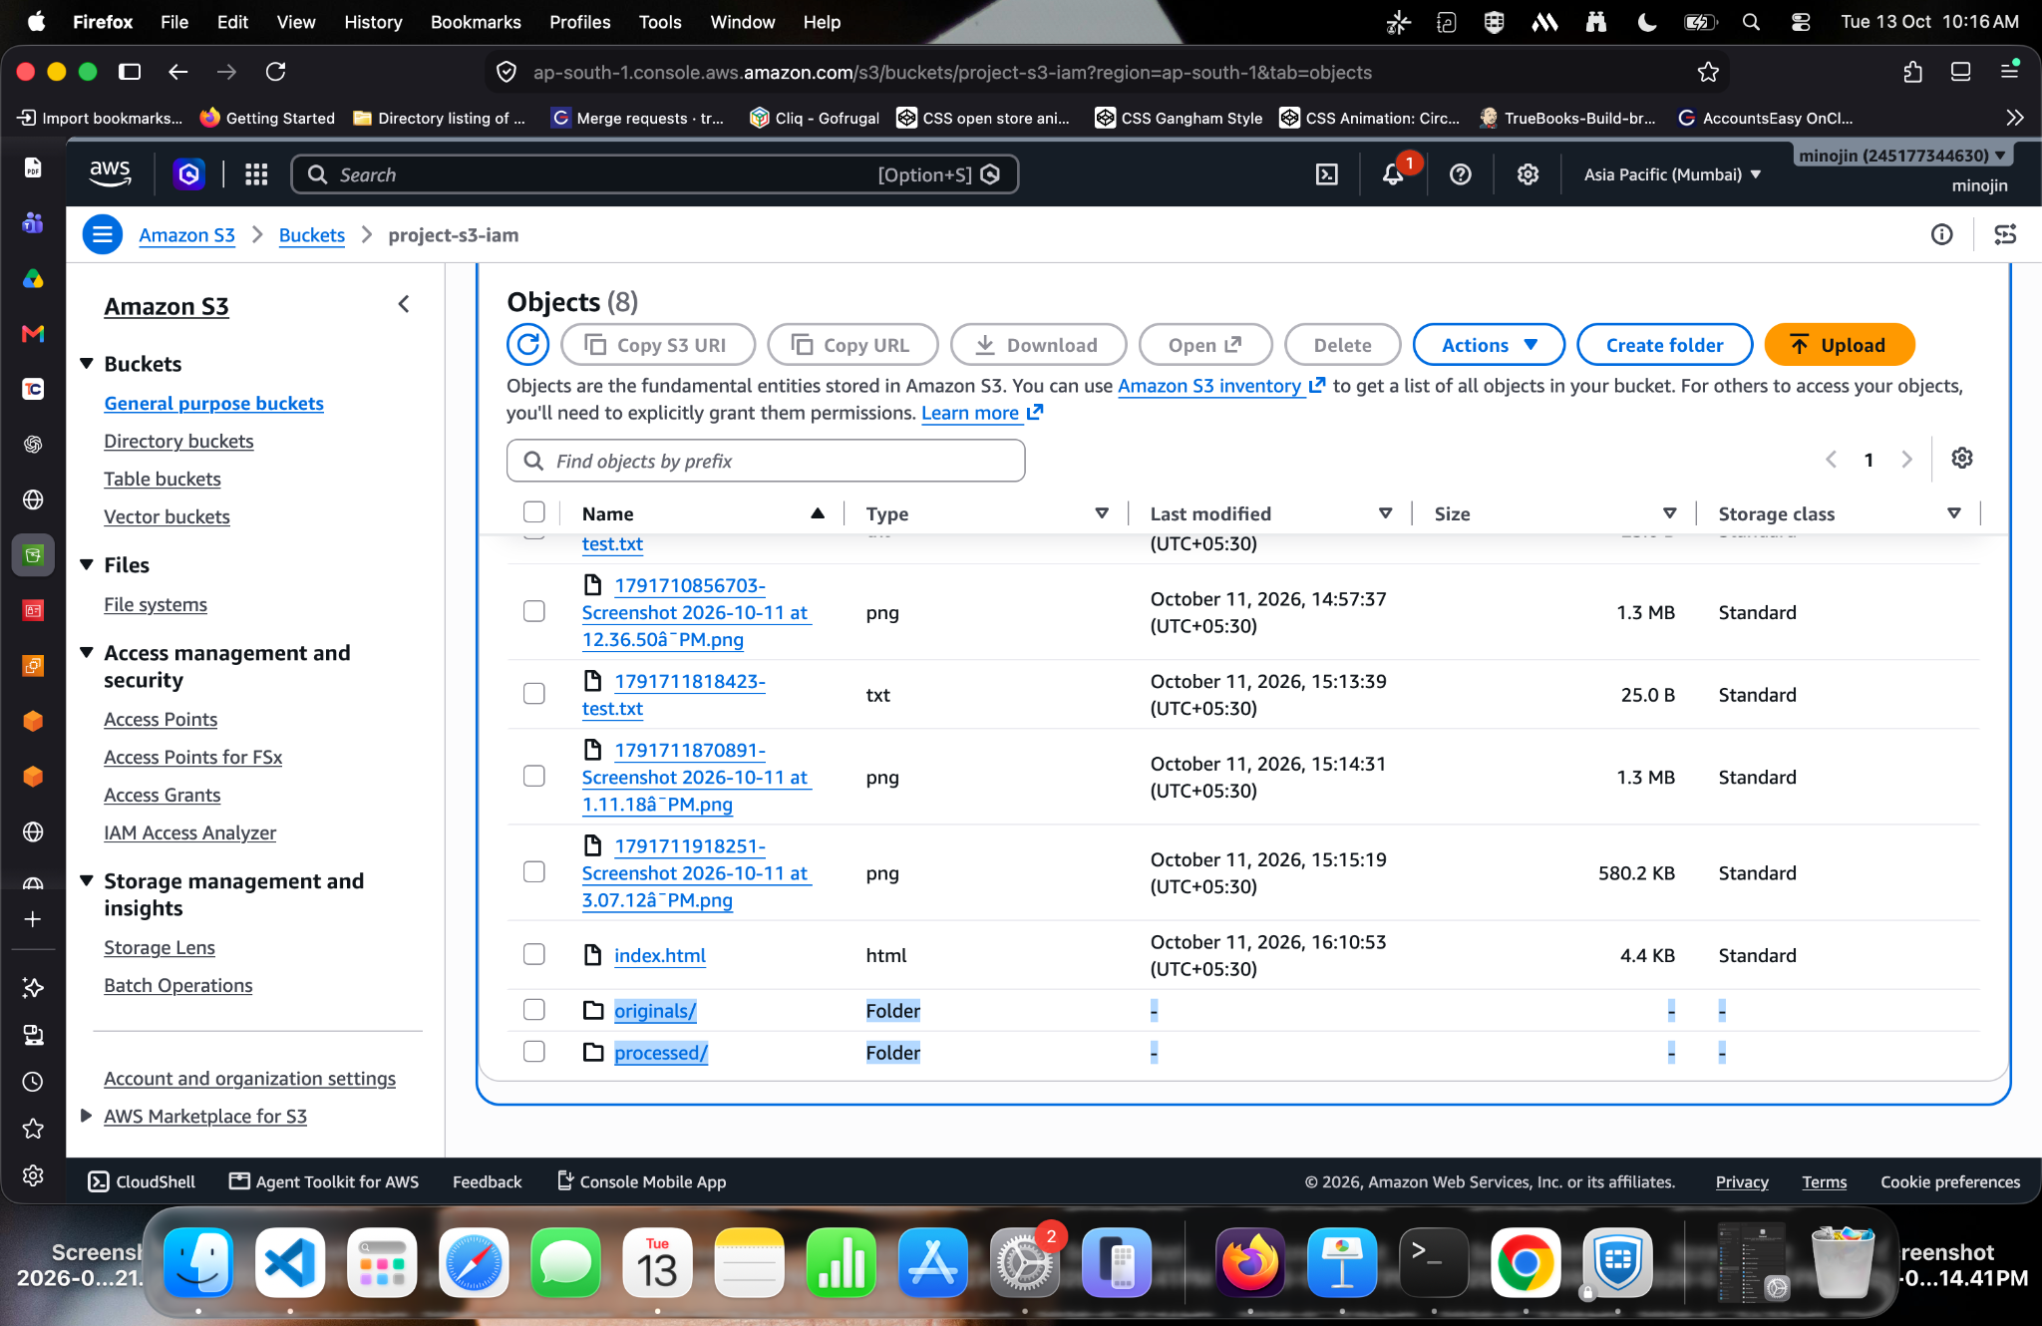
Evidence 2: Check the bucket layout

Step 3. Verify the original image
Open originals/ and confirm the uploaded source file is present. In the supplied evidence, the original is a PNG and is larger than the processed output.
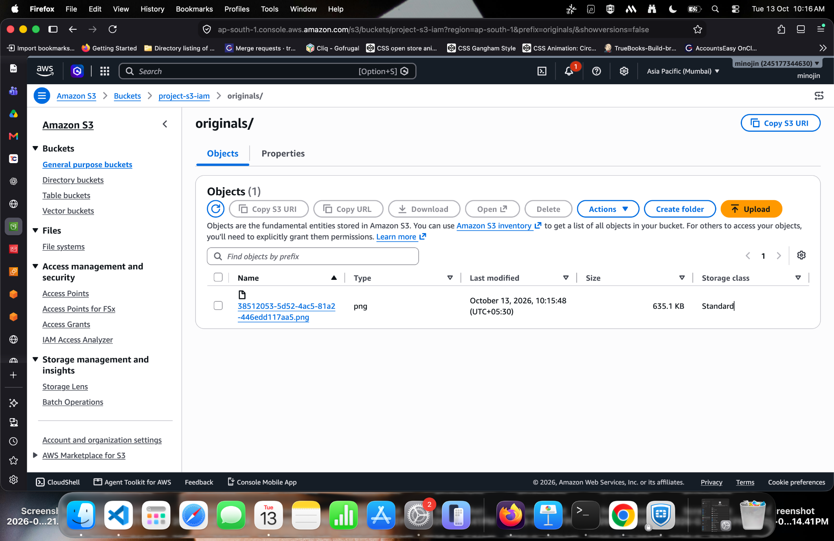
Evidence 3: Verify the original image

Step 4. Verify the processed JPEG
Open processed/ and confirm a JPG object exists. The processed file is approximately 40.6 KB in the screenshot, compared with the original PNG at approximately 635.1 KB.
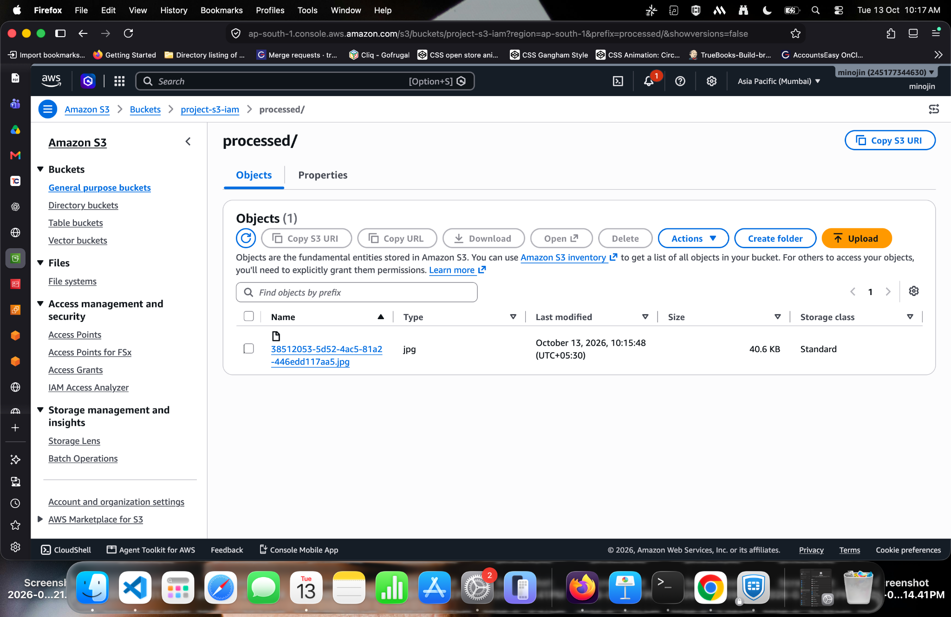
Evidence 4: Verify the processed JPEG

Step 5. Open the processed object
The browser screenshot shows the processed image rendered from an S3 URL. If the bucket is private, use a presigned URL or an authenticated application route rather than making the object public.
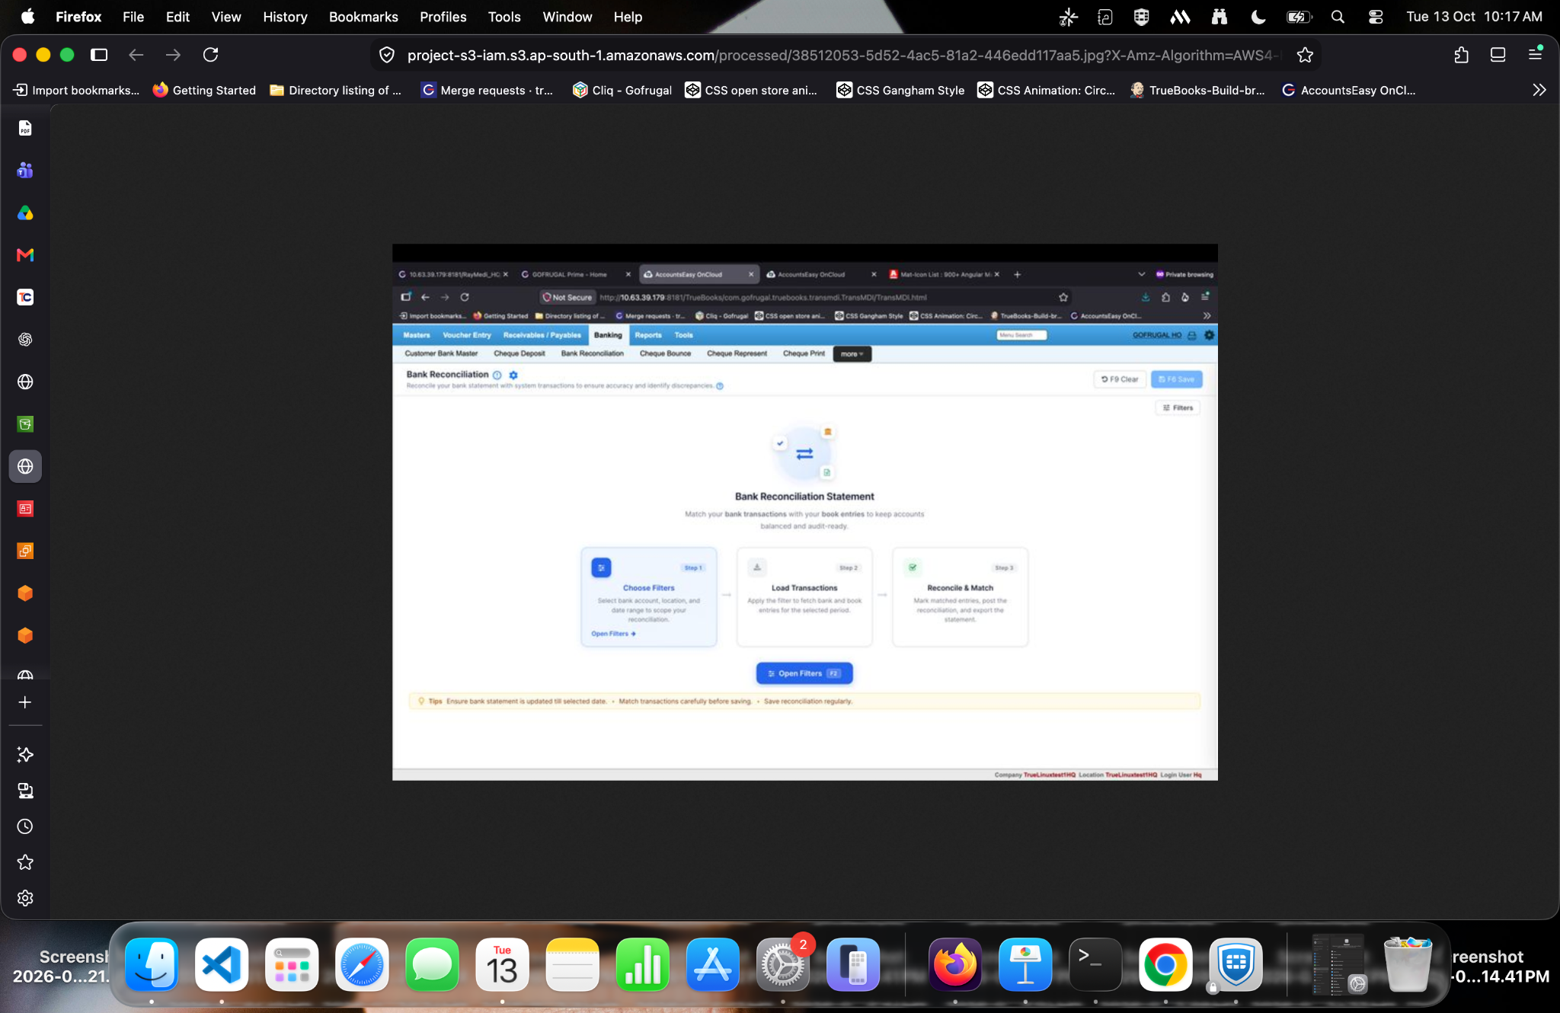
Evidence 5: Open the processed object

Step 6. Inspect the S3 object properties
The object details page shows the key under processed/, the bucket region, file type, size, S3 URI, ARN, and object URL. Use the key and metadata to confirm that the expected processed object was created.
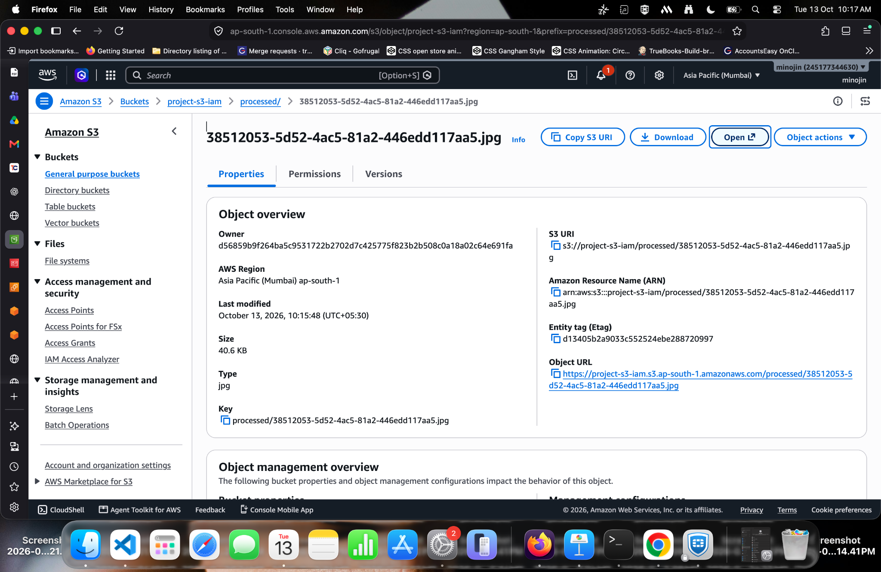
Evidence 6: Inspect the S3 object properties

3. Static_S3_EC2_IAM_Project_Guide
Goal: use the AWS CLI to upload a static HTML file to S3 and verify the IAM permissions used by the command. The supplied terminal evidence shows an initial AccessDenied response followed by a successful upload, so this guide preserves that troubleshooting sequence.

Implementation and troubleshooting sequence

Step 1. Check the AWS CLI identity and first upload attempt
Run aws sts get-caller-identity to confirm which IAM identity the CLI is using. The screenshot shows a PutObject AccessDenied response for the IAM user when attempting to upload index.html. This means the identity did not have an applicable s3:PutObject allow at that time.
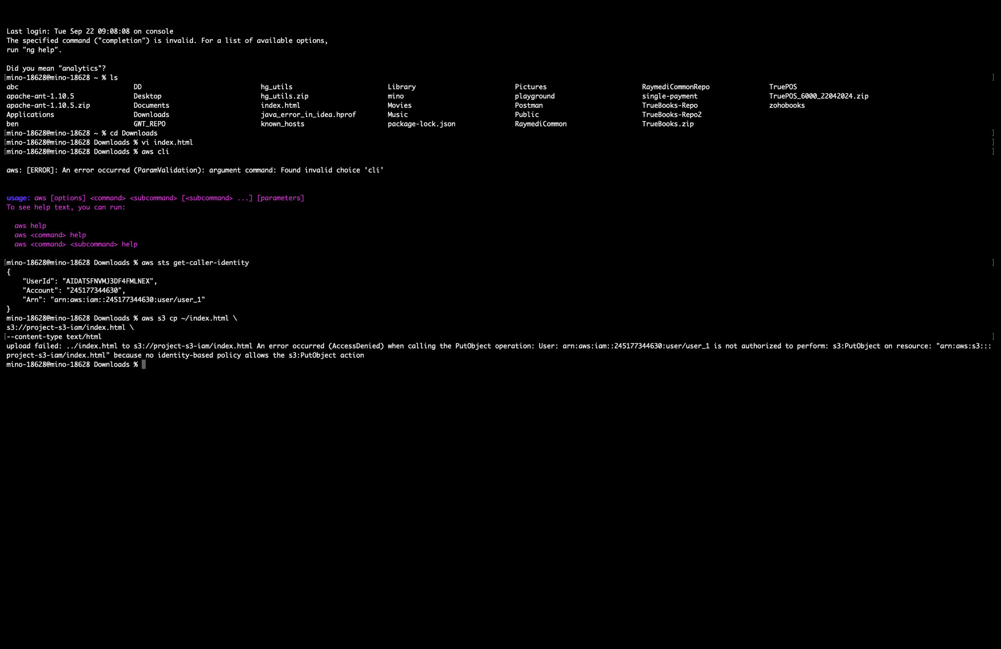
Evidence 1: Check the AWS CLI identity and first upload attempt

Step 2. Review IAM permissions
The IAM user screenshot shows AmazonS3FullAccess attached directly and other policies through a group. This is enough to explain why the later upload may succeed, but FullAccess is broader than needed. For a safer configuration, replace it with a custom policy scoped to the target bucket and required object prefix.
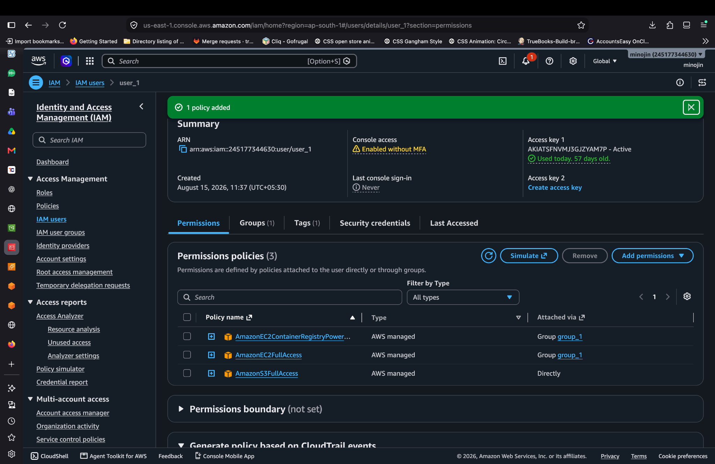
Evidence 2: Review IAM permissions

Step 3. Retry the static HTML upload
The terminal evidence shows the command aws s3 cp ~/index.html s3://project-s3-iam/index.html --content-type text/html succeeding after the permissions change. If access is still denied, check the bucket policy, permissions boundary, organization SCP, and whether the CLI is using the expected profile.
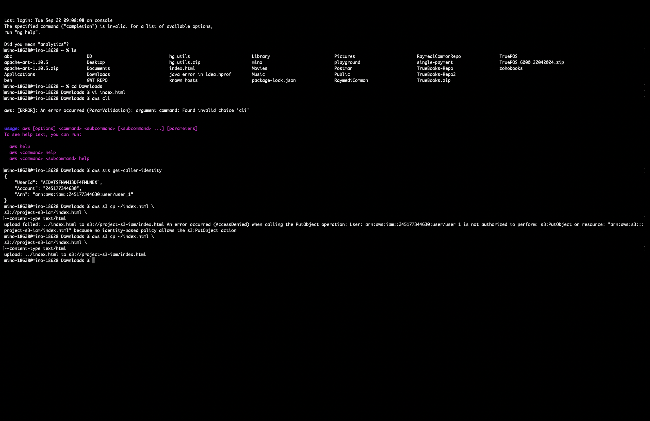
Evidence 3: Retry the static HTML upload

Step 4. Verify the uploaded S3 object
Open the bucket in the S3 console and confirm the HTML file or other test objects appear. The root listing screenshot shows objects in project-s3-iam. Uploading index.html does not by itself enable static website hosting; if website hosting is the goal, configure the bucket's static website hosting settings and make an explicit, informed decision about public access—or use CloudFront with private S3 access.
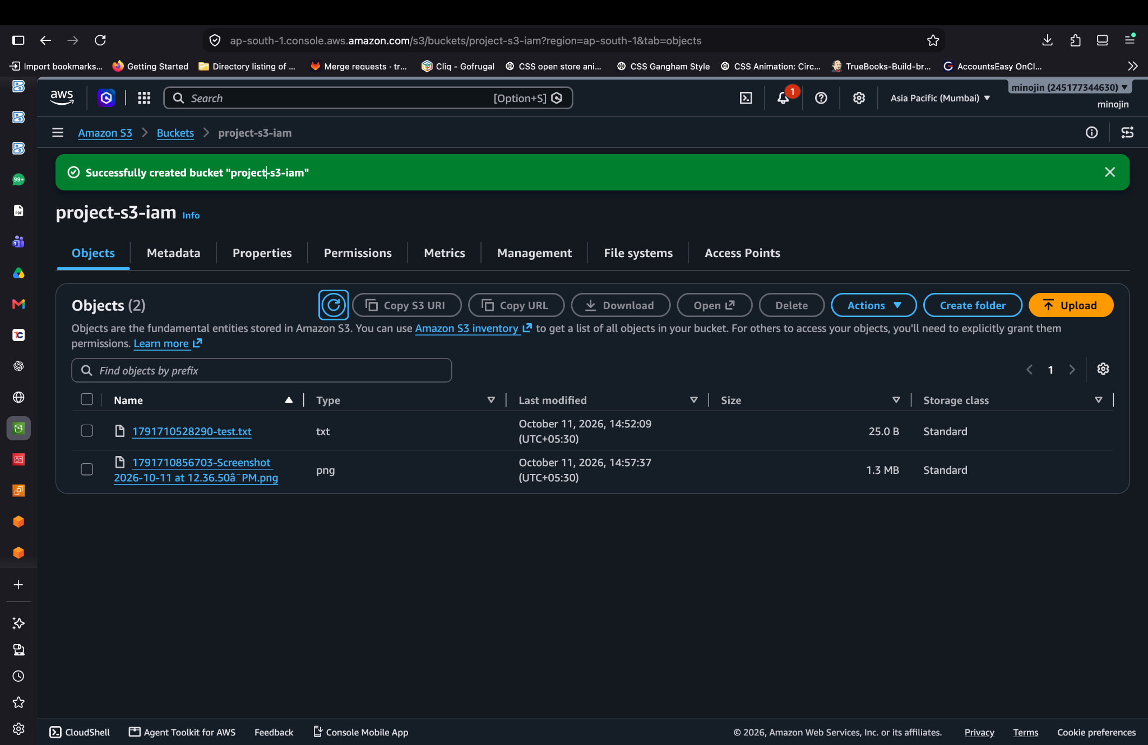
Evidence 4: Verify the uploaded S3 object

Final validation checklist
- EC2 instance is running and the correct application process listens on the intended port.
- The application uses the attached EC2 IAM role and does not contain long-lived AWS credentials.
- The S3 bucket name and region are correct.
- The file-upload project stores the selected file in S3 and returns a clear success/error response.
- The image-processing project stores both originals/ and processed/ objects and reports the expected dimensions and format.
- The static-file upload command uses the intended IAM identity and the object appears in the S3 console.
- Security group inbound rules are restricted; port 3000 is not left open to everyone unnecessarily.
- Before sharing this document, redact account IDs and access-key identifiers visible in screenshots.

