Evelyn Nguyen
PSU ID: 956446321
CS 430P Fall 2027
Lab 6
Table of Contents
06.1a: EB Guestbook 2
3. Running the application 2
4. Handling failures seamlessly 2
7. Deploying the Guestbook 3
06.1g: App Engine Guestbook 4
3. Deploying the Guestbook 4
4. Handling failures seamlessly 5
8. Setup secret proxy 6
10. Cloud Build 7
11. Deploy to Cloud Run 8
13. Deploy to Cloud Run with Secret Manager 10
06.3a: ECS Guestbook 11
5. Examine the service 11
6. Visit the site 12
4. View the Guestbook 15
06.4g: Cloud Functions, PubSub 16
4. - 16
7. Test function 17
11. PubSub via CLI 18
12. - 18
15. Test programs and clean up 19

06.1a: EB Guestbook

3. Running the application
- Take a screenshot showing it has been brought up successfully
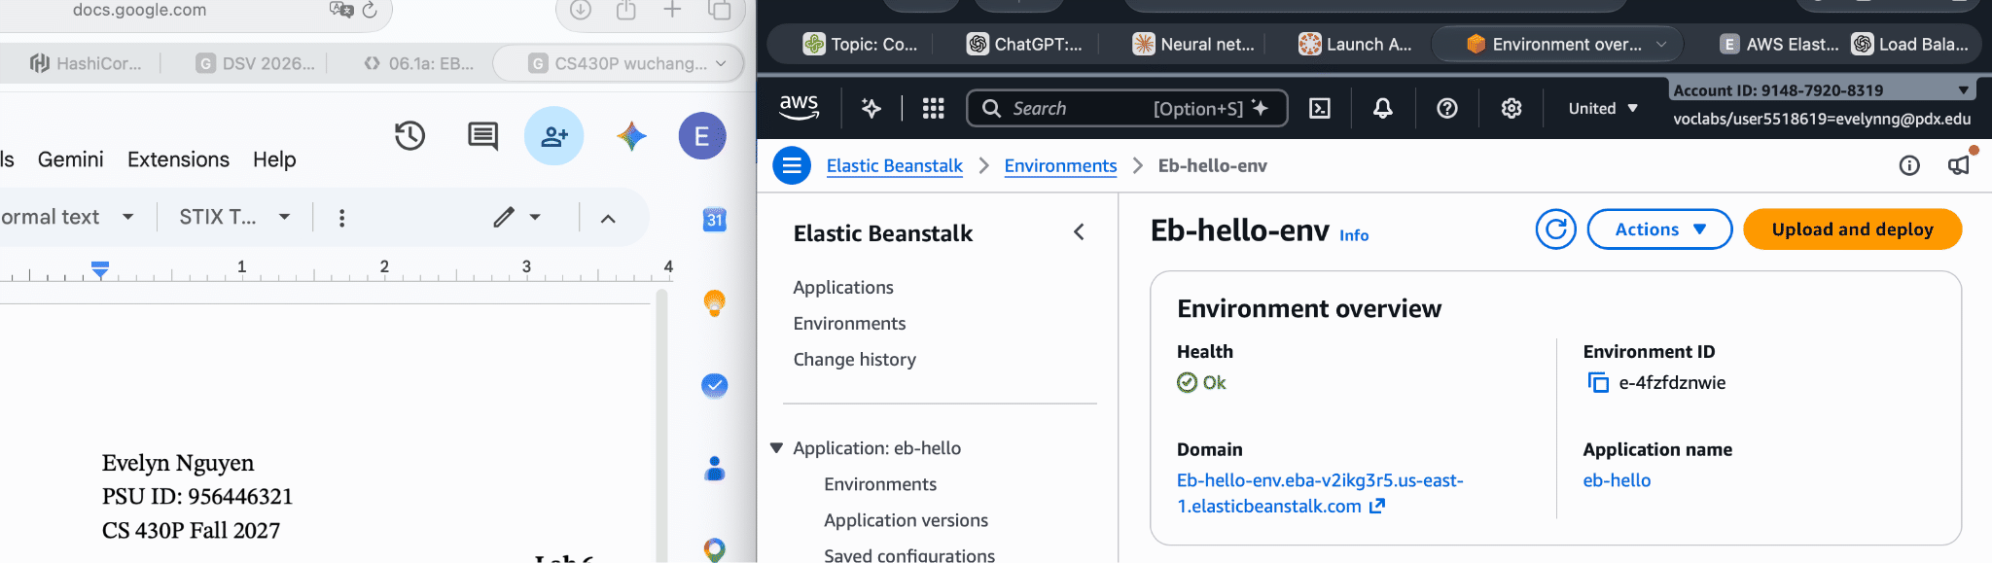
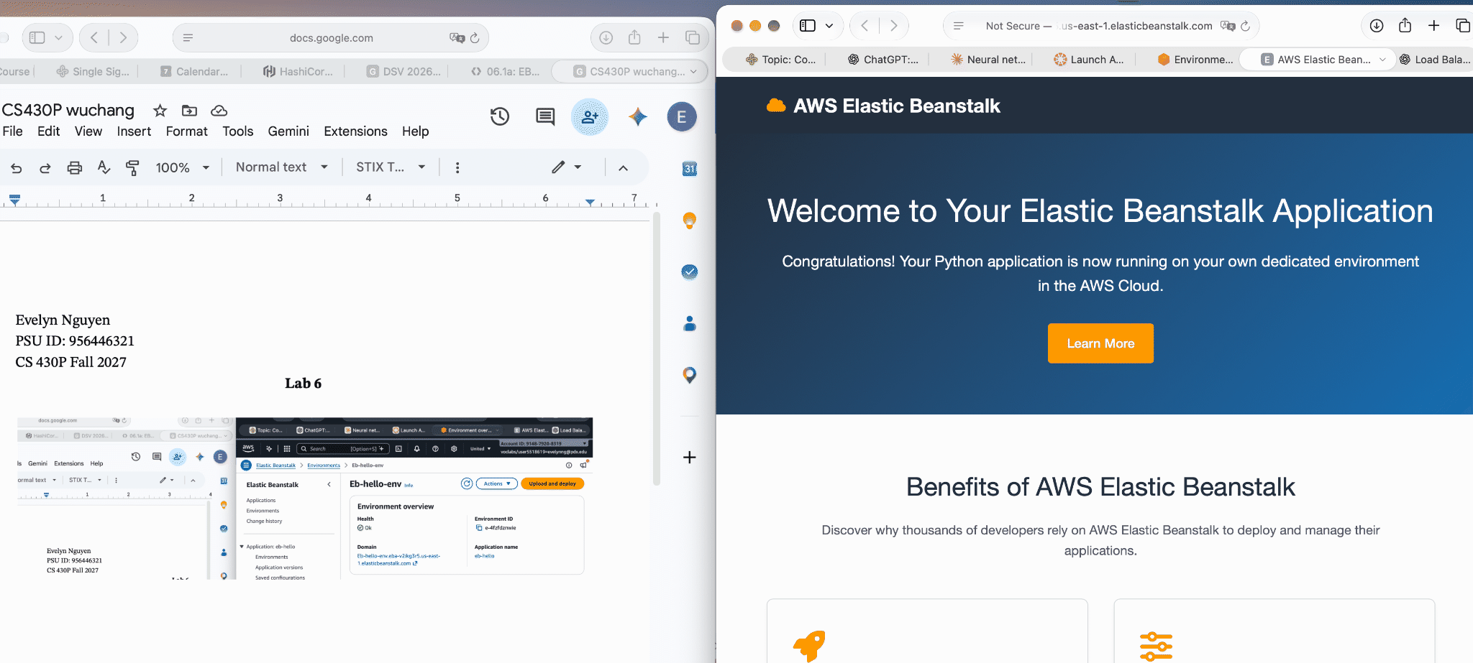

4. Handling failures seamlessly
- Take a screenshot of the replacement VM being started.
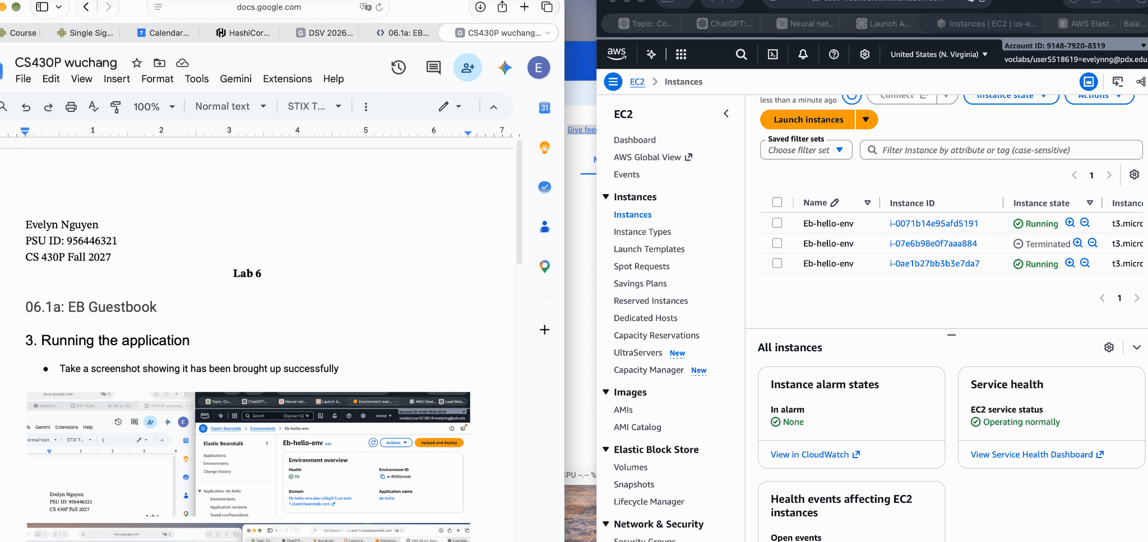

7. Deploying the Guestbook
- Take a screenshot of the Guestbook including the URL with the entry in it.

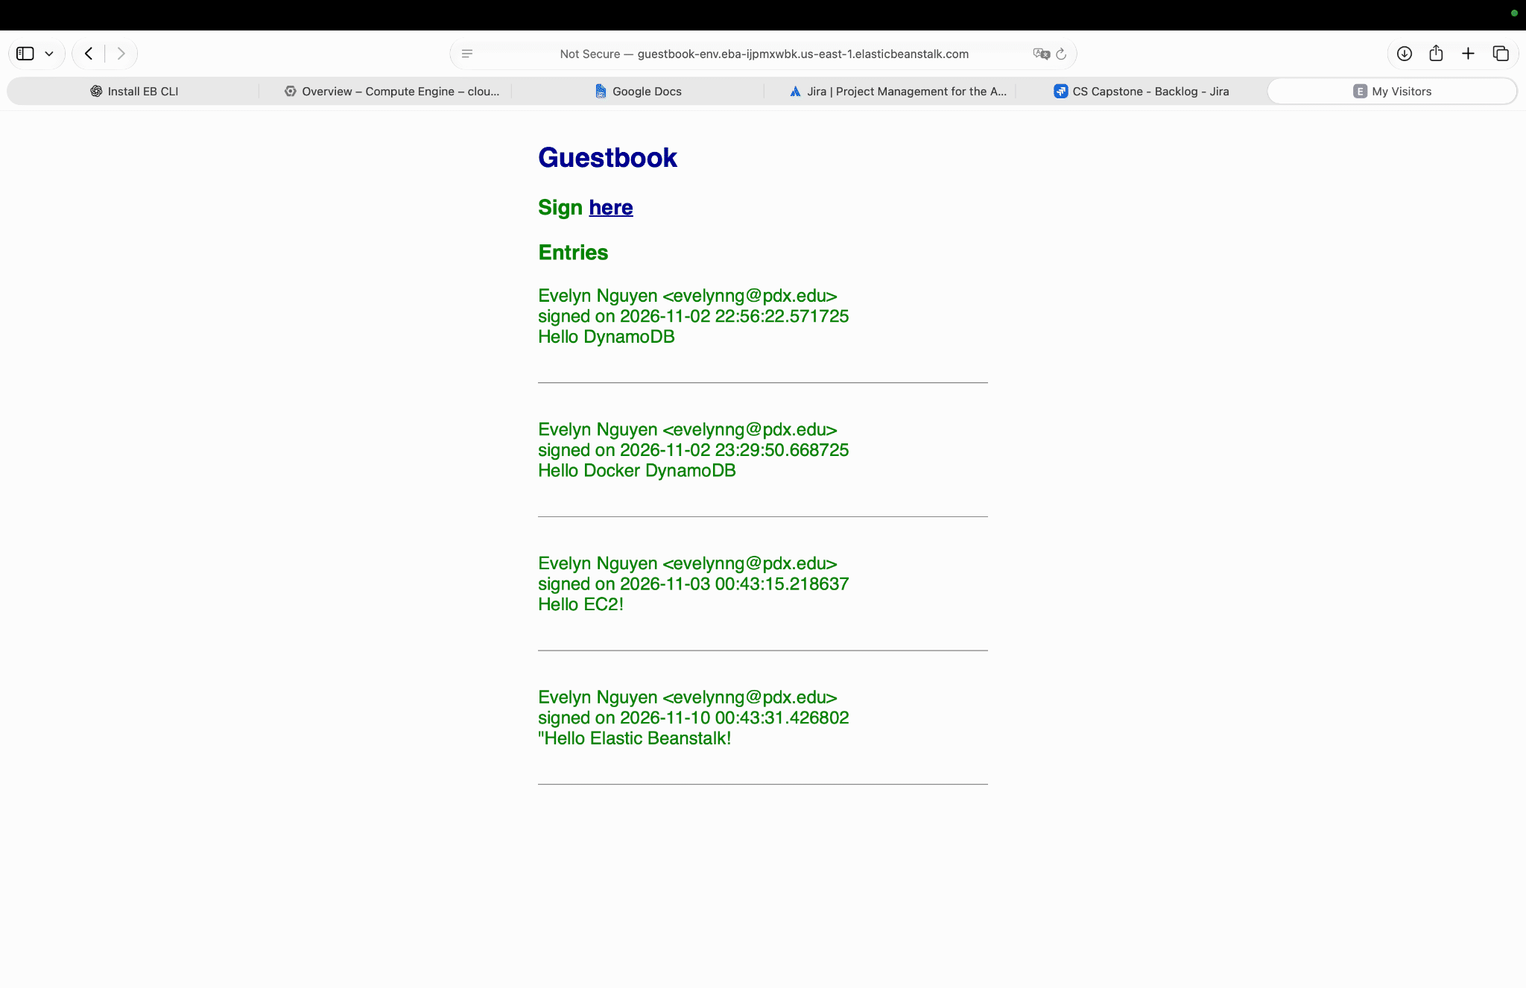

- Take a screenshot of them.
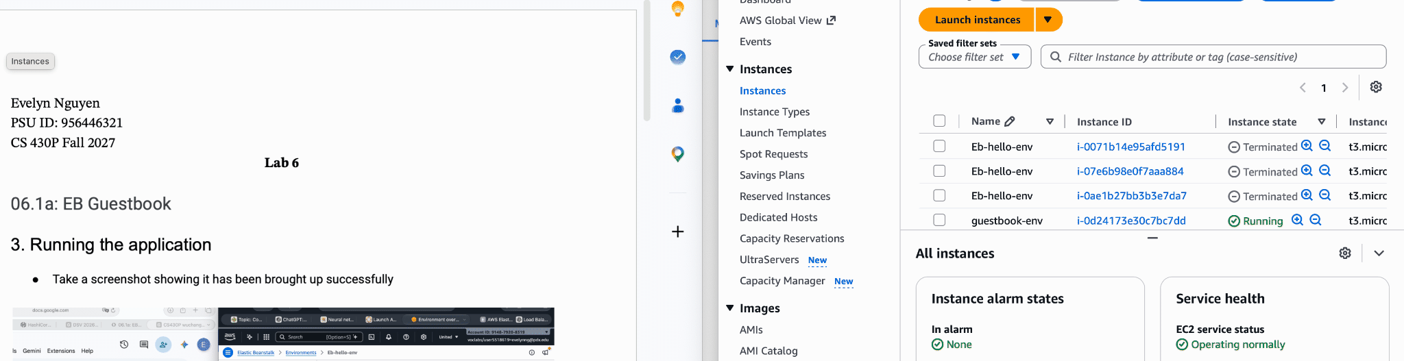

06.1g: App Engine Guestbook

3. Deploying the Guestbook
- Take a screenshot of the output that includes the URL in the address bar for your lab notebook.

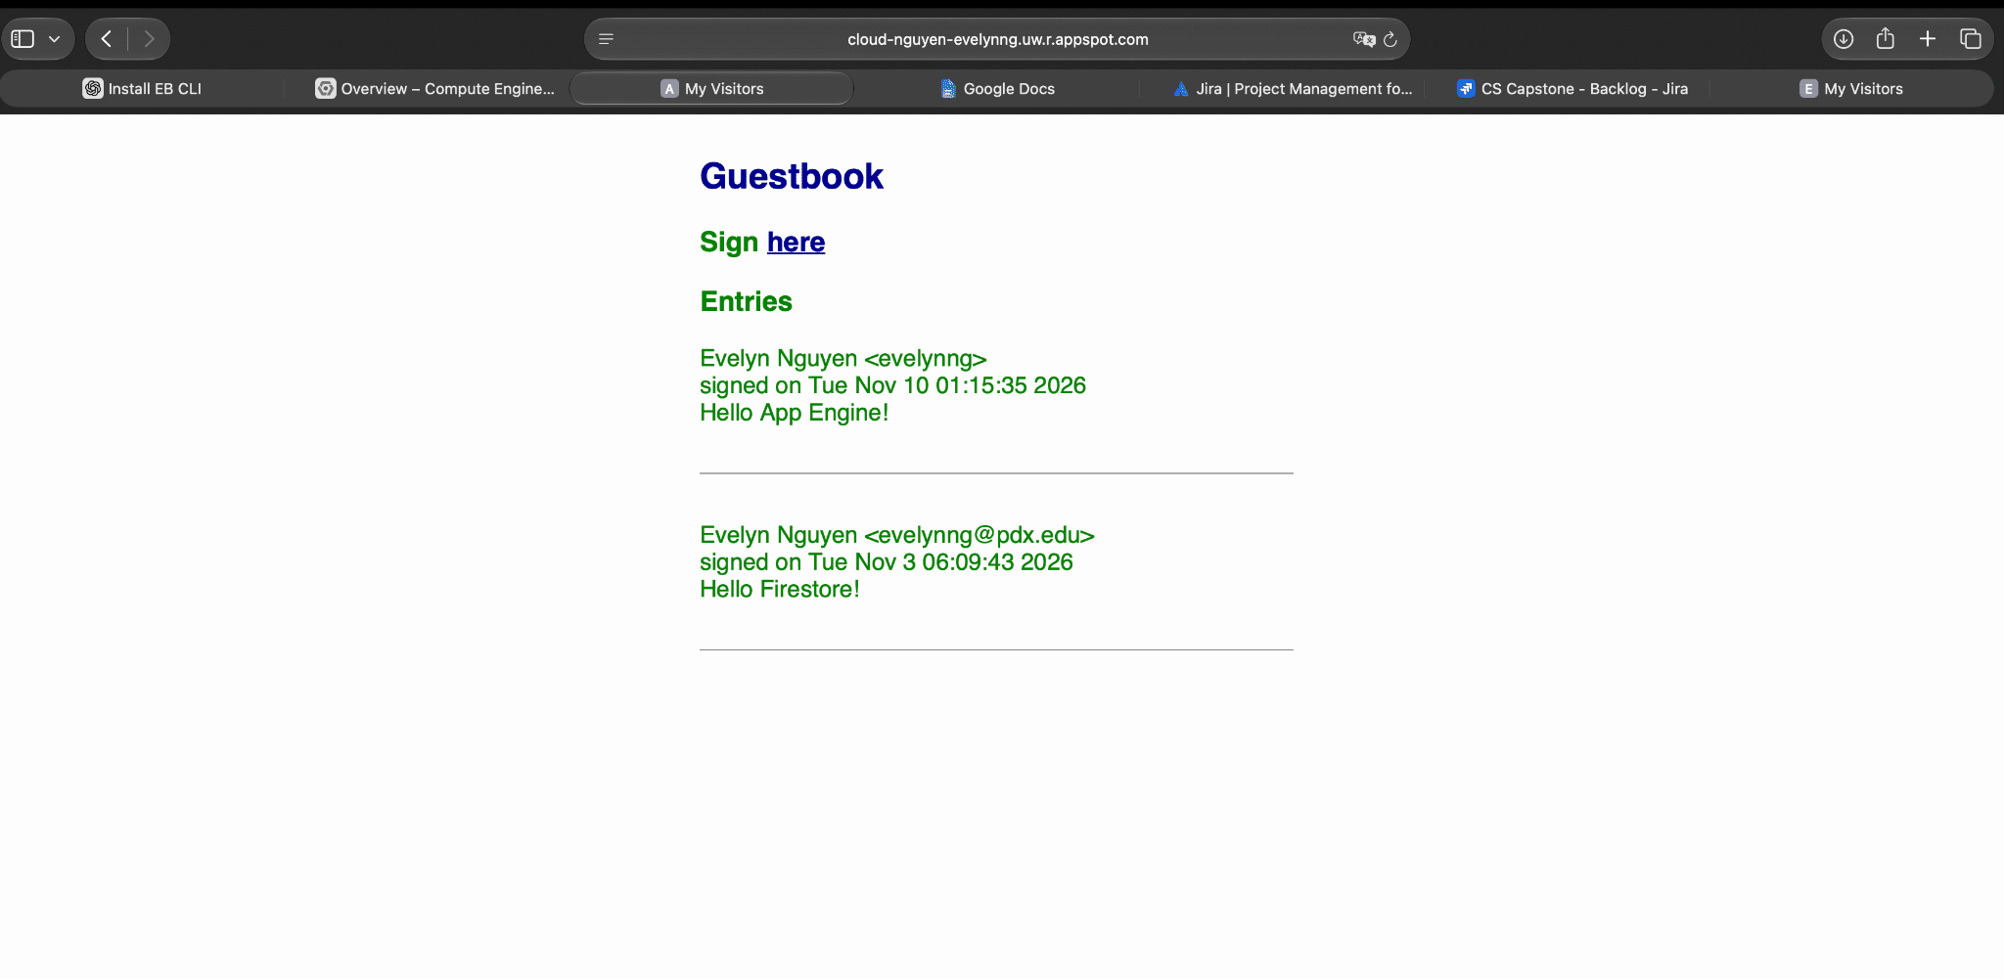

4. Handling failures seamlessly
- Take a screenshot of them.

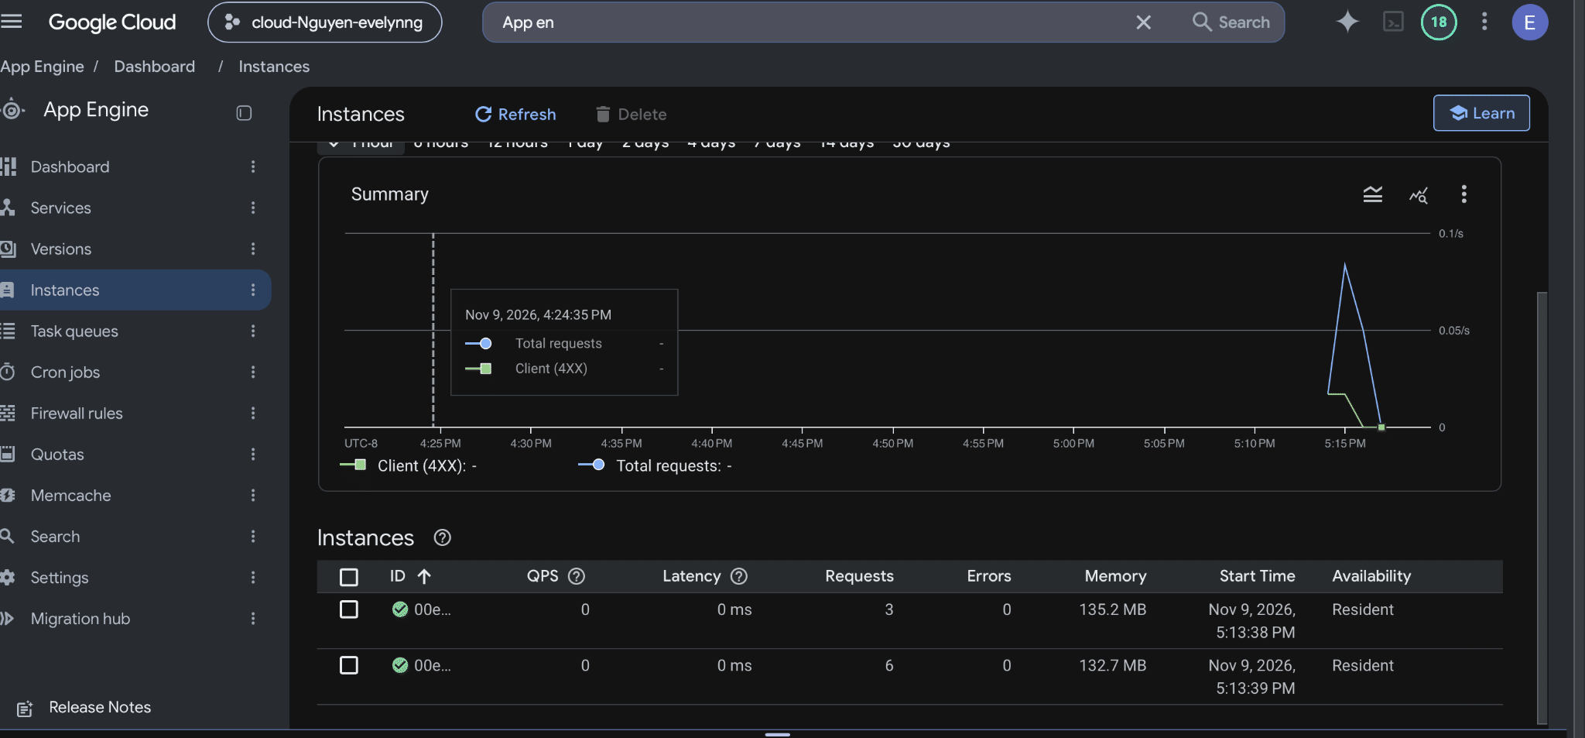

8. Setup secret proxy
- Take a screenshot of the proxy and its results including the URL containing your OdinID
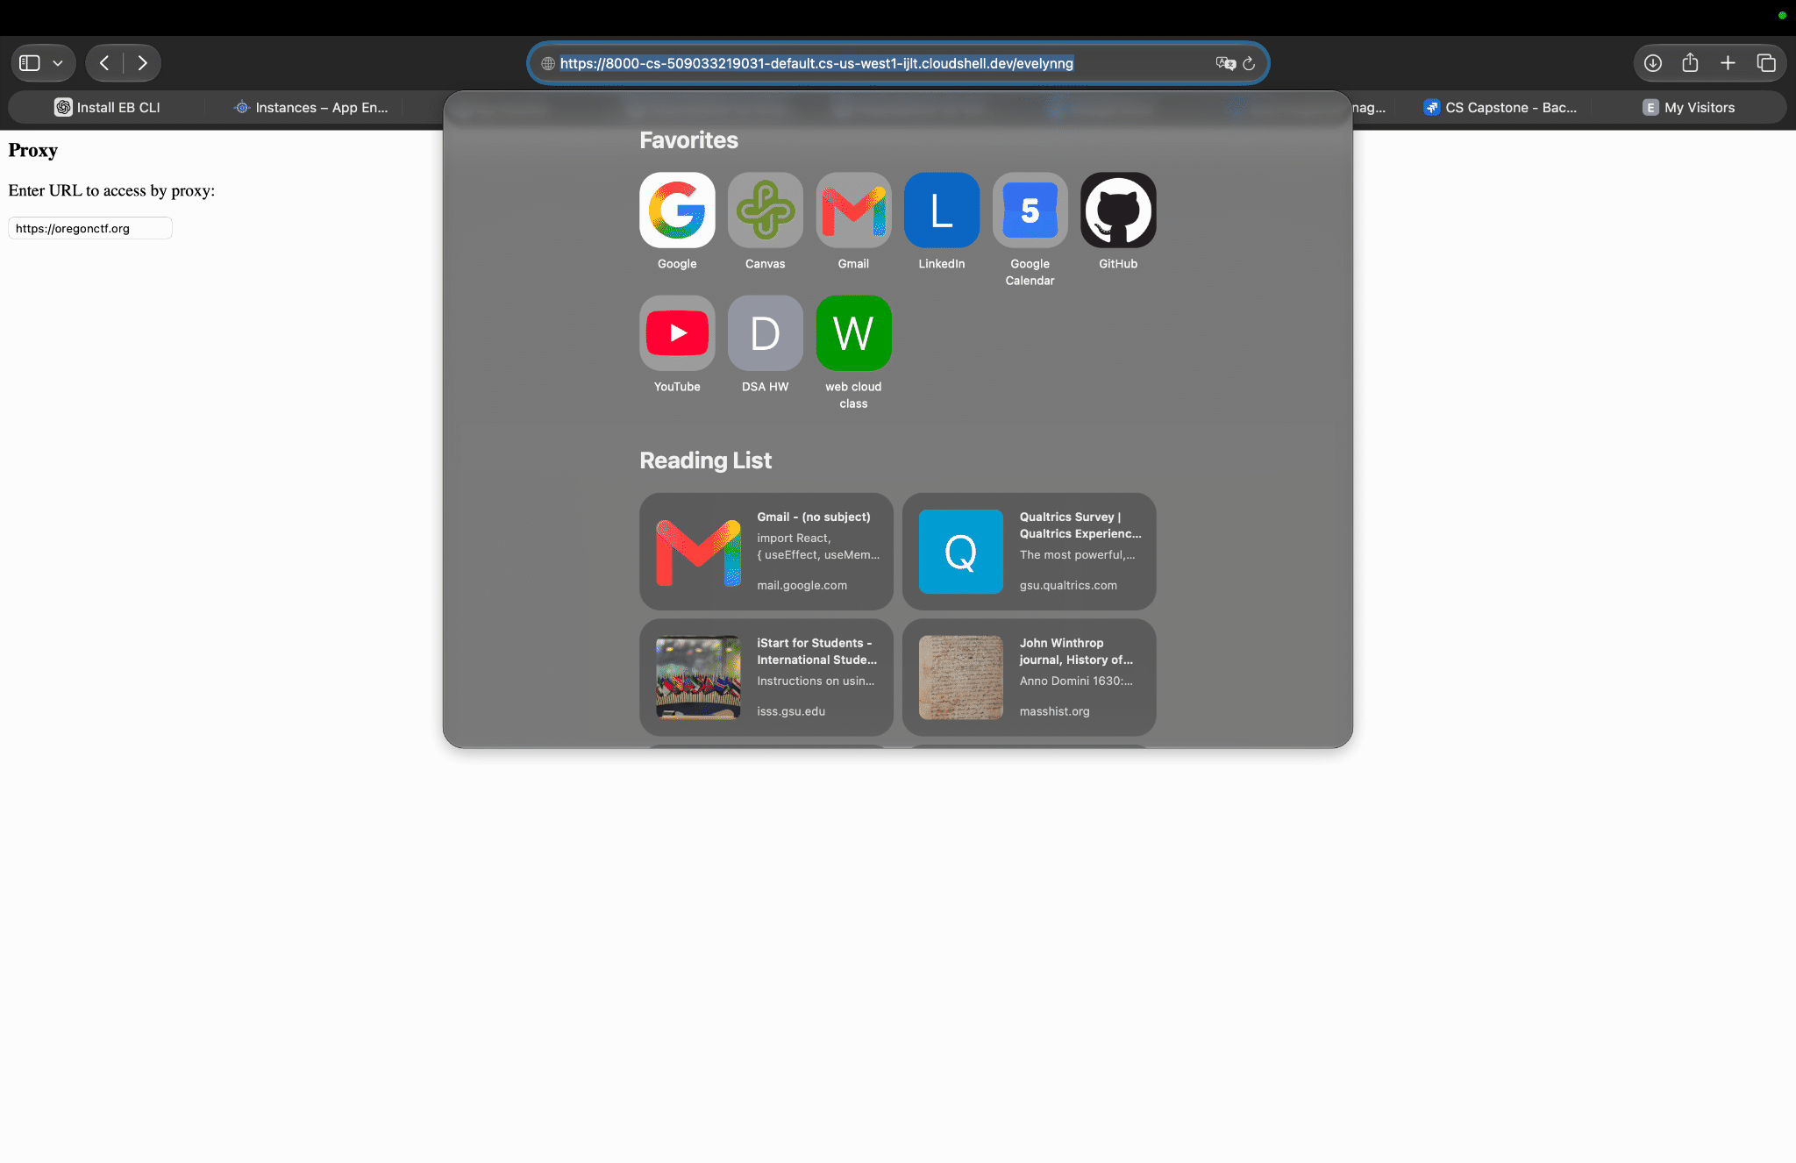

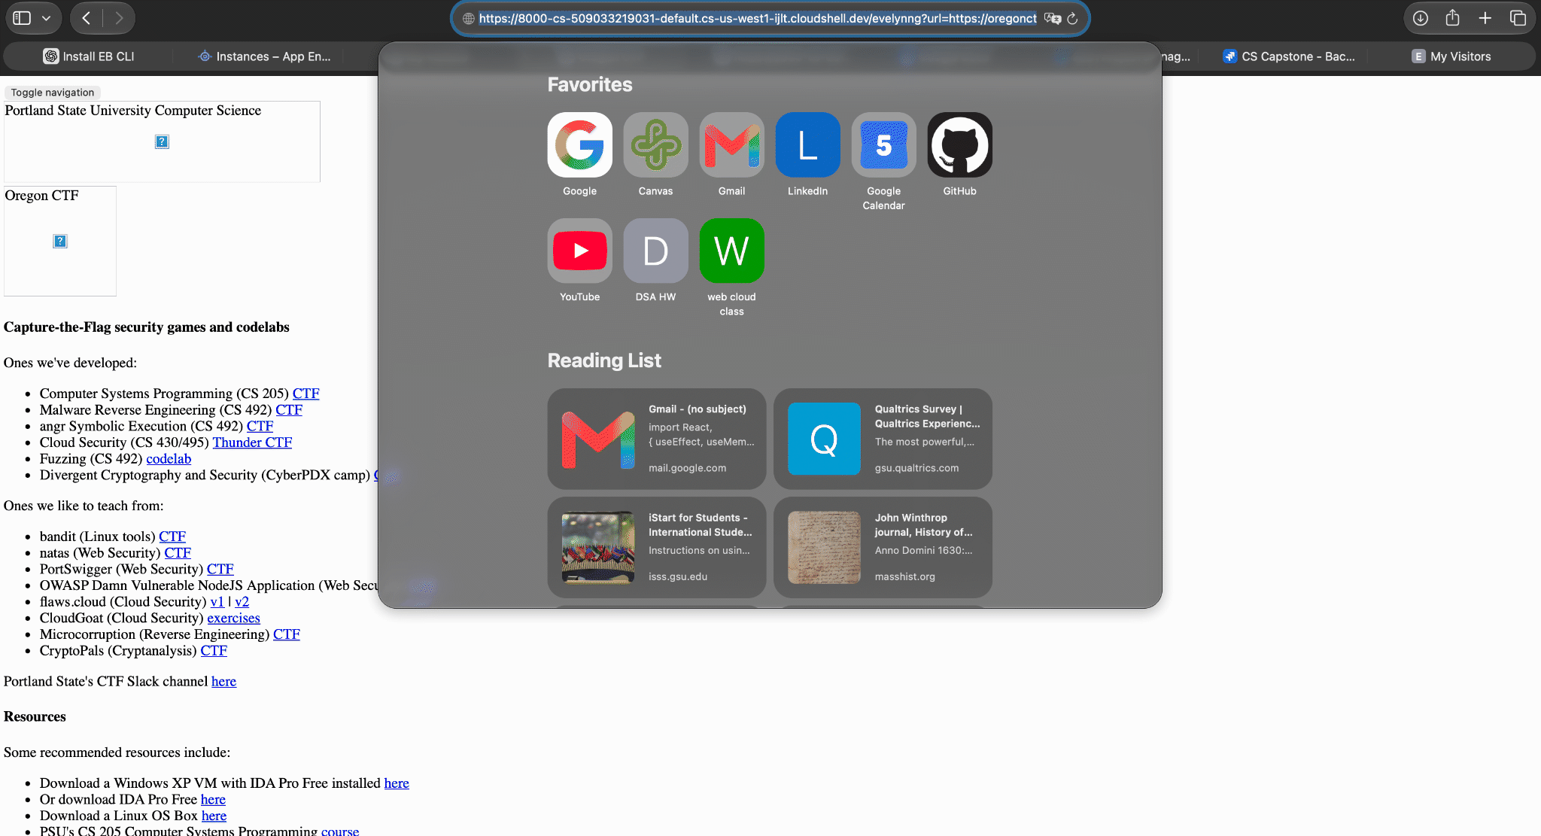

- What is the security advantage of passing in the secret proxy route as an environment variable?
by keeping the route out of the application's hardcoded source code. This makes the route easier to change without modifying or rebuilding the application and allows different deployment

10. Cloud Build
- Take a screenshot of the image in the registry that shows the size of the container for your lab notebook.

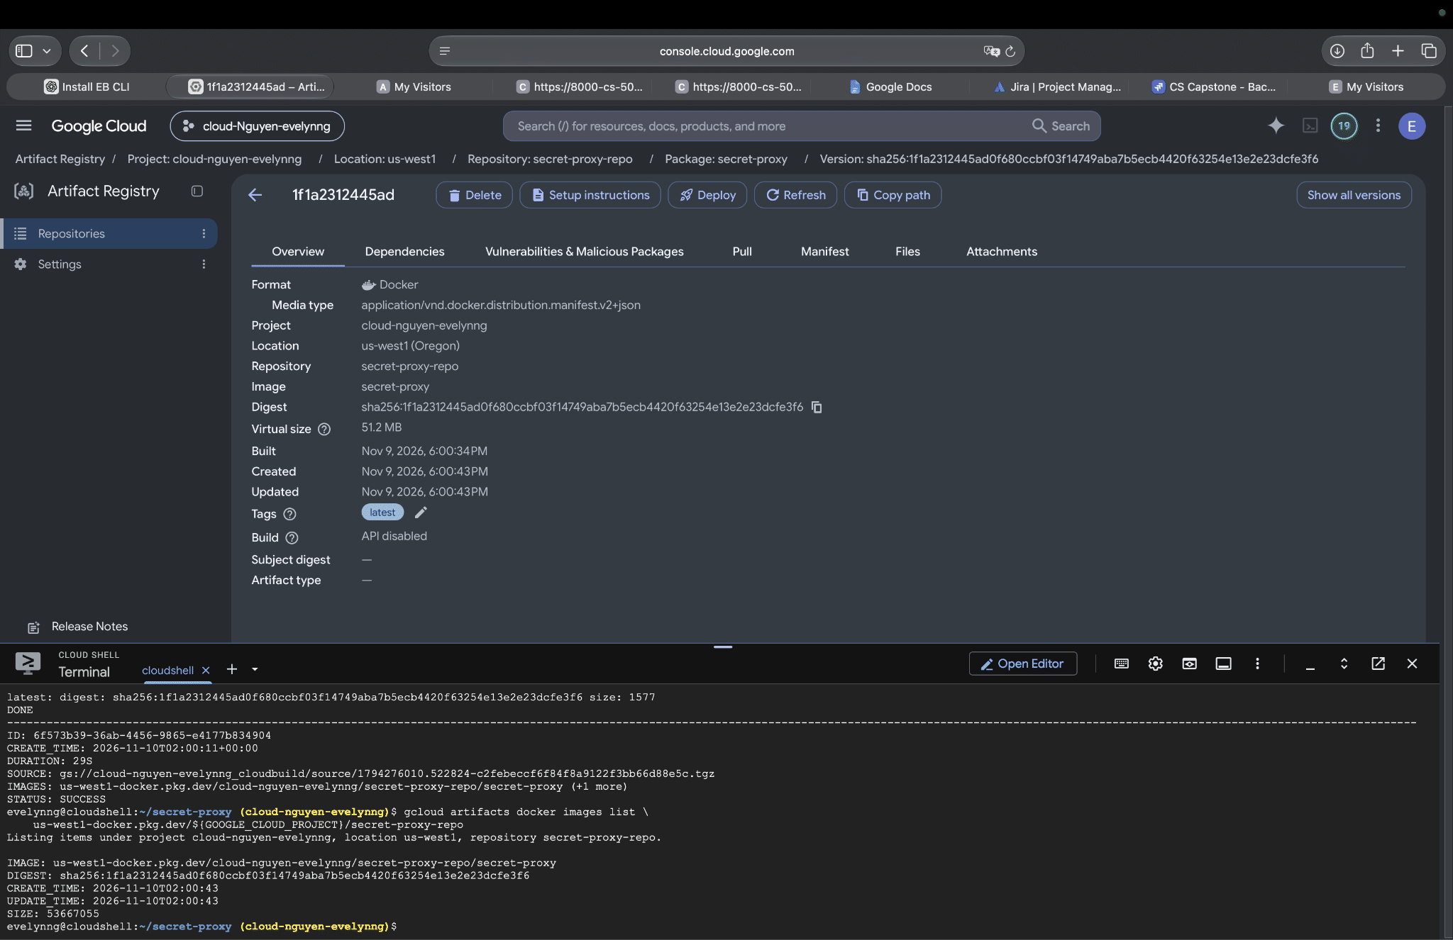

11. Deploy to Cloud Run

- Take a screenshot of it that includes the proxy URL for your lab notebook
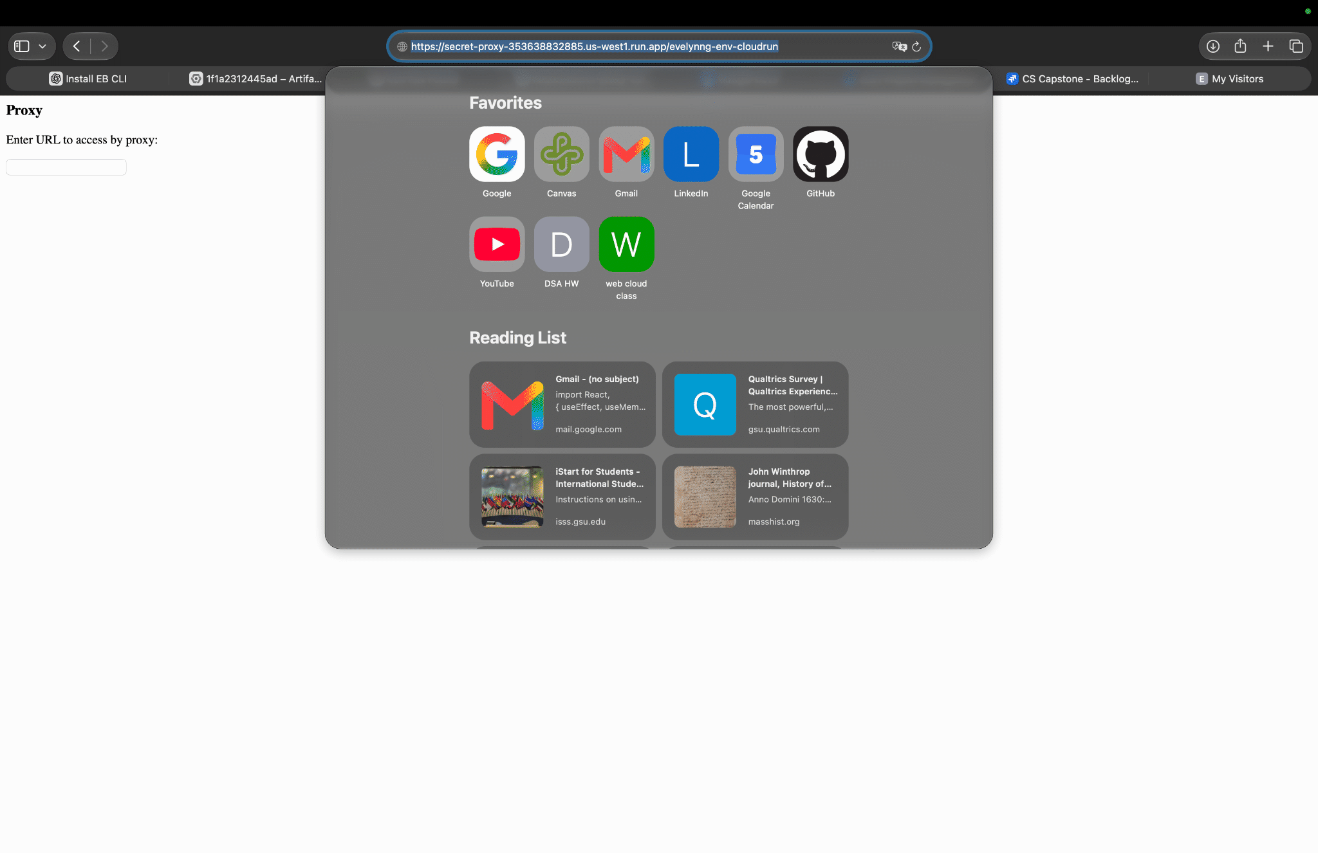

- Take a screenshot of the error page that includes the proxy URL for your lab notebook.
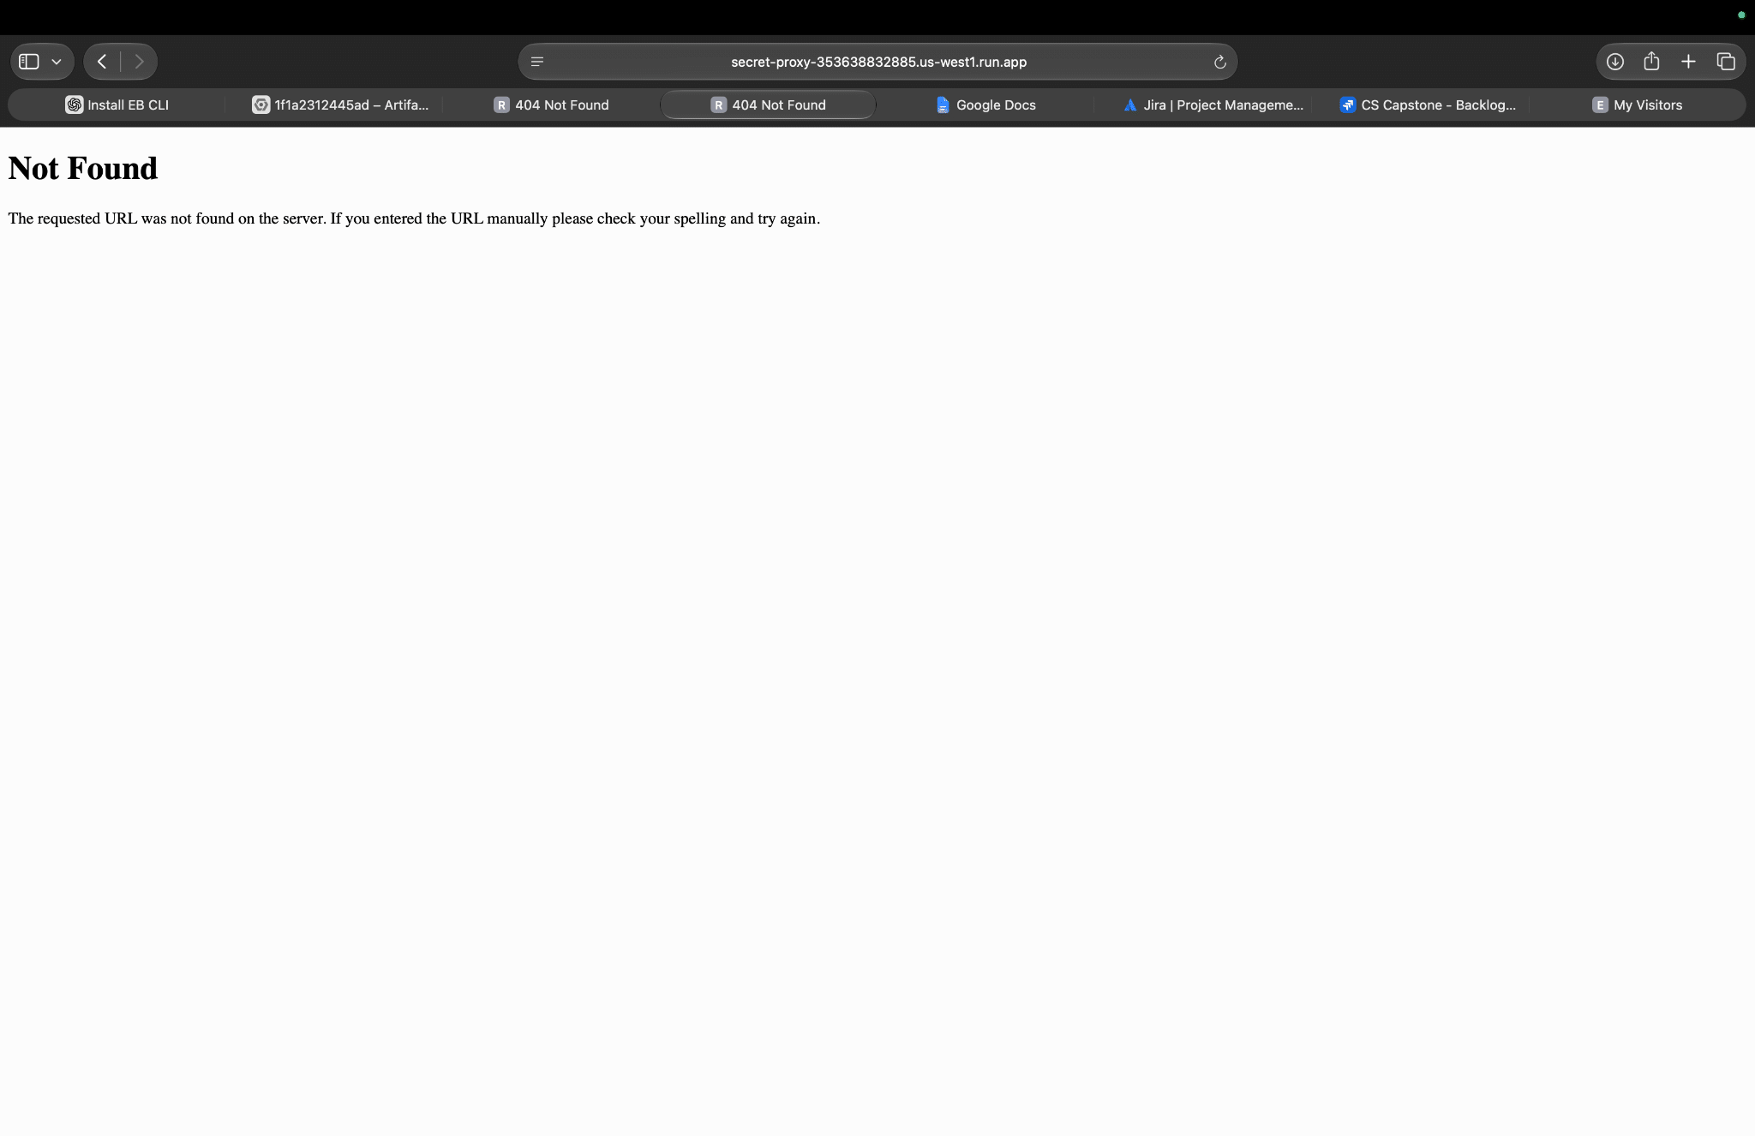

13. Deploy to Cloud Run with Secret Manager
- Take a screenshot of it that includes the proxy URL for your lab notebook.

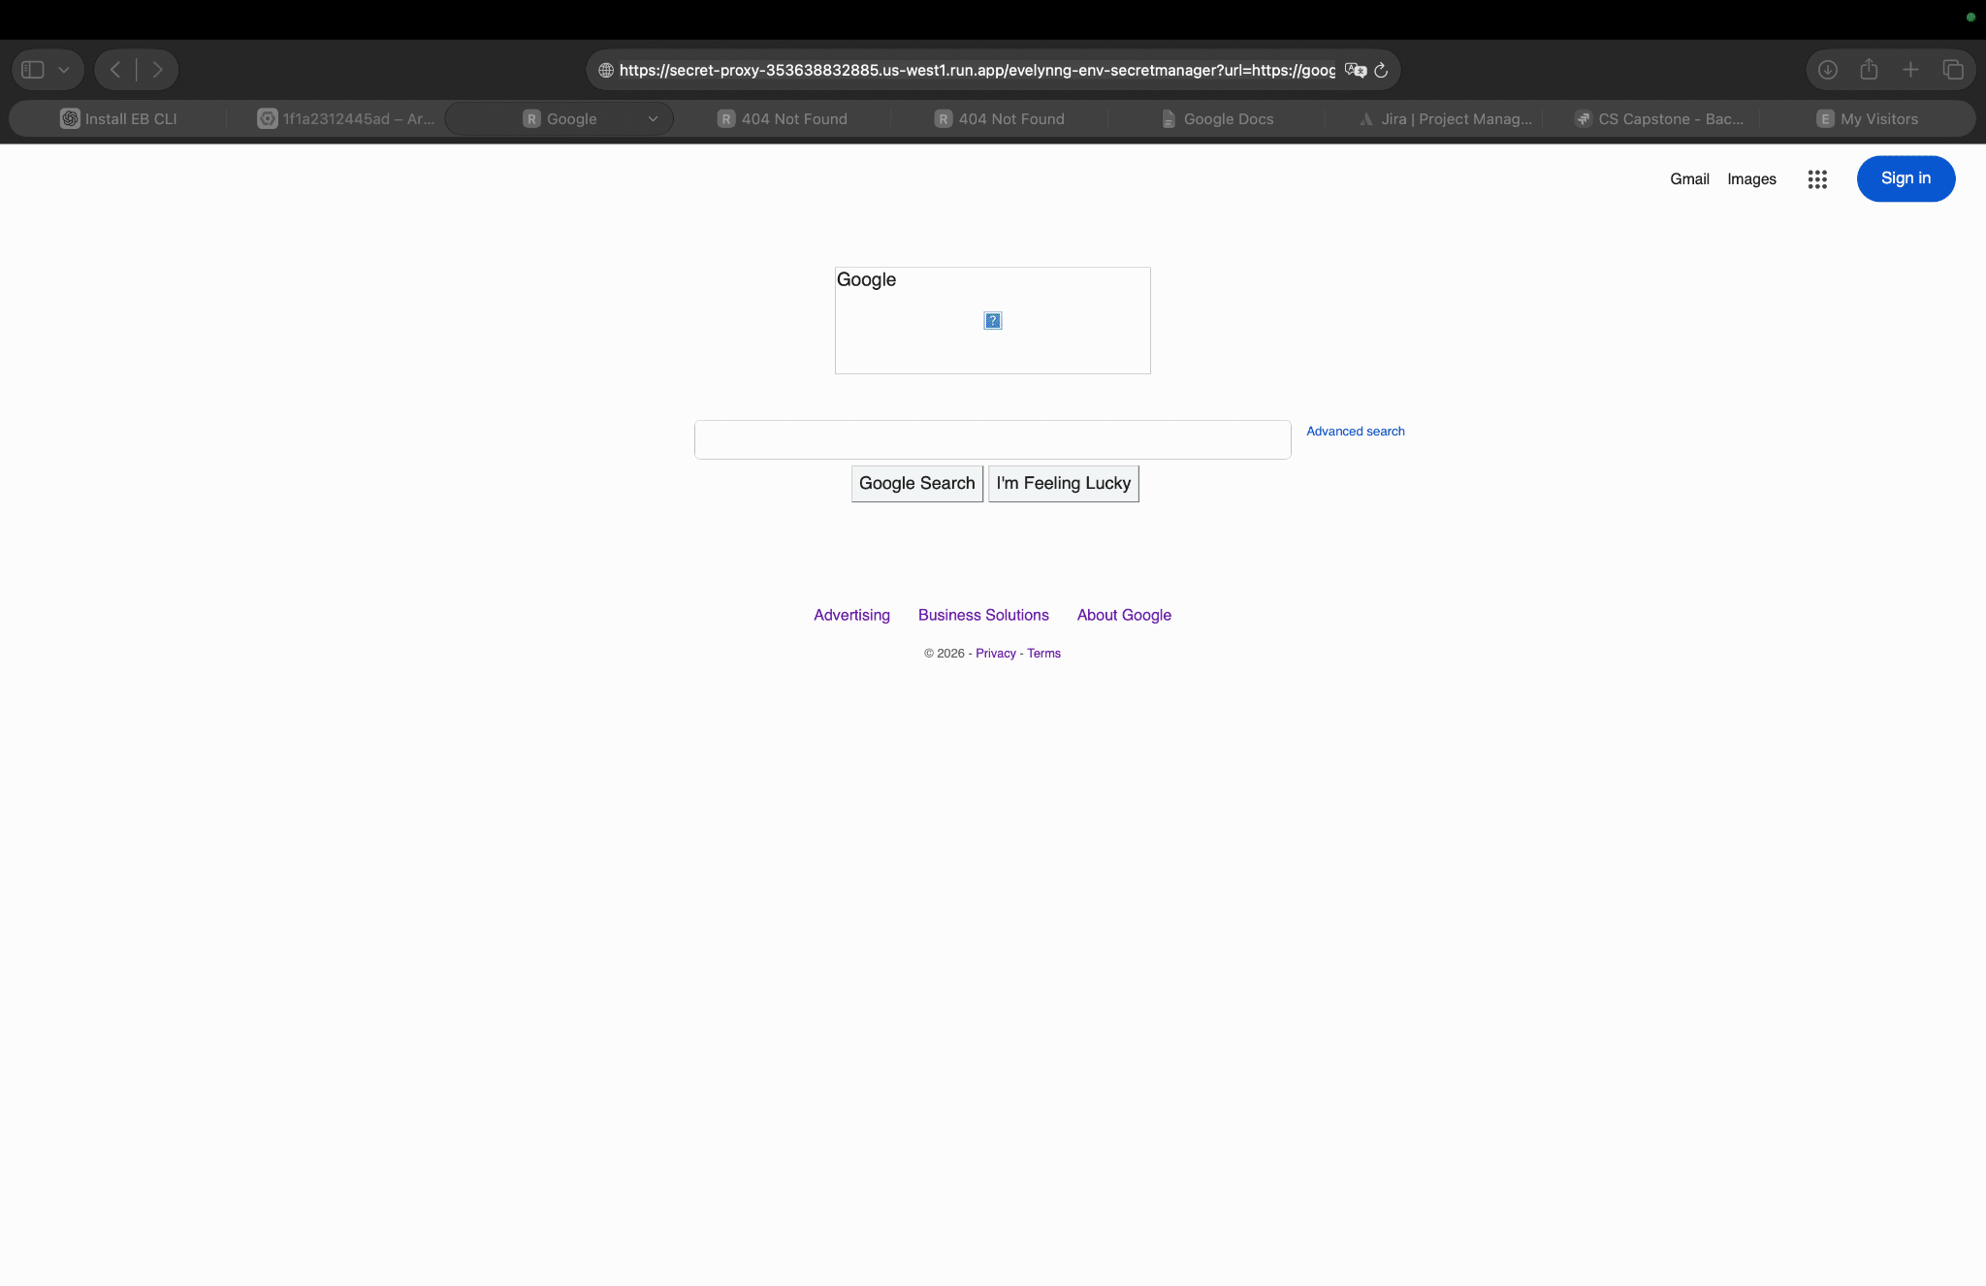

- Identify the vulnerability in your lab notebook that Google has prevented.
Google Cloud helps prevent Server-Side Request Forgery (SSRF) attacks from exposing sensitive VM metadata and service account credentials. An attacker could exploit a vulnerable proxy to access the internal metadata service at 169.254.169.254. Google requires a special Metadata-Flavor: Google request header, which helps block unauthorized metadata access through simple SSRF attacks. This reduces the risk of credential theft and unauthorized access to cloud resources.

06.3a: ECS Guestbook

5. Examine the service
- Take a screenshot of the DNS name of the guestbook-lb load balancer for your lab notebook

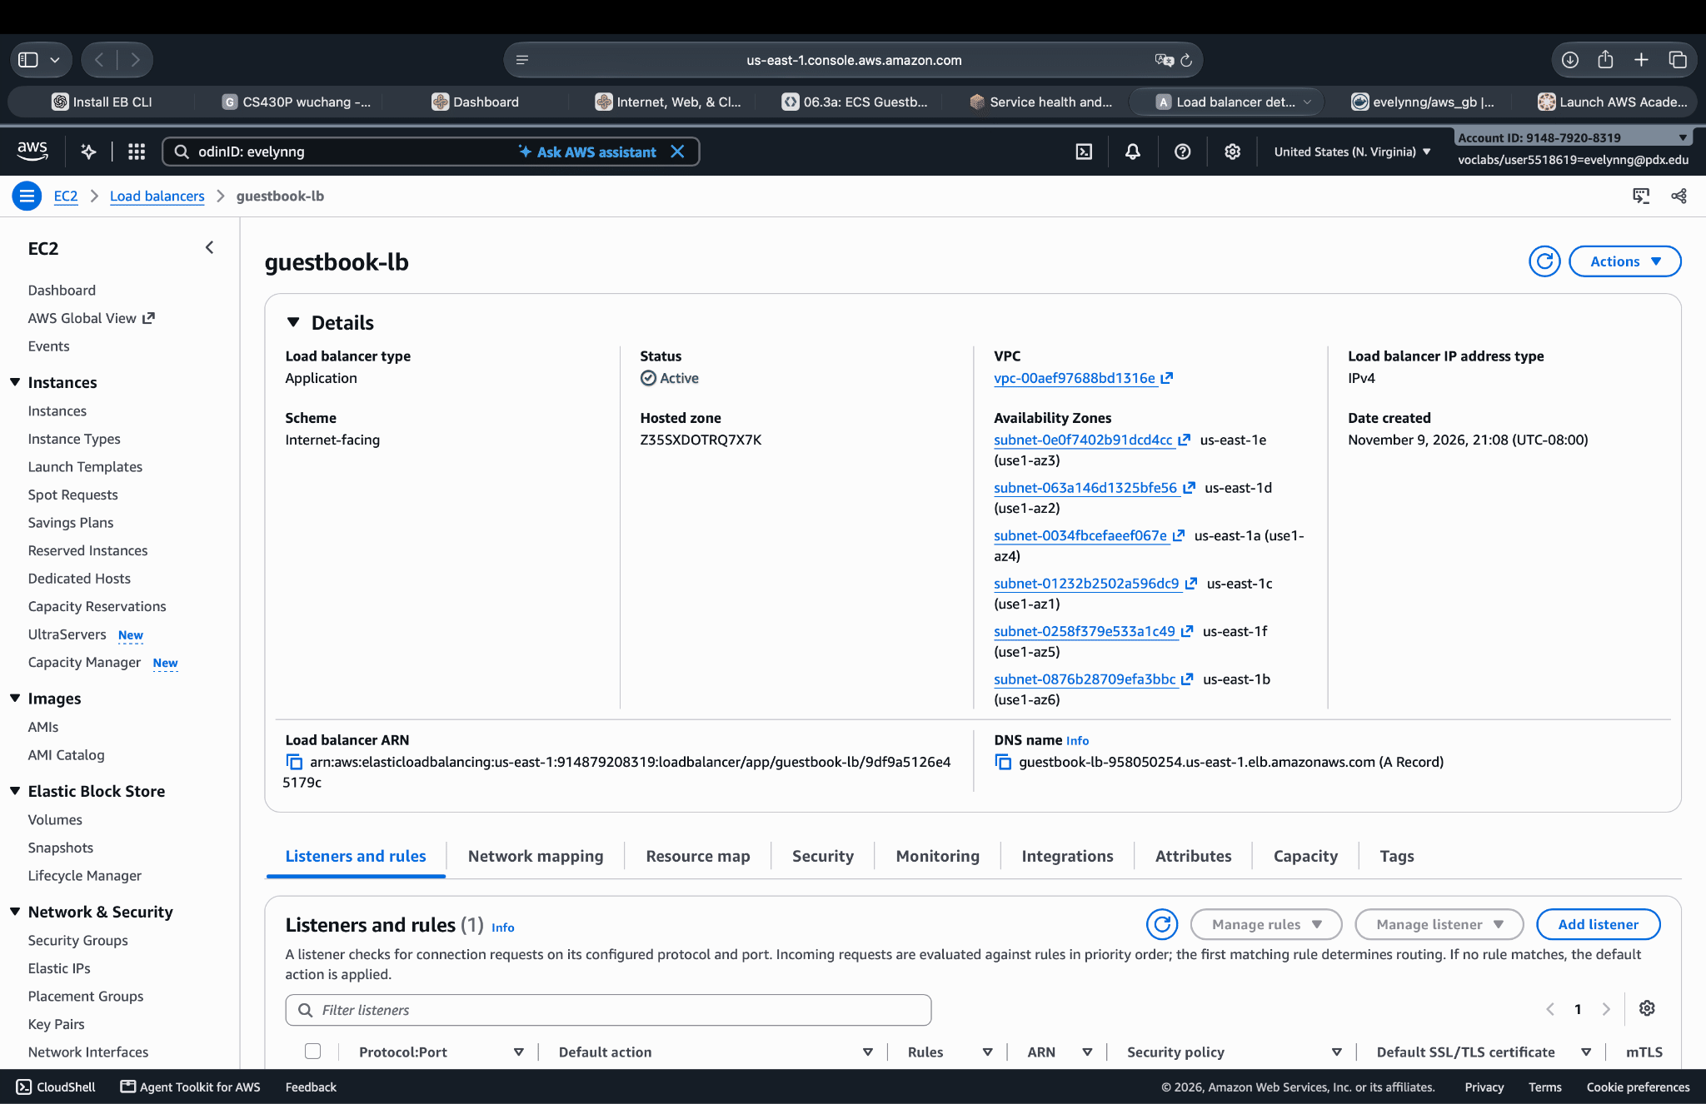

6. Visit the site

- Take a screenshot of the Guestbook app running in a browser that includes the DNS name of the site.
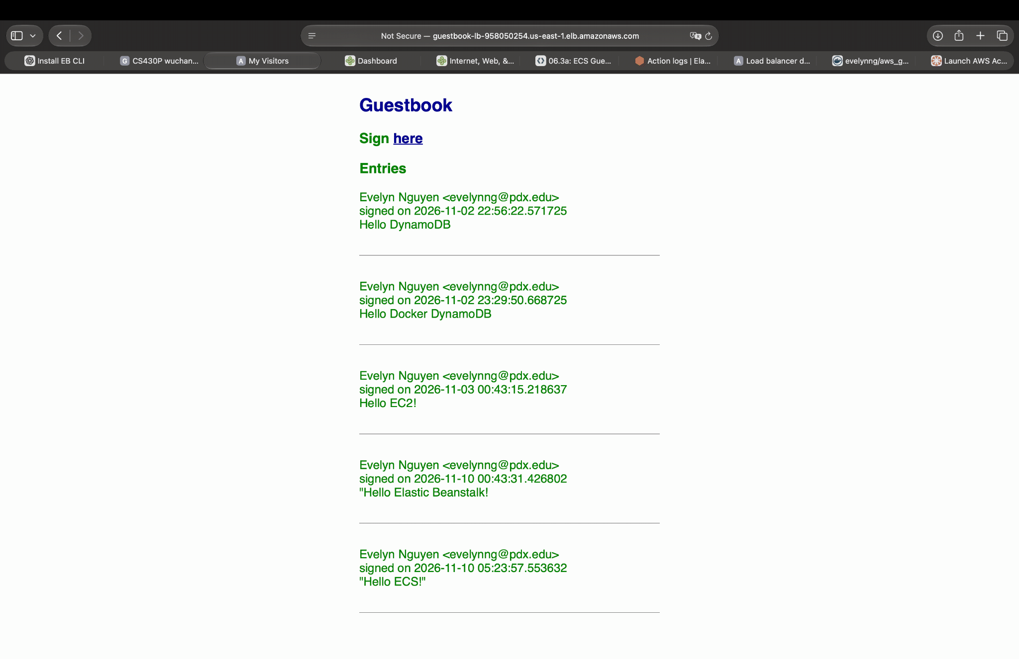

06.3g: Cloud Run Guestbook
- Take a screenshot that includes the output of the command and the time it took to execute.

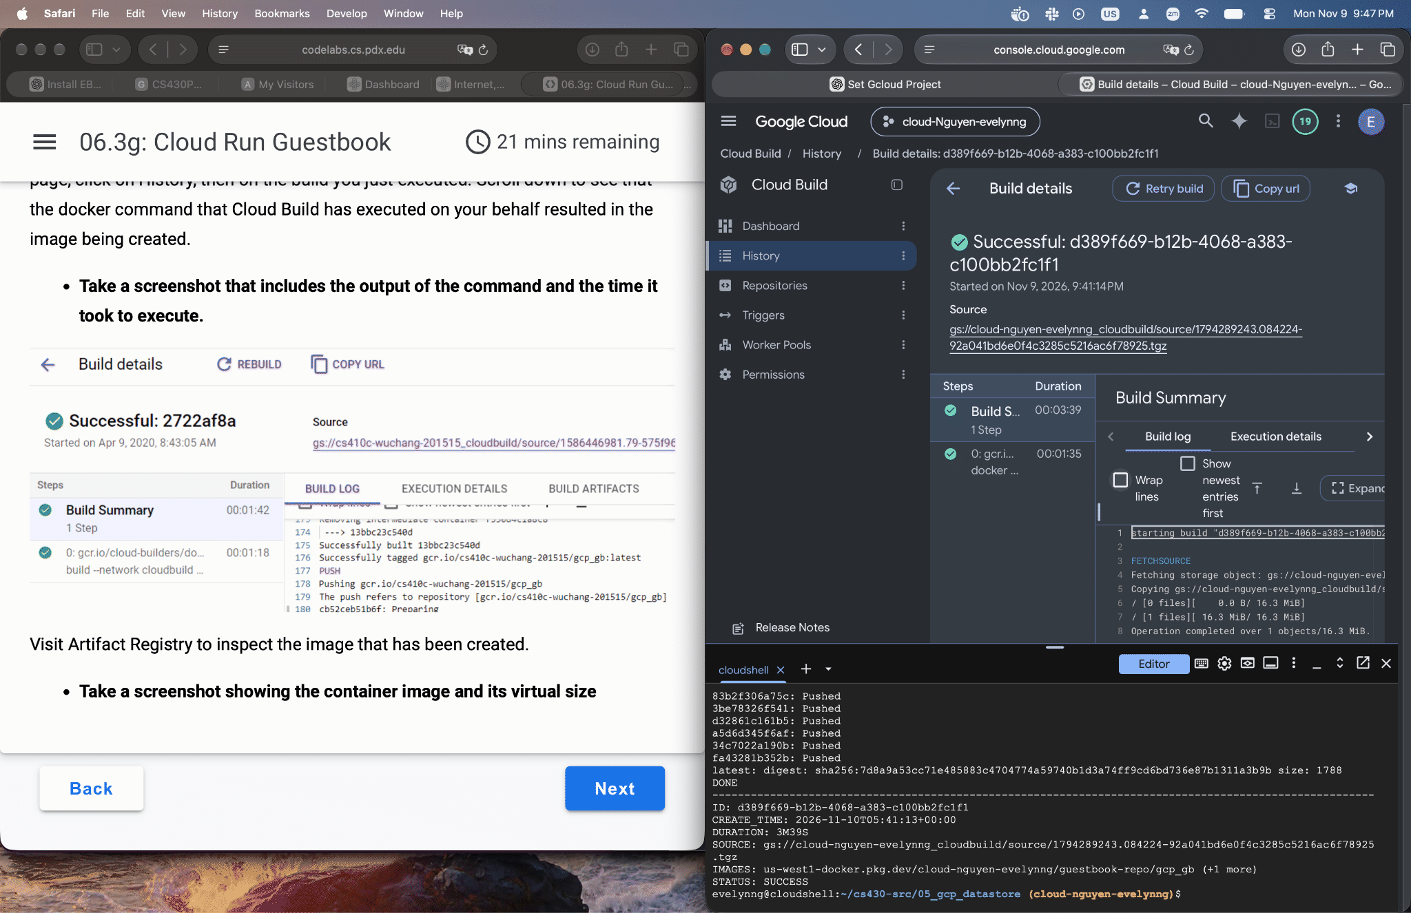

- Take a screenshot showing the container image and its virtual size
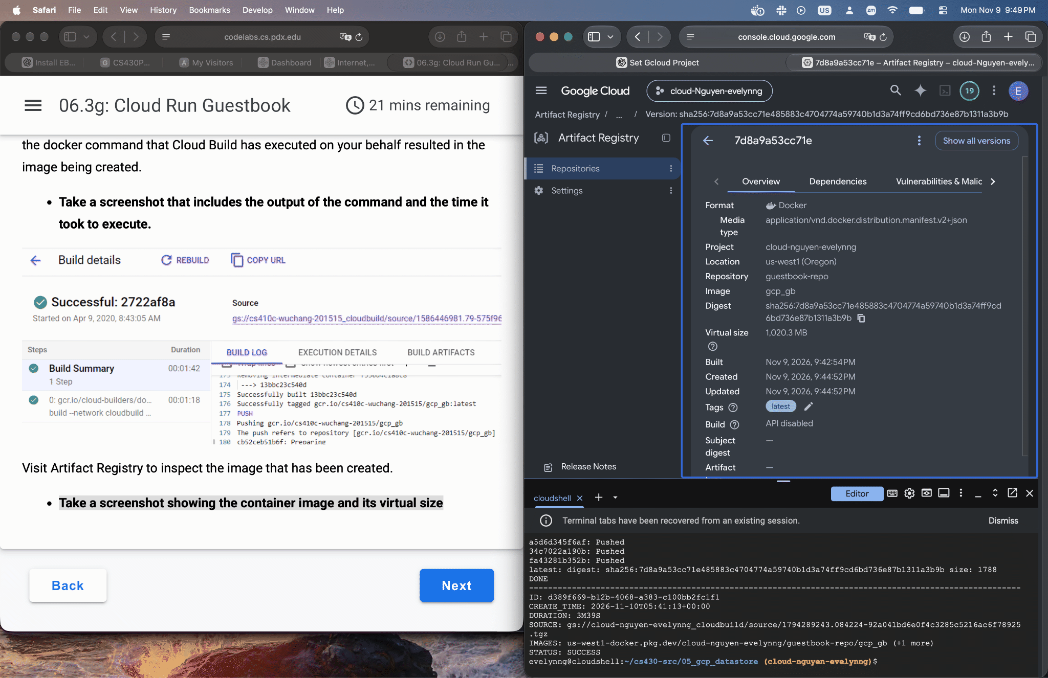

4. View the Guestbook
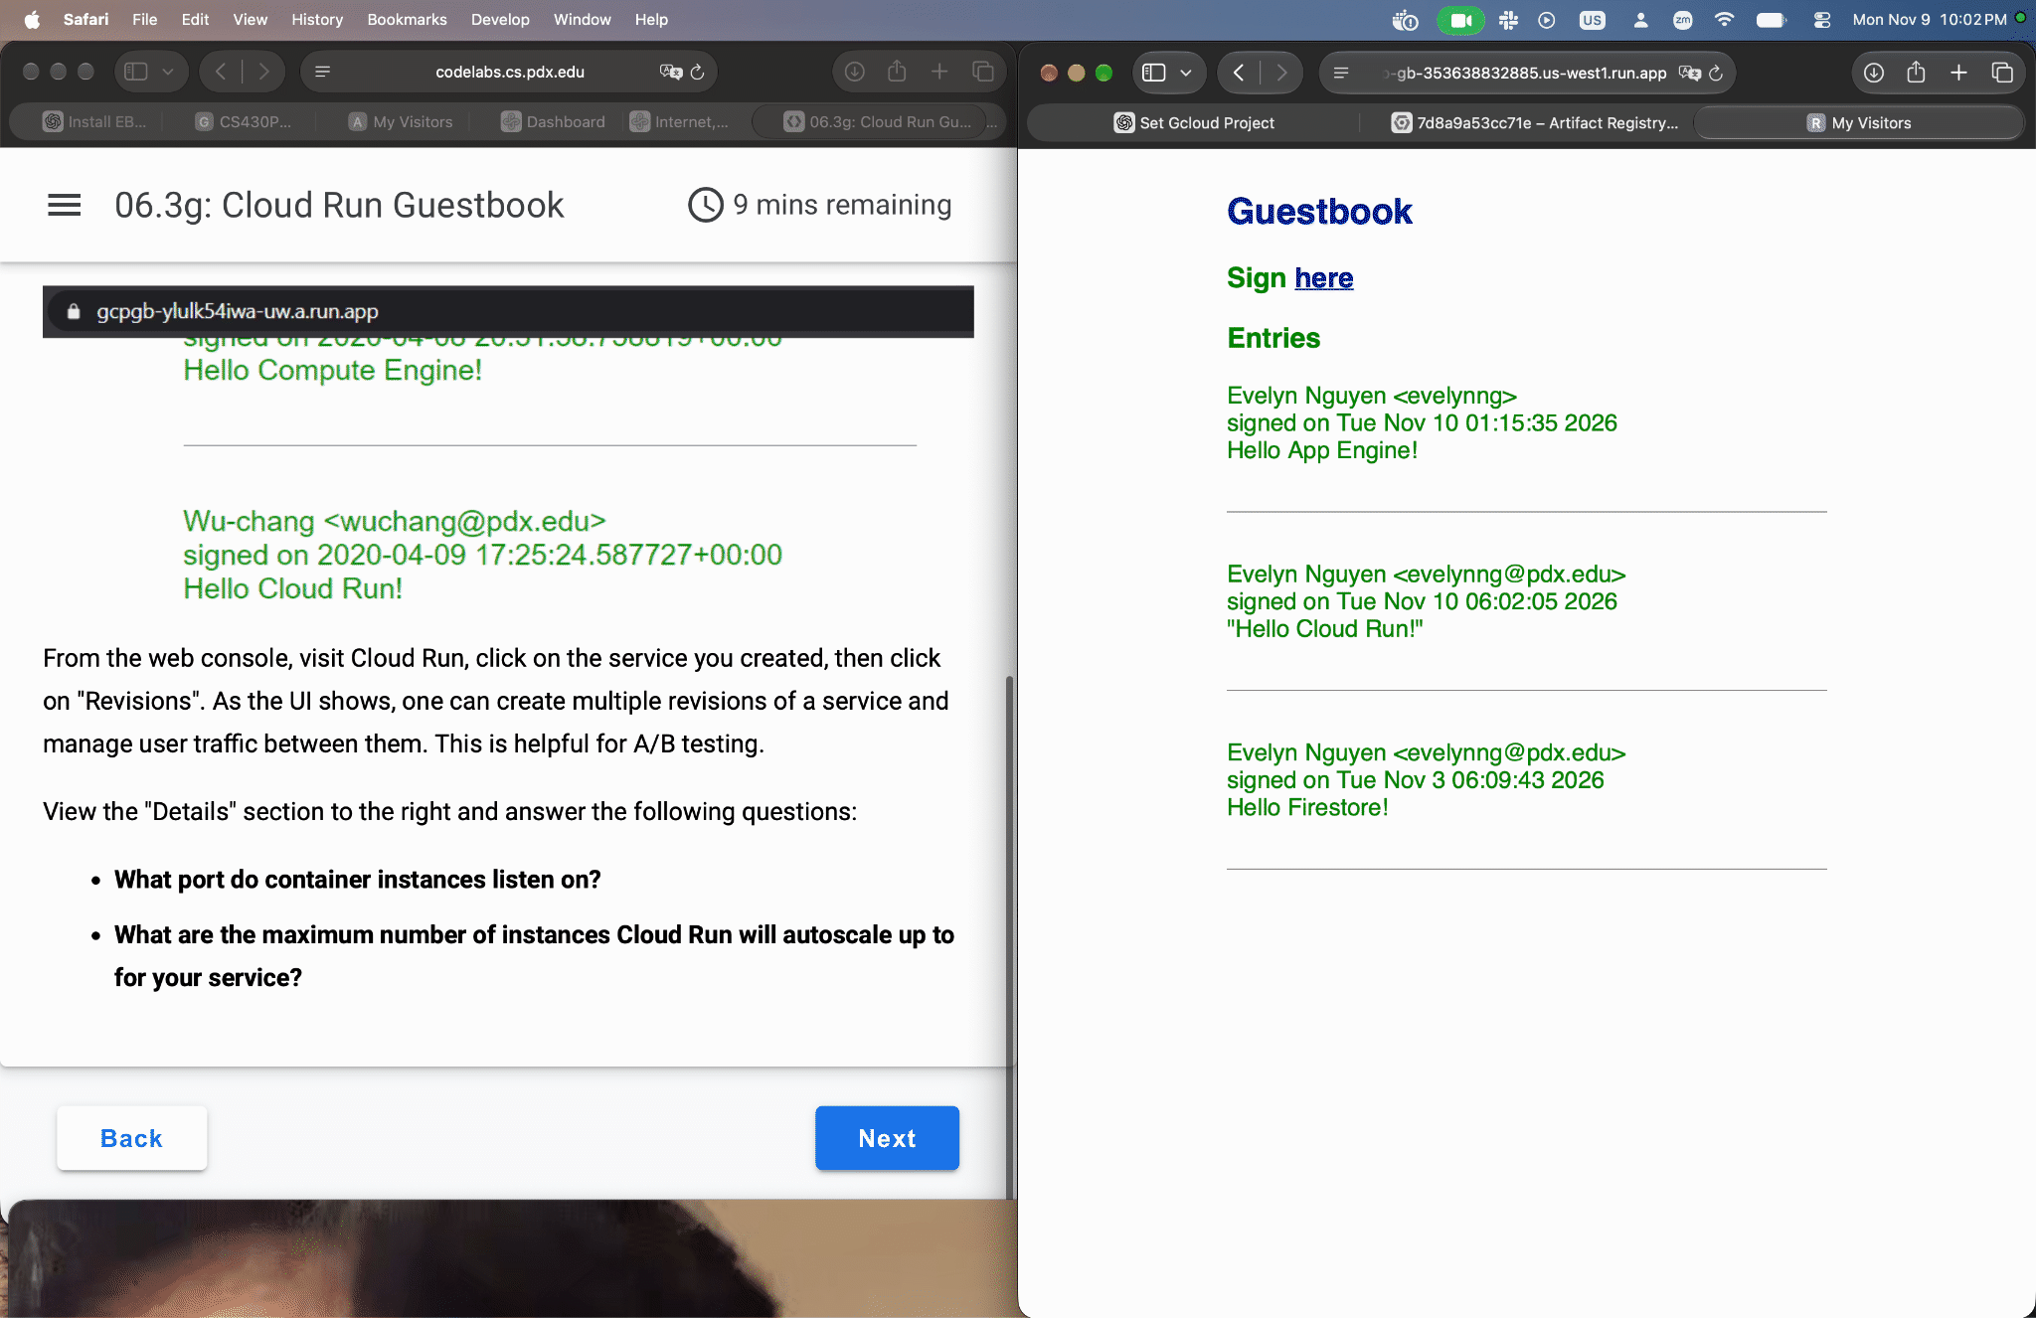

- What port do container instances listen on?
8080
- What are the maximum number of instances Cloud Run will autoscale up to for your service?
20

06.4g: Cloud Functions, PubSub

4. -
- After downloading the file from the bucket, where is it stored?
Temp file: Temp_local_filename
- What class in the ImageMagick package is used to do the blurring of the file?
Image class
- What lines of code perform the blurring of the image and its storage back into the filesystem?
image.blur(radius=0, sigma=16)
image.save(filename=temp_local_filename)

7. Test function
- Take a screenshot of the blurred image in the output bucket for your lab notebook

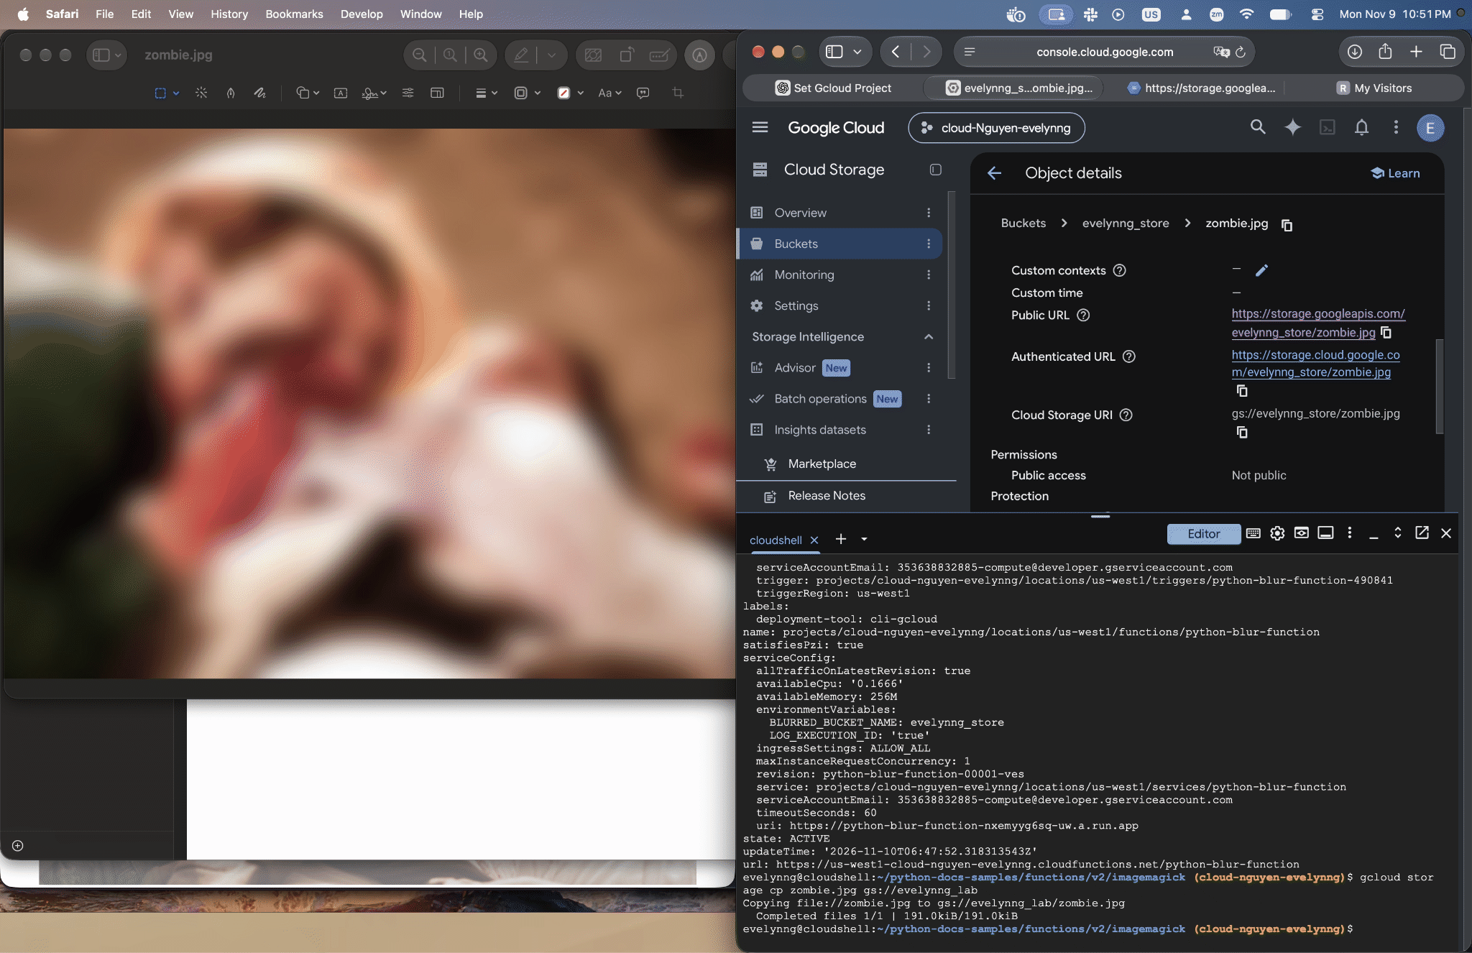

- Include a screenshot of the output logs that show that the above image was blurred.
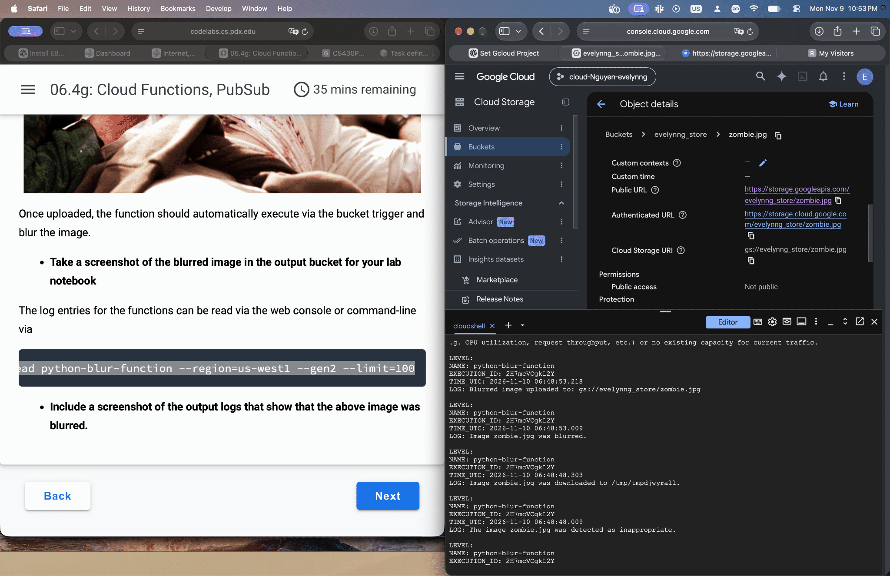

11. PubSub via CLI
- Why are there no items returned?
No messages are returned because the subscription was created after the message was published. Google Cloud Pub/Sub only delivers messages published after a subscription is created by default. Therefore, the earlier message was not stored for this new subscription.

12. -
- What is the messageId of the published message?
- '23334787009052052'
- Take a screenshot of the output of the successful pull that includes the message and its messageId
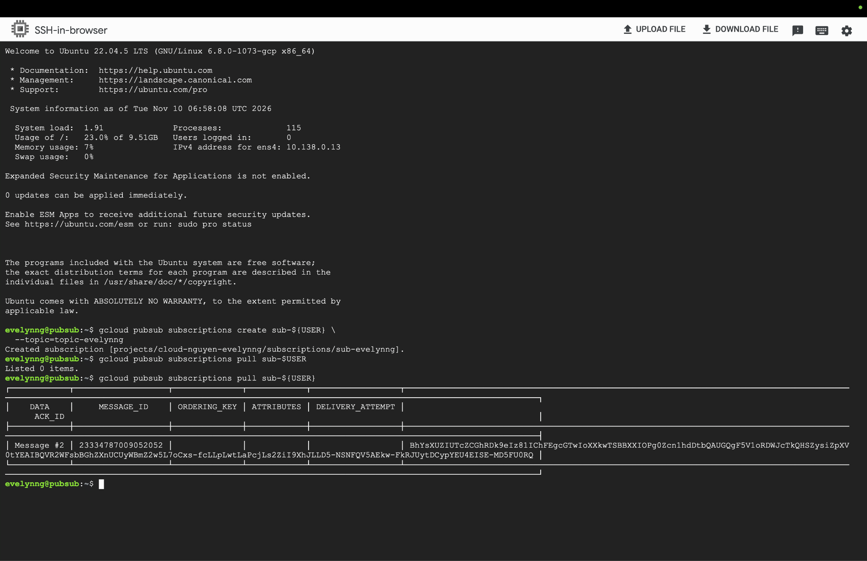

15. Test programs and clean up
- Take a screenshot showing the messageIds and messages sent
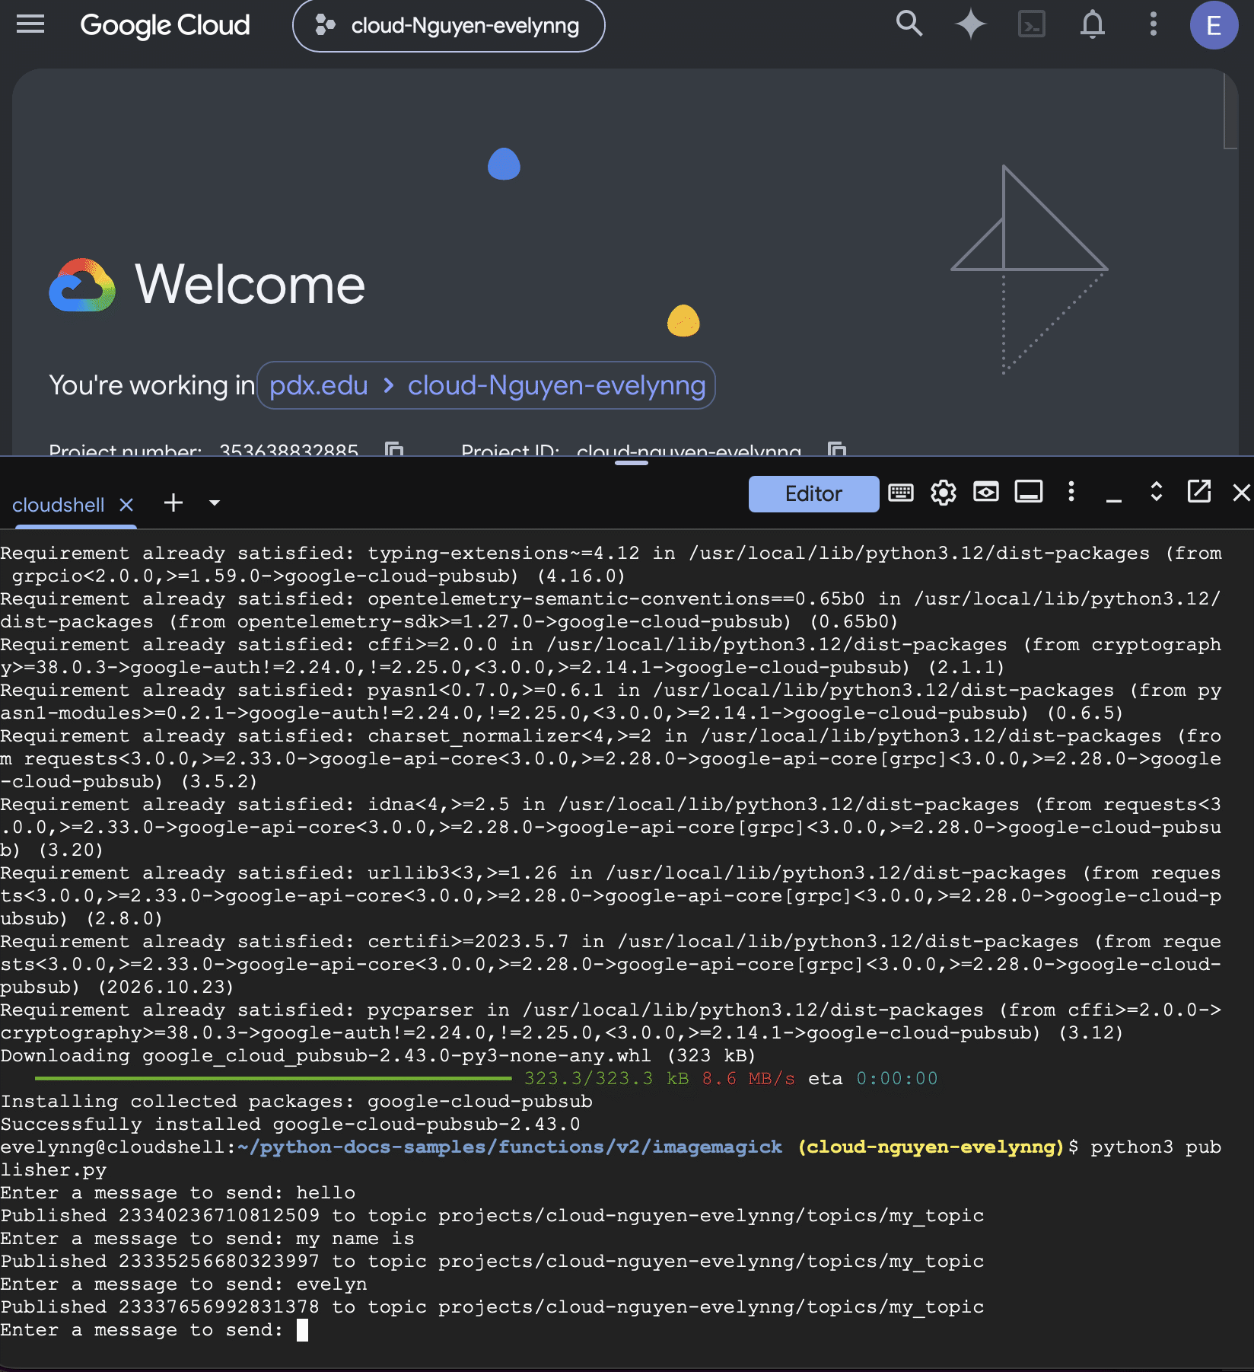

- Take a screenshot showing the same messageIds and messages received


