Ateneo de Naga University

Big Chabea’s Catering

Ordering System

Members:

Elevado, Ray James

Sebastian, Kim

Balane, Arnold Thaddaoeus

Table of Contents

1. Statement of the Problem

1.1 Introduction

1.2 Objectives

1.2.1 Main Objective

1.2.2 Specific Objectives

1.3 List of Features

1.4 Limitations

1. Screenshots
2. Methodology

3.1 Waterfall Methodology

3.2 Phases

3.2.1 Requirements

3.2.2 Design

3.2.3 Coding

3.2.4 Testing

3.2.5 Acceptance

1. Statement of the Problem

**1.1 Introduction**

* Big Chabea’s Catering negotiates with their customers manually. Customers are required to meet with the manager during transactions wherein they will be provided with printed forms and menus to choose their desired order which is very time-consuming. The organization uses Microsoft Excel in managing their monthly sales that sometimes results to duplication of records. With the expanding growth of technology, it is imperative to create an online catering ordering system that will promote efficient and effective transactions between customers and organizations.

**1.2 Objectives**

**1.2.1 Main Objective**

* The main objective of the system is to give the customers a user-friendly online ordering system that will let them order their desired food in just a few clicks.

**1.2.2 Specific Objectives**

* To develop a system that will surely satisfied the customer service.
* To evaluate its performance and acceptability in terms of security, user-friendliness, accuracy and reliability.
* To improve the communication between the client and the server and minimize the time of ordering.
* To design a system able to accommodate huge amount of orders at a time.

**1.3 List of Features**

* Online forms
* Price and list of food
* Generation of Reports
* Summary of Customers

**1.4 Limitations**

* The system will only cover customers within Camarines Sur area. It will not include online payments or any other financial transactions.

II – Screenshots

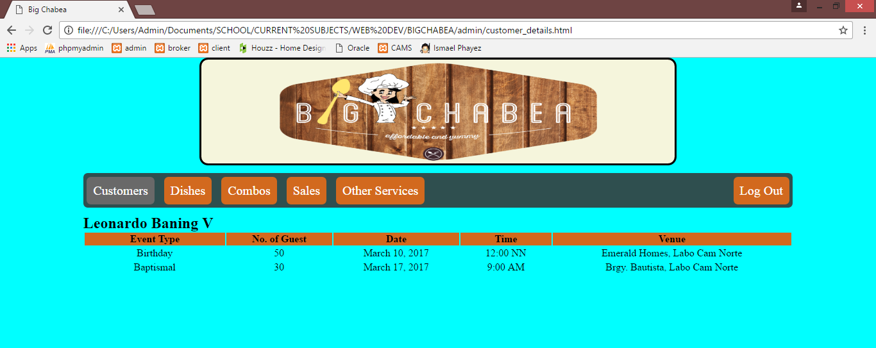

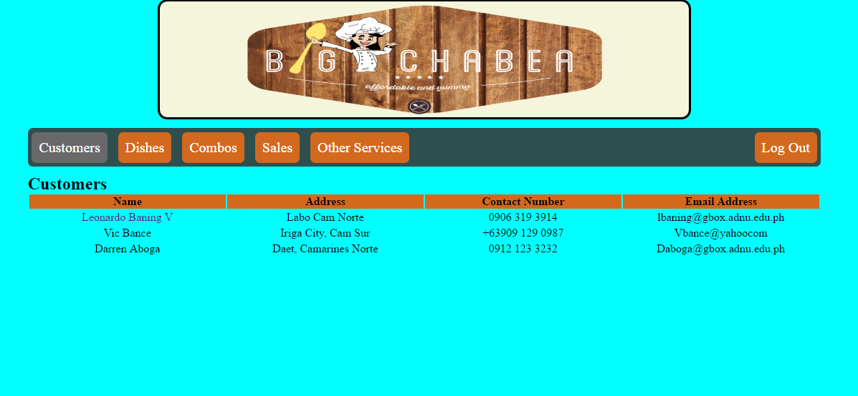

III - Methodology

**3.1 Waterfall Methodology**

* 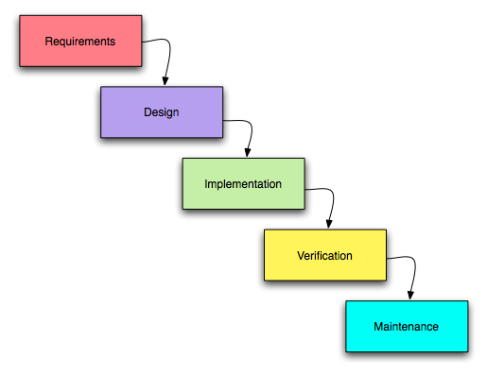The proponents decided to apply the waterfall methodology in the proposed project because it is the most appropriate model for a database project. Waterfall model is a [sequential](https://en.wikipedia.org/wiki/Sequence) [design](https://en.wikipedia.org/wiki/Design) process in which progress is seen as flowing steadily downwards through the phases of conception, initiation, [analysis](https://en.wikipedia.org/wiki/Analysis), [design](https://en.wikipedia.org/wiki/Software_design), construction, [testing](https://en.wikipedia.org/wiki/Software_testing), [production/implementation](https://en.wikipedia.org/wiki/Implementation) and [maintenance](https://en.wikipedia.org/wiki/Software_maintenance).

**3.2 Phases**

**3.2.1 Requirements**

* The proponents gathered data by consulting the general manager of Big Chabea Catering Services, asked for sample forms and summary of sample sales and customers. The general manager explained the time-consuming processes in their transactions and the improper storing of records in their contracts.

**3.2.2 Design**

**3.2.1 ER - Model**

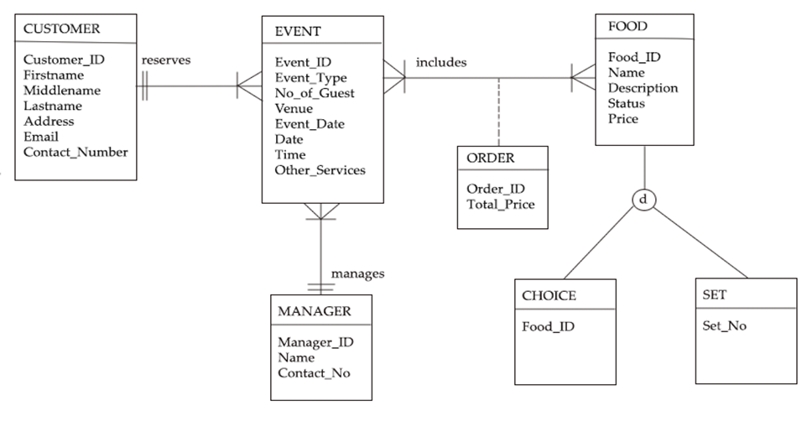**3.2.2 Flowchart**

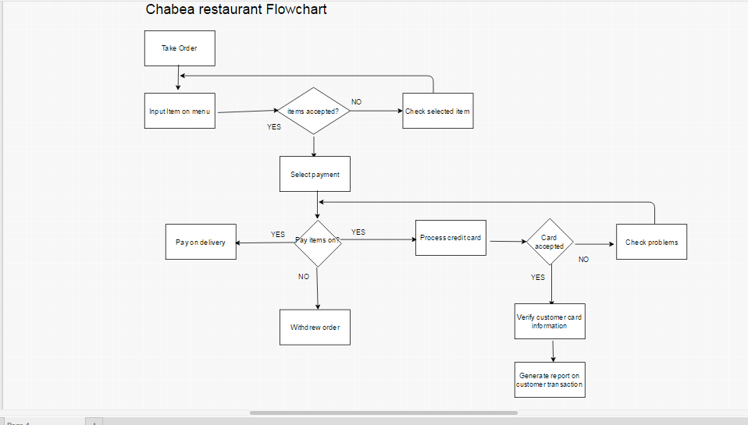

**3.2.3 Site Map**

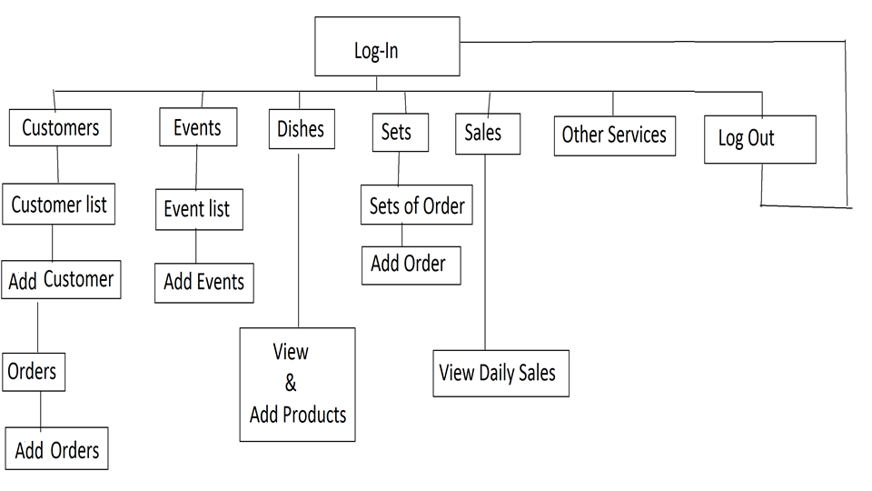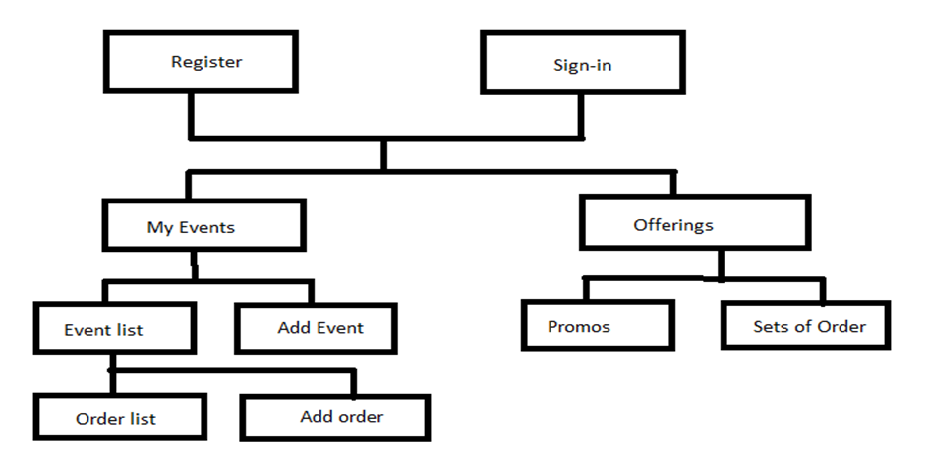

**3.2.3 Implementation**

* The proponents will execute the design document. They will attempt to adhere to the specifications, procedures, and timelines laid out in the early phases

**3.2.4 Verification**

* Full tests were done, bugs and defects were fixed. Verification by examination and through provision of objective evidence that specified requirements have been fulfilled.

**3.2.5 Maintenance**

* As problems are found due to improper requirements determination or other mistakes in the design process, or due to changes in the user’s requirements, there will be a management of changes to the system to support end users. Monitoring of system performance and continuation of end user support through training and documentation will be applied. To complete this phase, the following objectives must be achieved by the proponents:

*To provide detailed instructions for future business processes

*To ensure consistent execution of business processes

*To document and track system incidents

*To report on agreed upon system performance measurements

*To drive performance improvement