Angular
Explain with sample code in Angular 12 version for the below questions and topics and detail explanation.
What is Angular?

How this code works?
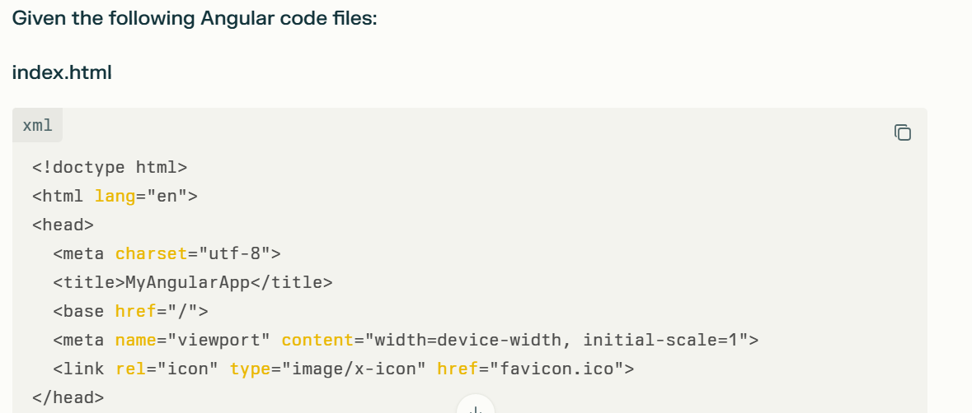
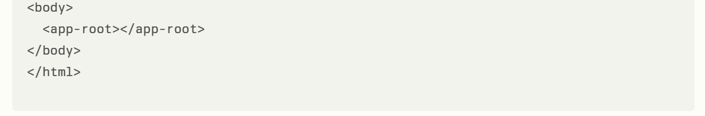
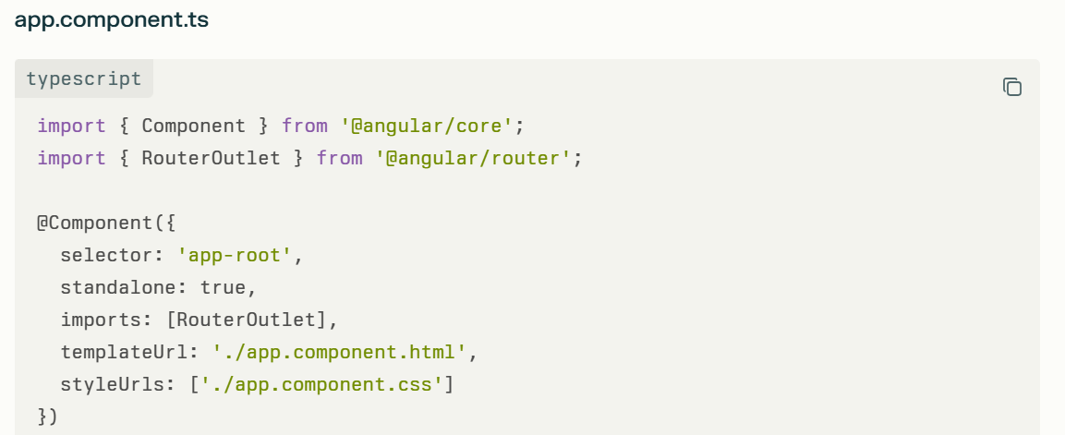
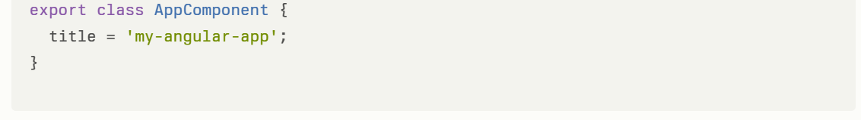
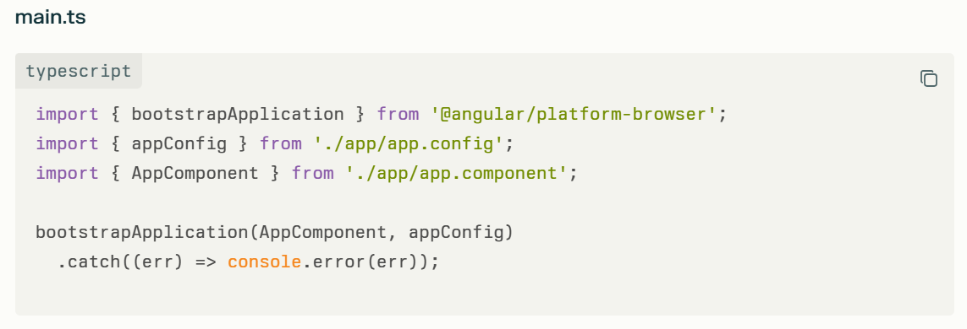

How does the selector <app-root></app-root> run and display the Angular application in the browser?
How does this code work together to render the UI inside the <app-root> element?
Your Angular app shows the <app-root></app-root> element in the browser because of Angular’s component bootstrapping mechanism, which connects the Angular component (AppComponent) to that custom HTML tag and renders the component’s template inside it.
Here’s how the whole flow works in your example:
1. index.html
- This is the main HTML file that the browser loads when you open your Angular app.
- Inside the <body>, you have the custom HTML tag <app-root></app-root>.
- At this point, it’s just a placeholder element — plain HTML — waiting for Angular to render content here.
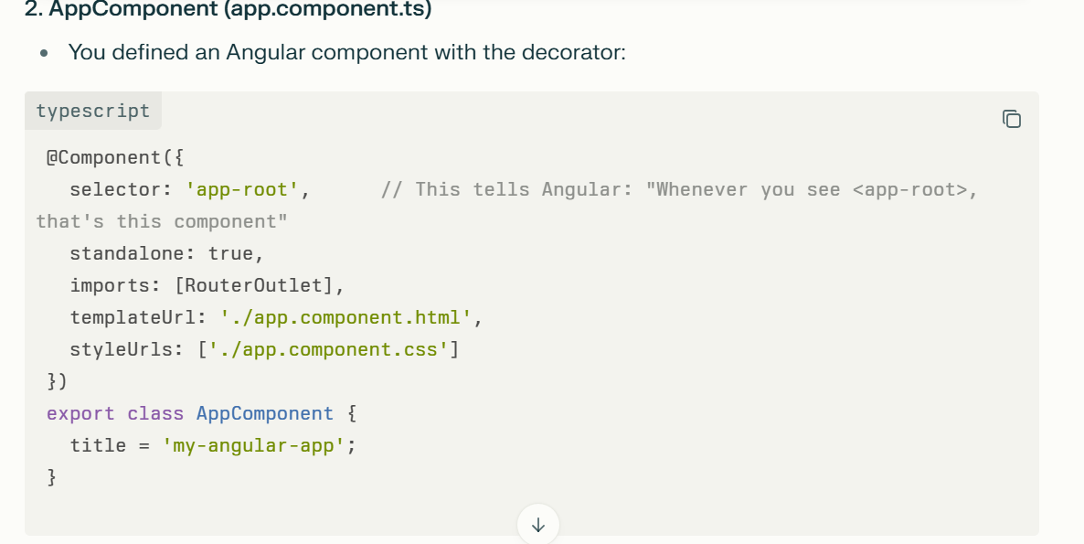
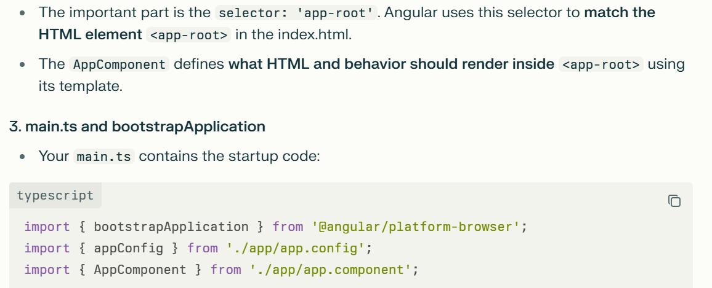
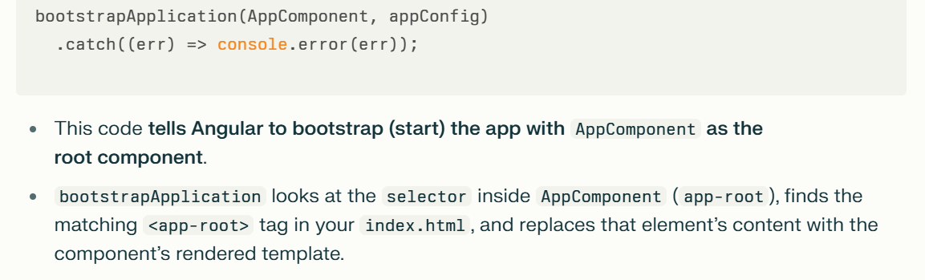
Summary of "How <app-root> works":
- The browser loads index.html and sees <app-root></app-root>.
- Angular starts via main.ts, bootstrapping AppComponent which is linked to <app-root>.
- Angular locates the <app-root> element in the DOM.
- Angular creates an instance of AppComponent.
- Angular renders the component’s template inside <app-root>, replacing or filling its content.
- The app’s UI becomes visible in place of <app-root>.
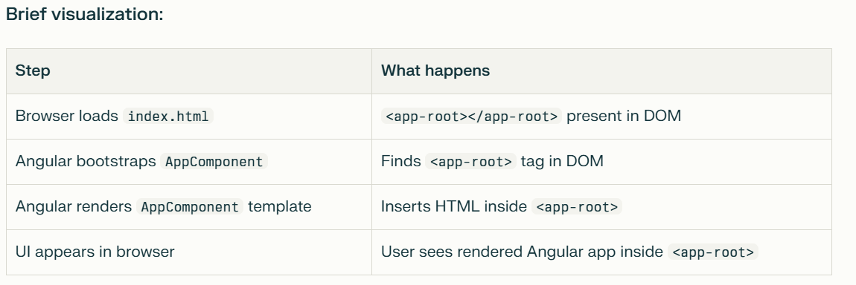
How Angular Detects Components at Runtime
Angular uses metadata reflection and DI (Dependency Injection) mechanisms during runtime to detect, instantiate, and render components:
- Component Metadata via Decorators:
  - Each Angular component class is decorated with @Component which specifies metadata including the component's selector, templateUrl, styles, and other configurations.
  - This metadata tells Angular what to render and where.
- Component Selector Matching:
  - When bootstrapping starts, Angular looks at the root component's selector (e.g., app-root).
  - It searches the DOM for the matching custom HTML element (<app-root></app-root>) from index.html.

Creating the new application
What is zone.js?
Do you want to create a 'zoneless' application without zone.js (Developer Preview)?
A "zoneless" application refers to an Angular application developed without relying on Zone.js, which is traditionally used in Angular for managing change detection.
Zone.js works by monkey-patching browser asynchronous APIs (such as events, timeouts, promises) to track when operations start and finish. This enables Angular to run change detection automatically after any async activity. While convenient, this approach can cause frequent and unnecessary change detection cycles, impacting performance, increasing bundle size, and making debugging harder.
Zoneless Angular eliminates the dependency on Zone.js to reduce overhead, improve performance, and provide better control over when change detection runs. Instead of automatic triggers, change detection is explicitly controlled—triggered by specific events such as DOM event handlers, signal updates, async pipes in templates, or manual calls to trigger change detection.
Benefits of creating a "zoneless" application include:
- Improved performance by reducing unnecessary change detection cycles.
- Smaller bundle size and faster startup by removing Zone.js.
- Easier debugging with clearer stack traces.
- Better compatibility with newer browser APIs and ecosystem libraries.
- More explicit and fine-grained control over UI updates.
To create such an application, Angular provides a provider like provideZonelessChangeDetection() that can be added during app bootstrap to enable this mode.
In summary, developing a "zoneless" Angular app means removing Zone.js to achieve a more performant, modern, and controllable change detection mechanism, though it requires developers to manage change detection triggers more explicitly.

Do you want to enable Server-Side Rendering (SSR) and Static Site Generation (SSG/Prerendering)? (y/N)
Enabling Server-Side Rendering (SSR) and Static Site Generation (SSG, also called Prerendering) in Angular means setting up your application to render HTML on the server rather than completely on the client, which can significantly improve load times, SEO, and user experience.
- Server-Side Rendering (SSR): The Angular app is rendered on the server for each user request, delivering fully populated HTML pages to the browser. This helps with initial load performance and search engine indexing. Angular Universal is the technology used to implement SSR in Angular.
- Static Site Generation (SSG) / Prerendering: The Angular app is rendered during build time into static HTML files. These prebuilt files are then served to users, which is very fast and improves caching and SEO for content that does not change often.
Developers can enable SSR or SSG when creating a new Angular project via CLI flags or add it to an existing project using Angular Universal libraries. Angular also supports hybrid rendering that lets you choose per route whether to use SSR, SSG, or CSR (Client-Side Rendering) for optimal flexibility.
For example, enabling SSR helps with dynamic, frequently changing content pages by rendering them on each request, while SSG is best for mostly static pages that can be prerendered for fast loading.
In summary, answering "yes" to enabling SSR/SSG means opting to improve performance, SEO, and overall user experience by moving some rendering responsibilities from the client to the server or the build process, using Angular Universal and related tooling.

Would you like to share pseudonymous usage data about this project with the Angular Team
at Google under Google's Privacy Policy at https://policies.google.com/privacy. For more
details and how to change this setting, see https://angular.dev/cli/analytics.
The question "Would you like to share pseudonymous usage data about this project with the Angular Team at Google under Google's Privacy Policy?" is a prompt displayed by Angular CLI asking for permission to collect anonymous usage analytics data.
Here's what it means and the context:
- By choosing Yes (y), you allow the Angular Team to collect anonymized data about how you use Angular CLI commands (like which commands are run, options used, environment info) to help improve the tools and prioritize features.
- The collected data is pseudonymous—meaning it does not identify you personally but can provide general usage patterns.
- Google handles the data according to their Privacy Policy (https://policies.google.com/privacy).
- If you choose No (N) or skip, no data is collected.
- You can always change this setting later.
- This prompt usually appears once during Angular CLI installation or the first time you run it.
For automation (CI/CD) or to avoid the prompt, set the Angular CLI configuration to disable analytics by running:
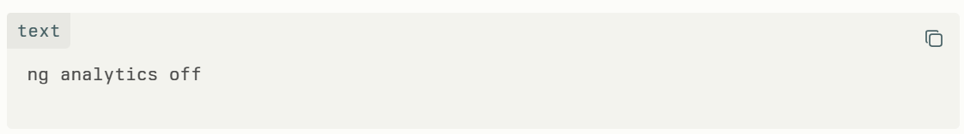
or configure analytics: false in the angular.json file under the "cli" section.
More information is available here: https://angular.dev/cli/analytics

What is Component?
How to use the component directive in html?
What is Module? Give example code.
What is Service? Give example code.
What is Dependency Injection? Give example code.
What is Directive? Give an example code for each directive.
What is Custom Directive? Give example code.
What are different pipes? Give an example code for each.
Give an example code for pure and impure pipes
Different types of data binding. Give example code for each type.
Give example code for Property binding
Can we share a component across multiple modules in Angular? Give example code.
Input and Output decorators. Give example code.
Data sharing methods between components. Give example code for each method.
How to Trigger an Event in Another Component Without a Direct Relationship in Angular?
Explain how to trigger an event in one Angular component from another component when there is no parent-child or sibling relationship between them. What are the best practices and methods to achieve this kind of component communication in Angular?
To trigger an event in another Angular component when there is no direct relationship (no parent-child or sibling relationship), the most effective approach is to use an Angular Service as a mediator for communication. This technique enables components to share data or events via a common service using RxJS Observables or Subjects.
Here is a detailed explanation and example of how to achieve this:

- Concept: Using an Angular Service with RxJS Subject
- Create a service that includes an RxJS Subject or BehaviorSubject which acts as a communication channel.
- One component emits or triggers an event by pushing new data or a signal into this Subject via the service.
- Another component subscribes to this Subject to receive event notifications or data updates.
- This allows any two unrelated components to communicate indirectly without requiring a parent-child hierarchy.

- Step-by-step Example
- Suppose you have two unrelated components: ComponentA triggers an event, and ComponentB wants to react to that event.
- 1. Create the Service
- Create a service that holds a Subject:
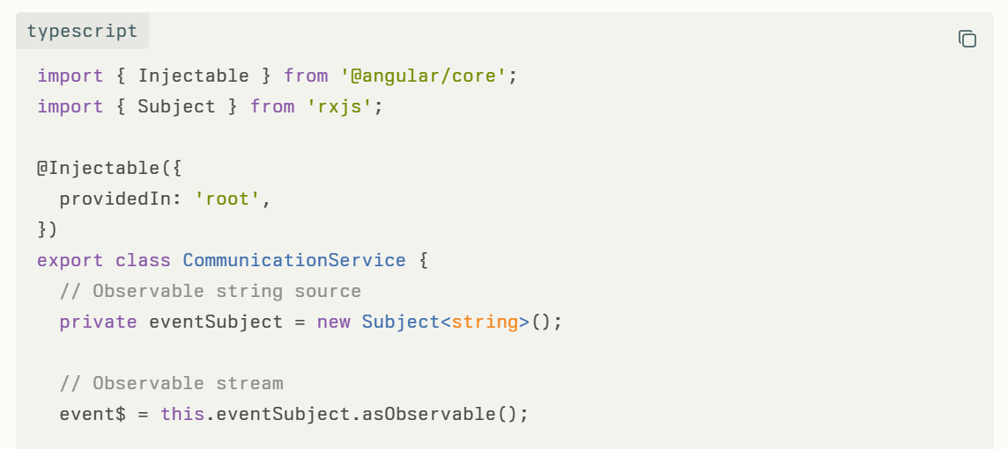
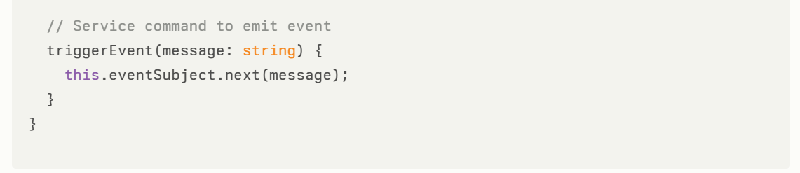
2. Emit Event from ComponentA
In ComponentA, inject the service and call triggerEvent() to send an event:
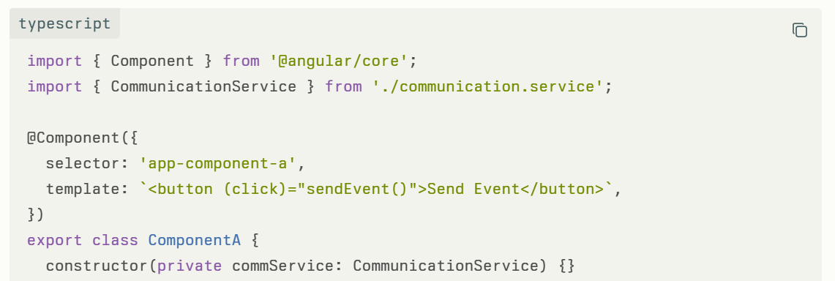
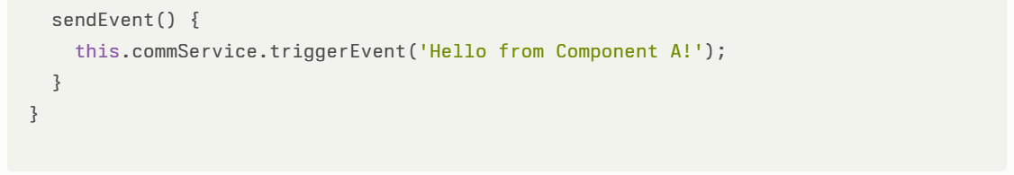
3. Subscribe to Events in ComponentB
In ComponentB, inject the service and subscribe to event$ in ngOnInit to listen for events:
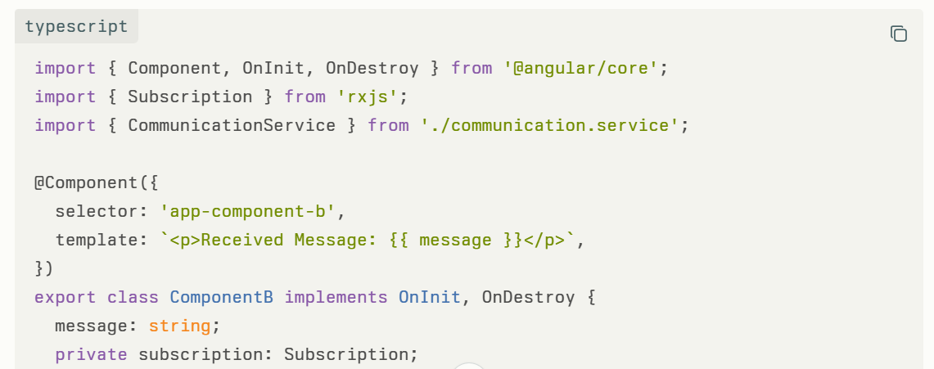
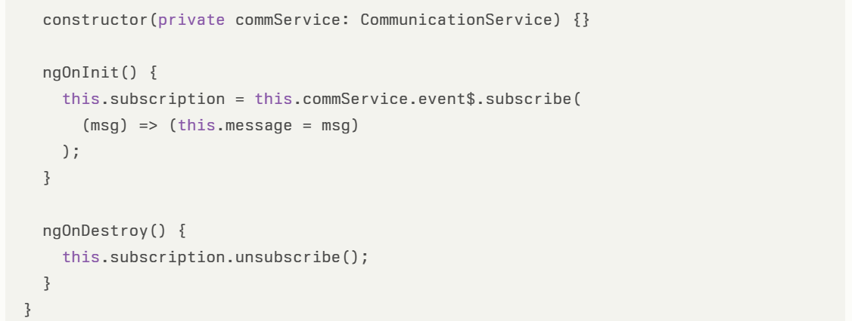
How it Works
- When the user clicks the button in ComponentA, it calls triggerEvent() on the service with a message.
- The service emits this message through the Subject.
- ComponentB, which subscribes to the service's observable, receives the message and updates its display.
- This communication happens independently of any hierarchical component relation.

Benefits of this Approach
- Decouples components more cleanly than requiring a direct relation.
- Supports multiple components subscribing to the same event stream.
- Encapsulates communication logic within a service.
- Works well for global events or loosely related components.

Summary
By using a shared service with RxJS Subjects or Observables, Angular developers can trigger events or share data between components that have no direct relationship. This approach makes application architecture more modular, maintainable, and scalable.

Give example code for ng-container.
Give example code for ng-template
Give example code for each Lifecycle hooks
In which Angular lifecycle the unhandled exception will be handled? Give example code.
Give example code for Route guards
Give example code for Lazy loading
Give example code for Async API calls
Give example code for Observable
Give example code for Subject
Give example code for BehaviorSubject
Give example code for Merge and mergeMap
Give example code for Combine two API calls results
Give example code for How to call httpGet, httpPost, httpPut and httpDelete API endpoints with proper headers (like bearer token) and handle responses?
Give example code for localStorage
Give example code for sessionStorage
Give example code for How to filter a collection of data by a given input?

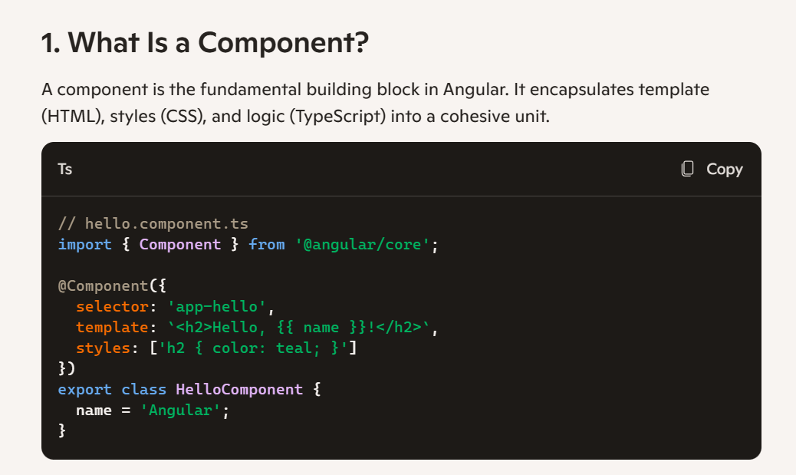
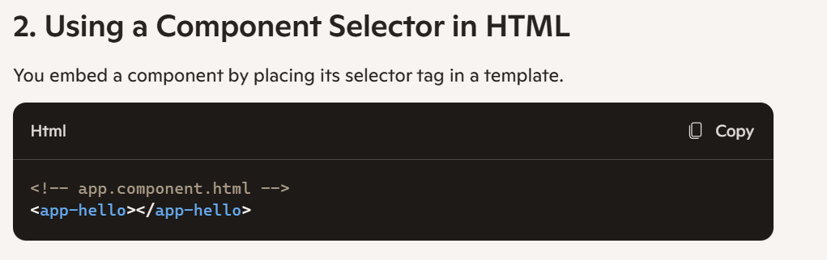
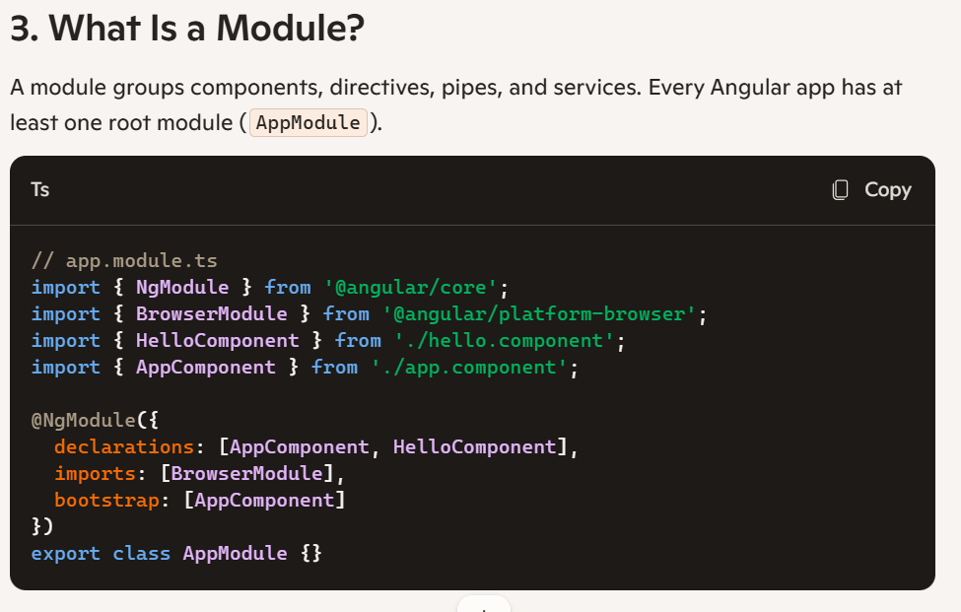
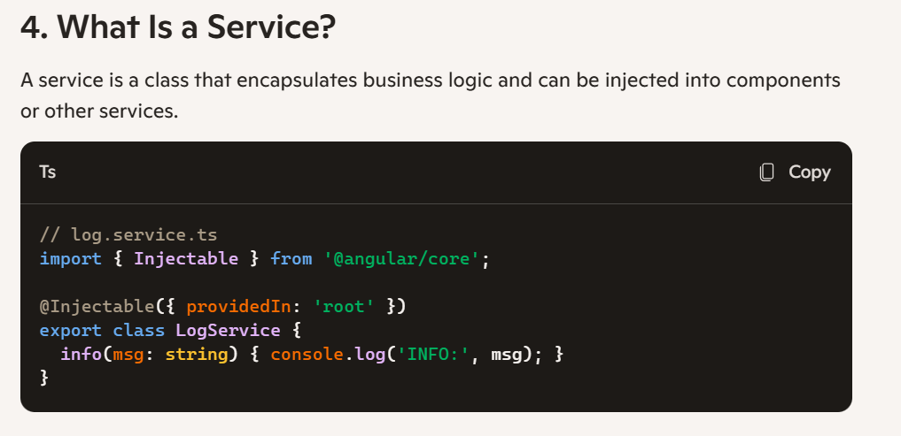

- How this code will work?
console.log('Start');
setTimeout(() => { console.log('Timeout'); }, 0);
Promise.resolve().then(() => { console.log('Promise'); });
console.log('End');

