Azure
System Architecture Description
Frontend: Angular SPA
Backend: .NET Core Web API
Authentication/Authorization: Azure Active Directory
Database: Azure SQL Database
Monitoring/Logging: Azure Application Insights
Architecture Flow Description
- User accesses the Angular SPA:
  - The Angular app initiates authentication against Azure Active Directory (using MSAL library).
  - Upon successful login, Azure AD issues a token to the Angular app.
- API calls from Angular SPA:
  - The Angular app sends HTTP requests to the .NET Core Web API.
  - The token acquired from Azure AD is included in the Authorization header.
- Backend API (.NET Core):
  - The Web API validates the JWT token using Azure AD authentication middleware.
  - The API interacts with Azure SQL Database for data operations.
  - Logging and telemetry events are sent to Azure Application Insights.
- Security:
  - Authentication and authorization are handled by Azure AD.
  - Only users with proper roles/claims can access protected endpoints.
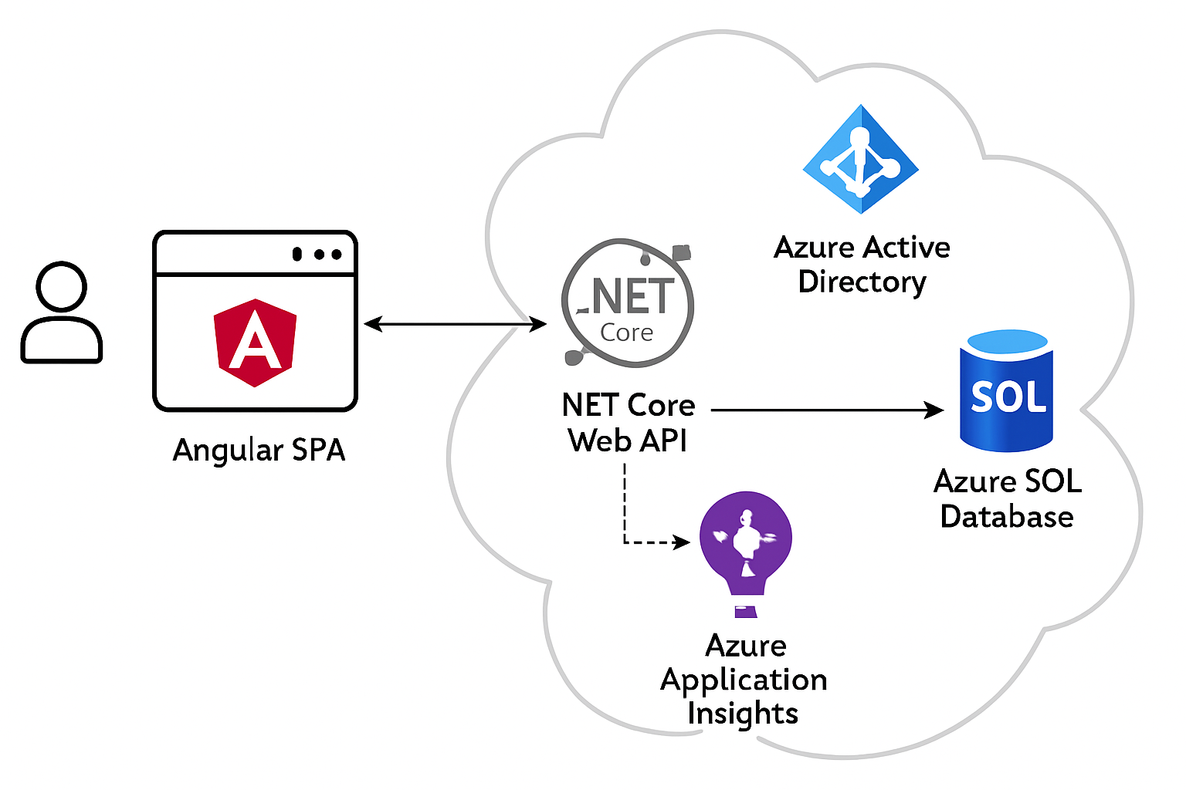
To implement authentication and authorization for a .NET Core Web API using Azure Active Directory (Azure AD), with an Angular SPA frontend, you'll follow these main steps:
1. Register applications in Azure AD
- Register your backend API (expose scopes, configure app roles).
- Register your SPA frontend (set redirect URIs, configure permissions to the API).
2. Backend (.NET Core API) Setup
- Add authentication middleware to validate JWT tokens issued by Azure AD.
- Specify application roles for authorization in your API.
3. Frontend (Angular) Setup
- Use libraries like @azure/msal-angular to handle user login, token acquisition, and API calls with correct Authorization headers.

Sample Workflow & Code Examples
Step 1: Register applications in Azure AD
- In the Azure Portal, register your API:
  - Expose an API (add scopes, e.g., api://{clientId}/access_as_user).
  - Add App Roles (e.g., ReadOnly, ReadWrite) in the Manifest.
- Register SPA:
  - Add API permissions; configure redirect URIs (e.g., http://localhost:4200).
Step 2: Configure .NET Core Web API for Azure AD Authentication
appsettings.json (API):
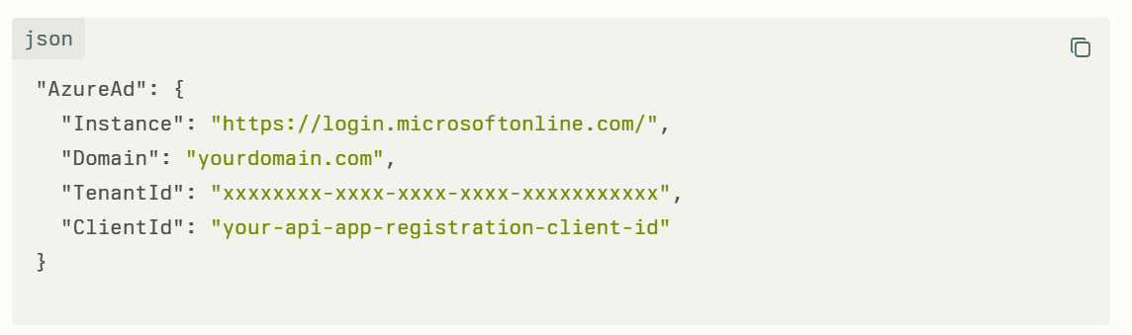
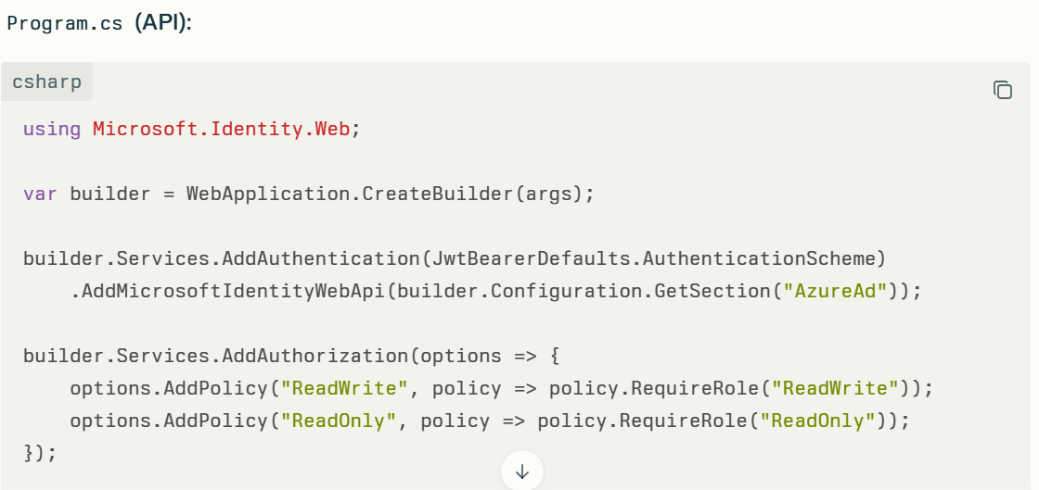
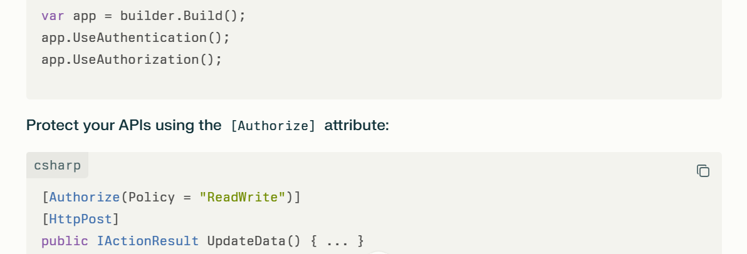
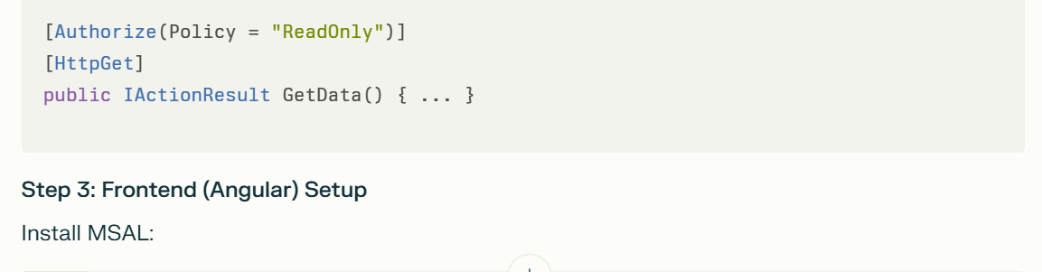
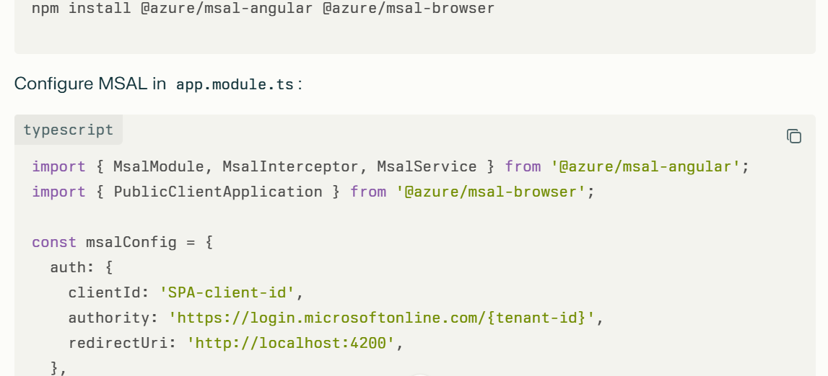
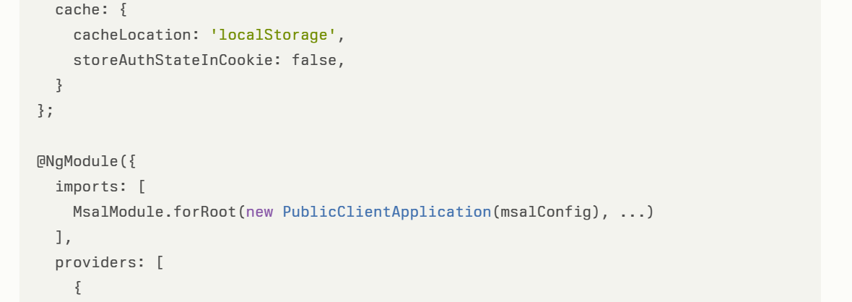
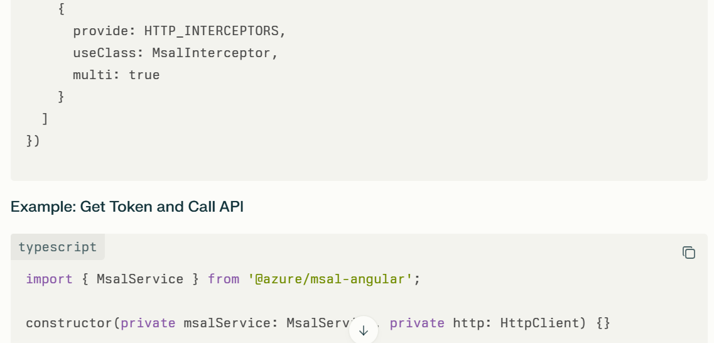
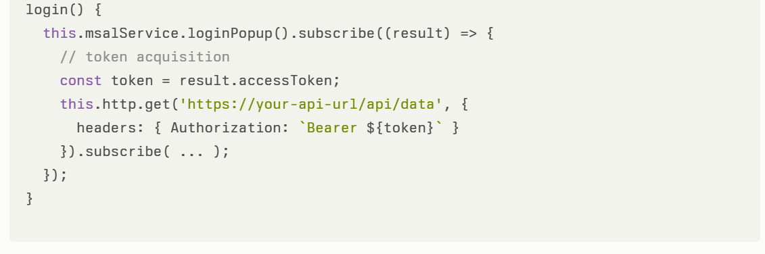
Workflow Diagram Steps
- User accesses Angular SPA.
- SPA redirects user to Azure AD for login.
- User authenticates (Azure AD).
- Azure AD issues an access token (JWT).
- SPA stores the token and attaches it to API requests via Authorization: Bearer <token>.
- .NET Core API validates token; extracts roles from claims.
- API enforces authorization policies via [Authorize] based on roles/scopes.
API executes endpoint logic if authorized, else returns 403 Forbidden.

Question:
Given the following architecture components:
- Frontend: Angular SPA
- Backend: .NET Core Web API
- Authentication/Authorization: Azure Active Directory
- Database: Azure SQL Database
- Monitoring/Logging: Azure Application Insights
How do you deploy the frontend and backend applications in the Azure cloud?
- What deployment strategies can be followed?
- Should we use Azure DevOps or Azure Kubernetes Service (AKS) for deployment?
- How do you enable authentication and authorization between the frontend and backend applications using the Azure Portal?

Best Approach: Deploy Angular SPA and .NET Core Web API on Azure App Service with Azure DevOps CI/CD

Step 1: Prepare your applications
- Angular SPA: Build a production-ready build using ng build --prod (or ng build for Angular 12+).
- .NET Core Web API: Make sure your API project is ready to deploy, and connection strings point to your Azure SQL Database.

Step 2: Create Azure Resources
- Create two Azure App Services:
  - One for Angular SPA (frontend)
  - One for .NET Core Web API (backend)
- Create Azure SQL Database as the backend data store.
- Enable Azure Application Insights on backend App Service for monitoring and logging.

Step 3: Set Up Azure DevOps for CI/CD Pipelines
- Set up a pipeline for Angular frontend:
  - Build Angular app (ng build).
  - Publish the build output to the frontend Azure App Service.
- Set up a pipeline for .NET Core Web API backend:
  - Restore NuGet packages.
  - Build and test the API.
  - Publish API artifacts.
  - Deploy to backend Azure App Service.
- Alternatively, combine both pipelines but keep build steps separate.

Step 4: Configure Azure Active Directory Authentication
- Register both frontend and backend apps in Azure AD portal.
- For Frontend SPA:
  - Configure app as Single Page Application.
  - Set Redirect URIs.
  - Enable Auth flows (e.g., PKCE).
- For Backend API:
  - Expose API scopes.
  - Configure backend to accept tokens from the frontend.
- Use libraries like MSAL.js in Angular to authenticate and acquire tokens.
- Configure the backend API middleware to validate JWT access tokens.

Step 5: Enable App Service Authentication in Azure Portal
- Enable App Service Authentication/Authorization on backend Azure App Service.
- Set Azure Active Directory as Identity Provider.
- Set proper permissions and scopes to restrict access.
- Configure CORS policy on backend API App Service to allow the frontend domain.

Step 6: Deploy and Test
- Push code changes to your repository.
- Trigger Azure DevOps pipelines.
- Validate deployments on Azure App Services.
- Test login, API authentication, and data flows.

In ASP.Net MVC Core App developed in .NET 8 with Azure SQL DB as back end running in Azure Clod. Using my windows credentials, how to achieve this authentication & authorization with Azure Active Directory integrations, Role-Based Access Control (RBAC). Give detail example with code.
To achieve authentication and authorization in your ASP.NET Core MVC app (.NET 8) running in Azure with Azure SQL DB backend using your Windows credentials, integrating Azure Active Directory (Azure AD) for authentication combined with Role-Based Access Control (RBAC), you need to:
- Authenticate users via Azure AD (using Microsoft Entra ID), enabling Windows (Azure AD) credentials login.
- Authorize users via Azure AD roles (app roles or groups) mapped to RBAC policies in your app.
- Use OpenID Connect middleware for authentication in your app.
- Protect controllers/actions using roles or policies configured from Azure AD.
- Optionally, leverage Azure SQL DB with Azure AD authentication to secure DB access.
Detailed Example with Code
Step 1: Register your ASP.NET Core app in Azure AD
- Go to Azure Portal → Azure Active Directory → App registrations → New registration
- Register your app:
  - Name: e.g. "MyAspNetCoreApp"
  - Supported account types: Single tenant (or multitenant if needed)
  - Redirect URI: https://localhost:5001/signin-oidc (or your deployed URL)
- After registration, note Application (client) ID and Directory (tenant) ID.
- Under Authentication, enable ID tokens.
- Optionally, define app roles under App Roles for RBAC (e.g., Admin, User).
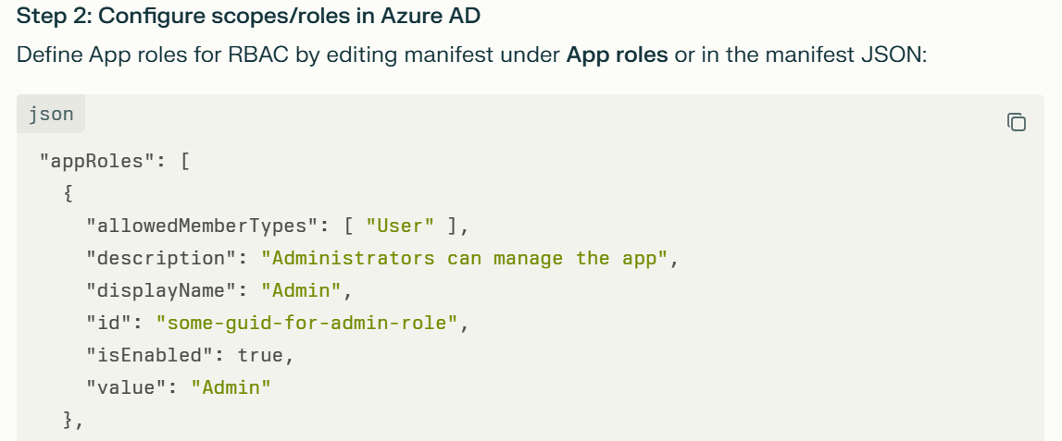
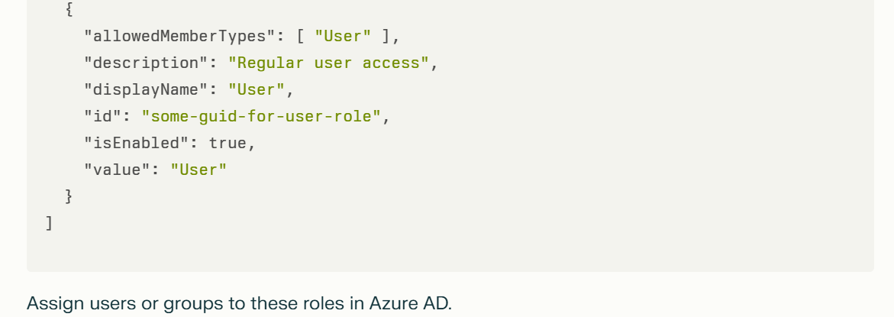

Step 3: Configure your .NET 8 ASP.NET Core MVC app for Azure AD authentication & authorization
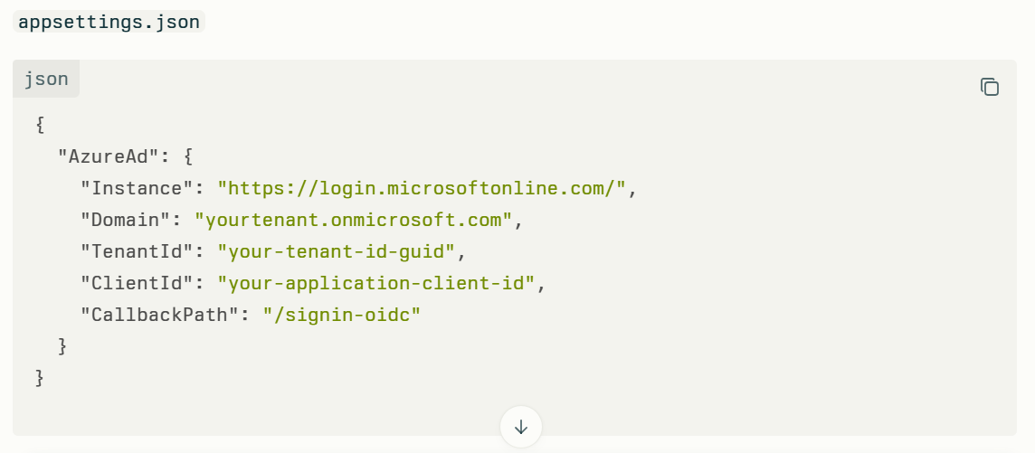
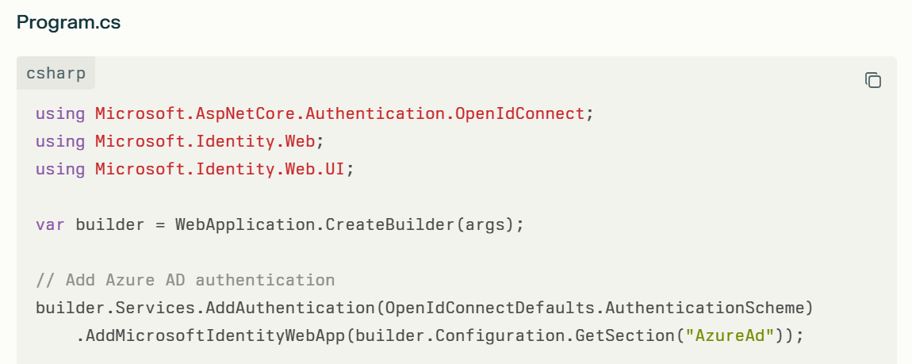
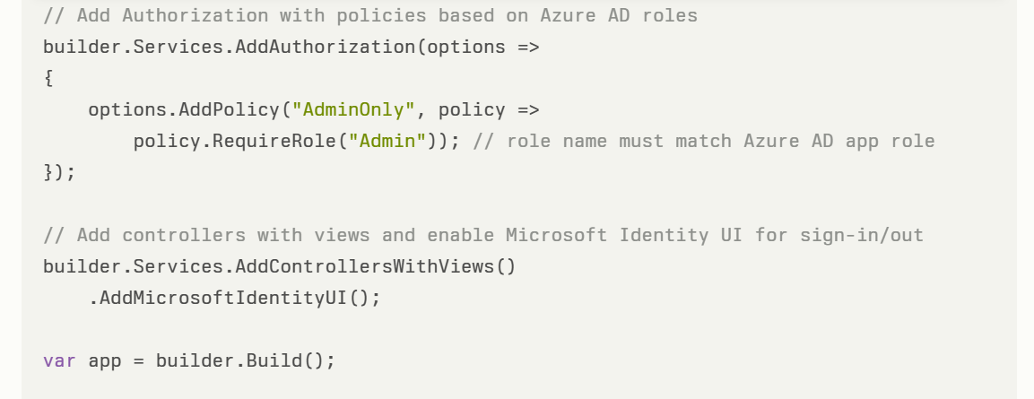
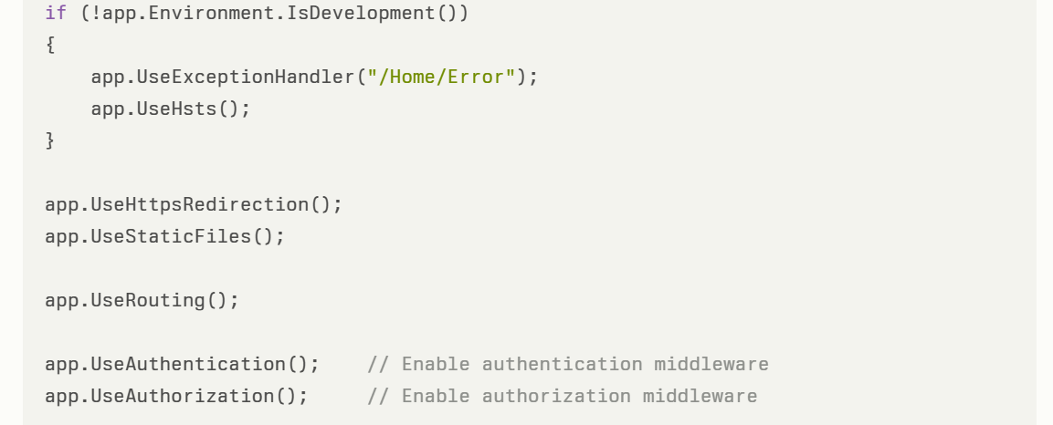
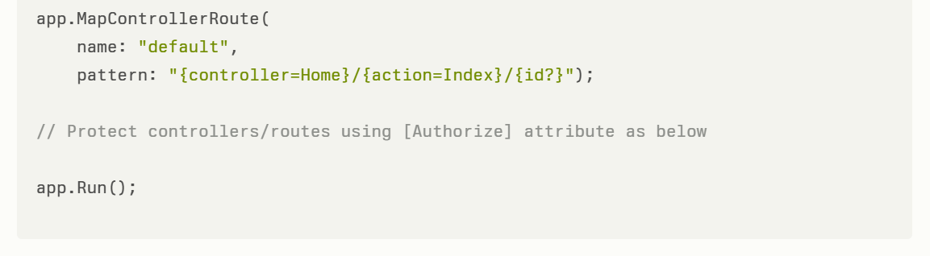
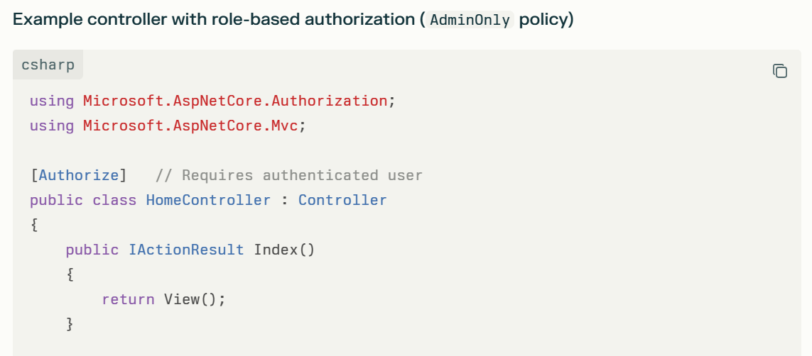
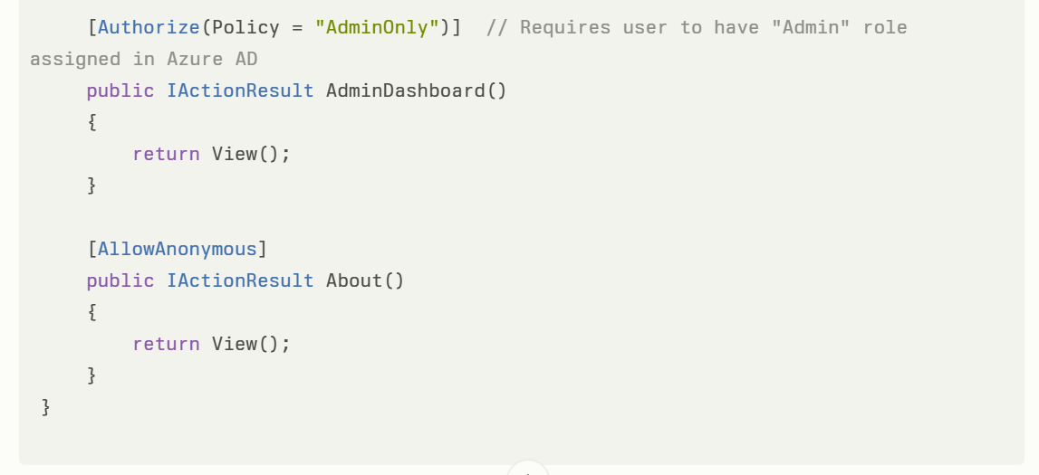
Step 4 (Optional): Configure Azure SQL DB with Azure AD Authentication
- In your Azure SQL DB, enable Azure AD authentication.
- Create contained database users for Azure AD identities or groups.
- Assign roles/permissions in SQL for these Azure AD users.
- In your connection string in appsettings.json, use Active Directory Integrated or Active Directory Password authentication mode for Azure AD auth.
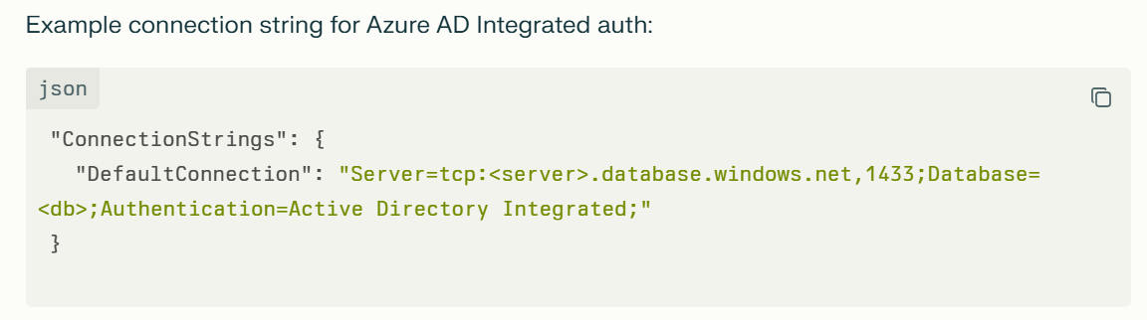Or with token-based authentication using Azure Identity SDK in advanced setups.
Summary
Step | Description | Key Code/Actions
1 | Register app in Azure AD | Azure Portal → App registrations
2 | Define roles in app manifest | Add appRoles array with Admin, User etc.
3 | Configure OpenID Connect middleware in .NET 8 app | AddMicrosoftIdentityWebApp(...) + app.UseAuthentication()
4 | Protect controllers with [Authorize(Policy = "AdminOnly")] | Use roles from Azure AD for RBAC
5 | Optional Azure SQL DB Azure AD auth | Use Azure AD user logins and configure DB permissions

Connecting Azure SQL Database from Azure App Service using Azure AD Authentication
1. Enable Managed Identity for the App Service
- In the Azure portal, go to your App Service.
- Under Settings, select Identity.
- Enable System assigned managed identity (set Status to On).
- Save the changes. This action creates an identity representing your app.
2. Create a User in Azure SQL Database for the Managed Identity
- Open the Azure SQL Database in the Azure portal.
- Go to Query editor (preview) and sign in with admin rights.
- Run the following T-SQL commands to create a user for the App Service managed identity and assign roles:
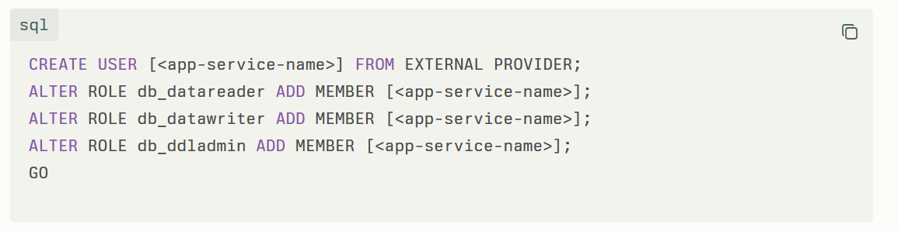
3. Configure the Connection String in App Service
- In the Azure portal, navigate to the App Service Configuration -> Connection strings section.
- Add a connection string named, for example, AZURE_SQL_CONNECTIONSTRING, with the following format:
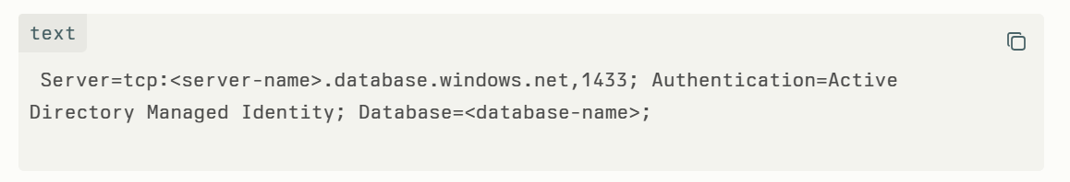
- Ensure your app code uses this connection string to connect to the database.
4. Update Application Code to Use Azure AD Authentication
- Use a supported data provider that integrates with Azure AD managed identity, such as Microsoft.Data.SqlClient.
- When running in Azure, the provider automatically authenticates using the App Service's managed identity.
- Sample connection string usage in .NET:
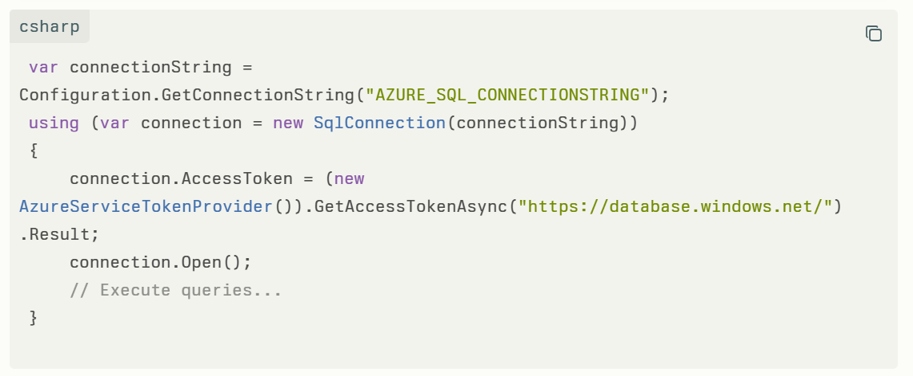
5. (Optional) Use Azure CLI to Automate Setup
You can use the Service Connector command to automate enabling managed identity and granting SQL access:
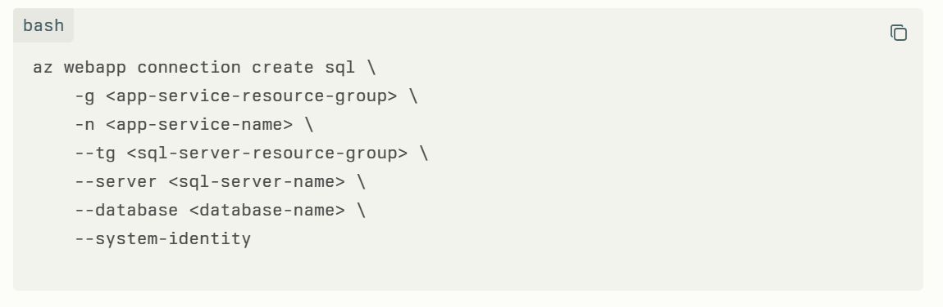
Important Notes
- This approach avoids storing secrets like passwords in configuration.
- Follow the principle of least privilege when assigning roles.
- For production, consider using separate managed identities for different access levels.

This method uses Azure AD managed identities to securely authenticate your web app with Azure SQL Database without needing passwords or secrets, simplifying secure access in cloud environments.
A web app is running in Azure App Service, and the backend database is located on-premises (outside of Azure). Which Azure service can be used to connect the backend database from the web app?

Blob storage is being accessed by unauthorized persons. How can we effectively restrict such unauthorized access?
How to Effectively Restrict Unauthorized Access to Azure Blob Storage
- Disable Public Access
Turn off anonymous public access to blob containers and storage accounts to prevent unauthorized read or write access.
- Use Azure RBAC for Authorization
Grant access using Azure role-based access control (RBAC) via Azure Active Directory rather than shared keys or SAS tokens. Assign minimum required permissions.
- Enforce Secure Transfer (HTTPS)
Require all connections to use HTTPS by enabling the "secure transfer required" setting to protect data in transit.
- Implement Network Restrictions
Use virtual network service endpoints or private endpoints to restrict access to trusted Azure networks or on-premises networks only. Enable storage firewall rules.
- Avoid Using Storage Account Keys Directly
Minimize use of storage account access keys. If necessary, store them securely in Azure Key Vault and rotate regularly.
- Use Shared Access Signatures (SAS) with Care
Prefer short-lived SAS tokens with limited permissions and use stored access policies for better control.
- Enable Advanced Threat Protection
Activate Microsoft Defender for Storage to get alerts on anomalous and potentially harmful activity.
- Enable Soft Delete and Immutable Blob Storage
Protect against accidental or malicious data deletion by enabling soft delete and legal hold policies.
- Use Customer-Managed Encryption Keys
For greater control over data protection, use your own encryption keys stored in Azure Key Vault.

Applying these recommendations will significantly reduce the attack surface and help prevent unauthorized access to your Blob Storage data while maintaining secure and manageable access controls.

I need to deploy a web app using CI/CD pipelines, and the code repository is hosted on GitHub. What are the main pieces of information I need to provide to the DevOps team to enable the CI/CD setup?
To enable the DevOps team to set up CI/CD pipelines for deploying your web app from a GitHub repo, you need to provide the following main information:

Main Information to Provide for CI/CD Setup (GitHub Repo → Web App Deployment)
- Repository Details
  - GitHub repository URL
  - Branch(es) to build and deploy (e.g., main, develop)
- Access Permissions
  - Access credentials or permissions for the DevOps team to the GitHub repo (SSH key, personal access token, or GitHub organization/team access)
  - Any required secrets or tokens stored securely (e.g., for deployment or external services)
- Build Instructions
  - Build commands or scripts (e.g., npm install, dotnet build, mvn package)
  - Required build environment or dependencies (runtime versions, tools)
- Test Commands (if any)
  - How to run automated tests during the pipeline (unit tests, integration tests)
- Deployment Details
  - Target Azure environment (subscription, resource group, web app name)
  - Deployment method preferences (e.g., Azure App Service deployment, containers, slots)
  - Connection or authentication information for deployment (service principal, managed identity, publish profiles)
- Configuration Settings
  - Environment-specific variables (e.g., connection strings, app settings)
  - Secrets to be used within the pipeline (e.g., database passwords, API keys)
- Pipeline Triggers
  - Events that trigger the pipeline (push to branch, pull requests, schedule)
- Additional Steps or Policies
  - Any required approval workflows, code quality or security scans
  - Rollback or versioning strategies if applicable

Providing this detailed information upfront helps the DevOps team create an efficient, secure, and automated CI/CD pipeline tailored to your web app deployment from GitHub.

If you don't have access to the Azure portal but need to create an Azure service, here are the main options available to accomplish this:
Options to Create Azure Services without Azure Portal Access
- Azure CLI (Command-Line Interface)
  - Use Azure CLI commands to create and manage Azure resources from your local machine or Cloud Shell.
  - Example: az webapp create ..., az vm create ...
- Azure PowerShell
  - Use Azure PowerShell cmdlets to automate creation and management of Azure services.
  - Supports scripting and automation from any PowerShell environment.
- ARM Templates (Azure Resource Manager)
  - Define infrastructure as code using JSON or Bicep templates.
  - Deploy templates via CLI, PowerShell, or REST API to create services declaratively.
- Azure REST API
  - Create and manage Azure resources programmatically by sending HTTP requests to Azure REST endpoints.
  - Useful for custom applications or integrations.
- Azure SDKs
  - Use Azure SDKs available for languages like .NET, Python, Java, JavaScript, Go, etc., to programmatically create and manage services.
- Infrastructure as Code (IaC) Tools
  - Tools like Terraform, Ansible, Pulumi can provision Azure resources using code and integrate with Azure APIs.

By leveraging these options, you can create and manage Azure services without direct access to the Azure portal UI.

Azure Functions
How to test an Azure Blob Trigger Function locally using Visual Studio 2022?
I have created an Azure Function with a Blob Trigger in Visual Studio 2022.
For example, my function looks something like this:
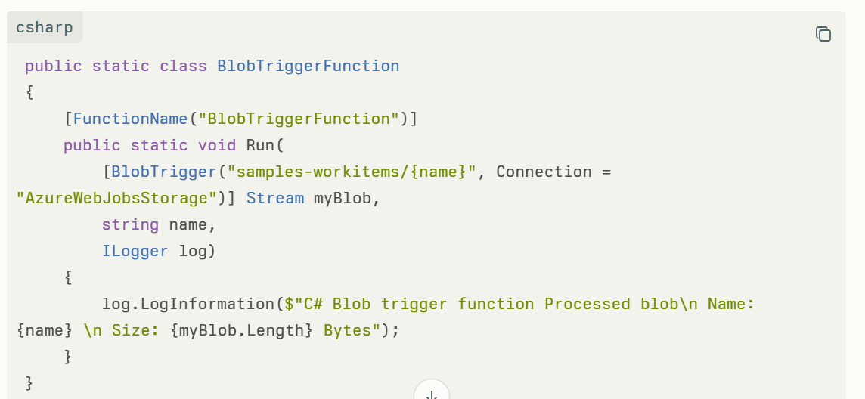
I want to be able to test this locally from my source code in Visual Studio 2022 before deploying it to Azure.
So far, I understand:
- I need to run the function locally with the Functions runtime.
- The local.settings.json file must contain the correct AzureWebJobsStorage connection string.
What I’m not sure about is:
- How do I simulate or upload blobs so that the trigger event is fired during local debugging?
- Do I need a real Azure Storage account, or can I use the Azurite storage emulator?
- How do I configure Visual Studio 2022 so that I can step through the function during local testing?
Goal:
I want to run and debug this Blob Trigger Function locally in Visual Studio 2022, validate that it processes uploaded blobs correctly, and later deploy it to Azure.
Answer:
You can test an Azure Blob Trigger Function locally in Visual Studio 2022 using either the Azurite storage emulator (recommended for local dev) or a real Azure Storage account. Here’s the typical setup:

1. Install Azurite (local storage emulator)
Azurite is the supported emulator for Azure Storage. There are two easy ways to install it:
Using npm:
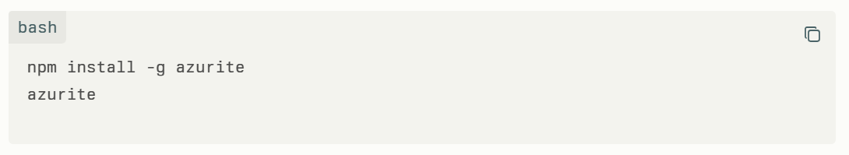
Using Docker:
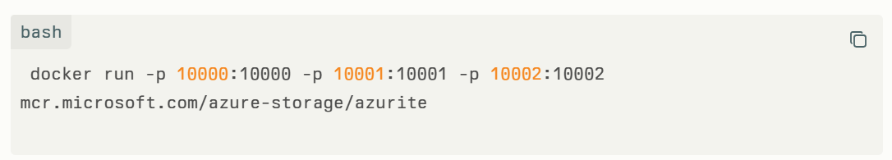
This creates local Blob, Queue, and Table endpoints.
Default connection string for Azurite is:
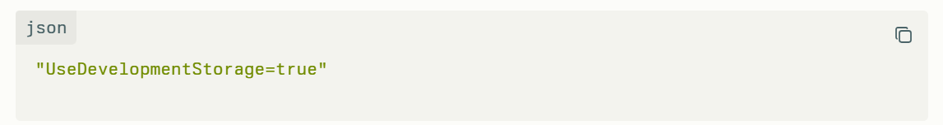
2. Configure local.settings.json
Update your local.settings.json in your Functions project to point AzureWebJobsStorage to Azurite (or real storage if you prefer):
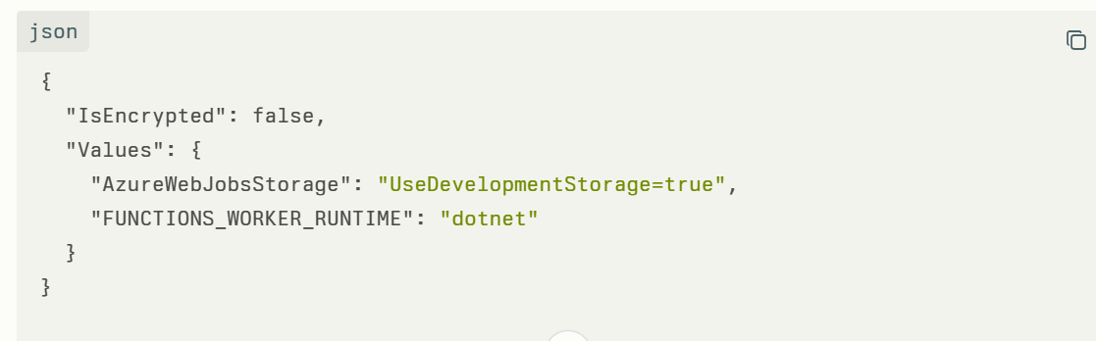
3. Start the Function App locally
Press F5 inside Visual Studio 2022.
You should see the Functions host start up in the debug console. It will listen for blob events from the configured storage account.

4. Upload a blob to trigger the function
- If using Azurite, use Azure Storage Explorer (free tool from Microsoft) or the az CLI to connect to the Azurite endpoint and upload a blob into the watched container (e.g., samples-workitems).
- If using a real Azure Storage account, just upload a blob directly to the container in the account.
Once uploaded, the Blob Trigger should fire, and you can step through your function in Visual Studio debugger.

5. Debug & Verify
When the blob upload happens, you should see log messages in your Visual Studio output window, or hit breakpoints in your function.

✅ Best Practices
- Use Azurite for local development, easy cleanup and isolation.
- Use a real Azure Storage account only when testing integration with other Azure services.
- Always check your host.json and local.settings.json for correct container names and connection strings.

Summary:
You don’t need to deploy to Azure just to test a Blob Trigger Function. With Azurite + Visual Studio 2022, you can run the function locally, upload a blob to your emulator storage, and debug it end-to-end before going live.

What are the ways to access the azure key vault?
There are several ways to access Azure Key Vault, each designed to suit different use cases and security models:
1. Access Models
- Control Plane: Used to manage the Key Vault itself (create, update, delete vaults, manage access policies and RBAC).
- Data Plane: Used to work with the data inside the Key Vault, such as keys, secrets, and certificates (add, delete, modify).
2. Authentication Methods
Applications and users can authenticate to Azure Key Vault through Microsoft Entra ID (formerly Azure Active Directory):
- Application-only: Uses service principals or managed identities (recommended for automated access by services and applications).
- User-only: Access via user accounts through tools like Azure portal, Azure CLI, or Azure PowerShell.
- Application-plus-user (Compound identity): The application acts on behalf of a specific user using the on-behalf-of (OBO) authentication flow.
3. Authorization Methods
- Access Policies: Legacy method where each user/application/group is explicitly granted a set of permissions.
- Azure Role-Based Access Control (RBAC): Modern and recommended approach for managing permissions via predefined or custom roles at various scopes (subscription, resource group, resource).
4. Access Interfaces
- Azure Portal: Manage and access secrets, keys, and certificates via the web UI.
- Azure CLI: Command-line interface for scripting and automation; assign access policies and retrieve secrets/keys.
- Azure PowerShell: PowerShell cmdlets to manage Key Vault and its contents, including setting access policies.
- REST API: Supports direct programmatic access for automation and integration scenarios.
- SDKs: Programming libraries for various languages (C#, Python, Java, etc.) that allow access to Key Vault from applications.
- Managed Identity (recommended): Provides secure, password-less authentication for Azure resources without storing credentials in code.
5. Security Controls
- Network restrictions: Restrict access to Key Vault from specific IP addresses or virtual networks for added security.
- Azure Groups: Assign permissions to groups to ease management of multiple users.
- Conditional Access: Apply advanced access policies for enhanced security.
Note: For highest security and granularity, Microsoft recommends using Azure RBAC over access policies when managing Key Vault access permissions.
You can access Azure Key Vault through the portal, CLI, PowerShell, REST API, SDKs, and by configuring managed identities for applications—using RBAC or access policies to control what each identity is permitted to do within the Key Vault.

An ASP.NET Web Application is currently running on-premises. The goal is to migrate this application to Microsoft Azure.
a. What is the best approach for migration with minimum changes?
b. What changes will need to be made when deploying the app to Azure?
Here’s a structured answer to your ASP.NET Web App migration questions:

a. Best Approach for Migration with Minimum Changes
Rehosting ("Lift-and-Shift") to Azure App Service is the best approach when you want to minimize code changes and get your application running in the cloud quickly.
- Azure App Service is designed to run web apps with minimal changes. Your ASP.NET web app (especially if targeting .NET Framework 4.x or .NET Core) can be published directly to Azure App Service.
- You can use tools like the App Service Migration Assistant to assess app readiness and automate much of the migration process—this scans your app and highlights dependencies or potential issues before you migrate.
- If the app relies heavily on IIS, you may also choose to run it in Azure Virtual Machines (IaaS) for maximum compatibility, though this requires more ongoing management.
- Use Azure Migrate to discover, assess, and orchestrate migrations (especially for at-scale or bulk migrations).
- For applications with complex dependency or tightly-coupled SQL Server databases, using Azure SQL Managed Instance or migrating your database through the Azure Database Migration Service is recommended.

b. Required Changes When Deploying to Azure
You may need to make adjustments in the following areas:
- Configuration Management
  - Externalize configuration files using Azure App Service Application Settings or Azure Key Vault instead of relying on local config files.
  - Consider connection strings (e.g. for databases) and update them to reference Azure SQL or other managed data services.
- Authentication/Authorization
  - Integrate with Azure Active Directory for modern authentication.
  - Update any access controls to use Role-Based Access Control (RBAC) for resources.
- File Storage
  - Move local or server file storage to Azure Blob Storage or similar cloud service.
  - Refactor any code that writes/reads to the file system if the app will run in App Service (as it does not offer persistent local storage).
- Dependencies
  - Review third-party code and libraries — ensure compatibility with Azure App Service environment.
  - Configure or migrate any background jobs or Windows services separately, possibly using Azure Functions or WebJobs.
- Networking and Security
  - Update firewall and network rules as needed.
  - If you use custom DNS or SSL/TLS, configure these in the Azure App Service.
- Monitor and Optimize
  - Set up monitoring with Azure Application Insights.
  - Review performance/scaling settings and enable autoscaling rules.
Summary Table: Migration Approaches
Approach | Minimum Changes | Key Steps | Use cases | Tools
Lift-and-Shift | Yes | Publish to App Service | Most legacy/.NET web apps | Azure Migrate, Migration Assistant
Refactor/Modernize | No (More changes) | Update to microservices, .NET Core | High performance/scalability needs | AKS, App Service, Azure Functions
Rebuild | No (Most changes) | Rewrite for cloud-native | Large technical debt/rewrite required | Azure DevOps

In summary:
For most ASP.NET apps, use Azure App Service with the Migration Assistant for a "lift-and-shift" cloud migration, update configurations and dependencies as required, and leverage Azure’s monitoring, identity, and security features for best results—without extensive code changes

An Azure Function is running on an App Service Plan, while another Azure Function is running on a Consumption Plan.
Which of these can be considered Azure serverless functions?
Only the Azure Function running on the Consumption Plan is considered an Azure serverless function.
- The Consumption Plan provides true serverless behavior, meaning resources are automatically allocated and scaled by Azure based on trigger events, and you only pay for actual execution time—there is no need to manage servers or pre-allocate capacity.
- The App Service Plan, on the other hand, requires you to provision and pay for a fixed set of compute resources regardless of usage, so it does not offer the "serverless" pay-per-execution and automatic scaling model.
In summary:
Azure Functions running in the Consumption Plan are serverless functions, while those running in the App Service Plan are not.

