C# - Design Patterns
What is design pattern and the purpose of this?
A design-pattern in software is a general, reusable solution to a commonly occurring in software design. Rather than being a finished piece of code, a design-pattern serves as a template or blueprint can be adopted to solve specific problems in various situations.
Types of design patterns in C#
C# design patterns are grouped into Creational, Structural, and Behavioural categories, each providing solutions for different types of software design challenges
Creational Design Pattern
What is Creational design pattern in C#?
It focuses how to create objects creation and initialization in a system. Instead of creating/instantiating the objects directly in the client code (using constructors) creation design patterns abstracts the process of object creation, making the system more flexible, decoupled, and easier to maintain.

Singleton pattern example in C#
The Singleton pattern is useful in scenarios where you need to ensure a single, globally accessible instance of a class that manages shared resources or services. Common real-world scenarios for using the Singleton pattern, especially in C# and modern .NET applications, include:
- Database Connection Management: Creating and managing database connections as a Singleton can optimize resource usage and improve application performance since connections can be reused rather than created repeatedly.
- Logging: Since file and I/O operations for logging are costly, having a Singleton logger ensures that all parts of the application write logs through the same instance, improving efficiency and coordinating access.
- Caching: Managing in-memory caches using a Singleton helps avoid repeated database calls by caching master or configuration data, improving response times and reducing load on external systems.
In summary, the Singleton pattern is often needed when there is a requirement for:
- A single point of control for critical shared resources or services.
- Global, thread-safe access to a shared instance.
- Efficient resource utilization by avoiding redundant object creations.
- Coordinated state or configuration management across an application.

How Singleton Works
- Single Instance: Only one object of the class can ever exist.
- Global Access: The instance is accessible globally in the application.
- Controlled Instantiation: The constructor is private, preventing external instantiation.
Sample Code
Singleton Class
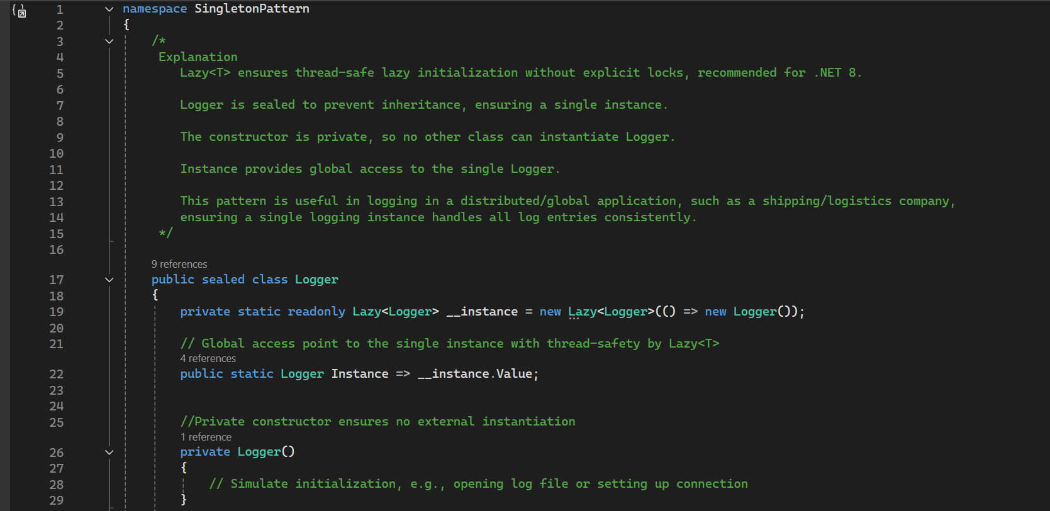
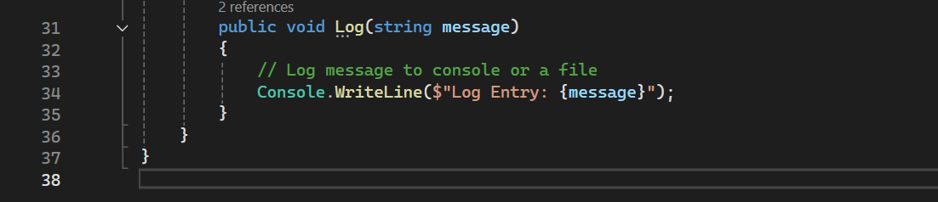

Program.cs
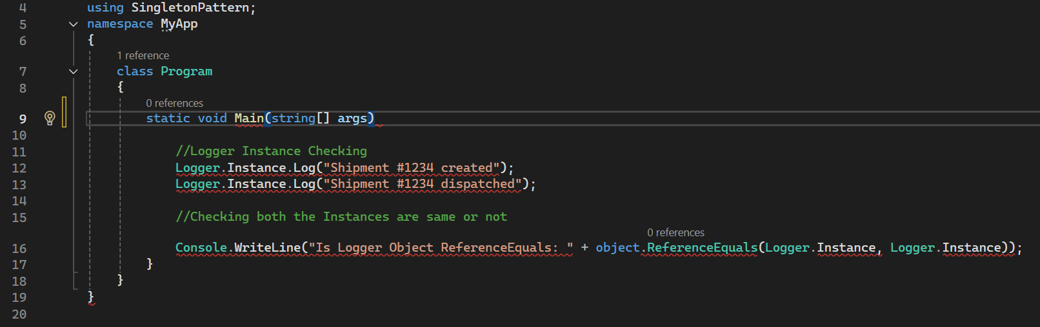

Factory pattern
It provides a way to create the objects without providing the exact class of the object that will be created. Instead, a factory class or method handles the instantiation of the object based on the input which is implemented a common interface or inherit from a common class. This promotes loose coupling and makes it easy to introduce new types without changing the existing client code.
How the Factory Pattern Works
- Define a common interface or abstract class for the product.
- Implement concrete classes for each product type.
- Create a factory class with a method that takes input (such as a string or enum) and returns the appropriate product instance.
Explanation URL - https://youtu.be/UAMuzJNucEE?si=SbEobnAWpMZD79PK

Q5 - Abstract factory Pattern
Explanation URL - https://youtu.be/HywWrQHZ5-g?si=NSoDy763XPGqIpqE

Structural Design Pattern
Structural Design Patterns are a category of design patterns in software engineering that focus on how classes and objects are composed to form larger, more complex structures. These patterns facilitate the design by identifying simple ways to realize relationships among entities, making code more flexible, reusable, and easier to maintain.
Key Characteristics of Structural Design Patterns:
- Simplify the relationships between objects or classes.
- Help manage complex class hierarchies.
- Enable composition of objects to add new functionality or hide complexity.
- Often improve code maintainability and scalability.

Adapter Pattern
This allows objects with incompatible interfaces work together by acting as a bridge between then. In .NET Core, it is commonly used when integrating third party libraries or legacy systems with your own codebase.
Real-World Example: HR System Integrating with Third-Party Billing System
Scenario:
- An existing HR system stores employee data as a string array.
- A third-party billing system requires a List<Employee> to process salaries.
- The two systems are incompatible due to different data structures.
- The Adapter pattern is used to convert the HR system's data format to what the billing system expects, allowing seamless integration.

Façade pattern
It provides a simplified interface to a set of complex sub systems. It hides a complexity of the system by exposing a single-entry point, making the system easier to use and maintain.
Real-World Example: Global Shipping and Logistics Company Process
Scenario:
A global shipping and logistics company typically involves multiple complex subsystems, for example:
- Inventory Management (tracking packages and materials)
- Payment Processing (billing customers, handling refunds)
- Shipping Management (scheduling shipments, tracking deliveries)
- Customer Notifications (sending status updates)
- Customs and Compliance (regulatory document handling)
Using the Facade pattern, a single class can provide a simplified interface to clients who need to perform shipping-related actions without having to interact with each subsystem individually.

Behavioural Design Pattern
Observer pattern
It allows an object (the subject) to notify multiple dependents (the observers) about the changes in its state, without needing to know who those observers are. This is useful in scenarios where one-to- many dependency exists between objects.
Real-World Example in C#.NET Core: Job Portal System
A Job Portal System is a great real-world example of the Observer pattern. When a company posts a new job listing, all registered job seekers who have expressed interest in such job types/categories should get a notification.

