.NET CORE
What is .NET Core?
.NET Core is a free, open-source, cross-platform, and modular framework developed by Microsoft for building modern, high-performance applications such as web apps, APIs, and microservices. It supports running applications on multiple operating systems including Windows, macOS, and Linux. Designed to be lightweight and flexible, .NET Core allows developers to use only the necessary components, resulting in faster startup times and better performance compared to the older .NET Framework. It includes features such as a modular HTTP request pipeline, built-in dependency injection, high-performance web server (Kestrel), and supports modern development patterns like microservices and cloud-native architectures. Additionally, it unifies previous ASP.NET frameworks and supports building real-time communication apps, API versioning, and flexible configuration across environments.
What is the major purpose using .net core vs .net framework?
The major purpose of using .NET Core vs .NET Framework centers around cross-platform development, performance, and modernization versus stability and Windows-centric legacy support.
.NET Core:
- Cross-Platform: It is designed to build applications that run on Windows, Linux, and macOS, making it ideal for companies targeting multiple operating systems.
- Modern Development: Suitable for creating modern, cloud-based, and microservices applications, especially when using containers like Docker.
- Performance and Scalability: Offers better performance and resource efficiency due to its lightweight and modular design. Updates are more frequent, and it embraces the latest technologies.
- Open Source & Flexibility: Completely open source with a flexible deployment model; you can update or deploy new versions independently for each app.
- Development Tools: Emphasizes lightweight editors and command-line tools, providing more flexibility for developers.
.NET Framework:
- Windows-Only: Best suited for applications that only run on Windows. It’s a mature platform, widely used for large, existing corporate and desktop (Windows Forms/WPF) applications.
- Legacy Support: Essential for maintaining or upgrading older enterprise software or any systems that rely on Windows-specific features or libraries not available in .NET Core.
- Full Feature Set: Includes certain features (like Windows Forms, WPF, and advanced Windows integration) that are not fully supported or available in .NET Core.
- Stability: Offers a stable environment, especially for robust desktop and server-based applications that do not need cross-platform capabilities.
When to Use Each:
- Choose .NET Core if:
  - You need your application to run on multiple platforms (Windows, Linux, macOS).
  - You are building new applications that require the latest performance, scalability, or cloud integration.
  - You are targeting microservices architecture or cloud-native solutions.
- Choose .NET Framework if:
  - Your application depends on Windows-only features.
  - You are maintaining or upgrading an existing Windows application.
  - You need features that are not available in .NET Core (like certain WCF or advanced Windows APIs).
In summary, .NET Core is preferred for new, cross-platform, high-performance, and cloud-ready applications, whereas .NET Framework remains relevant for established, Windows-specific, legacy applications that require comprehensive compatibility with older technologies.

What is Kestrel ?
Kestrel is a cross-platform, high-performance, and lightweight web server that is the default server used in ASP.NET Core applications. It is designed to handle incoming HTTP requests directly and efficiently by running on top of the operating system's network stack, implementing HTTP without relying on additional software layers. Kestrel supports common web protocols, including HTTP/1.1, HTTP/2, HTTP/3, and WebSockets, and it integrates seamlessly with the ASP.NET Core middleware pipeline and other framework components.
Kestrel is optimized for scalability and low resource usage, making it suitable for both development and production environments. It can run standalone or behind a reverse proxy server like IIS, Nginx, or Apache, which can provide additional features such as SSL termination and load balancing. The server supports HTTPS, has built-in security hardening, and offers performance diagnostics like logging and metrics. It is well-suited for modern web applications, including minimal APIs, MVC, Razor pages, SignalR, Blazor, and gRPC applications.
In summary, Kestrel is a fast, efficient, and secure web server built to host ASP.NET Core applications across multiple platforms (Windows, macOS, Linux) and is integral to the ASP.NET Core ecosystem.

.Net Core version history
- .NET Core 1.0: Released June 27, 2016. The first major release focusing on cross-platform support.
- .NET Core 1.1: Released November 16, 2016.
- .NET Core 2.0: Released August 14, 2017.
- .NET Core 2.1 (LTS): Released May 30, 2018; Long-Term Support version.
- .NET Core 2.2: Released December 4, 2018.
- .NET Core 3.0: Released September 23, 2019.
- .NET Core 3.1 (LTS): Released December 3, 2019; Long-Term Support.
- Transitioned to .NET 5 in November 2020, marking the unification of .NET Framework and .NET Core.
- Subsequent versions:
  - .NET 6 (LTS) - .NET 6 stable release date was November 8, 2021. It is a Long-Term Support (LTS) release, supported for three years until its end of support on November 12, 2024
  - .NET 7, .NET 8 (LTS released November 2023).
- Latest version as of July 2025 is .NET 9.0, actively maintained.
Support and End of Life (EOL) dates vary by version, with LTS versions supported for longer periods

Explain the NET 8 ASP.NET Core MVC project structure and provide detailed explanation of each line in Program.cs.
The .NET 8 ASP.NET Core MVC project structure generally follows a modern, streamlined organization based on the MVC (Model-View-Controller) pattern and the minimal hosting model. Here is a typical structure with explanations of key folders and files:
What is minimal hosting model in .NET 8? What is the advantage of this compare to previous versions of .NET? Explain detail.
The minimal hosting model in .NET 8 (which was introduced initially in .NET 6 and evolved further) is a simplified and streamlined way to build and host ASP.NET Core applications with minimal boilerplate code and configuration. It consolidates application startup, configuration, dependency injection setup, middleware registration, and routing into a single Program.cs file using top-level statements, eschewing the older model that separated these concerns across multiple files, such as Startup.cs and Program.cs.
What is the Minimal Hosting Model in .NET 8?
- Unified startup code in one file: The entire application configuration, including services registration, middleware pipeline, routing, and host building, happens inline inside the Program.cs file.
- Top-level statements: Uses C# features like implicit Main method and removes ceremony around boilerplate code.
- Simplified DI setup: Service registrations are concise and use a single builder.Services syntax.
- No separate Startup.cs needed: The startup logic that was previously in a Startup class now typically lives in Program.cs.
- Explicit environment conditionals: Environment-specific behavior (like error handling or HSTS) are set inline with simple conditional checks.
- Built-in defaults that can be extended easily: The minimal hosting model provides sensible defaults but is fully extensible for more advanced scenarios.

Advantages Over Previous Versions of .NET
Aspect | Previous Versions (e.g., .NET Core 3.x, .NET 5) | .NET 8 Minimal Hosting Model
File structure | Multiple files (Program.cs + Startup.cs) for setup | Single consolidated Program.cs file
Boilerplate | More ceremony: explicit Main method, created host, separate startup class | Minimal boilerplate with top-level statements
Service registration | Spread across multiple methods and classes | Inline and concise using builder.Services
Middleware config | In Configure() method in Startup.cs | Inline in Program.cs, easy to follow
Readability & clarity | Can be verbose and fragmented | Cleaner, linear, easier to read and maintain
Flexibility | Still flexible, but more code to organize | Equally flexible, more streamlined workflow
Onboarding speed | Steeper learning curve for new developers | Easier and quicker to understand for beginners
Modern C# features | Limited use of newer C# features | Leverages modern C# features like implicit Main

.NET 8 ASP.NET Core MVC Project Structure
- wwwroot/
Contains static files like CSS, JavaScript, images, and other assets directly served to clients.
- Controllers/
Holds controller classes. Controllers handle HTTP requests, process input, interact with models, and return responses (often views or JSON).
- Models/
Contains classes representing the application's data and business logic. These classes are used to define data structures and validate data.
- Views/
Contains Razor view files (.cshtml) responsible for rendering the user interface. Views correspond to controllers' actions.
- Program.cs
The central entry point of the application that configures services, middleware, routing, and runs the app, using the minimal hosting model introduced in .NET 6 and continued in .NET 8.
- appsettings.json
Configuration file for application settings such as logging levels, connection strings, and other custom configurations.
- Properties/
Contains configuration metadata such as launchSettings.json for running and debugging profiles.
Question - appsettings.json vs launchSettings.json in .NET 8
appsettings.json and launchSettings.json in .NET 8 serve distinct roles in how configuration and launch behavior are managed within a project:
File | Purpose | Usage Context | Lifetime / Scope
appsettings.json | Stores application configuration (e.g., connection strings, API keys, custom settings used at runtime). | Used by your application at runtime, both in development and production. | Included with published build and used for runtime configuration.
launchSettings.json | Stores launch and debugging profiles (how your app starts, which URL it uses, environment variables for local runs, etc.). | Used only during local development (e.g., with Visual Studio, VS Code, or dotnet CLI). | Not published or used in production; influences local development/debugging experience only.
Key Differences:
- appsettings.json
  - Contains key-value pairs for your app's configuration (database settings, feature toggles, etc.).
  - Supports environment-specific overrides via files like appsettings.Development.json, which are merged at runtime.
  - Readable via the .NET Configuration API within your code.
  - Used both locally and after the application is published/deployed.
- launchSettings.json
  - Defines profiles for running/debugging locally (e.g., which web server to use, what environment variables to set, which browser to open).
  - Can set the ASPNETCORE_ENVIRONMENT variable for local development, overriding other sources just for local runs.
  - Not available to your app once deployed; excluded from published output.
  - Only affects development tools' behavior, not runtime application logic.
Summary:
- Use appsettings.json for anything your application should know at runtime, in both development and production.
- Use launchSettings.json for controlling launch/debug settings on your local machine during development; it does not deploy with your app and does not provide runtime configuration for production

- *.csproj
The project file describing project settings and dependencies.
Additional folders like Data/ (for Entity Framework DbContext and Migrations), Services/ (for business logic), or Areas/ (for logically grouping features in larger apps) can be added as needed.
This structure promotes separation of concerns, maintainability, and clarity in ASP.NET Core MVC applications
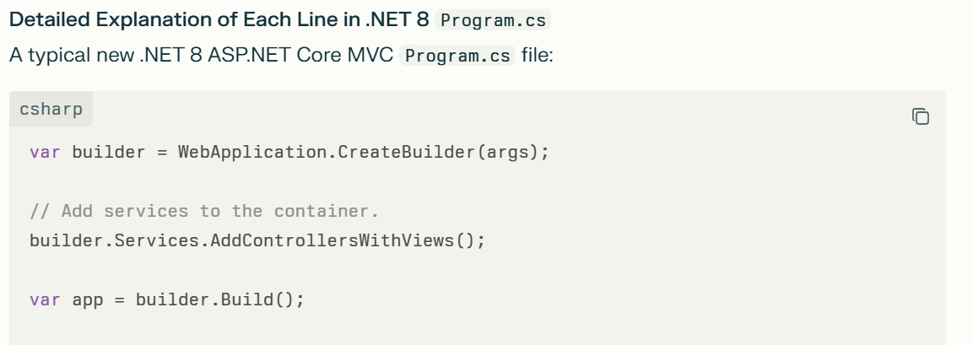
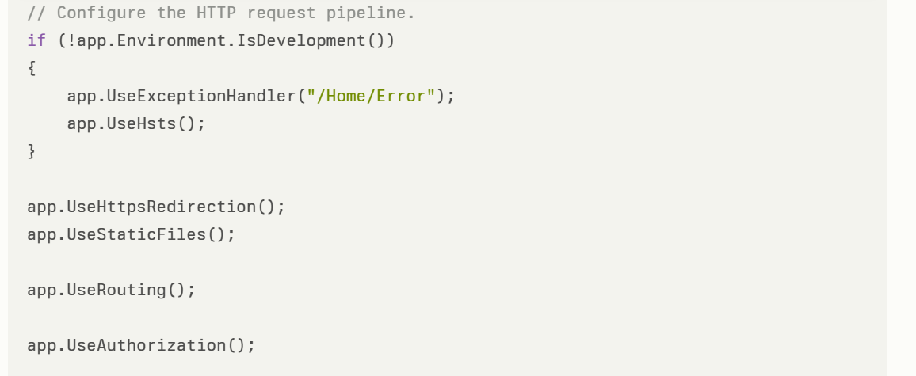
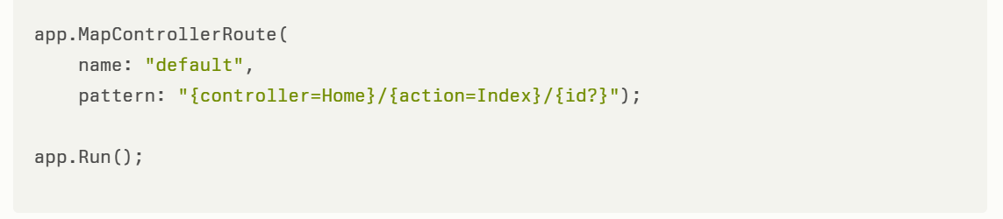

Line-by-line explanation:
- var builder = WebApplication.CreateBuilder(args);
Creates a builder that sets up the application's host, configuration, logging, and dependency injection container. It takes command-line arguments and prepares the app environment.
Explain this statement "It takes command-line arguments and prepares the app environment".
The args parameter represents the command-line arguments passed to the application when it starts. These arguments can be used to customize the app's configuration or behavior without changing code. For example, you might run your app with
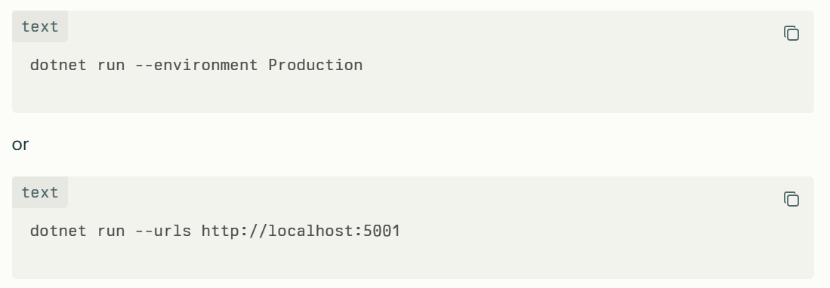
- WebApplication.CreateBuilder(args) uses these command-line arguments as one of the configuration sources. This means the builder reads and applies any settings specified through the command line, such as environment name (--environment), URLs, content root directory, and others. Command-line arguments have high priority in configuration.
- Besides command-line args, the builder also sets up the application's hosting environment: it prepares the environment name (e.g., Development, Production), content root path, web root path, logging, and other app infrastructure defaults.
- In other words, by passing args, the builder automatically configures the app startup environment and host options according to how the app was launched, making it flexible and responsive to runtime parameters.
- All this configuration setup happens as part of the initialization of a WebApplicationBuilder object, which is responsible for building the app's services, configuration, logging, and host before the final web app is constructed and run.

- builder.Services.AddControllersWithViews();
Registers the MVC services into the DI container, enabling controller and Razor view support required for an MVC web app.
Question:
What are MVC services here getting registered into DI container and how it happens?
What type of lifetime these MVC services?
When you call builder.Services.AddControllersWithViews() in .NET 8, it registers a set of MVC framework services into the Dependency Injection (DI) container that are necessary to support MVC controller and Razor view features. This allows the framework to instantiate controllers, render views, handle model binding, validation, and much more, all wired up via DI.
What exactly are the MVC services getting registered?
The extension method AddControllersWithViews() adds a collection of services related to MVC, including but not limited to:
- Controller activation and factories: Services to create controller instances with dependency injection.
- Model binding and validation: Services that bind incoming HTTP request data to action parameters and validate them.
- Action selection and routing: Services that determine which controller action to execute based on the incoming URL.
- View engines and Razor support: Services to locate, compile, and render Razor views.
- Filters and result executors: Services for handling cross-cutting concerns (e.g., authorization, logging) and producing HTTP responses.
- Diagnostics, logging, and data annotation support related to MVC.
Essentially, these are all the foundational components the MVC framework requires to process HTTP requests via the controller/view pattern.
How does this registration happen internally?
- The method AddControllersWithViews() is an extension method on IServiceCollection (the DI service registration abstraction).
- Internally, it calls multiple TryAdd* or Add* methods to register each of these services.
- Many MVC services use interface-to-implementation registrations, for example:
  - IControllerActivator to a default controller activator implementation.
  - IViewEngine to Razor view engine.
  - IActionInvokerFactory to default action invoker.
- It also adds required MVC middleware and configuration options.
- Services are registered with lifetimes that suit their typical usage patterns.
Service Lifetimes of MVC services
Most MVC framework services registered by AddControllersWithViews() use one of these lifetimes:
Service Type | Typical Lifetime | Reason
Controllers (activation) | Scoped | One controller instance per request scope, disposed at request end
Model binding/validation | Scoped | Per-request, as state often needed per HTTP request
View engines (Razor engine) | Singleton | Expensive to create, reused across requests
Action invoker, filters | Scoped | Per-request, as they execute action logic specific to each HTTP request
Other helpers (logging, etc) | Singleton/Scoped | Depending on whether they maintain state; configuration typically singleton
In ASP.NET Core’s DI container:
- Scoped means a new instance is created for each web request.
- Singleton means one instance is created for the whole application's lifetime.
- Transient means a new instance is created each time requested (rare for MVC framework services).
Controller instances themselves are scoped because each HTTP request should have its own independent controller instance.
Detailed steps overview when AddControllersWithViews() is called
- ServiceRegistration: When builder.Services.AddControllersWithViews() is called, it registers all required MVC services on the IServiceCollection.
- Configure Options: It configures MVC-related options like routing conventions, formatters, filters, and Razor view options.
- Register Implementations: It registers concrete implementations for interfaces like:
  - IControllerFactory
  - IModelBinderProvider
  - IViewEngine (like RazorViewEngine)
  - IActionInvokerFactory
  - Filter providers
- Setup Scoped Services: Many services are registered as scoped, so a new instance is created for each HTTP request.
- Application Building: When builder.Build() is called and the app runs, the DI container creates and manages these services per lifetime rules.
- Request Processing: On each HTTP request:
  - The DI container creates a scoped service provider for the request.
  - A controller instance is created via DI.
  - Controllers receive their dependencies injected automatically.
  - Views and other services are also resolved and used as needed.
- Disposal: Once the request finishes, scoped services like controllers are disposed.
This way, AddControllersWithViews() performs a set of registrations to the DI container that enable seamless MVC functionality with automatic injection and lifetime management.
Summary
- AddControllersWithViews() registers core MVC framework services needed for controllers and Razor view rendering.
- Services registered include controller factories, model binders, action invokers, view engines, filters, etc.
- Most services use a scoped lifetime for per-request instantiation; some like view engines are singletons.
- Registration happens via extension methods that configure and bind default implementations to MVC interfaces.
- At runtime, the DI container manages creation and disposal of these services with appropriate lifetimes per HTTP request.
This provides the infrastructure for MVC controller and view feature support in a clean, testable, and effective way using Microsoft's DI container in .NET 8.

- var app = builder.Build();
Builds the application pipeline with all registered services and middleware.
Question: What it does internally. Explain it.
The builder.Build() method in ASP.NET Core creates and returns a WebApplication instance by finalizing the setup of the web application builder. Internally, it performs several important steps:
- Finalize Service Provider and Configuration: It completes the dependency injection (DI) container setup by building the IServiceProvider that includes all registered services (like MVC services from AddControllersWithViews(), logging, configuration, etc.).
- Configure the Host Environment: It prepares the hosting environment configuration including server settings (e.g., Kestrel), environment variables, and other options gathered during the builder phase.
- Build the WebApplication Object: This returned object represents the configured web app with the complete DI container, middleware pipeline, and configuration, ready to be further customized (e.g., adding middleware) and then run.
- Middleware Pipeline Preparation: Internally, the middleware pipeline is prepared so that when the app runs, requests pass through the registered middleware and services.
- Returns WebApplication: This object enables the final app configuration like app.UseRouting(), app.MapControllers(), and eventually app.Run().
In essence, builder.Build() transitions from the setup phase (service registrations, configuration) to an executable web application instance prepared to handle HTTP requests.
This is summarized from the workings of .NET 7 and 8 WebApplicationBuilder and WebApplication: You use builder to register services and configure settings. Calling .Build() finalizes this setup into an immutable WebApplication instance that manages the app’s request pipeline, DI container, and hosting features
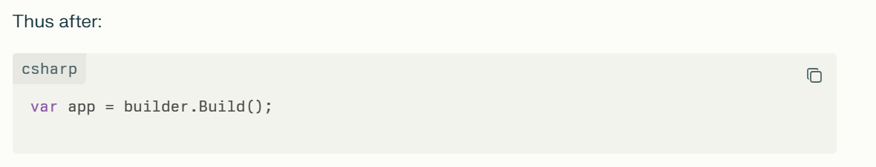
app is the fully initialized application hosting environment ready for further middleware configuration and to be run.

- if (!app.Environment.IsDevelopment())
Checks if the app is running outside the Development environment (usually Production or Staging).
Ways to change the Environment
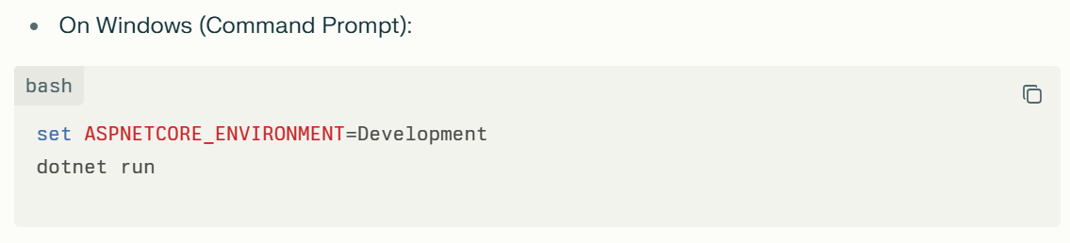
You can set this prior to launching your app, and ASP.NET Core will pick it up automatically.
Setting environment in launchSettings.json
If you are using Visual Studio or VS Code with the default launch profile, you can set the environment in the Properties/launchSettings.json file inside your project:
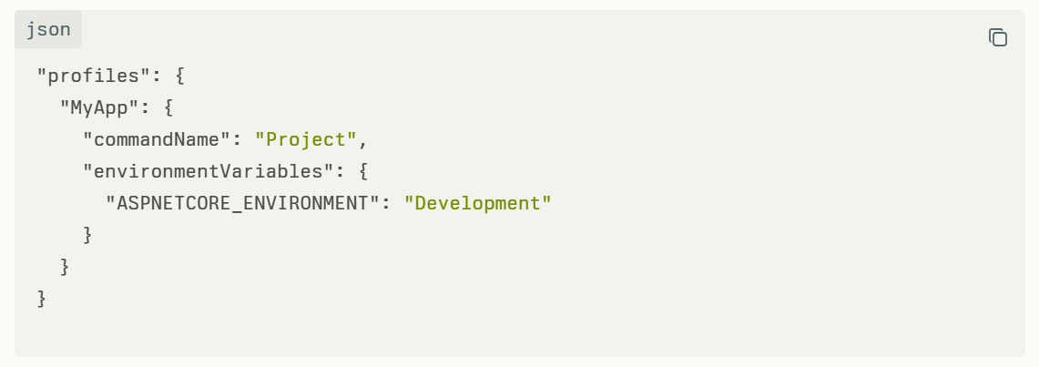
Change "Development" to "Production" or "Staging" or any custom environment name you want.
- app.UseExceptionHandler("/Home/Error");
Sets a centralized error handling middleware to display a friendly error page at /Home/Error in production environments.
Purpose of this
app.UseExceptionHandler("/Home/Error"); is middleware registration in an ASP.NET Core (.NET 8) application that enables centralized global exception handling. Its purpose is to catch unhandled exceptions that happen during HTTP request processing and redirect the user to a specified error handling path — in this case, the /Home/Error route. This allows the app to respond gracefully with a custom error page instead of crashing or showing raw error details, which is important especially in production environments.
Implementing the Error Handling Action in HomeController
You need a corresponding controller action to serve the error page:
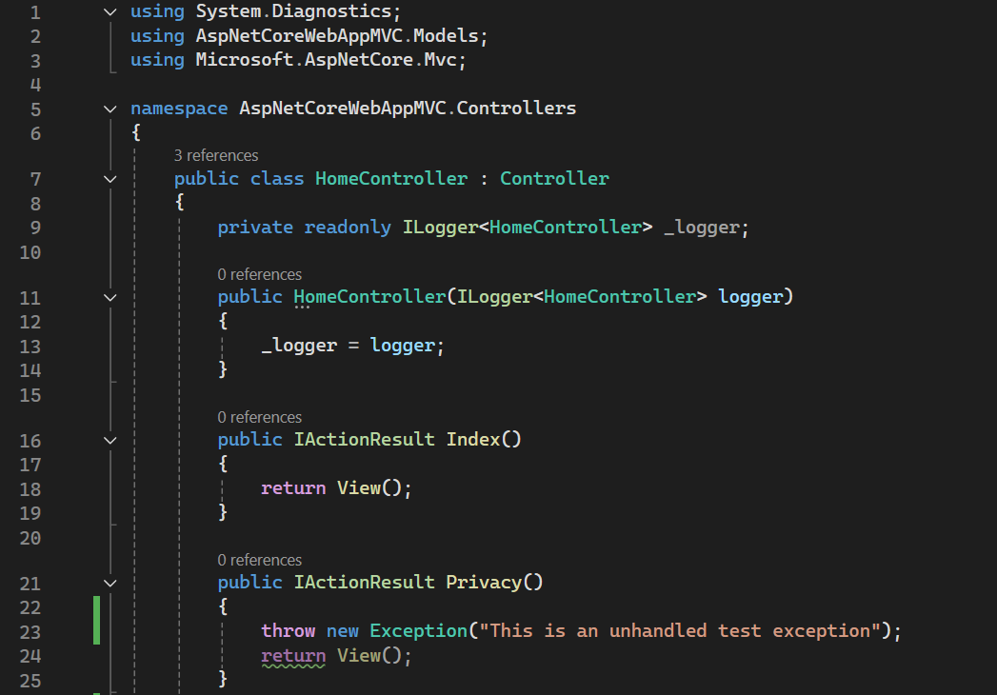
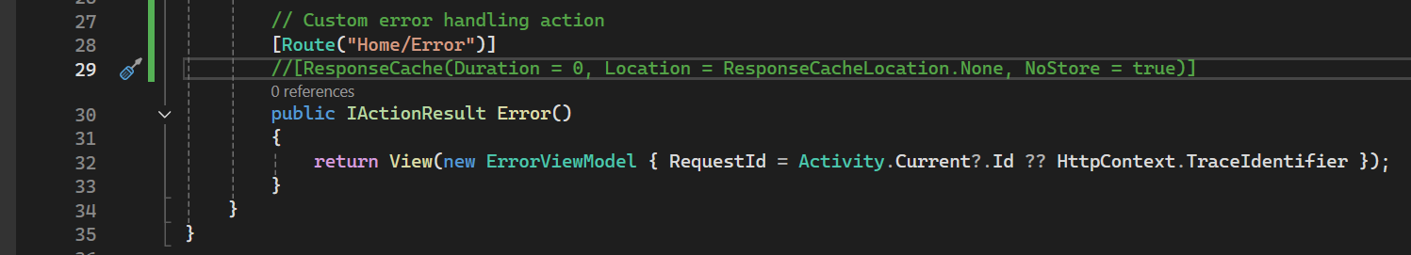
And you should create a Razor view (e.g., Views/Home/Error.cshtml) to display a user-friendly error message.
Here in the above code snippet line number 23, rasied the unhandled exception. So it will hit the HomeController Error() (line number 30) due to we have set the global exception handler (app.UseExceptionHandler(“/Home/Error”)in the Program.cs
Purpose of app.UseExceptionHandler("/Home/Error")
- Catches unhandled exceptions raised in downstream middleware or controllers.
- Prevents leaking sensitive exception details to end users.
- Redirects to a centralized error handling endpoint where you can log the error and show a user-friendly error page.
- Ensures a consistent and controlled error response across the app.
- Typically used in non-development environments to avoid showing detailed error info publicly.
- Improves application reliability and security by handling unexpected errors gracefully.
Summary
- app.UseExceptionHandler("/Home/Error") activates global exception handling middleware.
- When an exception occurs, it redirects to /Home/Error.
- Define an action method at this endpoint to handle and display errors properly.
- This setup is crucial for production apps to avoid exposing raw errors and to provide a good user experience regarding failures.
This practice is a fundamental pattern for managing error handling in ASP.NET Core MVC or Razor Pages applications to maintain robustness and security in live environments.
- app.UseHsts();
Enables HTTP Strict Transport Security (HSTS), instructing browsers to only use HTTPS for future requests to improve security.
Explain this with real time example use case and code
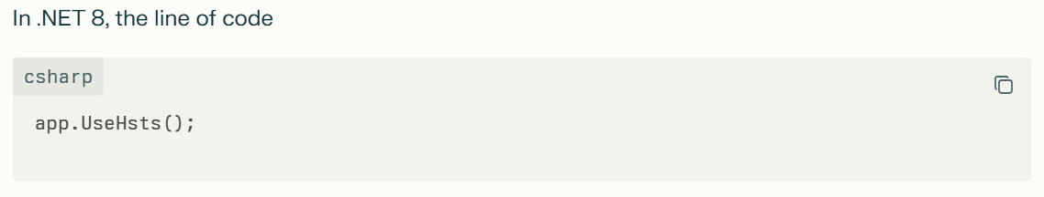
enables HTTP Strict Transport Security (HSTS) middleware. This middleware adds a special HTTP response header (Strict-Transport-Security) to instruct browsers to only communicate with the website over HTTPS for a specified duration, improving security by preventing protocol downgrade attacks and cookie hijacking.
What does HSTS do in real time?
- When a browser first visits your HTTPS-enabled site, the server sends the HSTS header.
- The browser remembers this instruction for the duration specified (e.g., 30 days, 1 year).
- During that period, any future request to your domain (including subdomains if specified) will automatically be made over HTTPS only, even if the user types http:// or clicks an insecure link.
- This prevents attackers from intercepting traffic and downgrading connections to insecure HTTP.
- It also blocks users from ignoring invalid or expired certificates by disabling browser prompts for insecure certificate exceptions.
Real-World Use Case
Consider a banking website https://securebank.com:
- Security is critical because personal and financial data is transmitted.
- By enabling HSTS, once a user visits the bank site using HTTPS, their browser will refuse to access the site over HTTP for the specified period.
- If an attacker tries a man-in-the-middle SSL stripping attack (downgrading HTTPS to HTTP), the browser blocks it because the bank is on the HSTS list.
- This enhances user security and trust by enforcing encrypted connections strictly.

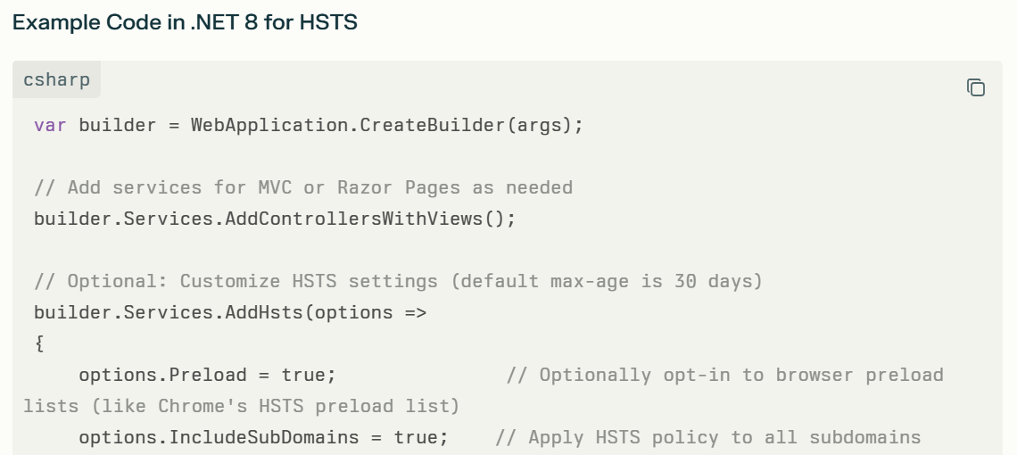
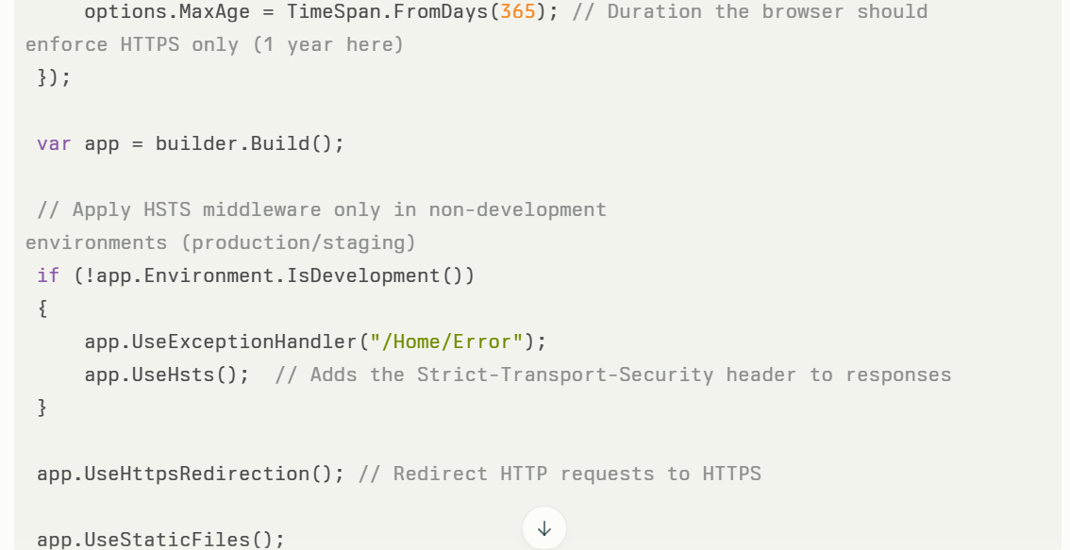
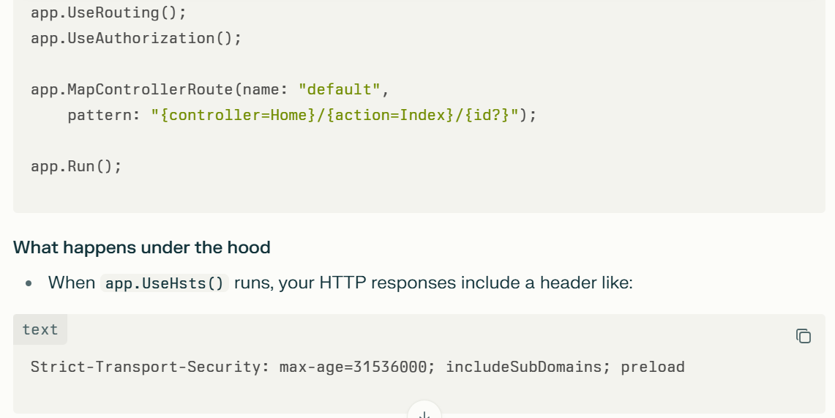
- This tells the browser it should refuse to load the site over plain HTTP for 31,536,000 seconds (1 year).
- If the user later tries visiting http://securebank.com, the browser will automatically redirect to https://securebank.com without hitting the network.
Summary
Aspect | Description
Purpose | Enforce HTTPS usage by browsers
How it works | Sends HTTP response header for strict transport security
Benefits | Prevents downgrade attacks and insecure HTTP access
Typical usage | Enabled in production & staging environments
Configuration options | MaxAge, IncludeSubDomains, Preload, ExcludedHosts
This practice is a critical security feature for any public web app that wants to ensure safe, encrypted connections and prevent users from unknowingly sending data insecurely.

- app.UseHttpsRedirection();
Redirects all HTTP requests automatically to HTTPS for secure communication.
Explain this with real time use case and code
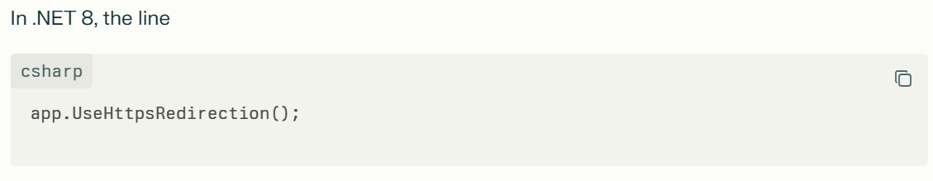
registers middleware that automatically redirects all incoming HTTP requests to the corresponding HTTPS URL, ensuring secure communication between the client and the server.

Detailed Explanation with Real-World Use Case
- When a user types or clicks an http:// URL for your site, the middleware intercepts this request.
- Instead of serving content insecurely over HTTP, it responds with a redirect status code (usually 307 Temporary Redirect) telling the client to try the same URL again but with https://.
- This guarantees that all communication happens over the encrypted HTTPS protocol, protecting data integrity and privacy.
- It helps prevent man-in-the-middle attacks and ensures confidentiality of sensitive data like passwords, personal info, or payment details.

Real-World Use Case:
Consider an e-commerce website https://shop.secure.com. A user might occasionally type http://shop.secure.com or click an insecure link. By enabling UseHttpsRedirection(), the website will:
- Automatically redirect the user to the secure https://shop.secure.com version.
- Prevent sending sensitive data over insecure HTTP.
- Improve SEO and user trust by enforcing HTTPS everywhere.
This is especially important in production environments where security and user data privacy are critical.

What Happens Internally?
- The UseHttpsRedirection() middleware listens to every HTTP request.
- It checks if the request scheme is http.
- If yes, it responds with a redirect status code (default is 307 Temporary Redirect).
- The client receives the redirect and reissues the request over https.
- If the request is already HTTPS, it passes the request down the middleware pipeline without modification.

- app.UseStaticFiles();
Enables serving static files (CSS, JS, images) from the wwwroot folder.
Question – How the static files are served from the wwwroot folder. Need example code. And how to use these static files in the view.
- app.UseRouting();
Adds routing middleware that matches incoming requests to route handlers (controllers and actions).
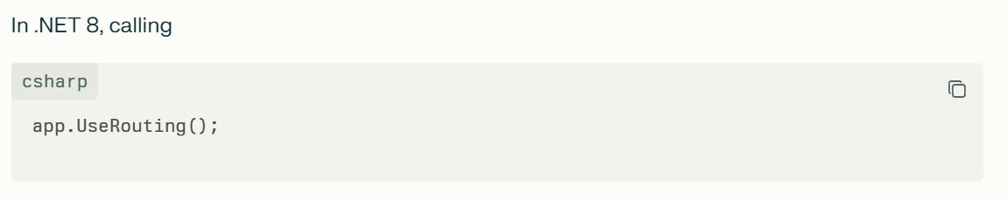
adds the routing middleware to the middleware pipeline. This middleware is responsible for matching incoming HTTP requests to route handlers, such as MVC controller actions, Razor Pages, or custom endpoints.
How Routing Works Internally
- Routing Middleware Intercepts Request:
The routing middleware inspects the incoming request's URL path and matches it against the routes configured in the app. These routes are built from the route templates you define in controllers, Razor Pages, or endpoint configuration (MapControllerRoute, MapRazorPages, etc.).
- Route Matching & Endpoint Selection:
Routing uses an efficient data structure (e.g., a decision tree) to find the best matching route pattern for the request URL. When a match is found, it sets two key pieces of data on the HttpContext:
  - The Endpoint selected (the associated controller/action or Razor page)
  - Route values extracted from the URL (e.g., controller name, action, id)
- Passing Route Data to Later Middleware:
The matching endpoint and route data are stored in HttpContext.Features and HttpContext.GetEndpoint(). Subsequent middleware can access this information to invoke the correct handler.
- Endpoint Middleware Executes the Handler:
After routing, the endpoint middleware (app.UseEndpoints() or app.Map*()) executes the matched endpoint (e.g., calls the controller action), producing the response.
Real World Use Case Example
Suppose you are building a blogging website with URLs like:
- /blog/post/123 to show post with ID 123
- /blog/archive/2025/07 to show posts from July 2025
In your .NET 8 app, you configure routing like:
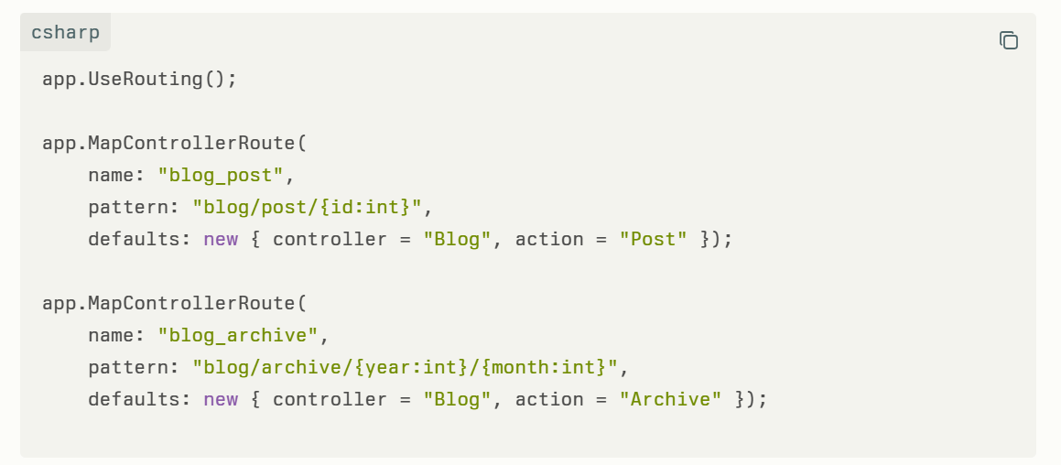
- When a request comes in for /blog/post/123, the routing middleware matches the "blog_post" route, extracts id=123, and sets the selected endpoint to BlogController.Post action.
- Then the endpoint middleware calls that action passing the route value.
- Are There Alternate Ways to Routing?
Routing Approach | Description | Use Case / Notes
Conventional Routing | Define route templates globally or per controller | Classic MVC apps; explicit route patterns like app.MapControllerRoute()
Attribute Routing | Routes defined on controllers/actions via [Route] / [HttpGet] attributes | Fine-grained route control close to code; commonly used in Web APIs and MVC
Endpoint Routing (default since ASP.NET Core 3.0) | Integrates routing with middleware pipeline, separating routing from execution | Modern recommended pattern, enables advanced features like authorization per endpoint
Razor Pages Routing | Pages map routes automatically based on folder structure, with attribute routing support | Razor Pages apps, simplified page-based routing
Custom Route Handlers or Middleware | Implement custom routing logic in middleware or endpoint handlers | For specific scenarios like dynamic URL handling beyond standard routing
Third-party Routing Middleware | Use alternative routing libs if needed | Rare, for special needs or legacy compatibility
- Similarly, /blog/archive/2025/07 matches the "blog_archive" route, extracts year and month, and invokes the BlogController.Archive action.
This enables clean, SEO-friendly URLs mapped directly to your controller methods.
Are There Alternate Ways to Routing?
Yes, ASP.NET Core supports several routing approaches:
What is the Best Way to Use Routing?
The best practice in .NET 8 ASP.NET Core apps generally is:
- Use Endpoint Routing with attribute routes for Web APIs or complex MVC apps that benefit from decorating controllers/actions with route info.
- Use Conventional routing for simpler MVC apps or when you want centralized route control.
- Always call app.UseRouting() early in the middleware pipeline (after static files, before authentication/authorization).
- Then use app.UseAuthorization() and finally map endpoints with app.MapControllers(), app.MapRazorPages(), or app.MapDefaultControllerRoute().
This approach ensures:
- Efficient route matching.
- Clear separation of routing and execution.
- Middleware that depends on route information (like auth) can act correctly.
- Flexibility for both attribute-driven and conventional routes.

Provide a simple sample demonstrating app.UseRouting() with attribute routing and conventional routing in .NET 8
Here is a simple .NET 8 sample demonstrating app.UseRouting() with both conventional routing and attribute routing in an ASP.NET Core MVC application.
Sample .NET 8 Web App with UseRouting(), Conventional Routing & Attribute Routing
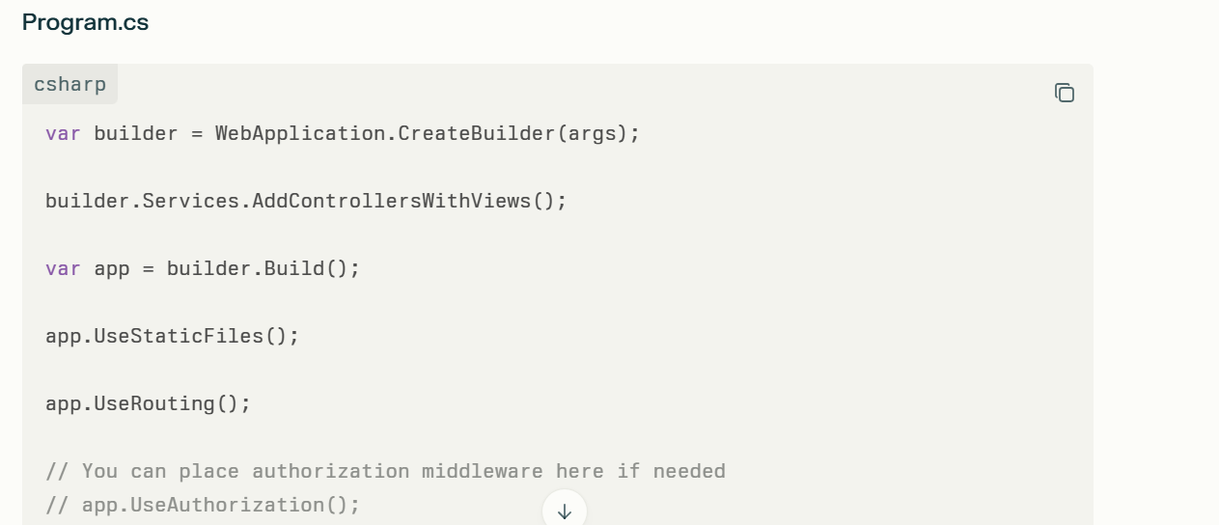
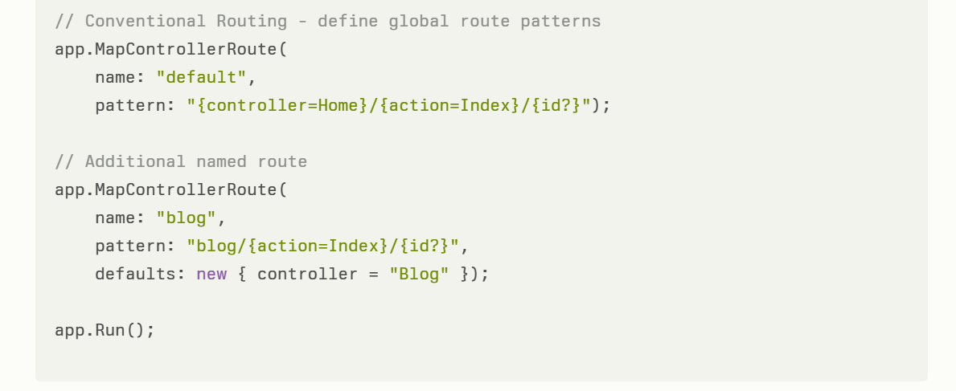

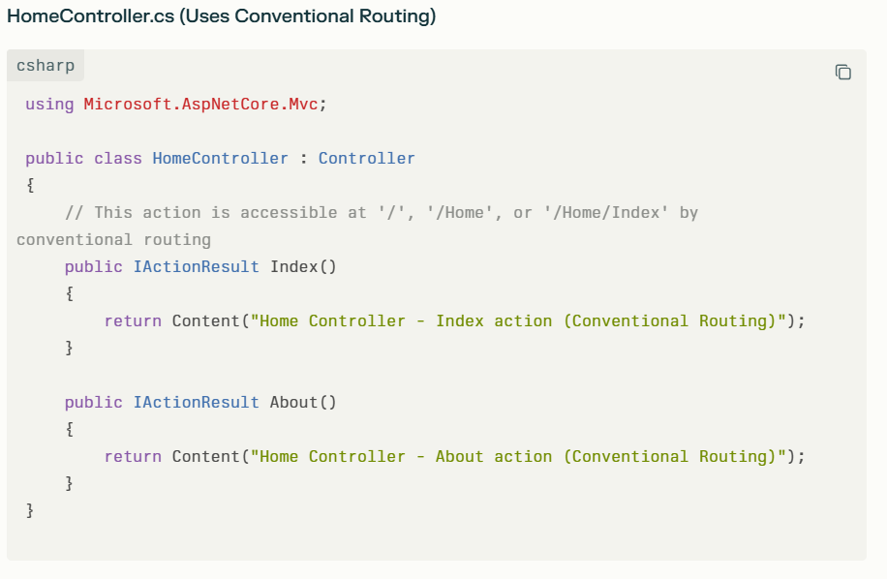
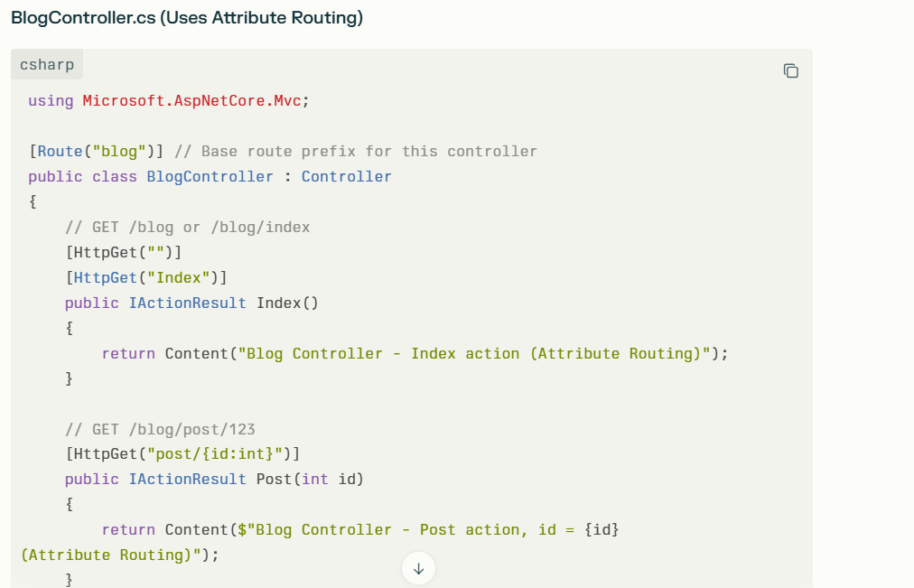

Explanation
- app.UseRouting() enables routing middleware that matches incoming requests to route handlers.
- Conventional routing uses route templates defined globally in MapControllerRoute(). For example, URL /Home/About routes to HomeController.About action by matching the pattern {controller=Home}/{action=Index}/{id?}.
- Attribute routing uses [Route] and [HttpGet] (or other verb) attributes on controllers/actions to specify routes inline. In the example, BlogController defines its routes using attributes, such as /blog/post/123.
- Both routing mechanisms coexist and can be used simultaneously.
- The routing middleware matches requests first, then executes the matched action.
Routes Examples and URLs
URL | Matches | Explanation
/ | HomeController.Index (conventional) | Default route to Home/Index
/Home | HomeController.Index (conventional) | Home controller, Index action
/Home/About | HomeController.About (conventional) | About action of Home controller
/blog | BlogController.Index (attribute) | Matches base route of Blog controller
/blog/index | BlogController.Index (attribute) | Explicit Index action on Blog
/blog/post/42 | BlogController.Post (id=42) (attribute) | Post action with route parameter id
This pattern exemplifies a simple, clean way to use app.UseRouting() supporting both attribute and conventional routing in ASP.NET Core .NET 8 apps.

- app.UseAuthorization();
Adds authorization middleware to enforce security policies on protected resources.
Explain this with real world example with code
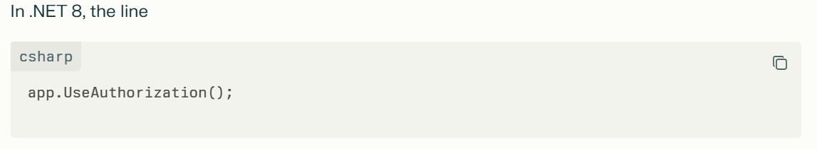
adds the authorization middleware to the request pipeline, which is responsible for enforcing authorization policies and rules on incoming HTTP requests. It ensures that only users who meet the specified security requirements can access protected resources such as controllers, actions, pages, or APIs.
How It Works
- Authorization middleware runs after routing (i.e., after app.UseRouting()), so it knows which endpoint (controller/action) will handle the request.
- It inspects the security metadata attached to endpoints (like [Authorize] attributes).
- It checks the user’s claims and roles against the authorization policy.
- If the user is authorized, the request proceeds.
- If unauthorized, it returns a 401 Unauthorized or 403 Forbidden responses, or redirects to a login page depending on the setup.
Real-World Use Case
Suppose you have a web application with a dashboard page visible only to authenticated users with an "Admin" role. You want to prevent unauthorized or anonymous users from accessing this page.
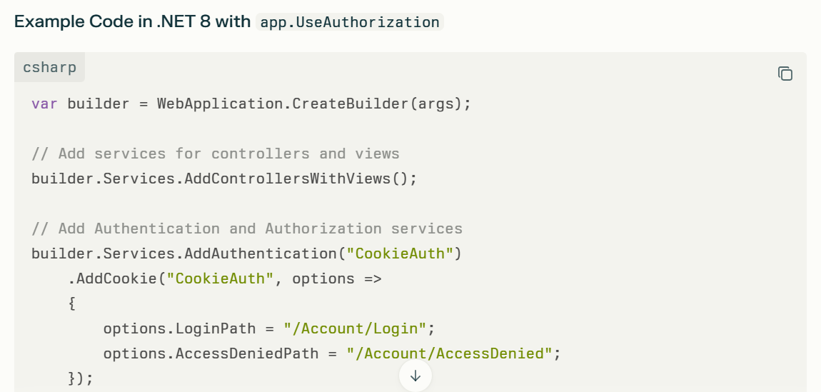
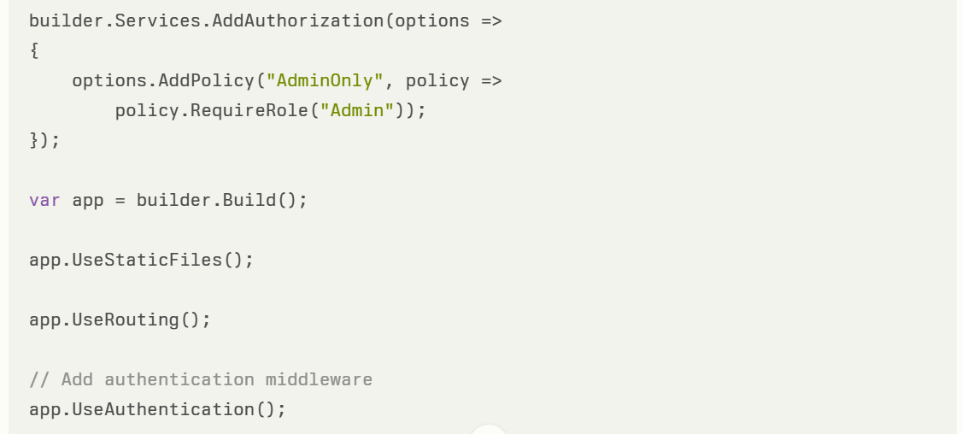
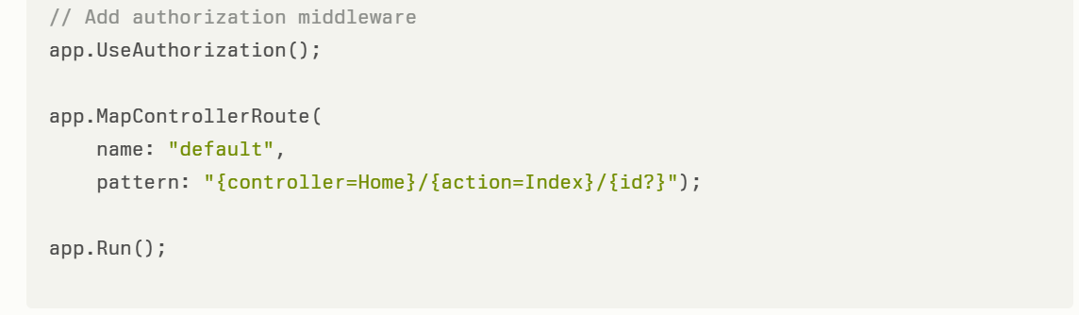

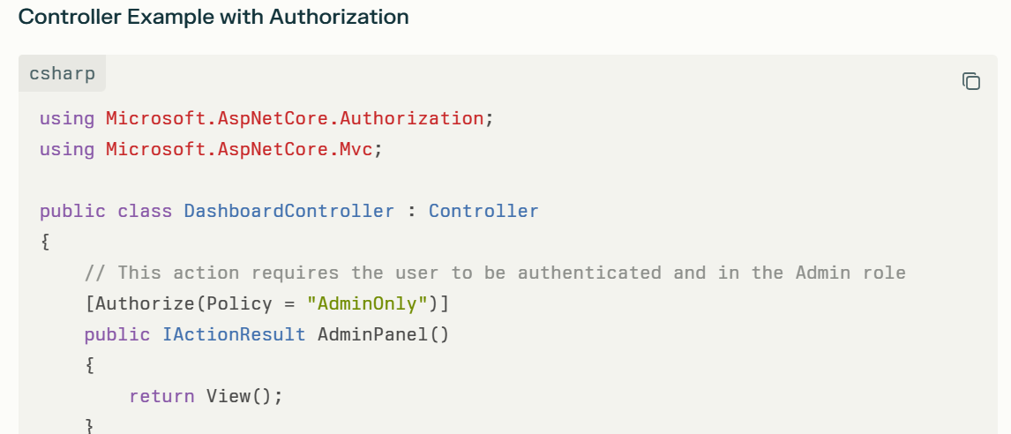
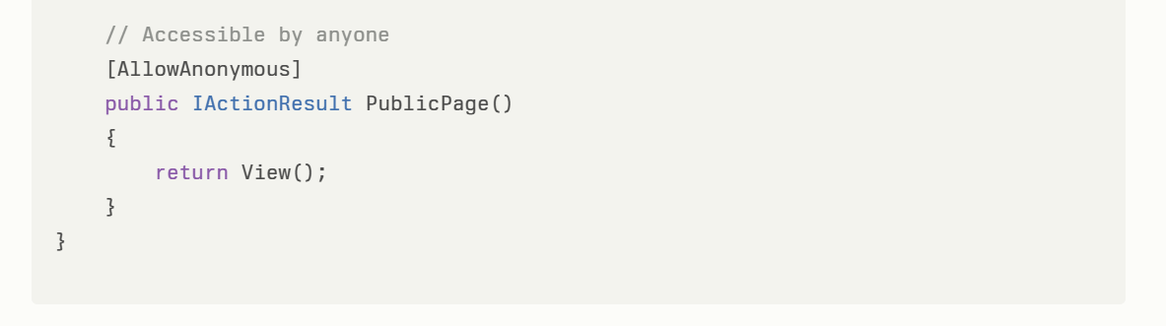
What Happens?
- The app.UseAuthorization() middleware checks if the current user is allowed to access the AdminPanel action.
- If not authenticated or not in the "Admin" role, the user is redirected to the login page or shown an access denied page.
- If authorized, the user sees the admin panel.
- Public pages marked [AllowAnonymous] bypass authorization checks.

Summary of Key Points
Aspect | Description
Purpose | Enforce authorization policies
Requires | Authentication middleware before it (app.UseAuthentication())
Checks | Endpoint metadata and user claims/roles
Denies Access | Returns 401/403 or redirects as configured
Real-world scenario | Protecting admin panels, sensitive APIs, or secure pages

- app.MapControllerRoute(...)
Defines the default conventional MVC routing pattern. If no controller or action is specified in the URL, it routes to the HomeController and its Index action method with an optional id parameter.
- app.Run();
Starts the web application and blocks until shut down, beginning to listen for incoming HTTP requests.
This minimal Program.cs consolidates application startup logic into one file, reflecting the modern, simplified approach of ASP.NET Core since .NET 6 and continued in .NET 8
What are the main benefits of using .NET Core for application development?
- Cross-platform support (Windows, macOS, Linux)
- High performance and scalability
- Modern development (support for cloud, microservices)
- Open-source and community-driven

In .NET 8, Authentication methods in ASP.Net Core MVC App
Method | Use Case | Characteristics
Identity API Endpoints | Modern token + cookie hybrid apps | Token issuance + cookie support, SPA-friendly
Cookie Authentication | Traditional MVC web apps | Session-based, server-managed cookies
JWT Bearer Authentication | APIs, SPAs, mobile clients | Stateless, token-based, API-focused

Cookie Authentication in ASP.NET Core MVC with .NET 8
What is Cookie Authentication?
Cookie Authentication is a common method in web apps where, upon successful login, the server generates an authentication cookie containing user identity claims. This cookie is sent with subsequent requests, enabling the server to identify and authorize the user without requiring re-login.
Step-by-Step Implementation in .NET 8 ASP.NET Core MVC App
Step 1: Setup the Project
Create or use an existing ASP.NET Core MVC project targeting .NET 8.
Step 2: Configure Services for Cookie Authentication
In your Program.cs (since .NET 8 uses top-level statements usually, or in Startup.cs if you still use that), add authentication and configure cookie options:
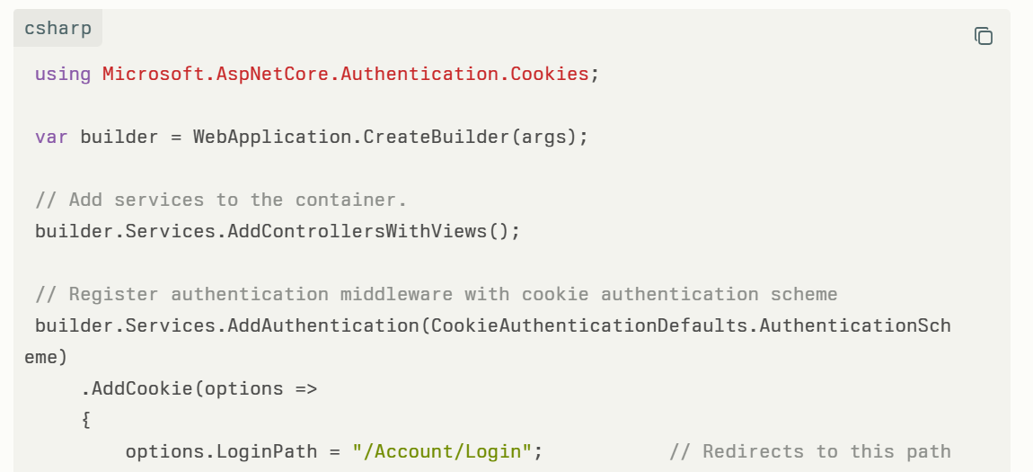
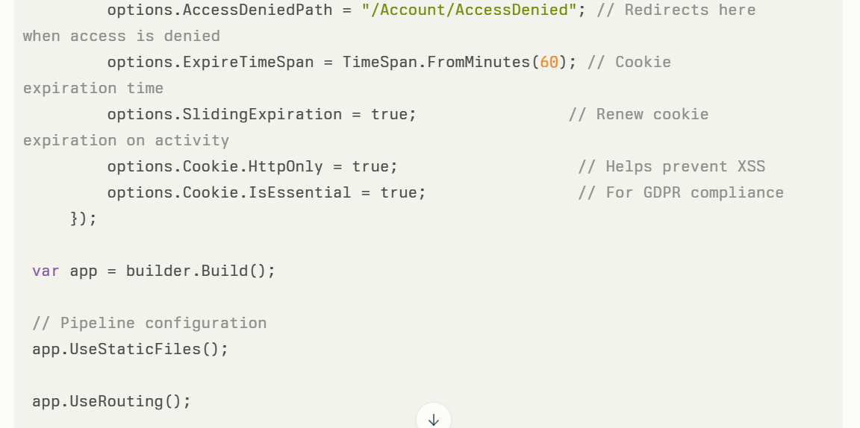
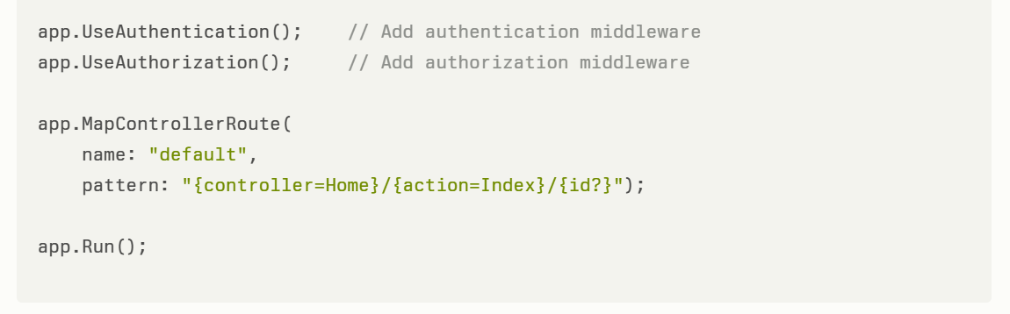
Step 3: Create Account Controller with Login and Logout
You need a controller to handle the login and logout flows, which create and remove the authentication cookie.
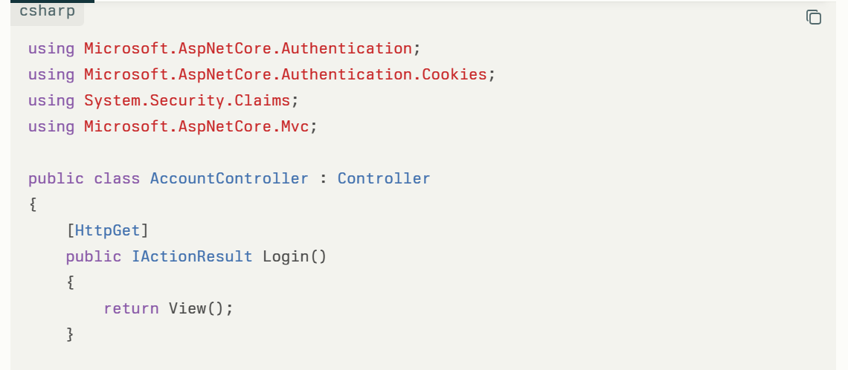
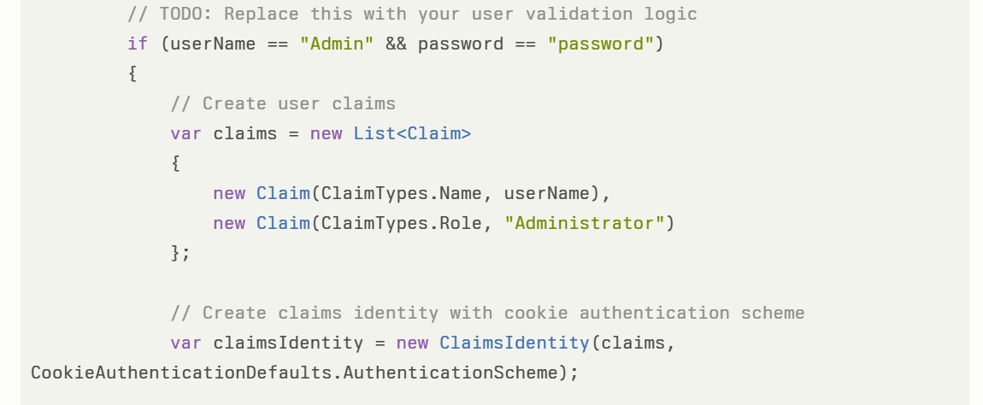
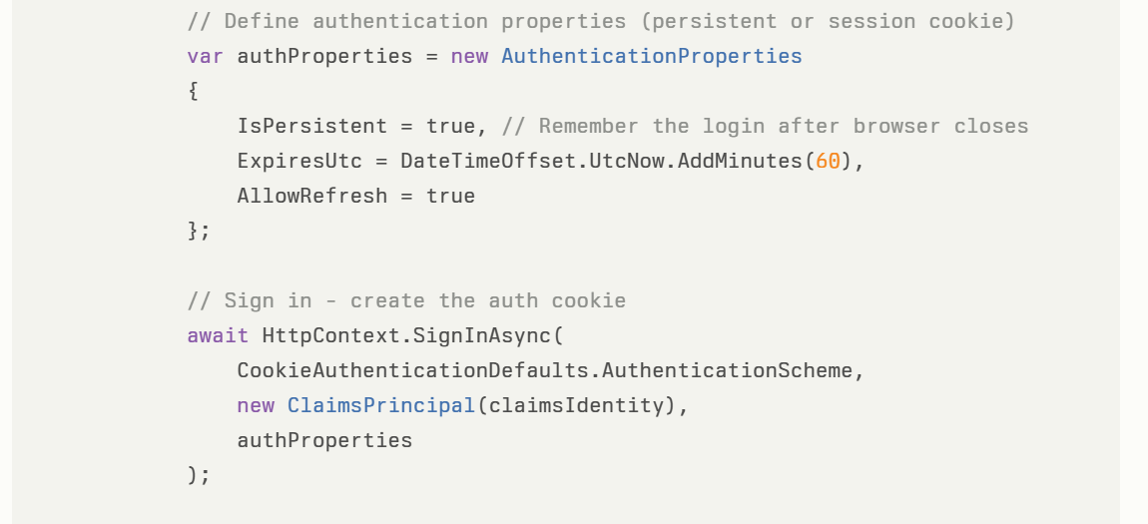
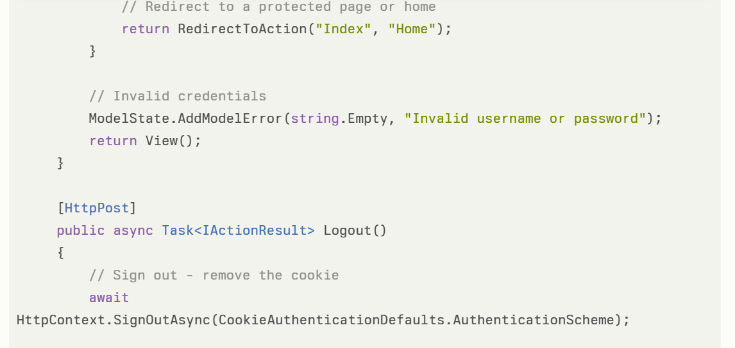
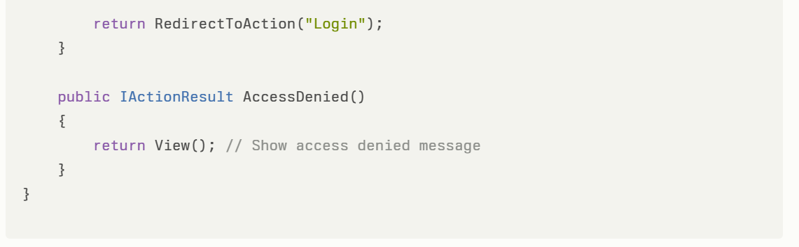
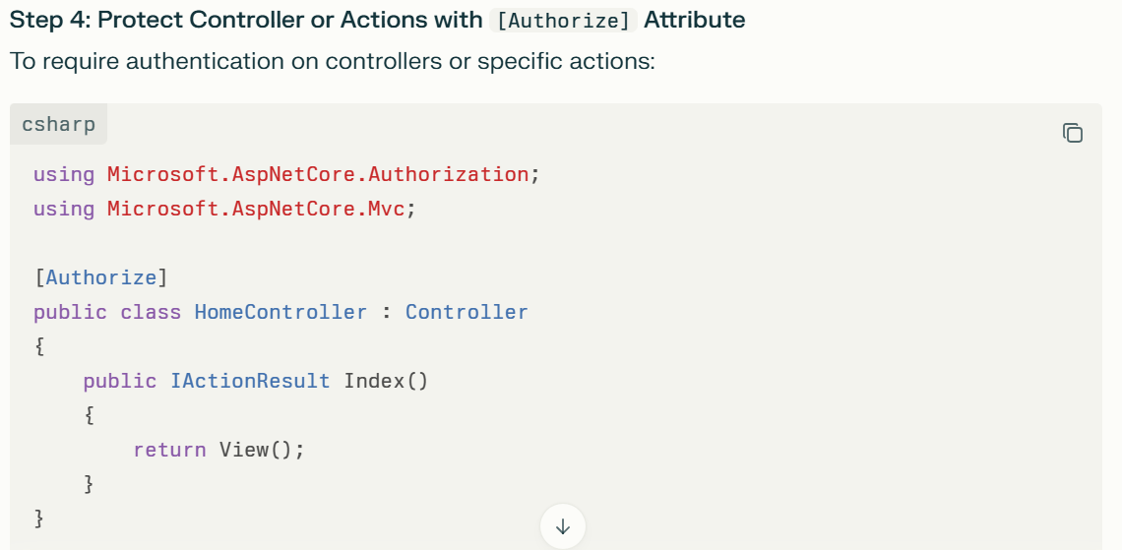
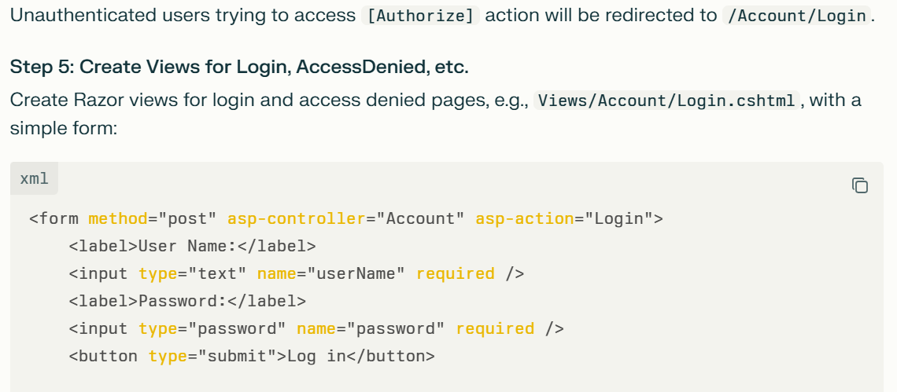
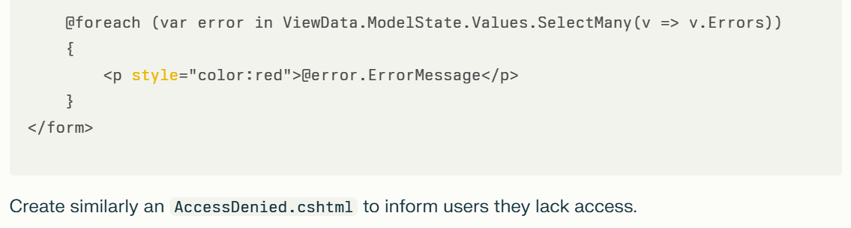

How It Works Internally
- When the user logs in successfully, SignInAsync creates an authentication cookie that contains serialized claims about the user.
- This cookie is sent back with every subsequent HTTP request.
- The middleware automatically reads this cookie, validates it, and recreates the ClaimsPrincipal that you can use in controllers to get user info (e.g., User.Identity.Name).
- When the user logs out, SignOutAsync deletes the cookie.
Step | What Happens
Register Authentication Middleware | Enables cookie auth and configures options
Handle Login POST | Validate user, create claims, sign-in cookie
Handle Logout POST | Remove the authentication cookie
Protect Actions/Controllers | Enforce auth using [Authorize]
Client sends cookie | Auth middleware validates and sets User
- The [Authorize] attribute makes sure only authenticated users can access protected routes, redirecting unauthorized users to the login page.
Summary Table:
This is the recommended standard approach for cookie authentication in .NET 8 web apps, providing a secure and scalable authentication system.

In a cookie-based authentication setup where the cookie expiration time is set to 15 minutes, and the user is actively using the application, what will happen once the cookie reaches its expiration time? Will the cookie expire and the user be logged out immediately, or will the cookie be renewed or extended during active use?
In a cookie-based authentication setup in ASP.NET Core MVC where the cookie expiration time is set to 15 minutes, whether the cookie expires and the user is logged out immediately after 15 minutes depends on the SlidingExpiration setting of the cookie authentication.
Key points:
- If SlidingExpiration = false (default behavior if not set), the cookie will expire exactly after 15 minutes from when it was issued. After that, the cookie becomes invalid, and the user will be logged out immediately once the cookie expires.
- If SlidingExpiration = true, the middleware will automatically renew (refresh) the cookie expiration time during active use. Specifically, if a user makes a request and the existing cookie is more than halfway (e.g., after 7.5 minutes if expiration is 15 minutes) through its lifetime, the server will issue a new cookie with a renewed expiration time (another full 15 minutes). This means the cookie lifetime "slides" forward with active requests, keeping the user logged in as long as they are active within the app.
In practice for your scenario:
- If your app has SlidingExpiration enabled and the user is actively interacting — making requests within the app — the cookie expiration time will be extended on each qualifying request, preventing immediate logout at the 15-minute mark.
- If SlidingExpiration is disabled or not enabled, the cookie will expire exactly after 15 minutes regardless of activity, and the user will have to log in again.
Important notes:
- Sliding expiration only renews the cookie if the cookie's lifetime has passed the halfway point during a request.
- If you want to avoid indefinitely renewing cookies for security (e.g., if a stolen cookie is used), you might implement an absolute expiration on top of sliding expiration manually.
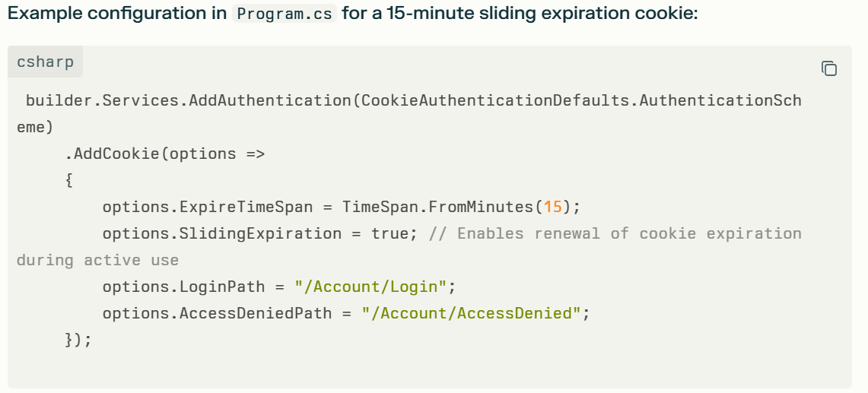
After logout in a cookie-based authentication setup, how is the cookie and user session information cleared from both the server and client sides?
Detailed Explanation
When a user logs out in ASP.NET Core cookie authentication, the cleanup of session information happens as follows:
- Client Side (Browser Cookie Removal):
  - The SignOutAsync() method on the server sends a response to the browser instructing it to delete the authentication cookie (usually .AspNetCore.Cookies or the configured cookie name).
  - This is typically done by setting the cookie expiration date to a past date or removing the cookie entirely.
  - Once deleted, the browser no longer sends the cookie in subsequent requests.
- Server Side (Session Invalidation):
  - Since cookie authentication is stateless by default, the server doesn’t maintain session state for the cookie. The server simply stops recognizing the cookie once it’s removed from the client.
  - If any server-side session or tokens are in use (like if you supplement cookie authentication with server session storage or tokens), you would explicitly clear or revoke those sessions or tokens at logout.
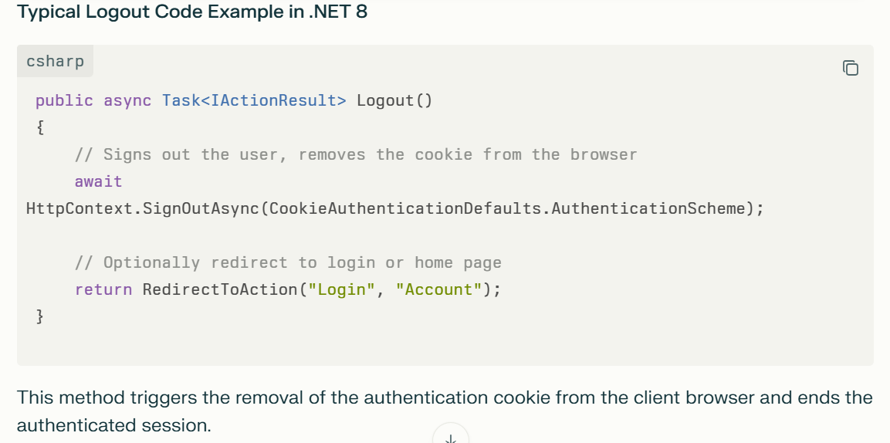

Where the cookie will store after login in cookie base authentication? In server side or client browser?
The cookie used in cookie-based authentication in ASP.NET Core MVC is stored on the client browser, not on the server.
Example Code Demonstrating Cookie Creation, Storage (Client), and Server-Side Validation in ASP.NET Core Cookie Authentication (.NET 8)
This example focuses on how the authentication cookie is generated by the server and stored on the client browser, then sent back to the server for validation upon each request.
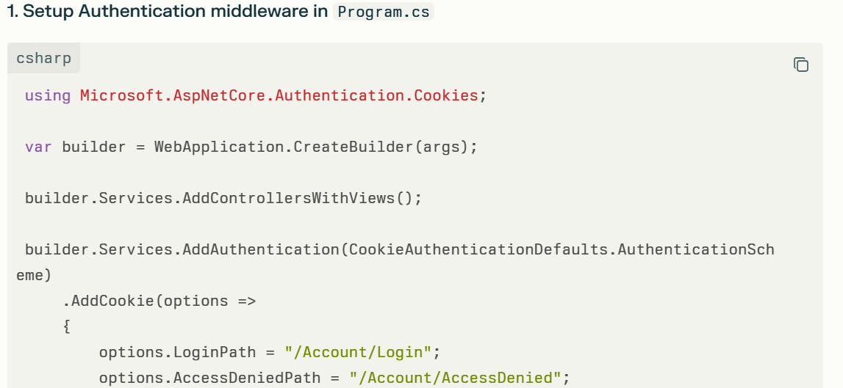
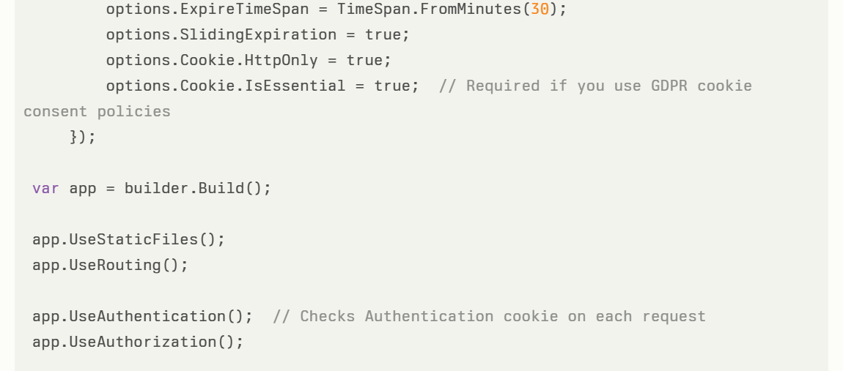
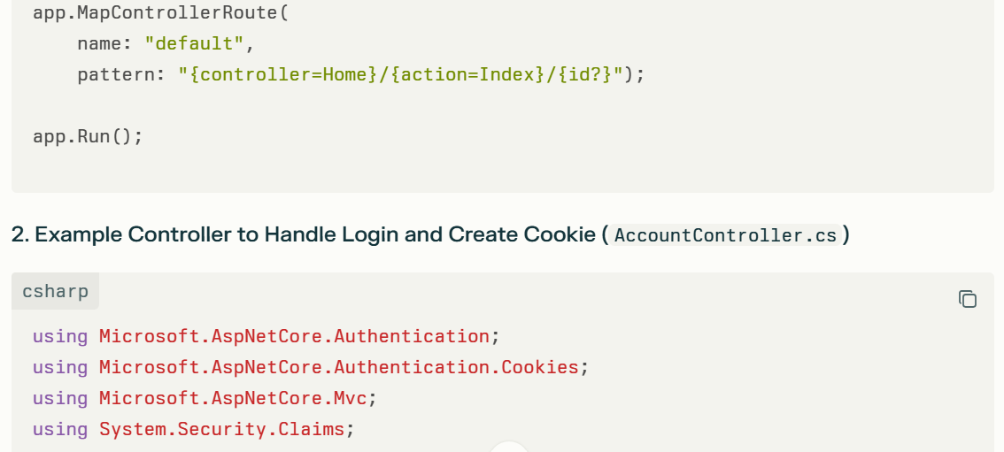
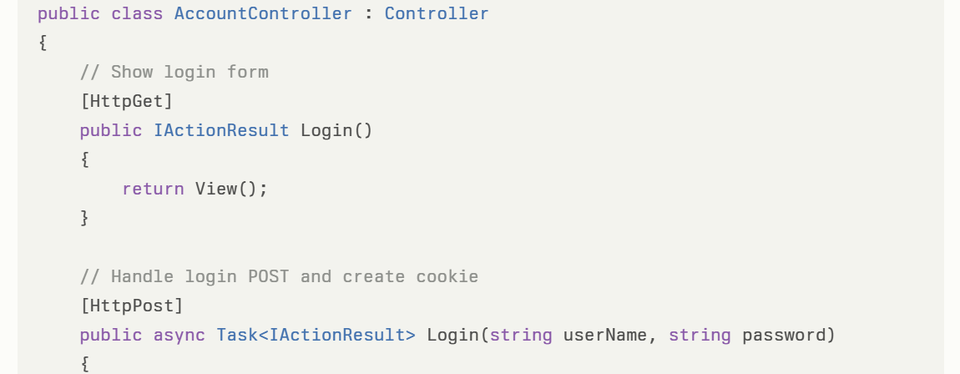
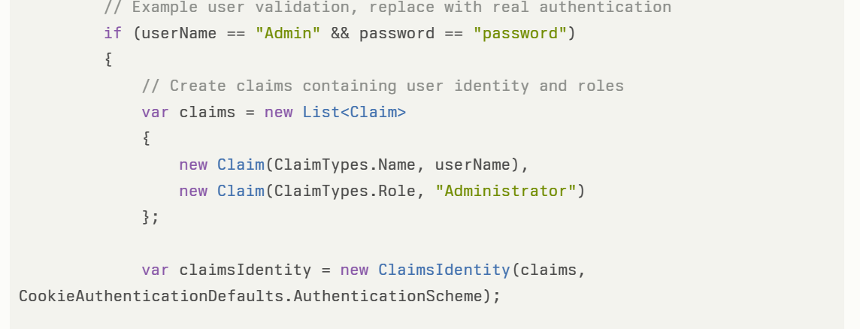
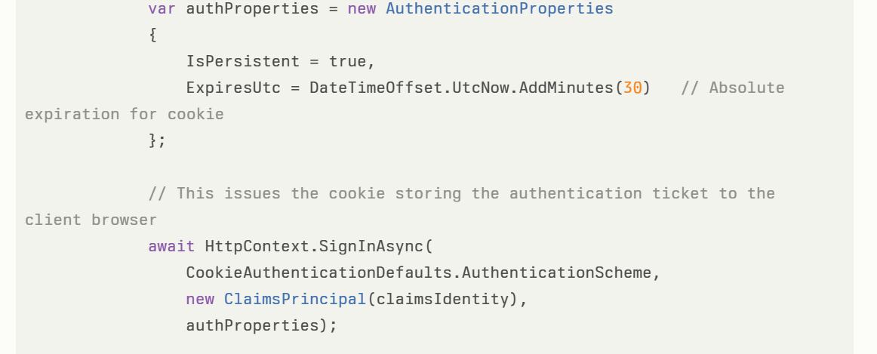
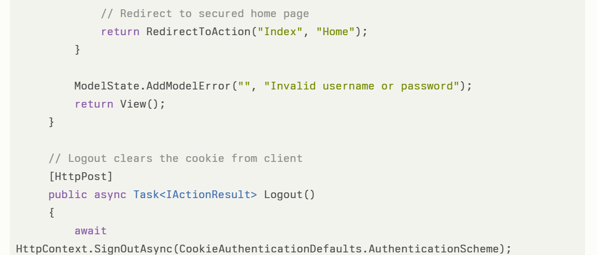
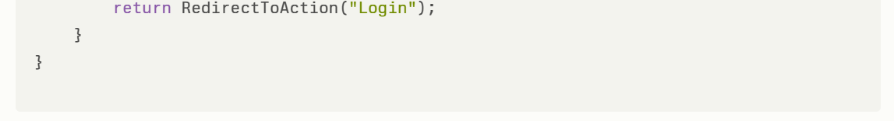

3. What Happens Behind the Scenes
- Calling HttpContext.SignInAsync() creates a serialized and encrypted authentication ticket containing user claims.
- The server issues an HTTP response header Set-Cookie with this encrypted ticket.
- The cookie is stored in the user's browser (client side).
- On subsequent requests, the browser sends the cookie back to the server.
- The server middleware automatically decrypts and validates the cookie using server-side data protection keys, reconstructs the user's identity (ClaimsPrincipal), and attaches it to HttpContext.User.
- Because the cookie stores the authentication information, no user session is kept server-side by default (stateless).

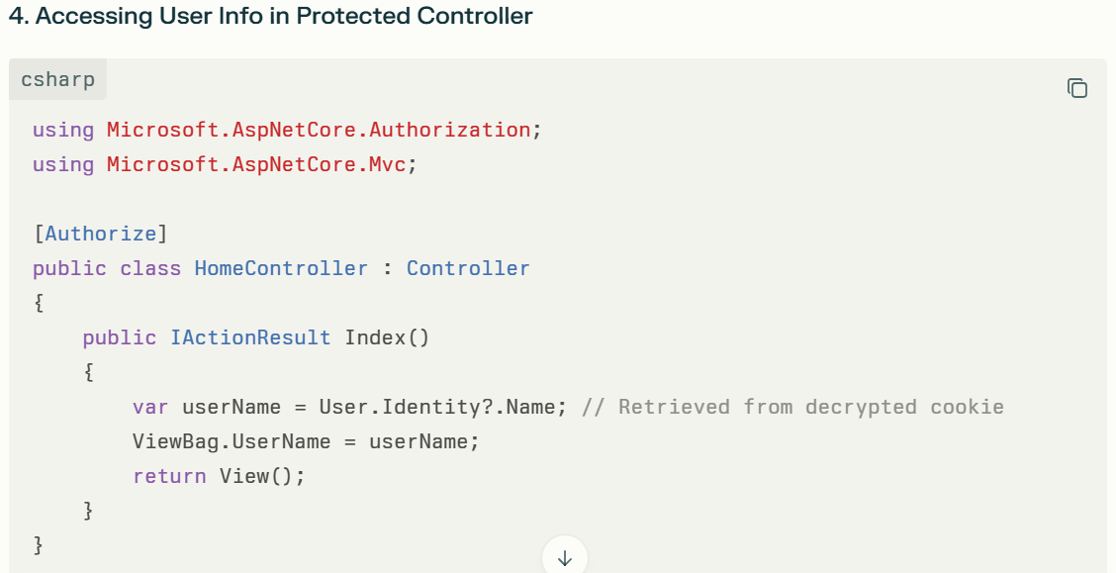

Summary
- The cookie is stored on the client browser after login.
- The cookie contains all necessary authentication info (encrypted).
- Server verifies and decrypts cookie on each request using stored keys.
- This provides stateless authentication with no server session persistence.

In ASP.NET Core cookie authentication, the server uses data protection keys to encrypt, decrypt, and validate the cookie contents, but it does not store session data or authentication state on the server by default.
Since the server produces the cookie, does it store any cookie information on its side? If so, how is that information stored? How does the server identify and validate the cookie in subsequent requests to ensure it is associated with the specific client to whom it was originally issued?
This version clearly separates the key points and asks about:
- Whether the server stores the cookie information,
- How it stores that information if at all,
- How the server validates and identifies the client cookie on future requests.
Detailed Explanation: How ASP.NET Core Manages Authentication Cookies
1. Does the Server Store the Cookie Information?
- No, the server does NOT store the contents of authentication cookies.
- When the user logs in, the server creates an authentication ticket containing the user's identity and claims.
- This ticket is serialized, encrypted, and signed with the server’s data protection keys.
- The encrypted ticket is sent to the client browser as a cookie. The browser stores it and sends it back on every request.
2. What DOES the Server Store?
- The only thing stored server-side is the data protection keys. These are typically:
  - In a secure location on the server (file system, Azure Key Vault, Redis, database, or another configured store), depending on how you configure Data Protection.
  - Used to encrypt (seal) and decrypt (unseal) authentication tickets placed in cookies.
3. How Does the Server Validate the Cookie?
- On every incoming request, ASP.NET Core’s authentication middleware:
  - Reads the authentication cookie sent by the browser.
  - Attempts to decrypt and validate it using the server’s data protection keys.
  - If the cookie can be decrypted and verified (the signature hasn’t been tampered with, the key matches, and the claims are intact), the user is considered authenticated, and the middleware reconstructs a ClaimsPrincipal object representing the user.
  - No session or lookup is needed; the data is all in the (secure) cookie.
4. How Does the Server Know Which Cookie Belongs to Which Client?
- The association is made because only the rightful client’s browser has the cookie. The server validates its contents cryptographically.
- If a client (browser) sends a valid, untampered cookie, the server can trust it (assuming the data protection keys are secure and have not been compromised).
- If the cookie is missing, expired, or invalid (e.g., forged, corrupted, or signed with a different key), the authentication fails.
Example Code: Data Protection Configuration and Cookie Authentication in ASP.NET Core (.NET 8)
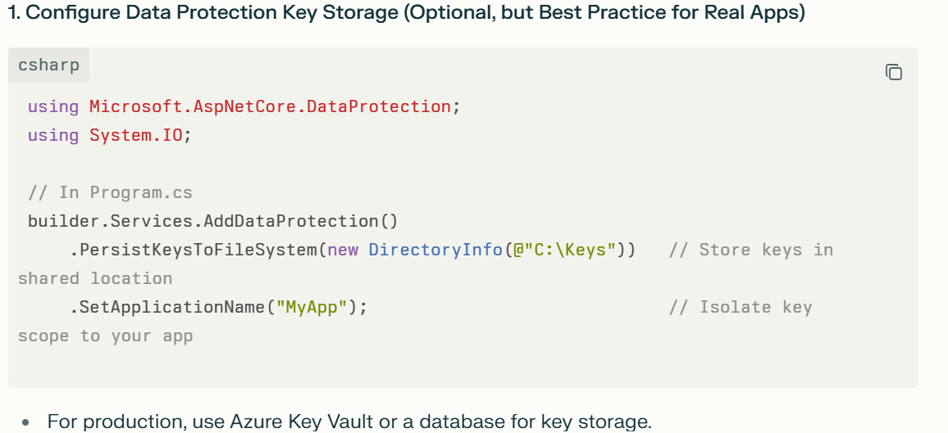
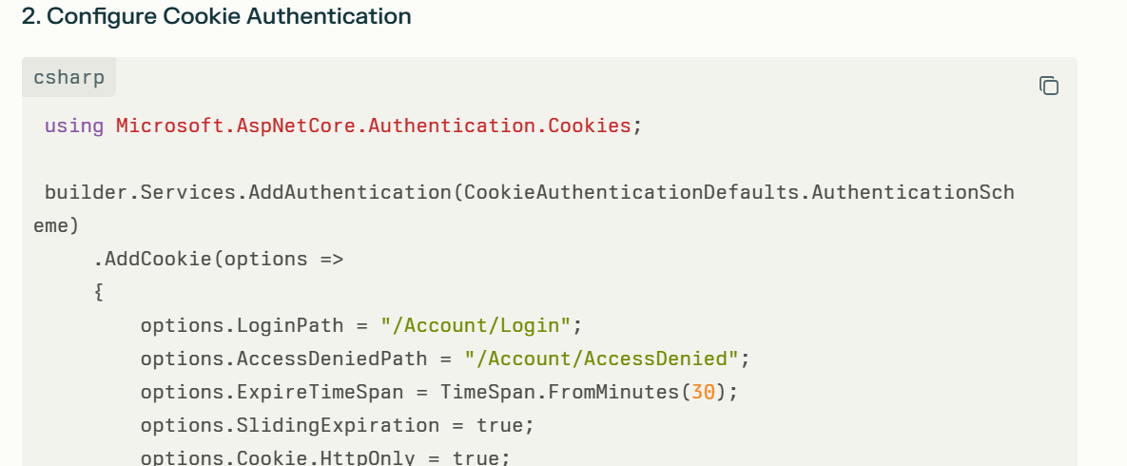
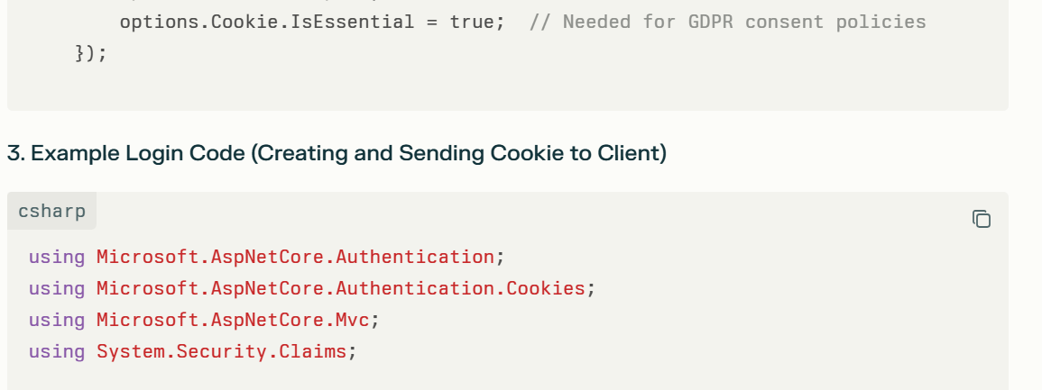
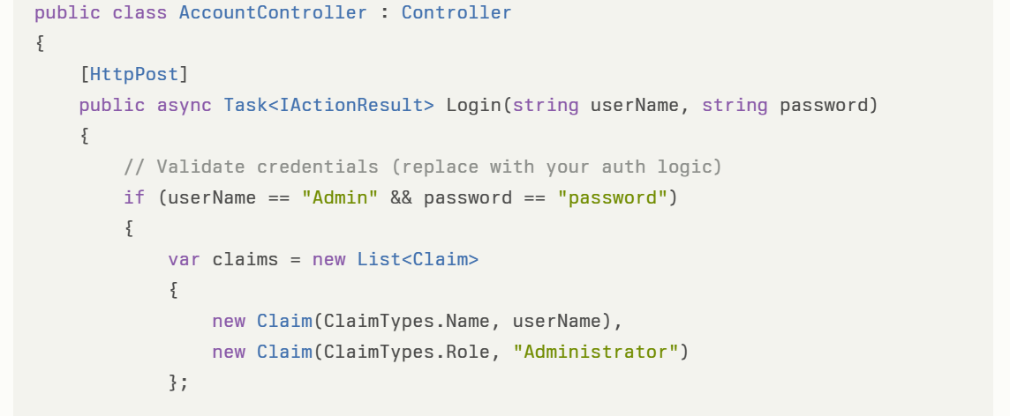
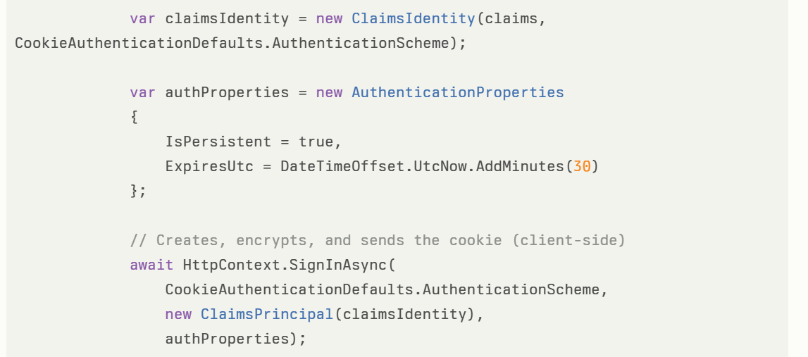
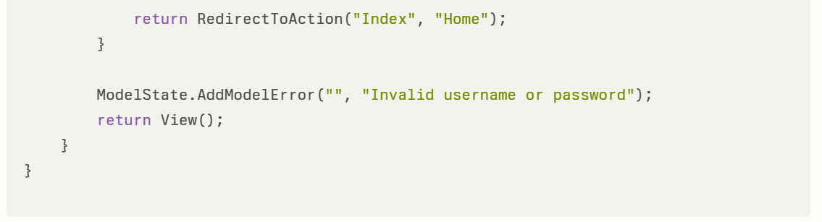
4. Validation on Subsequent Requests
- No extra code needed! The middleware automatically retrieves the cookie sent by the browser, decrypts and validates it using its keys, and reconstructs the ClaimsPrincipal representing the user.
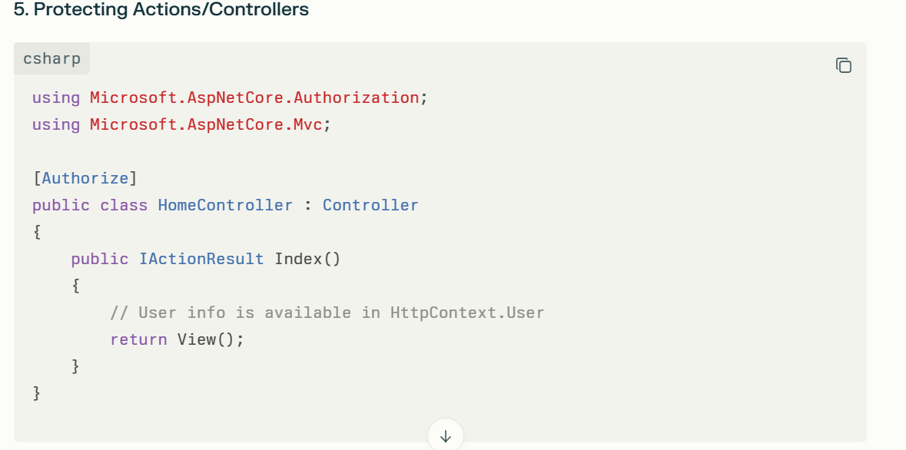
Key Takeaway
- The cookie is stored on the client.
- The server keeps only the cryptographic keys for encrypting/decrypting/validating cookies.
- Each request is authenticated by decrypting and verifying the cookie, not by server-side session state.
- Server validates the cookie via secure cryptographic signatures, ensuring integrity and authenticity.
This design enables stateless, secure, and scalable authentication out of the box in .NET 8 ASP.NET Core!

JWT-based authentication methods fall under which category of authentication methods? Are they considered a form of authentication leveraging OpenID Connect, OAuth 2.0, or both
Additional Context (Optional)
This question seeks clarification on how JWT (JSON Web Token) fits into the broader authentication and authorization standards:
- Is JWT itself an authentication method on its own?
- Is JWT primarily used within OAuth 2.0 as an access token format?
- Is JWT used in OpenID Connect for conveying user identity?
- Or does JWT-based authentication encompass both OAuth 2.0 and OpenID Connect protocols?
Provide a detailed answer explaining the relationship between JWT, OAuth 2.0, and OpenID Connect, including sample use cases and code examples in .NET 8

How the Authorization works in ASP.Net Core MVC App. Explain the below lines and give an example code
app.UseAuthorization();
Adds authorization middleware to enforce security policies on protected resources.

What is Middleware in ASP.NET Core? How does it work?
- Middleware is a software component that sits in the HTTP request/response pipeline.
- It processes incoming HTTP requests and outgoing responses.
- Each middleware can:
  - Inspect or modify the request/response.
  - Perform tasks such as authentication, logging, authorization, error handling, or routing.
  - Stop the request from going further (short-circuiting) or pass it to the next middleware.
- Middleware components run in the order they are registered in the pipeline, forming a chain of processing steps.
ASP.NET Core Middleware Pipeline: Visual Flow
- HTTP Request arrives from browser or client
- Middleware1
  - Processes the incoming request (e.g., logging)
  - Calls the next middleware (“next” method)
- Middleware2
  - Further processes (e.g., authentication)
  - Calls the next middleware
- Middleware3 (Terminal middleware)
  - Handles request, generates a response (e.g., outputs data)
  - Does not call next—ends the chain (short-circuits)
- Outgoing HTTP Response
  - Travels back through Middleware2 and Middleware1 (in reverse order)
  - Each can modify the response (e.g., add headers, log response time)

How Middleware Works:
- When a request enters the ASP.NET Core application, it passes through a pipeline made up of multiple middleware components.
- Each middleware receives the current HTTP context, performs its logic (e.g., logging, authentication), and either:
  - Passes control to the next middleware by calling a delegate (usually await next()), or
  - Terminates the pipeline early by generating a response immediately (short-circuiting).
- When the request traverses all middleware components, the response travels back through the middleware in reverse order, allowing each to modify the response if needed.
This sequential execution allows middleware to be modular, reusable, and customizable.

At which type of situation we will need to implement the custom middleware. Give me the real time use case with example code for banking domain.
Custom middleware is typically implemented when you need to handle cross-cutting concerns or specific request/response processing logic that is not addressed by built-in middleware. Situations where custom middleware is useful include request logging, authentication, authorization, error handling, modifying requests or responses, caching, rate limiting, or enforcing domain-specific policies specific to your business needs.
Real-time use case example in the banking domain:
Scenario: Logging and validating a custom security header on every API request to ensure requests come from authorized banking clients.
This middleware checks for a required custom header X-Bank-Client-Id, validates its value, and logs the request details. If the header is missing or invalid, the middleware returns a 400 Bad Request response and short-circuits the pipeline.
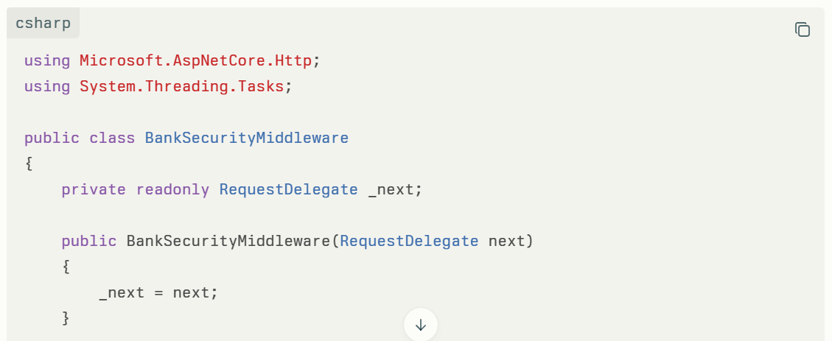
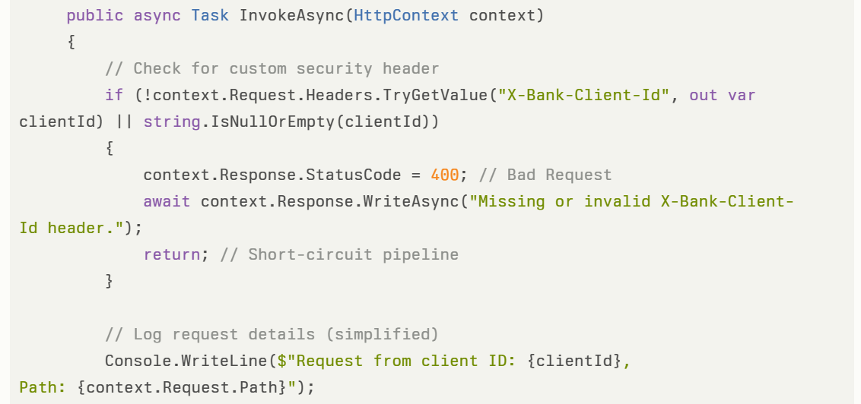
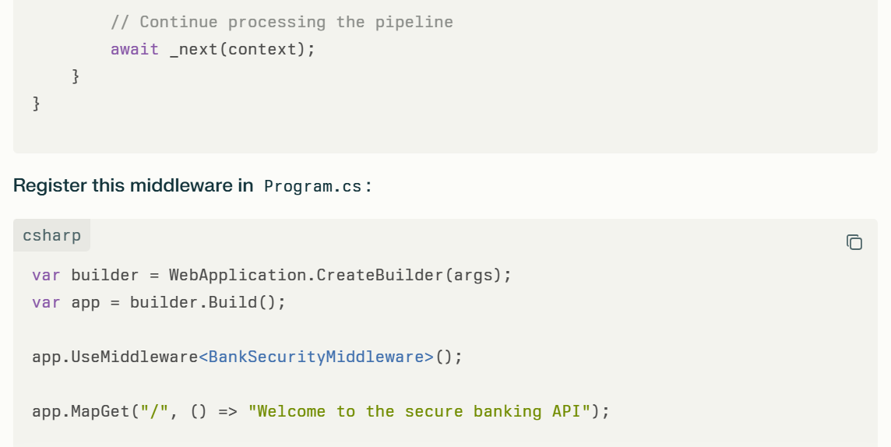
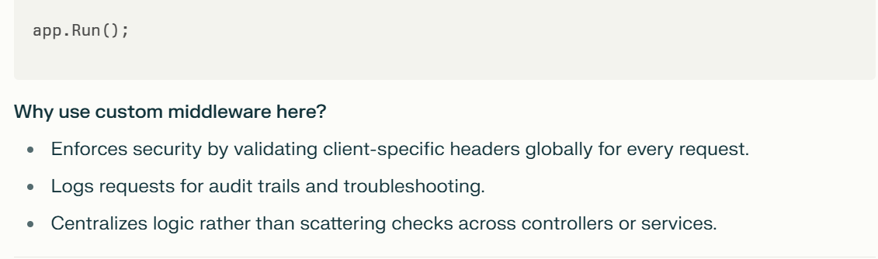

What are the ways to register middleware components .net core 8?
Explain the concept of Routing in ASP.NET Core.
How do you handle exceptions in ASP.NET Core?
How do you implement Dependency Injection (DI) in .NET Core?
How do you implement basic logging in .NET Core?‍
.NET Core provides built-in logging support through the ILogger interface. You can inject ILogger into controllers or services and log information using methods like LogInformation, LogWarning, and LogError.
How do you consume a Web API in a .NET Core application?‍
You can use HttpClient to consume a Web API. Create an instance of HttpClient, send a request using GetAsync or PostAsync, and process the response.

What are Filters in ASP.NET Core MVC? What are the types of filters?
Filters in ASP.NET Core MVC are used to execute custom logic before or after certain stages in the request pipeline, such as before an action is executed or after a result is returned. Filters provide a way to implement cross-cutting concerns like logging, authorization, caching, and exception handling.There are several types of filters:
Authorization Filters:
- Run before the action is executed to determine whether the user is authorized to execute the action.
- Example: [Authorize] attribute is an authorization filter.
Custom Authorization Filter:
public class CustomAuthFilter : IAuthorizationFilter
{
public void OnAuthorization(AuthorizationFilterContext context)
{
// Custom authorization logic
}
}
‍
Action Filters:
- Run before or after the action method is executed.
- Use case: Logging or modifying input parameters.
Example:
public class CustomActionFilter : IActionFilter
{
public void OnActionExecuting(ActionExecutingContext context) { }
public void OnActionExecuted(ActionExecutedContext context) { }
}
‍
Exception Filters:
- Handle exceptions thrown during the execution of an action or result.
- Use case: Logging errors or returning a custom error response.
Example:
public class CustomExceptionFilter : IExceptionFilter
{
public void OnException(ExceptionContext context)
{
context.Result = new RedirectToActionResult("Error", "Home", null);
}
}
‍
Result Filters:
- Run before or after the action result is executed.
- Use case: Modifying or processing the result before it's sent to the client.
Example:
public class CustomResultFilter : IResultFilter
{
public void OnResultExecuting(ResultExecutingContext context) { }
public void OnResultExecuted(ResultExecutedContext context) { }
}‍
Filters provide a way to inject custom behavior at different stages of the request processing pipeline, making them useful for cross-cutting concerns like authentication, caching, or logging.
Custom filters vs authorization in .net core
What is Task.Result in .Net Core?
Serialization and DeSerialization
Maximum 5 login can be in a same application in different browsers/different systems/different locations. How can we restrict the 6th login attempt? How can we manage the session expiration?

