MS-SQL
What is SQL?
Structured Query Language used to communicate with databases.

What are the different types of SQL statements?
SQL statements are broadly categorized into five main types based on their functionality. Here’s a breakdown of each type, along with example code for each category:
DDL, DML, DQL, DCL, TCL.
1. Data Definition Language (DDL)
These statements define, modify, or remove database structures.
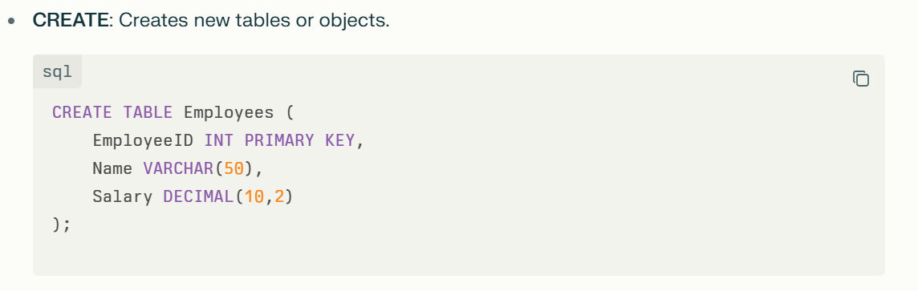
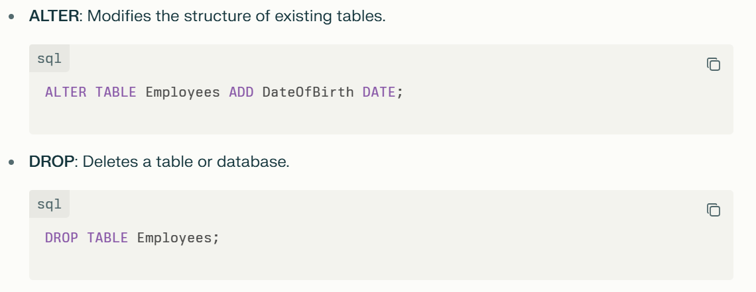
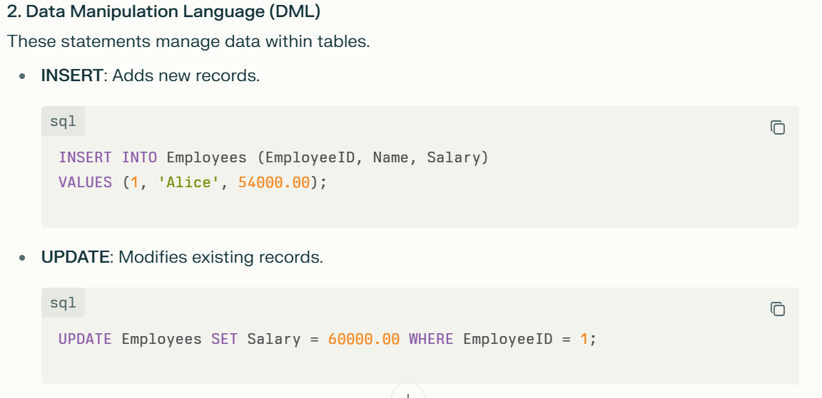
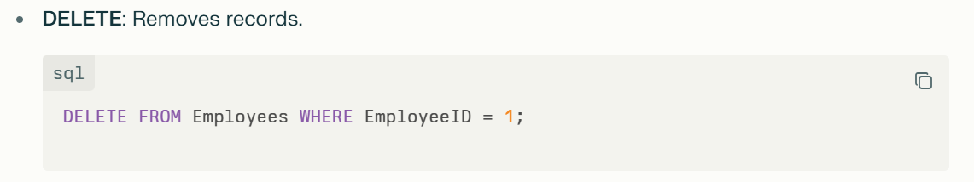
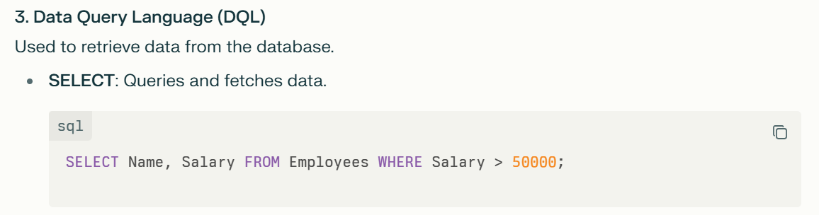
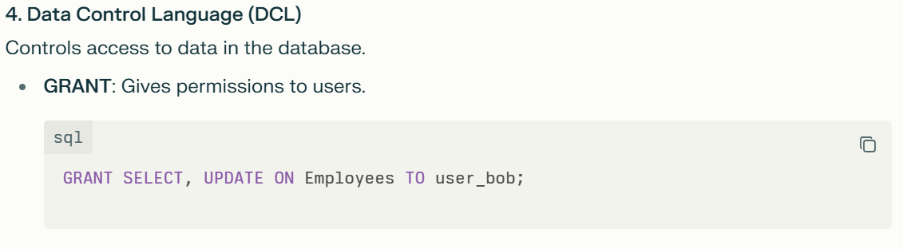
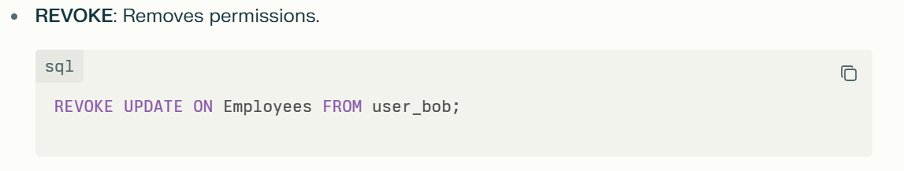
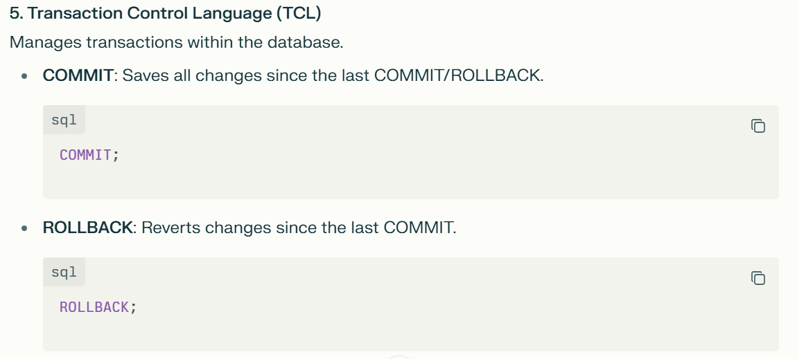

These categories encapsulate the core functionality of SQL, enabling effective definition, manipulation, querying, and control of database data and structure.

What is the difference between WHERE and HAVING?
The WHERE and HAVING clauses are both used to filter results in SQL, but they serve different purposes and operate at different stages of a query's execution:
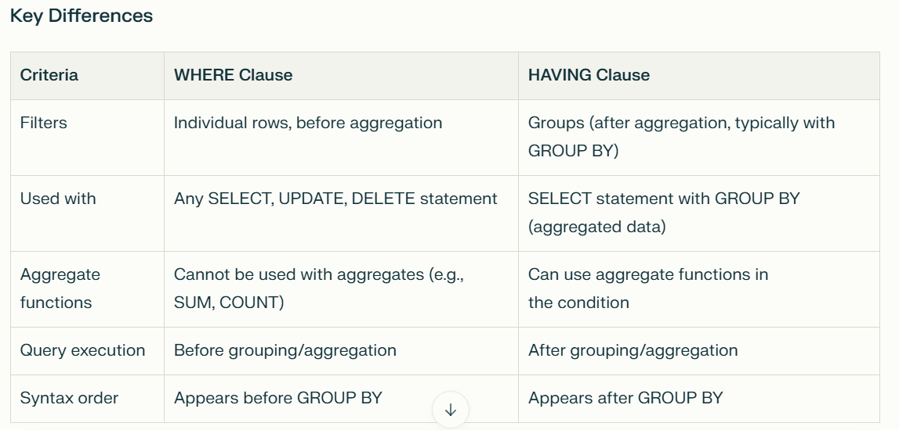

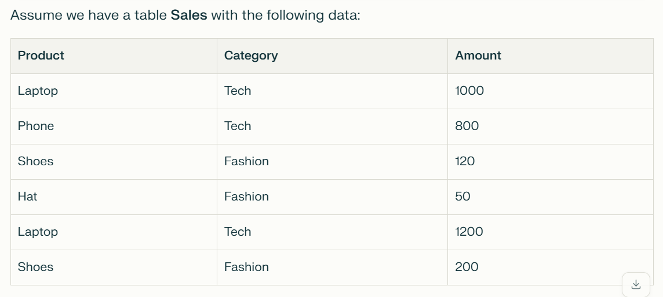
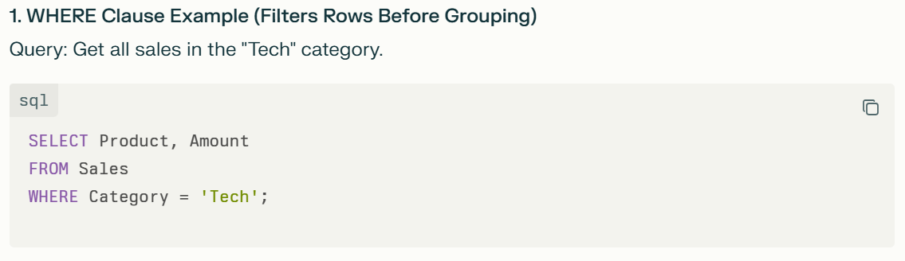
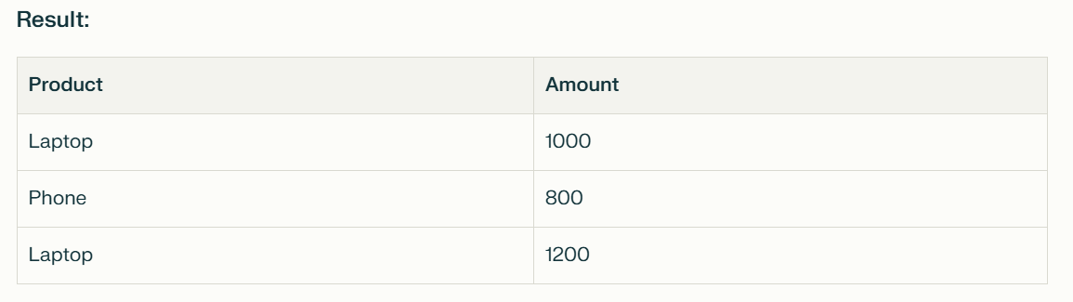
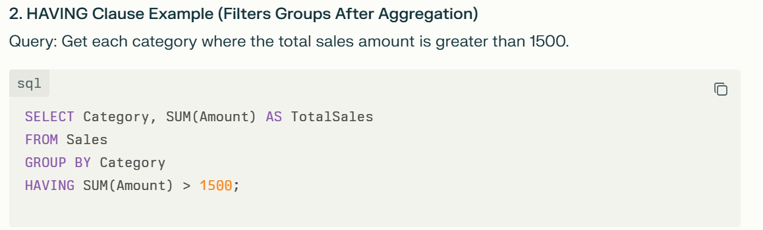

Explanation: The HAVING clause filters the groups formed by the GROUP BY clause after summing the Amount values, returning only categories with total sales above 1500.
Summary
- The WHERE clause filters individual rows before any aggregation.
- The HAVING clause filters aggregated groups after the GROUP BY.
This separation allows WHERE to tune data input, while HAVING refines aggregate results based on grouped computations, making both essential in SQL querying.

What is a JOIN? Name its types and explain with example code with results.
A JOIN in SQL is an operation used to combine rows from two or more tables based on a related column between them. It allows you to retrieve data that is spread across multiple tables, which is essential in a relational database where data is often normalized.
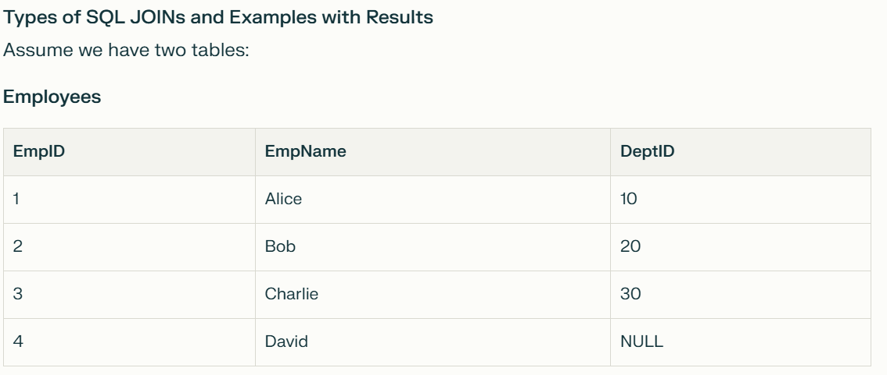
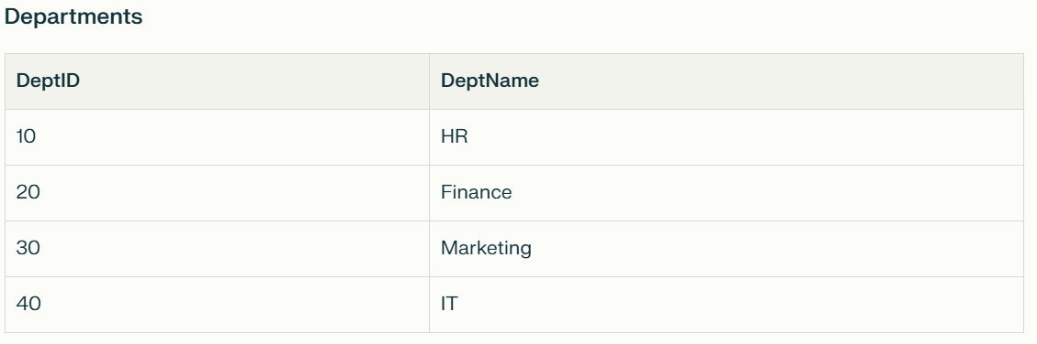
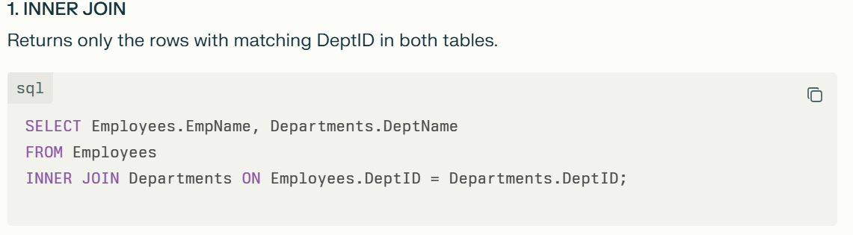
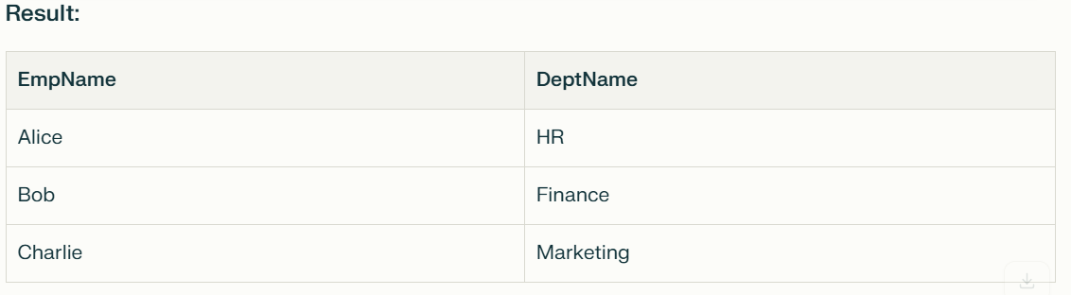
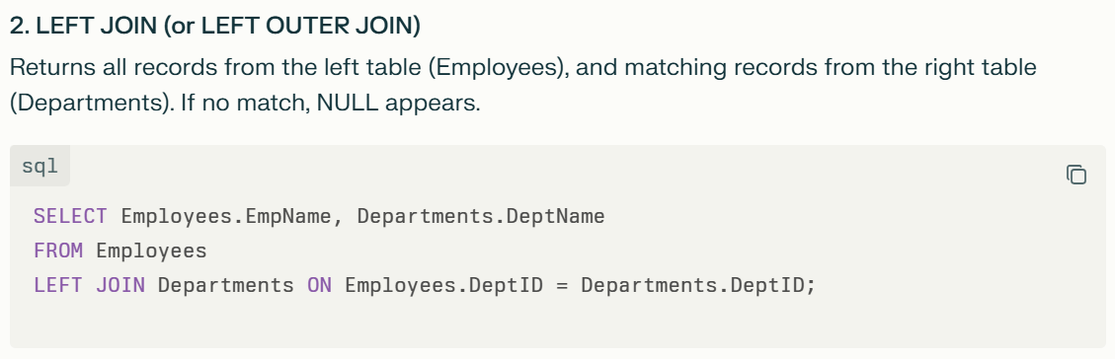
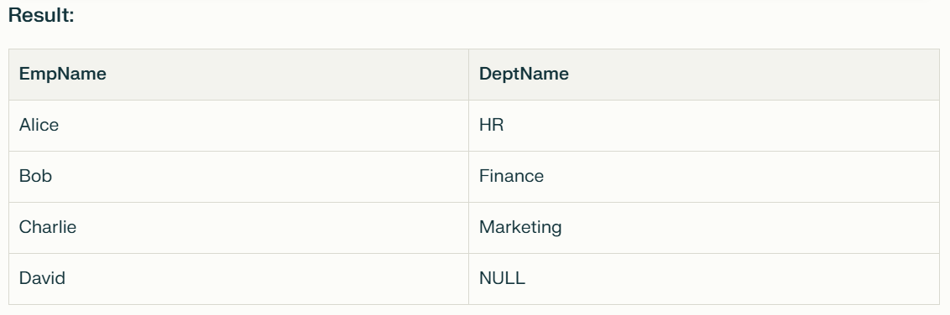
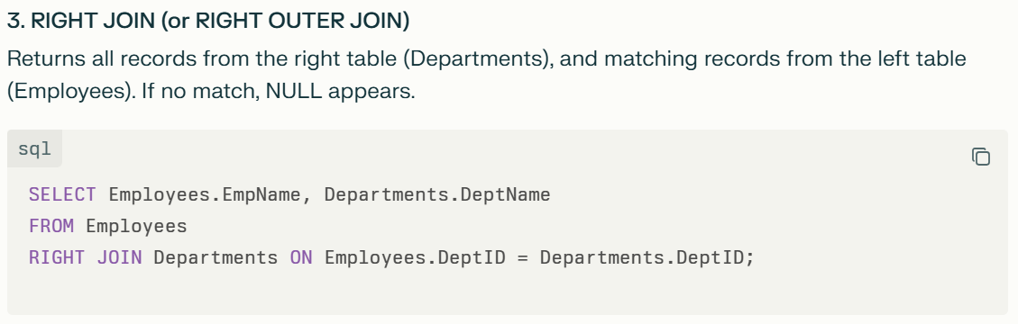
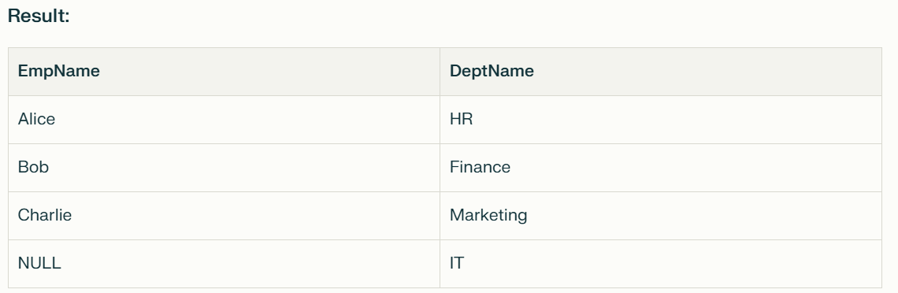
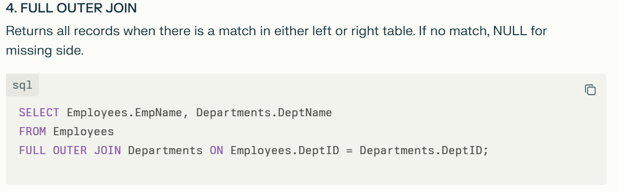
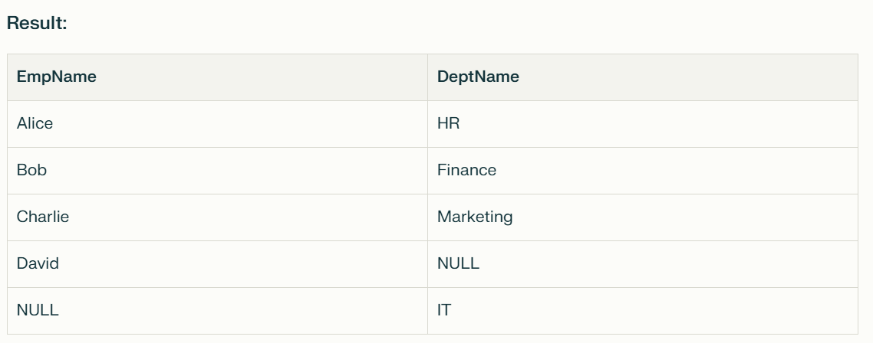
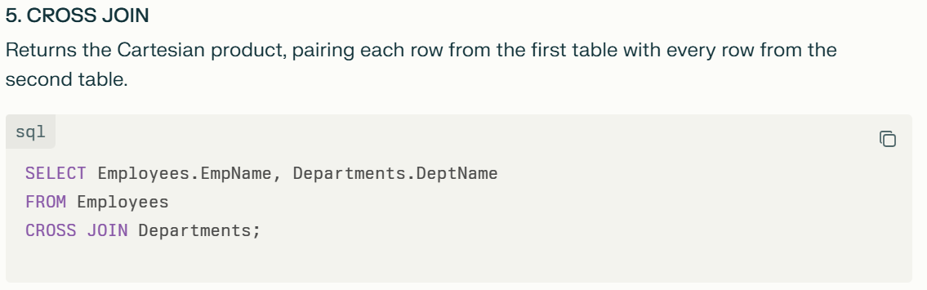
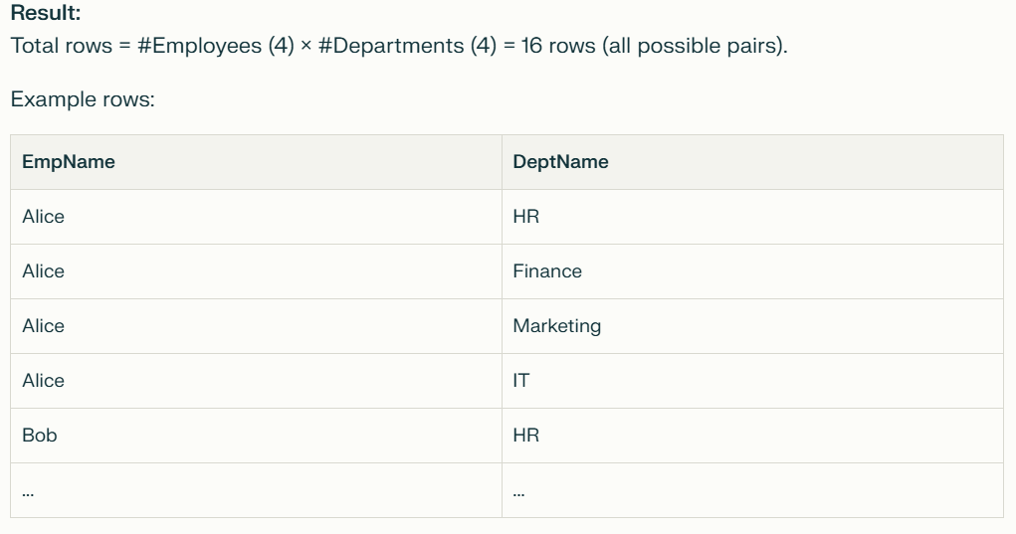
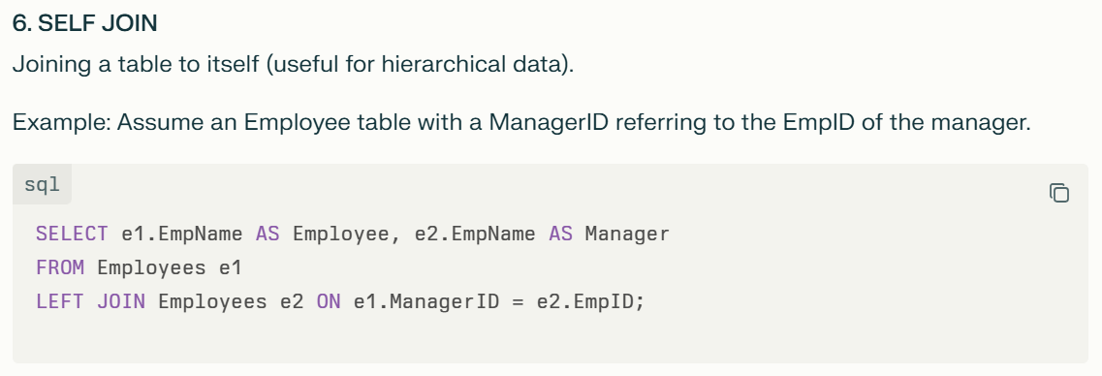
These joins allow flexible and powerful ways to combine related data across tables depending on the relationship and requirement.

What is the difference between UNION and UNION ALL?
What is normalization? Why we need that? Explain with example use case.
Normalization is a process in database design that organizes data to minimize redundancy and improve data integrity by dividing large tables into smaller, related tables and defining relationships between them.
Why Do We Need Normalization?
- Eliminates Data Redundancy: Each data item is stored only once, reducing duplication and saving storage space.
- Improves Data Integrity and Consistency: Changes to data appear consistently across the database as redundant copies are removed.
- Prevents Anomalies: Avoids insertion, update, and deletion anomalies that can cause inconsistent or lost data.
- Makes Data Organization Efficient: The database schema is clearer and easier to maintain.
- Easier Maintenance and Scalability: Adding or modifying data becomes simpler and safer, supporting growth.
- Improves Query Performance for Simple Operations: Smaller tables with less redundant data can be accessed and queried faster.
Example Use Case
Suppose we have a Library database that stores book and borrower details in one unnormalized table:
BookID | BookTitle | BorrowerName | BorrowerPhone
101 | "Data Science 101" | Alice | 1234567890
102 | "Machine Learning" | Bob | 9876543210
103 | "Data Science 101" | Alice | 1234567890
This table has redundancy: Alice’s details are repeated multiple times.
Normalized Version
Split data into separate tables:
BookID | BookTitle
101 | "Data Science 101"
102 | "Machine Learning"
- Books
- Borrowers
BorrowerID | BorrowerName | BorrowerPhone
1 | Alice | 1234567890
2 | Bob | 9876543210
BookID | BorrowerID
101 | 1
102 | 2
103 | 1
- Borrowed
Now:
- Borrower and book details are stored only once.
- Relationships are maintained via IDs.
- Data insertion, updates, and deletions are consistent and efficient.
Normalization organizes data logically, prevents duplication, and improves overall database quality and performance.

Primary Key Constraint vs Unique Key Constraint
Here is a detailed explanation of the difference between a Primary Key Constraint and a Unique Key Constraint in SQL, along with examples and a real use case:
Primary Key Constraint
- Purpose: Uniquely identifies each record in a table.
- Uniqueness: Ensures no duplicate values in the column(s).
- NULL values: Does NOT allow NULL values.
- Number per table: Only one primary key is allowed per table.
- Index: Creates a clustered index (by default).
- Use Case: Used as the main identifier for records, often referenced by foreign keys.
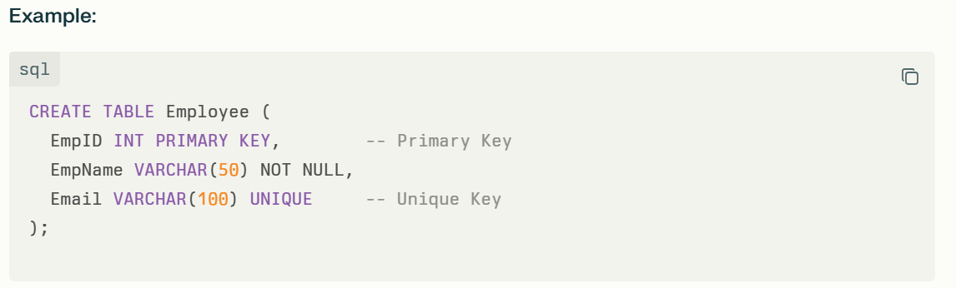
Unique Key Constraint
- Purpose: Ensures the column(s) contain unique values, preventing duplicates.
- Uniqueness: Ensures uniqueness except for NULL (can have one NULL).
- NULL values: Allows one NULL value.
- Number per table: Multiple unique keys can be defined in a table.
- Index: Creates a non-clustered index (by default).
- Use Case: Used to enforce uniqueness on columns other than the primary key, like email or phone number.
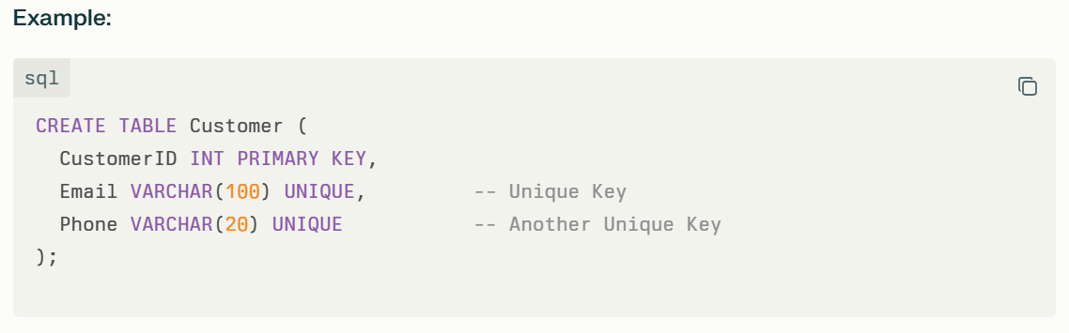
Real Use Case Scenario:
A company database has an Employee table where:
- EmpID is the unique identifier for each employee (Primary Key).
- The Email field must also be unique to prevent duplicate email addresses (Unique Key).
- Multiple unique keys can exist (e.g., unique email and unique phone).
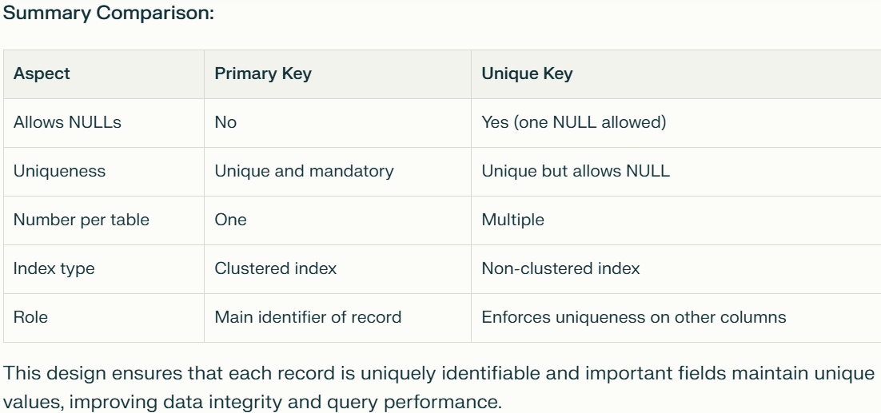

What are indexes? Explain cluster vs non-cluster indexes?
Indexes in a database are special data structures that improve the speed of data retrieval operations on a table, similar to an index in a book that helps quickly locate information without scanning every page.
What is an Index?
An index stores the values of one or more columns and pointers to the corresponding data rows. This allows the database engine to find rows faster than scanning the whole table.
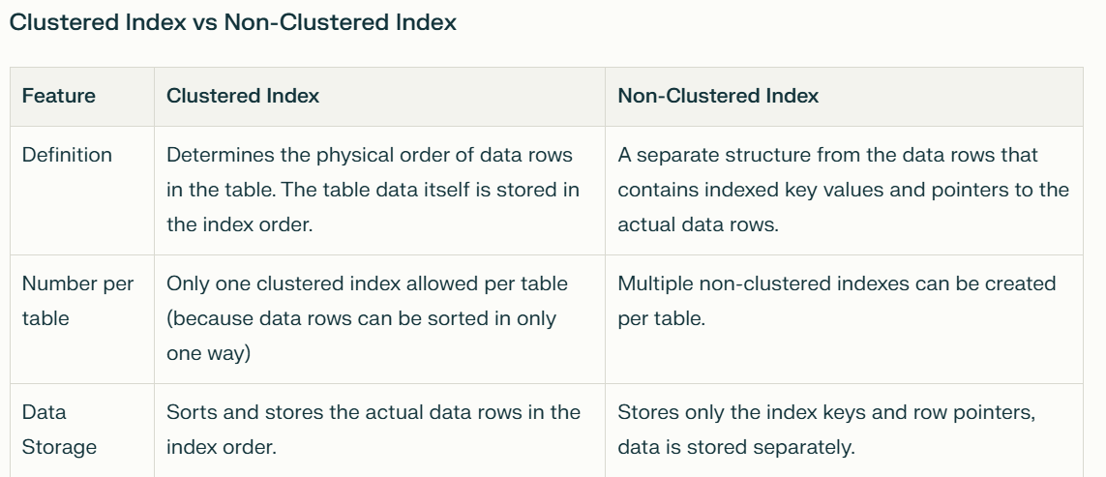
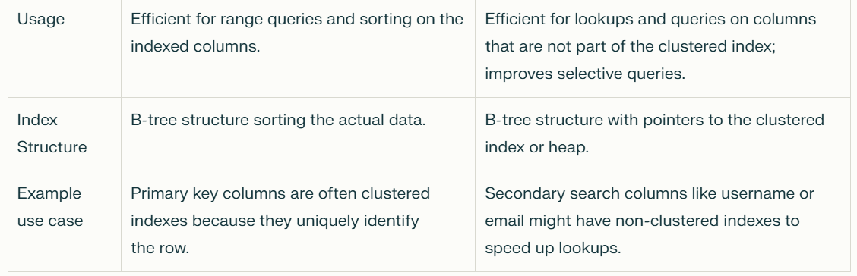
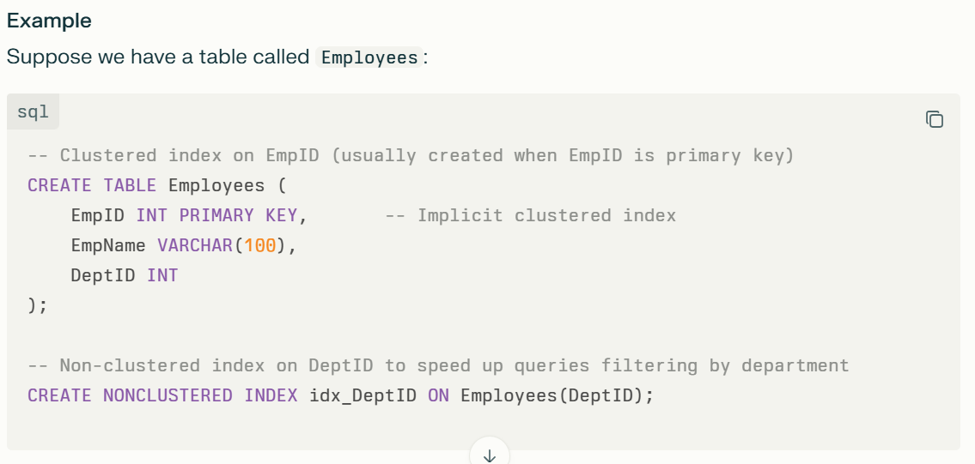
- The clustered index sorts the table by EmpID.
- The non-clustered index allows quick searching for employees by DeptID without scanning the whole table.
Summary
- Clustered Index: Sorts and stores the whole data rows physically in index order. Only one allowed per table.
- Non-Clustered Index: Separate from the data rows, stores pointers to data. Multiple allowed per table.
Indexes significantly improve query performance but come with additional storage and some maintenance overhead during data modifications.

Table scan vs Index scan
A Table Scan and an Index Scan are two different methods a database engine may use to access data in a table to satisfy a query.
Table Scan (Full Table Scan)
- The database engine reads every row in the entire table to find rows matching the query condition.
- This happens when no suitable index exists or when the optimizer estimates that scanning the whole table is cheaper than using an index.
- Table scans are expensive on large tables as it reads all pages sequentially.
- Usually occurs with small tables, or queries without filtering conditions (e.g., no WHERE clause).
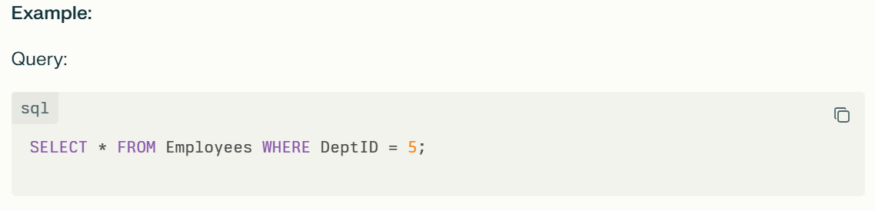
If there is no index on DeptID, the database performs a table scan scanning all rows to check which ones have DeptID = 5.
Index Scan
- The database engine scans the entire index rather than the whole table.
- The index is smaller and ordered based on the indexed columns, so scanning it can be faster than a table scan.
- It retrieves row references from the index and then accesses the corresponding rows in the table.
- Happens when a query filters on columns that are indexed but the filter is not very selective or the query requires scanning many rows.
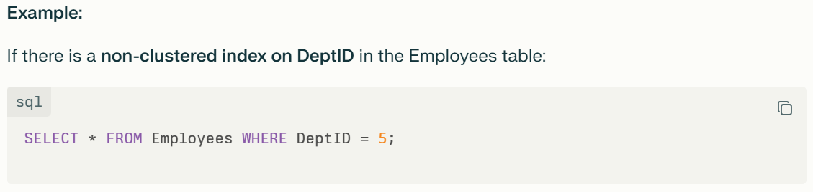
The engine will scan this index for matching DeptID values, then fetch the actual rows. This can be much faster than a full table scan.
Key Differences:
Aspect | Table Scan | Index Scan
Rows examined | All rows | Whole index entries scanned
Data access | Reads data rows from table | Reads rows referenced by index entries
Cost | High for large tables (reads all pages) | Lower especially if index is smaller
When used | No index exists or small table | Index exists but query scans many rows
I/O pattern | Sequential I/O | Random I/O (for fetching rows separately)
Summary:
- Table Scan is a brute-force search reading the whole table.
- Index Scan scans the index, which can be smaller and more efficient but involves random I/O to fetch actual rows.
Choosing between these depends on size of data, available indexes, and query selectivity.

What is a Schema? What is a Database? Explain these with hierarchy order.
Can we have multiple schemas in a database? In different schemas, can I have duplicate table names within the same database?

What is a subquery?
Can temp table columns have indexes?
Can we join a temp table with sql view?
What is Common Table Expression (CTE)
Differences between Common Table Expression and Temp Table
What are all the things needs to be considered while creating a new stored procedure?
Both Employees and Departments tables are having 3 records. But no matching records between these tables. Then what would be the output of the below query? Generate DDL and DML statements and after that explain the answer with the query result.
SELECT
E.EmployeeID,
E.EmployeeName,
D.DepartmentName
FROM
Employees AS E
FULL OUTER JOIN
Departments AS D
ON
E.DepartmentID = D.DepartmentID;

Find duplicate rows from a table? Duplicate criteria is all the column value will be duplicate
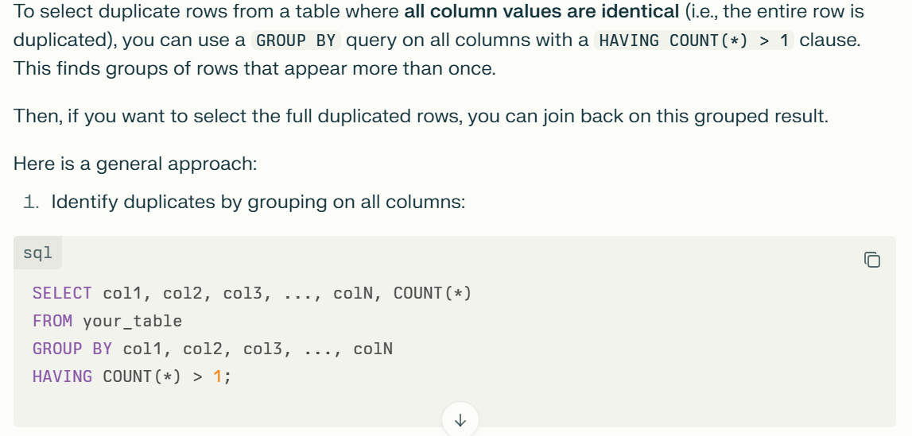

Temp store procedure vs Permenant stored procedure

