C# - Solid Principles
What is SOLID principle
Single Responsilby Pattern - https://youtu.be/27dhFPYBcIw?si=AhfHdLWffiT0h6AK
Open/Closed Principle - https://youtu.be/OAkyBnaCyDo?si=gEIzYvZbDpxHdPzl
Liskov Substitution Principle - https://youtu.be/DA_u3Etm9GE?si=ajuFVhul3xuIc_5T
Interface Segregation Principle
Dependency Inversion Principle
How the Dependency Inversion Principle getting inverted in .net core? Explain the IoC with example.
Can we use all the solid principle in one application?
How can we create a C# application that follows proper SOLID principles and design patterns to implement this logic in a way that can easily adapt to new future customer types?
User input will be CustomerName, CustomerType, and CustomerAddress.
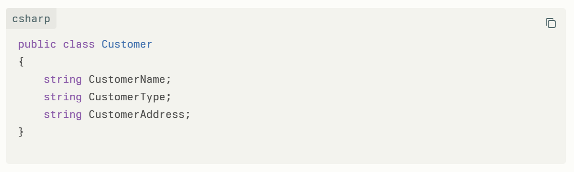
There is a table named CustomerDetails with the following columns:
- CustomerName
- CustomerType
- DiscountPercentage
- NotificationFreq
- NotificationType
- CustomerAddress
We need to calculate or generate values for the fields to insert into the CustomerDetails table based on the following rules:
- If CustomerType = "Gold":
  - DiscountPercentage = 10%
  - NotificationFreq = 3
  - NotificationType = "email"
- If CustomerType = "Silver":
  - DiscountPercentage = 5%
  - NotificationFreq = 1
  - NotificationType = "sms"

