Web APIs & Restful Services
Q1 – What are all the things needs to be considered while creating a new web Api project? Architect a C# microservices solution using OOP
- Explain how microservices communicate each other with example
- While consuming the REST API with the pagination, the application is experiencing the slow performance. How will you use the pagination effectively?
- HTTP status code 200, 201, 204, 401, 404, 500
- What is API versioning and how to do that? Example of .NET Core API versioning?
- How to achieve API versioning in .NET Core Web API project?
- API end point routing mechanisms in .NET Core Web API and how it works and example for this?
- Difference between PUT and Patch in Http methods with example in .NET Core Web API
- What factors will decide to choose Monolithic architecture or Microservices architecture
- Statefull and Stateless Apis?
- What is state management in the APIs?
I need the API endpoints (with fully qualified URLs) for the following operations in a .NET Core Web API:
- GetAllEmployee – Retrieve all employees
- GetEmployee – Retrieve a specific employee by ID
- AddEmployee – Add a new employee
- UpdateEmployee – Update an existing employee
Please provide:
- HTTP Method for each operation
- Relative route (API path)
- Fully managed/qualified URL assuming a base URL like https://yourdomain.com
- Example controller setup in C#
Generate a full example including model and repository patterns

Here is a comprehensive example for the requested .NET Core Web API employee CRUD operations including:
- Fully qualified API endpoints with URLs
- HTTP methods and routes
- Model class
- Repository pattern for data access
- Controller setup
Assuming base URL: https://yourdomain.com
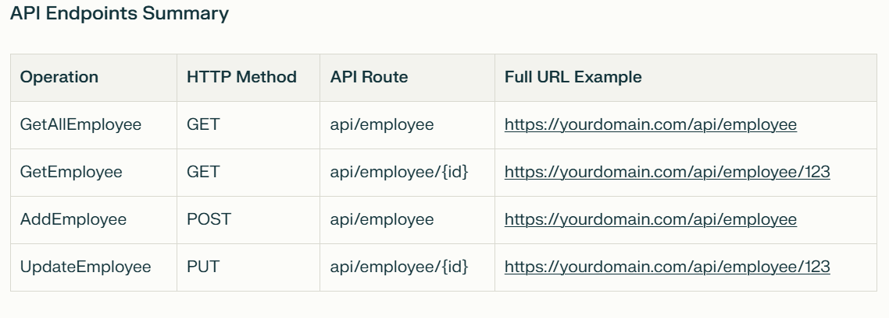
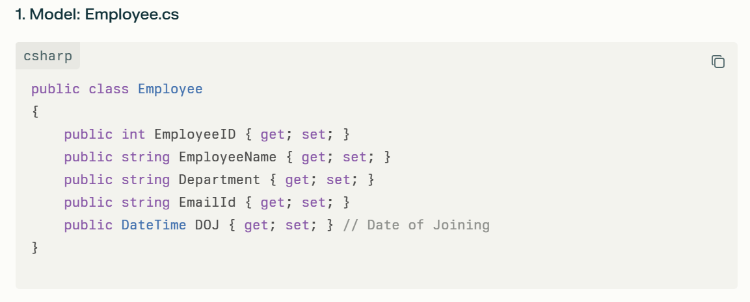
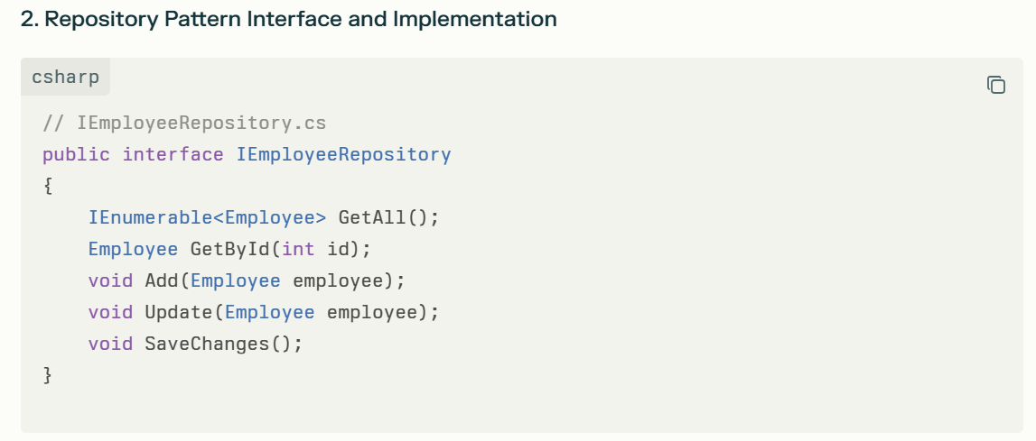
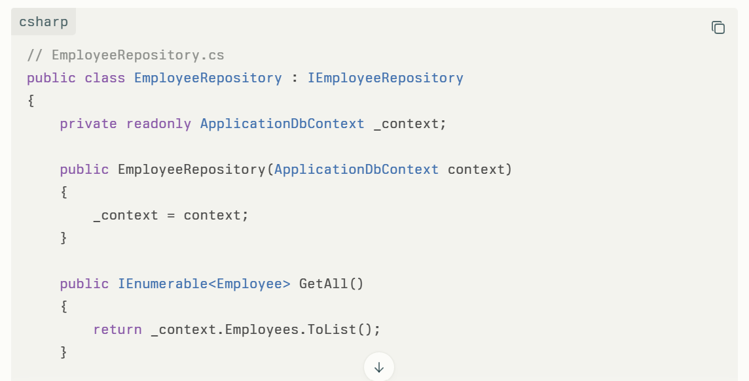
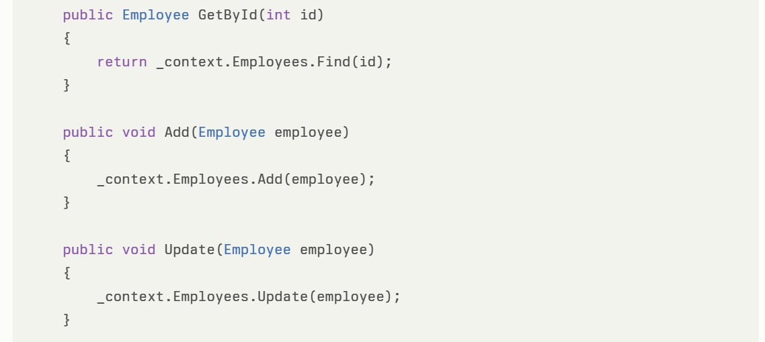
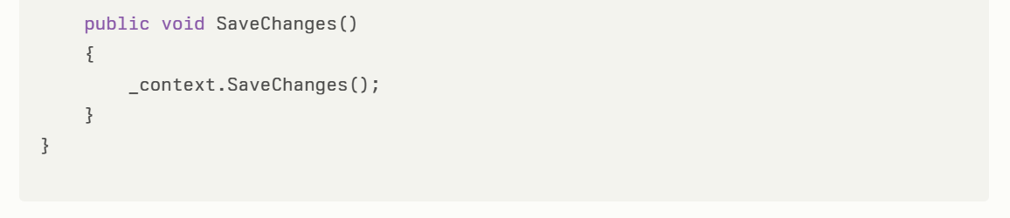

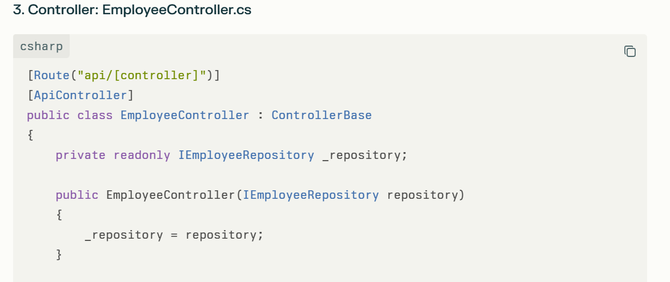
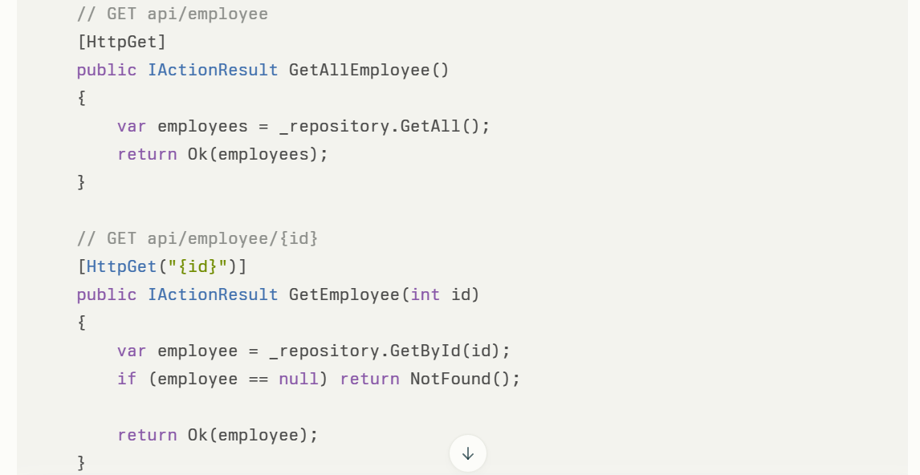
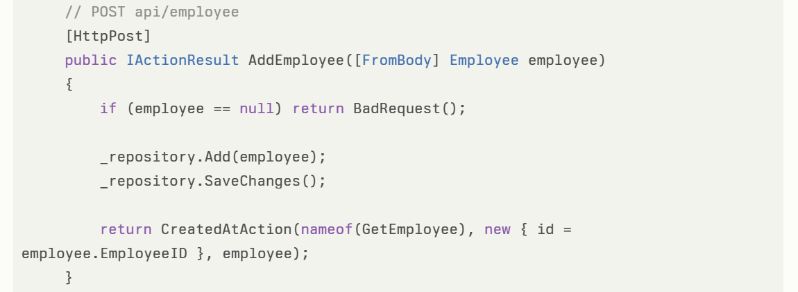
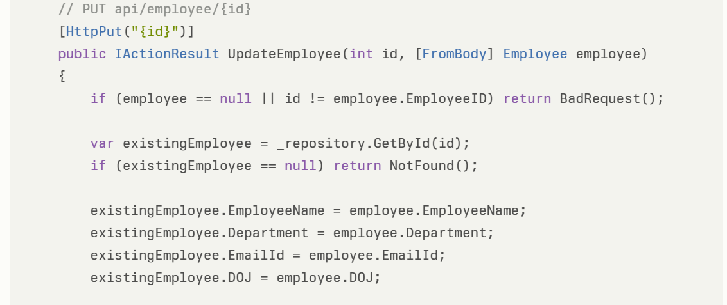
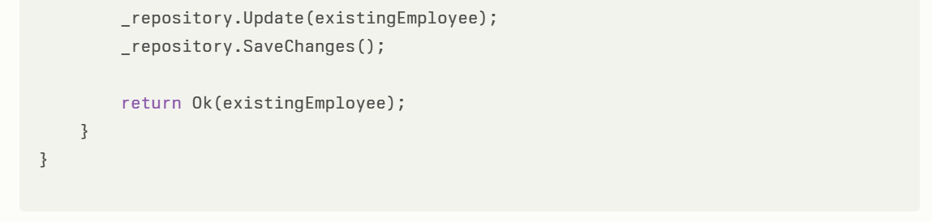
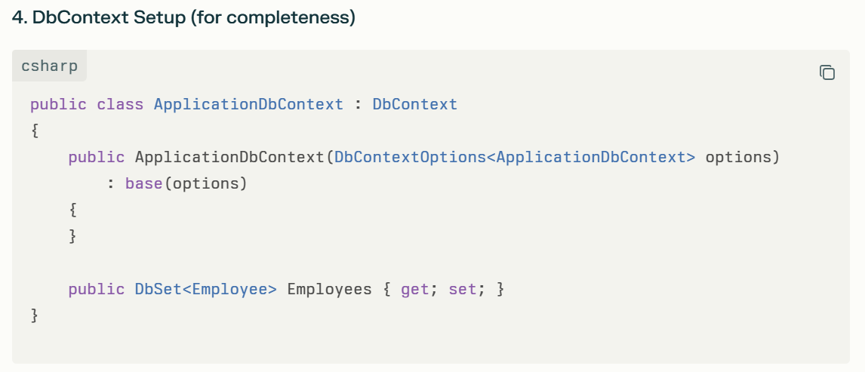
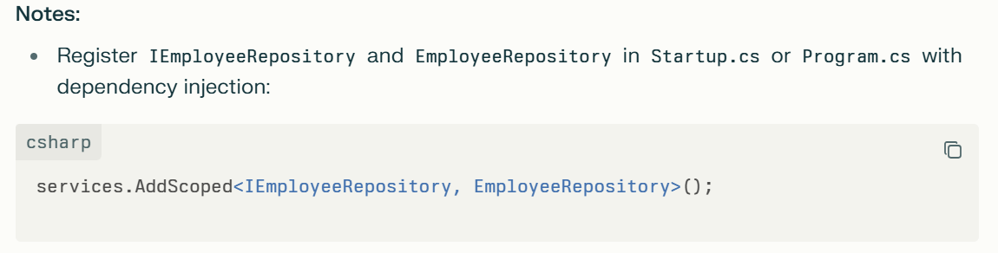
- Use Entity Framework Core for database operations.
- The example uses an integer EmployeeID as the primary key; you can adapt it to GUID if preferred.
- CRUD operations follow RESTful conventions with HTTP methods: GET, POST, PUT.
This structure provides a clean separation of concerns and is aligned with .NET Core Web API best practices.

