C# - OOPS
The four pillars of Object-Oriented Programming (OOP) in C# are Encapsulation, Abstraction, Inheritance and Polymorphism.

Abstraction
Abstraction in C# Object-Oriented Programming (OOP) is the concept of hiding implementation details and exposing only the necessary features of an object. It helps in reducing complexity and increasing efficiency by allowing users to focus on what an object does rather than how it does it.
When to Use Abstraction?
- Hide Complexity: When implementation details are unnecessary for the user and should be concealed.
- Improve Code Maintenance: To ensure that changes in implementation do not affect users of the class.
- Enhance Security: By restricting direct access to the implementation details.
- Define Contracts: When creating reusable components that provide a standard interface to interact with objects.
- In what aspects we should choose abstract classes or interfaces?
Here is a clear and concise example demonstrating Abstraction in C# using an abstract class, suitable for .NET 8:
A real-world example of abstraction in C# can be seen in domains like online payments or hospital management systems, where you want to hide complex implementation details and expose only essential functionality.
💳 Example: Payment Processing System
Imagine a hospital system that needs to process payments for medical services. Different payment methods (Credit Card, Insurance, Digital Wallet) exist, but the hospital staff shouldn’t worry about how each one works internally. They just need a simple interface to process payments.
C# Code
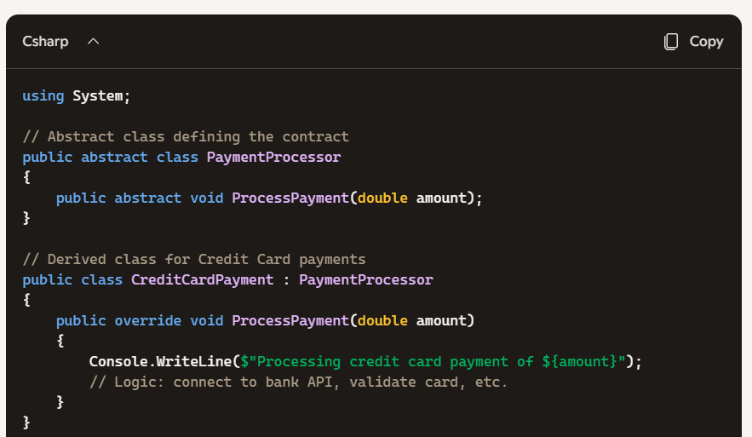
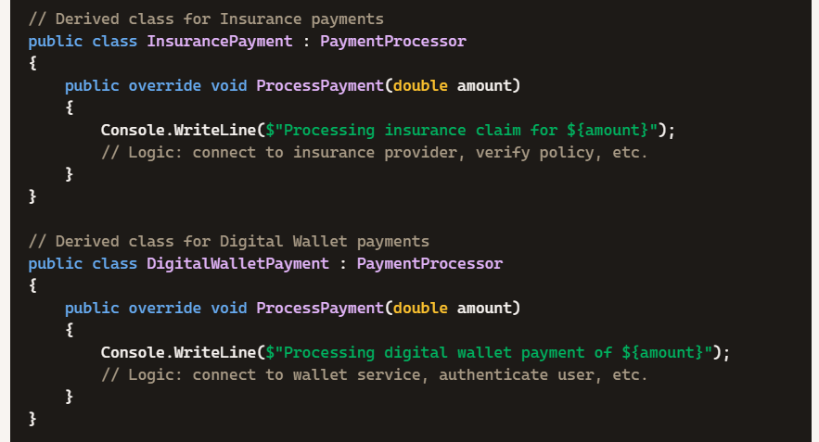
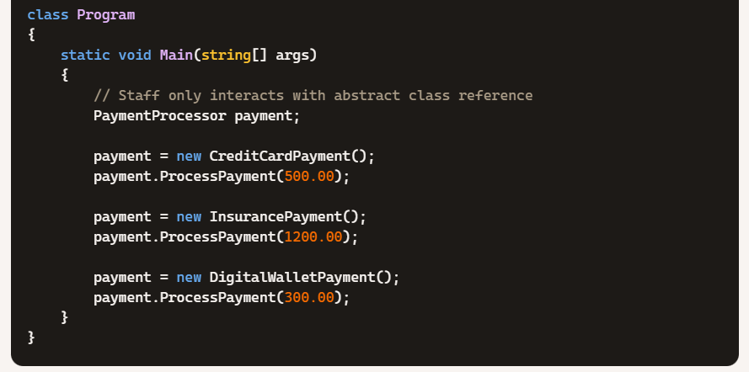
🔍 Explanation
- Abstract Class (PaymentProcessor) Defines the contract for processing payments. It doesn’t care about the details of credit card, insurance, or wallet systems.
- Derived Classes (CreditCardPayment, InsurancePayment, DigitalWalletPayment) Each provides its own implementation of ProcessPayment().
  - Credit card → Bank API
  - Insurance → Insurance provider system
  - Wallet → Wallet service
- Client Code (Program) Uses the abstract class reference. This means the hospital system can easily switch between payment methods without changing the core logic.
🏥 Real-World Application
In a hospital management system:
- Doctors and staff don’t need to know the technical details of how payments are processed.
- Abstraction ensures security, modularity, and flexibility.
- If a new payment method (e.g., UPI in India) is added, you just create a new derived class without touching existing code.

Question: If a new payment method (e.g., UPI in India) is added, you just create a new derived class without touching existing code. For this statement, if we add new payment method which is consider existing code here? the Program class?
Ans:
🧩 What Counts as Existing Code?
- Base Class (PaymentProcessor) This is part of the existing code. It defines the abstract contract (ProcessPayment) that all payment methods must follow. You don’t need to change this when adding a new payment method, unless you want to add new behaviors that apply to all processors like (CreditCardPayment, InsurancePayment, DigitalWalletPayment)
- Derived Classes (CreditCardPayment, InsurancePayment, DigitalWalletPayment) These are also existing code. They already implement the contract. You don’t touch them when adding UPI.
- Program Class (Client Code) This is where you use the payment processors. If you want to actually call the new UPI payment method, you’ll add a line here to instantiate and use it. Technically, this is the only place you’d “touch” when integrating the new class into your workflow.
🏦 Adding UPI Payment Example
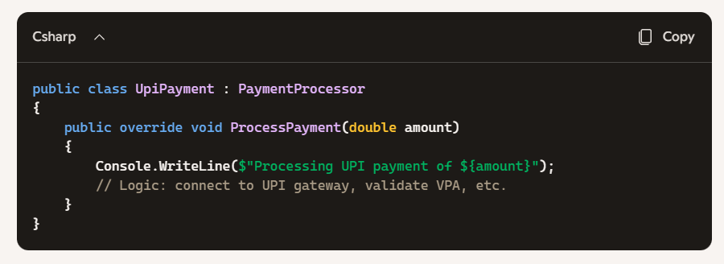

Program Class Update
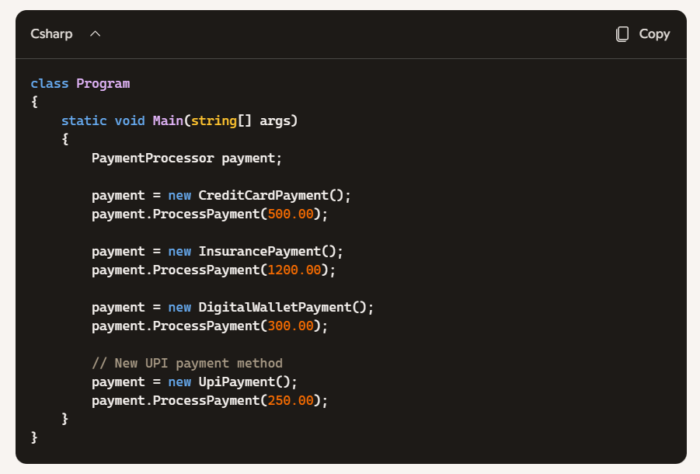
🔍 Key Insight
- Existing code = Base class + already implemented derived classes.
- Minimal change = Only the Program class (client code) needs a new line to use the new derived class.
- The beauty of abstraction: you don’t rewrite or modify existing payment classes, you just extend the system with a new one.

Question: What is the difference between abstract and virtual methods in C#? Since both use override in derived classes, how are they different?
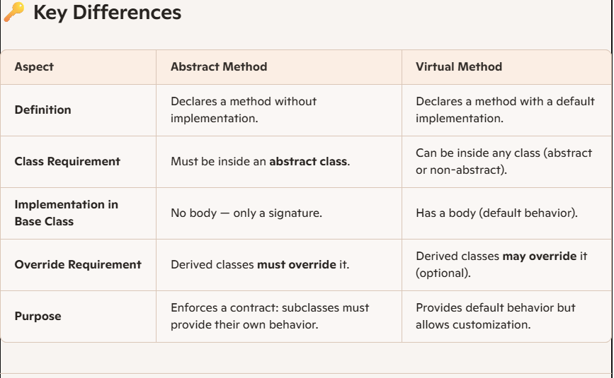

Question: Abstract vs Dependency injection vs Factory pattern. Explain these with example code with real time use case. When to use what?
Let’s break down Abstract Classes, Dependency Injection (DI), and the Factory Pattern in C#, with real-world healthcare use cases. They often overlap in purpose but solve different problems.
🩺 1. Abstract Classes
Purpose: Define a contract that all subclasses must follow. When to use: When you want to enforce that every derived class implements certain critical methods.
Example: Medical Record Storage
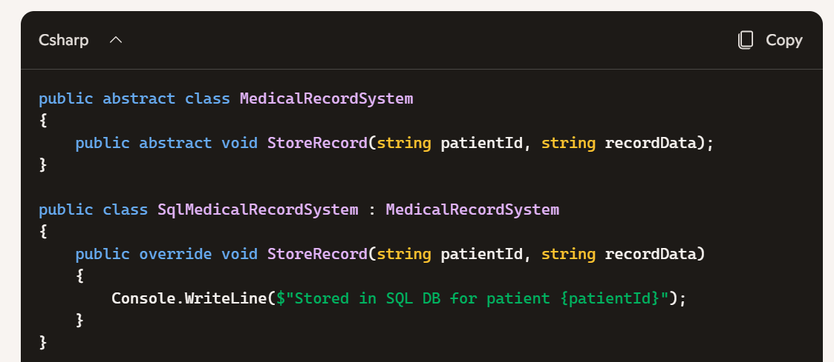
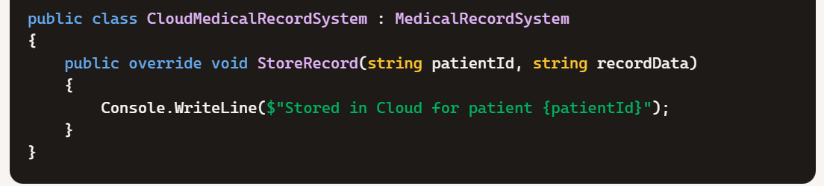
➡ Abstract ensures every system must implement StoreRecord.
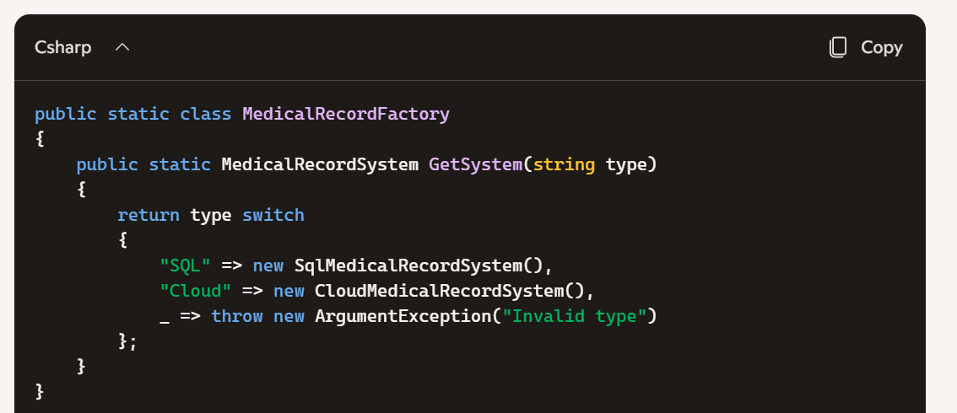
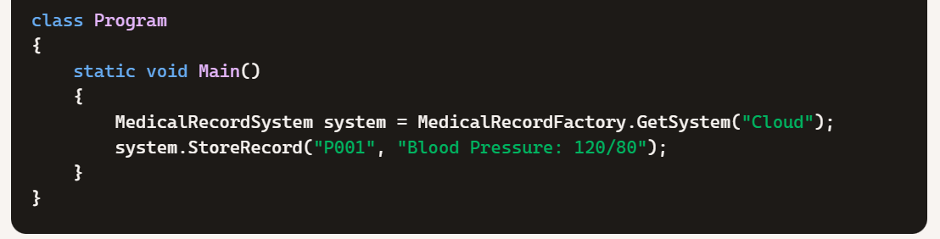
➡ Factory lets you add new storage types (e.g., FileSystem) without rewriting Program.

🏭 2. Factory Pattern
Purpose: Centralize object creation logic. When to use: When you want to decide at runtime which implementation to use, without changing client code.
Example: Choosing Storage Backend
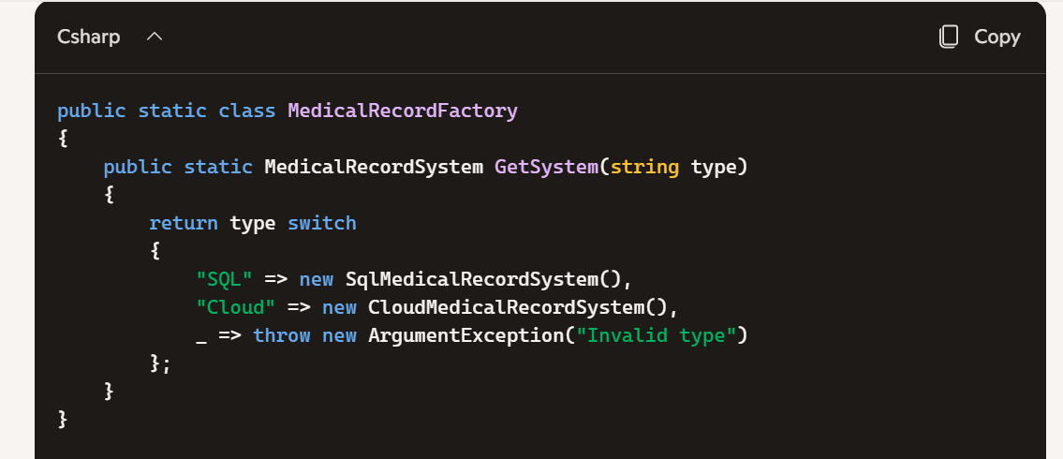
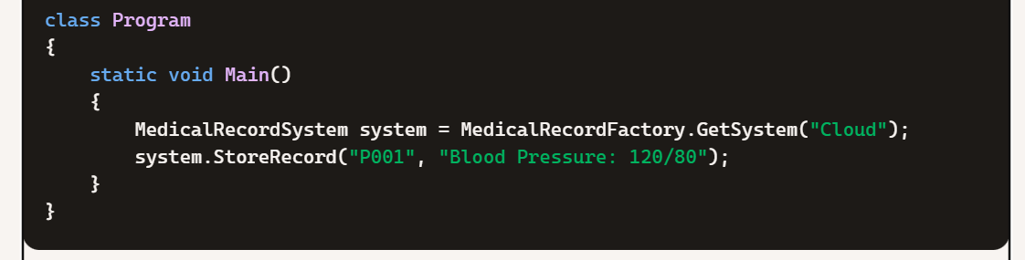
➡ Factory lets you add new storage types (e.g., FileSystem) without rewriting Program.

💉 3. Dependency Injection (DI)
Purpose: Invert control — let external configuration decide which implementation to inject. When to use: In large applications where you want flexibility, testability, and loose coupling.
Example: Injecting Storage System
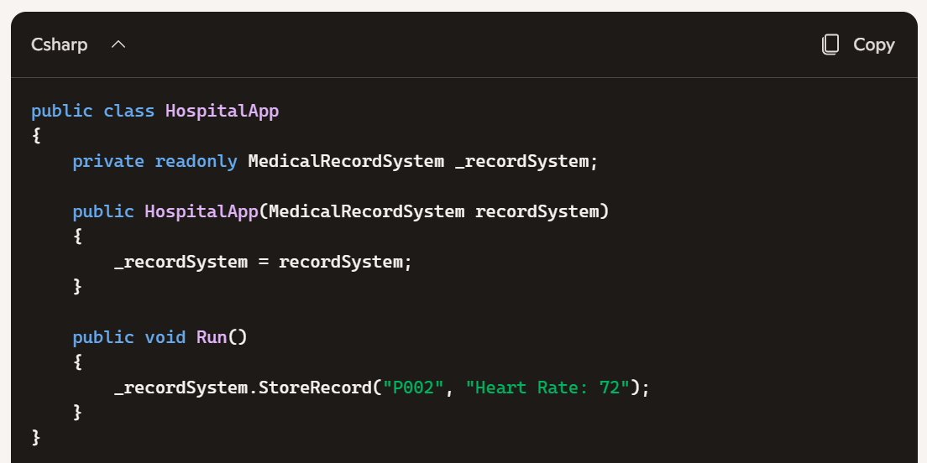
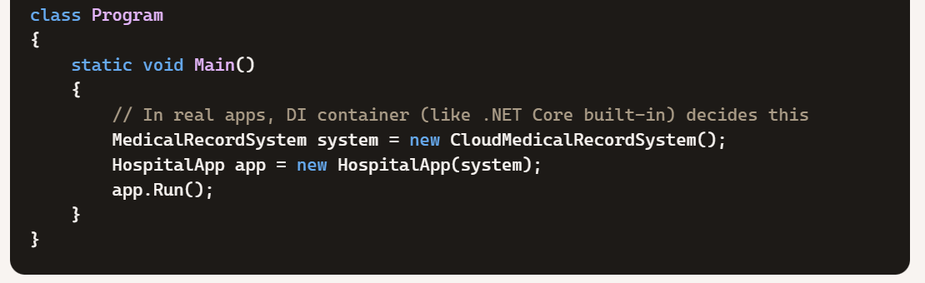
➡ DI allows swapping implementations (SQL, Cloud, FileSystem) without touching HospitalApp.
🔍 When to Use What?
- Abstract Class → Use when you want to enforce a contract across all implementations. Example: Every medical record system must implement StoreRecord.
- Factory Pattern → Use when object creation depends on runtime decisions. Example: Choose between SQL or Cloud storage based on hospital configuration.
- Dependency Injection → Use when you want maximum flexibility and testability in large systems. Example: Inject different storage systems into hospital apps without changing business logic.
🎯 Insight
Think of it like this:
- Abstract = “Every system must do this.”
- Factory = “I’ll decide which system to create.”
- DI = “I don’t decide — someone else injects the right system.”

Encapsulation
Encapsulation is an object-oriented programming principle that involves bundling data (variables) and methods (functions) that operate on that data into a single unit, typically a class. It also restricts direct access to some of an object's components, which is a way to protect the internal state of the object and only allow controlled access through public methods or properties.
Key Concepts:
- Data members of a class are typically declared as private to hide them from external access.
- Public properties or methods (getters and setters) are provided to access and update the private data safely.
- This mechanism is also known as data hiding.

Benefits of Encapsulation:
- Data protection: Prevents unauthorized or accidental modifications to sensitive data.
- Controlled access: Allows you to control how the data is accessed or modified, often including validation.
- Improved maintainability: Internal implementation can be changed without affecting external code using the class.
- Enhanced flexibility: You can make data read-only, write-only, or fully accessible by controlling the accessors.
- Increased modularity: Encapsulated classes are self-contained and easier to understand and manage.

Simple Example in C#
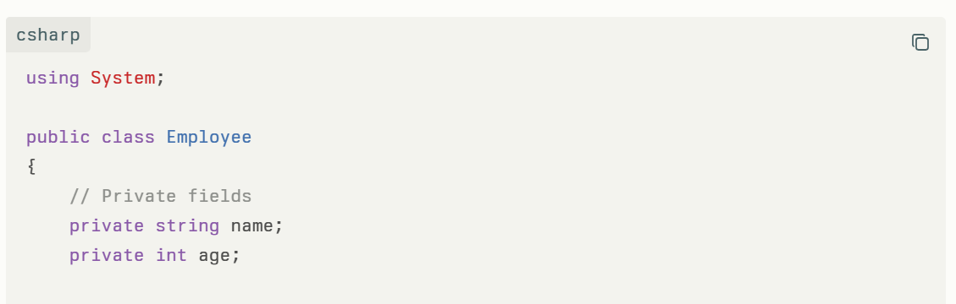
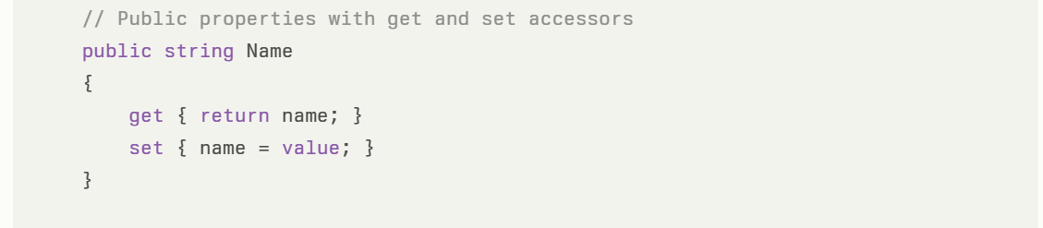
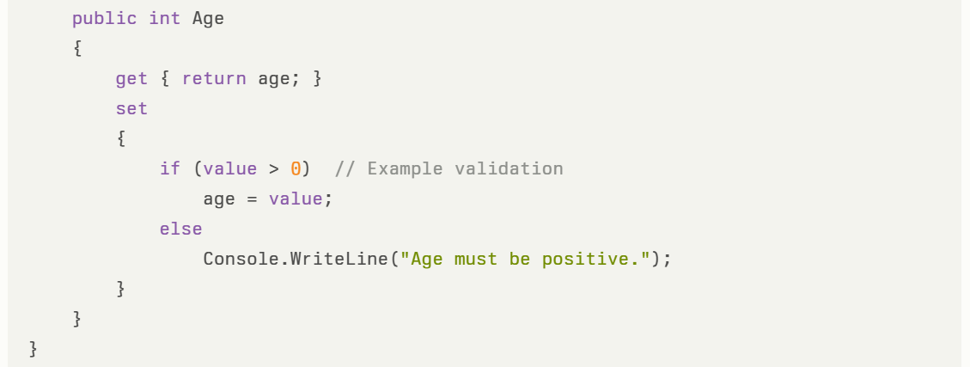
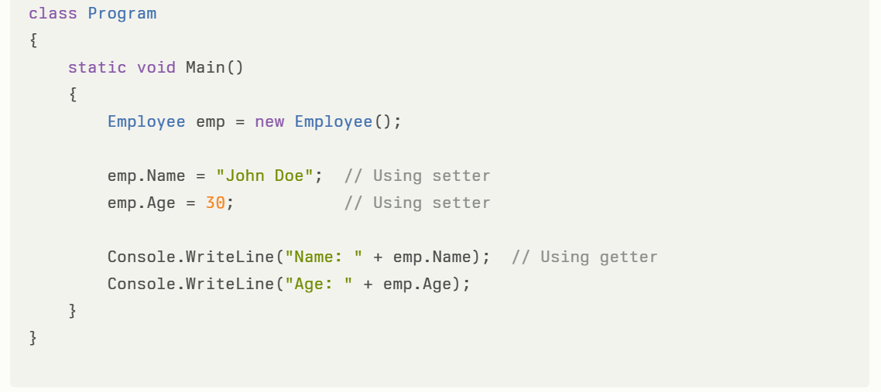

This example shows encapsulation by:
- Keeping name and age fields private.
- Allowing controlled access only through the public properties Name and Age.
- Adding validation inside the Age property setter to prevent invalid assignment.

Encapsulation is fundamental in C# because it protects data integrity and ensures that objects maintain valid states throughout their lifetimes.

Access Modifiers in C#
Access modifiers define the visibility and accessibility of classes and their members:
Access Modifier | Description
private | Accessible only within the containing class
public | Accessible from anywhere
protected | Accessible within the containing class and derived classes
internal | Accessible within the same assembly
protected internal | Accessible within derived classes OR the same assembly

Provide an example for each of the following Access Modifiers in C#:
- private
- public
- protected
- internal
- protected internal

Inheritance
Inheritance is a fundamental Object-Oriented Programming (OOP) concept in C# that allows a class (called the derived or child class) to inherit properties and behaviour (fields and methods) from another class (called the base or parent class). This promotes code reusability and establishes a natural hierarchy between classes.
Types of Inheritance in C#
- Single Inheritance: One derived class inherits from one base class (as in the example above).
- Multilevel Inheritance: A class inherits from a derived class, forming a chain.
- Hierarchical Inheritance: Multiple derived classes inherit from a single base class.
- Multiple Inheritance: C# does not support multiple inheritance with classes but supports it using interfaces.

What is the output from below code?
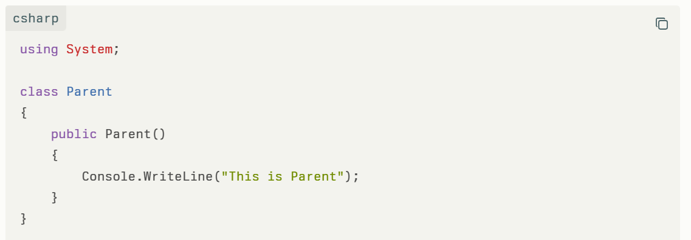
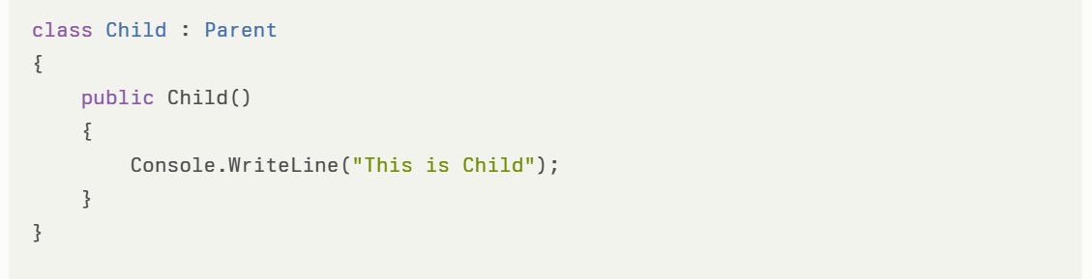
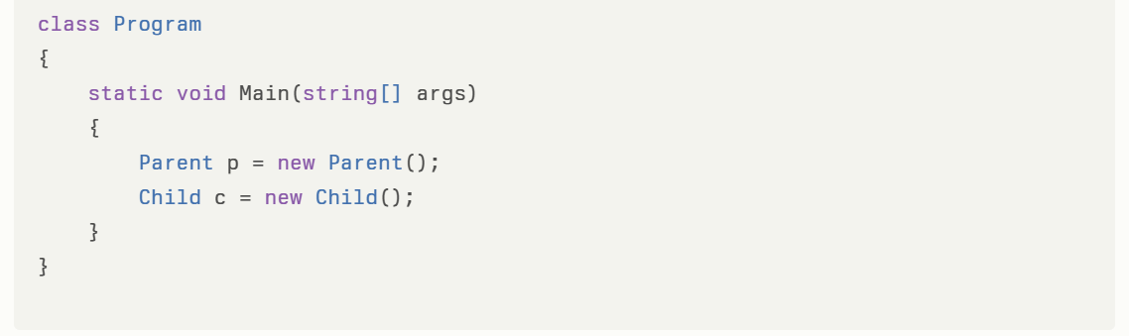
Explanation:
- Console.WriteLine calls are inside constructors to print messages when instances are created.
- The Main method instantiates Parent and Child objects to trigger the prints.
- The output will be:
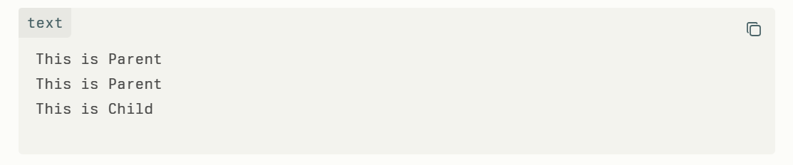
In C#, every class implicitly inherits from System.Object.
Given the following code:
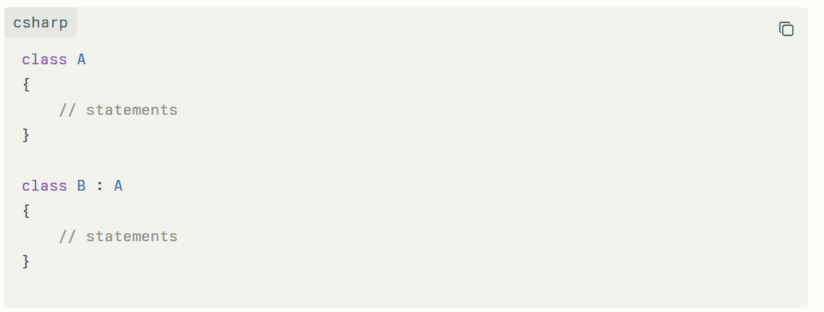
Can we say that the above code is an example of multiple inheritance?
If yes, why? If not, why not?
Please explain at the conceptual level.

1. Inheritance in C#
- In C#, inheritance means creating a new class (child/derived class) from an existing class (parent/base class).
- The derived class automatically gets access to the fields, properties, and methods of its parent class (unless restricted by access modifiers).
- Syntax:
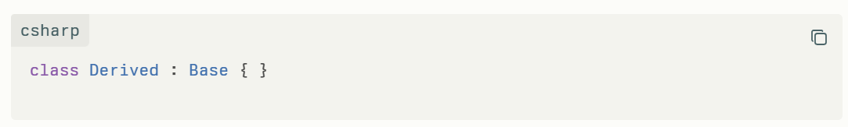

2. System.Object – The Root of All Classes
- In C#, every class directly or indirectly inherits from System.Object.
- This means whether you specify it or not, each class has the methods of System.Object, such as ToString(), Equals(), GetHashCode(), etc.
- Example:
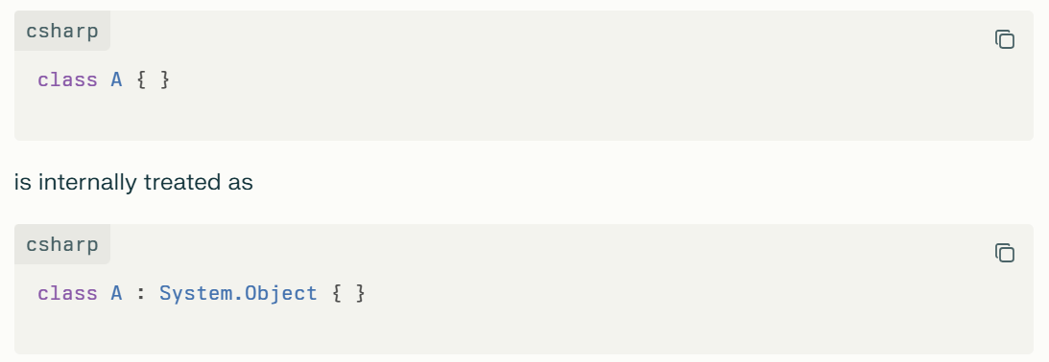
So, in your example:
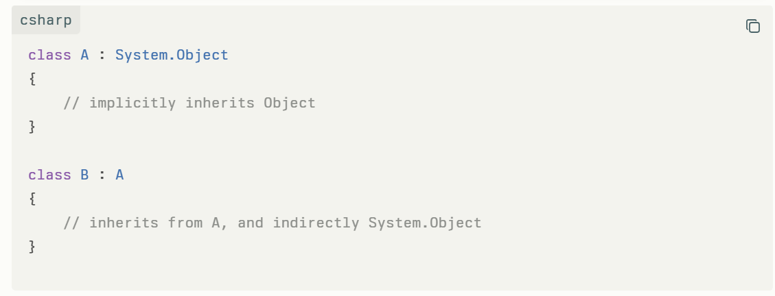
What is Multiple Inheritance?
- Multiple inheritance means a class can inherit from more than one direct base class.
- For example (hypothetical, not allowed in C#):
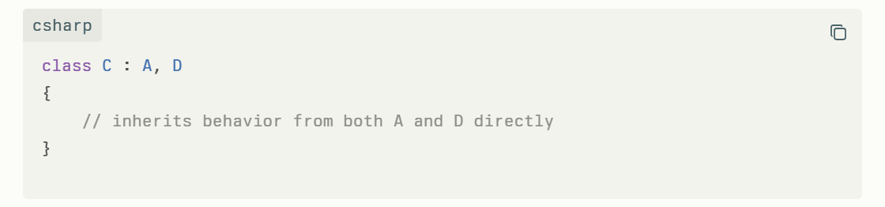
- This often creates problems like the diamond problem (ambiguity when two parent classes define the same method).
4. Does C# Support Multiple Inheritance?
- No. C# does not allow multiple inheritance with classes.
- A class in C# can only inherit from one base class.
- However, C# allows implementing multiple interfaces, which gives many of the benefits of multiple inheritance in a controlled manner.
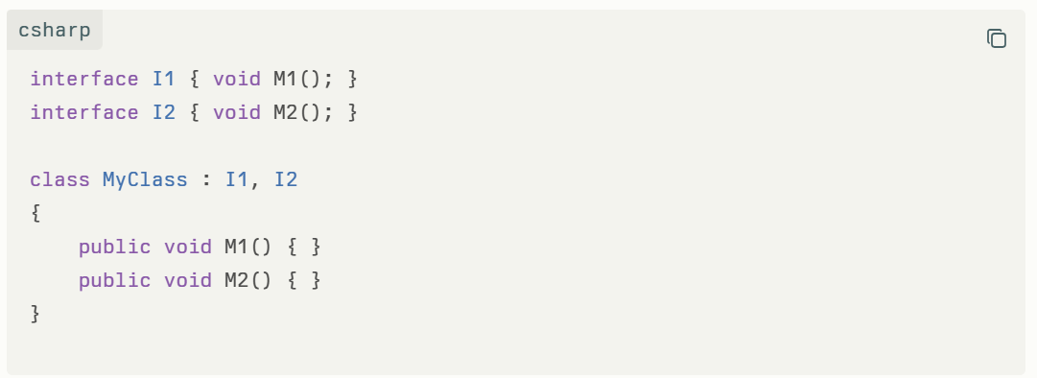
5. Answer to Your Question
Each class is inheriting from System.Object. With this statement can we say the below C# code is using multiple inheritance?
No, it is not multiple inheritance.
- Class A directly inherits from System.Object.
- Class B inherits from Class A. Since A already inherits from System.Object, B indirectly inherits from System.Object as well.
- But Class B has only one direct parent class (A). This is single inheritance, not multiple inheritance.
If it were multiple inheritance, Class B would need to inherit from two or more base classes at the same time, which is not possible in C#.

6. Conceptual Summary
- All classes in C# inherit (directly or indirectly) from System.Object.
- This doesn’t make your example multiple inheritance, because there is only one direct parent (A).
- C# supports single inheritance with classes and multiple inheritance through interfaces.

✅ So the precise answer:
➡️ No, the given code is not using multiple inheritance.

Polymorphism
Polymorphism means "many forms." It is an important concept in Object-Oriented Programming (OOP) that allows methods or objects to take multiple forms depending on the context.
In C#, polymorphism lets you use the same method name to perform different tasks based on the object or parameters provided.

Types of Polymorphism
- Compile-Time Polymorphism (Static Polymorphism)
  - Achieved through method overloading or operator overloading.
  - The method to invoke is determined at compile time based on method signatures.
- Run-Time Polymorphism (Dynamic Polymorphism)
  - Achieved through method overriding.
  - The method to invoke is determined at runtime based on the object's actual type.
  - Requires inheritance and virtual/override methods.

Example of Compile-Time Polymorphism (Method Overloading)
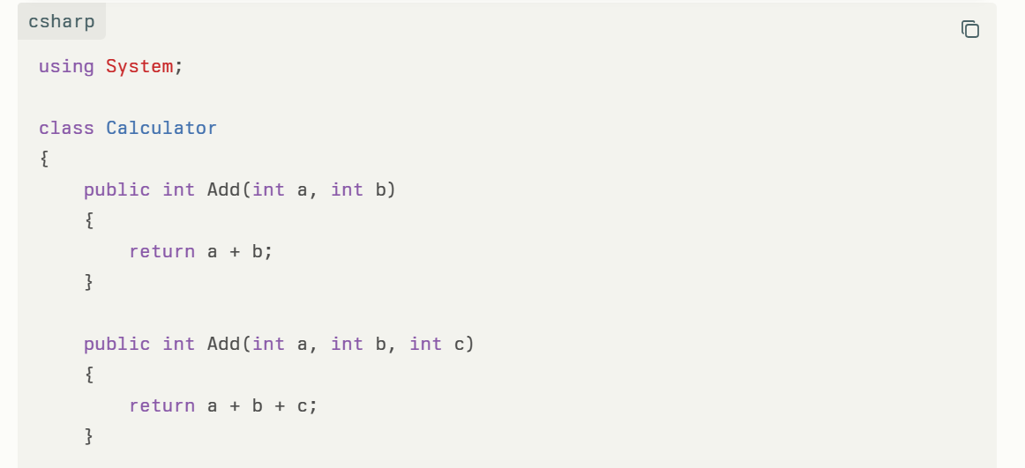
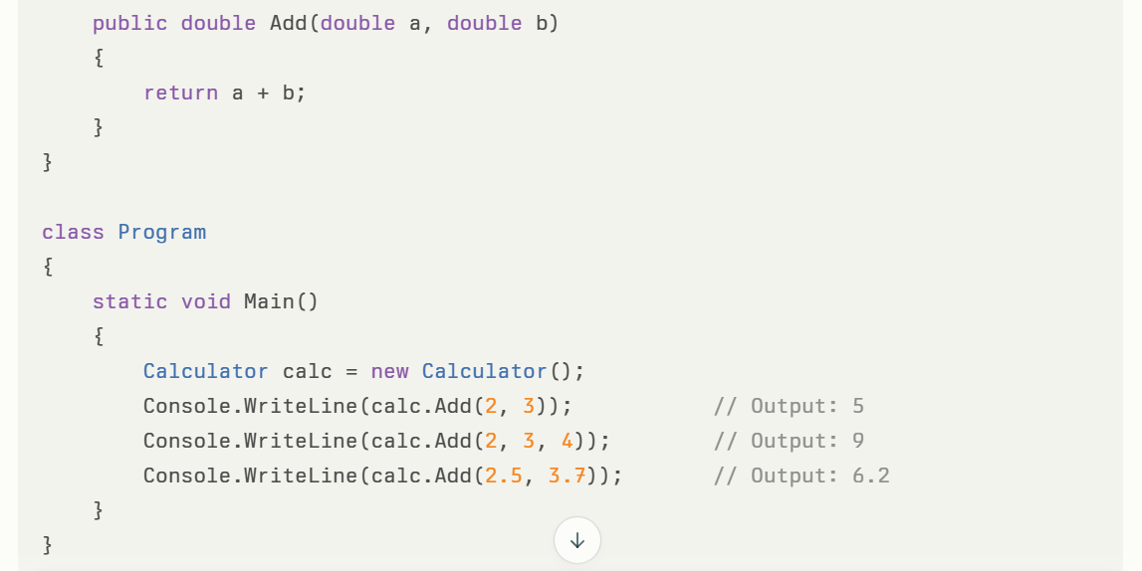

Example of Run-Time Polymorphism (Method Overriding)
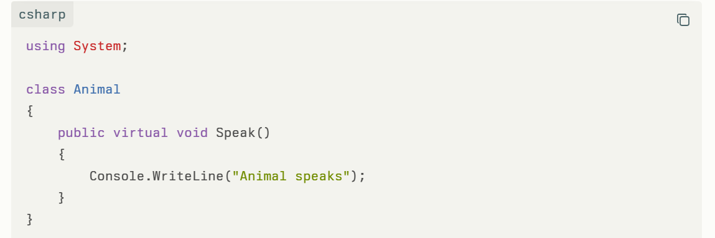
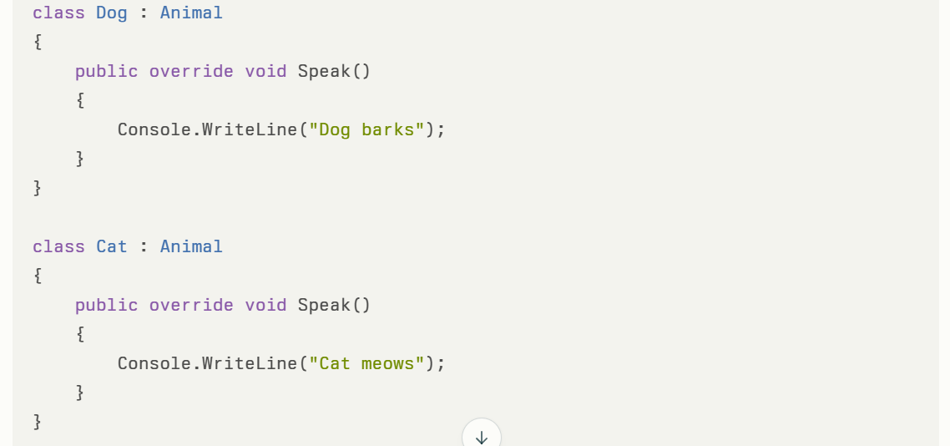
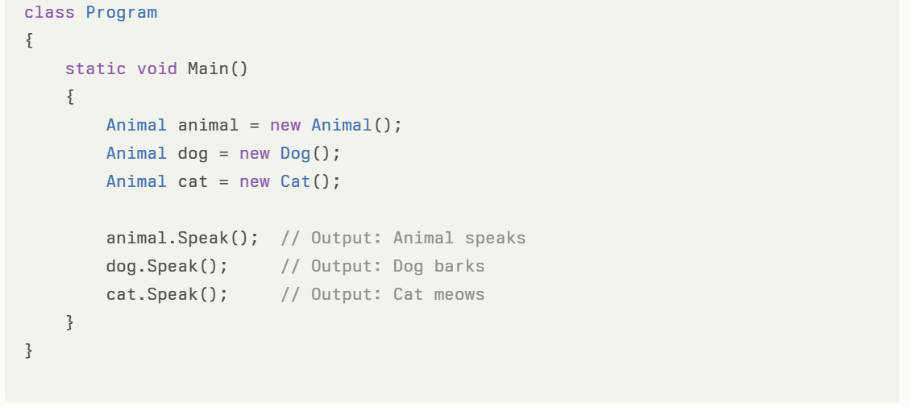
Summary
- Polymorphism allows objects to be treated as instances of their base class, but behave differently depending on their actual derived class.
- It improves code flexibility, extensibility, and reuse.
- Achieved by method overloading (compile-time) and method overriding (run-time).
What is Method Overriding?
Method overriding in C# is a feature of inheritance where a derived class provides a new implementation for a method that is already defined in its base class. The base class marks the method with the virtual keyword, allowing derived classes to override it using the override keyword. The method in both classes must have the same signature (name, return type, and parameters).
Code Snippet
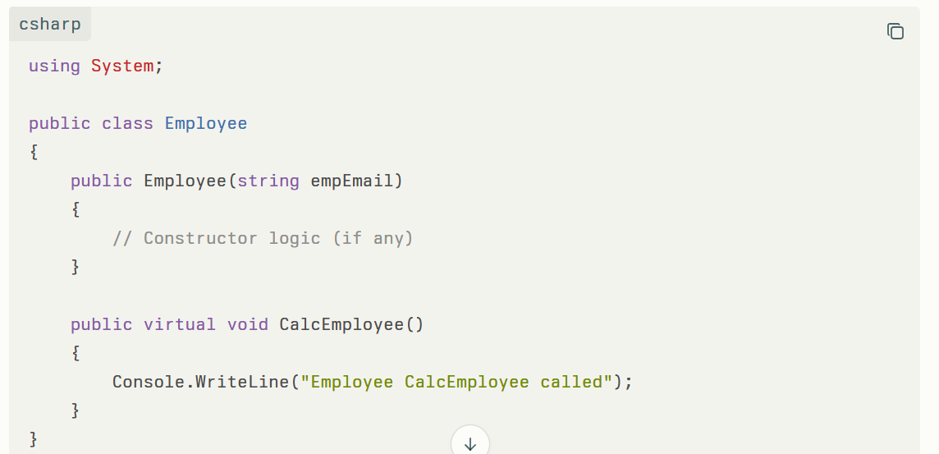
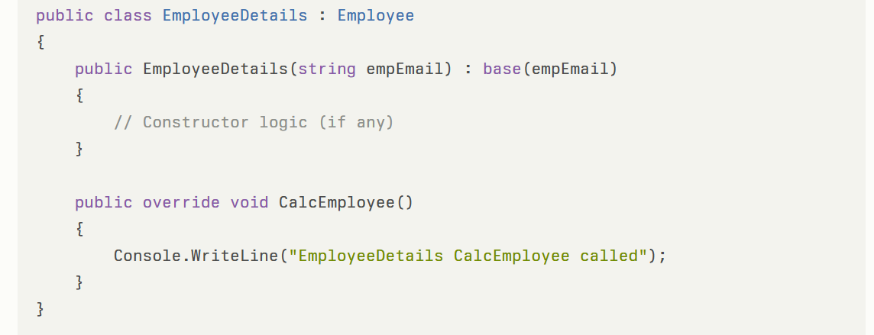
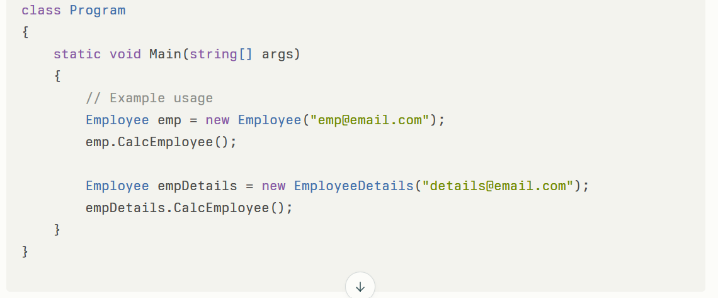
Yes — the approach shown in your code is Method Overriding in C#. ✅
Here’s why:
- You have a base class (Employee) with a virtual method CalcEmployee().
- The derived class (EmployeeDetails) uses the override keyword to provide its own implementation of that method.
Key points about method overriding:
- virtual: Marks a method in the base class as overridable.
- override: Replaces the base class implementation in the derived class.
- Polymorphism: When you call CalcEmployee() on a variable of type Employee, it will execute the derived class implementation if the object is of type EmployeeDetails.
Example of runtime polymorphism in your case:
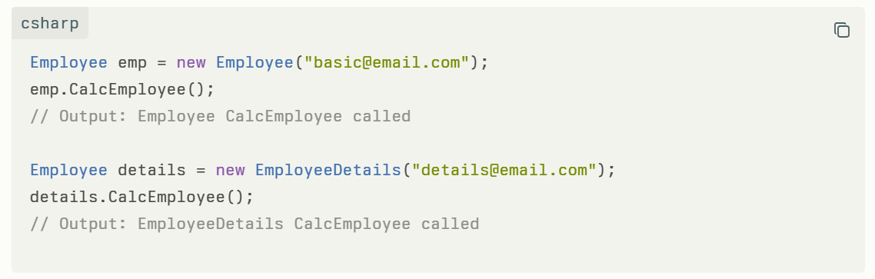
In your example:
- The base class Employee defines a virtual method CalcEmployee().
- The derived class EmployeeDetails overrides this method to provide its own specific behavior.
When you call CalcEmployee() on a base class reference that points to a derived class object, the derived class implementation is executed:
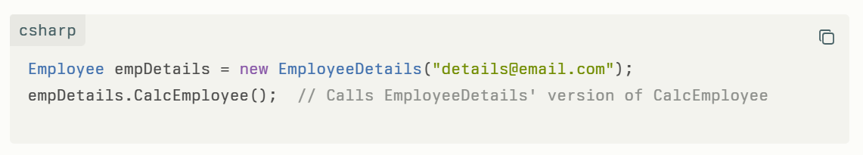
Benefits of Method Overriding for Future Extension
- Runtime Polymorphism:
It enables dynamic method dispatch—the program decides at runtime which method version to invoke depending on the actual object type. This supports flexible and extensible designs.
- Code Reusability and Maintainability:
Base classes implement common/shared logic, while derived classes can customize or extend this behavior without modifying the base class, adhering to the Open/Closed Principle (open for extension, closed for modification).
- Extensibility:
New derived classes can be added in the future to override base methods and provide specialized behavior without affecting existing code.
- Simplified Interface:
Clients of these classes can interact with base class references or interfaces without knowing the detailed implementation, but still benefit from overridden behaviors in subclasses.
Applying This to Your Code
If in the future you want to add new employee types with different calculations, you can simply create new subclasses and override CalcEmployee():
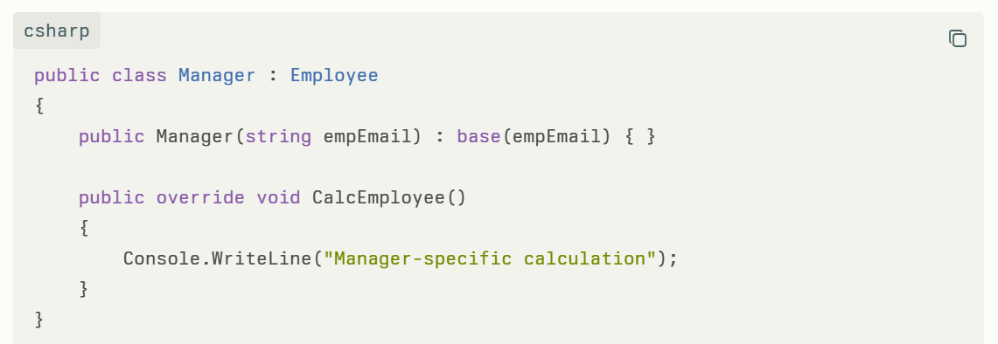
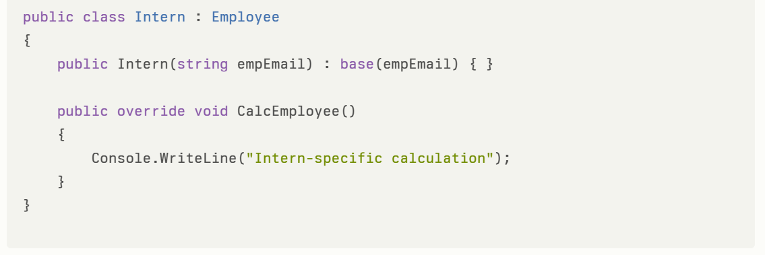
This keeps your design flexible and easily extendable without changing the base class.

In summary, method overriding supports polymorphism and clean extensible design by allowing derived classes to tailor or replace base class behaviors, which is critical for maintainable and scalable object-oriented systems.

Will this code work? Explain it.
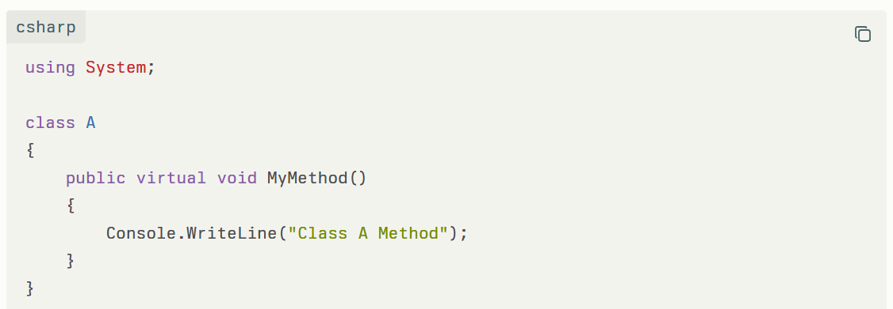
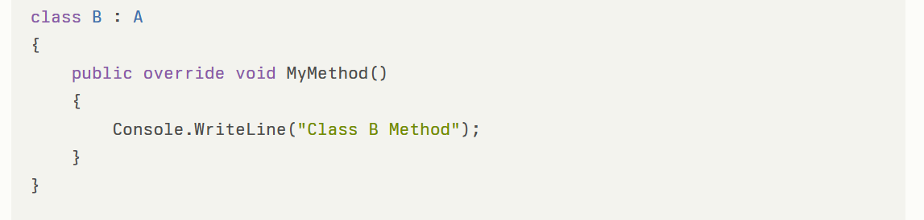
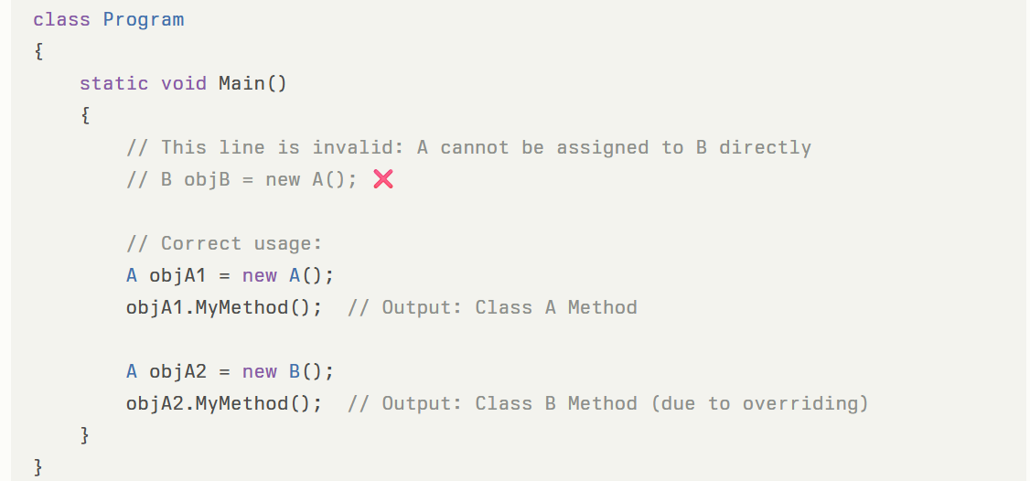
Fixed invalid instantiation:
- B objB = new A(); is invalid because a base-class object cannot be assigned to a derived type.
- Correct is A objA = new B(); (polymorphism works here).
Here’s our final working code again for reference:
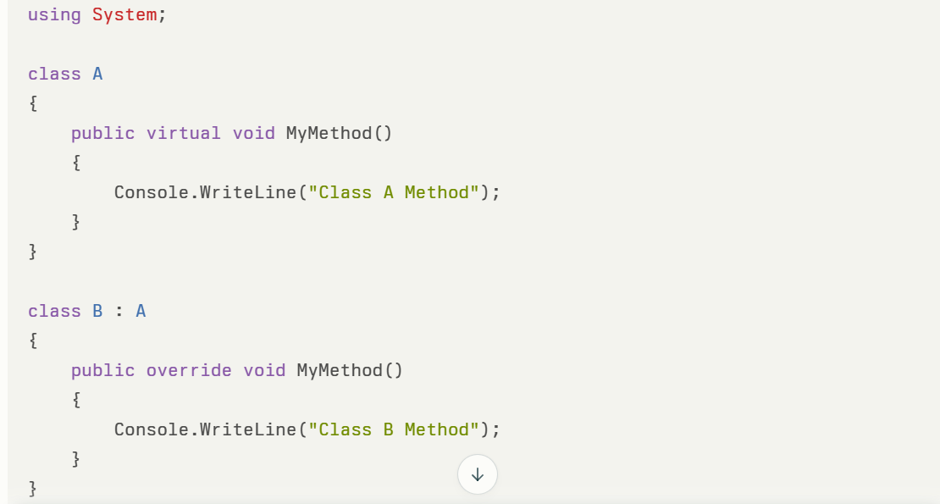
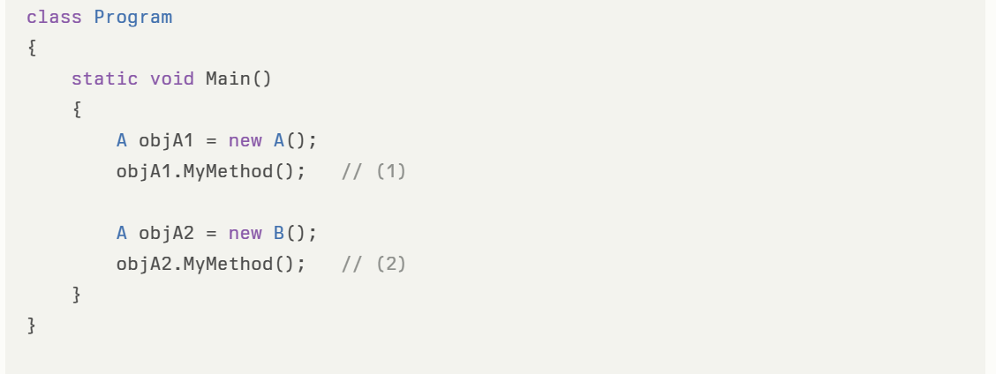
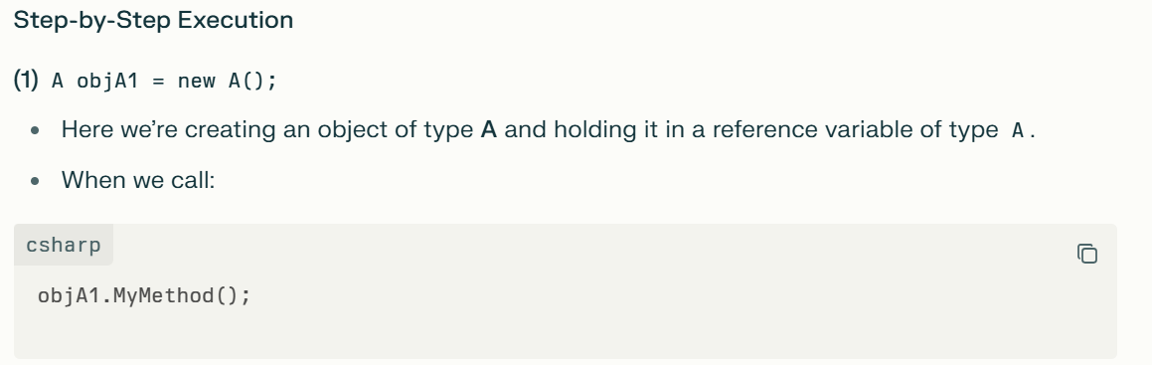
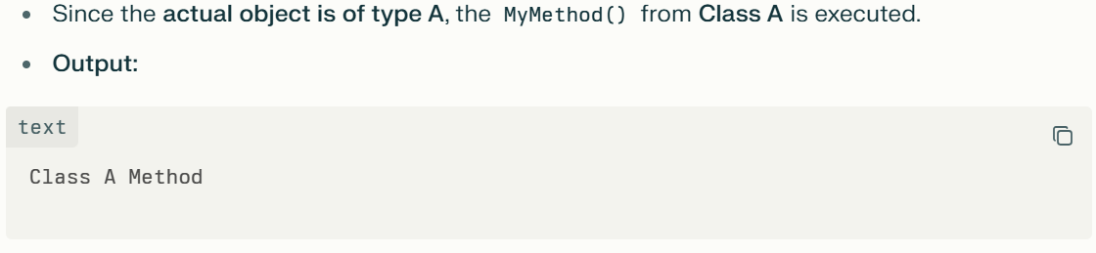
A objA2 = new B();
- Here, we create an object of type B but store its reference in a variable of type A (the base class).
- Even though the reference type is A, the actual object at runtime is B.
- Since MyMethod() is marked as virtual in class A and overridden in class B, C# uses runtime polymorphism (also called dynamic dispatch) to decide which method to run.
- The CLR (Common Language Runtime) looks at the actual type of the object (which is B) instead of just the reference type.
- So:
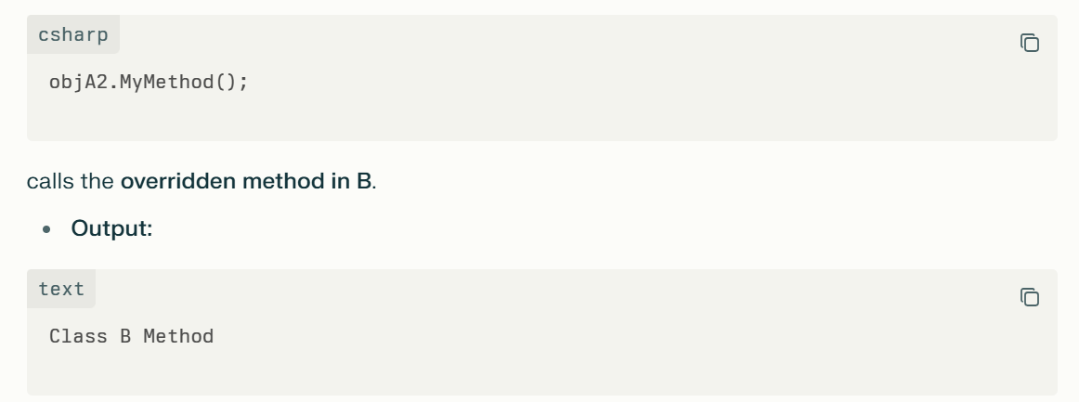
Why does this happen? (Polymorphism explanation)
- If a method in the base class is marked as virtual, and the derived class uses override, the method call is not bound at compile-time, but at runtime.
- The runtime checks the actual object type (not just the declared reference type) and invokes the most specific override of the method.
- That’s why new B() causes Class B Method to be printed even though the reference is declared as type A.
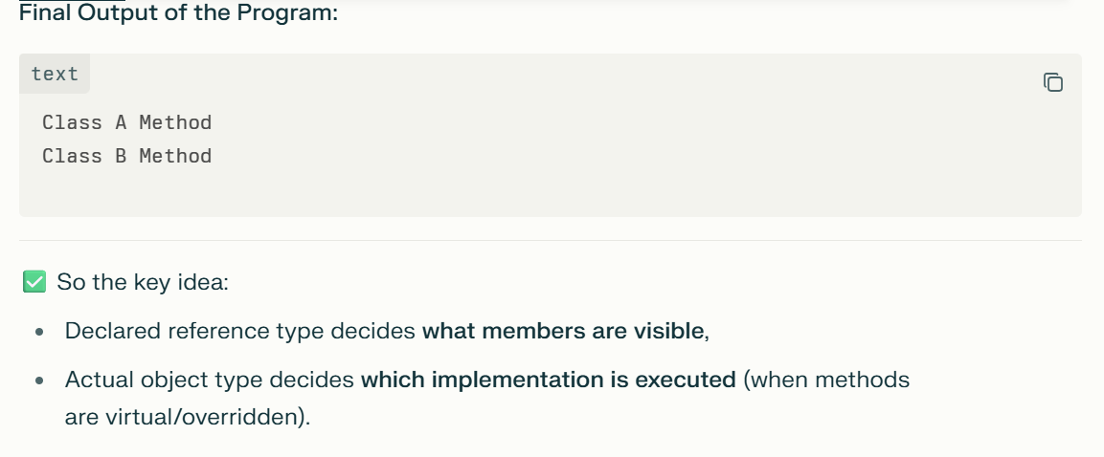

C# - Related
What are the different types of classes in C# OOPs?
The different types of classes in C# OOPs are:
- Regular (Concrete) Classes
A Regular (Concrete) Class in C# is a fully implemented class that can be instantiated to create objects. Unlike abstract classes or interfaces, concrete classes provide complete implementations of all their members (methods, properties, fields, etc.). They represent real-world entities or concepts in an application by encapsulating both data and behavior.
Key Characteristics of Concrete Classes in C#:
- Instantiable: Objects can be created directly from concrete classes using the new keyword.
- Complete Implementation: All methods and properties are fully implemented, with no abstract methods.
- Inheritance: Concrete classes can act as base classes or derived classes.
- Encapsulation: They encapsulate both state (fields/properties) and behaviors (methods).
- Example:
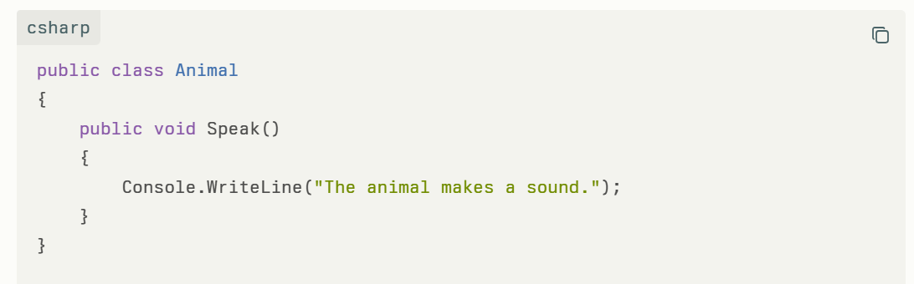
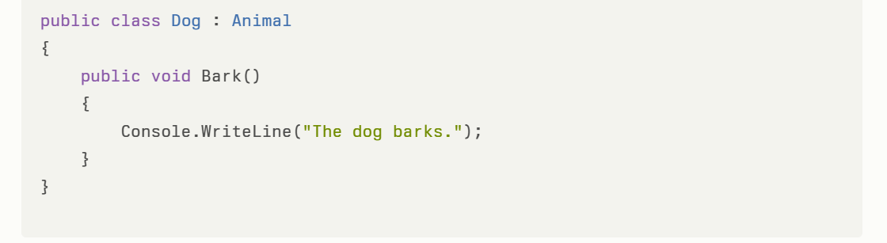
- Here, Animal and Dog are concrete classes because they can be instantiated and fully define their behaviors.
Usage
Concrete classes are the core building blocks in C# object-oriented programming to model real-world objects and behaviors. They are the most common type of classes used for application development.

- Abstract Classes
An abstract class in C# is a special class that cannot be instantiated directly and serves as a blueprint for other classes. It defines a common base with some implementation while enforcing derived classes to implement specific methods or properties marked as abstract.
Purpose of Abstract Classes:
- To provide a common definition and shared code for a group of related classes while requiring those classes to implement certain behaviours.
- To enforce a contract for derived classes by declaring abstract methods that must be implemented by subclasses.
- To promote code reuse by allowing concrete methods and properties in the abstract class while still mandating implementation of key methods in derived classes.
Real-time Use Case:
- Consider a shape drawing application: an abstract class Shape can define an abstract method Draw(). Specific shapes like Circle and Rectangle inherit from Shape and implement the Draw() method differently. This enforces a common interface and allows polymorphism.
Alignment with Design Patterns:
Abstract classes align well with the Template Method Pattern, where the base abstract class defines a skeleton of an algorithm, and subclasses customize specific steps by implementing abstract methods.
Alignment with SOLID Principles:
Abstract classes embody the Liskov Substitution Principle (LSP), ensuring subclasses can replace base class instances without altering correctness.
Also, they support the Open/Closed Principle (OCP)—abstract classes allow extension via inheritance without modifying existing code.

- Static Classes
  - Cannot be instantiated or inherited.
  - Contain only static members.
  - Useful for grouping utility or helper methods.
A class contains 10 member variables. Out of these 10 variables, 2 variables are declared as static.
- In what situations would we design a class in this way?
- Why would we declare only some variables as static and others as instance variables?
A class with a mix of static and instance variables is typically designed when some data needs to be shared among all instances, while other data is specific to each instance.
Situations to design a class like this:
- When certain properties or data are common for all objects of the class and do not depend on individual instances—these are declared static.
- When other properties need to be unique for every instance, such as state or attributes that differ between objects—they are declared as instance variables.
- Example: In an Employee class, the company name can be static (shared by all employees), while the employee's ID or name is instance-specific.
Why declare some variables static and others instance?
- Static variables occupy a single shared memory location for all instances, reducing memory usage for common data and ensuring consistent shared state.
- Instance variables are stored separately in each object, allowing each instance to maintain its own state.
- This design balances memory efficiency, data sharing, and encapsulation of unique object data.
Hence, declaring some variables as static and others as instance members allows proper resource management and logical modeling of shared versus individual attributes in object-oriented design.
Instead of keeping in static variable for single shared memory location for all instances, why can't we keep in the common variable or global variable?
In object-oriented programming, we prefer using static variables within classes rather than broad global variables or common variables because:
- Scope Control and Encapsulation
  - Static variables are scoped to the class they belong to, meaning they are only accessible within that class or through the class name. This limited scope prevents accidental modification from unrelated parts of the program, preserving encapsulation and reducing errors.
  - Global variables have program-wide visibility and can be accessed and modified from anywhere, which is considered poor design as it breaks encapsulation and makes debugging difficult.
- Controlled Access
  - Static variables can have access modifiers like private, protected, or public, allowing controlled access. Global variables do not have such fine-grained control.
- Namespace Pollution Avoidance
  - Using static variables avoids polluting the global namespace, which reduces naming conflicts and improves modularity.
- Object-Oriented Design Principles
  - Static variables fit naturally into the class structure, representing data shared by all instances of a class, aligning with OOP principles. Global variables tend to be procedural and do not reflect the concept of object encapsulation.
In summary, although static variables share memory like global variables, they are preferred in class-based designs to maintain encapsulation, controlled access, and modularity, which global variables lack.
- Sealed Classes
Sealed classes, which cannot be inherited further, are used when you want to prevent any further derivation of a class and ensure the class’s implementation remains unchanged and closed for extension.
Situations to use sealed classes:
- When a class is complete and stable in its behavior, and you want to avoid accidental or unauthorized inheritance that could break its functionality or security.
- When you want to restrict inheritance to maintain strict control over class design, such as in critical utility classes or security-related classes.
- When preventing subclassing can help improve performance slightly, as runtime optimizations can be applied because the class hierarchy is fixed.
- When implementing designs like Singletons, where inheritance could break the pattern’s constraints.
- To express closed hierarchies in domain models, where all possible subtypes are known and fixed (in languages like Kotlin, sealed classes are used for this).
Example use case:
- A Logger class that handles logging uniformly and must not be altered by subclasses.
- A configuration manager class that should have only one consistent behavior without variation.
- Classes representing core domain concepts that shouldn’t have extended variants for business rule integrity.
Sealed classes contrast with abstract classes, which are meant to be inherited and extended. Sealed classes ensure that the class is final in the inheritance chain and cannot be further modified by subclassing.Sealed classes, which cannot be inherited, are used when you want to prevent further derivation for reasons such as:
- Ensuring the class’s behavior and implementation remain fixed and unchanged.
- Restricting inheritance to maintain control over the class design (e.g., utility classes, core domain classes).
- Improving performance by allowing runtime optimizations when inheritance is closed.
- Implementing design patterns like Singleton, where subclassing would violate the pattern.
- Expressing closed hierarchies in domain modeling where all subclasses are known and fixed.
In summary, use sealed classes when you want to create a final, unextendable class that guarantees no further subclassing can occur, preserving integrity and potentially enhancing performance.

- Partial Classes
  - Allow a single class definition to be split across multiple files.
  - Help manage large codebases by organizing code better.
- Nested Classes
  - Classes defined within another class.
  - Useful for logically grouping classes that will only be used in one place.
- Generic Classes
  - Use type parameters to create reusable and type-safe classes.
  - Enable working with different data types without code duplication.

Constructors
A constructor in C# is a special method that is invoked when an object of a class or struct is created. Its primary role is to initialize the object's data members and ensure the object is in a valid state upon creation.
Key Features of C# Constructors
- Naming: The constructor must have the same name as the class.
- No Return Type: Constructors do not have a return type—not even void.
- Automatic Invocation: Called automatically when an object is created using the new keyword.
- Default Constructor: If you don't explicitly define any constructor, C# provides a default constructor that initializes all fields to their default values.
- Overloading: You can have multiple constructors in a class with different parameters (constructor overloading).
- Accessibility: Constructors can have different access modifiers (e.g., public, private).

Types of Constructors
Type | Description
Default Constructor | No parameters; initializes fields to default values
Parameterized | Takes arguments to initialize fields with specific values
Copy Constructor | Creates an object by copying data from another object
Static Constructor | Used to initialize static members of the class; called once, before any instance
Private Constructor | Restricts instantiation of the class from outside (commonly used in singleton pattern)

Example: Basic Constructor
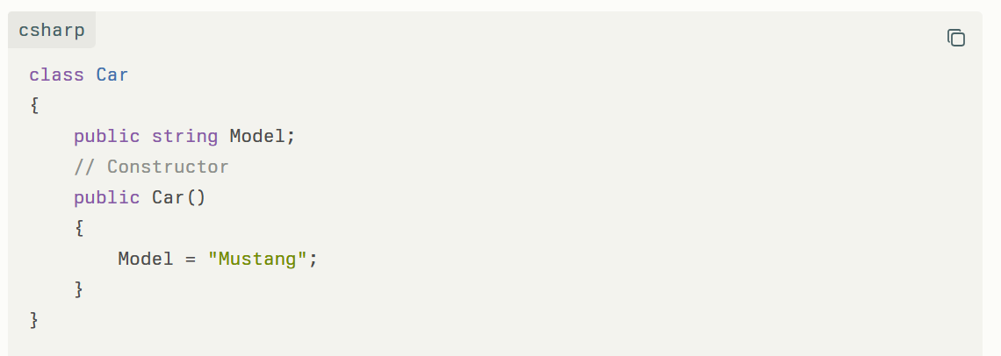
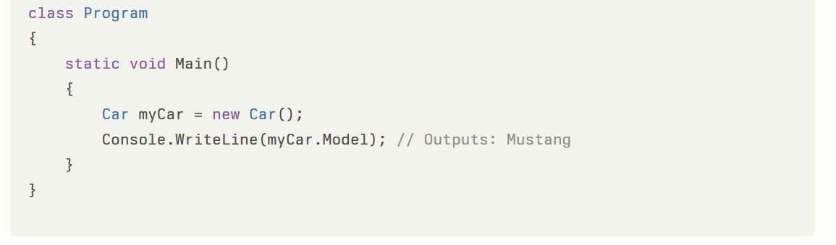

Example: Parameterized Constructor
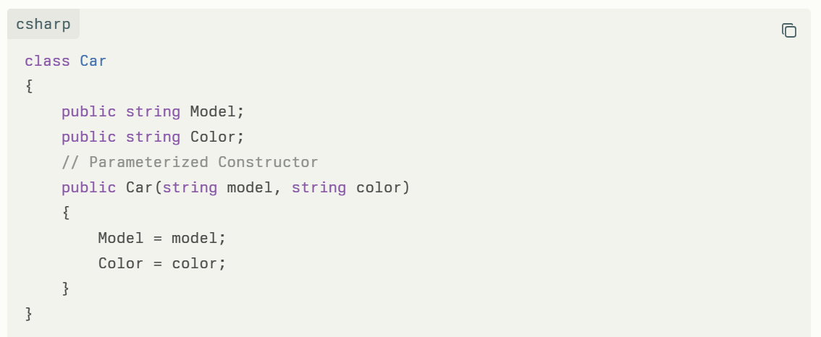
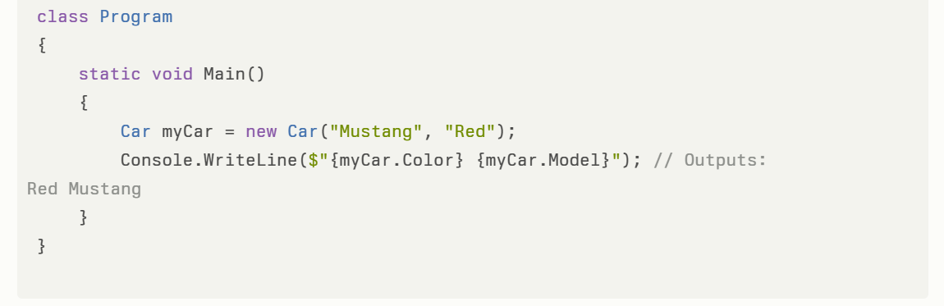
C# 12.0: Primary Constructors
C# 12.0 has introduced primary constructors, providing a more concise syntax for object initialization, particularly for records and classes with simple setup requirements.
In summary, constructors in C# are essential for robust object creation and initialization, supporting flexibility, encapsulation, and improved code readability.

What happens internally when creating an object for a class? How is memory allocated and deallocated in .NET Core?
What Happens Internally When Creating an Object?
- Memory Allocation:
  - .NET Core allocates memory for the object on the managed heap. This memory is large enough to hold all the fields of the object.
  - The heap memory is managed by the Garbage Collector (GC), which automatically tracks allocated objects.
- Zero Initialization:
  - When the memory is allocated, all fields are initially set to their default values (zero for numeric types, null for reference types, false for Booleans).
- Constructor Execution:
  - The constructor of the class is called to properly initialize the object's fields with meaningful values and execute any startup logic.
- Reference Return:
  - The new operator returns a reference to the allocated and initialized object.
How Is Memory Allocated?
- Memory for objects of reference types (classes) is allocated on the managed heap, which is a region of memory managed by the CLR.
- For value types (structs), memory is usually allocated on the stack or inside other objects if they are fields.
How Is Memory Deallocated?
- Memory deallocation in .NET Core is handled automatically by the Garbage Collector (GC).
- The GC periodically runs to identify objects that are no longer referenced by the program.
- It frees the memory occupied by these unreachable objects, reclaiming space for future allocations.
- This process relieves the developer from manual memory management and avoids issues like memory leaks and dangling pointers.
Summary
- Object creation in .NET Core involves allocation on the managed heap, zero initialization, and execution of the constructor.
- Memory management and deallocation are automated by the garbage collector, enhancing safety and efficiency in .NET applications
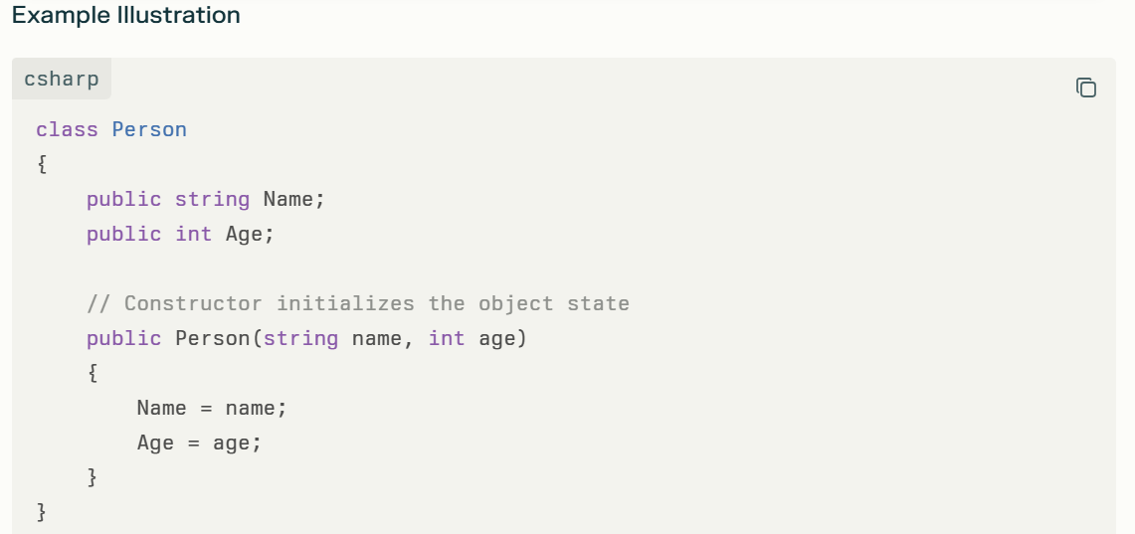
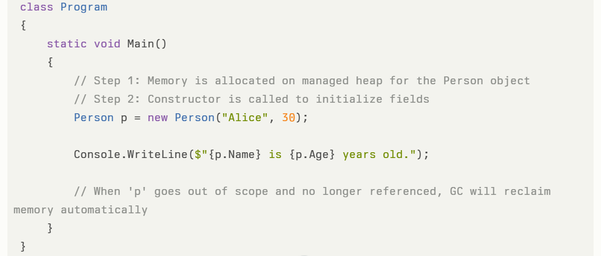
Summary
- Object creation in .NET Core involves allocating memory on the managed heap, zero-initializing it, then invoking the constructor to set up the object.
- The Garbage Collector manages deallocation automatically, freeing the developer from manual memory management and ensuring efficient memory use without leaks.
This process provides safety, consistency, and performance benefits in modern .NET applications.

What is a Private Constructor? When should it be used? What are the characteristics of a private constructor?
A private constructor is a constructor that is declared with the private access modifier. It can only be accessed and called within the same class where it is defined. This prevents any code outside the class from creating an instance of that class using this constructor.

When Should a Private Constructor Be Used?
- Singleton Pattern:
To ensure that a class can only have a single instance, a private constructor is used to prevent external instantiation. The only way to get the instance is through a static property or method inside the class.
- Utility or Static Classes:
Classes that contain only static members and should never be instantiated use a private constructor to prevent creating objects.
- Factory Methods:
When object creation is controlled by static factory methods inside the class rather than by external code using new.

Characteristics of a Private Constructor
- It restricts object creation from outside the class.
- It prevents inheritance because derived classes cannot call the private constructor of the base class.
- It prevents the automatic generation of a parameterless public constructor by the compiler.
- Can be used in classes with only static members to disallow instantiation.
- Allows controlled creation of instances within the class itself.

Example: Private Constructor Preventing External Instantiation
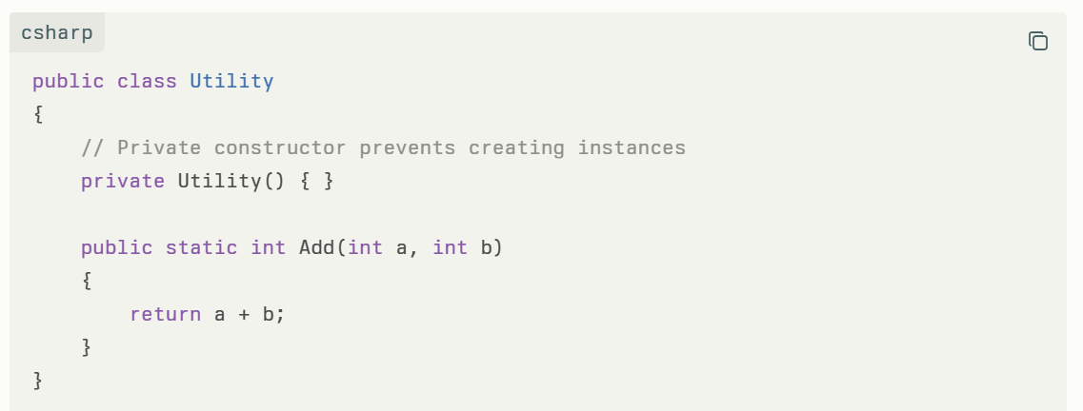
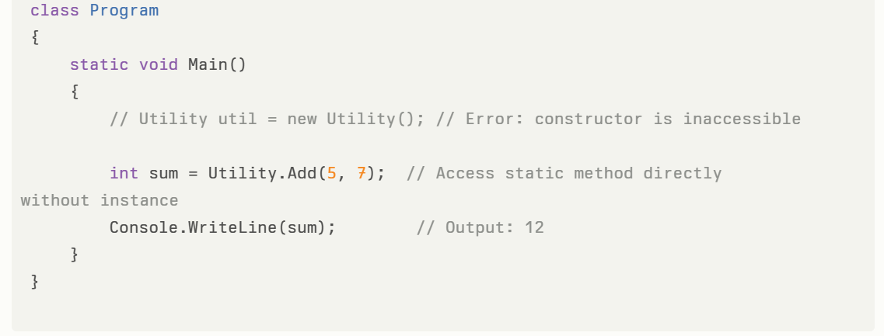
Example: Singleton Pattern Using Private Constructor
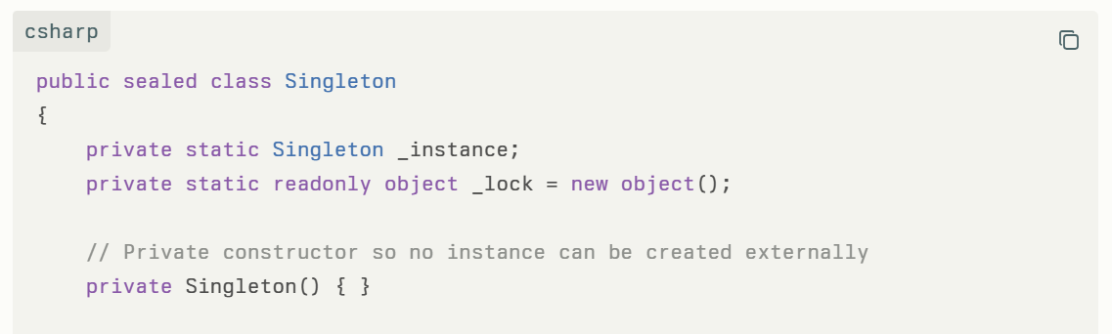
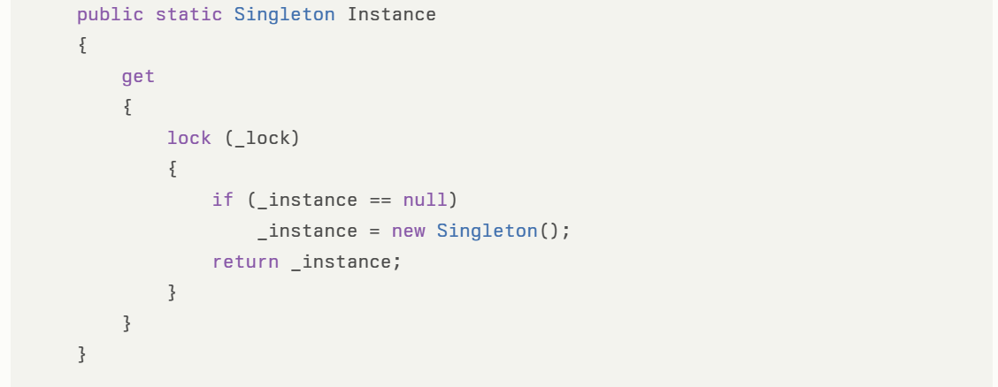
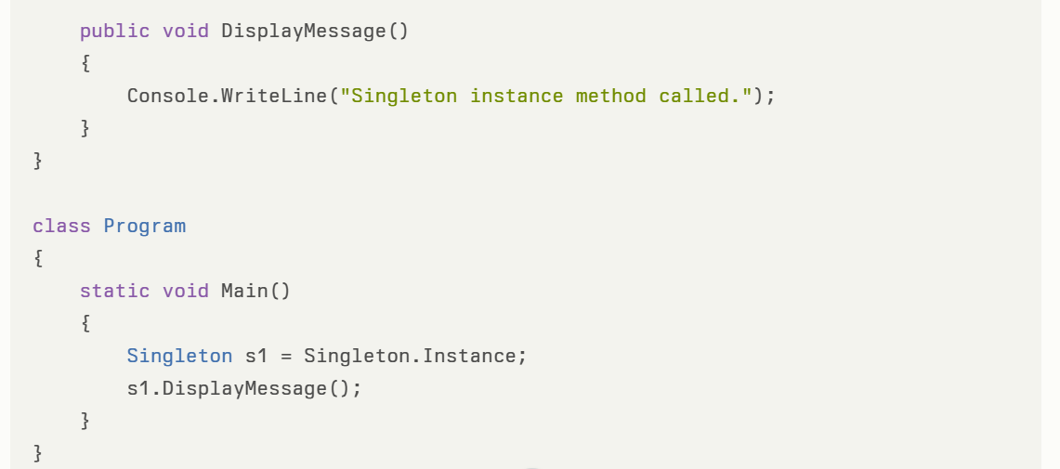
Using private constructors is a key technique in implementing design patterns that control object creation and enforce class usage policies.
C# Thread Constructor

C# Async and Await
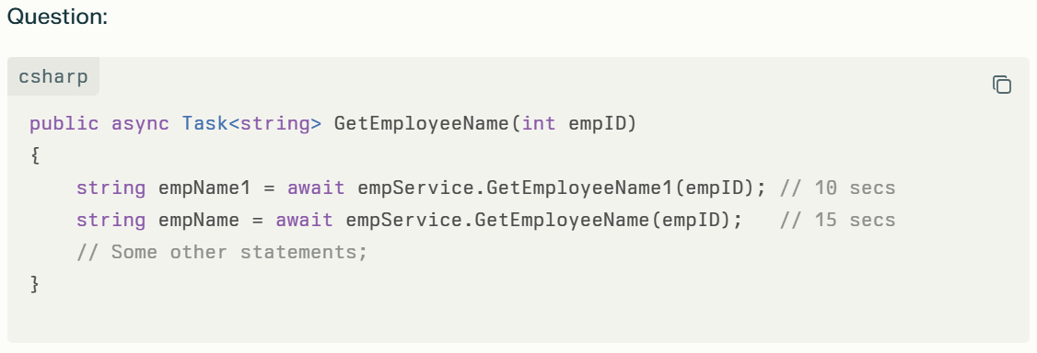
Each await statement takes 10 or 15 seconds to finish, and because they are awaited sequentially, the total time adds up. This means the method waits for each call to complete, resulting in longer total execution time.
In .NET 8, when you use async and await, the execution does not "wait" in the traditional blocking sense. Instead, when the await keyword is encountered, the method's execution is suspended at that point; control returns to the calling context, allowing other work (such as UI updates or other operations) to continue while the awaited asynchronous operation completes.
- If you use await on a task (such as Task.Delay or an asynchronous I/O operation), the code after await will only resume once the awaited operation is done.
- This pausing is non-blocking: the current thread is freed up while waiting for the task's completion.
- If you do not use await, the method continues execution immediately without waiting for the operation to finish, which can lead to unpredictable results.
So, await causes the execution of the method to pause until the awaited Task completes, but does not block the thread. This is true for .NET 8 and matches previous .NET versions.

How can we rewrite this code in an asynchronous way to consume less time by running tasks concurrently?
To reduce the total execution time and make the calls run concurrently, you can start both asynchronous operations without awaiting them immediately, then await both together using Task.WhenAll. Here’s how you can modify your code:
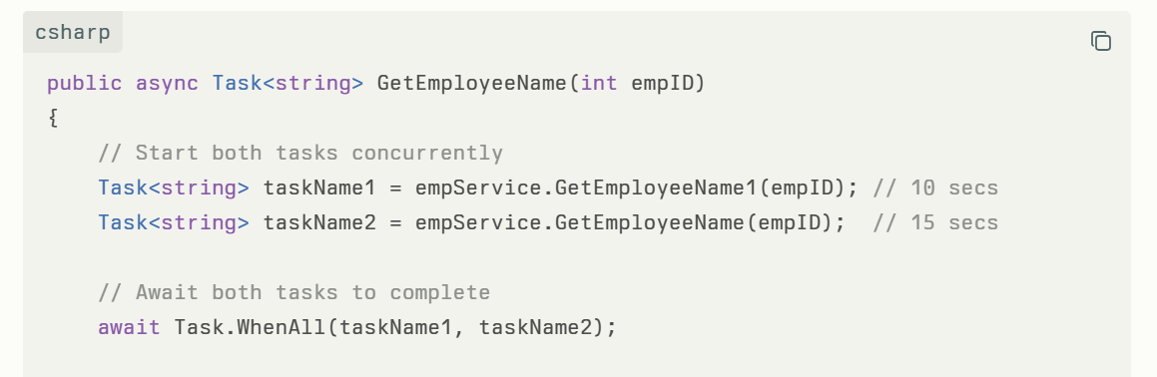
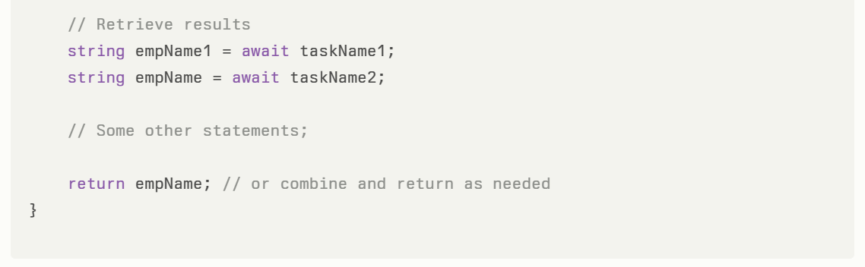
Explanation:
- Both tasks start running immediately.
- Task.WhenAll awaits completion of both in parallel.
- Total time taken will be roughly the duration of the longer task (~15 seconds), not the sum.
- This leverages asynchronous concurrency to improve performance.

1. Stack Memory vs Heap Memory
- Stack Memory
Stores value types (int, float, structs) and method call frames. It is fast, automatically managed, and limited in size. Lifespan is limited to the scope of the method call.
- Heap Memory
Stores reference types (objects, classes). Objects here are managed by the Garbage Collector (GC). Heap is larger but slower for allocation/deallocation than stack.
Example:
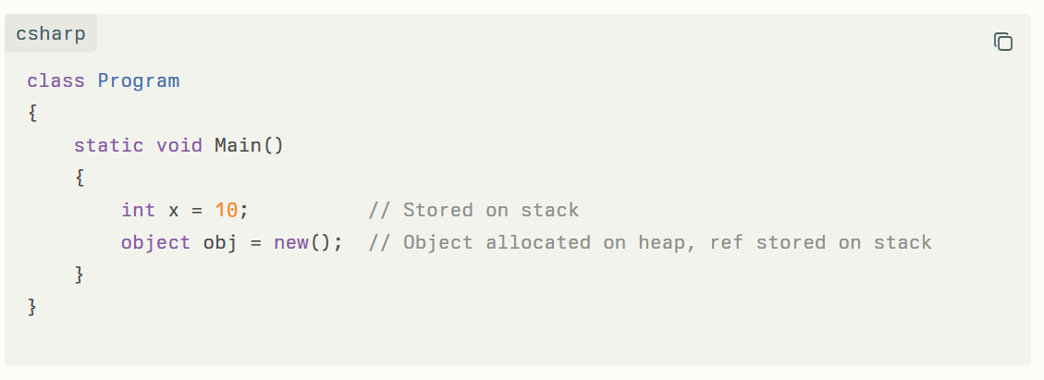
Explanation:
x is a value type stored on the stack. obj is a reference; the actual object is allocated on the heap.

Managed Heap Memory vs UnManaged Heap Memory in .NET Core
- Managed Heap Memory
Memory automatically handled by .NET runtime and Garbage Collector. All managed objects live here.
- Unmanaged Heap Memory
Memory allocated manually outside managed runtime control, e.g., via Marshal.AllocHGlobal or native code. Used when interoperating with unmanaged APIs or for performance reasons.
Example code for Unmanaged Heap Memory
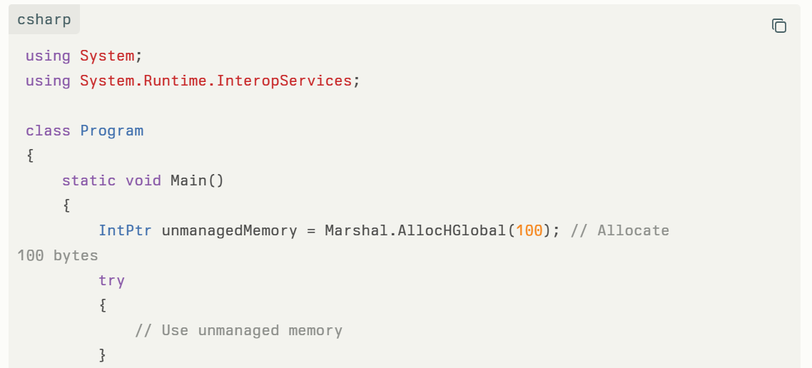
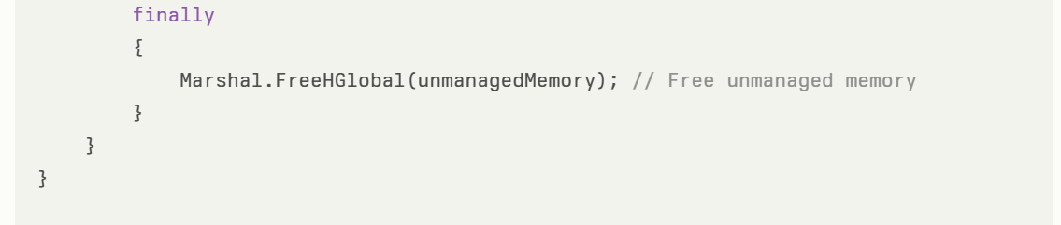

In .NET 8, How garbage collector works? What is the life cycle of garbage collector?
In .NET 8, the Garbage Collector (GC) is an automatic memory manager responsible for reclaiming unused memory to optimize application performance and reduce memory leaks. Here's an overview of how it works and its life cycle:

How the .NET 8 Garbage Collector Works
- Memory Allocation:
  - Objects are allocated on the managed heap, a reserved contiguous memory region managed by the runtime.
  - New objects get allocated at the next available space on the heap, usually very fast as it involves just moving a pointer.
- Generational Design:
  - The heap is divided into generations: Generation 0, Generation 1, and Generation 2, plus the Large Object Heap (LOH).
  - New objects start in Gen 0. Objects surviving collections move to higher generations.
  - This approach optimizes for the fact that most objects are short-lived; hence Gen 0 collections are frequent and fast.
- Roots and Reachability:
  - GC starts from roots which include static fields, local variables in threads’ stacks, CPU registers, and GC handles.
  - It builds a graph of live objects reachable from these roots.
  - Objects unreachable from roots are considered garbage.
- Garbage Collection Process:
  - Marking Phase:
The GC identifies reachable ("live") objects starting from roots.
  - Relocating Phase:
The GC updates references to objects that will be relocated during compaction.
  - Compacting Phase:
The GC frees memory occupied by dead objects and compacts the remaining live objects to remove fragmentation. This compaction moves surviving objects toward the older end of the heap.
  - Note: The Large Object Heap (for objects ≥ 85,000 bytes) is generally not compacted because copying large objects is costly, though .NET 8 introduces configurable LOH compaction in some scenarios.
- Thread Suspension:
  - Before starting a collection, the GC suspends all managed threads except the one triggering the GC, ensuring a consistent view of object references.

Life Cycle of Garbage Collector
- Allocation Phase:
Objects are allocated on the managed heap. When enough allocations have occurred or memory pressure exists, GC is triggered.
- Trigger GC:
Initiated by memory pressure or explicitly via API.
- Suspend Threads:
All managed threads except the GC thread are paused to ensure no changes during collection.
- Mark Phase:
Traverse object graph starting from roots, mark reachable objects.
- Sweep/Compact Phase:
Collect unreachable objects and optionally compact the heap by sliding objects to close gaps.
- Resume Threads:
Threads resume application execution with compacted heap and updated references.
- Promotion:
Surviving objects from Gen 0 move to Gen 1, survivors of Gen 1 move to Gen 2, representing longer-lived objects.

Improvements in .NET 8 GC
- .NET 8 adds features like DATAS (Dynamic Adaptation To Application Sizes) in server GC mode for better memory and performance optimization according to application needs.
- Enhanced configurability for large object heap compaction.
- Continuously improved throughput and latency for managed memory management.

Summary Diagram (Conceptual)
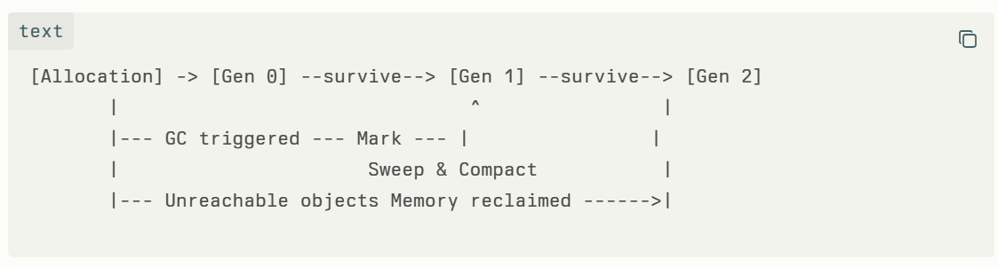
This automatic, generational, and optimizing design allows .NET applications to run efficiently without manual memory management burdens.
Notes on using explicit GC control:
- Typically, you do NOT need to call GC.Collect() manually; the GC runs automatically and optimally.
- Manual calls may degrade performance if used indiscriminately.
- Use manual collection primarily in scenarios like large memory release, integration with unmanaged code, or testing.

C# Extension Methods
Extension methods allow adding new methods to existing types without modifying their code or inheritance.
Example:
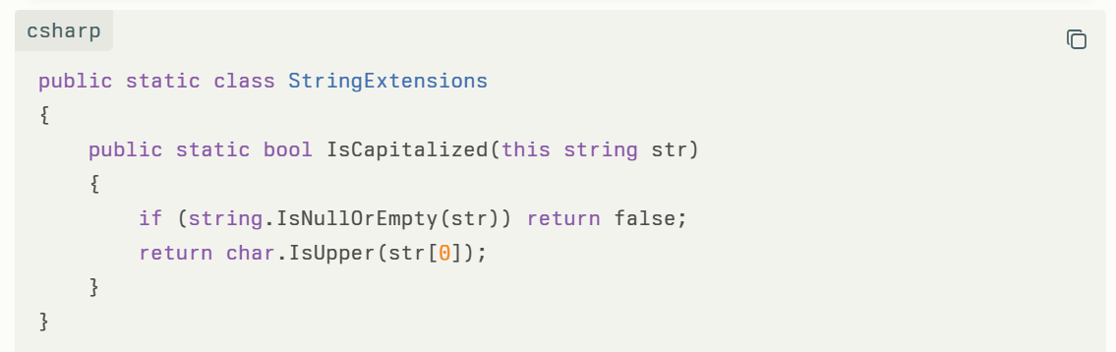
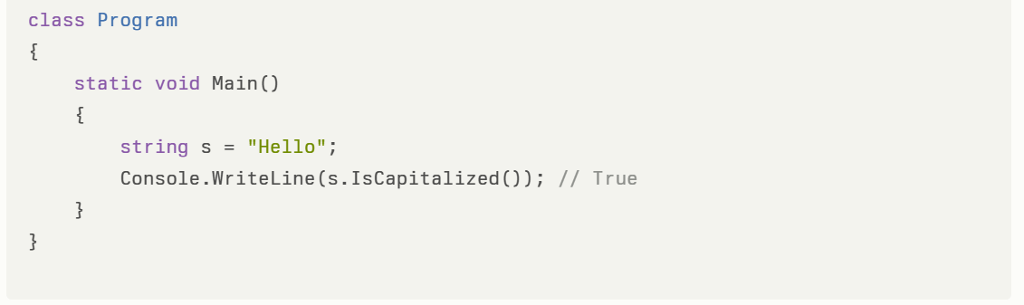

var vs dynamic in C#
- var: Compiled-time type inference. Type is fixed and known after compilation. You get all benefits of type checking and IntelliSense.
- dynamic: Runtime type resolution. No compile-time checking, errors only at runtime. Used for interoperability or reflection scenarios.
Example
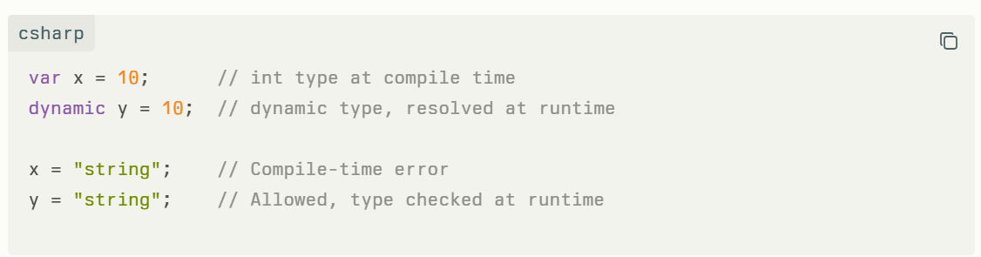

readonly vs const in C#
- const: Compile-time constant. Implicitly static. Value fixed at compile time.
- readonly: Runtime constant. Can be assigned once in declaration or constructor. Different value per instance possible.
Example
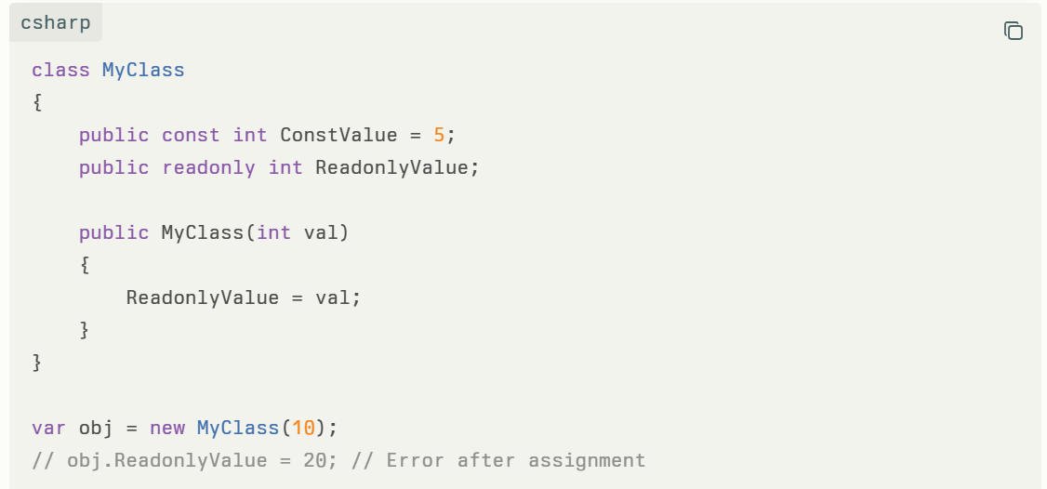

cast vs convert
- Casting changes type when types are compatible (reference or value).
- Converting transforms a value from one type to another using methods (e.g., Convert.ToInt32), and can handle incompatible types.
Example:
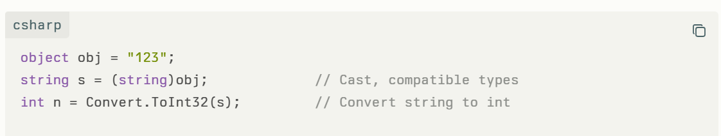

Method Hiding or Method Shadowing
A derived class method hides a base class method with the same signature using the new keyword.
In C#, method hiding and method shadowing are the same concept. The terms are used interchangeably in C#. Method hiding (also called shadowing) occurs when a derived class defines a method with the same name and signature as a method in the base class, using the new keyword. This causes the derived class method to hide or shadow the base class method.
- Both terms refer to re-implementing (not overriding) a parent class method in the child class with the same signature.
- The C# specification officially calls it "hiding," but "shadowing" is commonly used, especially among developers coming from languages like VB.NET.
- Method hiding/shadowing is achieved using the new keyword in the derived class:

Example:
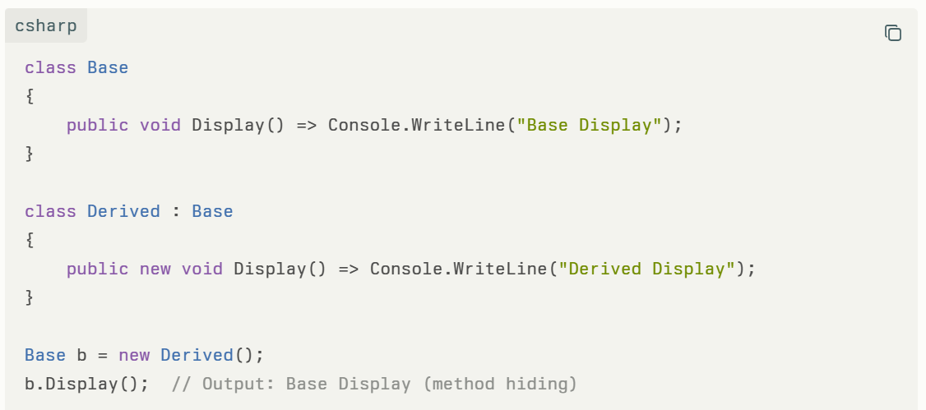
Key Points:
- Method hiding/shadowing is resolved at compile time based on the reference type, not at runtime like overriding.
- Overriding requires the base method to be virtual and uses the override keyword, resulting in runtime polymorphism.
- Hiding/shadowing does not require the base method to be virtual, and if you don't use the new keyword, the compiler will hide the method anyway but issue a warning.
In summary: Method Hiding and Method Shadowing are the same in C#, referring to the same feature. There is no difference between them in C#. The choice of term is mainly historical or based on language background.

Purpose of method hiding (shadowing)
The primary purpose of method hiding (shadowing) in C# is to allow a derived class to provide a new implementation for a method that exists in a base class when you do not want to (or cannot) use polymorphic behavior (method overriding). It is most useful in scenarios where:
- The base class method is not marked as virtual or abstract, so it cannot be overridden, but you still want a different behavior in the derived class for methods with the same signature.
- You want to avoid affecting base class behavior or you're working with legacy code where the base class cannot be changed.
- You anticipate future updates to the base class that might introduce a method with the same name as one you need in your derived class, and you want to protect your derived class from unexpected behavior changes.
- You need to provide a new implementation for the same method name, but you don't want polymorphism, i.e., you want the method execution to depend on the reference type, not the runtime type.
Real Use Cases
- Library or Framework Evolution:
Suppose a base class in a third-party library introduces a method with the same name as one you previously added to your derived class. Method hiding allows your derived class to retain its behavior independent of base class updates.
- Legacy Systems and Refactoring:
If you're refactoring old code or must maintain compatibility with legacy systems, method hiding lets you redefine base class methods without changing their virtual/abstract status or modifying base class code.
- Customizing Behavior without Polymorphism:
If you only want new behavior for a derived class when it is referenced directly (not via a base class reference), method hiding is useful. Overriding affects all references, while hiding only changes behavior for references of the derived type.
In summary, method hiding is a useful tool for re-implementing base class methods when you need to provide new behavior and overriding is not possible or desirable. It adds flexibility especially when working with non-virtual base methods, legacy code, or evolving libraries

