Here’s a Software Requirements Specification (SRS-style breakdown) for your retail application using React frontend, .NET Core Web API backend, and AWS-only services.
🛠 Software Requirements Details
1. Application Overview
- Domain: Retail (e-commerce style application).
- Frontend: React application for customer-facing UI.
- Backend: .NET Core Web API for business logic and data access.
- Cloud Provider: AWS (all services must be AWS-native).
- Database: AWS RDS (Relational Database Service).

2. Functional Requirements
- User Management: Registration, login, authentication (via AWS Cognito or custom JWT).
- Product Catalog: CRUD operations for products stored in RDS.
- Order Management: Place, update, and track orders.
- Image Handling: Product images stored in S3, accessible via frontend.
- API Exposure: Secure APIs exposed via API Gateway.
- Scalability: Auto-scaling backend services using ECS/EKS + ALB.
- Notifications: Order confirmation via AWS Lambda (email/SNS).

3. Non-Functional Requirements
- Scalability: Horizontal scaling via ECS/EKS.
- Availability: Multi-AZ deployment for RDS, ALB for load balancing.
- Security: IAM roles, VPC isolation, SSL/TLS via ACM.
- Performance: Low latency API responses (<200ms for catalog queries).
- Maintainability: CI/CD pipelines via AWS CodePipeline/CodeBuild.
- Cost Efficiency: Use AWS Free Tier for study, scale later for production.

4. AWS Service Mapping
Requirement | AWS Service
Database | AWS RDS (PostgreSQL/MySQL)
Image Storage | S3
Backend Deployment | ECS (Fargate) or EKS
Frontend Hosting | S3 + CloudFront
API Exposure | API Gateway
Load Balancing | ALB (Application Load Balancer)
Serverless Functions | Lambda
Authentication | Cognito (optional)
CI/CD | CodePipeline, CodeBuild, CodeDeploy
Monitoring | CloudWatch, X-Ray

5. Deployment Architecture
- React frontend → Hosted on S3 + CloudFront.
- .NET Core Web API backend → Containerized and deployed on ECS (Fargate) or EKS.
- ALB → Routes traffic to backend services.
- API Gateway → Provides secure API endpoints.
- RDS → Stores product, user, and order data.
- S3 → Stores product images and static assets.
- Lambda → Handles background tasks (image resizing, notifications).
- CloudWatch → Logs and monitoring.

6. Study Plan (AWS Free Tier)
- RDS: 750 hours/month (db.t2.micro).
- S3: 5GB storage free.
- Lambda: 1M requests/month free.
- API Gateway: 1M calls/month free.
- ECS/EKS: Limited usage (test small workloads).
- CloudFront: 50GB data transfer free.
👉 For study purposes, AWS Free Tier is sufficient. You can deploy the entire demo app without incurring costs if you stay within limits.

Architecture Diagram
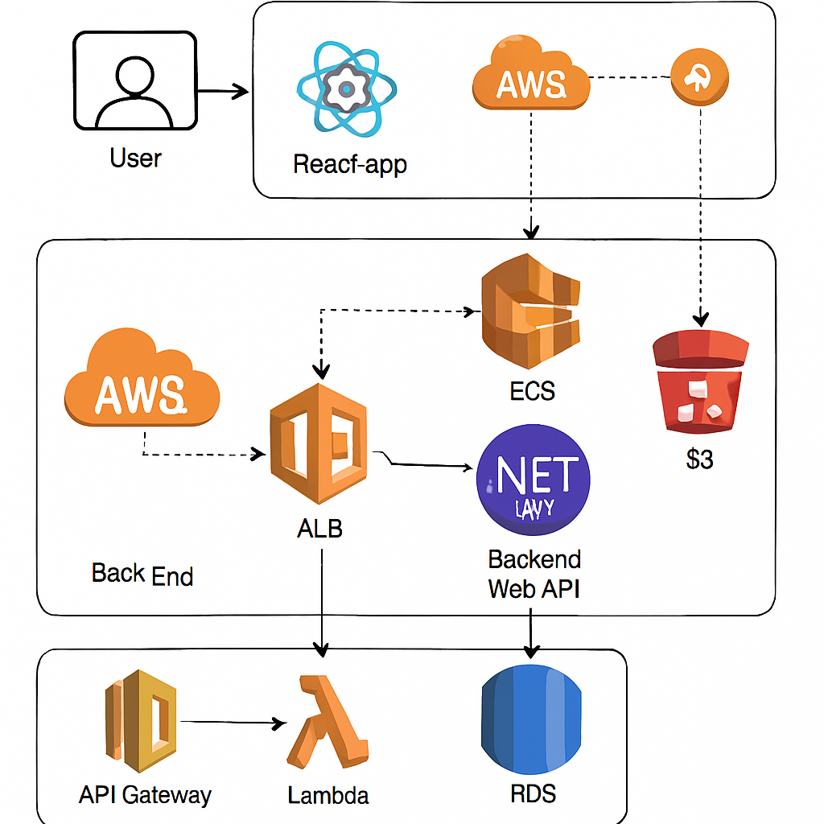

🔎 How to Read This Diagram
- Frontend (React App): Hosted on S3 + CloudFront for static content delivery.
- Backend (.NET Core Web API): Containerized and deployed on ECS/EKS, behind an Application Load Balancer (ALB).
- API Gateway: Provides secure endpoints for external clients.
- Database (RDS): Stores product catalog, users, and orders.
- S3: Stores product images and static assets.
- Lambda: Handles background tasks (e.g., image resizing, notifications).
- CloudWatch: Monitors logs, metrics, and application health.
📌 Key Benefits of This Setup
- Scalability: ECS/EKS + ALB ensures smooth scaling under heavy retail traffic.
- Security: IAM roles, VPC isolation, and SSL/TLS certificates protect data.
- Cost Efficiency: Free Tier covers most services for study purposes.
- Flexibility: Mix of serverless (Lambda, API Gateway) and containerized workloads (ECS/EKS).

