1. Makers do not have to run jar file by using command line and input filenames for all projects. Just using eclipse by using following steps.

2

Using eclipse to run the jar file for every jar file by following below steps.

Step1: create a Java Project

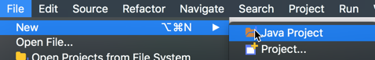

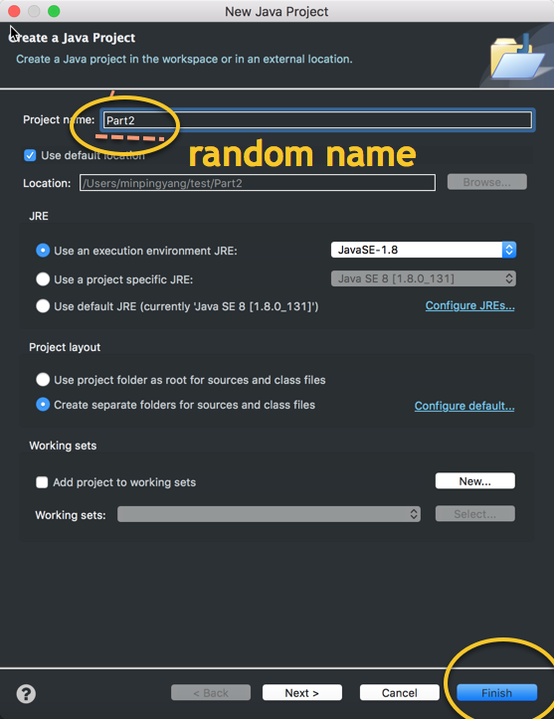

Step2: right click the created project, and select import

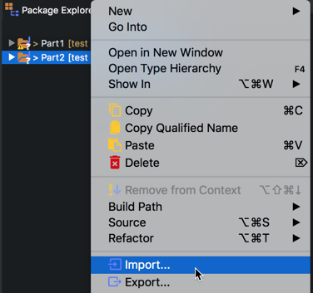

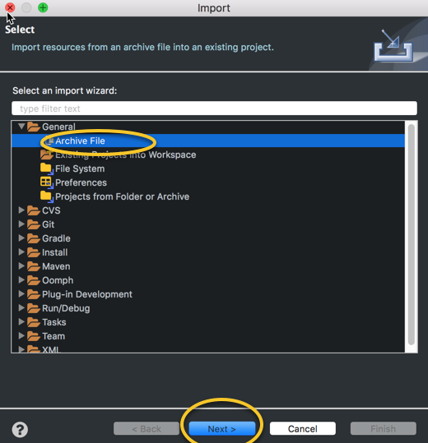

Step3: choose one of the jar file

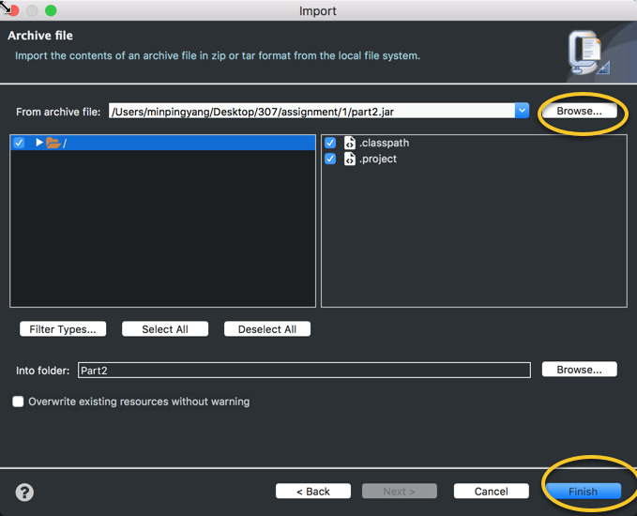

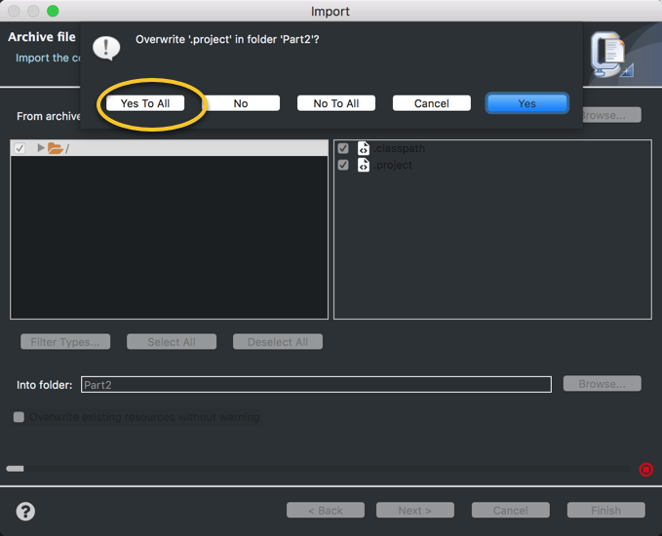

Step4: drag "code"(for part2.jar and part3.jar ) or "part1"(for part1.jar) folder into src folder

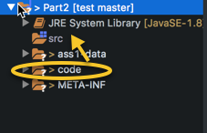

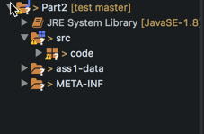

Step5: right click src folder to run java project

