Part1:

1. Init(Monkey_At(A)^Box_at(B)^Monkey_height(low) ^banana_at(C)）

Goal(Monkey_hold(Banana))

2.

Action(GoToBox(x,y) ,

PRECOND: Monkey_At(x)^Box_at(y)^x!=y

EFFECT: Monkey_At(y)^ ¬ Monkey_At(x)

)

Action(PushBox(x,y) ,

PRECOND: Monkey_At(x)^Box_at(x)^x!=y

EFFECT: Monkey_At(y)^Box_at(y)^ ¬ Monkey_At(x)^ ¬ Box_at(x)

)

Action( ClimbUp(x),

PRECOND: Monkey_At(x)^Box_at(x)^Monkey_height(low)

EFFECT: Monkey_height(high) ^¬Monkey_height(low)

)

Action(ClimbDown(x),

PRECOND: Monkey_At(x)^Box_at(x)^Monkey_height(high)

EFFECT: Monkey_height(low)

)

Action( Grasp(),

PRECOND: Monkey_At(x)^Box_at(x)^Banana_at(x)^Monkey_height(high)

EFFECT: Monkey_hold(Banana)

Action( Ungrasp(),

PRECOND: Monkey_hold(banana)^Monkey_At(x)^Box_at(x)^Banana_at(x)^Monkey_height(high)

EFFECT:

¬ Monkey_hold(banana)

)

3.

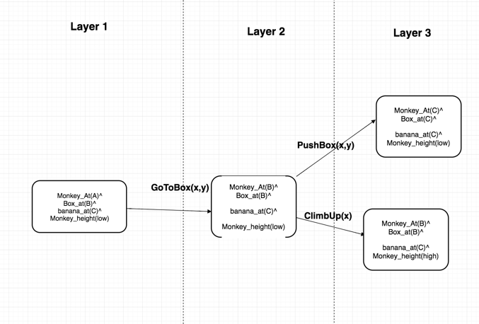

4.

• Initial state: Monkey_At(A)^Box_at(B)^banana_at(C)^Monkey_height(low)

• Action 1: GoToBox()

• State 1: Monkey_At(B)^Box_at(B)^Monkey_height(low)^ banana_at(C)

• Action 2: PushBox()

• State 2: Monkey_At(C)^Box_at(C)^Monkey_height(low) ^ banana_at(C)

• Action 3: ClimbUp(x)

• State 3: Monkey_At(C)^ Box_at(C)^Monkey_height(high) ^ banana_at(C)

• Action 5: Grasp()

• State 5: Monkey_hold(banana)^ Monkey_At(C)^ Box_at(C)^Monkey_height(high) ^ banana_at(C)

Part2

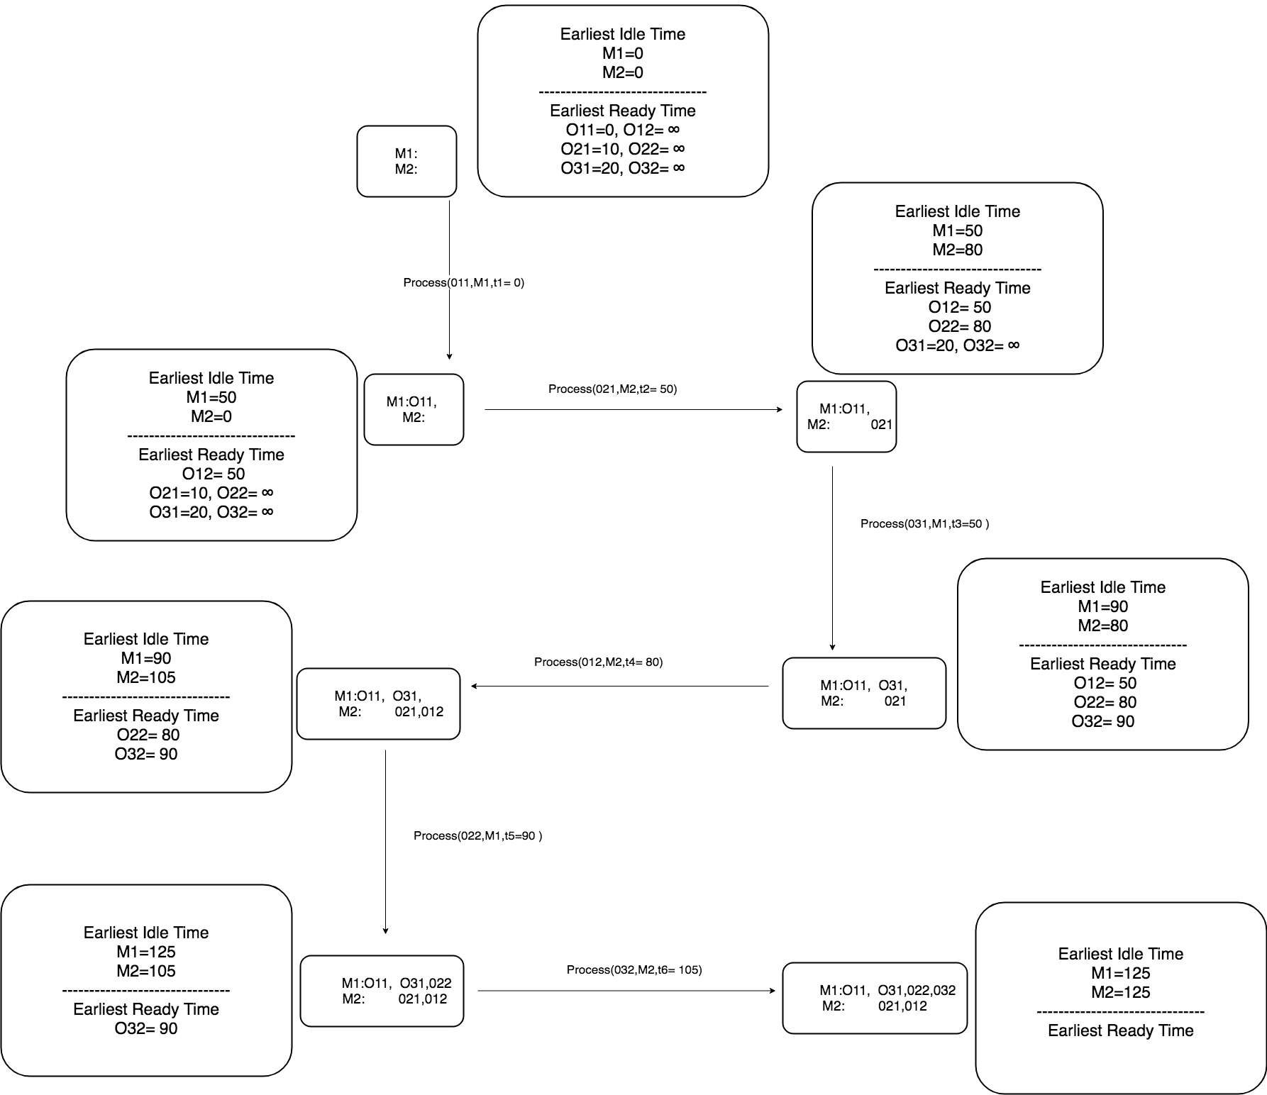

1. t1=0, t2= 10, t3=50, t4=50,t5=90,t6=90

2.

completion time of job1: t4+Proc(O12) = 50+25=75

completion time of job2: t5+Proc(O22) = 90+35=125

completion time of job3: t6+Proc(O32) = 90+20=110

the makespan of the solution is the time of completion time of latest job is 125

3.

Step1:

Partial solution: Process(011,M1,0)

earliestIdleTime(M1) =50, earliestIdleTime(M2) =0

earliestReadyTime(012)= 50

earliestReadyTime(021)= 10 earliestReadyTime(022)= ∞

earliestReadyTime(031)= 20 earliestReadyTime(032)= ∞

Step2:

Partial solution: Process(011,M1,0)->Process(021,M2,10)

earliestIdleTime(M1) =50, earliestIdleTime(M2) =40

earliestReadyTime(012)= 50

earliestReadyTime(022)= 40

earliestReadyTime(031)= 20 earliestReadyTime(032)= ∞

Step3:

Partial solution: Process(011,M1,0)->Process(021,M2,10)->Process(012,M2,50)

earliestIdleTime(M1) =50, earliestIdleTime(M2) =75

earliestReadyTime(022)= 40

earliestReadyTime(031)= 20 earliestReadyTime(032)= ∞

Step4:

Partial solution: Process(011,M1,0)->Process(021,M2,10)->Process(012,M2,50)->Process(022,M1,50)

earliestIdleTime(M1) =85, earliestIdleTime(M2) =75

earliestReadyTime(031)= 20 earliestReadyTime(032)= ∞

Step5:

Partial solution: Process(011,M1,0)->Process(021,M2,10)->Process(012,M2,50)->Process(022,M1,50)

->Process(031,M1,85)

earliestIdleTime(M1) =125, earliestIdleTime(M2) =75

earliestReadyTime(032)= 125

Step6:

Partial solution: Process(011,M1,0)->Process(021,M2,10)->Process(012,M2,50)->Process(022,M1,50)

->Process(031,M1,85) ->Process(032,M2,125)

earliestIdleTime(M1) =125, earliestIdleTime(M2) =145

Solution:

Process(011,M1,0)->Process(021,M2,10)->Process(012,M2,50)->Process(022,M1,50)

->Process(031,M1,85) ->Process(032,M2,125)

the makespan of the solution is 145

4.

By SPT rule:

completion time of job1: starting time of O12+ProcTime(O12) =50+25=75

completion time of job2: starting time of O22+ProcTime(O22) =50+35=85

completion time of job3: starting time of O32+ProcTime(O32) =125+20=145

the makespan of the solution is the time of completion time of latest job is 145

By FCFS rule:

completion time of job1: starting time of O12+Proc(O12) = 50+25=75

completion time of job2: starting time of O22+Proc(O22) = 90+35=125

completion time of job3: t6+Proc(O32) = 90+20=110

the makespan of the solution is the time of completion time of latest job is 125

By comparing the makespan of two rules, FCFS performance better in makespan

5.

|  |  |  |
| --- | --- | --- |
|  | SPT rule | FCFS rule |
| Completion time of Job 1 | 75 | 75 |
| Completion time of Job 2 | 85 | 125 |
| Completion time of Job 3 | 145 | 110 |
| makespan | 145 | 125 |

From the above table we can see, even though FCFS performs better in makespan, but by comparing completion time of Job2 from two different rules, SPT rule performance better than FCFS rule. Furthermore, SPT rule performance same as FCFS rule in completing Job1. So we cannot say FCFS rule generates the solution is better than the other rule, by only comparing their makespan.

Part3

Q1.

R1（1,2,3,5,1)

R2 (1,6,8,4,1)

R3 (1,7,9,10,1)

Q2.

len(R1)= len(1,2)+ len(2,3)+ len(3,5)+ len(5,1)= 1+1+1+2.24=5.24

len(R2)= len(1,6)+ len(6,8)+ len(8,4)+ len(4,1)=1.41+1.41+1.41+3.16=7.39

len(R3)= len(1,7)+ len(7,9)+ len(9,10)+ len(10,1)=2.23+3.16+2+5.39=12.78

total length = len(R1) + len(R2) + len(R3)= 5.24+7.39+12.78=25.41