# Design Principles

What is Good Software?

**Goals & Solutions**

•External Criteria (what clients expect)

» correctness, robustness, efficiency

•Internal Criteria (regarding solution)

» extensibility, modularity ...

•Design Techniques (how to meet internal criteria)

» principles, rules, best practices

Only external factors really matter. But the key to achieving them are the internal ones

Bad Design

A piece of software has a bad design if it fulfils its requirements and yet exhibits any or all of the following three traits

» **Rigidity** It is hard to change because every change affects too many other parts of the system

» **Fragility** When you make a change, unexpected parts of the system break

» **Immobility** It is hard to reuse in another application because it cannot be disentangled from the current application

Extensibility

•Extensibility characterizes the ease of adapting software to changes of specification

» ...and we know the specification is going to change

•"Big" is often "Bad“

» as software grows bigger, it becomes harder to adapt

» .unless, appropriate counter measures are taken

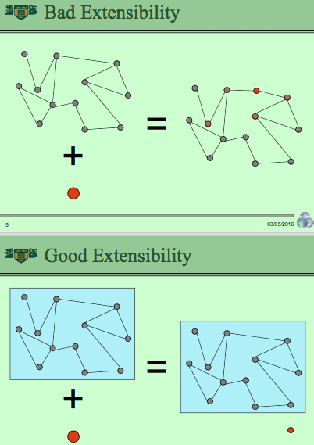

Modularity

•Any mechanism that works towards producing self-contained building blocks, communicating through restricted and explicit channels only, improves modularity

•Modularity aids both » extensibility » reusability

**Five Fundamental Requirements**

•Decomposability & Composability

» how to separate & combine

•Understandability

» if you want to change, you need to know what

•Continuity

» avoiding the "change avalanche"

•Protection

» avoiding "error creep"

Decomposability

A software construction method satisfies Modular Decomposability if it helps in the task of decomposing a software problem into a small number of less complex sub-problems, connected by a simple structure, and independent enough to allow further work to proceed separately on each of them. 

• Division of labour!

» decomposition aids parallel development

^ dependencies must be

» explicit, as they form the interfaces for cooperative work

» few, as every dependency increases communication overhead & adds to system rigidity / fragility

Positive Example

» structured analysis & design » OO classes

Negative Example

» global, common initialization module: endangers autonomy of participating modules

Composability

A design method satisfies Modular Composability if it favors the production of software elements which may be freely combined with each other to produce new systems, possibly in environments quite different from the one in which they were initially developed.

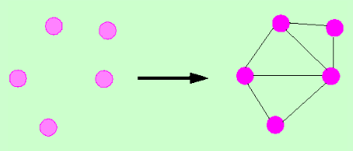

• Reusability!

» components are required to be sufficiently independent from the immediate goal that led to their existence

^ designated tasks must be

» not too narrow, so that reuse makes sense

» well-defined, so that the components are usable

**Positive Example**

» Unix shell pipes: processing of ASCII streams enables numerous combinations

**Negative Example**

» language extensions through pre-processors: any single solution works but cannot be combined with others

Understandability

A method favors Modular Understandability if it helps produce software in which a human reader can understand each module without having to know the others, or, at worst, by having to examine only a few of the others.

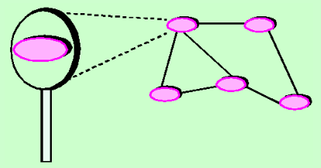

Positive Example

» lazy initialization

Negative Example

» modules, only working correctly if activated in a certain prescribed order; for example, B can only work properly if you execute it after A and before C.

Continuity

A method satisfies Modular Continuity if, in the software architectures that it yields, a small change in a problem specification will trigger a change of just one module, or a small number of modules.

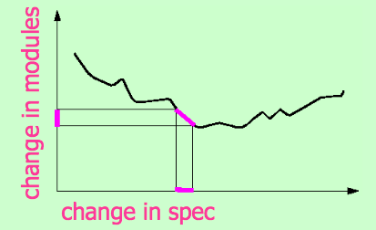

**Positive Example**

» symbolic constants: If a value changes, the only thing to update is the constant definition instead of numerous occurrences of the value

**Negative Example**

» case analysis over object types

Protection

A method satisfies Modular Protection if it yields architectures in which the effect of an abnormal condition occurring at run time in a module will remain confined to that module, or at worst will only propagate to a few neighbouring modules.

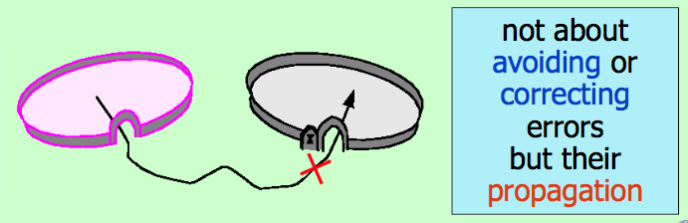

Positive Example

» preconditions: checking the validity of input data before it is used

Negative Example

» undisciplined exceptions: unless caught at appropriate places, they can create and propagate errors without bounds

Obtaining Modularity

From the five modularity requirements, we may derive rules which we must

observe to ensure modularity

•Direct Mapping •Interfaces » few, small, and explicit

• Information Hiding

Direct Mapping

The modular structure devised in the process of building a software system should remain compatible with any modular structure devised in the process of modelling the problem domain.

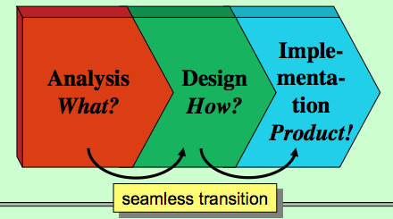

Related to the criteria

•Decomposability

» the analysis of the problem domain structure may provide a good starting point for the modular decomposition of the software

•Continuity

» keeping a trace of the problem’s modular structure in the solution’s structure makes it easier to assess and limit the impact of changes

Few Interfaces

Every module should communicate with as few others as possible.

If a system is composed of n modules, the number of connections should remain much closer to the minimum, n-1 (C), than to the maximum, n (n - 1) /2 (B).

How to reduce the interface count

• Layering

» layers only interact with adjacent layers, stops change avalanches, separates concerns

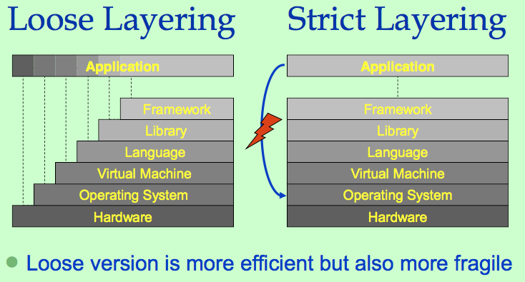

How to reduce the interface count

•Layering

» layers only interact with adjacent layers, stops change avalanches, separates concerns

•One more level of indirection ...

» reduce connection explosion (n+m not n*m)

» introduce variation point (decoupling & selection)

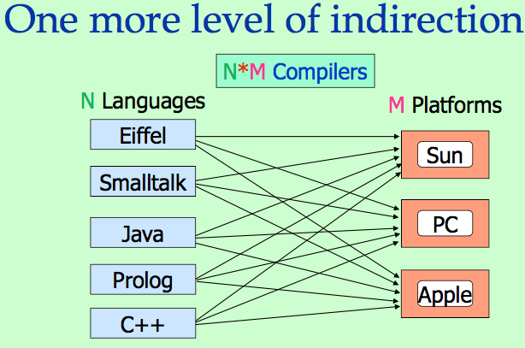

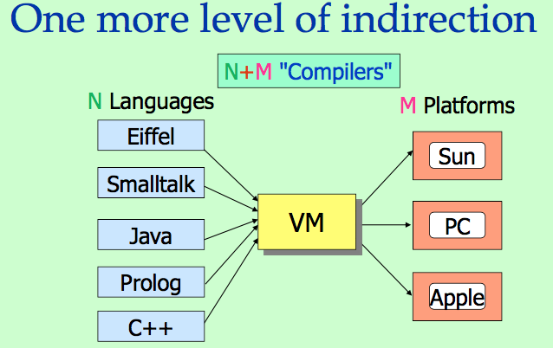

Caveat

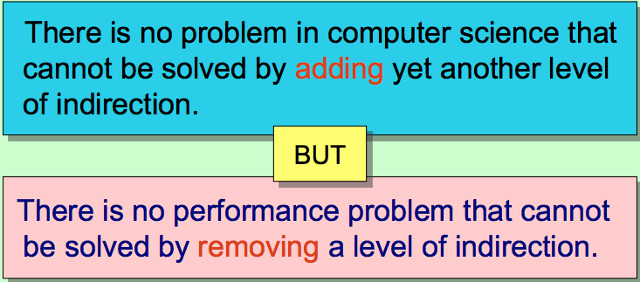

Small Interfaces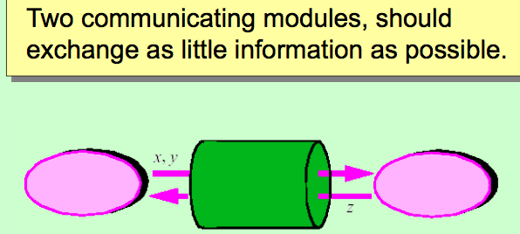

Counter-example: Fortran‘s “common block”

COMMON /common_name / variable!, ... variablen

» the variables listed are accessible to any other module which includes a COMMON directive with the same common_name

» every module may misuse the common data, modular continuity and protection are endangered

Languages with nested structures may suffer from similar trouble

Explicit Interfaces

Whenever two modules A and B communicate, this must be obvious from the text of A or B or both.

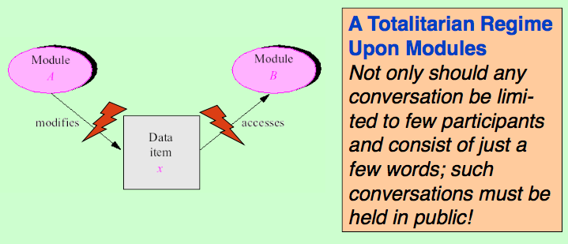

Information Hiding

The designer of every module must select a subset of the module’s properties as the official information about the module, to be made available to authors of client modules.

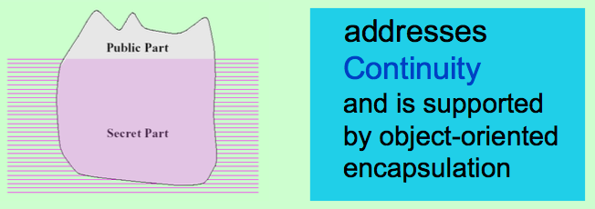

More Modularity Heuristics

•"What" not "How" »request behaviour, instead of spelling out the solution

•Low Coupling & High Cohesion

» use interfaces to decouple entities

» create entities with a well-defined meaning

"What" not "How"

Violating the Dilbert Principle:

total := 0

aPlant billings do: [:each |(each status == #paid and: [each date > startDate])

ifTrue: [total := total + each amount]

].

Let someone else do the work for you

total := aPlant totalBillingsPaidSince: startDate.

High Coupling

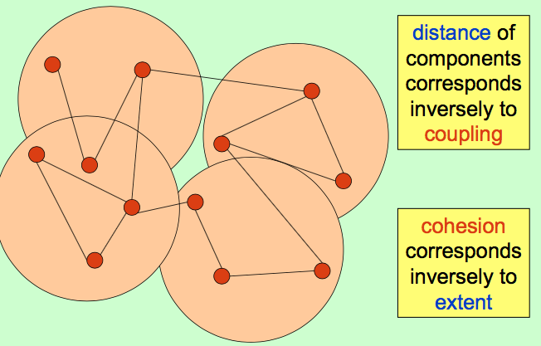

Less Coupling

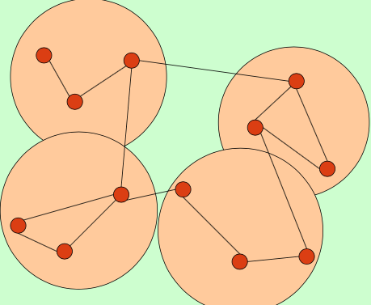

Less coupling & Low Cohesion

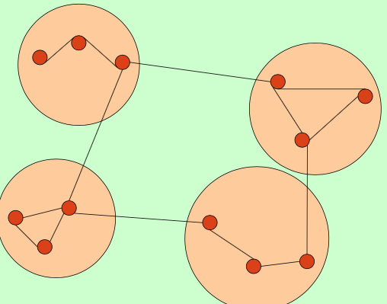

Less coupling & More Cohesion

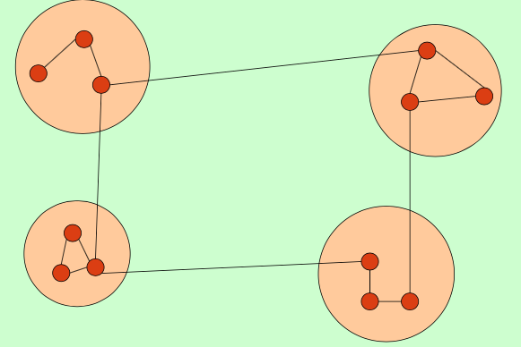

Low Coupling & High Cohesion

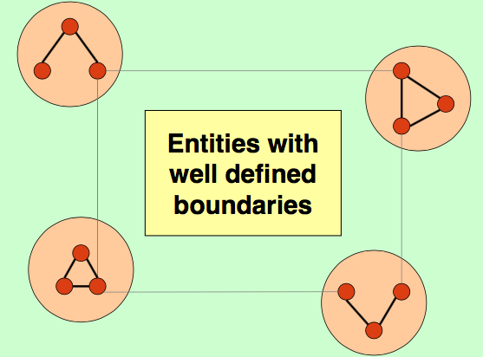

Cohesion Levels

1. Very low cohesion: a class is responsible for many things in different functional areas

A class called Storage-RPC-Interface, responsible for interacting with relational databases and files and for handling remote procedure calls. Should be split into several classes.

1. Low cohesion: A class has sole responsibility for a complex task in one functional area

A class called Storage Interface, responsible for interacting with relational databases and files. The methods of the class are all related, but there are lots of them and they do too much. Should be split into several lightweight classes sharing the work.

1. Moderate cohesion: A class has moderate responsibilities in a few different areas that are logically related to the class concept, but not to each other

A class called RDB Interface, responsible for interacting with relational databases. Its features include creating, modifying and querying databases.

1. High cohesion: a class has lightweight responsibilities in one area and collaborates with other classes to fulfil tasks

A class called RDB Query Interface, partially responsible for interacting with databases. It interacts with a number of other classes related to DB access.

Low Cohesion & High Coupling?

•Classes with low cohesion are much more difficult to understand

•Changes to a class with low cohesion may affect more than one (the intended) aspect

•High coupling causes changes to propagate through the system

•Highly coupled classes are difficult to reuse as they dependent upon many other classes

Recognising Good Design

•If all methods within a class use a similar set of instance variables, the class is considered highly cohesive

•Classes with high cohesion can often be described by a simple sentence

High cohesion and low coupling is preferred

•Loosely coupled classes' communication is based on abstract interfaces rather than concrete classes

•Loosely coupled classes can be described and understood with minimal reference to other classes